Circadian vital sign characteristics in postoperative patients with and without subsequent complications

Supplemental appendix

Vital sign artefact filtering algorithms
Oxygen saturation
There needs to be at least 1 second per minute of valid SpO₂ data. Changes in SpO₂ > 4% per second were considered artefacts.
PPG signals were compared to the average signal in the same minute, and signals with low correlation were removed.

Heart rate
The HR measurement from the Lifetouch patch was derived from the automatic detection of R-peak intervals in the electrocardiogram signal.
Values of HR and RR derived from noisy electrocardiographic signals* were defined as artefacts.
R-R intervals < 20 ms(HR > 500 min⁻¹) or > 4 seconds(HR < 15 min⁻¹) are removed
QRS complexes were compared to the average QRS complex in the same minute, and signals with low correlation were removed.

Respiration frequency
Respiration frequencies were removed if there were no ECG segments with an acceptable quality pending artefact filtering as above.

*Noisy electrocardiographic signals were defined as:
- Amplitude of more than 25% of QRS complexes in a segment is below 0.5 mV
- Correlation analysis of individual QRS complexes and all QRS complexes in a segment with a coefficient of < 0.4

Table 1: Results from sensitivity analysis
Modality | Variable | Periods with subsequent SAE | Periods with no subsequent SAE | P value
SpO₂, % | N periods | 56 | 1010
 | MESOR | 93.4 91.9 - 94.7 | 93.5 [92.0 - 94.9] | 0.41
 | Amplitude | 1.5 [0.8 - 2.6] | 1.6 [1.0 - 2.8] | 0.44
RF, min⁻¹ | N periods | 77 | 1232
 | MESOR | 16.0 [14.4 - 18.3] | 14.8 [13.2 - 16.4] | <0.001 *
 | Amplitude | 1.5 [1.0 - 2.6] | 1.4 [0.9 - 2.4] | 0.24
HR, min⁻¹ | N periods | 77 | 1232
 | MESOR | 82.1 [IQR 74.7 - 90.3] | 76.1 [IQR 67.7 - 84.3] | <0.001 *
 | Amplitude | 6.7 [IQR 3.9 - 9.7] | 6.0 [3.7 - 10.0] | 0.48
SBP, mmHg | N periods | 40 | 853
 | MESOR | 129.8 [116.1 - 140.5] | 125.7 [113.2 - 140.2] | 0.36
 | Amplitude | 9.7 [7.1 - 15.6] | 11.0 [6.5 - 18.2] | 0.27
Abbreviations: CI: Confidence interval, SpO2: Peripheral Oxygen Saturation, RF: Respiration Frequency, HR: Heart Rate, SBP: Systolic Blood Pressure, mmHg: millimetres of Mercury, MESOR: Midline estimating statistic of rhythm. *Statistically significant (P<0.01)

Table 2: Discrimination based on sensitivity analysis
Modality |  | Youden's value | Sensitivity  (%) | Specificity  (%) | Risk Ratio  (99% CI)
SpO₂, % | MESOR | 93.8 | 46.4 | 57.0 | 1.14 (0.58 - 2.23)
 | Amplitude | 5.4 | 10.7 | 94.3 | 1.88 (0.65 - 5.43)
RF, min⁻¹ | MESOR | 15.8 | 55.8 | 66.4 | 2.37 (1.34 - 4.19) *
 | Amplitude | 0.7 | 90.9 | 20.0 | 2.41 (0.88 - 6.58)
HR, min⁻¹ | MESOR | 73.2 | 84.4 | 40.3 | 3.45 (1.55 - 7.64) *
 | Amplitude | 5.5 | 64.9 | 44.5 | 1.45 (0.79 - 2.64)
SBP, mmHg | MESOR | 127.5 | 60.0 | 53.6 | 1.69 (0.75 - 3.81)
 | Amplitude | 7.1 | 77.5 | 28.3 | 1.34 (0.51 - 3.48)
Cosinor parameters greater than Youden's index. Abbreviations: CI: Confidence interval, SpO2: Peripheral Oxygen Saturation, RF: Respiration Frequency, HR: Heart Rate, SBP: Systolic Blood Pressure, mmHg: millimetres of Mercury, MESOR: Midline estimating statistic of rhythm. *Statistically significant

Figure 1: Example of feature calculation for two different patients

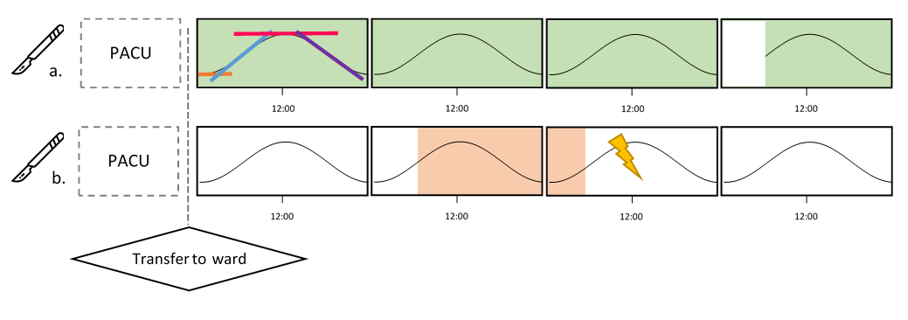

Legend: Example of calculation of circadian vital value windows after surgery.
Values for a single modality (e.g. heart rate) are presented in 24-hour blocks.
Green and red backgrounds represent blocks from which non-SAE / SAE values are calculated.
Circadian windows are represented in patient a. as orange, blue, pink and purple lines.
Patient a. developed no complication, and all 24h-blocks were available for feature extraction. Note that in the last block, insufficient (<4 hours) data for night-time nadir was available, and the feature was thus omitted.
Patient b. developed a complication on day 3. Values from the preceding 23-hour period were used.

Figure 2: Illustration of cosinor fitting of values

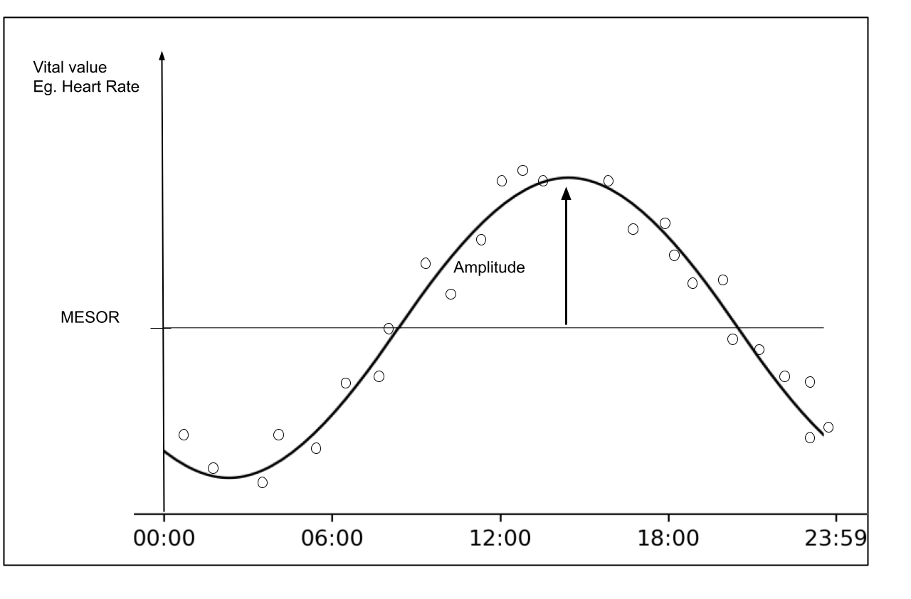
Legend: Values from cosinor fitting illustrated. MESOR: Midline estimating statistic of rhythm.

Figure 3: Type and number of SAE
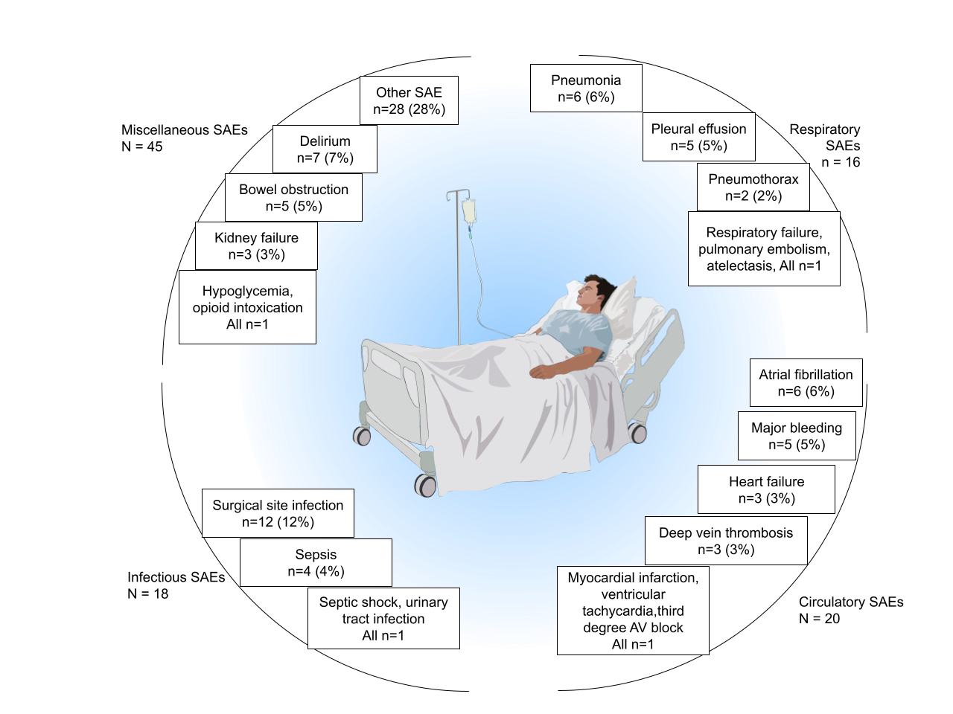

Legend: Distribution of 99 serious adverse events (SAE). Each SAE is classified as either respiratory, circulatory, infectious or miscellaneous.
Background image by Wakana Sasaki from https://doi.org/10.7875/togopic.2020.173 licensed under the Creative Commons Attribution 4.0 International licence.

Figure 4: Forest plot of relative risk of SAE for patients deviating from Youden’s optimal cut-off.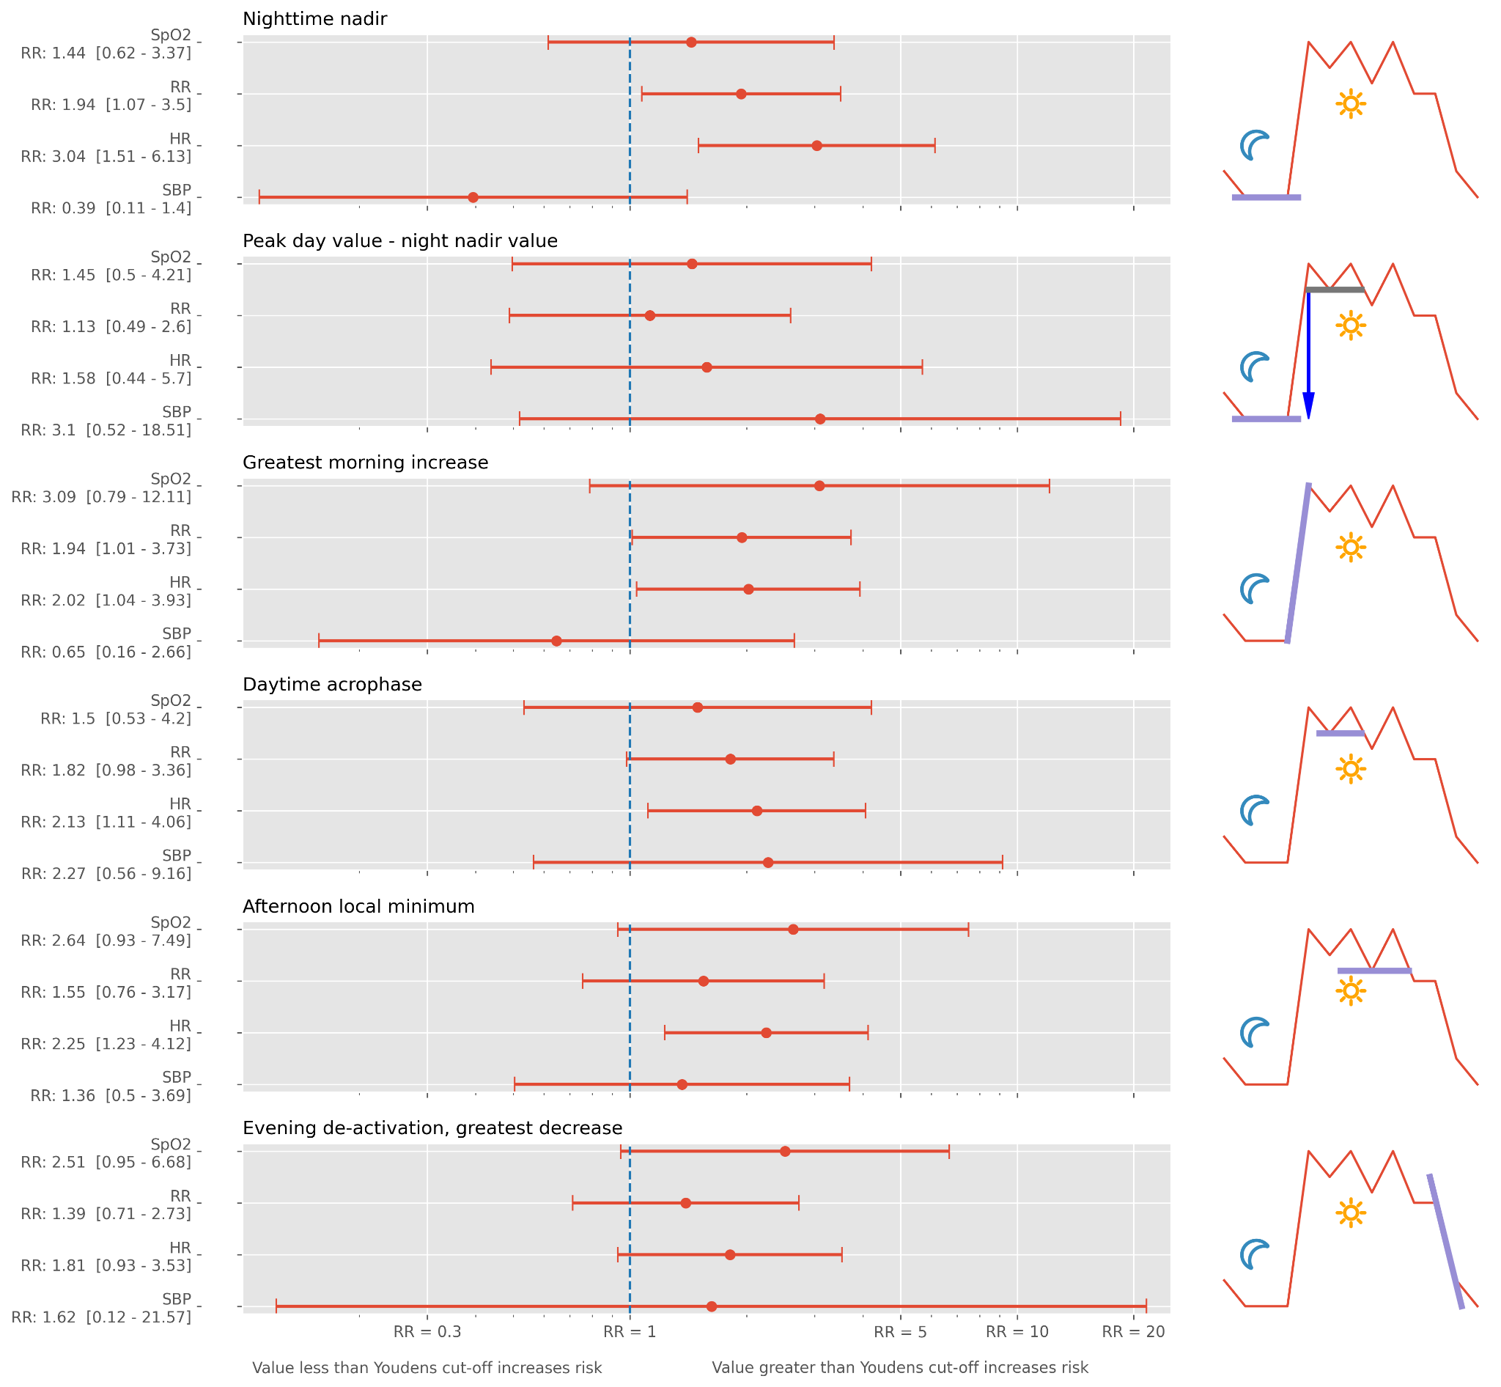
Legend: Plots show the relative risk of deviating from Youden’s optimal cut-off for the different modalities. Values are presented as relative risk [99% confidence interval]. The dashed line indicates a risk ratio of one.
The right column depicts a stylised figure showing the definition of the circadian feature for each plot.
Abbreviations: SpO₂: Peripheral oxygen saturation, RF: Respiration frequency, HR: Heart rate, SBP: Systolic blood pressure, RR: Relative Risk.

