Supplementary Table
Table S1. Wavenumbers of identified peaks of crude extracts from green leafy vegetables as absorbed in Fourier transform infrared spectroscopy.
Scientific name | Wavenumbers (cm⁻¹)
Scientific name | Functional group region (4000-1450 cm⁻¹) |  |  |  |  | Fingerprint region (1450-400 cm⁻¹)
Scientific name | O─H | C─H | C═O | N─H | C─N | CH₃ | C─O | C═C | COO⁻ | S─S
Allium cepa | 3264.28 | 2924.90 | NP | 1596.20 | NP | 1397.73 | 1032.08 | NP | NP | 517.78
Allium fistulosum | 3273.82 | 2923.46 | NP | 1614.31 | NP | 1397.96 | 1033.34 | 871.04 | 772.13 | 515.99
Apium graveolens L. | 3266.50 | 2928.81 | NP | 1603.32 | NP | 1390.66 | 1035.47 | 820.02 | NP | 521.54
Brassica perviridis | 3250.37 | 2922.99 | NP | 1601.68 | NP | 1396.55 | 1038.26 | NP | 791.33 | 524.01
Brassica chinensis L. | NP | 2923.52 | NP | 1593.23 | 1503.80 | 1391.77 | 1040.17 | NP | NP | 526.45
Coriandrum sativum | 3179.76 | 2924.86 | NP | 1579.40 | NP | 1392.51 | 1043.04 | NP | NP | 524.69
Ipomoea aquatica Forsk | 3188.32 | 2922.29 | NP | 1610.63 | NP | 1388.59 | 1044.73 | 821.65 | NP | 526.98
Ocimum basilicum | 3299.62 | 2921.24 | 1728.17 | 1601.12 | NP | 1384.59 | 1042.25 | 824.52 | NP | 529.52
Petroselinum crispum | 3239.12 | 2922.32 | NP | 1590.97 | 1500.50 | 1348.77 | 1040.92 | 824.03 | NP | 517.02
Spinacia oleracea L. | NP | 2923.64 | NP | 1600.39 | NP | 1378.27 | 1042.02 | 820.95 | NP | 524.92
NP: No peak detected

Table S2. Wavenumbers of identified peaks of crude extracts from green leafy vegetables in synergistic combinations as absorbed in Fourier transform infrared spectroscopy.
Samples code | Wavenumbers (cm⁻¹)
Samples code | Functional group region (4000-1450 cm⁻¹) |  |  |  |  | Fingerprint region (1450-400 cm⁻¹)
Samples code | O─H | C─H | C═O | N─H | C─N | CH₃ | C─O | C═C | S─S
1 | 3259.38 | 2926.66 | NP | 1600.33 | NP | 1399.85 | 1031.90 | 817.56 | 513.70
4 | 3191.89 | 2922.98 | 2108.69 | 1578.67 | 1511.20 | 1392.63 | 1042.75 | NP | 521.86
6 | 3276.65 | 2925.55 | NP | 1600.79 | 1503.31 | 1399.36 | 1065.95 | NP | 518.82
NP: No peak detected

Supplementary Figure
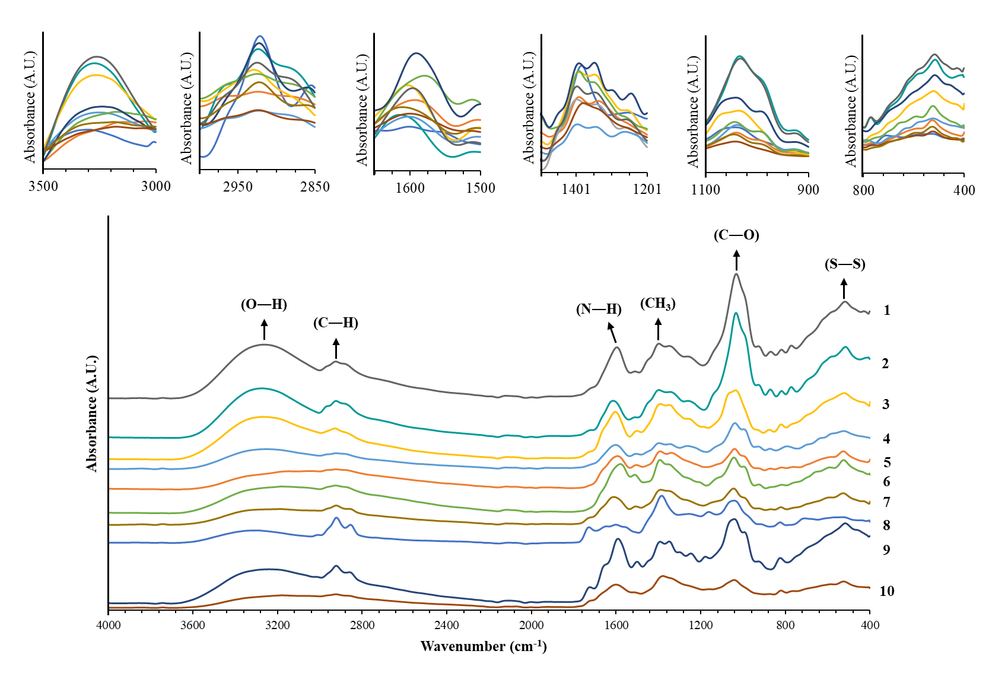

Figure S1. Fourier transform infrared (FTIR) spectroscopy spectra of crude extracts of green leafy vegetables. 1: A. cepa, 2: A. fistulosum, 3: A. graveolens L., 4: B. perviridis, 5: B. chinensis L., 6: C. sativum, 7: I. aquatica Forsk, 8: O. basilicum, 9: P. crispum, 10: S. oleracea L.

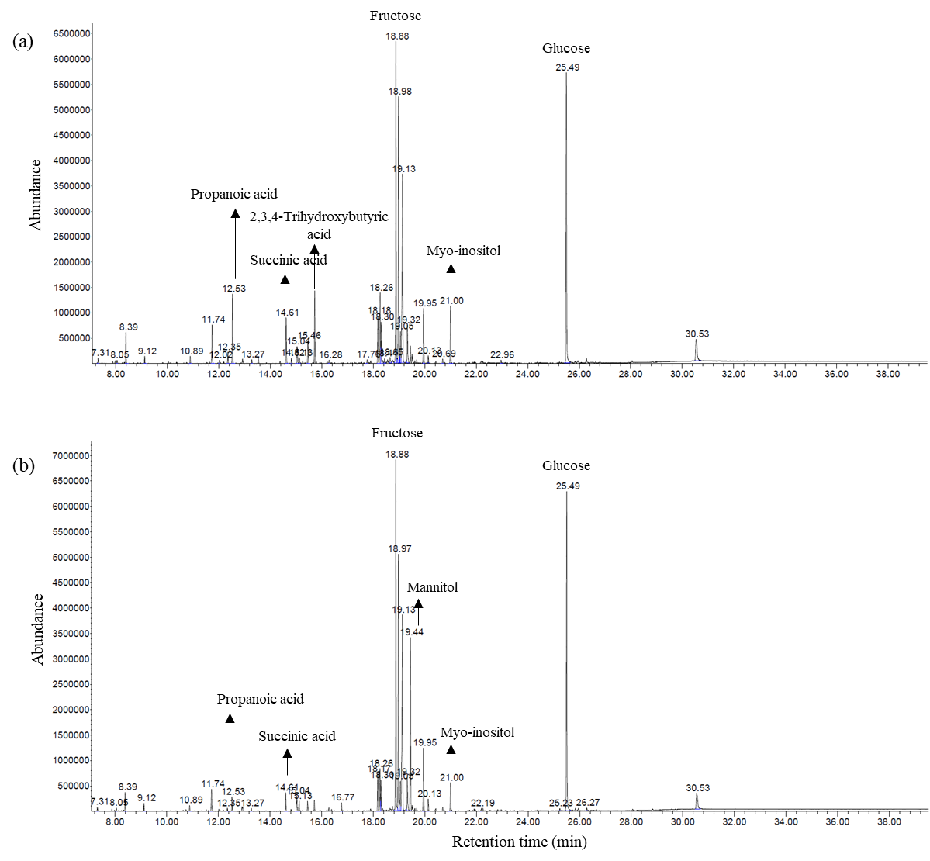
Figure S2. Gas chromatography-mass spectrometry (GC-MS) chromatograms of Allium cepa (a) and combination-1 (b) extracts.

