Supporting Information for

Aptamer-functionalized interface nanopores enable amino acid-specific single-molecule proteomics

Tilman Schlotter†, Tom Kloter†, Julian Hengsteler†, Sujeni Ragavan†, Haiying Hu†, Xinyu Zhang†, Jens Duru†, János Vörös†, Tomaso Zambelli†, and Nako Nakatsuka†*
† Laboratory of Biosensors and Bioelectronics, Institute for Biomedical Engineering, ETH Zürich,
8092 Zürich, Switzerland
* Corresponding author

Supplementary tables

Peptide name | Amino acid sequence  (1 and 3 letter) | Molecular  mass [kDa] | Stock concentration  [mg/ml] | Net Charge  at pH 7 | Purity
Porcine Dynorphin A (Dyn) | NH2- YGGFLRRIRP KLKWDNQ -COOH | 2.15 | 0.2 | +4e | ≥ 95 %
Porcine Dynorphin A (Dyn) | Tyr-Gly-Gly-Phe-Leu-Arg-Arg-Ile-Arg-Pro-Lys-Leu-Lys-Trp-Asp-Asn-Gln
 | 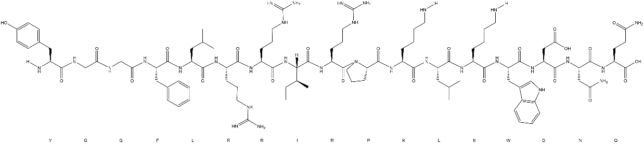
Negative control (Control) | NH2- SGTWWYYINT GGRRRRR -COOH | 2.19 | 0.5 | +5e | 98.16 %
Negative control (Control) | Ser-Gly-Thr-Trp-Trp-Tyr-Tyr-Ile-Asn-Thr-Gly-Gly-Arg-Arg-Arg-Arg-Arg
 | 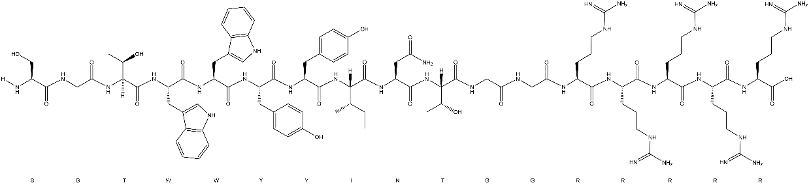
Single stretch (Phe) | NH2- SGTFFFFINT GGRRRRR -COOH | 2.08 | 0.5 | +5e | 98.14 %
Single stretch (Phe) | Ser-Gly-Thr-Phe-Phe-Phe-Phe-Ile-Asn-Thr-Gly-Gly-Arg-Arg-Arg-Arg-Arg
 | 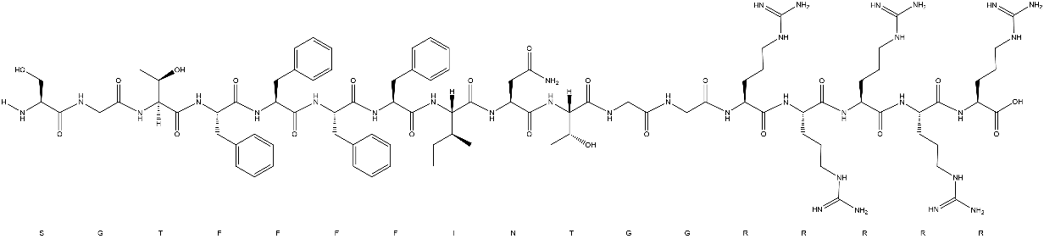
Table S1: Chemical structures and properties of the peptides used in this manuscript. The chemical structures were made in ChemDraw.

Porcine Dynorphin A (Dyn) |  | Negative control (CTRL)
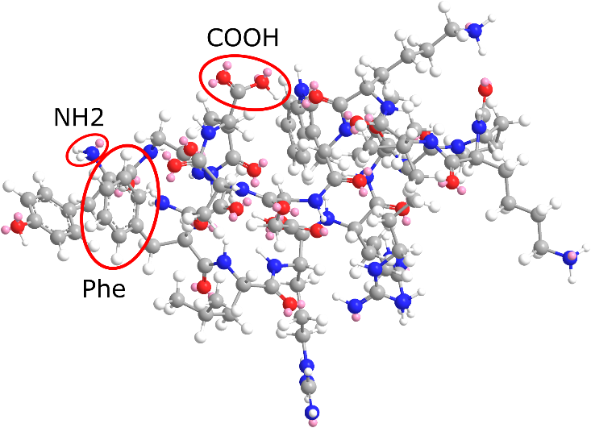 |  | 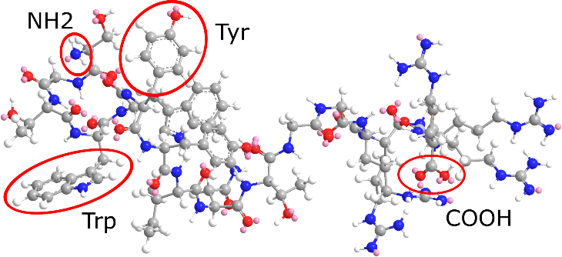
Single stretch (Phe1)
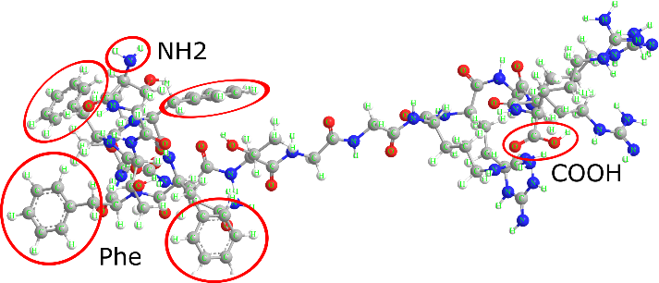
Table S2: 3D-structure of peptides used in this manuscript. The 3D structures were generated with Chem3D (PerkinElmer, USA) using the MM2 energy minimization algorithm provided in Chem3D.

Supplementary methods

Verification of covalent DNA immobilization
Since each step of the functionalization procedure introduces polar functional groups on the surface, hydrophilicity of the substrate increases throughout the process. The increase in hydrophilicity upon each step was monitored by observing the water contact angle. On untreated PDMS, a 100 μl MQ water droplet had a 90° contact angle as depicted in Fig. S1. Upon silanization and MBS treatment, water contact angles got smaller and reached a minimum of around 20° after DNA immobilization (Fig. S1b, c, and d, respectively). This change in hydrophilicity was also observed from the top view (Fig. S1e - h).
Further confirmation of DNA immobilization was gathered by DNA staining with the fluorescent dye SYBRTM gold (Fig. 1). Under a light microscope, functionalized slides showed a cracked surface. Those surface cracks are a result of n-hexane treatment, which removed excess uncured residues in the PDMS-coated glass slides. When submersed in n-hexane, the PDMS layer expanded and subsequently contracted again when the n-hexane was removed, leading to mechanical tearing of the substrate. The tearing force led to crack formation, but the areas in between presented a smooth surface for nanopore approaches. This surface structure was also observed in fluorescent images as seen in Fig. 1c and d.
a
b
d
e
f
g
h
c

Fig. S1: Water contact angle measurement for functionalization steps. a-d, Side view of a 100 μl MQ water droplet on PDMS surfaces that are a untreated, b silanized, c MBS-functionalized, and d aptamer-functionalized. Water contact angles are indicated with angle signs. e-h, Top view onto the same slides.

Surface passivation of Teflon reservoir does not yield nonspecific translocation events
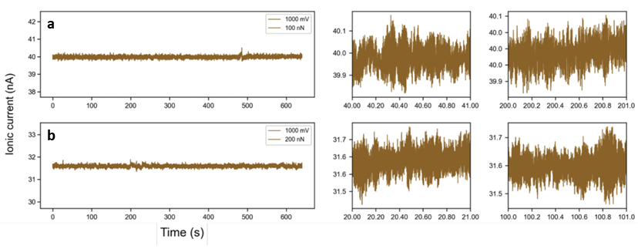
Fig. S2: Control measurements to ensure no free bovine serum albumin (BSA) is present in the reservoir post-passivation. Data in a and b were collected within the same measurement series on different locations on aptamer-modified PDMS at 1.0 V. Instead of the peptide solution, only PBS was filled into the Teflon holder reservoir. Aspiration and measurements were conducted in the same manner as typical experiments in the main text. This control test confirmed that negligible free BSA remained in the reservoir post rinsing, and that the passivation treatment of the Teflon reservoir does not generate translocation events.

Supplementary figures

Specific and non-specific binding of peptides to aptamers
For statistical analyses, Fig. S3 shows the end points (signal saturation) of the transient optical waveguide lightmode spectroscopy (OWLS) curves of Fig. 2b-d. The Phe peptide on the Phe aptamer-functionalized OWLS chips show significant increase in bound mass compared to the controls and Dyn peptide. No significant difference was observed between the two control chips: the control peptide on Phe aptamer-modified chips and the Phe peptide tested on scrambled DNA chips. The Dyn peptide binding on the OWLS chip is significantly lower, which can be attributed to the combination of less Phe moieties (one in Dyn vs. four in Phe1) and a lower net charge (+4e for Dyn vs. +5e for the Phe1 and the Control peptide).
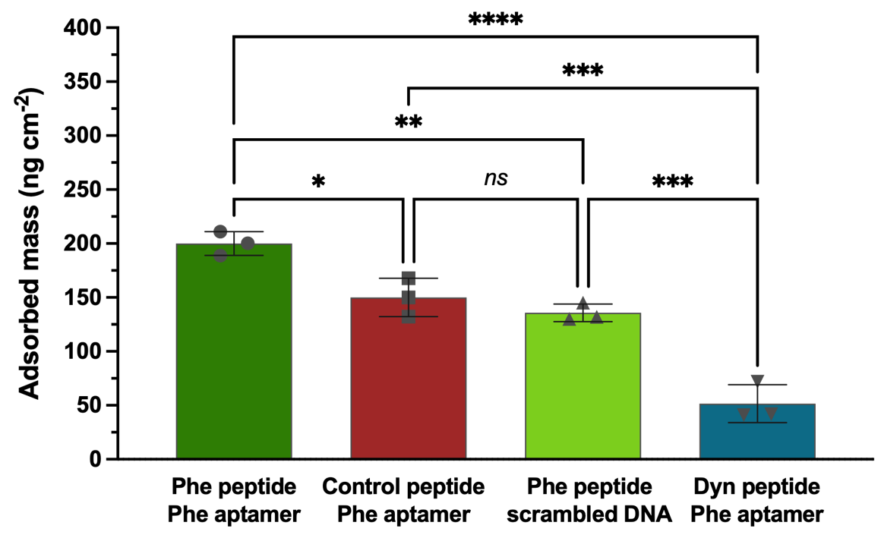
Fig. S3: Optical waveguide lightmode spectroscopy (OWLS) surface binding. Mass bound to OWLS chip for three different peptides (Phe, Control, Dyn) on either aptamer-modified or scrambled DNA-functionalized OWLS chips. The mean mass absorption and the standard deviation are shown for three different chips (N=3). A one-way ANOVA was performed to compare the interactions between the different groups tested. Statistically significant differences were observed in the mean adsorbed mass values for at least three groups (F(3,8) = [56.03], p<0.0001). Tukey’s test for multiple comparisons found that the mean was significantly different between Phe peptide+Phe aptamer vs. all other groups with varying p values indicated in the plot where *: p<0.05, **p<0.01, ***p<0.001, and ****p<0.0001. There was no statistical significance in the mean between the two controls tested (ns: not significant, p=0.63).

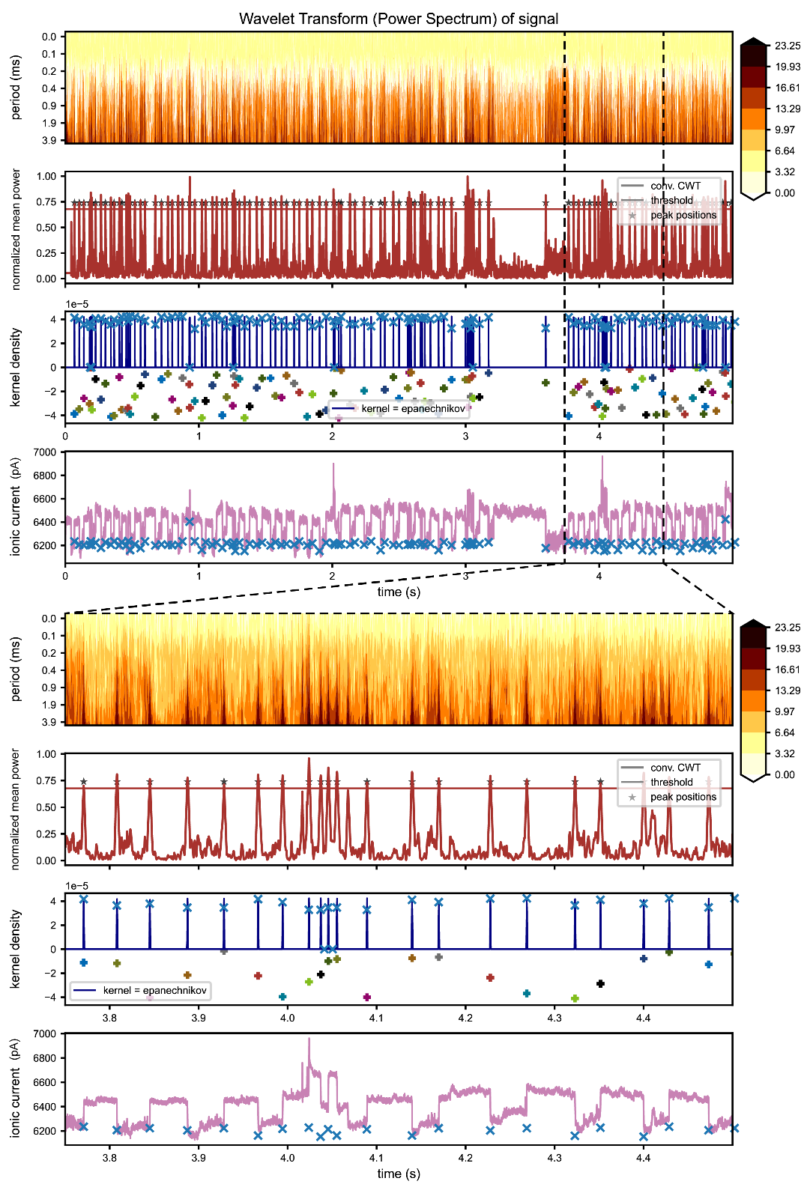
Continuous wavelet transformation for change point and event detection

Fig. S4: Wavelet transformation and spike detection. The current trace is shown in the lowest figure (purple line) and the corresponding wavelet transformation is shown as a contour plot in the top figure. Below, (red line) the normalized signal of the mean continuous wavelet transformation (CWT) is shown with the identified peak positions marked by a star. The kernel density estimation (blue line) of the peak positions (colored crosses corresponding to the categories defined in the text and figure below) distribution and the resulting cluster peak positions (blue cross) are shown. Bottom figures are zoom-ins of top figures.

Classical thresholding approaches for event detection cannot be applied to the data as it causes too many errors. Therefore, spike detection via continuous wavelet transformation^{1,2} is applied to detect the rapid changes in the signal (Fig. S4). Each detected peak is subsequently assigned to one of four categories:
0 | The kernel density estimation cluster has only one peak identified and a total gradient below 0.25 and above -0.25 and is therefore seen as a spike.
-1 | The kernel density estimation cluster has only one peak identified and a total gradient below 0.25 and is therefore classified as a drop.
1 | The kernel density estimation cluster has only one peak identified and a total gradient below 0.25 and is therefore classified as an increase.
2 | The kernel density estimation cluster identified more than one peak.

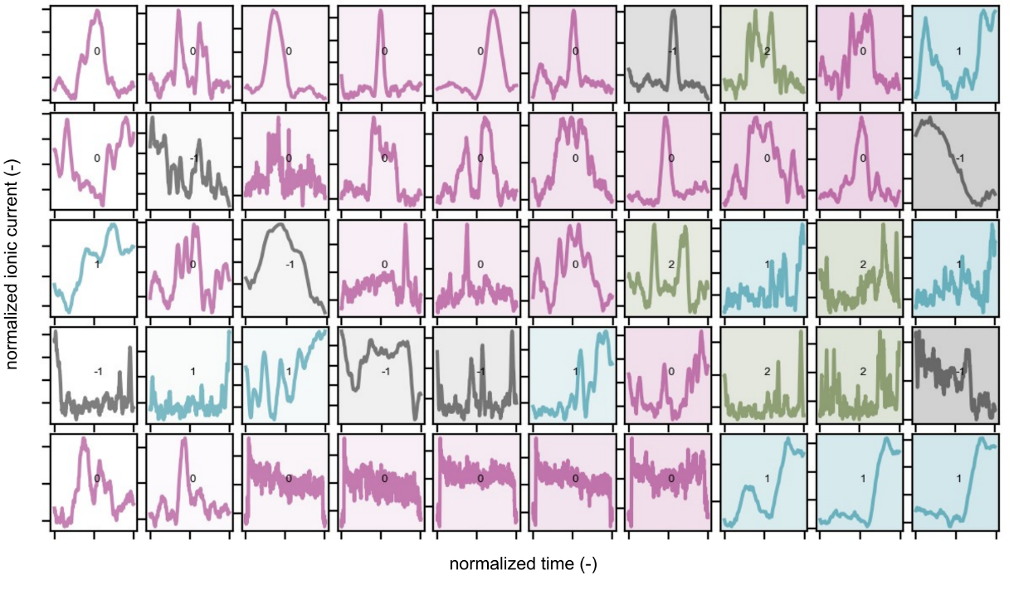
Fig. S5: Classification of identified signal changes. Blue panels show an increase in current (1), black panels show a decrease in current (-1), purple panels show an event with both increases and decreases (0). Green panels could not be assigned to any of the prior categories (2).

Afterwards, an algorithm identifies the individual translocations based on the information extracted. The software is written in Python 3.

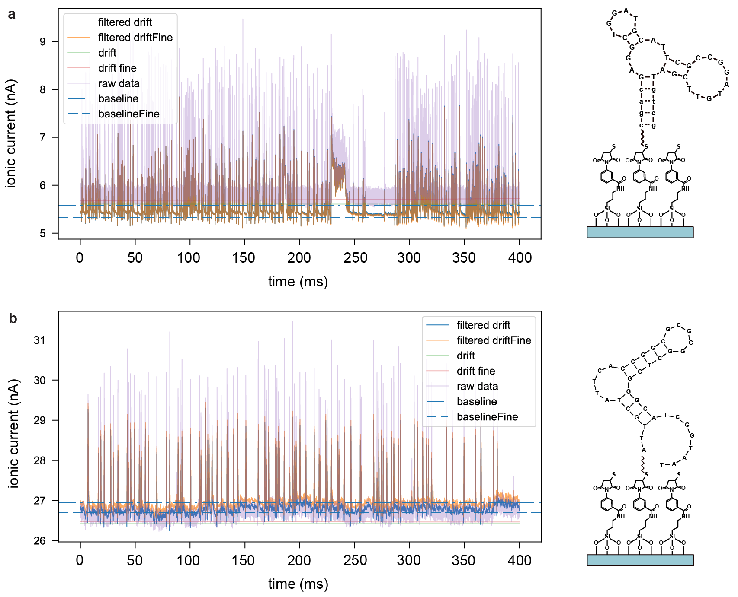
Time series recording of control peptide and translocation characterization
Fig. S6: Current traces of translocation measurements of the Control peptide. a, signal obtained from peptide translocations on substrates with the specific aptamer functionalization. b, signal obtained on substrates modified with the scrambled sequence. The figures show the data after several filtering steps. The purple line represents the unfiltered raw data. A long-term and a fine drift in the data is extracted using an ALS³ algorithm and the median of the drift signal is used as the corresponding baseline current. A filtered signal is created using a Savitzky-Golay filter with a window of 20 data points. Subsequently, the drift (or drift fine) is subtracted from the signal and the baseline (or baselineFine) is added again.

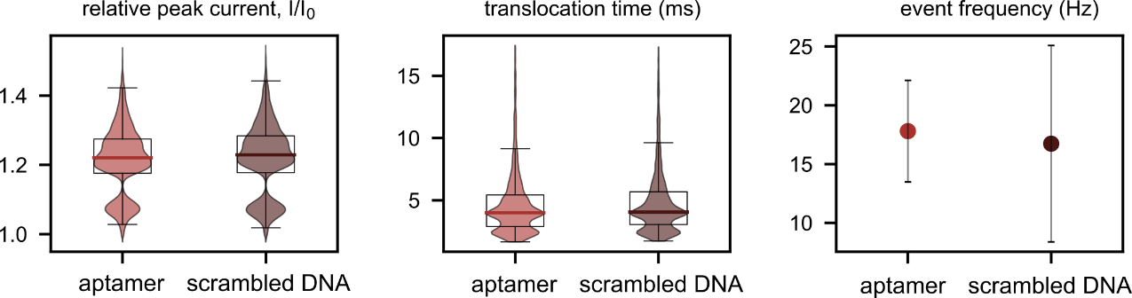
Fig. S7: Translocation characterization of the Control peptide. Violin plots of peak currents, translocation times (as shown in the density plot of Fig. 3c), and translocation frequencies (including the standard deviation) for the Control peptide through both Phe aptamer- and scrambled DNA-functionalized interface nanopores. The translocations of Control peptides on the two different substrates do not show significant differences in translocation characteristics.

Shape analysis of peptide translocations
Dimension reduction either by a principal component analysis (PCA), t-distributed stochastic neighbor embedding (t-SNE)^{4,5}, or uniform manifold approximation and projection for dimension reduction (UMAP)⁶ were used to identify patterns in translocation events. A subsequent clustering of the dimension reduction analysis was done both by density-based cluster scanning (DBSCAN)⁷ and by ordering points to identify the clustering structure (OPTICS)⁸, which are two closely related clustering algorithms.
DBSCAN, OPTICS, PCA, and t-SNE are part of the sklearn package of Python3 and for the UMAP algorithm an own package is available (https://umap-learn.readthedocs.io/en/latest/).
The shape analysis was always a combination of a dimension reduction analysis (either PCA, t-SNE, or UMAP) followed by a clustering (DBSCAN or OPTICS), which yields six different analysis possibilities as shown in Fig. S8. The PCA analysis (for the first two principal components) did not yield clusters compared to t-SNE or UMAP. Between the latter two, UMAP yielded better results within a shorter computation time. OPTICS yielded a finer clustering compared to DBSCAN which is why the preferred combination was a UMAP dimension reduction followed by an OPTICS clustering.
The identified clusters are shown in subsequent plots where the x- and y-axes represent the two dimensions in the UMAP and t-SNE space. If an event was not attributed to a cluster, it was considered as “noise”. The events not attributed to a cluster were classified as “-1” (Fig. S9, Fig. S10). As the events were stretched to equal length prior to analysis, mean shape calculation could be done for each cluster by averaging all cluster-specific events. Each mean shape of a cluster was plotted in a different color (Fig. S8). The shape analysis showed different peak characteristics for Phe peptide translocations on aptamer-functionalized substrates and all the other translocation configurations.

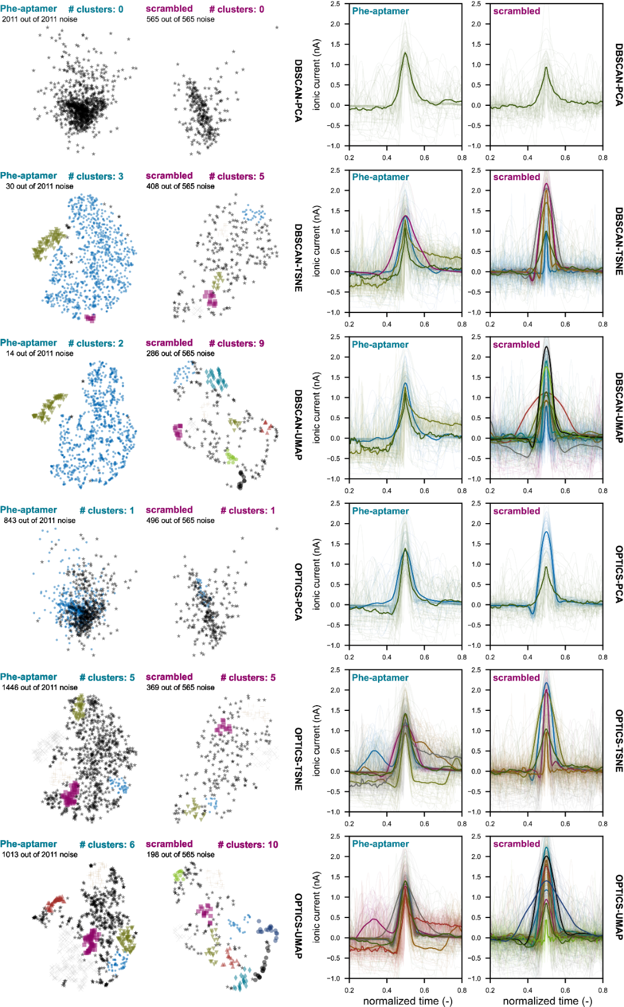
Fig. S8: Clustering and peak analysis of the Control peptide. On the left side, the results of the different clustering algorithms are shown for both the translocation through a scrambled and an aptamer-modified interface nanopore. The noise gives the amount of translocation events that could not be categorized into one cluster (black dots). Principal component analysis (PCA) with DBSCAN yields only one cluster (all events are categorized as “noise” that are the “-1” cluster that can be seen on the right side).
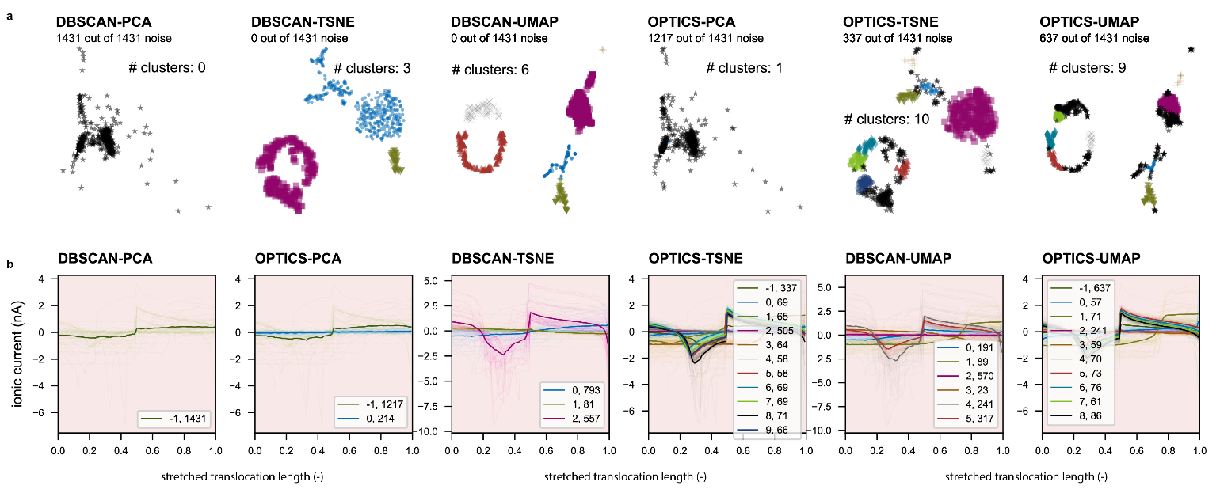
Fig. S9: Clustering and peak analysis of Phe peptide translocations through aptamer-functionalized surfaces at 1.5V. a, Color-coded clusters analyzed with OPTICS or DBSCAN clustering algorithms. b, Corresponding ionic currents and cluster-mean-shapes. The legend in b shows the cluster number and the number of events that are attributed to that specific cluster.
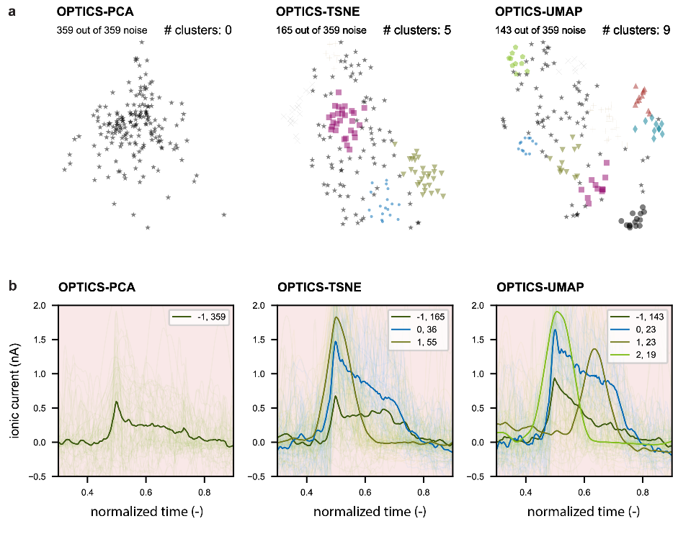
Fig. S10: Clustering and peak analysis of Phe peptide translocations through scrambled DNA-functionalized surface at 1.5V. a, Color-coded clusters analyzed with OPTICS clustering algorithms. b, Corresponding ionic currents and cluster-mean-shapes. The legend in b shows the cluster number and the number of events that are attributed to that specific cluster.

COMSOL simulations
A COMSOL simulation was performed based on the model of Zeng et al.⁹. As the iNP is created by interfacing a soft substrate with the FluidFM, the simulation was adapted for a non-rotational symmetric 2D simulation. A 2D simulation was chosen due to the complexity of the simulation resulting in computational limitations. Similar to our prior publication,¹⁰ the geometry was created by subtraction of a circle with a radius of 340 nm from a hollow 11° tilted triangle with a thickness of 80 nm that represents the cantilever wall thickness (see Fig. S11a). Afterwards, a simulation domain is defined (Fig. S11b), which includes one side of the FluidFM cantilever wall (Fig. S11c) and in the nanogap region, a 17-residue peptide is emulated by subtracting 17 circles next to each other each with radii of 1 nm (Fig. S11d). The height of the gap between the cantilever was set to 2 nm. A fillet was added to the corner of the cantilever wall with a radius of 0.5 nm.
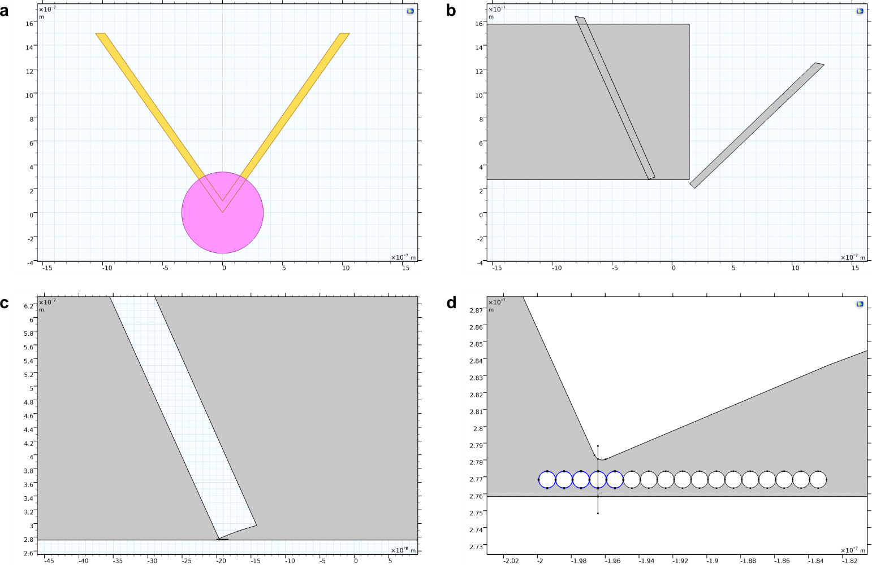
Fig. S11: Geometry of COMSOL simulations. a, Shows the hollow triangle with a subtracted circle. b, Shows the simulation domain. c, one side of the cantilever wall. d, Magnification of nanogap with a chain of 17 circles of 1 nm diameter. The gap was set to 2 nm.

A Multiphysics model is created including the modules Transport of Diluted Species, Electrostatics, and Laminar Flow. Two species are added representing Cl⁻ and K⁺ ions, respectively. Diffusion coefficients, D, were user defined with values 1.8e-9 m²/s and 1.87 m²/s and the mobility of both species is calculated using $μ=\frac{D}{R T}$. The solution concentration at the inlet and outlet is set to 150 mol/m³. In the electrostatics module, the top boundary inside of the cantilever was set to a potential of 1 V and the left edge of the simulation domain was set to ground. Surface charges on the cantilever wall were set to 0.01 C/m², on the amino acid circle 0.02 C/m², and on the bottom substrate 0.03 C/m². The space charge density was user defined as $q*N*(c_{1}*z_{1}+c_{2}*z_{2})$ with c_{1/2} being the concentrations of species 1 (K⁺) and species 2 (Cl⁻) and z_{1/2} the corresponding ion charge, and N the Avogadro constant. In the laminar flow module, an inlet on the left side, an outlet inside of the cantilever, and a volume force in x $(c_{1}-c_{2})*N*q*es.Ex$) and y-direction $(c_{1}-c_{2})*N*q*es.Ey$) was defined. The es.Ex/Ey are vector components of the electrical field in the x- and y-direction, respectively. The mesh is physics controlled and the element size was set to “extra fine”. The solution is a stationary solver with a parametric sweep of the peptide position. The ion concentrations and the electric field inside the nanopore without peptides present inside the pore is shown in Fig. S12.
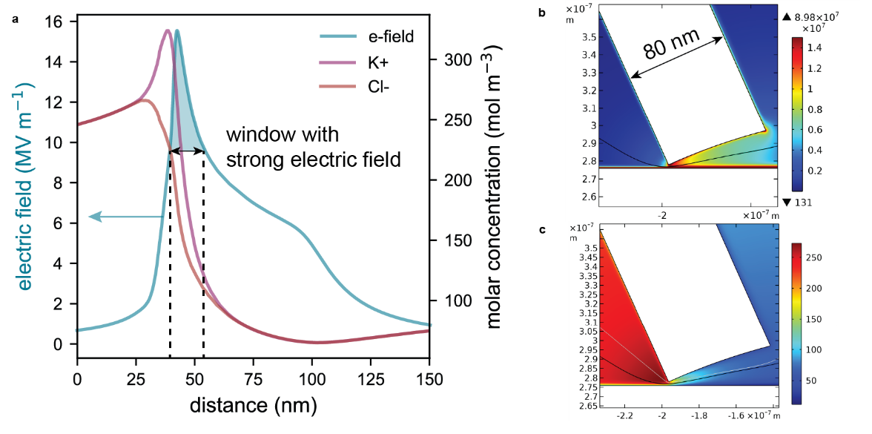
Fig. S12: Electric field and ion concentrations inside the nanopore. a, Plot of the electric field (blue line, left y-axis) and the corresponding ion concentrations in a 150 mM KCl solution. Red and purple lines correspond to the Cl⁻ and K⁺ concentrations. b, 2D surface plot of the electric field. c, 2D surface plot of the Cl⁻ concentration inside the nanopore. The line plot shows the data along the black line in b and c.

To simulate the difference between a translocation where the positive charges enter the iNP first (forward, from the C-terminus side) vs. where the charges enter the iNP last (backward, from the N-terminus side), the current through the iNP with respect to the amino acid-position of the middle amino acid (which is the 9th moiety in the backbone) was calculated. Since the peptide is positively charged, it translocates from the inside to the outside of the cantilever while the inside positions (on the x-axis) are positive and the outside positions are negative. Therefore, the x-axis of Fig. S13 is inverted. The current through the nanopore was derived from a line integral along the vertical line in Fig. S11d, which goes through the pore. The resulting currents are shown in Fig. S13 and indicate that a forward movement results in a current drop first with a subsequent current increase while a backward movement starts with a current increase. We note that the simulation represents a simplified model that is not expected to perfectly fit the current measurements. However, it could be used as a qualitative explanation of the observed differences. As we conducted a 2D-simulation, the current is given in ampere per meter (y-axis).

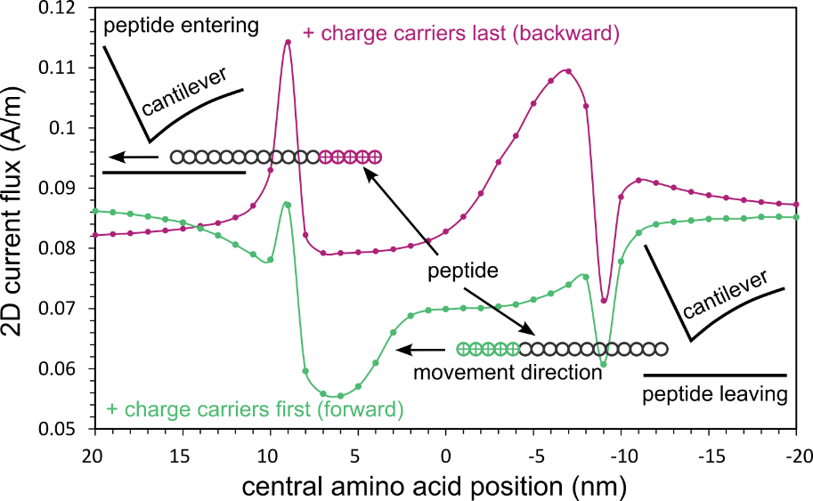
Fig. S13: COMSOL simulations of a peptide translocating through a 2 nm small pore confirms orientation-dependent peptide translocation. The purple curve shows a steady-state solution of the peptide movement when the positive amino acids are at the back of the peptide with respect to the movement direction (peptide translocating through N-terminus). The green curve shows the same simulation but when the positive charges of the peptide reach and leave the interface nanopore first (peptide translocating through C-terminus).

Current level extraction by change point detection
Fig. S14 illustrates an example of the current level extraction. A window with a fixed amount of sample datapoints was shifted over the current signal shifting one data point at a time. For the signal shown in Fig. 4p-q, the window’s length was chosen to correspond to 5 ms (200 data points). In Fig. S14, we show a simplified illustration of the method using windows used that contain 5 samples as this is the approximated extent of the electric field. A computed signal with an arbitrary sample rate is shown. Windows that contain a changepoint, a change in the local mean value of the signal, have a higher standard deviation resulting in a peak in the computed standard deviation signal (Fig. S14b). A peak detection (from Python library scipy.signal module find_peaks (prominence was set to 0.3)) was applied to identify the changepoints. The current level was then calculated by taking the mean in between two changepoints (Fig. S14c).
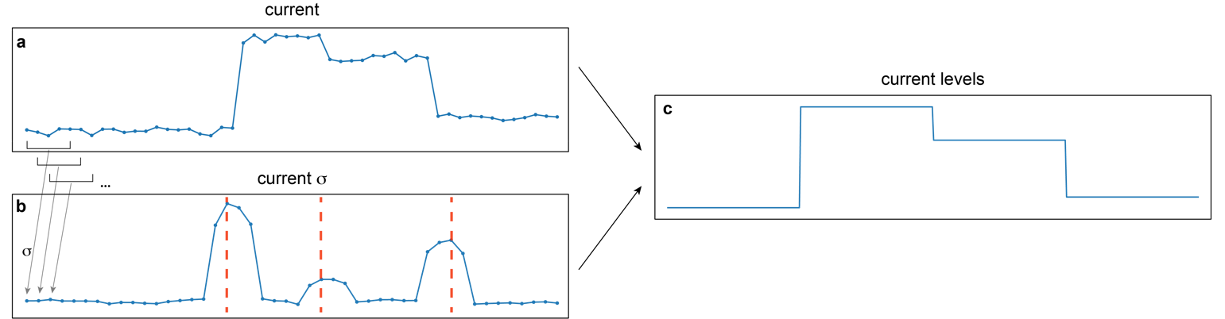
Fig. S14: Current level extraction of a computed example current signal. a, The generated raw current signal. b, The standard deviation calculated from a rolling window with a length of 5 samples showing peaks at the changepoints. c, The current levels extracted from the changepoints and the mean of the current signal in between two successive changepoints.

Virtual peptide signal generation
To create a “virtual” peptide signal of a peptide sequence with n amino acids (AA1, …, AAn) we considered the different parameters of each amino acid in the sequence, that could have an influence on the current signal upon translocation (i.e., volume, mass, and charge). For each of these parameters, we introduce a weight, w to tune the respective influence on the virtual signal. In an ideal case, the observed current signal, x would then follow the equation:

 | $$\left(\begin{matrix}AA1_{vol} & AA1_{charge} \\ AA2_{vol} & AA2_{charge} \\ ⋮ & ⋮ \\ AAn_{vol} & AAn_{charge}\end{matrix}\right)∙\left(\begin{matrix}w_{vol} \\ w_{charge}\end{matrix}\right)∝\left(\begin{matrix}x_{1} \\ x_{2} \\ ⋮ \\ x_{n}\end{matrix}\right)$$ | (3.7-1)

However, the sensitive region of the nanopore typically includes more than one amino acid. Hence, we introduce an averaging operation that, in our case, spans 8 amino acids (arbitrary averaging sizes are possible). Windows of 8 were taken due to the finite extension of the electric field (Fig. S12a) Thus, the minimal number of amino acids within the sensing volume was assumed to be 8 amino acid lengths, which yields the following equation for the virtual signal:

 | $$\frac{1}{8}\left(\begin{matrix}1 & 1 & 1 & 1 & 1 & 1 & 1 & 1 & 0 & 0 & ⋯ & 0 \\ 0 & 1 & 1 & 1 & 1 & 1 & 1 & 1 & 1 & 0 & … & 0 \\ ⋮ & ⋮ & ⋮ & ⋮ & ⋮ & ⋮ & ⋮ & ⋮ & ⋮ & ⋮ & ⋱ & ⋮ \\ 0 & 0 & 0 & … & 1 & 1 & 1 & 1 & 1 & 1 & 1 & 1\end{matrix}\right)∙\left(\begin{matrix}AA1_{vol} & AA1_{charge} \\ AA2_{vol} & AA2_{charge} \\ ⋮ & ⋮ \\ AAn_{vol} & AAn_{charge}\end{matrix}\right)∙\left(\begin{matrix}w_{vol} \\ w_{charge}\end{matrix}\right)$$ | (3.7-2)

The values used for the specific amino acids of this work are summarized in Table S2:
Amino Acid Name | Solution Volume at 25°C (ml/mol)¹¹ | Surface Charge¹²
Arginine | 111.5 | +1
Asparagine | 74.1 | 0
Glycine | 43.5 | 0
Isoleucine | 107.5 | 0
Lysine | 108.5 | +1
Phenylalanine | 121.3 | 0
Serine | 60.8 | 0
Threonine | 77.1 | 0
Tryptophan | 144.1 | 0
Tyrosine | 123.6 | 0
Table S2: Parameters used for the single amino acids in the signal generation. The molecular weights were taken from Sigma Aldrich.

Sliding windows with a length of 10 levels (N amino acids of peptide – averaging window of 8 due to electric field distribution inside the nanopore) were autocorrelated with the measured ionic current signal to find repetitive motifs. If the Pearson correlation factor was higher than a predefined threshold, (0.7) the corresponding part of the signal was marked as a reoccurrence of the respective motif. Overlapping motifs were discarded. The motif with the most reoccurrences with no overlaps is shown in Fig. S15. If the reverse representation of the motif exceeded the correlation factor threshold, this reverse reoccurrence was also marked and regarded as a backwards translocation (peptide translocating through C-terminus, Fig. S15d as discussed in Fig. S13). A virtual signal was then generated as described above, to find correlations between the identified motifs and the translocating peptide. By optimizing the weights (w_{vol} = 0.022 and w_{charge} = -1), a strongly correlating virtual signal with a Pearson correlation factor of 0.95 was found. Using this method, a correlation between the known peptide sequence (Phe peptide) and a highly reoccurring motif within the signal could be found (Fig. S15e), which hints at sequence related information in the acquired signal.
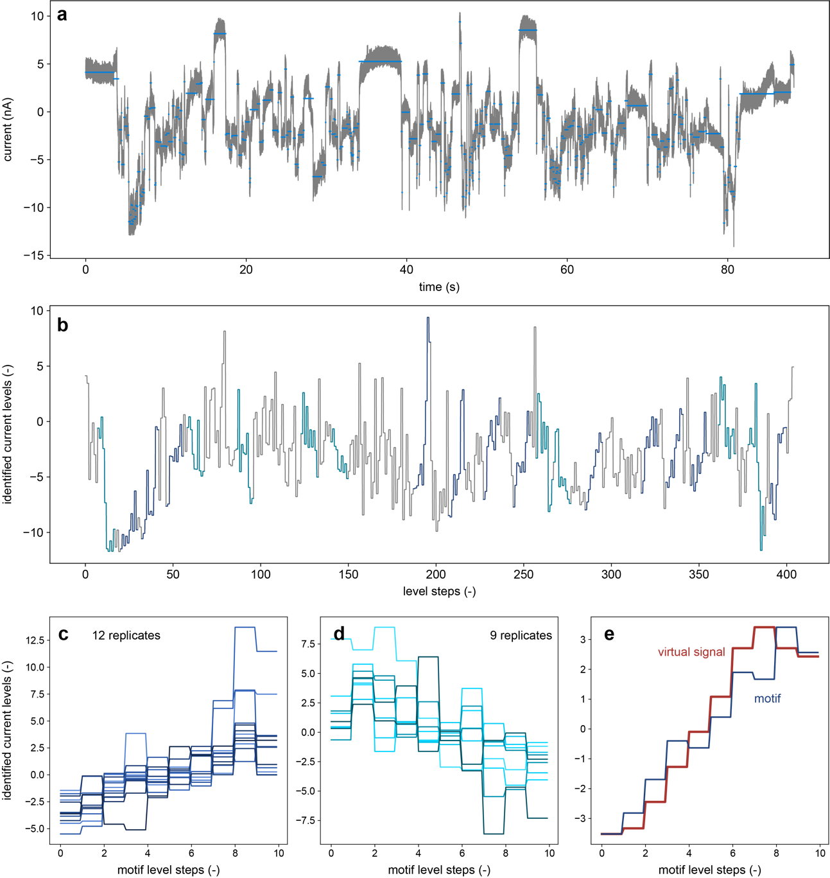
Fig. S15: Motif search by autocorrelation of a sliding window and virtual signal from the peptide sequence. a, Current trace of Phe peptide at 0.5 V. b, Offline level detection shows distinct current levels. The identified levels are shown with similar length. The mostly reoccurring motif (21 times) is marked in blue both for forward (dark blue) and backward (light blue) reoccurrences. The mean Pearson correlation factor of the reoccurring patterns with the main motif was 0.81. Different reoccurrences offset by their median current level for c, forward translocations, and d, backward translocations). e, An artificial peptide signal was generated by weighting parameters of the single amino acids (volume, charge) as described above. The weights were optimized to yield the largest pearson correlation factor (0.95) of the virtual signal with the main motif. The weights were (w_{vol}, w_{charge}) = (0.022, -1).

Supplementary references
1. Pavlov, A. N. et al. Wavelet analysis in neurodynamics. Physics-Uspekhi 55, 845–875 (2012).
2. Addison, P. S. The illustrated wavelet transform handbook: introductory theory and applications in science, engineering, medicine and finance. (CRC press, 2017).
3. Eilers, P. H. C. & Boelens, H. F. M. Baseline correction with asymmetric least squares smoothing. Leiden University Medical Centre Report 1, 5 (2005).
4. Maaten, L. van der & Hinton, G. Visualizing data using t-SNE. Journal of machine learning research 9, 2579–2605 (2008).
5. Kobak, D. & Berens, P. The art of using t-SNE for single-cell transcriptomics. Nat Commun 10, 1–14 (2019).
6. McInnes, L., Healy, J. & Melville, J. UMAP: Uniform manifold approximation and projection for dimension reduction. arXiv preprint arXiv:1802.03426 (2018) doi:1802.03426. arXiv.
7. Ester, M., Kriegel, H.-P., Sander, J. & Xu, X. A density-based algorithm for discovering clusters in large spatial databases with noise. in KDD-96 Proceedings vol. 96 226–231 (AAAI, 1996).
8. Ankerst, M., Breunig, M. M., Kriegel, H.-P. & Sander, J. OPTICS: ordering points to identify the clustering structure. ACM Sigmod record 28, 49–60 (1999).
9. Zeng, S., Wen, C., Solomon, P., Zhang, S.-L. & Zhang, Z. Rectification of protein translocation in truncated pyramidal nanopores. Nat Nanotechnol 14, 1056–1062 (2019).
10. Schlotter, T. et al. Force-Controlled Formation of Dynamic Nanopores for Single-Biomolecule Sensing and Single-Cell Secretomics. ACS Nano 14, 12993–13003 (2020).
11. Zamyatnin, A. A. Protein Volume in Solution. Progress in Biophysics and Molecular Biology 24, 107-123 (1972).
12. PepCalc.com - Peptide property calculator. https://pepcalc.com/ (2022).
13. Brinkerhoff, H., Kang, A. S. W., Liu, J., Aksimentiev, A. & Dekker, C. Multiple rereads of single proteins at single-amino acid resolution using nanopores. Science (1979) 374, 1509–1513 (2021).

