Supplementary Materials
An individualized protein-based prognostic model to stratify pediatric patients with papillary thyroid carcinoma
Zhihong Wang^{1#}, He Wang^{2,3,4#}, Yan Zhou^{2,3,4#}, Lu Li^{2,3,4,5}, Mengge Lyu^{2,3,4}, Chunlong Wu⁶, Tianen He^{2,3,4}, Lingling Tan⁶, Yi Zhu^{2,3,4}, Tiannan Guo^{2,3,4}, Hongkun Wu^{7,8*}, Hao Zhang^{1*}, Yaoting Sun^{2,3,4*}
¹Department of Thyroid Surgery, the First Hospital of China Medical University, 155 Nanjing Bei Street, Shenyang 110001, China;
²iMarker lab, Westlake Laboratory of Life Sciences and Biomedicine, Key Laboratory of Structural Biology of Zhejiang Province, School of Life Sciences, Westlake University, 18 Shilongshan Road, Hangzhou 310024, China;
³Institute of Basic Medical Sciences, Westlake Institute for Advanced Study, No. 18 Shilongshan Road, Hangzhou 310024, China;
⁴Research Center for Industries of the Future, Westlake University, No. 600 Dunyu Road, Hangzhou 310030, China;
⁵College of Pharmaceutical Sciences, Zhejiang University, No. 866 Yuhangtang Road, Hangzhou 310058, China;
⁶Westlake Omics (Hangzhou) Biotechnology Co., Ltd., No. 1 Yunmeng Road, Hangzhou 310024, China;
⁷Department of Hepatobiliary and Pancreatic Surgery, the First Affiliated Hospital, Zhejiang University School of Medicine, No. 79 Qingchun Road, Hangzhou 310003, China;
⁸Zhejiang Provincial Key Laboratory of Pancreatic Disease, No. 79 Qingchun Road, Hangzhou 310003, China.

#Co-first authors;
*Corresponding author(s): Yaoting Sun (sunyaoting@westlake.edu.cn); Hao Zhang (haozhang@cmu.edu.cn); Hongkun Wu (wuhongkun@zju.edu.cn).

Supplementary Table 1. Clinical characteristics of the pediatric cohort
 | PM (N=85) (%) | PB (N=83) (%) | P-value
Sex
Female | 62 (72.94) | 68 (81.93) | 0.164
Male | 23 (27.06) | 15 (18.07) | 0.164
Age
Mean ± SD | 15.710 ± 2.429 | 15.900 ± 1.865 | 0.443
Bilateral
No | 69 (81.18) | 55 (66.27) | 0.028
Yes | 16 (18.82) | 28 (33.73) | 0.028
Tumor size (mm)
Mean ± SD | 23.920 ± 12.875 | 37.560 ± 12.633 | <0.001
≤10 mm | 15 (17.65) | 0 (0.00) | <0.001
10-20 mm | 26 (30.59) | 6 (7.23) | <0.001
20-40 mm | 38 (44.71) | 49 (59.04) | <0.001
>40 mm | 6 (7.06) | 28 (33.73) | <0.001
Multifocal
Yes | 16 (18.82)
No | 69 (81.18)
Hashimoto thyroiditis
Yes | 26 (30.59) | 2 (2.41) | <0.001
No | 59 (69.41) | 81 (97.59) | <0.001
Capsule invasion
Yes | 1 (1.18)
No | 84 (98.82)
Extrathyroidal extension
Yes | 14 (16.47)
No | 71 (83.53)
Total lymph node metastasis patient number
Yes | 69 (81.18)
No | 16 (18.82)
Lateral lymph node metastasis patient number
Yes | 43 (50.59)
No | 42 (49.41)
Lateral lymph node metastasis number
Mean ± SD | 3.240 ± 4.884
Lateral resected lymph node number
Mean ± SD | 10.650 ± 15.268
Lateral lymph node metastasis rate
Mean ± SD | 0.206 ± 0.294
Total lymph node metastasis number
Mean ± SD | 4.429 ± 5.907
Total resected lymph node number
Mean ± SD | 18.220 ± 17.917
Total lymph node metastasis rate
Mean ± SD | 0.407 ± 0.316
Tumor (T) stage
T1a | 18 (21.18)
T1b | 33 (38.82)
T2 | 15 (17.65)
T3a | 5 (5.88)
T3b | 3 (3.53)
T4a | 11 (12.94)
T4b | 0 (0.00)
Node (N) stage
N0 | 16 (18.82)
N1a | 26 (30.59)
N1b | 43 (50.59)
Metastasis (M) stage
M0 | 84 (98.82)
M1 | 1 (1.18)
American Joint Committee on Cancer (AJCC) stage
I | 84 (98.82)
II | 1 (1.18)
American Thyroid Association (ATA) initial risk stratification
Low | 15 (17.65)
Intermediate | 56 (65.88)
High | 14 (16.47)
Recurrence
Yes | 12 (14.12)
No | 73 (85.88)

Supplementary Table 2 Final hyperparameters setting and feature set
Model and mlr3learner used | Final hyperparameters setting | Feature set
CliCox  lrn ("surv.coxph") | NA | Ten clinical features
CliRsf  lrn ("surv.rfsrc") | nodesize = 5  ntree = 1000  mtry = 3 | Ten clinical features
ProtCox  lrn ("surv.glmnet") | lambda = 0.1116327  alpha = 1 | "P10645" "P17931" "P22897" "P23378" "P27635" "Q06033" "Q6PHW0"
ProtRsf  lrn ("surv.rfsrc") | nodesize = 6  ntree=1000  mtry = 4 | "Q8TBF5" "P10645" "P12111" "Q96RP7" "O00584" "L0R819" "P17931" "Q99972" "P13612" "Q9Y4Z0" "Q4G0X9" "Q96AN5" "Q9NQ79" "Q86Y22" "Q96F24" "Q9BXJ5" "Q96JY6" "Q08495" "P23378"
CliProtRsf  lrn ("surv.rfsrc") | nodesize = 5  ntree=1000  mtry = 5 | "Q8TBF5" "P10645" "P12111" "O00584" "Q96RP7" "Q99972" "L0R819" "P17931" "P13612" "Q86Y22" "Q9Y4Z0" "Q4G0X9" "Q8N4C6" "Q9Y6R1" "Q96F24" "P23378" "Q9BXJ5" "O76038"  "P00488" "Q6ZU35" "P22897"

Supplementary Table 3 The 19 selected protein features
UniProt  ID | Gene  name | Protein  name | Thyroid  cancer  related | Thyroid  function  related
P10654 | CHGA | Chromogranin-A (CGA, PHE5, PHES) | Yes | -
Q86Y22 | COL23A1 | Collagen alpha-1(XXIII) chain | Yes | -
P12111 | COL6A3 | Collagen alpha-3(VI) chain | Yes | -
P13612 | ITGA4 | Integrin alpha-4 | Yes | -
P17931 | LGALS3 | Galectin-3 | Yes | -
Q99972 | MYOC | Myocilin | - | Yes
Q08495 | DMTN | Dematin | - | -
Q8TBF5 | PIGX | Phosphatidylinositol glycan anchor biosynthesis class X | - | -
O00584 | RNASET2 | Ribonuclease T2 | - | -
Q96RP7 | GAL3ST4 | Galactose-3-O-sulfotransfaerase 4 | - | -
Q4G0X9 | CCDC40 | Coiled-coil domain-containing protein 40 | - | -
Q96JY6 | PDLIM2 | PDZ and LIM domain protein 2 | - | -
P23378 | GLDC | glycine decarboxylase | - | -
Q9BXJ5 | C1QTNF2 | Complement C1q tumor necrosis factor-related protein 2 | - | -
Q96F24 | NRBF2 | Nuclear receptor-binding factor 2 | - | -
Q9Y4Z0 | LSM4 | U6 snRNA-associated Sm-like protein LSm4 | - | -
L0R819 | ASDURF | ASNSD1 upstream open reading frame protein | - | -
Q9NQ79 | CRTAC1 | Cartilage acidic protein 1 | - | -
Q96AN5 | TMEM 143 | Transmembrane protein 143 | - | -

Supplementary Figure 1
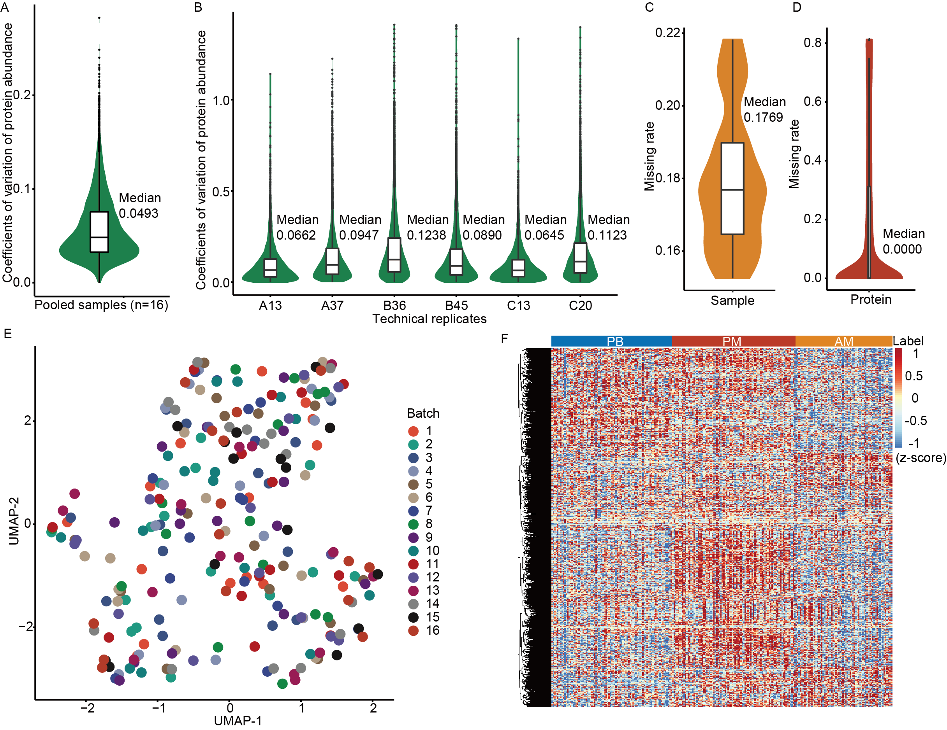
Supplementary Figure 1. Data quality control and preprocessing. (A) CVs of the protein abundances across pooled samples. (B) CVs of the protein abundances across technical replicates. (C-D) Violin plots showing the missing value rates of (C) samples and (D) proteins. (E) UMAP visualization of 240 thyroid tissue samples grouped in 16 batches. (F) Heatmap of 9154 proteins from 240 thyroid tissue samples.

Supplementary Figure 2
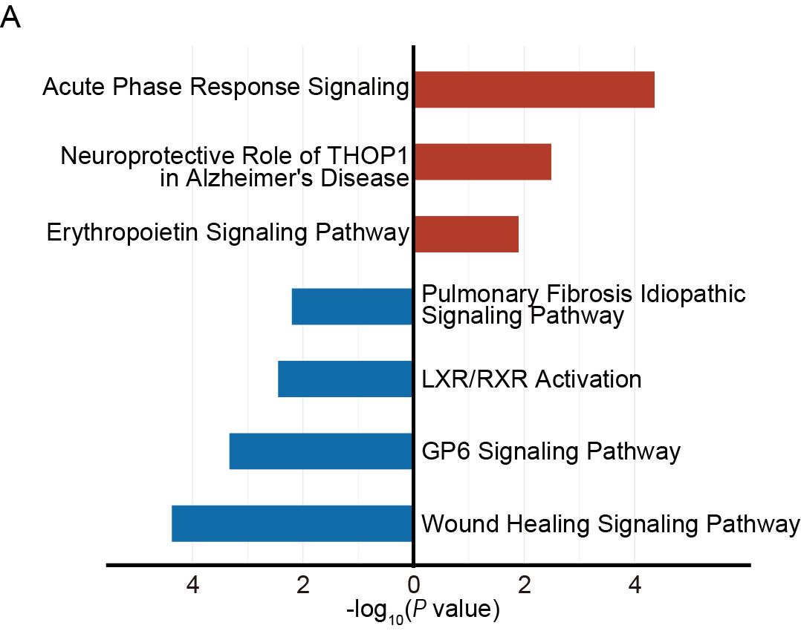
Supplementary Figure 2. Pathway analysis. (A) Pathway enrichment of dysregulated proteins from PM vs. AM by IPA software.

Supplementary Figure 3
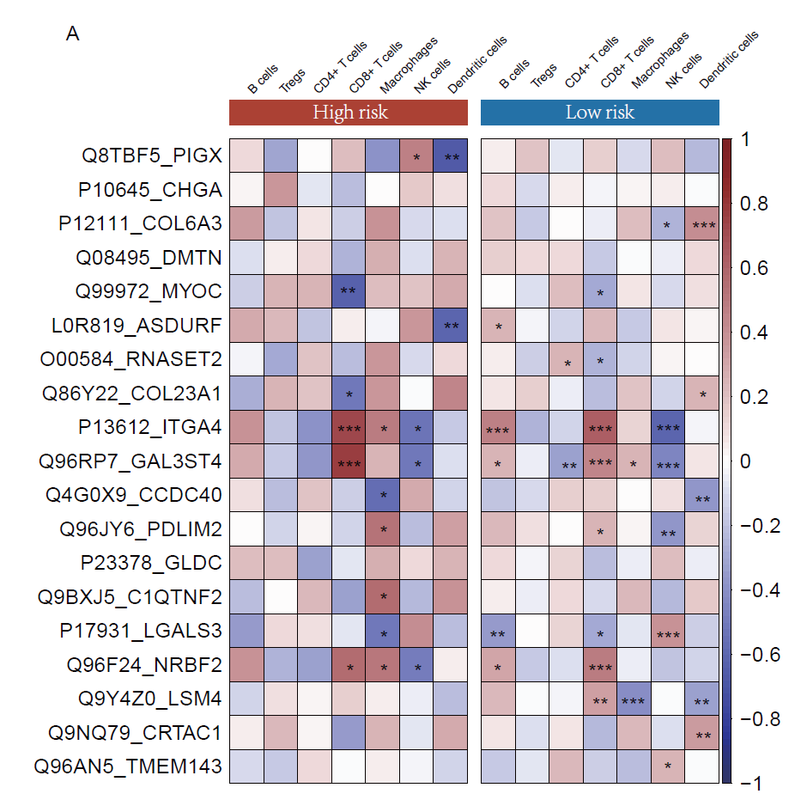
Supplementary Figure 3 Pearson correlations of immune cell fractions and the 19 proteins from the ProtRsf model. The plots showing the correlation coefficient of high- and low-risk of disease recurrence groups which were predicted by our ProtRsf model (*P< 0.05, **P< 0.01 and ***P < 0.001).

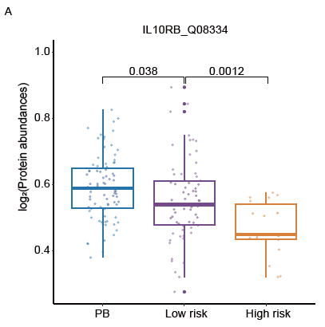
Supplementary Figure 4
Supplementary Figure 4 The abundance of immune checkpoint IL10RB in PB, low-risk and high-risk PM samples. The low- and high-risk groups were predicted by the ProtRsf model.

