Supplementary Online Materials
eFigure 1. Optimized Optos and red-free channel Optos fundus imaging systems
eTable 1. DR Grading Comparing Five-field Imaging with Covered Optimized Optos Imaging
eTable 2. DR Grading Comparing Five-field Imaging with Covered Clarus Imaging
eTable 3. DR Grading Comparing Covered Optimized Optos Imaging with Covered Clarus Imaging
eTable 4. DR Grading Comparing Five-field Imaging with Optimized Optos Imaging
eTable 5. DR Grading Comparing Five-field Imaging with Clarus 133° Imaging
eTable 6. DR Grading Comparing Five-field Imaging with Clarus 200° Imaging
eTable 7. DR Grading Comparing Optimized Optos Imaging with Clarus 133° Imaging
eTable 8. DR Grading Comparing Optimized Optos Imaging with Clarus 200° Imaging
eTable 9. DR Grading Comparing Clarus 133° Imaging with Clarus 200° Imaging
eTable 10. DR Grading Comparing Optimized Optos Imaging with Red-free Channel Optos imaging
eTable 11. DR Grading of Five‑Field, Covered Clarus Imaging and Grading Standard
eTable 12. Accuracy of Five-Field Images for Detecting Any Diabetic Retinopathy
eTable 13. Accuracy of Covered Clarus for Detecting Any Diabetic Retinopathy

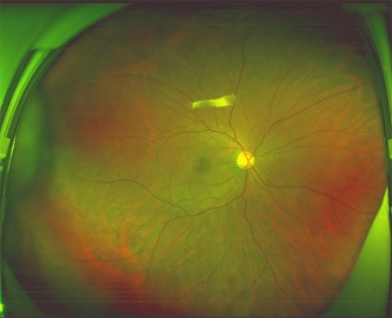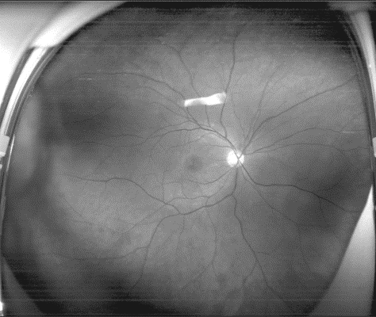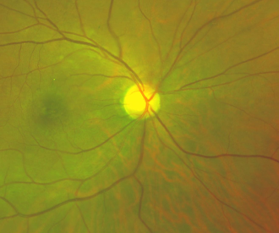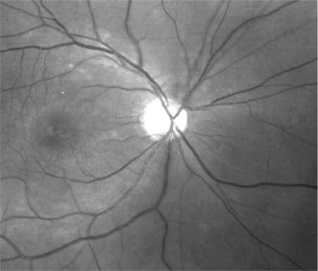
c
a
b
d
eFigure 1 Optimized Optos and red-free channel Optos fundus imaging systems: a, Optimized Optos fundus imaging; b, Optimized Optos fundus imaging with zoom; C, Red-free channel Optos fundus imaging; d, Red-free channel Optos fundus imaging with zoom. Arrow indicates microaneurysms or hemorrhage. Notably, microaneurysms or hemorrhage can be identified in red-free channel Optos fundus imaging. However, they are difficult to identify because of lower contrast in optimized Optos fundus imaging.

eTable 1. DR Grading Comparing Five-field Imaging with Covered Optimized Optos Imaging
 | Covered optimized Optos imaging
Five-field imaging | No DR | Mild  NPDR | Moderate  NPDR | Severe  NPDR | Total | Weighted Kappa (95% CI)
No DR | 172 | 2 | 0 | 0 | 174 | 0.471  (0.376-0.558)
Mild NPDR | 53 | 19 | 3 | 0 | 75 | 0.471  (0.376-0.558)
Moderate NPDR | 7 | 14 | 24 | 0 | 45 | 0.471  (0.376-0.558)
Severe NPDR | 0 | 0 | 3 | 5 | 8 | 0.471  (0.376-0.558)
Total | 232 | 35 | 30 | 5 | 302 | 0.471  (0.376-0.558)

Abbreviations: DR, diabetic retinopathy; NPDR, non-proliferative diabetic retinopathy; CI, confidence interval.

eTable 2. DR Grading Comparing Five-field Imaging with Covered Clarus Imaging
 | Covered Clarus imaging
Five-field imaging | No DR | Mild  NPDR | Moderate  NPDR | Severe  NPDR | Total | Weighted Kappa  (95% CI)
No DR | 162 | 10 | 2 | 0 | 174 |  | 0.809  (0.750-0.864)
Mild NPDR | 0 | 61 | 12 | 2 | 75 |  | 0.809  (0.750-0.864)
Moderate NPDR | 0 | 0 | 36 | 9 | 45 |  | 0.809  (0.750-0.864)
Severe NPDR | 0 | 0 | 0 | 8 | 8 |  | 0.809  (0.750-0.864)
Total | 162 | 71 | 50 | 19 | 302 |  | 0.809  (0.750-0.864)

Abbreviations: DR, diabetic retinopathy; NPDR, non-proliferative diabetic retinopathy; CI, confidence interval.

eTable 3. DR Grading Comparing Covered Optimized Optos Imaging with Covered Clarus Imaging
 | Covered Clarus imaging
Covered optimized Optos imaging | No DR | Mild  NPDR | Moderate  NPDR | Severe  NPDR | Total | Weighted Kappa (95% CI)
No DR | 161 | 56 | 13 | 2 | 232 | 0.396  (0.318-0.480)
Mild NPDR | 1 | 15 | 15 | 4 | 35 | 0.396  (0.318-0.480)
Moderate NPDR | 0 | 0 | 22 | 8 | 30 | 0.396  (0.318-0.480)
Severe NPDR | 0 | 0 | 0 | 5 | 5 | 0.396  (0.318-0.480)
Total | 162 | 71 | 50 | 19 | 302 | 0.396  (0.318-0.480)

Abbreviations: DR, diabetic retinopathy; NPDR, non-proliferative diabetic retinopathy; CI, confidence interval.

eTable 4. DR Grading Comparing Five-field Imaging with Optimized Optos Imaging
 | Optimized Optos imaging
Five-field imaging | No DR | Mild  NPDR | Moderate  NPDR | Severe  NPDR | Total | Weighted Kappa (95% CI)
No DR | 159 | 13 | 2 | 0 | 174 | 0.463  (0.383-0.544)
Mild NPDR | 44 | 22 | 9 | 0 | 75 | 0.463  (0.383-0.544)
Moderate NPDR | 7 | 9 | 27 | 2 | 45 | 0.463  (0.383-0.544)
Severe NPDR | 0 | 0 | 2 | 6 | 8 | 0.463  (0.383-0.544)
Total | 210 | 44 | 40 | 8 | 302 | 0.463  (0.383-0.544)

Abbreviations: DR, diabetic retinopathy; NPDR, non-proliferative diabetic retinopathy; CI, confidence interval.

eTable 5. DR Grading Comparing Five-field Imaging with Clarus 133° Imaging
 | Clarus 133° imaging
Five-field imaging | No DR | Mild  NPDR | Moderate  NPDR | Severe  NPDR | Total | Weighted Kappa (95% CI)
No DR | 144 | 24 | 6 | 0 | 174 | 0.521  (0.455-0.585)
Mild NPDR | 0 | 43 | 27 | 5 | 75 | 0.521  (0.455-0.585)
Moderate NPDR | 0 | 0 | 14 | 31 | 45 | 0.521  (0.455-0.585)
Severe NPDR | 0 | 0 | 0 | 8 | 8 | 0.521  (0.455-0.585)
Total | 144 | 67 | 47 | 44 | 302 | 0.521  (0.455-0.585)

Abbreviations: DR, diabetic retinopathy; NPDR, non-proliferative diabetic retinopathy; CI, confidence interval.
eTable 6. DR Grading Comparing Five-field Imaging with Clarus 200° Imaging
 | Clarus 200° imaging
Five-field imaging | No DR | Mild  NPDR | Moderate  NPDR | Severe  NPDR | Total | Weighted Kappa (95% CI)
No DR | 139 | 29 | 6 | 0 | 174 | 0.500  (0.431-0.575)
Mild NPDR | 0 | 43 | 27 | 5 | 75 | 0.500  (0.431-0.575)
Moderate NPDR | 0 | 0 | 14 | 31 | 45 | 0.500  (0.431-0.575)
Severe NPDR | 0 | 0 | 0 | 8 | 8 | 0.500  (0.431-0.575)
Total | 139 | 72 | 47 | 44 | 302 | 0.500  (0.431-0.575)

Abbreviations: DR, diabetic retinopathy; NPDR, non-proliferative diabetic retinopathy; CI, confidence interval.
eTable 7. DR Grading Comparing Optimized Optos Imaging with Clarus 133° Imaging
 | Clarus 133° imaging
Optimized Optos imaging | No DR | Mild NPDR | Moderate NPDR | Severe NPDR | Total | Weighted Kappa (95% CI)
No DR | 140 | 50 | 18 | 2 | 210 | 0.323  (0.245-0.401)
Mild NPDR | 4 | 17 | 17 | 6 | 44 | 0.323  (0.245-0.401)
Moderate NPDR | 0 | 0 | 12 | 28 | 40 | 0.323  (0.245-0.401)
Severe NPDR | 0 | 0 | 0 | 8 | 8 | 0.323  (0.245-0.401)
Total | 144 | 67 | 47 | 44 | 302 | 0.323  (0.245-0.401)

Abbreviations: DR, diabetic retinopathy; NPDR, non-proliferative diabetic retinopathy; CI, confidence interval.

eTable 8. DR Grading Comparing Optimized Optos Imaging with Clarus 200° Imaging
 | Clarus 200° imaging
Optimized Optos imaging | No DR | Mild  NPDR | Moderate  NPDR | Severe  NPDR | Total | Weighted Kappa (95% CI)
No DR | 139 | 51 | 18 | 2 | 210 | 0.349  (0.276-0.423)
Mild NPDR | 0 | 21 | 17 | 6 | 44 | 0.349  (0.276-0.423)
Moderate NPDR | 0 | 0 | 12 | 28 | 40 | 0.349  (0.276-0.423)
Severe NPDR | 0 | 0 | 0 | 8 | 8 | 0.349  (0.276-0.423)
Total | 139 | 72 | 47 | 44 | 302 | 0.349  (0.276-0.423)

Abbreviations: DR, diabetic retinopathy; NPDR, non-proliferative diabetic retinopathy; CI, confidence interval.

eTable 9. DR Grading Comparing Clarus 133° Imaging with Clarus 200° Imaging
 | Clarus 200° imaging
Clarus 133° imaging | No DR | Mild  NPDR | Moderate  NPDR | Severe  NPDR | Total | Weighted Kappa (95% CI)
No DR | 139 | 5 | 0 | 0 | 144 | 0.976  (0.951-0.995)
Mild NPDR | 0 | 67 | 0 | 0 | 67 | 0.976  (0.951-0.995)
Moderate NPDR | 0 | 0 | 47 | 0 | 47 | 0.976  (0.951-0.995)
Severe NPDR | 0 | 0 | 0 | 44 | 44 | 0.976  (0.951-0.995)
Total | 139 | 72 | 47 | 44 | 302 | 0.976  (0.951-0.995)

Abbreviations: DR, diabetic retinopathy; NPDR, non-proliferative diabetic retinopathy; CI, confidence interval.
eTable 10. DR Grading Comparing Optimized Optos Imaging with Red-free Channel Optos Imaging
 | Red-free channel Optos imaging
Optimized Optos imaging | No DR |  | Mild  NPDR | Moderate  NPDR | Severe  NPDR | Total | Weighted Kappa  (95% CI)
No DR |  | 165 | 34 | 11 | 0 | 210 | 0.491  (0.418-0.517)
Mild NPDR |  | 2 | 26 | 14 | 2 | 44 | 0.491  (0.418-0.517)
Moderate NPDR |  | 0 | 0 | 16 | 24 | 40 | 0.491  (0.418-0.517)
Severe NPDR |  | 0 | 0 | 0 | 8 | 8 | 0.491  (0.418-0.517)
Total |  | 167 | 60 | 41 | 34 | 302 | 0.491  (0.418-0.517)

Abbreviations: DR, diabetic retinopathy; NPDR, non-proliferative diabetic retinopathy; CI, confidence interval.

eTable 11. DR Grading of Grading Standard, Five‑Field and Covered Clarus Imaging
DR severity level | Grading standard | Five-field imaging | Covered Clarus imaging
No DR | 166 (55.0%) | 174 (57.6%) | 162 (53.6%)
Mild NPDR | 68 (22.5%) | 75 (24.8%) | 71 (23.5%)
Moderate NPDR | 50 (16.5%) | 45 (14.9%) | 50 (16.6%)
Severe NPDR | 18 (6.0%) | 8 (2.7%) | 19 (6.3%)

Abbreviations: DR, diabetic retinopathy; NPDR, non-proliferative diabetic retinopathy;

eTable 12. Accuracy of Five-Field Imaging for Detecting Any Diabetic Retinopathy
Threshold | Sensitivity  (95% CI) | Specificity  (95% CI) | Positive Predictive Value | Negative Predictive Value | AUC  (95% CI)
DR absent VS.  DR Present | 1.000  (0.998-1.000) | 0.976  (0.952-0.999) | 0.971 | 1.000 | 0.971  (0.947-0.974)
Mild NPDR or better VS. Moderate NPDR or worse | 0.779  (0.678-0.881) | 1.000  (0.997-1.000) | 1.000 | 0.940 | 0.956  (0.925-0.987)
Moderate NPDR or better VS. Severe NPDR | 0.444  (0.190-0.699) | 1.000  (0.990-1.000) | 1.000 | 0.996 | 0.942  (0.900-0.984)

Abbreviations: DR, diabetic retinopathy; NPDR, non-proliferative diabetic retinopathy; CI, confidence interval. AUC, the area under curve;

eTable 13. Accuracy of Covered Clarus Imaging for Detecting Any Diabetic Retinopathy
Threshold | Sensitivity  (95% CI) | Specificity  (95% CI) | Positive Predictive Value | Negative Predictive Value | AUC  (95% CI)
DR absent VS.  DR Present | 0.941  (0.901-0.981) | 1.000  (0.998-1.000) | 1.000 | 0.954 | 0.994  (0.987-1.000)
Mild NPDR or better VS. Moderate NPDR or worse | 1.000  (0.997-1.000) | 0.996  (0.987-1.000) | 0.986 | 1.000 | 0.998  (0.995-1.000)
Moderate NPDR or better VS. Severe NPDR | 1.000  (0.996-1.000) | 0.996  (0.990-1.000) | 0.947 | 1.000 | 0.998  (0.994-1.000)

Abbreviations: DR, diabetic retinopathy; NPDR, non-proliferative diabetic retinopathy; CI, confidence interval. AUC, the area under curve;

