Supplementary Files:
Fig. S1 Areas of Bainong 64 grown in China, 1996-2008
Fig. S2 Disease severities of powdery mildew for Jingshuang 16 and Bainong 64 at different times after inoculation
Fig. S3 Frequency distributions of the disease severities of powdery mildew for the Jingshuang 16/Bainong 64 RIL population across five environments and BLUE
Fig. S4 QTL validation for powdery mildew response in the Xindong 22/ BFB10 RIL population
Fig. S5 QTL Validation for powdery mildew in cultivar population
Fig. S6 Mean disease severities for RILs with different QTL combinations in the Jingshuang 16/Bainong 64 RIL population
Table S1 Primer sequences of KASP markers used for saturating genetic map and QTL validation
Table S2 Correlation coefficients (r) of maximum disease severities for powdery mildew in Jingshuang 16/Bainong 64 RIL population across five environments
Table S3 ANOVA of powdery mildew disease severities for 171 F₆ lines derived from the cross of Jingshuang 16/Bainong 64
Table S4 The genetic map information of Jingshuang 16/Bainong 64 RIL population based on 15K SNP chip
Table S5 Genotype calling result of KASP markers for QPmjbr.caas-1DL, QPmjbr.caas-2BS and QPmjbr.caas-6BL in Xindong 22/BFB10 RIL population
Table S6 Genotype calling result of KASP markers for QPmjbr.caas-1DL, QPmjbr.caas-2BS, QPmjbr.caas-2DL and QPmjbr.caas-6BL in cultivar population
Table S7 Wheat accessions containing two to three slow-mildewing resistance loci

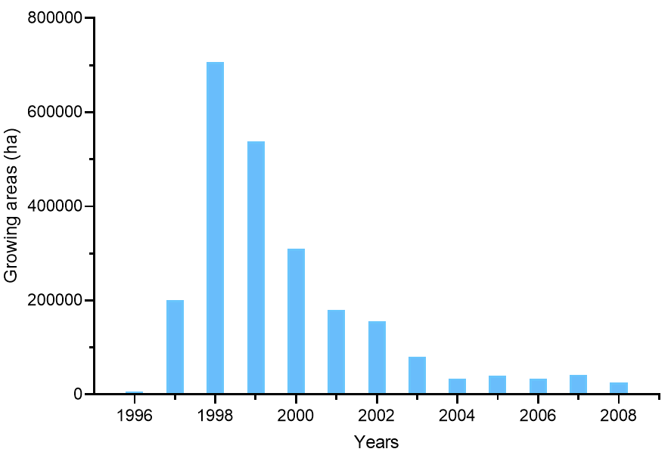
Fig. S1 Areas of Bainong 64 grown in China, 1996-2008 (data source http://202.127.42.47:6006/Home/BigDataIndex)
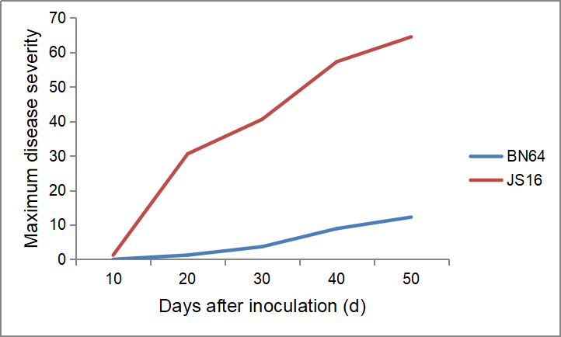Fig. S2 Disease severities of powdery mildew for Jingshuang 16 and Bainong 64 at different times after inoculation
Fig. S3 Frequency distributions of the disease severities of powdery mildew for the Jingshuang 16/Bainong 64 RIL population across five environments and BLUE. Values for parents Jingshuang 16 and Bainong 64 are indicated by arrows; 2020BJ, 2020 Beijing, 2020GC, 2020 Gaocheng, 2020GY, 2020Gaoyi, 2021BJ, 2021Beijing, 2022BJ, 2022Beijing, BN64, Bainong 64, JS16, Jingshuang 16
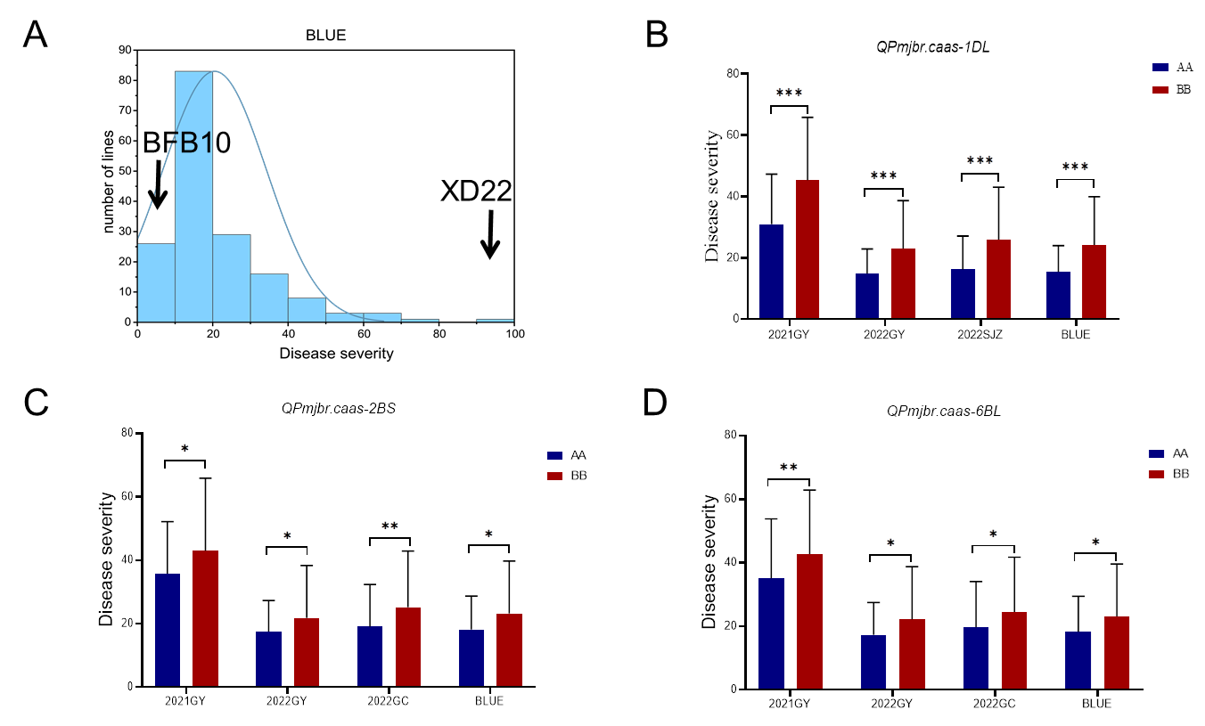Fig. S4 QTL validation for powdery mildew response in the Xindong 22/ BFB10 RIL population. (A) Frequency distributions of disease severities for BLUE value across three environments for the population. Genetic effects of (B) QPmjbr.caas-1DL, (C) QPmjbr.caas-2BS and (D) QPmjbr.caas-6BL on disease severities for different alleles in the population across environments, AA and BB represent the haplotypes of Bainong 64 and Jingshuang 16, respectively

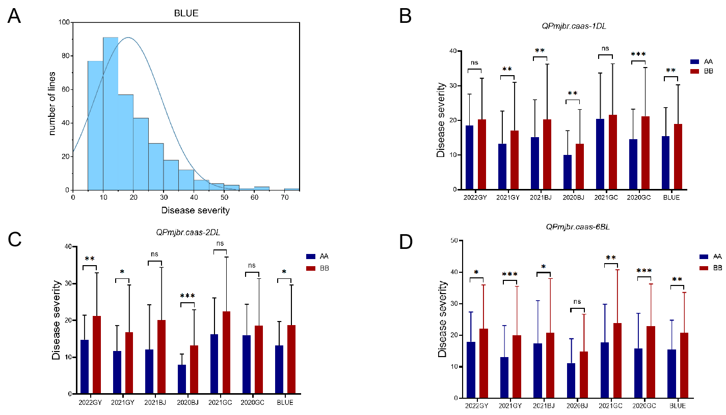Fig. S5 QTL validation for powdery mildew in cultivar population. (A) Frequency distributions of disease severities (DS) for BLUE value across six environments for the panel. Haplotype effects of (B) QPmjbr.caas-1DL, (C) QPmjbr.caas-2DL, and (D) QPmjbr.caas-6BL on disease severities across environments. AA and BB represent the haplotypes of Bainong 64 and Jingshuang 16, respectively
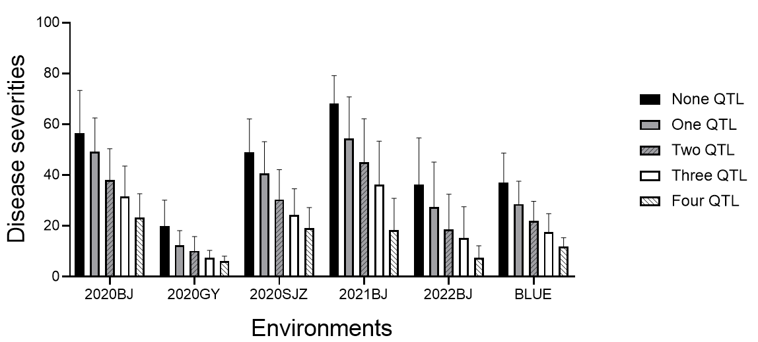
Fig S6. Mean disease severities for RILs with different QTL combinations in the Jingshuang 16/Bainong 64 RIL population

