Controlling rheological properties of nanocellulose from cocoa shell to produce cocoa butter in water Pickering emulsions.
Catalina Gómez Hoyos¹*Luis David Botero¹; Andrea Flórez-Caro¹, Jorge Andrés Velásquez-Cock¹ Lucas Vélez P.² and Robin Zuluaga³
¹ Programa de Ingeniería en Nanotecnología, Universidad Pontificia Bolivariana
² Centro de Investigación, Desarrollo y Calidad - CIDCA, Compañía Nacional de Chocolates S.A.S,
³ Facultad de Ingeniería Agroindustrial, Universidad Pontificia Bolivariana
* Corresponding author: catalina.gomezh@upb.edu.co

Supplementary information
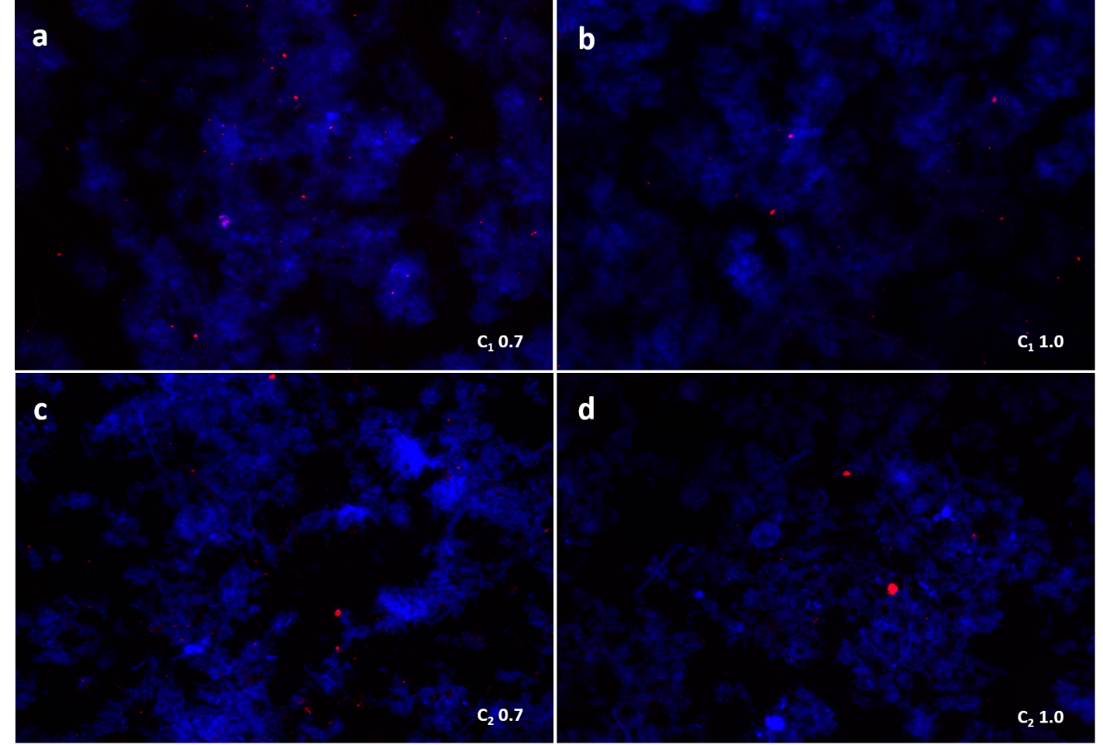
Figure 1. Fluorescent microscopy images of CNFs; (a, c) 0.7 wt.%; (b, d) 1.0 wt.%.

Figure 2. ATR-FTIR spectra deconvolution between 3700 and 3000 cm⁻¹. _E represents sample after removing extractives: (a, c) ATR-FTIR spectra deconvolution of C₁ samples; (b, d) ATR-FTIR spectra deconvolution of C₂ samples.

