Supplementary Information
Multi-layered CuO/SiO₂ core-shell structure improves electrocatalytic CO₂-to-n-propanol conversion
Sha Wang,^{[a]} Jianling Zhang,^{*[a], [b]} Yingzhe Zhao,^{[a], [b]} Jiajun Zhong,^{[c]} Zhongjun Chen,^{[c]} Yisen Yang,^{[a], [b]} Buxing Han,^{[a], [b]} Yongxin Cheng,^{[d]} Meiling Li,^{[a], [b]} Qian Li^{[d]}
[a] Dr. S. Wang, Prof. J. Zhang, Y. Zhao, Y. Yang, Prof. B. Han, M. Li
Beijing National Laboratory for Molecular Sciences, CAS Key Laboratory of Colloid, Interface and Chemical Thermodynamics, CAS Research/Education
Center for Excellence in Molecular Sciences, Institute of Chemistry, Chinese Academy of Sciences
Beijing 100190, P. R. China
E-mail: zhangjl@iccas.ac.cn
[b] Prof. J. Zhang, Y. Zhao, Y. Yang, Prof. B. Han, M. Li
School of Chemical Sciences
University of Chinese Academy of Sciences
Beijing 100049, P. R. China
[c] J. Zhong, Dr. Z. Chen
Beijing Synchrotron Radiation Facility (BSRF), Institute of High Energy Physics, Chinese Academy of Sciences
Beijing 100049, P. R. China
[d] Dr. Y. Cheng, Dr. Q. Li
Center for Physicochemical Analysis and Measurement, Institute of Chemistry, Chinese Academy of Sciences
Beijing 100190, P. R. China

Results
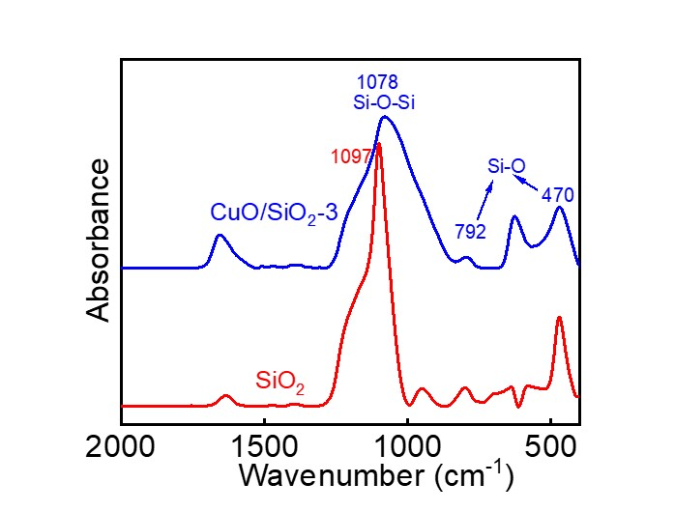
Figure S1. FT-IR spectra of CuO/SiO₂-3 and pure SiO₂.
The adsorption peak at 1078 cm⁻¹ corresponds to the asymmetrical stretching vibration of Si-O-Si, which confirms the existence of SiO₂ in CuO/SiO₂-3. It is red-shifted compared with that of pure SiO₂ (1097 cm⁻¹), implying there is a strong interaction between CuO and SiO₂.

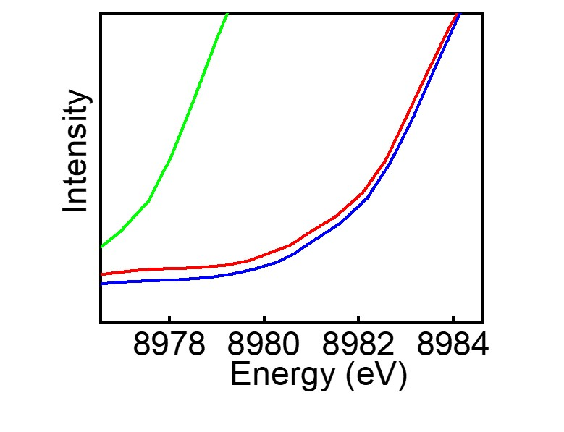
Figure S2. An enlarged view of the selected section in Figure 2c.

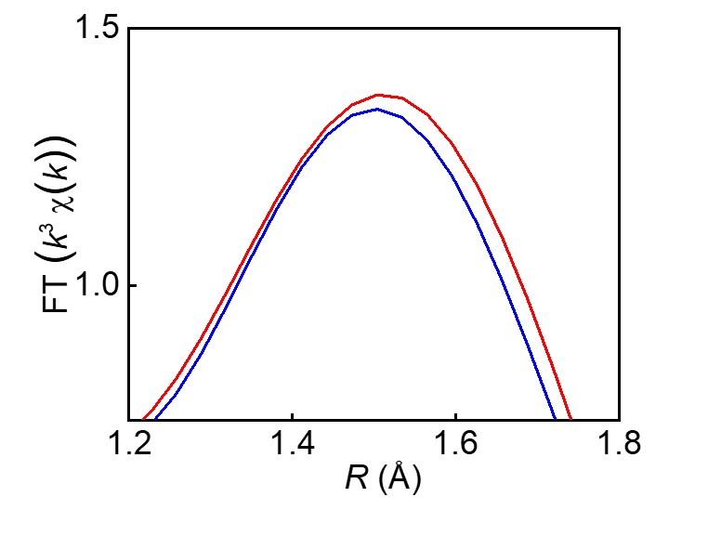
Figure S3. An enlarged view of the selected section in Figure 2f.

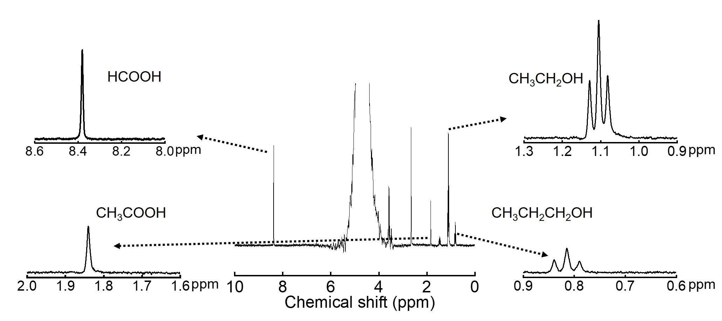
Figure S4. A typical ¹H NMR spectrum of liquid products over CuO/SiO₂-3 at -2.38 V after ECO₂RR in flow cell.

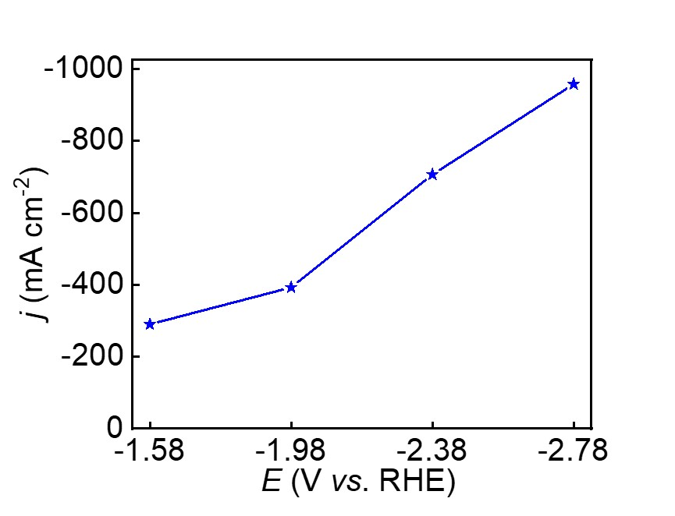
Figure S5. Total current density at various potentials on CuO/SiO₂-3.

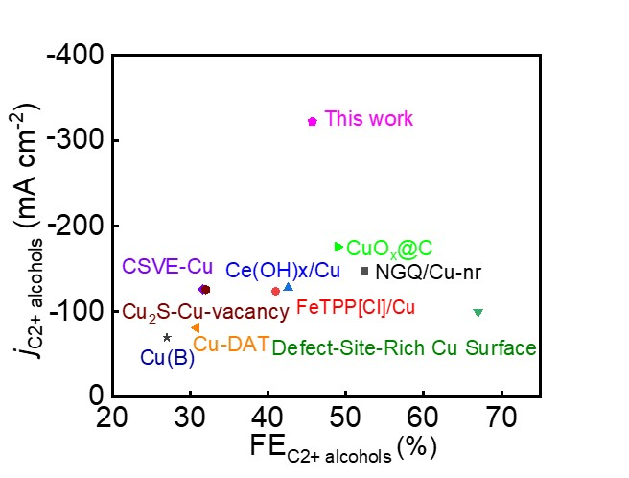
Figure S6. Comparison of electrochemical performances of j_{C2+} _{alcohols} vs. FE_{C2+} _{alcohols} during ECO₂RR on Cu-based electrocatalysts in flow cell.

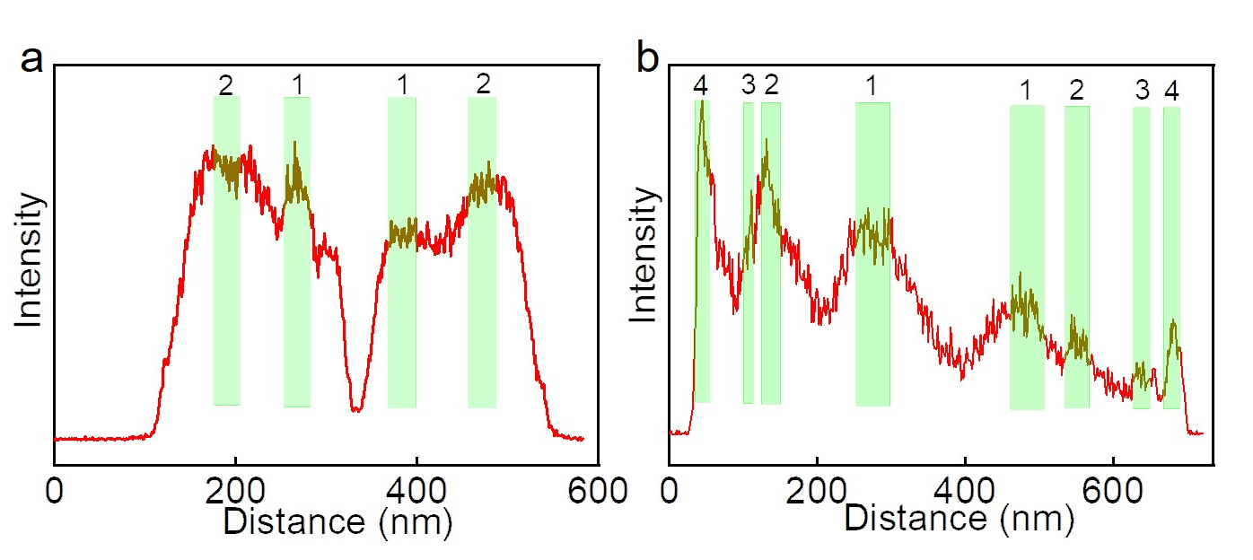
Figure S7. EDX element line scan of (a) CuO/SiO₂-2 and (b) CuO/SiO₂-4.

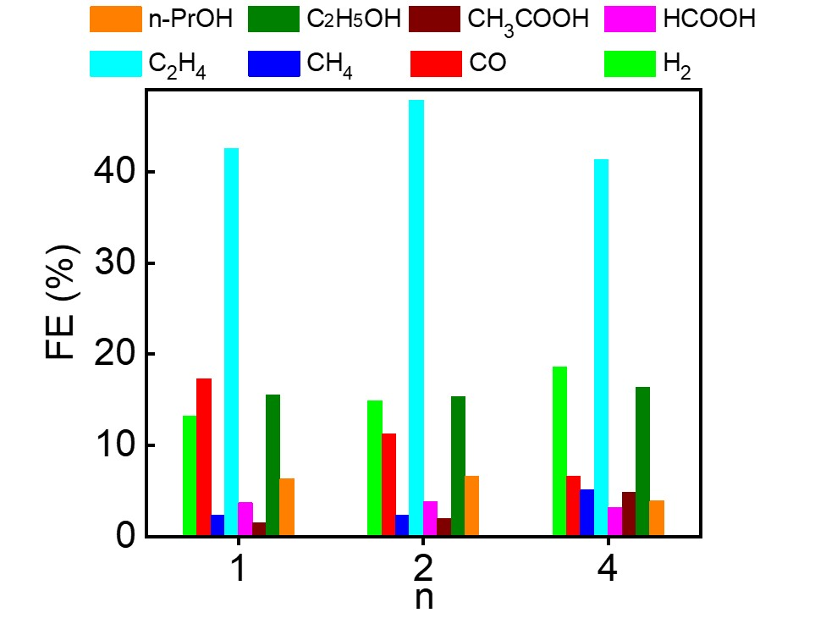
Figure S8. FE values of various products at -2.38 V over CuO/SiO₂-n (n=1, 2 and 4).

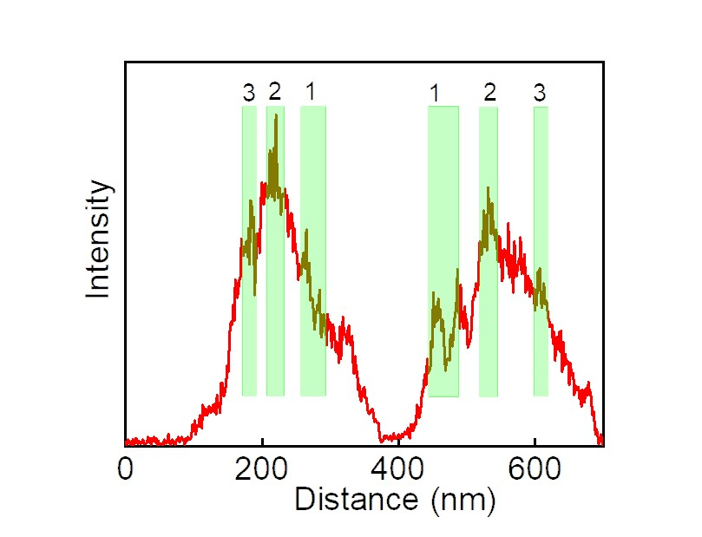
Figure S9. EDX element line scan of CuO-3.

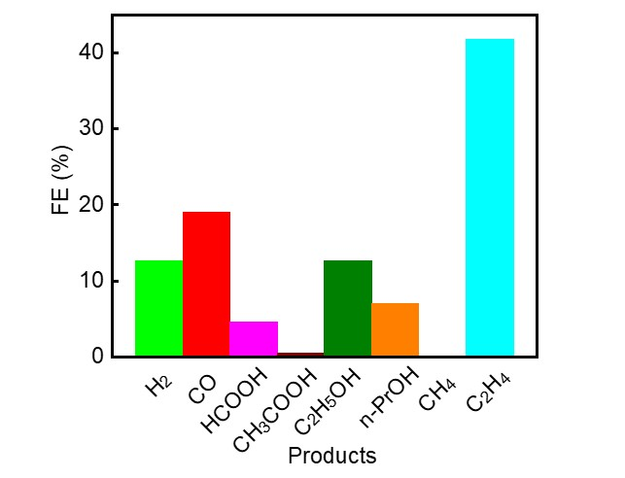
Figure S10. FE values of various products at -2.38 V over CuO-3.

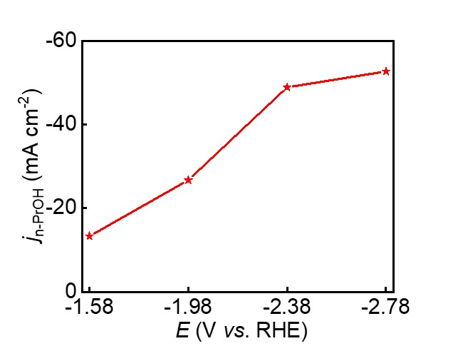
Figure S11. n-PrOH FE and partial current density on CuO-3 at various potentials.

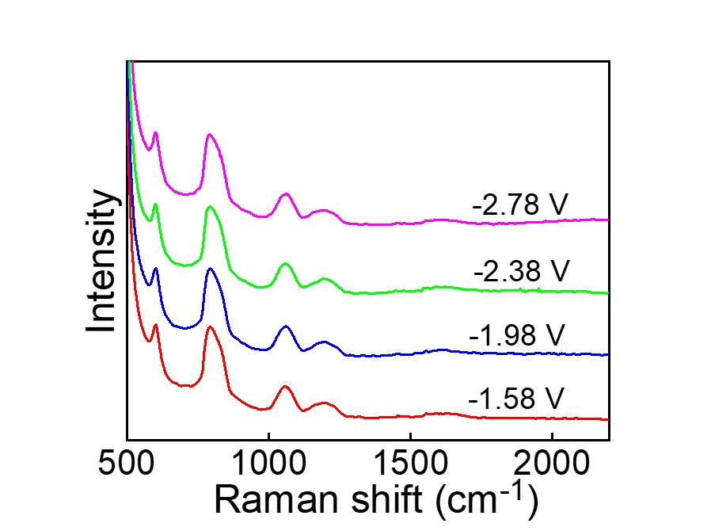
Figure S12. In situ Raman spectroscopy at various potentials over CuO/SiO₂-1.

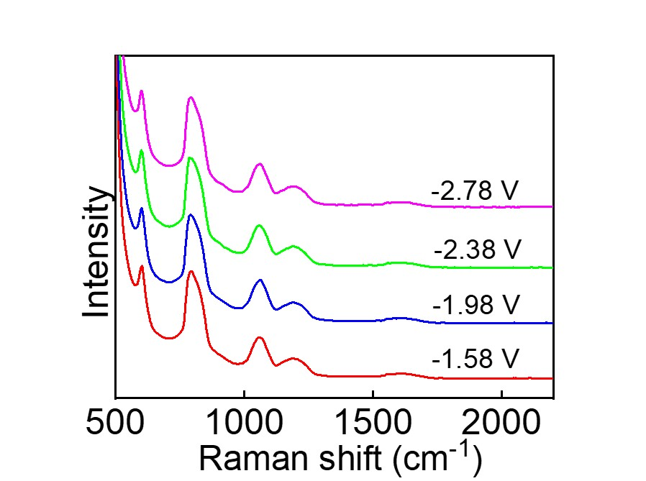
Figure S13. In situ Raman spectroscopy at various potentials over CuO/SiO₂-4.

Table S1 Comparison of electrochemical performances for CO₂ reduction to n-PrOH on Cu-based electrocatalysts in flow cell and H-type cell. The given potential is iR-corrected one for the sake of comparison.
catalyst | FE_{n-PrOH} (%) | j_{n-PrOH}  (mA cm⁻²) | E (V vs. RHE) | cell | Ref.
Activated Cu mesh | 13.1 | ＜2 | -0.9 | H cell | ACS Catal.  2017, 7, 7946
Pd₉Cu₉₁ catalyst | 13.7 | 1.15 | -0.65 | H cell | Green Chem.  2020, 22, 6497
Cu-NC₂₀ | ∼10.6 | 1.50 | -0.95 | H cell | - Phys. Chem. Lett.  2016, 7, 20
Cu-on-Cu₃N | 6 | 1.3 | -0.95 | H cell | Nat. Commun.  2018, 9, 3828
Cu₂O nanostructure | 12.6 | 0.65 | -0.3 | H cell | ACS Appl. Mater. Interfaces  2021, 13, 39165
Hex-2Cu-O | 18.3  ~8 | 2.2  ~21.0 | -1.2  -0.66 | H cell  flow-cell | Nat. Commun.  2022, 13, 5122
CuS_{x} with double-sulfur vacancy | 15.4  ~3.8 | 3.1  9.9 | -1.05  -0.85 | H cell  flow-cell | Nat. Commun.  2021, 12, 1580
modified Cu₂S | 8.0  7.0 | 2.5  27.9 | -0.95  -0.92 | H cell  flow-cell | Nat. Catal.  2018, 1, 421
NGQ/Cu-nr | ~7 | ~20.0 | -0.9 | flow-cell | Angew. Chem. Int. Ed.  2020, 59, 1
CuO/SiO₂-3 | 13.3 | 94.0 | -0.81 | flow-cell | This work

Table S2 Comparison of electrochemical performances for CO₂ reduction to C₂₊ alcohols on Cu-based electrocatalysts in flow cell.
catalyst | FE_{C2+ alcohols} (%) | j_{C2+ alcohols} (mA cm⁻²) | E (V vs. RHE) | Ref.
NGQ/Cu-nr | 52.4 | 147.8 | -0.9 | Angew. Chem. Int. Ed.  2020, 59, 16459
FeTPP[Cl]/Cu | 41 | 124 | -0.82 | Nat. Catal.  2020, 3, 75
Ce(OH)_{x}/Cu | 42.6 | 128 | -0.7 | Nat. Commun.  2019, 10, 5814
Defect-Site-Rich Cu Surface | 67 | >100 | -0.95 | Joule  2021, 5, 429
Cu₂S-Cu-vacancy | 31.6 | 126 | -0.85 | Nat. Catal.  2018, 1, 421
Cu-DAT | 30.8 | 81.2 | -0.69 | ACS Catal.  2017, 7, 3313
CuO_{x}@C | 49 | 176 | -1.0 | Angew. Chem. Int. Ed.  2022, 61, e2022096
Cu(B) | 27 | 70 | -1.1 | Nat. Chem.  2018, 10, 974
CuO/SiO₂-3 | 45.7 | 322.8 | -0.81 | This work

