Supplementary Materials for

Wide-field Fourier magnetic imaging with electron spins in diamond

Zhongzhi Guo ^{1, 2, ‡}, You Huang ^{1, 2, ‡}, Mingcheng Cai ^{1, 2, ‡}, Chunxing Li ^{1, 2}, Mengze Shen ^{1, 2}, Mengqi Wang ^{1, 2}, Pei Yu ^{1, 2}, Ya Wang ^{1, 2, 3}, Fazhan Shi ^{1, 2, 3, 4}, Pengfei Wang ^{1, 2, 3, *}, Jiangfeng Du ^{1, 2, 3, 5, *}

*Corresponding author. Email: wpf@ustc.edu.cn (P. Wang); djf@ustc.edu.cn (J. Du)

This PDF file includes:

Supplementary Text
Figs. S1 to S9

Supplementary Text
Widefield Fourier magnetic microscope
The widefield Fourier magnetic microscope includes a widefield optically detected magnetic resonance microscope and gradient microcoils plated on a diamond substrate. A 532 nm high-power laser (Lighthouse, Sprout-D-5W) generates a continuous laser for illuminating NV centers. The laser passed through three acousto-optic modulators (two Isomet M1133-aQ80L-1.5 and one Gooch & Housego R35085-3) to modulate the laser pulse. This resulted with an on-off ratio of ~10⁷ : 1 and optical efficiency of ~30 %. To form widefield illumination, a lens is used to focus the laser onto the back focal plane of the objective lens (OLYMPUS, LUCPlanFLN60×). The fluorescence of NV centers is collected by the same objective lens and focused by a lens (Thorlabs AC508-200-B-ML, f = 200 mm) onto pixel plane of the EMCCD (Princeton Instruments ProEM-HS:1024B × 3, pixel size = 13 μm×13 μm). In this case, the pixel size of a widefield fluorescence image is set to 195 nm.

The NV diamond sample is attached on an Ω-shape coplanar coil (see Ref.¹) with UV-curing optical adhesive. The microwave coil is fabricated on the printed circuit board (PCB). The gradient microcoils are plated on a diamond substrate (see Methods) and are placed near the top surface of diamond sample. Two pieces of copper heat sink are attached to the back of the diamond substrate to dissipate current induced Joule heat through gradient microcoils. The copper heat sink and microwave coil are bounded together and mounted on an acrylic base. The acrylic base is mounted on a three-dimension (3D) piezo scanner (Physik Instrumente, P-562.3CD) combined with a two-dimension micro-positioner. For temperature control, the whole sample stage is placed in a copper chamber with a heating resistor. A thermistor is attached on the bottom of copper heat sink for monitoring the temperature. A temperature controller (Stanford Research System, PTC10) records temperature data in real time and controls temperature by PID algorithms.

The origin ($B_{E}=0$) and gradient measurement
Theoretically, the real-space origin can be identified from the equivalent expression of the k-space signal $S_{i}\left(k\right)\sim \exp\left(2πk∙r_{i}\right)=\exp\left(2πγ_{e}τB_{E}\right)$. From this expression, the condition of $B_{E}=0$ can be always established at the position of $r_{i}=0$ for different magnetic gradients and evolution time. We measure the magnetic gradient by sending current pulses to microcoils in x or y direction and performing pulse-ODMR experiment. The magnetic field projecting on the NV axis can be calculated by $B_{E}=\left(F-F_{0}\right)/γ_{e}$, where $F$ ($F_{0}$) is resonance frequency with (without) sending current into the gradient microcoils. The magnetic field map is showed in Fig. S2c. The profile along y direction is linear-fitted for extraction of gradient and position of real-space origin ($B_{E}=0$) (inset of Fig. S2d). The gradients for different current are showed in Fig. S2d.

For single NV centers in nanopillars, we measure gradient by calculating the frequency difference of NV 1 and NV 2. The origin of real space ($B_{E}=0$) is simply asuumed as the location where the resonance frequency is invariant for different gradient currents. We drawed the linear trendline for different currents and solved the intersection between each of them (Fig. S3). Finally, we calculated the most probable value of these intersections in the 2-dimensional parameter space with the following criteria:
$$\min_{\left(x_{0},f_{0}\right)}{Σ_{i}{\left[{\left(x_{0}-x_{i}\right)}^{2}+{\left(f_{0}-f_{i}\right)}^{2}\right]}^{\frac{1}{2}}}, \left(S1\right)$$
and assigned the position value to real-space origin.

K value measurement of nanopillars sample
Because of the small number of NV centers in the single NV sample, we determined the k-value by combining the gradient-current curve with the current waveform measurements. In the phase encoding process, we used an AC current to produce a gradient magnetic field. In the experiment we recorded the current waveform and then calculated the average gradient, with the proportional gradient-current coefficients measured in Fig. S3. The mean gradient is given by
$$G_{i}=\frac{1}{τ}\int_{0}^{τ}{α_{i}I_{i}\left(t\right)g(t)dt}. \left(S2\right)$$
where $i=x or y$ represents the direction in real space, $τ$ is the time of phase encoding, $α_{i}$ is the calibrated proportional gradient-current coefficients in Fig. S3, and the filter function of Hahn echo sequence is
$$g\left(t\right)=\left\{\begin{aligned} 1, 0≤t<τ/2 \\ -1, τ/2≤t<τ\end{aligned}\right.. \left(S3\right)$$
So, the k value can be calculated by
$$k_{i}=γτG_{i}=γα_{i}\int_{0}^{τ}{I_{i}\left(t\right)g(t)dt}≡\left(γα_{i}\right)ϕ_{i}, \left(S4\right)$$
and the step of k can be given by $Δk_{i}=\left(γα_{i}\right)∙Δϕ_{i}$, where $ϕ_{i}$ represents an effective integration of current.

The k value measurement of ensemble
For the ensemble NV sample, the expressions of the resulting widefield fringes are $Re\left(r\right)\sim \left(1+\cos\left(2πk∙r\right)\right)/2$ and $Im\left(r\right)\sim \left(1-\sin\left(2πk∙r\right)\right)/2$ with manipulation of the sequence shown in Fig.1c of the main text. The spatial period of two fringes is both ${\left|k\right|}^{-1}$ and two fringes are visible for small k value. The real and imaginary parts (the top two panels of Fig.S5a) are linearly combined and then transformed to the spatial frequency domain (the bottom panel of Fig.S5a) via two-dimensional Fourier transform. The peak position of signal represents the value of k and can be read out directly.

Quadrature phase detection of NV centers
To confirm the validity of the quadrature phase detection, we acquired 1D k-space images of the real and imaginary signals using single NV centers in nanopillars. The sampling range of k-space in the experiment is $[-49Δk, 49Δk]$ with $Δk=0.27 μm^{-1}$, and the corresponding real space step size is $Δr=37.4 nm$. In both real and imaginary k-space data of NV1 (Fig. S6a), oscillatory signals with frequency ~50 Hz were found. After performing Fourier transform, it is found that symmetrical signal peaks appear at y = 1.67 μm and y = -1.67 μm in real-space images (Fig. S6b). Each result shows a sign ambiguity of the position of the NV center. After combining the real and imaginary parts to obtain a complex k-space signal and performing Fourier transform, a single peak is obtained in the real-space, and the amplitude of the signal peak is the sum of the amplitudes of the real and imaginary signal peaks, which is consistent with the theoretical prediction, as shown in Fig. S6b. A low-frequency modulation signal is found in the k-space signal of both real and imaginary parts. After Fourier transform, the corresponding sign ambiguity does not disappear. We also found this modulation in the signals of other NV centers (Fig. S6c). The same modulation signal may be caused by position drift during the data acquisition.

T₁ and T₂* test
To verify the validity of the coherence decay sequence in Fig. 4 in the main text, we tested the T₁ and T₂* decay curves of the ensemble NV centers (Fig.S7). The results show that the coherence decays completely in about 4 μs (orange curve), while a great part of the polarization is retained in 10 μs (blue curve).

Numerical simulation of Fourier nuclear magnetic imaging of proton
To show a potential application of the WFMI method, we conducted a numerical simulation for widefield Fourier nuclear magnetic imaging. In analogy to the measurement sequence in Fig. 4 in the main text, we use the Hahn echo sequence to sense the statistical polarization generated from an ensemble of protons located on the surface of diamond, by fixing the delay time between microwave pulses to half of the Larmor period of protons. Subsequently, the two-dimensional signal distribution is read out. Finally, we compare results of Fourier magnetic imaging and normal widefield imaging to identify the resolution advantage of this technique.

The statistical polarization of the proton ensemble is calculated for every NV centers. Following in the dipole-dipole interaction model in Ref. ², the field distribution of a set of N protons to the $i$th NV center is
$$B_{i}\left(N\right)=\sqrt{\sum_{j=0}^{N_{p}}{B_{rms,j}^{2}}} , \left(S5\right)$$
with the field distribution of the $j$th proton
$$B_{rms,j}=\sqrt{\frac{2}{3}}\frac{3μ_{0}μ_{p}}{4πr_{j}^{3}}\sqrt{{\left(\left(\vec{e_{2}}∙\vec{n_{l}}\right)\left(\vec{e_{1}}∙\vec{n_{l}}\right)\right)}^{2}+{\left(\left(\vec{e_{3}}∙\vec{n_{l}}\right)\left(\vec{e_{1}}∙\vec{n_{l}}\right)\right)}^{2}}, \left(S6\right)$$
where $μ_{0}=4π×{10}^{-7} T∙m/A$ is the permeability of vacuum, $μ_{p}=1.41{×10}^{-26} J/T$ is the magnetic moment of proton, $r_{j}$ and $\vec{n_{l}}$ are the distance and the direction of the distance vector between the $j$th proton and the $i$th NV center, respectively. $\vec{e_{1}}$,$\vec{e_{2}}$, $\vec{e_{3}}$ is set of orthonormal bases, and $\vec{e_{1}}$ is aligned along the NV axis, as well as the bias magnetic field $\vec{B_{0}}$. In the computation program, we defined $\vec{e_{1}}=1/\sqrt{3}\left(\sqrt{2},0,1\right)$,$\vec{e_{2}}=1/\sqrt{3}\left(-1,0,\sqrt{2}\right)$, $\vec{e_{3}}=(0,1,0)$, which are consistent with the laboratory coordinate system.

To compute the decoherence of NV centers, we construct the effective magnetic field oscillating at Larmor frequency of proton with random phase and random amplitude detected by $i$th NV center (The model is similar to Ref. ³. In the computation program, we used a uniformly random distributed phase within an interval of $\left[0, 2π\right]$ and a normally random distributed amplitude with an excepted value of $0$ and a standard deviation of $B_{i}\left(N\right)$:$B_{eff,i}\left(t\right)=B_{r}\cos\left(ω_{Larmor}t+ϕ_{r}\right).$ After the evolution of Hahn echo sequence, the population on the |0⟩ state is calculate for each NV center. This procedure is repeated for 50 times to acquire the average population.

For simulating widefield imaging and widefield Fourier magnetic imaging, we generate a pixel array of $20×20$ with pixel size of 100 nm, the center of pixel array is placed at the origin of real space. The normalized fluorescence image on pixel array (also the point spread function, PSF) is calculated for all NV centers. The optical diffraction limit is set to 250 nm, corresponding to a fluorescence of λ=700 nm and an objective of NA=1.4.

To calculate the widefield CCD image of population on |0⟩ state, population of each NV center is multiplied by their own PSF. The result is then summated together for all NV centers.

To calculate the image of widefield Fourier magnetic imaging, following with the Hahn-echo sensing of random magnetic field, each NV center with an initial population is Fourier encoded by quadrature phase encoding sequence. The CCD pixel array collect the k-space data and each pixel collects signal with a weighted factor decided by optical diffraction. For each k-sampling point, there is a 2-dimension CCD image. The k-space data of each pixel are superimpose of NV centers that emit fluorescence to the corresponding pixel. For each pixel, the k-space data are converted to real-space data via Fourier transform. With summating the real-space data of all pixels, the widefield Fourier image of proton NMR is generated with diffraction-unlimited resolution.

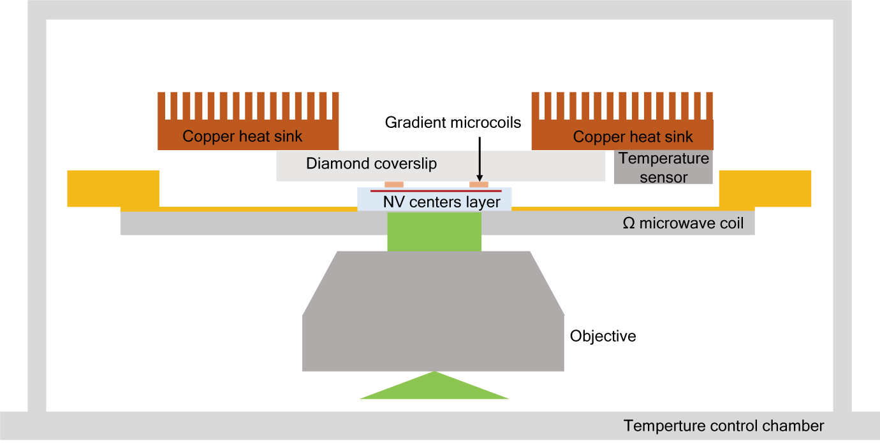

Fig. S1.
Schematic of widefield Fourier magnetic imaging microscope.

Fig. S2.
The origin and gradient measurement of NV ensemble. (a) The ODMR pulse sequence for gradient measurement. (b) The photos of gradient microcoils and schematic of current flowing into the microcoils. (c) The map of gradient magnetic field along the NV axis, with a current flowing into the y-direction microcoils. y₀ is the y position of the real-space origin (blue dashed line). (d) The measured relations of the gradient strength and the current for the y-direction microcoils. Inset: the data on the black dashed line in (c) and its fitting line. The real-space origin (y₀) is located at the position of $B_{E}=0$.

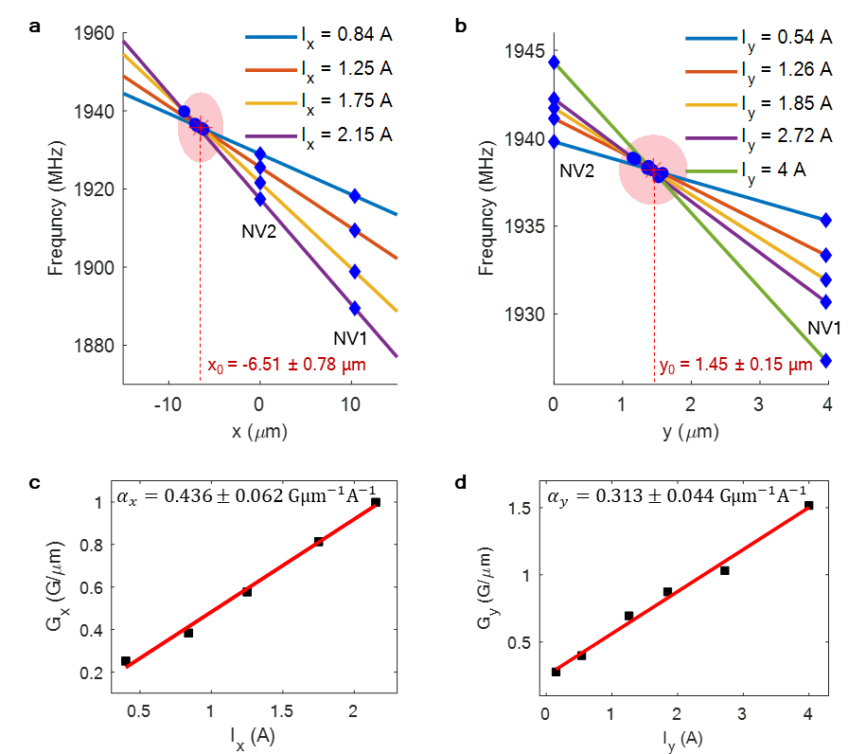

Fig. S3.
The origin and gradient measurement in NV centers in pillar. The x and y positions of the origin are measured in (a) and (b), respectively. The size of the red shading represents for the standard deviation of the most probable value of position and resonance frequency. The measured relations of the gradient strength and the current are showed in (c) and (d). The slopes are used to calculate the k value.
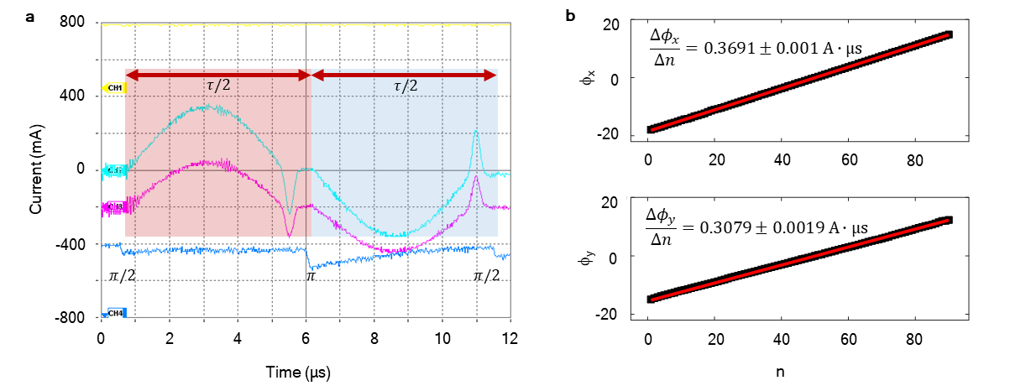
Fig. S4.
The k measurement for NV centers in nanopillars. (a) The waveform acquired by the oscilloscope corresponding to the experiment sequence in Fig. 1 of the main text. The baseline of each channel is offset for a clear view. Channel 1 (yellow) is the triggering signal for EMCCD exposure.. Channel 2 (cyan) is current waveform of the x-direction gradient field. Channel 3 (purple) is current waveform of the y-direction gradient field. Channel 4 (blue) is the microwave signal modulated by a detector diode to record the microwave pulse duration. The current waveform is set up with an overshoot tail before the microwave pulse is applied, in order to eliminate the residual gradient field. Red and blue shading areas indicate the filter function of the microwave sequence with opposite sign before and after the action of $π$ pulse. (b) The cumulative phase measurement in x and y directions, n indicates the nth k sampling point. The cumulative phase varies linearly with n, and the slopes are used to calculate the average k-sampling step.

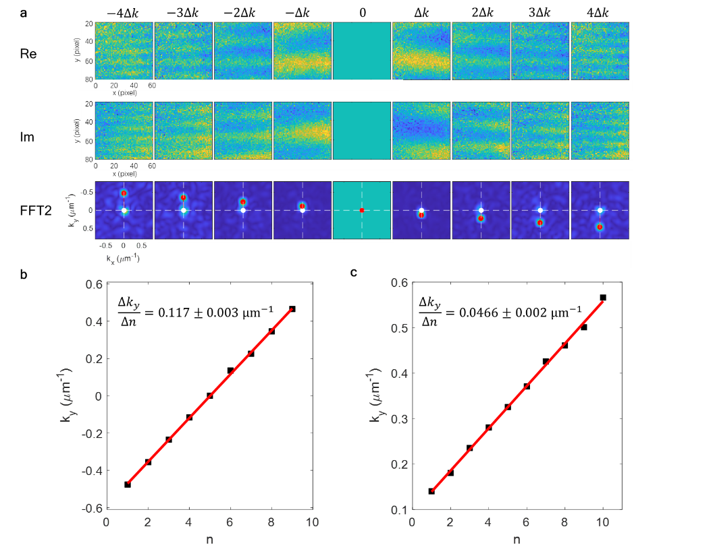

Fig. S5.
The k measurement for ensemble NV centers. (a) Widefield fringes in the y-direction and the k-value measurement. (b) k-value measurement for Fig. 3 in the main text. The horizontal coordinates indicate the nth k-sampling point. All k-values are consistent with a linear relationship, and the sampling step is calculated then combined with the n-value to calculate the k-value for each sampling point. (c) k-value measurement for Fig. 4 in the main text. The step size is $4Δk_{y}=0.186 μm^{-1}$ for k-space imaging with reduced FOV.

Fig. S6.
Demonstration of the quadrature Fourier imaging on a single NV center.

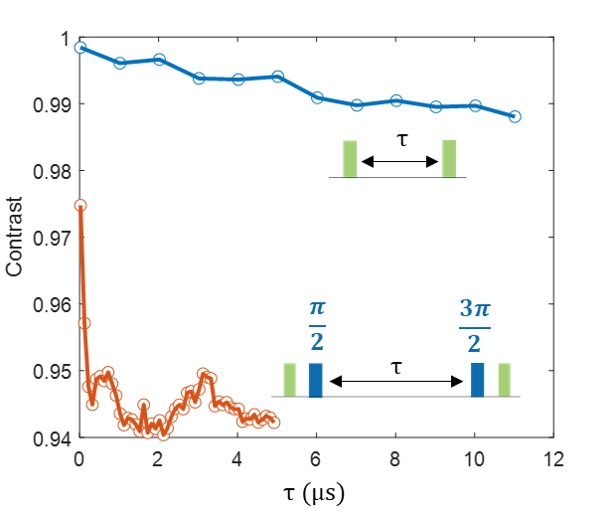

Fig. S7.
Polarization and coherence decay test of the ensemble NV centers.

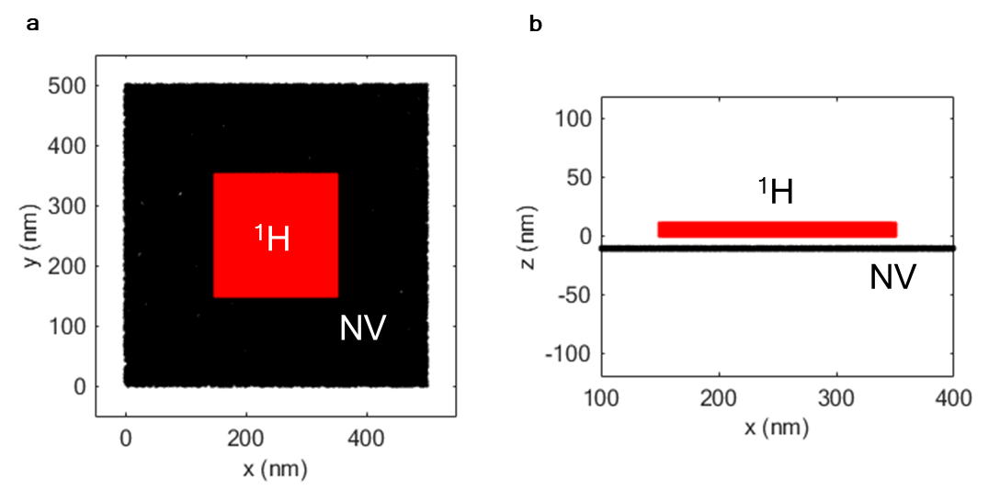

Fig. S8.
The distribution of NV centers and the protons. $N_{p}=2×{10}^{7}$ protons are placed inside a 200 nm × 200 nm × 10 nm box with uniformly random distribution in three dimensions, corresponding to a concentration of 50 / nm³ (a typical proton density of organic samples); the bottom of the box is defined as the surface of the diamond. $N_{NV}=5×10⁴$ NV centers locate at 10 nm below the diamond surface, with uniformly random distribution in the whole area of 500 nm × 500 nm × 2 nm.

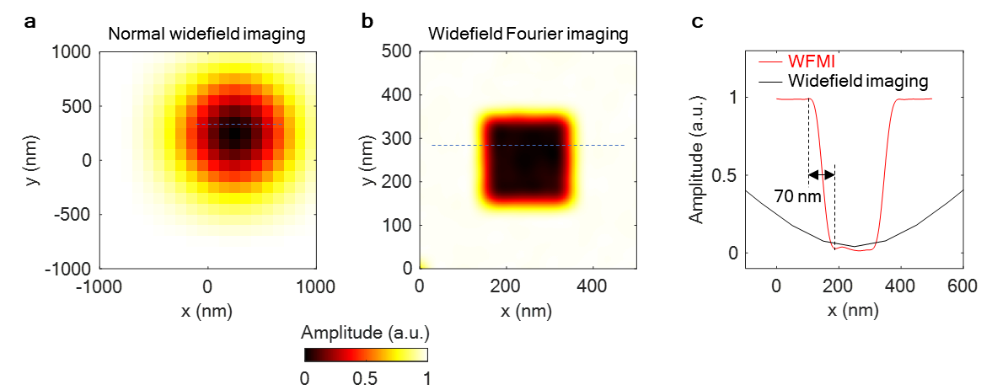

Fig. S9.
Numerical simulation of proton nuclear imaging with normal widefield imaging and widefield Fourier imaging. Proton signal distribution with (a) normal CCD widefield imaging and (b) widefield Fourier magnetic imaging. (c) The line profiles for data in (a) and (b). The spatial resolution of Fourier imaging is set to 20 nm, but the ultimate resolution of 70 nm is degraded by the distance of NV layer between the protons and the Hamming window of the k-space data adding before FFT.

Supplementary References

1 Cai, M. et al. Parallel optically detected magnetic resonance spectrometer for dozens of single nitrogen-vacancy centers using laser-spot lattice. Review of Scientific Instruments 92, 045107, doi:10.1063/5.0039110 (2021).
2 Staudacher, T. et al. Nuclear Magnetic Resonance Spectroscopy on a (5-Nanometer)3 Sample Volume. Science 339, 561-563, doi:10.1126/science.1231675 (2013).
3 Reinhard, F. et al. Tuning a Spin Bath through the Quantum-Classical Transition. Physical Review Letters 108, 200402, doi:10.1103/PhysRevLett.108.200402 (2012).

