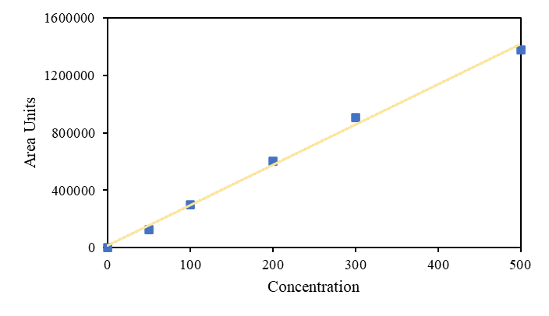
Fig. S1. Calibration curve for quantification of capsaicin using Ultra-Fast Liquid Chromatography.

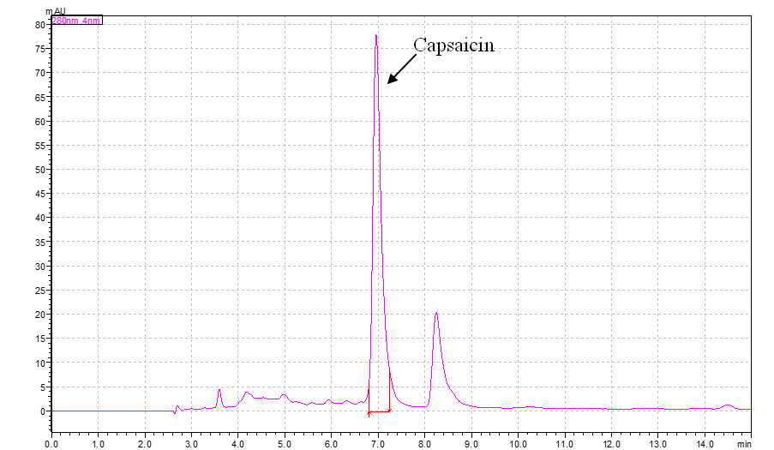
Fig. S2. Identification of capsaicin using Ultra-Fast Liquid Chromatography.

