Supplementary Data

Structure-based virtual screening suggests inhibitors of 3-Chymotrypsin-Like Protease of SARS-CoV-2 from Vernonia amygdalina and Occinum gratissimum

Gideon A. Gyebi¹, Abdo A. Elfiky^{2*}, Oludare M. Ogunyemi^{3*}, Ibrahim M. Ibrahim², Adegbenro P. Adegunloye⁴ Joseph O. Adebayo⁴, Charles O. Olaiya⁵, Joshua O. Ocheje³, Mercy M. Fabusiwa³

¹Department of Biochemistry, Bingham University, Karu, Nasarawa, Nigeria
²Faculty of Sciences, Department of Biophysics Cairo University, Giza Egypt
³Human Nutraceuticals and Bioinformatics Research Unit, Department of Biochemistry, Salem University, Lokoja, Nigeria
⁴Department of Biochemistry, Faculty of Life Sciences, University of Ilorin, Ilorin, Nigeria
⁵Nutritional and Industrial Biochemistry Research Unit, Department of Biochemistry, College of Medicine, University of Ibadan, Ibadan, 200005, Nigeria

Table S1: Binding affinity of reference compounds and bioactive compounds from Occinum gratissimum and Vernonia amygdalina against the 3CL^{pro} of SARS-CoV-2.

S/No | Compounds from Occinum gratissimum | Binding affinities (Kcal/mol)
S1 | Lopinavir | -7.2
S2 | Ritonavir | -7.2
1 | chicoric acid | -7.7
2 | Luteolin | -7.7
3 | Rosmarinic acid | -7.7
4 | Beta-Sitosterol | -7.5
5 | Apigenin | -7.4
6 | Basilimoside | -7.3
7 | Nepetoidin A | -7.3
8 | Lopinavir | -7.2
9 | Nevadensin | -7.2
10 | Ritonavir | -7.2
11 | Salvigenin | -7.1
12 | Apigenin 7,4'-dimethyl ether | -7.0
13 | Hymenoxin | -7.0
14 | Xanthomicrol | -6.8
15 | beta- Bourbonene | -6.5
16 | beta_eusdemole | -6.5
17 | gamma_Cadinene | -6.5
18 | alphaCopaene | -6.3
19 | Sinapic acid | -6.3
20 | ylangene | -6.3
21 | epi cubenol | -6.2
22 | Germacrene D | -6.2
23 | alpha-Humulene | -6.1
24 | beta_caryophyllene epoxide | -6.1
25 | chamigrene | -6.1
26 | Aromadendrene | -6.0
27 | Bicyclogermacrene | -6.0
28 | cubebol | -6.0
29 | nerolidol | -6.0
30 | Spathulenol | -6.0
31 | 4 epi cubebol | -5.9
32 | alloaromadendrene | -5.9
33 | beta- Copaene | -5.9
34 | calamenene | -5.9
35 | Caryophyllene | -5.9
36 | alphaCubebene | -5.8
37 | Beta_Cubebene | -5.8
38 | Beta_Elemene | -5.8
39 | Caryophyllene oxide | -5.8
40 | Elemol | -5.8
41 | humulene oxide | -5.8
42 | longifoline | -5.8
43 | alpha_Bergamotene | -5.7
44 | Beta_bisabolene | -5.7
45 | iso-eugenol | -5.7
46 | Thymol acetate | -5.7
47 | Thymol methyl ether | -5.7
48 | Thymol | -5.7
49 | alpha-Terpineol | -5.6
50 | carveol | -5.6
51 | isolongifolol | -5.6
52 | Methyl cinnamate | -5.6
53 | alpha-Muurolene | -5.5
54 | citronellol acetate | -5.5
55 | bisabolol | -5.4
56 | pCymen-8-ol | -5.4
57 | trans-Sabinene hydrate | -5.4
58 | Carvacrol | -5.3
59 | cis-Sabinene hydrate | -5.3
60 | Eugenol | -5.3
61 | Farnesene | -5.3
62 | methyl eugenol | -5.3
63 | alpha-Thujene | -5.1
64 | Nerol | -5.1
65 | Terpinolene | -5.1
66 | alpha-Terpinene | -5.0
67 | fenchone | -5.0
68 | gamma_Terpinene | -5.0
69 | linalyl acetate | -5.0
70 | pCymenene | -5.0
71 | P-Tolylpropene | -5.0
72 | Vanillin | -5.0
73 | alpha-Phellandrene | -4.9
74 | estragole | -4.9
75 | gama-2-Carene | -4.9
76 | Limonene | -4.9
77 | Neoisomenthol | -4.9
78 | pCymene | -4.9
79 | trans-Sabinenehydrate | -4.9
80 | 1,3,8-p-Menthatriene | -4.8
81 | 1,8-Cineole | -4.8
82 | beta-Phellandrene | -4.8
83 | Pinocarvone | -4.8
84 | Sabinene | -4.8
85 | Borneol | -4.7
86 | Ocimene | -4.7
87 | trans-pinocarveol | -4.7
88 | alpha-Pinene | -4.6
89 | Camphene | -4.6
90 | Myrcene | -4.5
91 | Zbeta Ocimene | -4.4
92 | 1-Octen-3-ol | -4.3
93 | Hexenol | -3.8
94 | Obatoclax | -3.6
Compounds from Vernonia amygdalina |  | Binding affinities (Kcal/mol)
95 | Vernolide | -8.0
96 | Vernomygdin | -7.9
97 | 11, 13-dihydrovernodalin | -7.8
98 | Neoandrographolide | -7.7
99 | Vernomenin | -7.7
100 | isohamnetin | -7.6
101 | Luteolin | -7.5
102 | Luteolin-7-O-glucuronoside2 | -7.5
103 | 4-deoxyandrographolide | -7.4
104 | Myricetin | -7.3
105 | Vernodalin | -7.3
106 | Andrograpanin | -7.2
107 | Vernolepin | -7.2
108 | 1,2,3,15,11,13,2,3-octahydrovernodalin2 | -7.1
109 | 7-O-methyldihydrowogonin | -7.1
110 | Andrographolide2 | -7.1
111 | Vernodalol | -7.1
112 | 1, 8-dihydroxy-3, 7-dimethoxy-xanthone2 | -7.0
113 | Andrographolactone | -7.0
114 | 7-O-methylwogonin | -6.9
115 | 1,2,2,3-tetrahydroovernoodalin2 | -6.8
116 | 1,2,11,13,2,3-hexahydrovernodalin2. | -6.8
117 | Andrographidoid A2 | -6.8
118 | Dihydroskullcapflavone | -6.8
119 | 4,8-dihydroxy-2,7-dimethoxy-xanthone2 | -6.7
120 | Andrographoside | -6.7
121 | luteolin7glucoside2 | -6.7
122 | vernodalinol2 | -6.7
123 | 14-deoxy-11, 12-didehydroandrographolide | -6.6
124 | Andrographidoid B2 | -6.6
125 | Andrographidoid C2 | -6.6
126 | 5, 7, 2, 3-tetramethoxyflavonone2 | -6.5
127 | 5-hydroxy-7, 2, 3-trimethoxy flavone2 | -6.5
128 | DOG2 | -6.5
129 | 1,2-dihydroxy-6, 8-dimethoxy-xanthone2 | -6.4
130 | 4,15-dihydrovernodalin2 | -6.4
131 | 5-hydroxy-7, 8, 2, 3- tetramethoxyflavone2 | -6.4
132 | CAT2 | -6.4
133 | Guaiazulene2 | -6.4
134 | 5-hydroxy-7,2,6-trimethoxyflavone2 | -6.3
135 | 7-O-methylwogonin-5-glucoside2 | -6.3
136 | alpha muurolol | -6.1
137 | Epivernodalol2 | -6.1
138 | muurolol2 | -6.1
139 | 3,7,8-trimethoxy-1-hydroxy-xanthone2 | -6.0
140 | alphaCubebene | -5.8
141 | Caryophyllene oxide | -5.8
142 | beta -Selinene2 | -5.7
143 | alpha Calacorene2 | -5.6
144 | Caryophyllene | -5.6
145 | alpha-Elemene2 | -5.4
146 | Isophytol2 | -5.4
147 | Vernonioside A12 | -5.4
148 | Andrographidoid E2 | -5.2
149 | Vernolic | -5.2
150 | Thymol | -5.0
151 | linoleic2 | -4.9
152 | 1,8-Cineole | -4.8
153 | Methyl salicylate2 | -4.8
154 | myrtanal | -4.8
155 | pinocarveol2 | -4.7
156 | trans-pinocarveol | -4.7
157 | Linalool | -4.6
158 | alpha-Pinene | -4.5
159 | beta -Thujone2 | -4.5
160 | eucalyptol. | -4.5
161 | gamma-Terpinene2 | -4.5
162 | O-cymene2 | -4.4
163 | pinene | -4.4
164 | Vernonioside A22 | -4.2
165 | Vernonioside A32 | -3.5
166 | vernonioside E2 | -2.0
167 | Veronicoside A | -1.8
168 | vernonioside B12 | -1.5
169 | vernonioside D2 | -2.9
170 | vernoniamyoside A2 | -2.5
171 | vernoniamyoside D2 | -2.5
172 | vernoamyoside D2 | -2.3
173 | Vernonioside A42 | -2.2

Table S2: Binding affinity of reference compounds and top 21 compounds to the 3CLpro of SARS-Coronaviruses.
S/N | Compound | Plant | Binding energies (Kcal/mol)
S/N | Compound | Plant | SARS-CoV-2 | SARS-CoV | MERS-CoV
S1 | Lopinavir |  | -7.2 | -8.3 | -7.5
S2 | Ritonavir |  | -7.2 | -7.2 | -7.1
1 | Neoandrographolide | Vernonia amygdalina | -7.7 | -8.3 | -8.1
2 | isohamnetin | Vernonia amygdalina | -7.6 | -8.0 | -8.4
4 | Vernolide | Vernonia amygdalina | -8.0 | -7.9 | -7.7
5 | 11, 13-dihydrovernodalin | Vernonia amygdalina | -7.8 | -7.8 | -7.2
6 | Hydroxyvernolide | Vernonia amygdalina | -7.2 | -7.8 | -7.7
7 | Vernomygdin | Vernonia amygdalina | -7.9 | -7.7 | -7.2
8 | Luteolin | Occinum Gratissimum | -7.7 | -7.7 | -8.3
9 | Basilimoside | Occinum Gratissimum | -7.3 | -7.6 | -6.7
10 | Andrograpanin | Vernonia amygdalina | -7.2 | -7.6 | -6.4
11 | myricetin | Occinum Gratissimum | 7.7 | -7.5 | -8.0
12 | chicoric acid | Occinum Gratissimum | -7.7 | -7.4 | -8.9
13 | Luteolin-7-O-glucuronoside2 | Vernonia amygdalina | -7.5 | -7.4 | -7.7
14 | 4-deoxyandrographolide | Vernonia amygdalina | -7.4 | -7.4 | -6.7
15 | Vernodalin | Vernonia amygdalina | -7.3 | -7.4 | -6.9
16 | Nevadensin | Occinum gratisimum | -7.2 | -7.4 | -7.3
17 | Rosmarinic acid | Occinum Gratissimum | -7.7 | -7.2 | -8.7
18 | Beta-Sitosterol | Occinum Gratissimum | -7.5 | -7.2 | -6.2
19 | Apigenin | Occinum Gratissimum | -7.4 | -7.2 | -8.7
20 | Vernolepin | Vernonia amygdalina | -7.2 | -7.0 | -6.7
21 | Vernomenin | Vernonia amygdalina | -7.7 | -6.9 | -6.7
The 3 top-ranked phytocompounds are presented in bold face

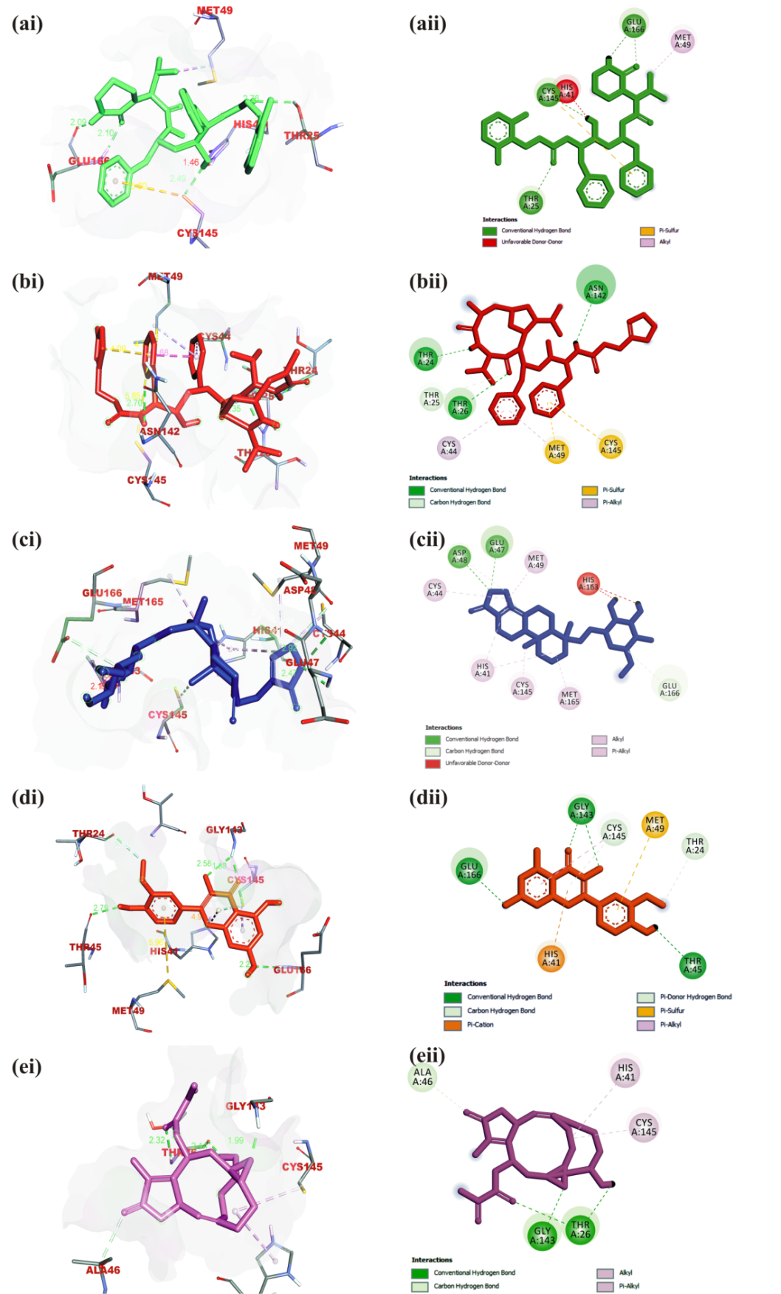
Figure S1: Interaction of amino acid residues of 3-Chymotrypsin-like protease of SARS-CoV with phytochemicals of Vernonia amygdalina in (i) 3D and (ii) 2D representation. Ligands in stick representation are presented in different colours (a) Green: Lopinavir (b) Red: Ritonavir (c) Blue: Neoandrographolide (d) Orange: Isorhamnetin (e) Purple: Vernolide.
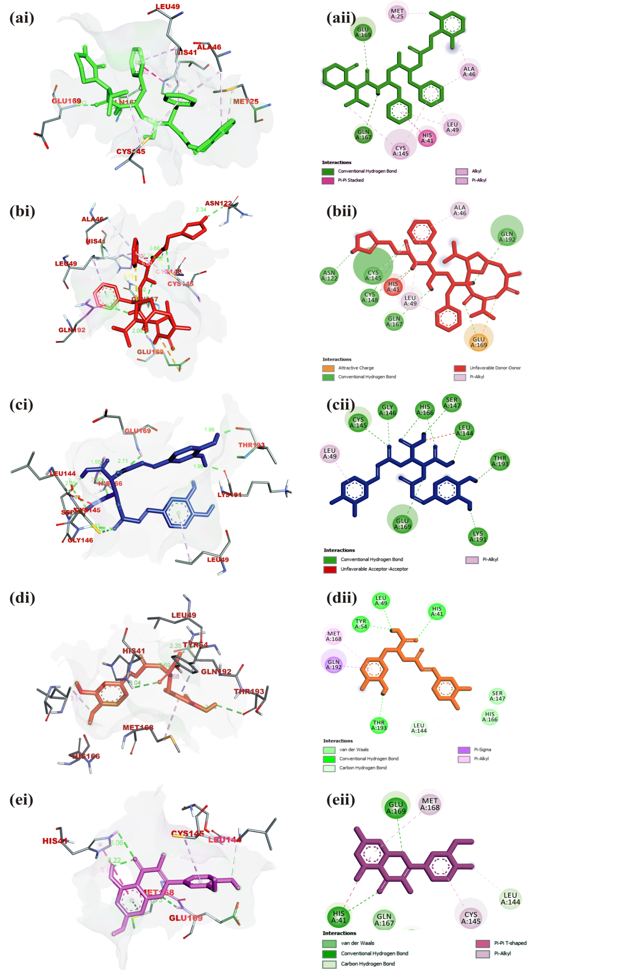
Figure S2: Interaction of amino acid residues of 3-Chymotrypsin-like protease of MERS-CoV with phytochemicals of Occinum gratissimum in (i) 3D and (ii) 2D representation: Ligands in stick representation are presented in different colours: (a) Green: Lopinavir (b) Red: Ritonavir (c) Blue: chicoric acid (d) Orange: Rosmarinic acid (e) Purple: Isorhamnetin
Figure S3: Shows the thermodynamics parameters (RMSD, RoG, SASA and H-bonds) of the apo form of SARS-CoV-2 3CLpro

