ORIGINAL IMAGES OF FIGURE 3
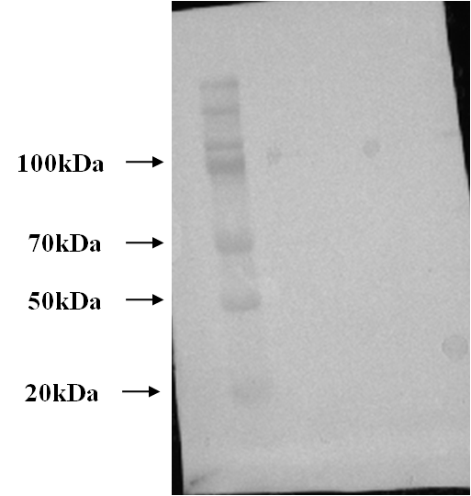
1. Protein Marker:

2. Original Representative images of pRb (Normal Control) (110 Kd). Each band represents different sample for pRb expression.
pRb (control)
pRb (control)
pRb (control)
pRb (control)

pRb (control)

3. pRb Cervical Cancer (110 kd) Left to Right: Stages I-IV

I II III IV
I II III IV
pRb (SI-S IV)
pRb (SI-S IV)

pRb (SI-S IV)
I II III IV
I II III IV
pRb (SI-S IV)

4. GAPDH (40 kd) internal Control:
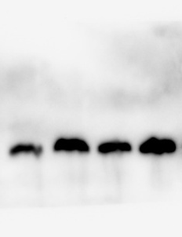
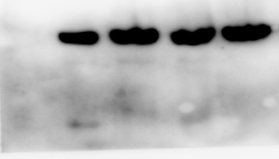
42kD
GAPDH
42kD
GAPDH
GAPDH

ORIGINAL IMAGES OF FIGURE 5

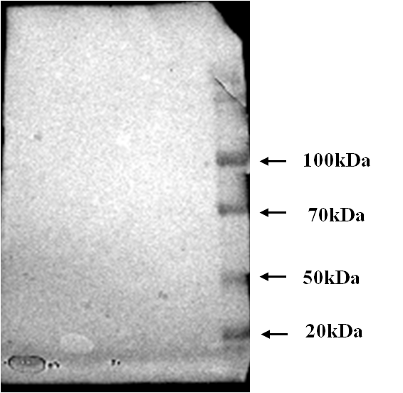
5. Protein Marker:

6. Representative western blotting images of HPV-E7 (Stages I-IV ) in different cervical cancer tissue samples
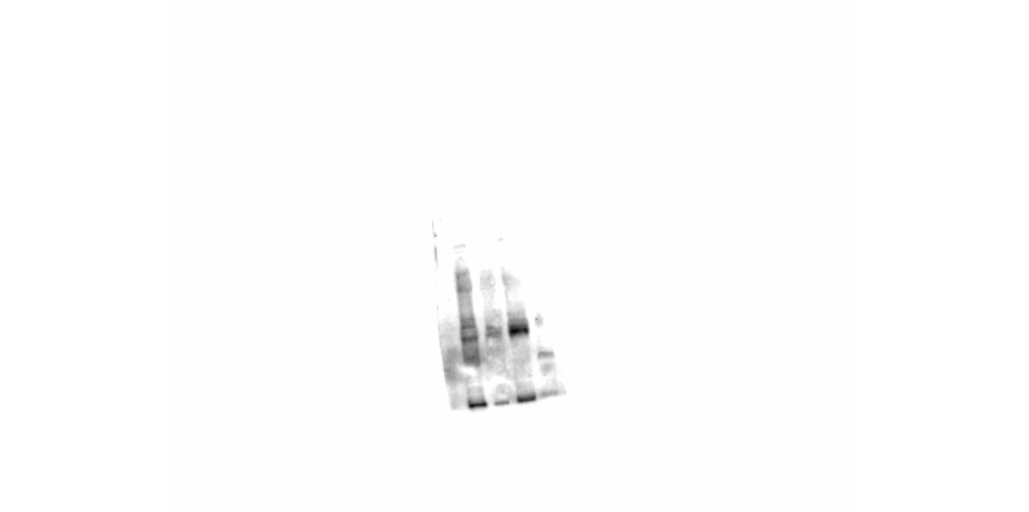
I II III IV
HPV E7 (SI-S IV)
HPV E7 (SI-S IV)
I II III IV

I II III IV
I II III IV
HPV E7 (SI-S IV)
HPV E7 (SI-S IV)

