Su(Hw) interacts with Combgap to establish long-range chromatin contacts
Nadezhda E. Vorobyeva^{1,2}, Alexey N. Krasnov¹, Maksim Erokhin¹, Darya Chetverina¹, Marina Mazina^{1,2}*
¹ Institute of Gene Biology, Russian Academy of Sciences, Moscow 119334, Russia
² Center for Precision Genome Editing and Genetic Technologies for Biomedicine, Institute of Gene Biology, Russian Academy of Sciences
* Corresponding author (email to mazinam@genebiology.ru)

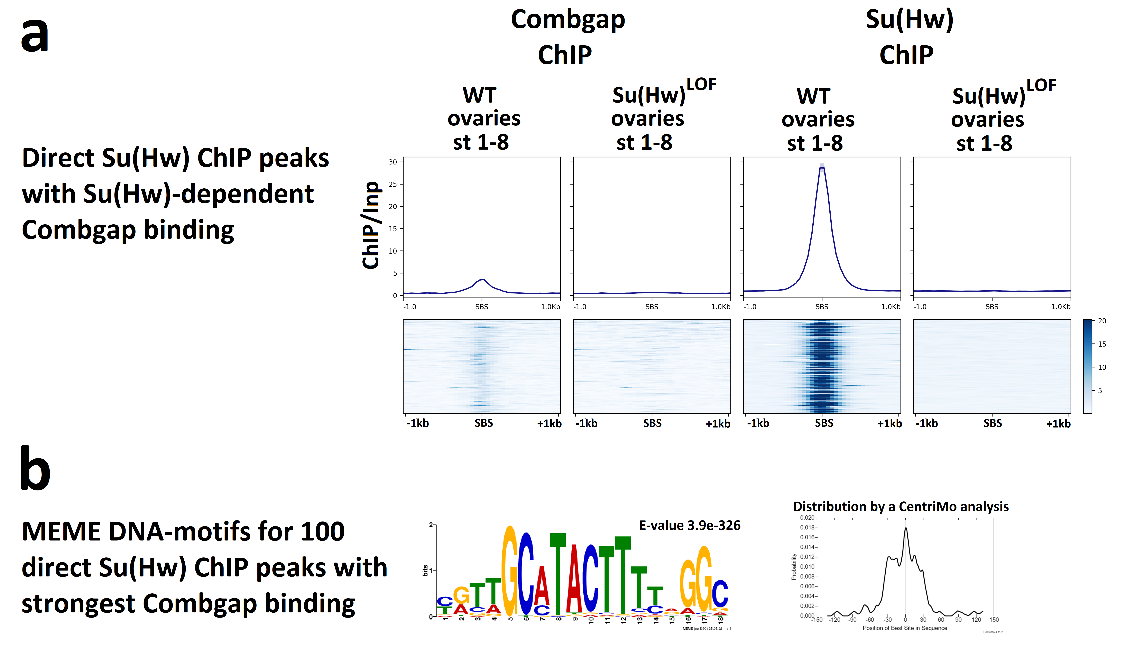
Supplementary figure 1. Su(Hw) enables Combgap binding to Su(Hw) ChIP-Seq peaks.
(a) Heatmaps of Combgap and Su(Hw) ChIP/Inp signal on direct Su(Hw) ChIP-Seq peaks intersecting with Combgap ChIP-Seq peaks. Heatmaps are made for the wild type (WT) and Su(Hw)^{LOF} Drosophila ovaries and are sorted by the strength of the median Su(Hw) ChIP/Inp signal in the wild type Drosophila ovaries.
(b) The DNA-motifs determined by MEME suite 5.4.1 in the set of 100 direct Su(Hw) ChIP-Seq peaks with the strongest Combgap binding.

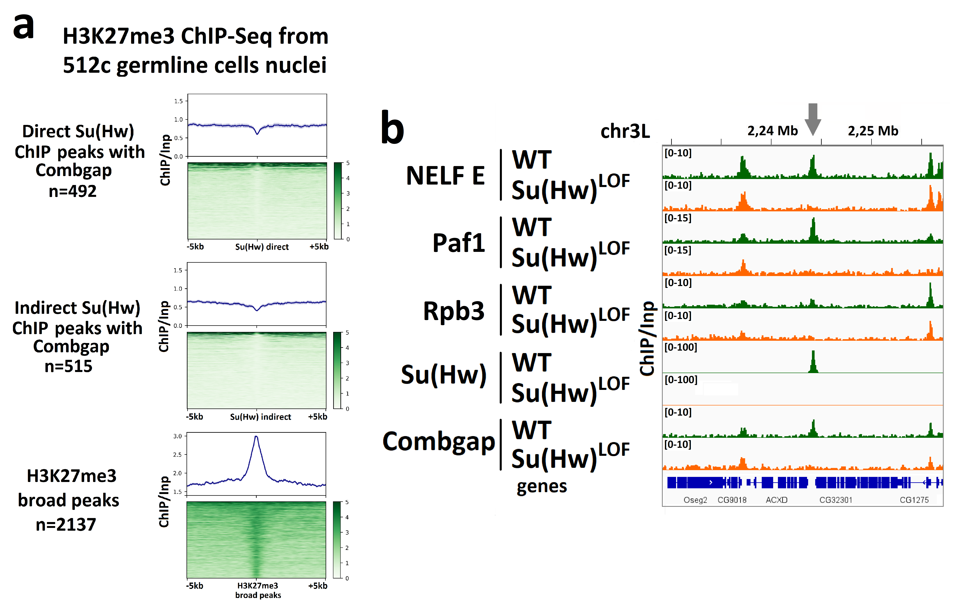
Supplementary figure 2. Common Su(Hw)-Combgap ChIP-Seq peaks are associated with active chromatin factors rather that Polycomb-directed repression.
(a) Heatmaps and pile-up profiles of H3K27me3 ChIP/Inp signal from 512c FACS-sorted germline cells nuclei (from DeLuca at al (2020) Elife, 9:e56922) on direct and indirect ovarian Su(Hw) ChIP peaks, intersecting with Combgap, and H3K27me3 broad peaks. Heatmaps are sorted by the strength of the median H3K27me3 ChIP/Inp signal.
(b) Genome browser (IGV) example highlighting that NELF E, Paf1 and Rpb3 binding to direct Su(Hw) ChIP-Seq peaks coincides with Combgap binding and is Su(Hw)-dependent. The position of direct Su(Hw) ChIP-Seq peak is marked on top of the tracks with an arrow.
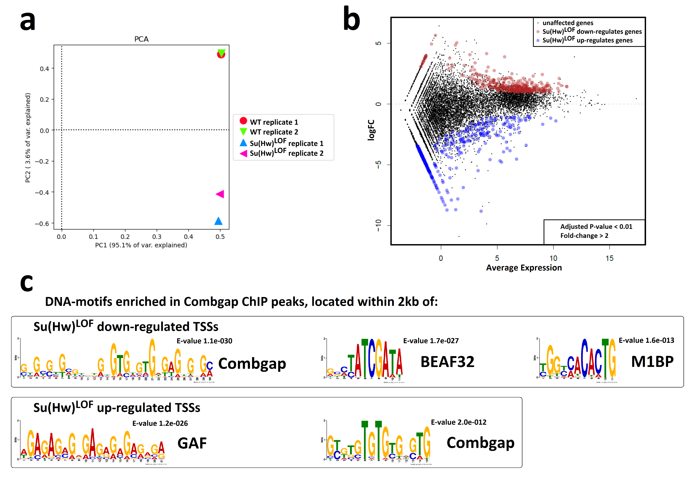
Supplementary figure 3. Characteristics of Su(Hw)^{LOF} mis-regulated genes.
(a) PCA correlation plot for two biological replicates of RNA-Seq experiments from the wild-type (WT) and Su(Hw)^{LOF} ovaries of egg chamber stages 1-8.
(b) The MD-plot showing the changes in gene expression (according to RNA-Seq data) upon Su(Hw)^{LOF} compared to the wild-type (WT) ovaries of egg chamber stages 1-8. Significantly down- and up-regulated genes are highlighted in red and blue, respectively.
(c) DNA-binding motifs identified by MEME suite 5.4.1 (Machanick and Bailey (2011) Bioinformatics 27, 1696-1697) in Combgap ChIP-Seq peaks, located within 2 kbp of Su(Hw)^{LOF} up- and down-regulated genes.

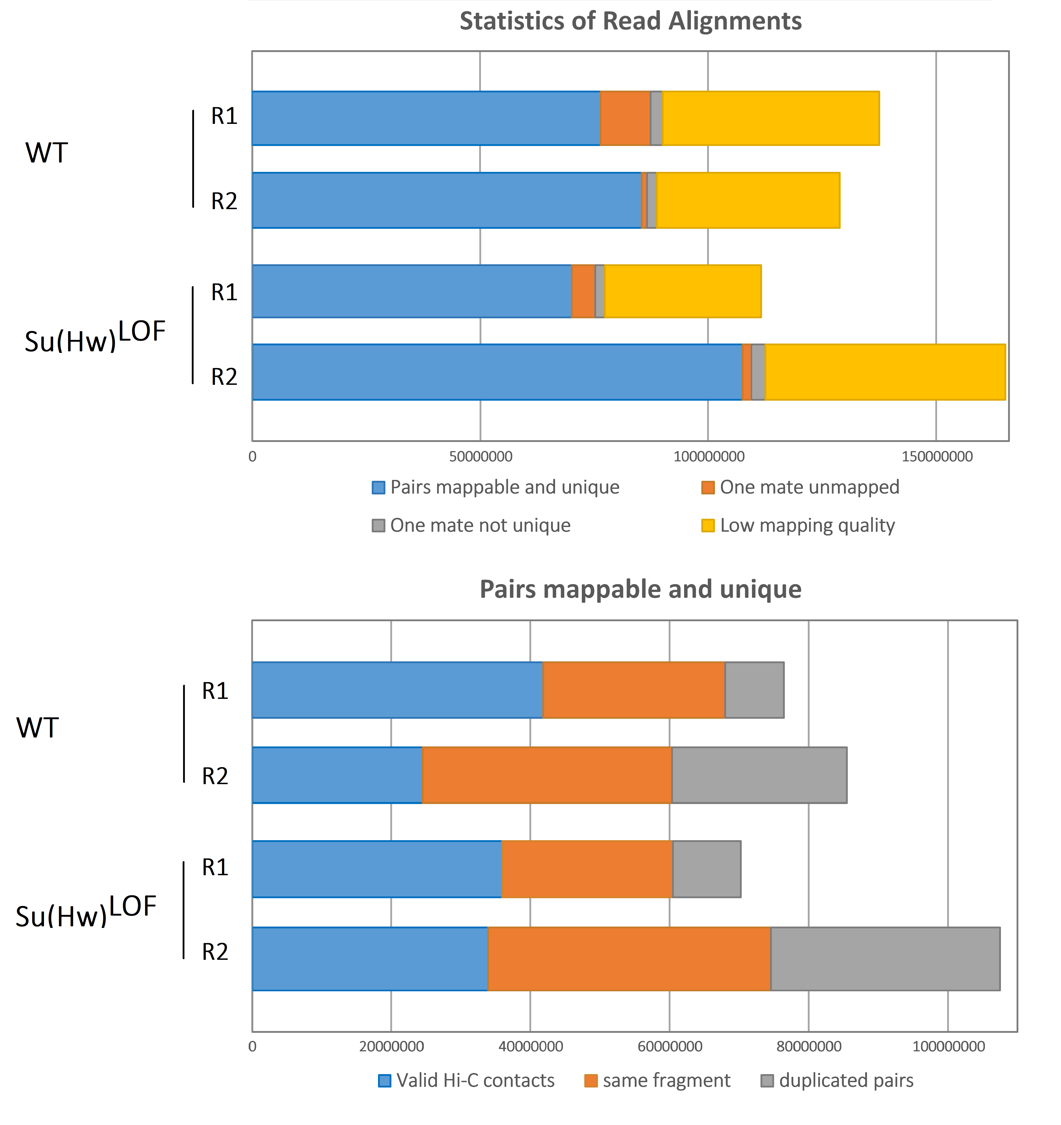
Supplementary figure 4. The statistics for Hi-C data, obtained in the study.
The read alignments, mapped reads and valid Hi-C pairs are generated in hicBuildMatrix 3.4.2 for raw contact matrices in the wild-type (WT) and Su(Hw)^{LOF} ovaries of egg chamber stages 1-8 (also present in Supplementary Table 2).

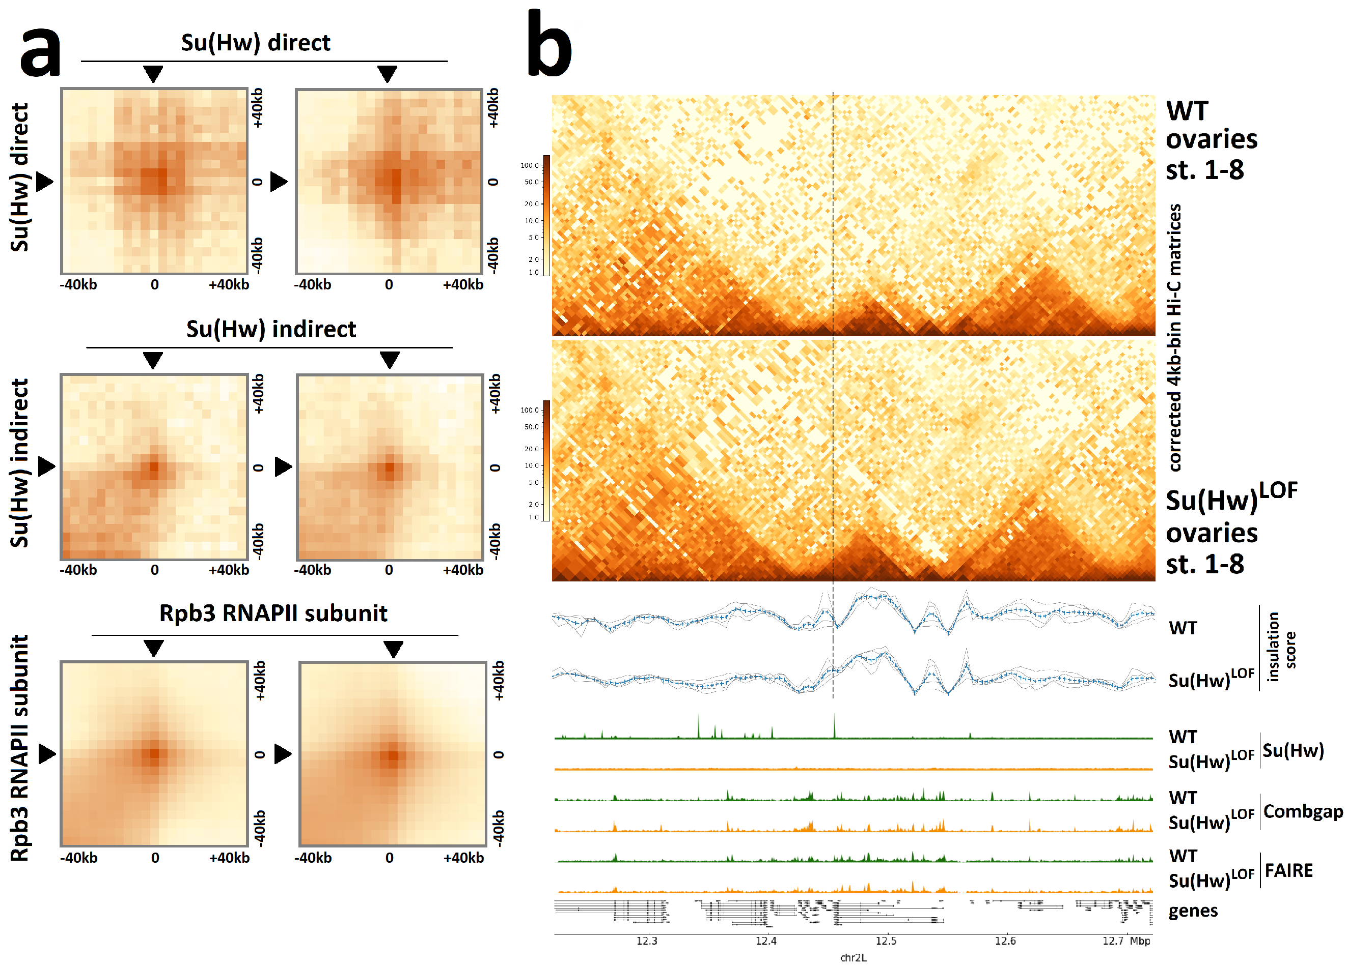
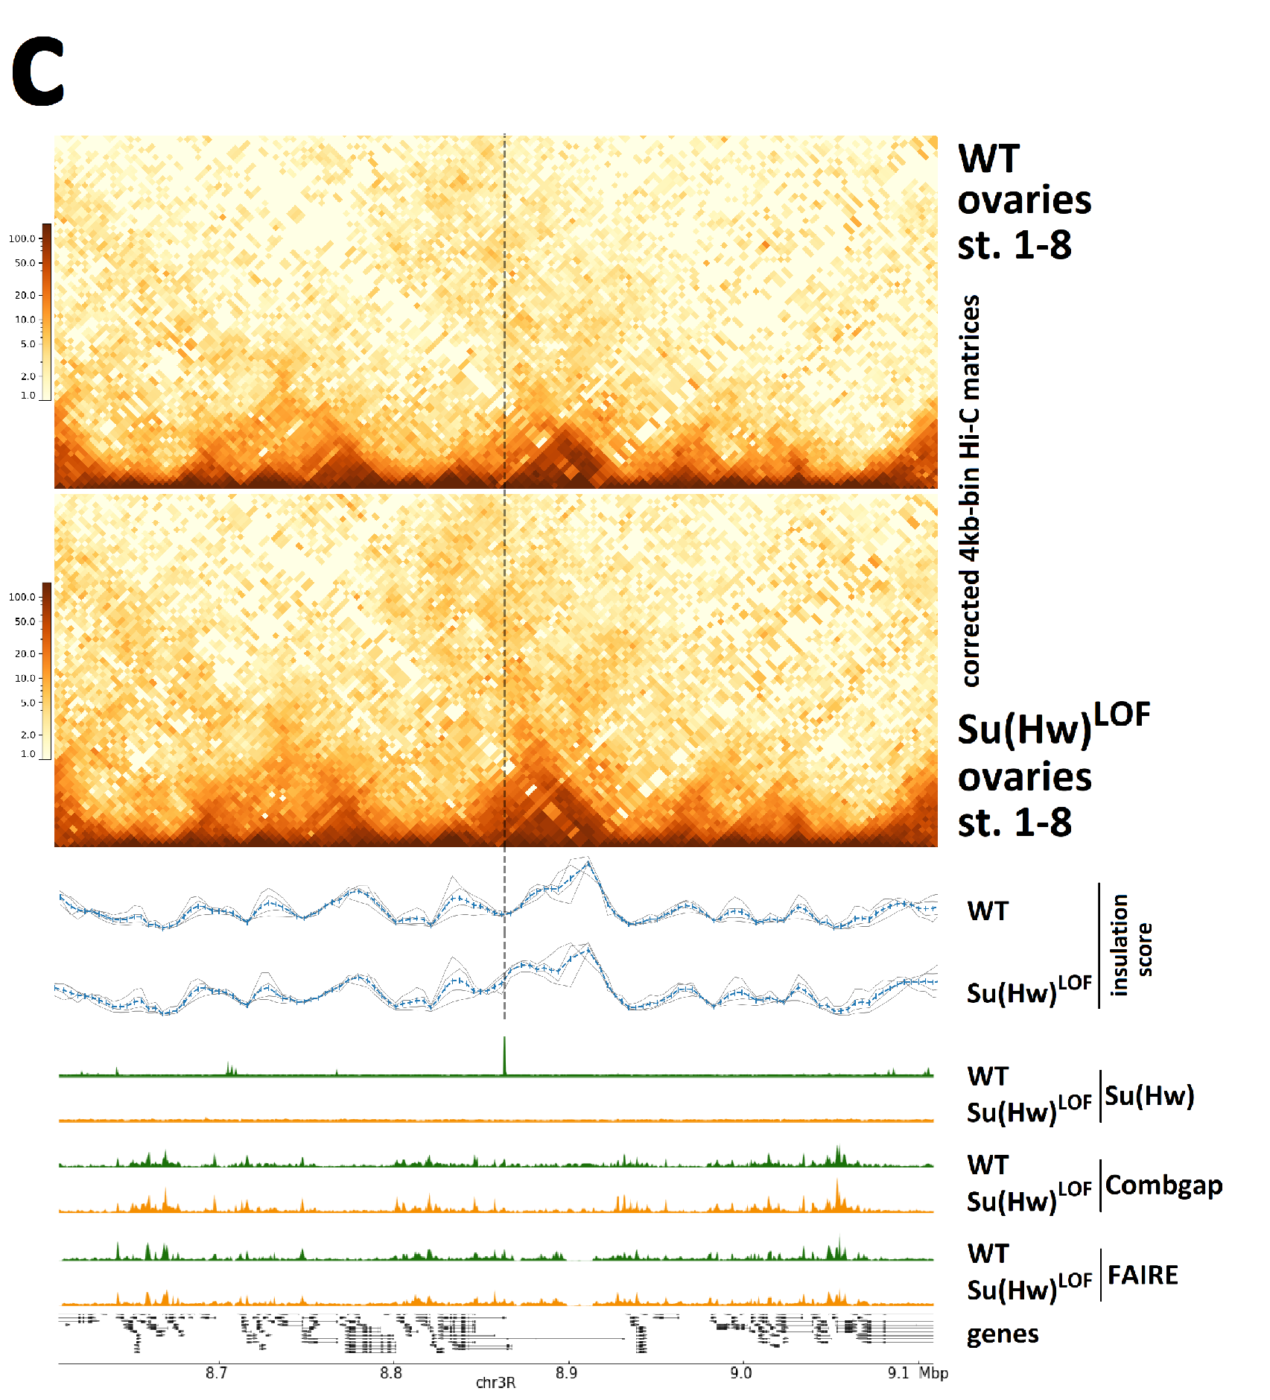

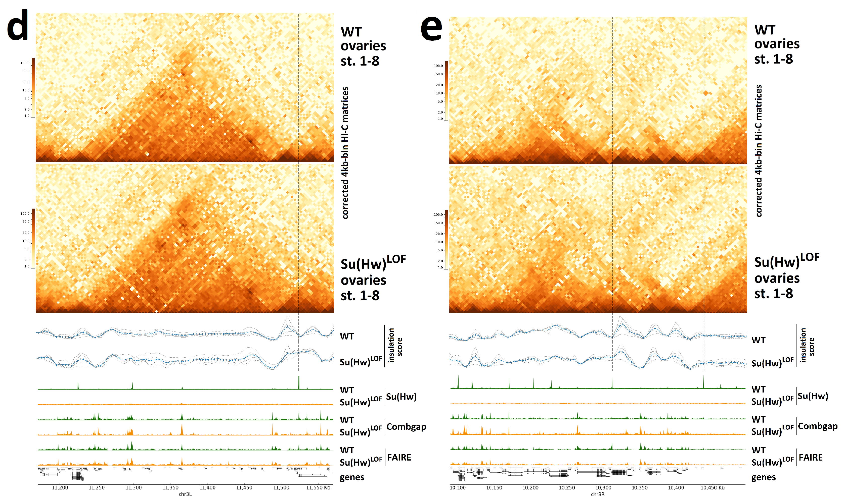
Supplementary figure 5. LRIs between Su(Hw) and Combgap ChIP-Seq peaks.
(a) Averaged spatial interactions in the sets of direct Su(Hw), indirect Su(Hw) and Rpb3 (positive control) ChIP-peaks in the wild-type (WT) and Su(Hw)^{LOF} ovaries, estimated with a coolpup.py program. The minimal and maximal distances of interactions were set at 200 kbp and 1000 kbp, correspondingly, the pad size is ±40 kb around the central pixel.
(b-e) Hi-C matrices from the wild-type (WT) and Su(Hw)^{LOF} ovaries (on top), showing two genomic region with insulator scores and occupancies of Su(Hw), Combgap (ChIP-Seq) and open chromatin regions (according to FAIRE-Seq) in the wild-type (WT) and Su(Hw)^{LOF} ovaries. The image was generated using pyGenomeTracks. This particular regions were selected to illustrate Su(Hw)-dependence of long range interactions (LRIs) between direct Su(Hw) FAIRE+ and Combgap ChIP-Seq peaks (position of direct Su(Hw) FAIRE+ peaks in these LRIs are marked with the vertical lines).

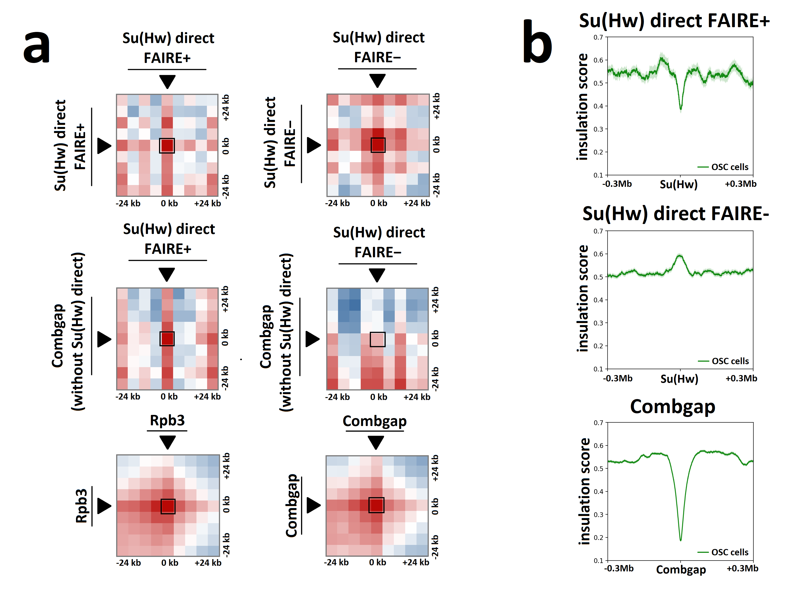
Supplementary figure 6. LRIs between Su(Hw) and Combgap ChIP-Seq peaks from Drosophila ovarian somatic cell (OSC) line Hi-C.
(a) Averaged spatial interactions in the sets of direct Su(Hw) FAIRE+, direct Su(Hw) FAIRE-, Combgap and Rpb3 (positive control) ChIP-peaks from the wild-type ovaries estimated in Hi-C from EGFP dsRNA treated control OSC cells (from Iwasaki et al (2021) EMBO J, 40(18):e108345) with a coolpup.py program. The minimal and maximal distances of interactions were set at 200 kbp and 1000 kbp, correspondingly, the pad size is ±24 kb around the central pixel.
(b) Profile plots of insulation score at direct Su(Hw) FAIRE+, Su(Hw) FAIRE- and Combgap ChIP-Seq peaks from the wild-type ovaries, calculated using Hi-C from EGFP dsRNA treated control OSC cells (from Iwasaki et al (2021) EMBO J, 40(18):e108345). The pile-up profiles were generated as a median of insulation score signal. The standard error is displayed on the profiles as semi-transparent area around the main line of the profiles.

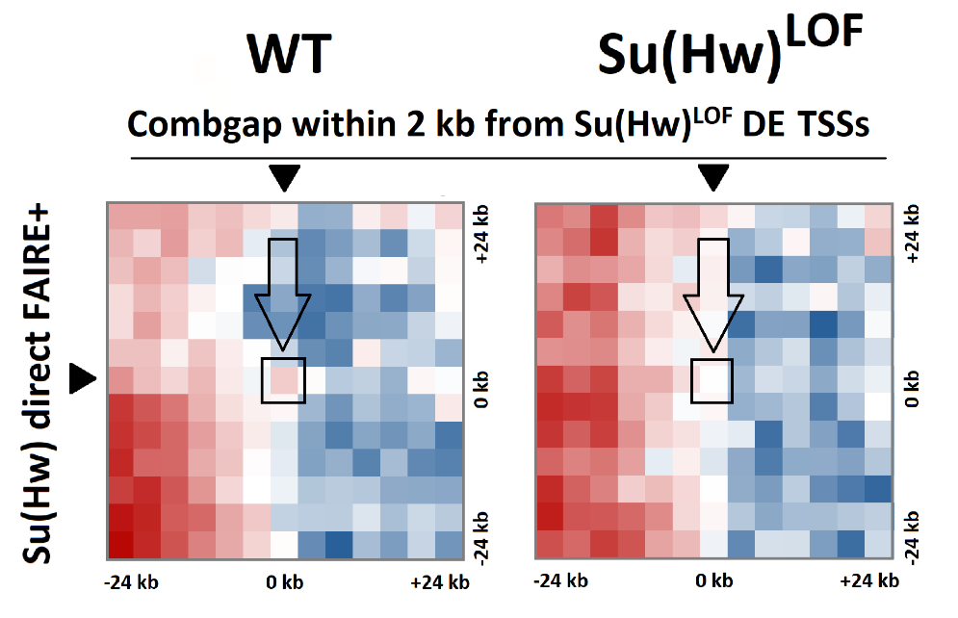
Supplementary figure 7. Averaged spatial interactions between the sets of direct Su(Hw) FAIRE+ ChIP-Seq peaks and Combgap ChIP-Seq peaks located within 2kb from TSSs of Su(Hw)^{LOF} DE genes in the wild-type (WT) and Su(Hw)^{LOF} ovaries, estimated with a coolpup.py program. The minimal and maximal distances of interactions were set at 50 kb and 200 kb, correspondingly, the pad size is ±24 kb around the central pixel.
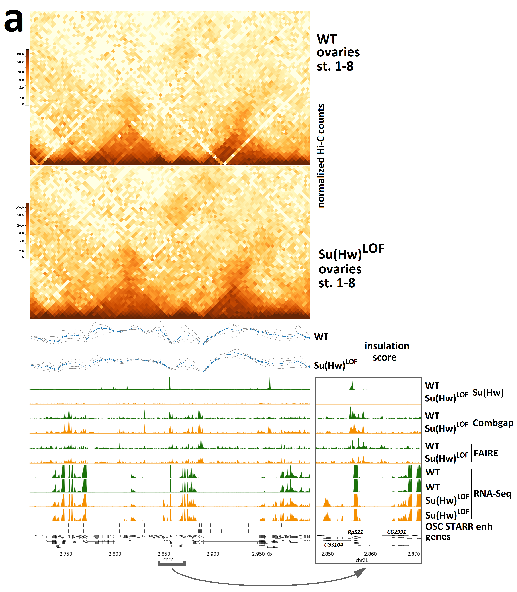
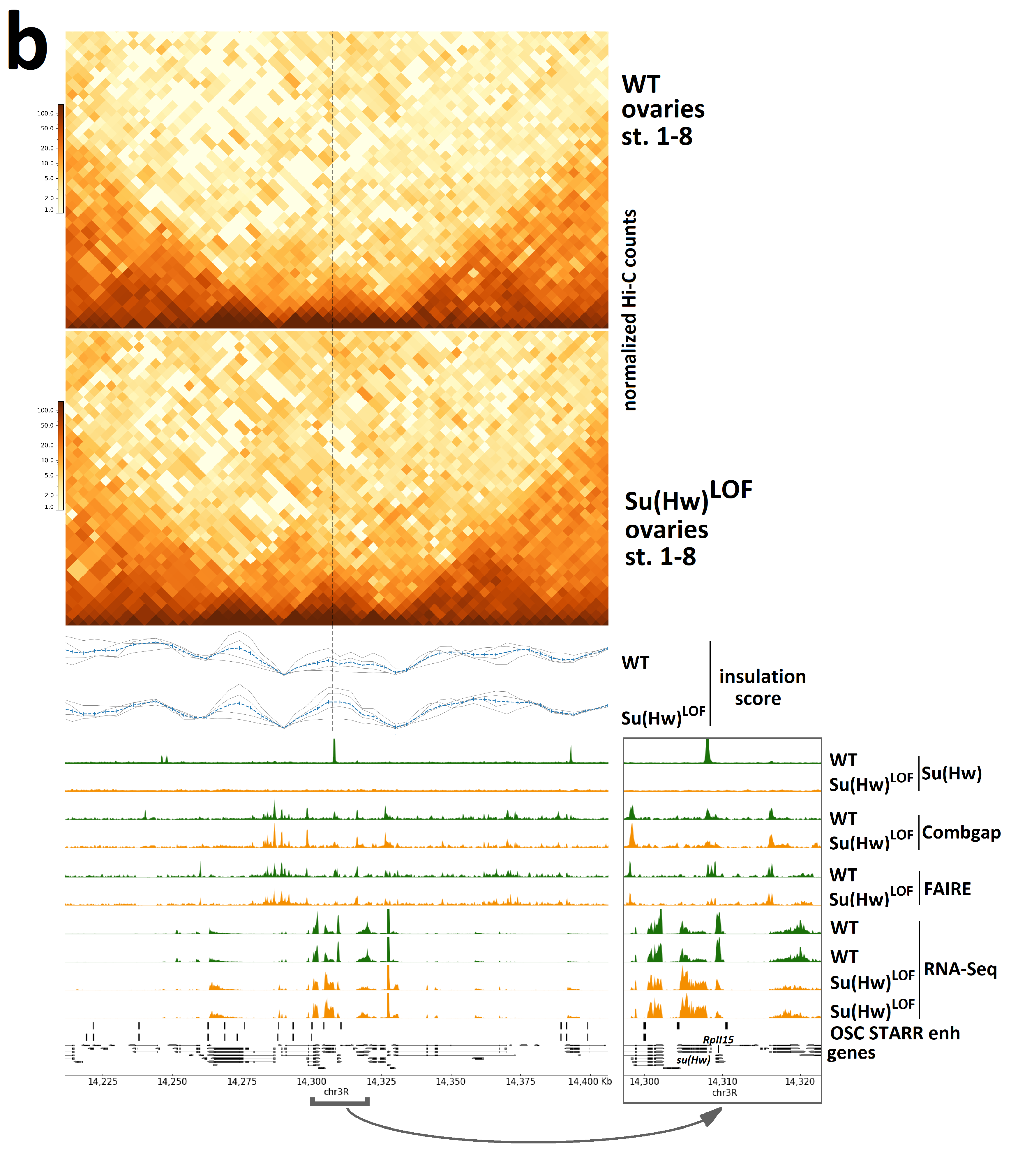
Supplementary figure 8. LRIs between Su(Hw) and Combgap ChIP-Seq peaks correlate with transcription mis-regulation in Su(Hw)^{LOF} background. (a-b) Hi-C matrices from the wild-type (WT) and Su(Hw)^{LOF} ovaries (on top), showing four genomic region with insulator scores and occupancies of Su(Hw), Combgap (ChIP-seq), open chromatin regions (FAIRE-Seq), and gene expression (RNA-Seq) in the wild-type (WT) and Su(Hw)^{LOF} ovaries. The image was generated using pyGenomeTracks. For RNA-Seq two biological replicates are shown for each genotype. This particular regions were selected to illustrate correlation between the changes in long range interactions between direct Su(Hw) FAIRE+ and Combgap ChIP-Seq peaks and gene expression (position of direct Su(Hw) FAIRE+ peaks in these LRIs are marked with *). The Su(Hw)^{LOF} mis-regulated genes are indicated on the areas enlarged near direct Su(Hw) FAIRE+ peaks (on the right from each figure).
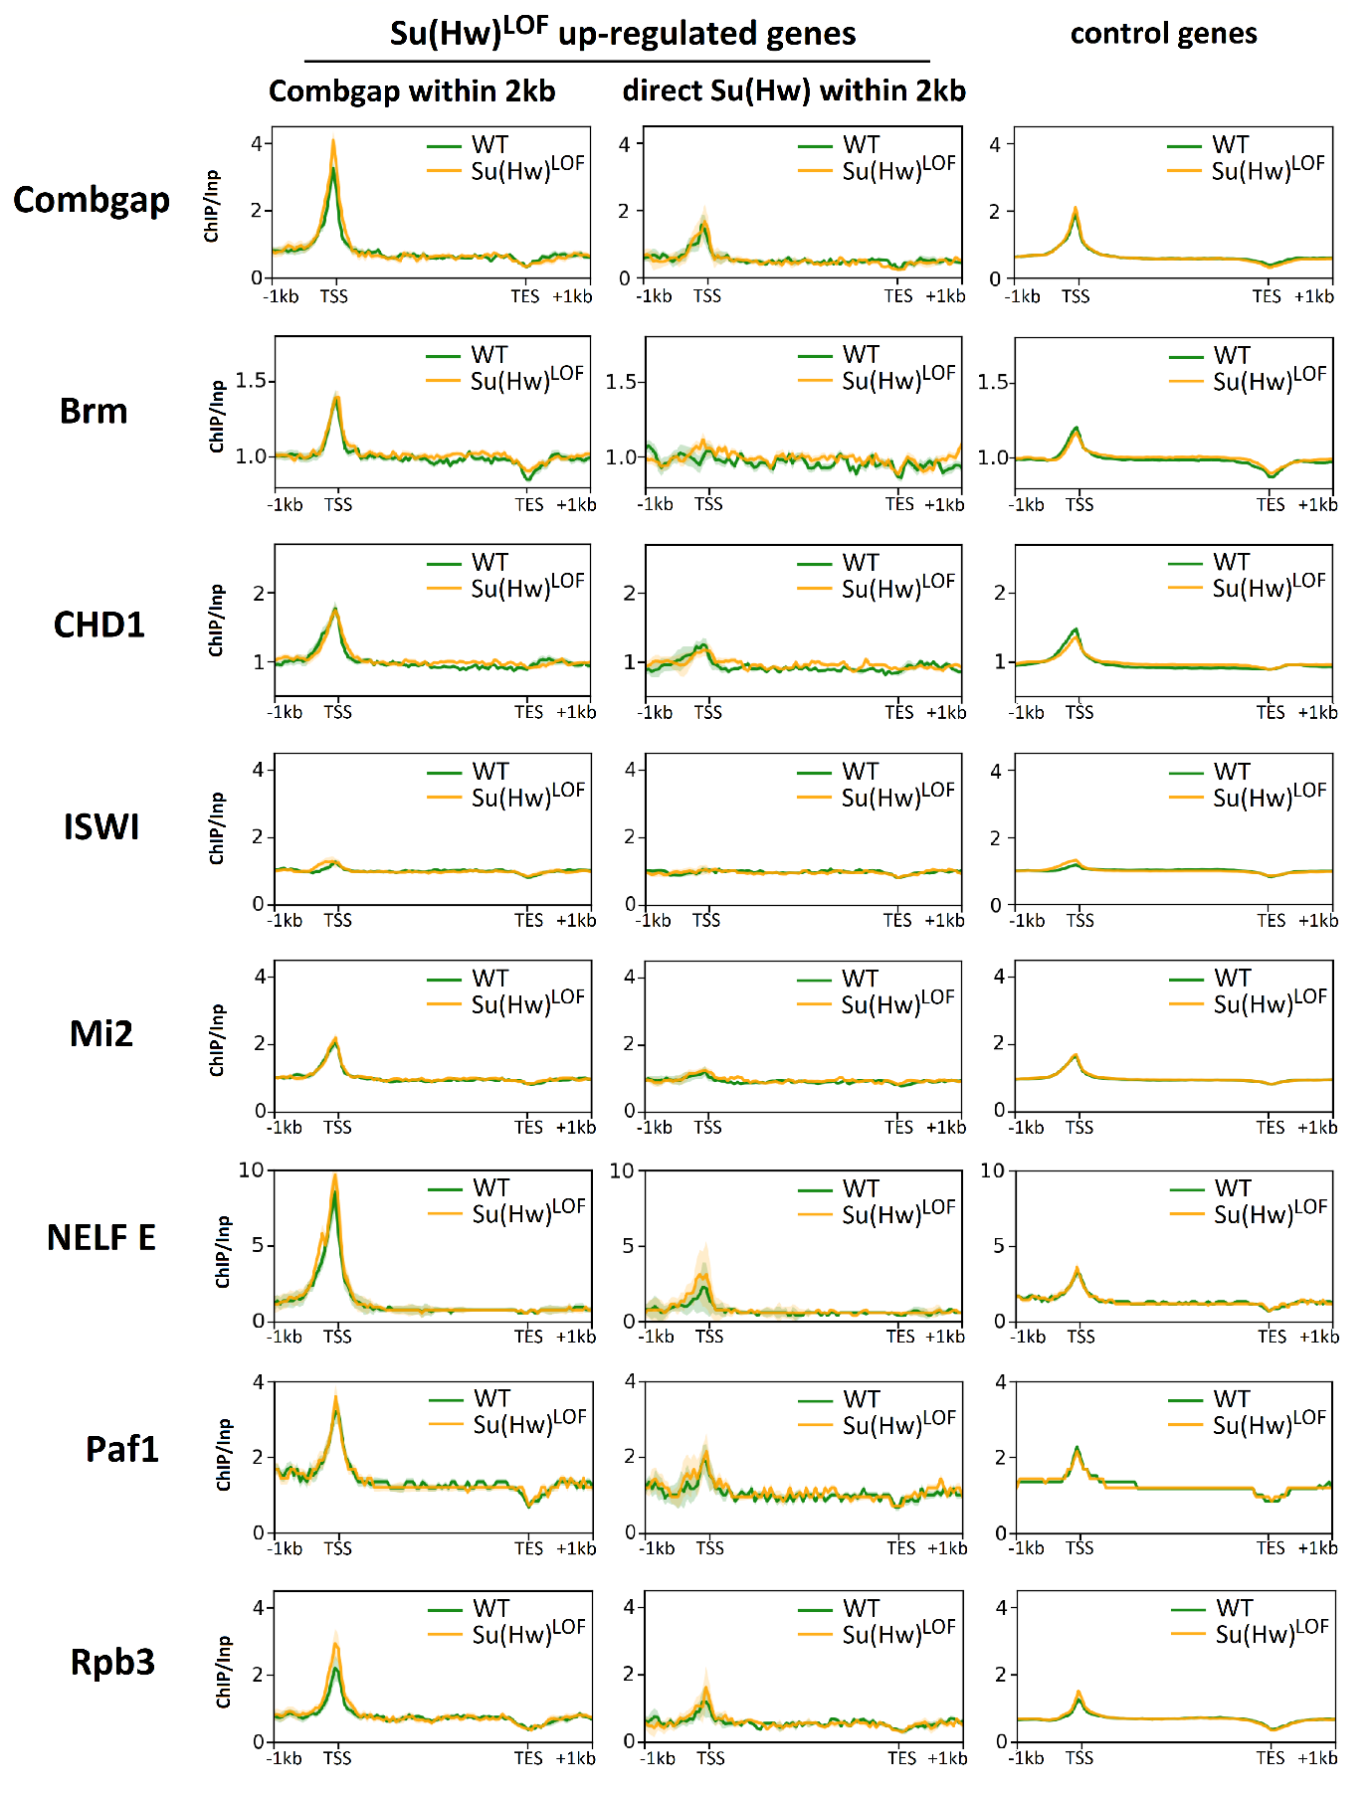
Supplementary figure 9. Average profiles of Combgap, Brm, CHD1, ISWI, Mi-2, NELF E, Paf1 and Rpb3 ChIP/Input signals on the genes, up-regulated in Su(Hw)^{LOF} ovaries compared to the wild-type. The pile-up profiles were generated as a median of ChIP/Input signal. The significant changes in ChIP/Input signal upon Su(Hw)^{LOF} are marked with *. As a set of control we used genes, expression of which does not change significantly in Su(Hw)^{LOF} ovaries compared to the wild-type (fold-change < 2). The standard error is displayed on the profiles as semi-transparent area around the main line of the profiles.

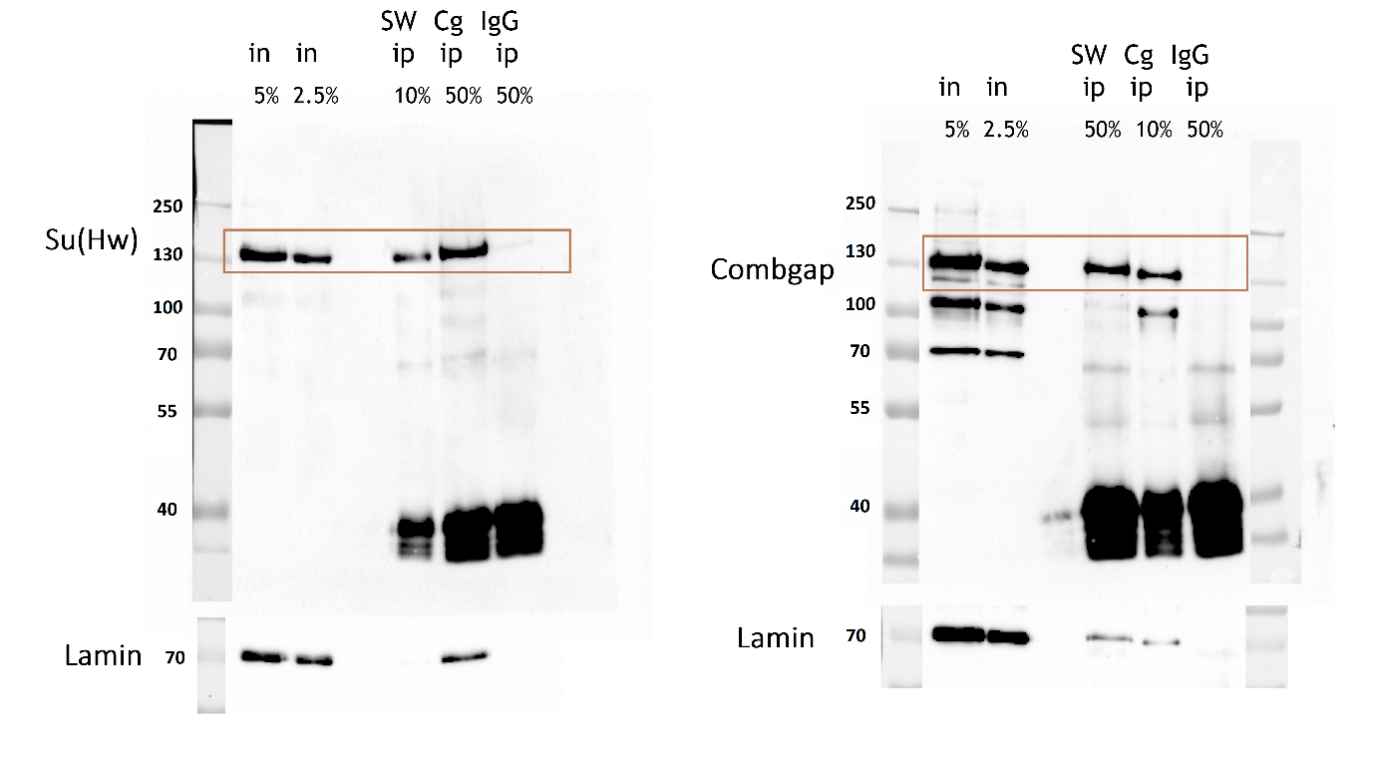
Supplementary figure 10. The full Western blots used in Fig. 1d. The IPs were performed with antibodies against Combgap and Su(Hw) (a serum of non-immunized rabbits (ip IgG) was used as a negative control), which is indicated on the top of the figure. Western blots were stained with the corresponding antibodies indicated on the left of the figures. Anti-lamin staining was used as loading control. All input and IP samples were loaded on a single western blot. The numbers above the inputs represent a portion of a loaded fraction (in respect to the amount used for immunoprecipitations). The brown frames indicate the regions of the blots with specific antibody staining that were presented at Fig. 1d.

Supplementary Table 1. Transcripts that are significantly differentially expressed in Su(Hw)^{LOF} ovaries (with adjusted p-value < 0.01 and fold-change (FC) > 2)
(a) The list of Su(Hw)^{LOF} up-regulated transcripts
ENSEMBLTRANS | SYMBOL | logFC | Average Expression | Adjusted  P-value
FBtr0081088 | ncm | -1,3888 | 10,2231 | 0,0035
FBtr0310323 | CG13185 | -1,1602 | 9,7655 | 0,0037
FBtr0076457 | aay | -1,6668 | 9,0552 | 0,0035
FBtr0329922 | qin | -1,1528 | 7,9212 | 0,0077
FBtr0290134 | CG42232 | -1,1195 | 7,8927 | 0,0038
FBtr0083154 | AOX1 | -1,0067 | 7,7839 | 0,0045
FBtr0088226 | RpS15Ab | -1,0195 | 7,7063 | 0,0075
FBtr0079466 | CG5958 | -3,3924 | 7,5849 | 0,0044
FBtr0302586 | RpL3 | -1,3484 | 7,5559 | 0,0076
FBtr0301163 | Pih1D1 | -1,2592 | 7,5032 | 0,0077
FBtr0073414 | Imp | -1,3201 | 7,1553 | 0,0073
FBtr0071498 | Atg8a | -2,3524 | 6,9677 | 0,0037
FBtr0086897 | rhi | -1,4345 | 6,9540 | 0,0099
FBtr0302084 | lbk | -1,1683 | 6,9344 | 0,0038
FBtr0082287 | CG4570 | -1,9567 | 6,9098 | 0,0038
FBtr0310385 | Su(var)3-9 | -1,0788 | 6,5661 | 0,0078
FBtr0273437 | Cubn | -2,0762 | 6,5571 | 0,0061
FBtr0073270 | Chd64 | -1,2763 | 6,5489 | 0,0089
FBtr0074635 | Atg101 | -1,0654 | 6,5053 | 0,0069
FBtr0084289 | CG5346 | -1,7111 | 6,4107 | 0,0037
FBtr0072064 | Pi3K59F | -1,1357 | 6,2586 | 0,0076
FBtr0335275 | Src42A | -1,1175 | 6,2241 | 0,0064
FBtr0302027 | Mrp4 | -1,9097 | 6,2158 | 0,0053
FBtr0074684 | CG8034 | -2,4991 | 6,1776 | 0,0051
FBtr0300082 | wech | -1,9308 | 6,1684 | 0,0054
FBtr0085715 | CG15547 | -3,8401 | 6,1468 | 0,0058
FBtr0078267 | fng | -1,6833 | 6,0980 | 0,0038
FBtr0332210 | kek1 | -1,8697 | 6,0166 | 0,0035
FBtr0071661 | CG10082 | -1,4458 | 5,9340 | 0,0077
FBtr0070406 | Ilp6 | -3,6480 | 5,8837 | 0,0035
FBtr0074884 | kto | -1,2508 | 5,8512 | 0,0062
FBtr0299657 | bun | -3,1342 | 5,8231 | 0,0071
FBtr0085110 | Men-b | -1,0716 | 5,8004 | 0,0053
FBtr0075657 | sstn | -1,5564 | 5,7214 | 0,0084
FBtr0078274 | Six4 | -1,6973 | 5,6531 | 0,0071
FBtr0082233 | CG12592 | -3,9369 | 5,5693 | 0,0045
FBtr0076106 | CG32091 | -2,7929 | 5,5461 | 0,0038
FBtr0082747 | Dic1 | -1,6715 | 5,5411 | 0,0043
FBtr0082569 | GstD2 | -4,7833 | 5,3906 | 0,0038
FBtr0331689 | CG17801 | -1,0767 | 5,3758 | 0,0061
FBtr0339612 | CG12290 | -2,2651 | 5,2835 | 0,0088
FBtr0084702 | sosie | -4,6768 | 5,2513 | 0,0054
FBtr0301313 | Zasp52 | -2,5944 | 4,9666 | 0,0052
FBtr0073069 | CG14961 | -2,4982 | 4,9268 | 0,0077
FBtr0085631 | Fer1HCH | -1,1851 | 4,9006 | 0,0077
FBtr0344717 | Akt1 | -1,3427 | 4,8265 | 0,0091
FBtr0085803 | CycG | -1,3274 | 4,7509 | 0,0076
FBtr0070681 | pon | -1,7891 | 4,6657 | 0,0077
FBtr0070183 | CG11638 | -2,1028 | 4,6242 | 0,0044
FBtr0077156 | Uev1A | -1,0919 | 4,4882 | 0,0085
FBtr0303999 | Tao | -1,1919 | 4,4537 | 0,0077
FBtr0114586 | egl | -1,4769 | 4,4338 | 0,0090
FBtr0072561 | Reg-2 | -1,6310 | 4,4241 | 0,0054
FBtr0087893 | CG17739 | -4,5770 | 4,3682 | 0,0074
FBtr0076136 | CG6071 | -2,6782 | 4,3439 | 0,0042
FBtr0075811 | Tgi | -2,2931 | 4,1782 | 0,0044
FBtr0088936 | Gdap2 | -2,3574 | 4,1681 | 0,0044
FBtr0302711 | CG42673 | -1,7837 | 4,1540 | 0,0065
FBtr0303781 | CG17732 | -1,4477 | 4,1479 | 0,0079
FBtr0075023 | CG6836 | -2,5009 | 4,1262 | 0,0042
FBtr0076808 | Mcad | -1,5739 | 4,0957 | 0,0068
FBtr0082277 | Rbp1 | -1,1741 | 4,0770 | 0,0096
FBtr0072742 | Pcyt2 | -2,4185 | 4,0732 | 0,0047
FBtr0076724 | ERR | -1,9200 | 4,0589 | 0,0052
FBtr0078216 | CG5059 | -3,2331 | 3,9578 | 0,0038
FBtr0331790 | fmt | -1,6375 | 3,8935 | 0,0063
FBtr0078506 | CG11426 | -2,6043 | 3,8501 | 0,0065
FBtr0075424 | Cpr72Ec | -2,4147 | 3,8341 | 0,0065
FBtr0310343 | CG42450 | -2,5921 | 3,7984 | 0,0080
FBtr0304867 | CG43066 | -1,7291 | 3,7728 | 0,0091
FBtr0073728 | CG32640 | -1,5343 | 3,7099 | 0,0076
FBtr0290036 | stas | -2,3767 | 3,6920 | 0,0077
FBtr0340007 | CG30089 | -1,2312 | 3,6772 | 0,0091
FBtr0333347 | Nhe3 | -2,0745 | 3,6668 | 0,0092
FBtr0084536 | Pisd | -2,1152 | 3,6535 | 0,0045
FBtr0088107 | CG13227 | -2,5734 | 3,6115 | 0,0044
FBtr0332936 | CG1695 | -8,8209 | 3,5730 | 0,0093
FBtr0073729 | CG32640 | -2,4192 | 3,5546 | 0,0042
FBtr0332386 | CG42340 | -2,4654 | 3,5391 | 0,0044
FBtr0080287 | Ada1-2 | -2,4736 | 3,5272 | 0,0074
FBtr0089855 | rho-5 | -1,9616 | 3,5186 | 0,0052
FBtr0072239 | CG4797 | -3,7264 | 3,4488 | 0,0044
FBtr0086180 | Tsp42Ee | -1,5648 | 3,4063 | 0,0072
FBtr0071036 | ogre | -1,6172 | 3,3953 | 0,0071
FBtr0304994 | Sarm | -1,6984 | 3,3153 | 0,0063
FBtr0083791 | CG11453 | -5,4819 | 3,3043 | 0,0091
FBtr0088525 | RpL31 | -2,2110 | 3,2921 | 0,0091
FBtr0304622 | ths | -2,1171 | 3,2547 | 0,0062
FBtr0334498 | orb | -2,5699 | 3,1501 | 0,0052
FBtr0303874 | Apoltp | -1,6989 | 3,0749 | 0,0086
FBtr0343610 | Npc1a | -1,7278 | 3,0496 | 0,0098
FBtr0333726 | Fas1 | -2,4754 | 3,0319 | 0,0052
FBtr0085180 | TTLL6B | -1,8717 | 3,0278 | 0,0079
FBtr0304054 | Esp | -2,9045 | 2,9507 | 0,0051
FBtr0087370 | scb | -2,5239 | 2,8231 | 0,0082
FBtr0085150 | CG6277 | -2,1461 | 2,7703 | 0,0069
FBtr0333664 | msi | -1,8757 | 2,7564 | 0,0078
FBtr0075983 | SCaMC | -2,6667 | 2,7111 | 0,0048
FBtr0073916 | CG9411 | -1,5735 | 2,6895 | 0,0088
FBtr0076164 | nkt | -3,0604 | 2,6081 | 0,0063
FBtr0076885 | RhoGEF4 | -2,1226 | 2,4870 | 0,0061
FBtr0076126 | CG11658 | -2,6459 | 2,4559 | 0,0049
FBtr0290076 | kay | -2,9489 | 2,4218 | 0,0052
FBtr0071653 | Egfr | -1,8659 | 2,3943 | 0,0073
FBtr0308682 | CG13004 | -3,0548 | 2,3697 | 0,0091
FBtr0303757 | Kank | -2,2837 | 2,3634 | 0,0063
FBtr0080527 | CG18507 | -2,0327 | 2,2772 | 0,0090
FBtr0112812 | dlg1 | -2,2395 | 2,1770 | 0,0083
FBtr0331535 | CG10089 | -3,1348 | 2,1287 | 0,0086
FBtr0335385 | CG17261 | -2,2891 | 2,1213 | 0,0071
FBtr0074048 | Alp11 | -3,1431 | 2,0637 | 0,0045
FBtr0076485 | CG3982 | -3,0797 | 2,0311 | 0,0061
FBtr0331700 | CG7362 | -3,4476 | 2,0255 | 0,0051
FBtr0089426 | CG18853 | -6,8745 | 1,9872 | 0,0061
FBtr0100469 | CG3662 | -2,8416 | 1,9800 | 0,0076
FBtr0332661 | Oseg2 | -3,1179 | 1,9797 | 0,0063
FBtr0072402 | emp | -2,8533 | 1,9179 | 0,0084
FBtr0072255 | AANAT1 | -3,0869 | 1,8441 | 0,0061
FBtr0081771 | CG2993 | -4,0338 | 1,8323 | 0,0051
FBtr0070340 | Sik2 | -2,2460 | 1,8196 | 0,0073
FBtr0079127 | tomb | -2,8946 | 1,8002 | 0,0077
FBtr0301417 | IA-2 | -2,6028 | 1,7298 | 0,0061
FBtr0303106 | Dhc62B | -2,9648 | 1,7290 | 0,0076
FBtr0081118 | CG33120 | -2,9123 | 1,7227 | 0,0052
FBtr0083790 | CG11407 | -3,9742 | 1,7065 | 0,0095
FBtr0112846 | Hnf4 | -4,1836 | 1,5770 | 0,0050
FBtr0310433 | Tpst | -3,6220 | 1,5764 | 0,0044
FBtr0340635 | chas | -3,8381 | 1,5564 | 0,0044
FBtr0077478 | ft | -2,5766 | 1,5545 | 0,0073
FBtr0089418 | Cyp12d1-d | -7,8101 | 1,4967 | 0,0078
FBtr0307203 | CG9593 | -2,3972 | 1,4549 | 0,0077
FBtr0075282 | rogdi | -3,6065 | 1,4127 | 0,0096
FBtr0077686 | CG3104 | -5,2666 | 1,3756 | 0,0042
FBtr0113135 | ens | -3,1602 | 1,2257 | 0,0069
FBtr0085496 | CG31038 | -2,8838 | 1,0769 | 0,0066
FBtr0072563 | Kah | -2,2832 | 1,0211 | 0,0093
FBtr0307508 | CG31817 | -3,3111 | 1,0156 | 0,0099
FBtr0333219 | olf413 | -3,2914 | 0,9561 | 0,0092
FBtr0344333 | Hph | -2,6591 | 0,9509 | 0,0077
FBtr0113389 | CG31103 | -4,4141 | 0,9437 | 0,0089
FBtr0302283 | Trpml | -7,9001 | 0,9260 | 0,0065
FBtr0075931 | CG32110 | -3,1265 | 0,9032 | 0,0089
FBtr0075435 | Notum | -3,6786 | 0,8350 | 0,0072
FBtr0083810 | CG6231 | -2,6756 | 0,8282 | 0,0092
FBtr0080811 | Tep1 | -6,0747 | 0,8002 | 0,0038
FBtr0299573 | CG42260 | -5,2976 | 0,7903 | 0,0044
FBtr0303998 | Ilp6 | -4,3543 | 0,6774 | 0,0044
FBtr0078591 | Osi24 | -3,3059 | 0,6318 | 0,0077
FBtr0074952 | Trpml | -8,7238 | 0,5334 | 0,0042
FBtr0082084 | CG18542 | -7,1050 | 0,5201 | 0,0045
FBtr0340086 | Pkcdelta | -3,0049 | 0,4959 | 0,0085
FBtr0077394 | hoe2 | -4,1603 | 0,4671 | 0,0068
FBtr0087651 | CG6209 | -2,5810 | 0,4616 | 0,0091
FBtr0081883 | CG8036 | -3,3742 | 0,4342 | 0,0062
FBtr0080623 | ms(2)34Fe | -2,8904 | 0,4302 | 0,0077
FBtr0089963 | Tm1 | -2,8904 | 0,4302 | 0,0077
FBtr0273192 | CG3339 | -3,7774 | 0,3803 | 0,0079
FBtr0086171 | Tsp42Ea | -8,3107 | 0,3539 | 0,0061
FBtr0333154 | hwt | -6,4516 | 0,1853 | 0,0058
FBtr0344825 | Gem4b | -4,0149 | 0,1425 | 0,0059
FBtr0082085 | CG18542 | -7,8617 | 0,1131 | 0,0035
FBtr0084845 | Muc96D | -3,8779 | 0,0729 | 0,0063
FBtr0075188 | CG32182 | -3,8829 | 0,0680 | 0,0096
FBtr0329896 | mthl8 | -7,6914 | 0,0361 | 0,0038
FBtr0113333 | CG12355 | -2,8089 | -0,0950 | 0,0098
FBtr0334906 | betaTub97EF | -3,3825 | -0,1629 | 0,0100
FBtr0070599 | Crg-1 | -7,2720 | -0,1718 | 0,0044
FBtr0086929 | CG30103 | -5,5478 | -0,2683 | 0,0076
FBtr0333065 | jeb | -3,1691 | -0,2793 | 0,0092
FBtr0080871 | CG4631 | -3,6033 | -0,4307 | 0,0064
FBtr0085453 | Gycalpha99B | -5,0696 | -0,4944 | 0,0080
FBtr0081549 | alpha-Est6 | -3,4034 | -0,5397 | 0,0091
FBtr0273260 | CG11898 | -3,4034 | -0,5397 | 0,0091
FBtr0302291 | PPO1 | -4,9220 | -0,5718 | 0,0081
FBtr0076982 | GluRIA | -6,4805 | -0,5944 | 0,0062
FBtr0331441 | CG3609 | -5,8565 | -0,8980 | 0,0042
FBtr0307033 | Nlg2 | -5,6168 | -1,0051 | 0,0038
FBtr0080252 | kek2 | -5,5028 | -1,0885 | 0,0094
FBtr0344276 | Unc-115a | -5,4711 | -1,0975 | 0,0062
FBtr0076718 | CG7213 | -5,0956 | -1,2895 | 0,0086
FBtr0342919 | CG17321 | -5,0066 | -1,3068 | 0,0046
FBtr0083864 | CG10887 | -4,9633 | -1,3179 | 0,0087
FBtr0082376 | Ugt35E2 | -4,9571 | -1,3533 | 0,0059
FBtr0302199 | GlcAT-S | -4,9320 | -1,3580 | 0,0044
FBtr0083671 | VAChT | -4,8754 | -1,3724 | 0,0049
FBtr0087485 | Dh44-R1 | -4,8803 | -1,3757 | 0,0044
FBtr0333355 | nrv3 | -4,9050 | -1,3773 | 0,0053
FBtr0339951 | CG6329 | -4,8491 | -1,4031 | 0,0051
FBtr0086238 | dpr1 | -4,8623 | -1,4049 | 0,0086
FBtr0087756 | CG4714 | -4,8093 | -1,4085 | 0,0045
FBtr0088503 | Or45a | -4,8067 | -1,4158 | 0,0044
FBtr0082820 | ninaB | -4,8102 | -1,4290 | 0,0072
FBtr0082745 | PK2-R1 | -4,7311 | -1,4446 | 0,0051
FBtr0080786 | CG18109 | -4,7357 | -1,4486 | 0,0044
FBtr0084949 | boss | -4,7105 | -1,4486 | 0,0063
FBtr0307079 | CG18641 | -4,6442 | -1,4847 | 0,0059
FBtr0307538 | RSG7 | -4,6126 | -1,4938 | 0,0095
FBtr0289998 | side | -4,6293 | -1,5126 | 0,0052
FBtr0072029 | CG3530 | -4,6293 | -1,5126 | 0,0052
FBtr0086165 | CG30158 | -4,6441 | -1,5150 | 0,0099
FBtr0301558 | Rph | -4,5706 | -1,5248 | 0,0052
FBtr0332932 | CG43901 | -4,5706 | -1,5248 | 0,0052
FBtr0085347 | DIP-gamma | -4,5582 | -1,5454 | 0,0051
FBtr0081327 | sNPF | -4,5582 | -1,5454 | 0,0051
FBtr0300354 | CG15635 | -4,5582 | -1,5454 | 0,0051
FBtr0080675 | CG3491 | -4,5582 | -1,5454 | 0,0051
FBtr0088495 | CG1688 | -4,4800 | -1,5815 | 0,0051
FBtr0303203 | CG42741 | -4,4800 | -1,5815 | 0,0051
FBtr0088476 | lectin-46Ca | -4,4478 | -1,6056 | 0,0061
FBtr0290073 | CG33287 | -4,3899 | -1,6151 | 0,0056
FBtr0079797 | Ggamma30A | -4,3931 | -1,6216 | 0,0051
FBtr0336963 | Ir92a | -4,3931 | -1,6216 | 0,0051
FBtr0070764 | CanB | -4,3695 | -1,6417 | 0,0058
FBtr0079305 | TTLL3A | -4,2953 | -1,6667 | 0,0052
FBtr0299681 | CCKLR-17D1 | -4,2782 | -1,6667 | 0,0067
FBtr0345656 | CG43187 | -4,2953 | -1,6667 | 0,0052
FBtr0085754 | bnk | -4,2782 | -1,6667 | 0,0067
FBtr0088113 | CG13223 | -4,2782 | -1,6667 | 0,0067
FBtr0336953 | Ir67a | -4,3150 | -1,6780 | 0,0091
FBtr0087071 | CG8910 | -4,3150 | -1,6780 | 0,0091
FBtr0347504 | CG2528 | -4,2826 | -1,6818 | 0,0053
FBtr0079432 | wg | -4,2826 | -1,6818 | 0,0053
FBtr0070352 | Edem1 | -4,2367 | -1,7141 | 0,0076
FBtr0085764 | ppk24 | -4,2367 | -1,7141 | 0,0076
FBtr0074663 | CG14190 | -4,2367 | -1,7141 | 0,0076
FBtr0073550 | Gr10b | -4,1836 | -1,7183 | 0,0061
FBtr0303652 | CG15144 | -4,1478 | -1,7270 | 0,0095
FBtr0081739 | CG10919 | -4,1848 | -1,7270 | 0,0053
FBtr0086484 | hrg | -4,1498 | -1,7542 | 0,0068
FBtr0074605 | CG12609 | -4,1498 | -1,7542 | 0,0068
FBtr0345371 | CG13321 | -4,1498 | -1,7542 | 0,0068
FBtr0273191 | CG10183 | -4,0731 | -1,7786 | 0,0059
FBtr0335132 | CG3104 | -4,0533 | -1,7786 | 0,0077
FBtr0074184 | CG32581 | -4,0533 | -1,7786 | 0,0077
FBtr0346169 | CG32695 | -4,0533 | -1,7786 | 0,0077
FBtr0300989 | CG32259 | -4,0731 | -1,7786 | 0,0059
FBtr0088108 | CG13226 | -4,0533 | -1,7786 | 0,0077
FBtr0309116 | CG14088 | -4,0520 | -1,7994 | 0,0063
FBtr0075710 | CG17177 | -4,0520 | -1,7994 | 0,0063
FBtr0074604 | Cyp308a1 | -4,0520 | -1,7994 | 0,0063
FBtr0332191 | dpr19 | -4,0520 | -1,7994 | 0,0063
FBtr0079604 | CG14274 | -4,0520 | -1,7994 | 0,0063
FBtr0083541 | CG14317 | -4,0520 | -1,7994 | 0,0063
FBtr0345543 | CG31955 | -3,9428 | -1,8388 | 0,0067
FBtr0087780 | CG3955 | -3,9428 | -1,8388 | 0,0067
FBtr0302430 | CG42263 | -3,9428 | -1,8388 | 0,0067
FBtr0087577 | VGAT | -3,9428 | -1,8388 | 0,0067
FBtr0076801 | CG14838 | -3,9428 | -1,8388 | 0,0067
FBtr0081694 | Ccp84Ae | -3,9402 | -1,8510 | 0,0061
FBtr0336964 | Ir11a | -3,9402 | -1,8510 | 0,0061
FBtr0332502 | Pif1A | -3,9402 | -1,8510 | 0,0061
FBtr0071734 | PpN58A | -3,9402 | -1,8510 | 0,0061
FBtr0080990 | CG7094 | -3,9402 | -1,8510 | 0,0061
FBtr0076587 | CG13312 | -3,9402 | -1,8510 | 0,0061
FBtr0333336 | beat-VI | -3,9402 | -1,8510 | 0,0061
FBtr0078605 | Osi13 | -3,9402 | -1,8510 | 0,0061
FBtr0339524 | Qtzl | -3,9402 | -1,8510 | 0,0061
FBtr0089045 | CG11060 | -3,9402 | -1,8510 | 0,0061
FBtr0071969 | CG9899 | -3,9402 | -1,8510 | 0,0061
FBtr0084345 | CG13837 | -3,9402 | -1,8510 | 0,0061
FBtr0070555 | CG14422 | -3,9402 | -1,8510 | 0,0061
FBtr0340114 | CG15602 | -3,9402 | -1,8510 | 0,0061
FBtr0343296 | CG6106 | -3,9402 | -1,8510 | 0,0061
FBtr0113232 | CCHa1 | -3,8848 | -1,8900 | 0,0092
FBtr0087516 | phyl | -3,8848 | -1,8900 | 0,0092
FBtr0088895 | Prosalpha1 | -3,8848 | -1,8900 | 0,0092
FBtr0071150 | CG10920 | -3,8848 | -1,8900 | 0,0092
FBtr0333136 | scrt | -3,8848 | -1,8900 | 0,0092
FBtr0073497 | Sk1 | -3,8848 | -1,8900 | 0,0092
FBtr0308027 | Ugt35E1 | -3,8100 | -1,9112 | 0,0064
FBtr0084742 | CG13634 | -3,8100 | -1,9112 | 0,0064
FBtr0113244 | CG14331 | -3,8100 | -1,9112 | 0,0064
FBtr0082905 | CG31533 | -3,8100 | -1,9112 | 0,0064
FBtr0083837 | CG4390 | -3,8100 | -1,9112 | 0,0064
FBtr0304869 | FoxP | -3,7871 | -1,9112 | 0,0093
FBtr0340231 | raw | -3,7871 | -1,9112 | 0,0093
FBtr0343348 | CARPA | -3,8100 | -1,9112 | 0,0064
FBtr0303149 | Gr47a | -3,8100 | -1,9112 | 0,0064
FBtr0332385 | RunxB | -3,8100 | -1,9112 | 0,0064
FBtr0110939 | SNF4Agamma | -3,8100 | -1,9112 | 0,0064
FBtr0078291 | CG33284 | -3,8100 | -1,9112 | 0,0064
FBtr0333135 | CG43915 | -3,8100 | -1,9112 | 0,0064
FBtr0073774 | CG1640 | -3,8100 | -1,9112 | 0,0064
FBtr0332105 | SPoCk | -3,7871 | -1,9112 | 0,0093
FBtr0074796 | SkpD | -3,7871 | -1,9112 | 0,0093
FBtr0081578 | Syt4 | -3,7871 | -1,9112 | 0,0093
FBtr0112432 | CG34238 | -3,7871 | -1,9112 | 0,0093
FBtr0332996 | CG13954 | -3,7728 | -1,9416 | 0,0078
FBtr0072238 | CG4763 | -3,7728 | -1,9416 | 0,0078
FBtr0081836 | Or85a | -3,7728 | -1,9416 | 0,0078
FBtr0343684 | CG33310 | -3,7728 | -1,9416 | 0,0078
FBtr0087925 | CG13157 | -3,7728 | -1,9416 | 0,0078
FBtr0078503 | CG11449 | -3,7728 | -1,9416 | 0,0078
FBtr0087080 | Acp53Ea | -3,6545 | -1,9836 | 0,0077
FBtr0300486 | Ace | -3,6545 | -1,9836 | 0,0077
FBtr0077423 | Bsg25A | -3,6545 | -1,9836 | 0,0077
FBtr0091928 | CheB74a | -3,6545 | -1,9836 | 0,0077
FBtr0332183 | OS9 | -3,6545 | -1,9836 | 0,0077
FBtr0079281 | ppk7 | -3,6545 | -1,9836 | 0,0077
FBtr0076069 | SdhAL | -3,6545 | -1,9836 | 0,0077
FBtr0078233 | CG5282 | -3,6545 | -1,9836 | 0,0077
FBtr0082951 | CG14841 | -3,6545 | -1,9836 | 0,0077
FBtr0077286 | CG1314 | -3,6545 | -1,9836 | 0,0077
FBtr0076329 | Ilp2 | -3,6545 | -1,9836 | 0,0077
FBtr0290293 | Ir94f | -3,6545 | -1,9836 | 0,0077
FBtr0077005 | Or65b | -3,6545 | -1,9836 | 0,0077
FBtr0085929 | CG1428 | -3,6545 | -1,9836 | 0,0077
FBtr0073051 | CG14960 | -3,6545 | -1,9836 | 0,0077
FBtr0076576 | CG6576 | -3,6545 | -1,9836 | 0,0077
FBtr0334692 | CG44038 | -3,6545 | -1,9836 | 0,0077
FBtr0346123 | CG15743 | -3,6545 | -1,9836 | 0,0077
FBtr0076981 | axed | -3,6425 | -2,0019 | 0,0076
FBtr0346170 | CARPB | -3,6425 | -2,0019 | 0,0076
FBtr0085934 | tplus3a | -3,6425 | -2,0019 | 0,0076
FBtr0345622 | CG34193 | -3,6425 | -2,0019 | 0,0076
FBtr0075511 | CG17032 | -3,6425 | -2,0019 | 0,0076
FBtr0075101 | CG7271 | -3,6425 | -2,0019 | 0,0076
FBtr0300330 | Pde6 | -3,4869 | -2,0742 | 0,0077
FBtr0113295 | ppk15 | -3,4869 | -2,0742 | 0,0077
FBtr0086341 | CG13872 | -3,4869 | -2,0742 | 0,0077
FBtr0073373 | CG32232 | -3,4869 | -2,0742 | 0,0077
FBtr0077006 | Or65c | -3,4869 | -2,0742 | 0,0077
FBtr0080101 | CG17097 | -3,4869 | -2,0742 | 0,0077
FBtr0091620 | CG33643 | -3,4869 | -2,0742 | 0,0077
FBtr0081534 | CG14598 | -3,4869 | -2,0742 | 0,0077
FBtr0083327 | CG14892 | -3,4869 | -2,0742 | 0,0077
FBtr0082561 | CG3942 | -3,4869 | -2,0742 | 0,0077
FBtr0310493 | CG43689 | -3,4869 | -2,0742 | 0,0077

(b) The list of Su(Hw)^{LOF} down-regulated transcripts
ENSEMBLTRANS | SYMBOL | logFC | Average Expression | Adjusted  P-value
FBtr0347286 | CG33946 | 5,0472 | 1,4039 | 0,0096
FBtr0082044 | GstZ1 | 4,1492 | 4,0626 | 0,0042
FBtr0073205 | dib | 4,0637 | 2,5742 | 0,0038
FBtr0080500 | CG7110 | 3,9315 | -1,3456 | 0,0084
FBtr0082707 | Hsc70-2 | 3,8866 | 5,6651 | 0,0076
FBtr0085640 | CecB | 3,8743 | -1,3757 | 0,0077
FBtr0091660 | CG33680 | 3,8119 | -1,4085 | 0,0071
FBtr0345708 | CG18508 | 3,7888 | -1,4309 | 0,0078
FBtr0346569 | CG10616 | 3,7734 | 0,7750 | 0,0072
FBtr0075556 | yellow-k | 3,7278 | -1,4486 | 0,0084
FBtr0304952 | TTLL4A | 3,5643 | -1,5299 | 0,0099
FBtr0302355 | alpha-Est9 | 3,5588 | -1,5454 | 0,0087
FBtr0340449 | tn | 3,4830 | -1,5815 | 0,0078
FBtr0333344 | Hr4 | 3,3988 | -1,6216 | 0,0077
FBtr0070664 | CG15571 | 3,3884 | 3,0376 | 0,0060
FBtr0343637 | CG42598 | 3,3041 | -1,6667 | 0,0079
FBtr0340028 | Top3beta | 3,2282 | 0,6145 | 0,0076
FBtr0331990 | CG13398 | 3,1763 | 2,0662 | 0,0053
FBtr0111144 | mRpS5 | 3,0542 | 2,7829 | 0,0052
FBtr0084288 | CG33099 | 3,0387 | 4,1968 | 0,0051
FBtr0309871 | HP1b | 3,0387 | 0,9542 | 0,0073
FBtr0344354 | RhoGAP92B | 2,8332 | 0,6671 | 0,0095
FBtr0083375 | EMC2A | 2,8131 | 2,9867 | 0,0065
FBtr0331630 | cpb | 2,7745 | 2,6747 | 0,0051
FBtr0087744 | GstE14 | 2,7560 | 4,7392 | 0,0055
FBtr0342743 | wisp | 2,7003 | 4,0514 | 0,0073
FBtr0087867 | nemy | 2,5317 | 3,1506 | 0,0072
FBtr0083992 | CG17272 | 2,4946 | 6,3132 | 0,0035
FBtr0346140 | CG1307 | 2,4385 | 2,8933 | 0,0052
FBtr0300582 | CG42495 | 2,4351 | 3,1749 | 0,0053
FBtr0079241 | CG13998 | 2,4262 | 3,4356 | 0,0059
FBtr0089192 | Arf102F | 2,3805 | 3,2908 | 0,0051
FBtr0337015 | CG14882 | 2,3686 | 1,8510 | 0,0092
FBtr0086110 | sced | 2,3454 | 3,5494 | 0,0076
FBtr0082853 | Rbp4 | 2,3381 | 2,0151 | 0,0076
FBtr0078624 | jagn | 2,3140 | 3,9728 | 0,0061
FBtr0346348 | RpII15 | 2,2251 | 2,5963 | 0,0072
FBtr0077814 | CG15362 | 2,2052 | 4,2717 | 0,0081
FBtr0085397 | stg | 2,1748 | 6,0414 | 0,0035
FBtr0071249 | Hexo2 | 2,1581 | 6,2064 | 0,0076
FBtr0112388 | CG34195 | 2,1495 | 5,7819 | 0,0038
FBtr0334085 | CG7841 | 2,1386 | 2,8129 | 0,0064
FBtr0340612 | Ubqn | 2,1305 | 7,3290 | 0,0067
FBtr0083608 | CG7168 | 2,1173 | 5,4453 | 0,0073
FBtr0079601 | strat | 2,0835 | 5,7276 | 0,0059
FBtr0070987 | CG14440 | 2,0585 | 5,1263 | 0,0068
FBtr0083713 | P5cr | 2,0350 | 6,2956 | 0,0061
FBtr0080998 | GCS2beta | 2,0324 | 2,9733 | 0,0075
FBtr0083913 | CG5466 | 2,0259 | 4,1314 | 0,0051
FBtr0333492 | Ubc2 | 2,0181 | 4,6418 | 0,0051
FBtr0087254 | Ric | 2,0069 | 3,8025 | 0,0094
FBtr0334869 | Orct2 | 2,0015 | 3,1034 | 0,0092
FBtr0079598 | CG7840 | 1,9992 | 7,8886 | 0,0038
FBtr0079253 | Nepl4 | 1,9983 | 4,3047 | 0,0052
FBtr0339820 | CG1677 | 1,9732 | 4,7591 | 0,0059
FBtr0074686 | CG32536 | 1,9648 | 3,2679 | 0,0064
FBtr0077154 | Pfdn4 | 1,9628 | 7,4710 | 0,0061
FBtr0333748 | Tom40 | 1,9373 | 7,0777 | 0,0051
FBtr0076396 | CG16711 | 1,9271 | 4,6524 | 0,0052
FBtr0080232 | Ge-1 | 1,8888 | 3,4528 | 0,0063
FBtr0333425 | CycY | 1,8831 | 4,5416 | 0,0096
FBtr0081135 | EMC5 | 1,8609 | 6,4500 | 0,0038
FBtr0071371 | CG15317 | 1,8448 | 5,6103 | 0,0077
FBtr0344600 | RpII140 | 1,8356 | 3,8236 | 0,0059
FBtr0333305 | flw | 1,8049 | 5,1341 | 0,0068
FBtr0076511 | mRpL12 | 1,7959 | 8,8925 | 0,0051
FBtr0087059 | ste24a | 1,7930 | 7,6645 | 0,0038
FBtr0076984 | ndl | 1,7908 | 8,1359 | 0,0035
FBtr0308699 | Top1 | 1,7892 | 6,0502 | 0,0079
FBtr0087521 | CG8323 | 1,7788 | 4,4161 | 0,0051
FBtr0346130 | CG43313 | 1,7757 | 4,6488 | 0,0049
FBtr0075558 | CrebA | 1,7621 | 4,7011 | 0,0044
FBtr0346163 | Rbm13 | 1,7559 | 4,7635 | 0,0069
FBtr0080957 | CG12288 | 1,7483 | 8,0573 | 0,0038
FBtr0088942 | mRpL52 | 1,7287 | 6,8461 | 0,0067
FBtr0087586 | CG13344 | 1,7287 | 5,5847 | 0,0048
FBtr0076689 | mus301 | 1,7261 | 5,5485 | 0,0042
FBtr0081146 | CG10470 | 1,7107 | 7,6789 | 0,0038
FBtr0088422 | Pfk | 1,7057 | 3,3079 | 0,0077
FBtr0082969 | BigH1 | 1,7040 | 9,4713 | 0,0035
FBtr0072904 | oxt | 1,7016 | 7,2773 | 0,0035
FBtr0076393 | alphaTub67C | 1,6914 | 10,4708 | 0,0044
FBtr0113361 | Ttd14 | 1,6880 | 6,6537 | 0,0059
FBtr0084481 | CG10184 | 1,6853 | 7,0834 | 0,0035
FBtr0307290 | east | 1,6652 | 4,9391 | 0,0059
FBtr0084583 | Slimp | 1,6521 | 5,0069 | 0,0049
FBtr0076613 | mtrm | 1,6349 | 8,9969 | 0,0044
FBtr0076516 | CG5026 | 1,6318 | 3,2185 | 0,0077
FBtr0308566 | wds | 1,6313 | 6,3229 | 0,0092
FBtr0077768 | PIG-Wa | 1,6207 | 4,2284 | 0,0076
FBtr0084285 | CG5326 | 1,6077 | 8,0841 | 0,0052
FBtr0085458 | Pcd | 1,5938 | 7,3466 | 0,0038
FBtr0081878 | SLIRP2 | 1,5823 | 3,7478 | 0,0088
FBtr0113473 | nvd | 1,5791 | 4,2990 | 0,0077
FBtr0088924 | CG12107 | 1,5722 | 8,3956 | 0,0035
FBtr0082930 | PR-Set7 | 1,5655 | 5,3284 | 0,0099
FBtr0086691 | PIG-O | 1,5641 | 6,7626 | 0,0038
FBtr0082371 | ZnT86D | 1,5586 | 7,4590 | 0,0045
FBtr0087261 | EMC7 | 1,5563 | 7,4998 | 0,0044
FBtr0084797 | EMC6 | 1,5469 | 6,5310 | 0,0092
FBtr0310001 | Afti | 1,5414 | 4,0346 | 0,0076
FBtr0079937 | Pen | 1,5323 | 10,7028 | 0,0035
FBtr0083283 | Manf | 1,5269 | 8,5654 | 0,0063
FBtr0076879 | Srp19 | 1,5255 | 7,6367 | 0,0077
FBtr0071039 | Setd3 | 1,5254 | 5,8523 | 0,0042
FBtr0087498 | Sec61beta | 1,5195 | 9,5192 | 0,0042
FBtr0084808 | Alg9 | 1,5189 | 6,8215 | 0,0070
FBtr0113179 | Sgf11 | 1,5163 | 5,5557 | 0,0099
FBtr0073926 | CG11674 | 1,5154 | 9,6381 | 0,0044
FBtr0075453 | SsRbeta | 1,5134 | 9,4373 | 0,0046
FBtr0075076 | CG3902 | 1,5043 | 9,3386 | 0,0061
FBtr0083815 | CG11447 | 1,5041 | 5,4853 | 0,0045
FBtr0073094 | CG17746 | 1,4951 | 3,8296 | 0,0092
FBtr0072233 | Pym | 1,4940 | 6,6166 | 0,0038
FBtr0273271 | Srp14 | 1,4928 | 7,3990 | 0,0077
FBtr0345392 | CG8180 | 1,4918 | 5,3500 | 0,0045
FBtr0073976 | CG12398 | 1,4881 | 7,5589 | 0,0090
FBtr0084755 | beta4GalT7 | 1,4815 | 6,5685 | 0,0053
FBtr0331967 | CG1344 | 1,4786 | 4,8613 | 0,0055
FBtr0335518 | CG10979 | 1,4750 | 5,4631 | 0,0064
FBtr0078198 | CG5969 | 1,4711 | 6,9318 | 0,0038
FBtr0076241 | CG32069 | 1,4699 | 5,5095 | 0,0049
FBtr0077460 | CG3652 | 1,4680 | 6,5385 | 0,0051
FBtr0075067 | CG6843 | 1,4658 | 6,9623 | 0,0072
FBtr0088058 | ERp60 | 1,4582 | 11,1809 | 0,0044
FBtr0077025 | CG5568 | 1,4525 | 6,7369 | 0,0044
FBtr0084870 | Sil1 | 1,4509 | 5,2738 | 0,0085
FBtr0339838 | Rbp1-like | 1,4469 | 5,2170 | 0,0061
FBtr0084671 | CG13625 | 1,4438 | 7,0155 | 0,0038
FBtr0083993 | CG17271 | 1,4412 | 7,1646 | 0,0065
FBtr0083539 | CG7785 | 1,4323 | 4,7565 | 0,0051
FBtr0112557 | CG34348 | 1,4322 | 6,8699 | 0,0064
FBtr0083316 | mRpS33 | 1,4268 | 6,9166 | 0,0077
FBtr0075897 | mRpL20 | 1,4263 | 7,5868 | 0,0076
FBtr0087840 | spt4 | 1,4240 | 6,3602 | 0,0044
FBtr0087185 | fidipidine | 1,4240 | 6,0149 | 0,0051
FBtr0113781 | Tim23 | 1,4239 | 9,3800 | 0,0035
FBtr0100063 | CG34008 | 1,4231 | 4,3808 | 0,0060
FBtr0083408 | Det | 1,4229 | 5,6606 | 0,0044
FBtr0075766 | 26-29-p | 1,4222 | 11,2035 | 0,0092
FBtr0084670 | Syx18 | 1,4115 | 6,3256 | 0,0045
FBtr0089355 | lola | 1,4089 | 4,9243 | 0,0053
FBtr0075457 | CG5027 | 1,4080 | 6,2986 | 0,0038
FBtr0082172 | CG3909 | 1,4050 | 6,8048 | 0,0061
FBtr0072207 | CG16787 | 1,3959 | 6,1974 | 0,0077
FBtr0110879 | CG34132 | 1,3925 | 8,2813 | 0,0076
FBtr0079540 | CCDC53 | 1,3829 | 4,3192 | 0,0074
FBtr0077243 | Mgstl | 1,3804 | 5,5841 | 0,0052
FBtr0079988 | CG4972 | 1,3766 | 8,5361 | 0,0035
FBtr0082423 | CG14715 | 1,3714 | 8,4294 | 0,0068
FBtr0300775 | Fdx2 | 1,3690 | 7,0960 | 0,0062
FBtr0079682 | PIG-U | 1,3688 | 6,9414 | 0,0063
FBtr0081099 | Grip71 | 1,3683 | 7,2721 | 0,0045
FBtr0083909 | CG5412 | 1,3670 | 6,7110 | 0,0038
FBtr0084576 | CG5510 | 1,3655 | 6,2536 | 0,0042
FBtr0089007 | Eaf | 1,3653 | 4,6782 | 0,0091
FBtr0086706 | CG5323 | 1,3637 | 7,7286 | 0,0076
FBtr0332107 | Tudor-SN | 1,3587 | 5,5336 | 0,0064
FBtr0075697 | gnu | 1,3549 | 9,1399 | 0,0044
FBtr0088176 | dare | 1,3527 | 5,7951 | 0,0071
FBtr0079960 | Snx17 | 1,3511 | 7,2205 | 0,0044
FBtr0083682 | CG7718 | 1,3417 | 7,0724 | 0,0038
FBtr0302226 | uex | 1,3380 | 3,5397 | 0,0091
FBtr0086627 | MetRS | 1,3332 | 8,2207 | 0,0089
FBtr0080122 | EMC3 | 1,3298 | 7,5667 | 0,0038
FBtr0073338 | CG11342 | 1,3245 | 4,9046 | 0,0064
FBtr0078348 | Aef1 | 1,3245 | 5,8885 | 0,0044
FBtr0077391 | CG3036 | 1,3243 | 4,6093 | 0,0077
FBtr0086306 | plu | 1,3224 | 5,8214 | 0,0051
FBtr0077435 | Dim1 | 1,3194 | 6,3609 | 0,0094
FBtr0075064 | Uggt | 1,3178 | 8,3141 | 0,0046
FBtr0076000 | CG32099 | 1,3126 | 5,1564 | 0,0061
FBtr0079027 | Rpn11 | 1,3119 | 9,2535 | 0,0052
FBtr0080850 | CG5861 | 1,3095 | 7,6010 | 0,0038
FBtr0084587 | eIF4EHP | 1,3095 | 5,8709 | 0,0099
FBtr0084190 | Idh3b | 1,3064 | 6,7921 | 0,0063
FBtr0084688 | Rpb10 | 1,3041 | 7,5901 | 0,0093
FBtr0079403 | Sem1 | 1,3040 | 9,0614 | 0,0038
FBtr0087852 | mRpL18 | 1,3029 | 7,2668 | 0,0052
FBtr0073620 | FucT6 | 1,3000 | 6,6674 | 0,0056
FBtr0078440 | CG7407 | 1,2988 | 5,6396 | 0,0048
FBtr0085808 | CG11334 | 1,2959 | 3,7589 | 0,0081
FBtr0070721 | CG6927 | 1,2905 | 7,6548 | 0,0099
FBtr0075875 | CG11267 | 1,2885 | 10,3915 | 0,0085
FBtr0087880 | CG8778 | 1,2868 | 7,8834 | 0,0051
FBtr0343412 | l(1)G0320 | 1,2830 | 8,7112 | 0,0081
FBtr0082406 | mgr | 1,2815 | 8,9456 | 0,0053
FBtr0084968 | CG14543 | 1,2796 | 7,5603 | 0,0053
FBtr0082715 | CG7966 | 1,2785 | 7,2928 | 0,0044
FBtr0077964 | CG14341 | 1,2673 | 5,1282 | 0,0091
FBtr0084213 | PyK | 1,2620 | 5,0308 | 0,0064
FBtr0076750 | Srp9 | 1,2606 | 8,0216 | 0,0038
FBtr0113217 | CG6567 | 1,2593 | 6,3809 | 0,0099
FBtr0075643 | CG6878 | 1,2589 | 7,5544 | 0,0053
FBtr0073505 | Uba5 | 1,2586 | 7,4687 | 0,0038
FBtr0343116 | Jwa | 1,2577 | 8,3831 | 0,0083
FBtr0071860 | bonsai | 1,2496 | 8,2934 | 0,0082
FBtr0076653 | GstO2 | 1,2442 | 7,8024 | 0,0038
FBtr0339155 | Patr-1 | 1,2441 | 4,4657 | 0,0077
FBtr0078432 | Rpb8 | 1,2426 | 7,5764 | 0,0042
FBtr0086899 | CG30105 | 1,2422 | 5,0952 | 0,0061
FBtr0086832 | icln | 1,2402 | 7,9184 | 0,0038
FBtr0079984 | CG4953 | 1,2398 | 5,6630 | 0,0069
FBtr0083391 | CG5220 | 1,2353 | 7,3031 | 0,0072
FBtr0086892 | P32 | 1,2337 | 9,8145 | 0,0044
FBtr0071907 | EMC8-9 | 1,2317 | 7,1668 | 0,0071
FBtr0089968 | Tm1 | 1,2310 | 6,1791 | 0,0057
FBtr0075483 | PDCD-5 | 1,2306 | 7,7972 | 0,0075
FBtr0339749 | CG1578 | 1,2271 | 5,4007 | 0,0064
FBtr0074210 | Prosalpha4 | 1,2250 | 9,6205 | 0,0054
FBtr0081687 | twr | 1,2217 | 7,2566 | 0,0076
FBtr0088126 | san | 1,2206 | 8,2878 | 0,0042
FBtr0084882 | msi | 1,2124 | 5,3424 | 0,0057
FBtr0084758 | bai | 1,2106 | 8,7902 | 0,0054
FBtr0086745 | CG10914 | 1,2052 | 6,3877 | 0,0089
FBtr0081439 | Mtp | 1,1989 | 7,1364 | 0,0044
FBtr0273404 | Tsp39D | 1,1963 | 6,0278 | 0,0052
FBtr0074202 | CG11679 | 1,1939 | 6,5268 | 0,0077
FBtr0078736 | CG31548 | 1,1936 | 7,9444 | 0,0063
FBtr0080444 | mRF1 | 1,1927 | 6,0180 | 0,0054
FBtr0083308 | Sdhaf3 | 1,1908 | 6,0907 | 0,0067
FBtr0083781 | Nup58 | 1,1907 | 7,1303 | 0,0093
FBtr0083616 | CG12321 | 1,1874 | 7,2551 | 0,0059
FBtr0076737 | Arp3 | 1,1862 | 6,3273 | 0,0052
FBtr0075645 | CG7011 | 1,1839 | 6,6081 | 0,0044
FBtr0085776 | CG15561 | 1,1820 | 7,5210 | 0,0076
FBtr0083373 | AdSL | 1,1796 | 8,6546 | 0,0035
FBtr0071472 | Gip | 1,1680 | 7,8400 | 0,0069
FBtr0081822 | CG2767 | 1,1680 | 6,9303 | 0,0063
FBtr0073841 | Grip91 | 1,1658 | 6,7796 | 0,0044
FBtr0084786 | Stt3B | 1,1657 | 9,1703 | 0,0064
FBtr0076614 | Cbl | 1,1611 | 6,6441 | 0,0046
FBtr0079613 | Ostgamma | 1,1588 | 8,2945 | 0,0035
FBtr0078807 | CG11999 | 1,1586 | 6,8859 | 0,0044
FBtr0087535 | Usp20-33 | 1,1569 | 7,1463 | 0,0059
FBtr0078124 | mRpL10 | 1,1547 | 7,7327 | 0,0038
FBtr0084452 | Rpt5 | 1,1434 | 9,2966 | 0,0067
FBtr0337044 | mats | 1,1393 | 5,7203 | 0,0052
FBtr0089318 | mRpL13 | 1,1376 | 7,0981 | 0,0082
FBtr0078630 | CG1218 | 1,1372 | 7,3295 | 0,0061
FBtr0078709 | CG12170 | 1,1331 | 6,4074 | 0,0052
FBtr0085836 | CG1890 | 1,1326 | 8,3712 | 0,0079
FBtr0078090 | CG13690 | 1,1284 | 6,8153 | 0,0076
FBtr0084913 | CG14545 | 1,1260 | 9,1578 | 0,0053
FBtr0081130 | msl-1 | 1,1245 | 5,1006 | 0,0062
FBtr0083483 | CG31249 | 1,1213 | 6,2692 | 0,0061
FBtr0077456 | MFS18 | 1,1213 | 6,4324 | 0,0052
FBtr0086076 | CG30440 | 1,1206 | 5,9190 | 0,0064
FBtr0078060 | shv | 1,1191 | 7,4406 | 0,0041
FBtr0072208 | CG3803 | 1,1184 | 6,2426 | 0,0052
FBtr0070993 | CG3226 | 1,1177 | 8,7892 | 0,0066
FBtr0086674 | GstE6 | 1,1157 | 9,1664 | 0,0072
FBtr0078080 | Spp | 1,1157 | 8,8599 | 0,0035
FBtr0083667 | CG7706 | 1,1119 | 6,0673 | 0,0061
FBtr0273238 | CG18190 | 1,1098 | 8,1886 | 0,0042
FBtr0079975 | me31B | 1,1090 | 7,9891 | 0,0053
FBtr0088463 | GstT1 | 1,1071 | 7,6574 | 0,0038
FBtr0087262 | Prosbeta1 | 1,1049 | 9,1192 | 0,0077
FBtr0089998 | Prosalpha7 | 1,1010 | 9,6721 | 0,0038
FBtr0075629 | Prosbeta2 | 1,0980 | 9,5235 | 0,0044
FBtr0079372 | CG13773 | 1,0965 | 7,7876 | 0,0071
FBtr0088010 | SmF | 1,0954 | 8,7007 | 0,0052
FBtr0076728 | Nmt | 1,0952 | 9,2085 | 0,0038
FBtr0091612 | CG33635 | 1,0949 | 5,0798 | 0,0082
FBtr0086696 | rswl | 1,0866 | 6,9716 | 0,0077
FBtr0088478 | Marc | 1,0861 | 7,2671 | 0,0044
FBtr0080228 | CG6230 | 1,0861 | 7,8413 | 0,0052
FBtr0081981 | TrpRS | 1,0856 | 8,0816 | 0,0058
FBtr0082849 | CG9588 | 1,0837 | 6,4975 | 0,0072
FBtr0087738 | CG4627 | 1,0759 | 6,1009 | 0,0086
FBtr0077192 | fliI | 1,0746 | 7,6077 | 0,0061
FBtr0079049 | Gmd | 1,0698 | 7,0977 | 0,0051
FBtr0072095 | Alg3 | 1,0643 | 6,5543 | 0,0052
FBtr0087976 | 128up | 1,0637 | 9,2007 | 0,0064
FBtr0080222 | CG6287 | 1,0633 | 10,4937 | 0,0044
FBtr0340271 | CG30109 | 1,0600 | 6,7299 | 0,0087
FBtr0073945 | mRpS25 | 1,0582 | 7,5376 | 0,0061
FBtr0079029 | CG14036 | 1,0537 | 8,0740 | 0,0051
FBtr0081177 | l(2)37Bb | 1,0488 | 7,3518 | 0,0045
FBtr0085955 | Tif-IA | 1,0480 | 9,3179 | 0,0042
FBtr0077080 | QC | 1,0468 | 6,5468 | 0,0071
FBtr0075360 | Prosbeta6 | 1,0424 | 9,6437 | 0,0049
FBtr0087206 | Rrp42 | 1,0419 | 7,2929 | 0,0044
FBtr0079052 | Scox | 1,0400 | 7,9743 | 0,0068
FBtr0083710 | CG14286 | 1,0375 | 6,8953 | 0,0045
FBtr0079874 | Bka | 1,0368 | 7,3502 | 0,0039
FBtr0089553 | Ubc10 | 1,0366 | 7,5507 | 0,0038
FBtr0072706 | cue | 1,0356 | 8,9966 | 0,0044
FBtr0082634 | trus | 1,0353 | 6,6628 | 0,0052
FBtr0086945 | cyp33 | 1,0350 | 6,9006 | 0,0064
FBtr0084493 | CG13599 | 1,0338 | 5,4991 | 0,0076
FBtr0082974 | Rad17 | 1,0329 | 5,8209 | 0,0082
FBtr0077693 | Elba2 | 1,0325 | 6,8900 | 0,0044
FBtr0075952 | SmD1 | 1,0283 | 7,9544 | 0,0076
FBtr0073159 | Sc2 | 1,0245 | 8,3406 | 0,0059
FBtr0086502 | TBCB | 1,0232 | 7,0490 | 0,0052
FBtr0083835 | mdlc | 1,0142 | 6,8069 | 0,0045
FBtr0077189 | Rpt6 | 1,0117 | 9,2113 | 0,0049
FBtr0075563 | CG16979 | 1,0109 | 6,6565 | 0,0077
FBtr0088429 | Cdc2rk | 1,0101 | 6,1780 | 0,0059
FBtr0070830 | GAA1 | 1,0097 | 7,8823 | 0,0038
FBtr0079560 | SmE | 1,0078 | 8,9500 | 0,0091
FBtr0083117 | Surf4 | 1,0055 | 8,5050 | 0,0046
FBtr0084704 | CG7006 | 1,0048 | 8,0627 | 0,0042
FBtr0080313 | Hacd1 | 1,0047 | 7,2122 | 0,0044
FBtr0081897 | mRpS18A | 1,0032 | 7,7837 | 0,0065
FBtr0075605 | CG7857 | 1,0027 | 6,4906 | 0,0064
FBtr0300214 | ksh | 1,0022 | 7,3787 | 0,0042

Supplementary Table 2. The statistics for the read alignments, mapped reads and valid Hi-C pairs generated in hicBuildMatrix 3.4.2 for raw contact matrices in the wild-type (WT) and Su(Hw)^{LOF} ovaries of egg chamber stages 1-8.
 | WT | Su(Hw)^{LOF}
Sequenced reads | 137547510 | 111549056
Min rest. site distance | 300 | 300
Max library insert size | 1000 | 1000
Pairs mappable and unique | 76434015 | 70143558
Valid Hi-C contacts | 41830915 | 35895064
One mate unmapped | 10968817 | 5062095
One mate not unique | 2659770 | 2099812
Low mapping quality | 47484908 | 34243591
dangling end
self-ligation (removed)
One mate not close to rest site
same fragment | 26162749 | 24542562
self-circle
duplicated pairs | 8440351 | 9705932
inter chromosomal | 12844758 | 7451265
Intra short range (< 20kb) | 11580026 | 8512857
Intra long range (>= 20kb) | 17406131 | 19930942
Read pair type: inward pairs | 6743752 | 6788843
Read pair type: outward pairs | 8058306 | 7651332
Read pair type: left pairs | 7095626 | 7006498
Read pair type: right pairs | 7088473 | 6997126

Supplementary Table 3. Primers used for ChIP-qPCR experiments.
primer | sequence
1A2 for | ACCACACATCAGTCATCGTGT
1A2 rev | AGCATTCTTTTACCATGCGTAT
50A for | TTGATAAATAGTCCAGCACGCATAC
50A rev | ATACAAAGTGGTTTCAGCCAAGAAG
62D for | TGATACCAGGCGAACAGAAATC
62D rev | TTTGGGCTTGGTGAGAACAG
66E for | AACTCCATTCCATTCACCTGTCTC
66E rev | GCTGCTGATCCTCGCTTTCC
87E for | TTTGCGTTTCGGCTGCTGTC
87E rev | GGATGTTACATTGAGAGTGCTTAGG
1A1 for | CTATTAAATGATTATCGCCCGATTACC
1A1 rev | GCTTAGTGGATATACTCGTACATATAC
CG1677 rev | CTGCTGCACGCACACGAACA
CG1677 for | GCGTAAAGTGCCTGCCTGTC
CR43651 for | GTTTTATCATTTCACACACACACAACC
CR43651 rev | TTGCGCGCACACATACAAAA
Crol for | CCTCCTCGCTTTATTTTGTA
Crol rev | ACGCTACGTACAATTCCCAG
SMR rev | TCGTGCGCAGGAACGTTCGT
SMR for | CGGCACTCAGTTGCCAACGACTCTG

