For all cases except patient 5, a second assistant (MD), residents and a biomedical engineer from the ultrasound company were present during the procedure.
All the patients had normal INR and platelet count above 100K before the procedure.
Technique description:
All patients were attached to full vital sign monitors, Endotracheal suctioning was performed, and a leak test was done with positive results on all patients. Afterward, patients were deeply sedated with fentanyl, and midazolam and paralyzed with rocuronium.
Asepsis and antisepsis were performed from the mandibular angle to the second thoracic ribs. Full body draping was done with exposure of the area from the angle of the mandible, whole neck, and upper chest till the second rib.
Two approaches were done. First, Group NA was done without adjustment of the Endotracheal tube position during the initial steps (patients 4 and 6). Second, group A (patients 1,2,3, and 5) adjustment of the Endotracheal tube till the level of the vocal cords.
Group A:
Step 1: Endotracheal tube adjusted to the level of vocal cords by Anesthesia resident/inhalation Nurse/ ICU physician.
Step 2: The Neck was scanned longitudinally with ultrasound with proper identification of the cricoid and tracheal rings.
Figure 1: Longitudinal ultrasound of neck: anatomy showing the cricoid and tracheal rings.
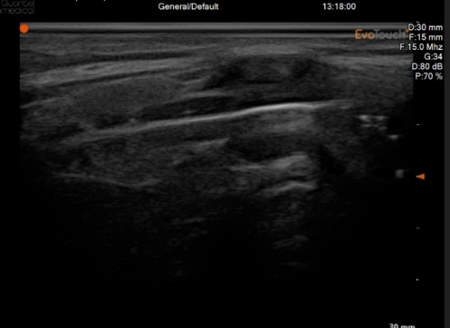
d
c
b
a
P
A
Figure 1.1: (a) cricoid cartilage, (b) 1st tracheal ring, (c) 2nd tracheal ring, (d) 3rd tracheal ring
- Anterior side, (P) Posterior side

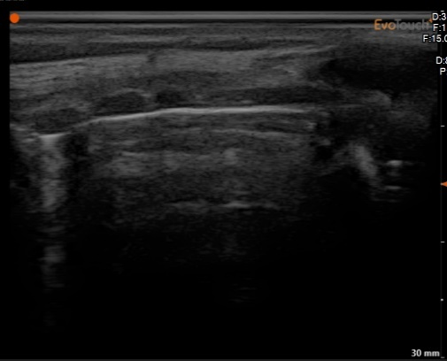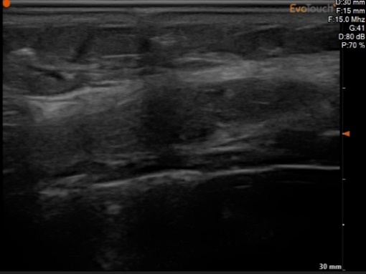
d
c
b
d
c
b
a
Figure 1.3: (a) cricoid cartilage, (b) 1st tracheal ring, (c) 2nd tracheal ring, (d) 3rd tracheal ring
- Anterior side, (P) Posterior side
A
P
P
A
Figure 1.2: (a) cricoid cartilage, (b) 1st tracheal ring, (c) 2nd tracheal ring, (d) 3rd tracheal ring
- Anterior side, (P) Posterior side

a
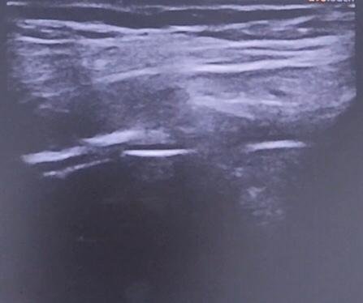
c
b
a
Figure 1.4: (a) cricoid cartilage, (b) 1st tracheal ring, (c) 2nd tracheal ring
- Anterior side, (P) Posterior side

P
A
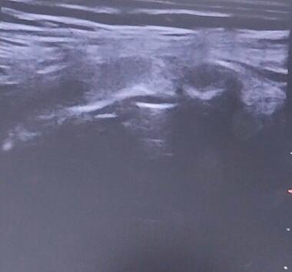
c
b
a
Figure 1.5: (a) cricoid cartilage, (b) 1st tracheal ring, (c) 2nd tracheal ring
- Anterior side, (P) Posterior side

P
A

Step 3: Proper localization and marking, of the spaces of the tracheal ring, under ultrasonic observation, at the same time that a 22 gauge needle slides, (the needle is represented by a dark shadow due to ultrasound absorption)
Figure 2: Needle localization on ultrasound longitudinal view
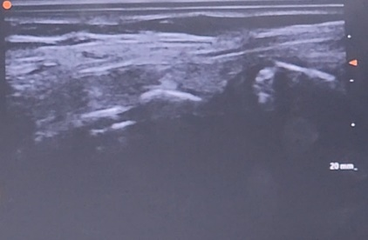
Figure 2.1: (a) cricoid cartilage, (b) 1st tracheal ring, (c) 2nd tracheal ring, (d) 3rd tracheal ring, (white arrow) needle black shadow
- Anterior side, (P) Posterior side

d
c
b
a
↘
P
A
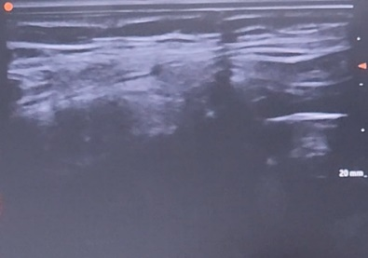
Figure 2.2: (white arrow) needle black shadow
- Anterior side, (P) Posterior side

↘
P
A
Step 4: Cross section Scanning of the marked level with ultrasound to identify the midline, no arteries or vein were present in our field of work. The soft tissue structures observed are the right and left thyroid lobes, as well as the isthmus.
Figure 3: Cross sectional view of the neck visualizing thyroid and tracheal anatomy
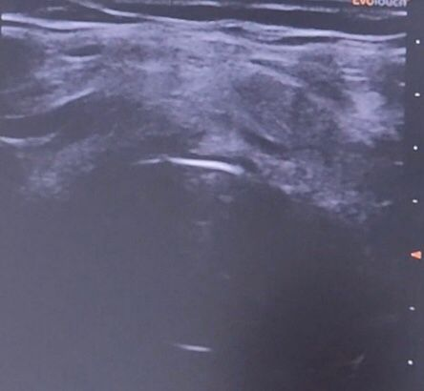
I
RT
LT
T
Figure 3: (T) trachea, (RT) Right thyroid lobe, (LT) Left thyroid lobe, (I) isthmus, (R)Right, (L)Left
L
R

Step 5: Local Anesthetic infiltration of the skin
Step 6: Under ultrasound guidance, a 14 French needle is inserted till the tip reaches the anterior superior tracheal wall.
Figure 4: Cross-sectional view of neck locating midline structures: thyroid trachea
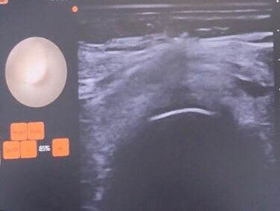
L
LT
Figure 4.1: (T) trachea, (LT) Left thyroid lobe, (white arrow) needle shadow, (black arrow) tracheal lumen (R)Right, (L)Left

↘

↘

T
R
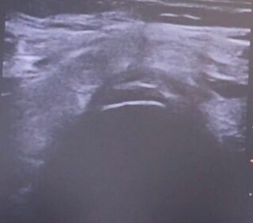
*

T
↘

L
R
ThR
ThL
Figure 4.2: (T) trachea, (ThR) Right thyroid lobe, (ThL) Left thyroid lobe, (white arrow) needle shadow, (*) anterior superior tracheal wall, (R)Right, (L)Left

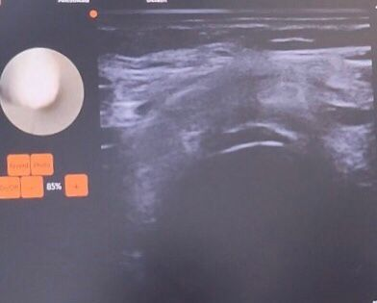
Figure 4.3: (T) trachea, (black arrow) tracheal lumen, (*) anterior superior tracheal wall, (R)Right, (L)Left

*

T
R
L
↘

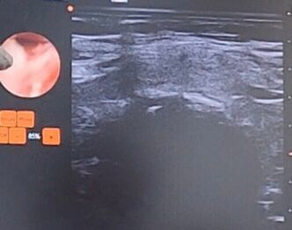
Figure 4.5: (T) trachea, (black arrow) tracheal lumen, (white arrow) needle shadow, (*) anterior superior tracheal wall, (R)Right, (L)Left

↘

*

R
T
↘

L
Step 7: At this point the Realtime imaging is shifted from the ultrasound to Realtime scope image and the space between the tracheal rings 2 and 3 is pricked
Figure 5: Real-time micro endo-scope image showing intratracheal cartilage
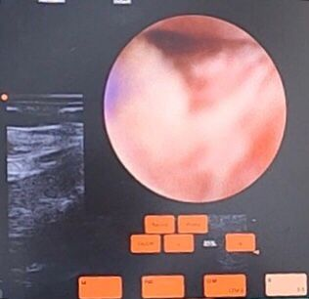
Figure 5.1: view: intratracheal cartilage

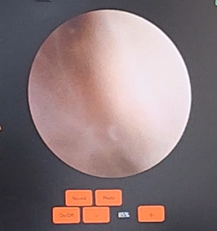
Figure 5.2: view: intratracheal cartilage
T trachea
T

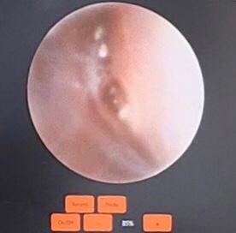
Figure 5.3: view: intratracheal cartilage
(T) trachea lumen

T

*

Step 8: We can confirm through scope that the needle is the trachea and we have not gone through the posterior wall, no tube can be visualized.
Figure 6: (6.1-6.2-6.3-6.4-6.5-6.6): Real-time view or the tracheal lumen: (C) Carina, (T) Trachea lumen, (*) anterior superior tracheal wall, (**) posterior tracheal muscular wall, (1) tracheal rings
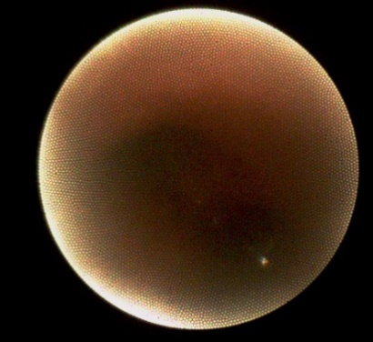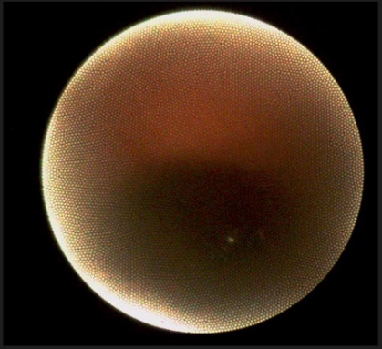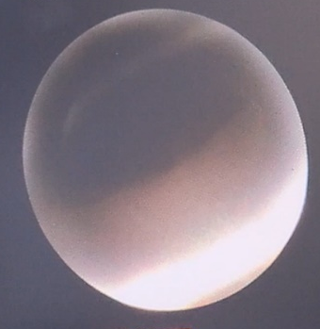
1
C
**

**

*

*

*

T
Figure 6.3
Figure 6.2
Figure 6.1
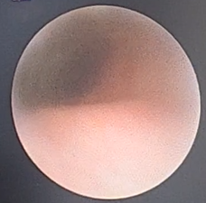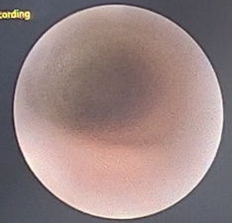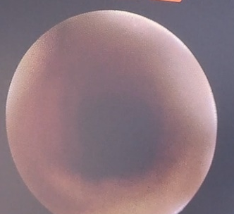
*

T
T
T
*

*

1
1
1
1
1
Figure 6.6
Figure 6.5
Figure 6.4

Step 9: The angiocath is under vision and the camera and metallic needle is withdrawn and wire is inserted.
Step 10: This type of percutaneous tracheostomy has only two step dilation preferred since less risk of accidental wire withdrawal.
Step 11: Tracheostomy tube is inserted, and cuff inflated and confirmation done by inserting micro-endoscope in the tracheostomy tube to visualize the carina or the intratracheal walls and rings, after this step the ET tube is removed.
Figure 7: Carinal view from inside the trachea: Real-time view: (C) carina, (Rb) Right Bronchus lumen, (Lb) left Bronchus lumen
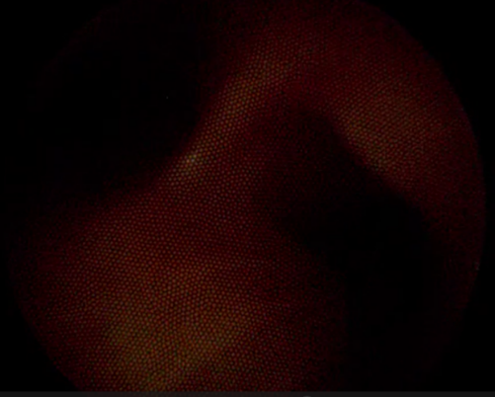
RB
C
LB
Group NA, ET tube was kept in the same position until serial dilatation was attempted.
Step 1: The Neck was scanned longitudinally with ultrasound with proper identification of the cricoid and tracheal rings.
Figure 8: longitudinal ultrasound image of the neck: (a) cricoid cartilage, (b) 1st tracheal ring, (b) 2nd tracheal ring, (3^{rd)} tracheal ring.
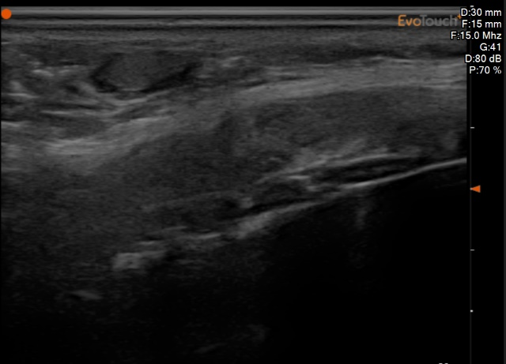
d
c
b
a
Step 3: Proper localization and marking, of the spaces of the tracheal ring, under ultrasonic observation, at the same time that a 22 gauge needle slides, (the needle is represented by a dark shadow due to ultrasound absorption)
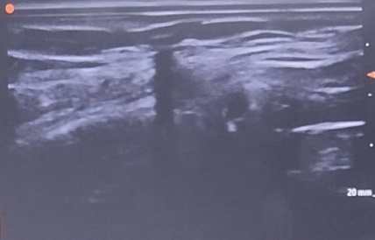
c
b
a
Figure 2.3: (a) cricoid cartilage, (b) 1st tracheal ring, (c) 2nd tracheal ring, (white arrow) needle black shadow between (b) and (c)
- Anterior side, (P) Posterior side

P
A
Step 3: Cross section ultrasound Scanning of the marked level to identify the midline, no arteries or vein were present in our field of work. Observed structure soft tissue, right, left thyroid lobe and isthmus.
I
RT
LT
T
L
R

Figure 3: (T) trachea, (RT) Right thyroid lobe, (LT) Left thyroid lobe, (I) isthmus, (R)Right, (L)Left

Step 4: Local Anesthetic infiltration of the skin
Step 5: Under ultrasound guidance, a 14 French needle is inserted until the tip reaches the anterior superior tracheal wall.
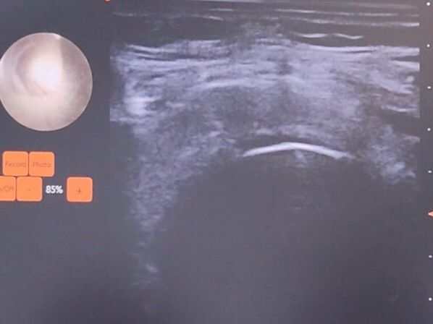
*

Figure 4.4: (T) trachea, (black arrow) tracheal lumen, (white arrow) needle shadow, (*) anterior superior tracheal wall, (R)Right, (L)Left

↘

↘

T
R
L
Step 6: At this point the Realtime imaging is shifted from the ultrasound to Real-time scope image and the space between the tracheal rings 2 and 3 is pricked.
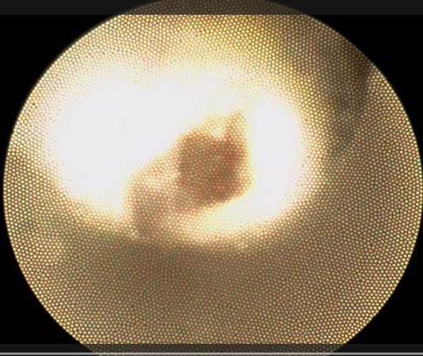
Figure 9.1

T
Step 7: Micro-endoscope conformation of the needle position and have not perforated gone posterior wall, ET tube and balloon.
Figure 9 (9.1-9.2-9.3-9.4-9.5-9.6-9.7-.9.8): real-time scope image intratracheal cartilage dissection : (T) tracheal lumen, (*) anterior superior tracheal wall, (**) posterior tracheal wall, (ET) endotracheal tube, (C) carina.
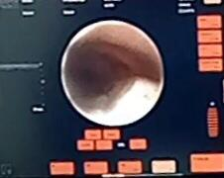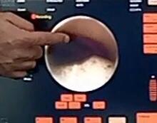
Figure 9.3
Figure 9.2
ET
T
**
*
*
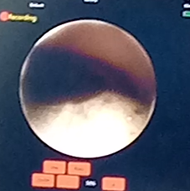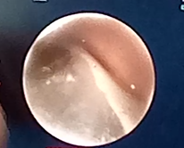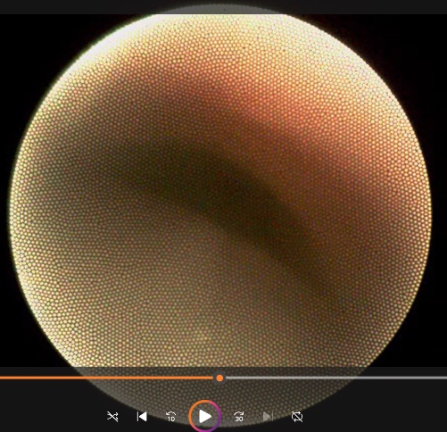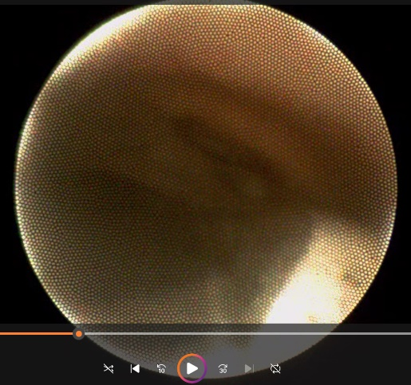
*
*
*
Figure 9.4
ET
Figure 9.7
Figure 9.6
Figure 9.5
C
ET
ET
T
*
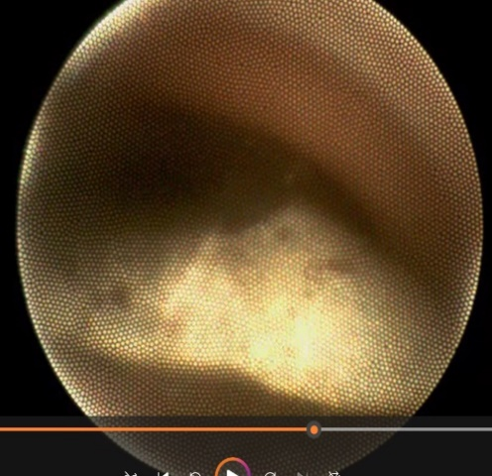
Figure 9.8
C
*
Step 8: The angiocath slides under vision, both the camera and the metal needle are removed and the wire is inserted, the ET is moved cephalad.
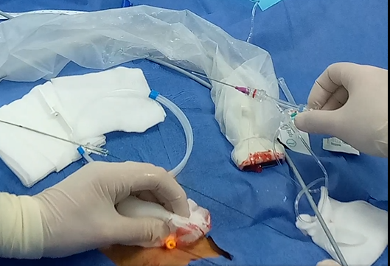 Figure 10: wire placement and needle withdrawal
Figure 11: Real-time scope view within the needle
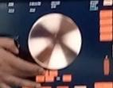
Step 9: ET tube is withdrawn till the vocal cord level and two step dilatation is done.
Step 10: Tracheostomy tube is inserted, and the cuff is inflated.

Step 11: Conformation of the intratracheal position is done by inserting micro-endoscope in the tracheostomy tube and visualization of carina or intratracheal wall and rings.
Figure 11 (11.1-11.2): Real-time view within the trachea : (C) carina
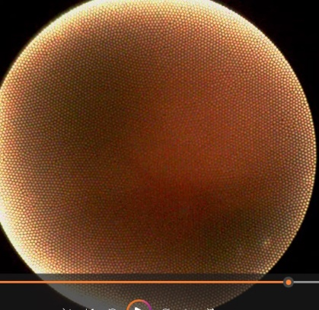
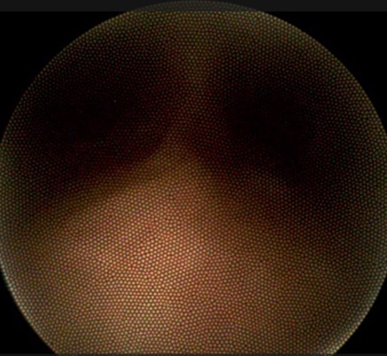
RB
LB

C
C
LB
RBB
Figure 11.2
Figure 11.1

