Supplementary information
Membrane fouling monitoring by 3ω sensing
Mads Koustrup Jørgensen^{1,*}, Frederikke Kildeberg Paulsen¹, Anders Bentien², Astrid Ræbild Kjul¹, Maiken Poulsen¹, Louise Mailund Mikkelsen¹, Nikitha Thavaneswaran¹, Simon Abildgaard Hansen¹, Pernille Krogsager Jensen¹, Jacob Andersen¹, David N. Østedgaard-Munck³, Jan Dimon Bendtsen⁴, Morten Lykkegaard Christensen¹
¹Center for Membrane Technology, Department of Chemistry and Bioscience, Aalborg University, DK-9220 Aalborg East, Denmark
²Department of Biological and Chemical Engineering, Aarhus University, Åbogade 40, DK-8200 Aarhus N, Denmark
³LiqTech International A/S, Benshøj Industrivej 24, DK-9500 Hobro, Denmark
⁴Department of Electronic Systems, Aalborg University, Fredrik Bajers Vej 7, DK-9220 Aalborg Øst
*Correspondence: mkj@bio.aau.dk

This file includes:
Supplementary Figures S1-S7.

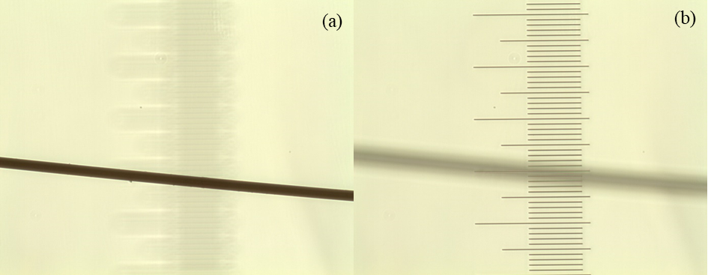
Figure S1: Microscopy image of platinum wire with wire (a) and scale (b) in focus. Every bar on the scale is 10 μm. The microscope is an Axioskop epifluorescence microscope (Carl Zeiss, Oberkochen, Germany, 1000x magnification).

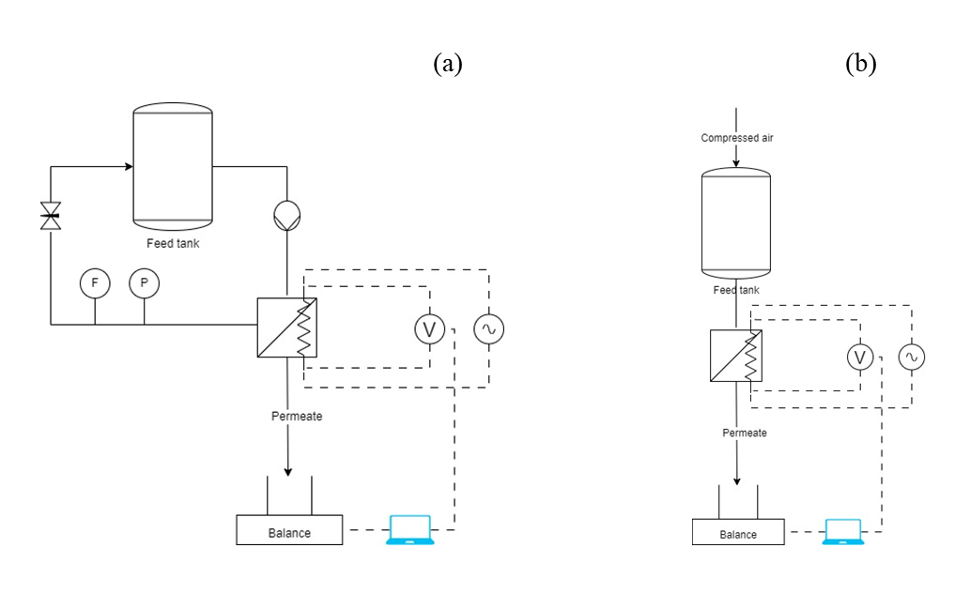
Figure S2: Schematic of semi-dead-end filtration setup (a) and crossflow filtration setup (b).

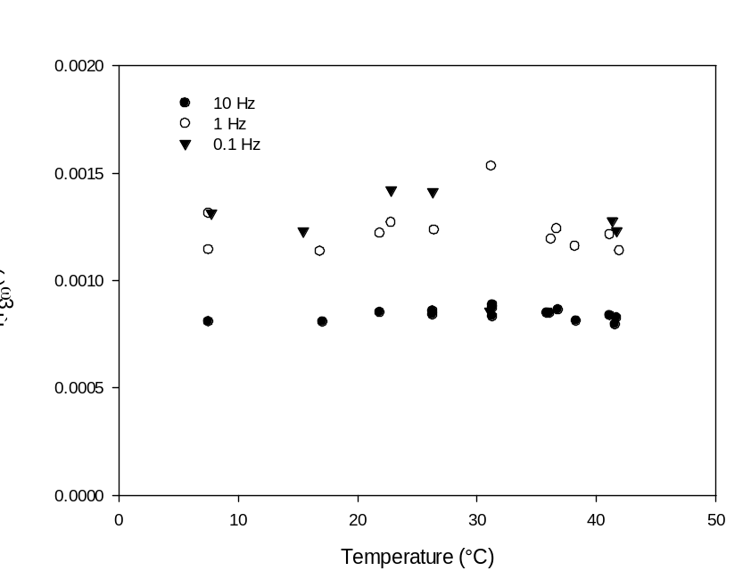
Figure S3: Ù_{3ω} collected at 75 mA AC current through a platinum wire on a membrane in DI water using an AC frequency of 1 Hz (a), and Ù_{3ω} found by normalization of U_{1ω} and U_{3ω} collected at 0.1, 1 and 10 Hz AC currents of 75 mA.

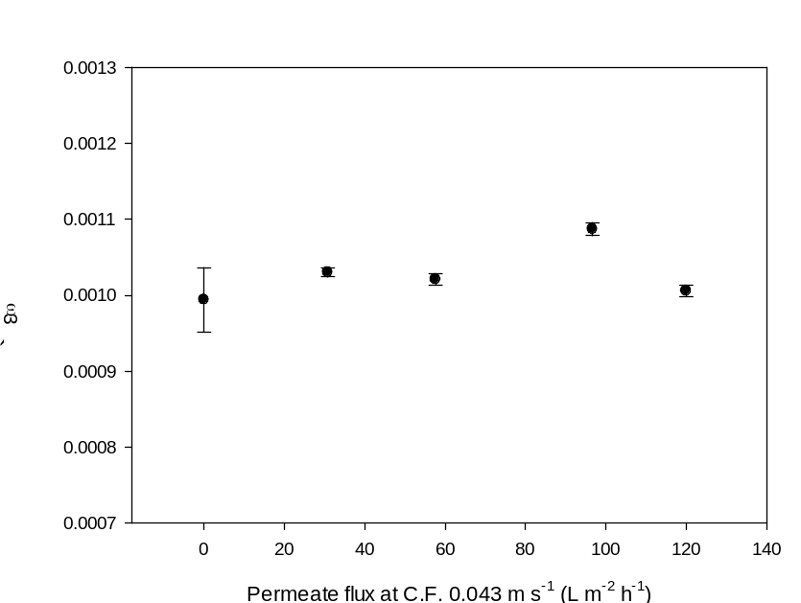
Figure S4: Ù_{3ω} collected at 75 mA AC current with a frequency of 1 Hz and a crossflow velocity of 0.043 m s⁻¹ for varying permeate fluxes during filtration of DI water.

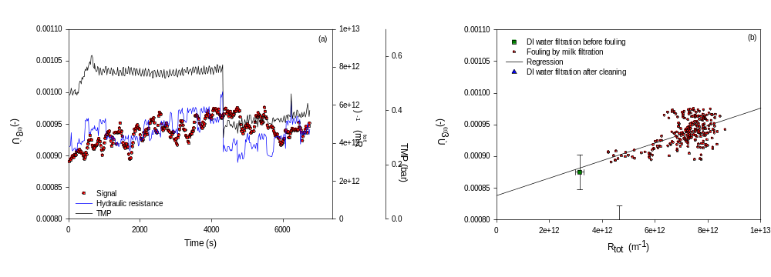
Figure S5: Ù_{3ω} and TMP and hydraulic resistance to filtration plotted against time during filtration of dilute milk samples (0.035% fat content) (a), and Ù_{3ω} plotted against hydraulic resistance during filtration of DI water, dilute milk and DI water after membrane cleaning (b).

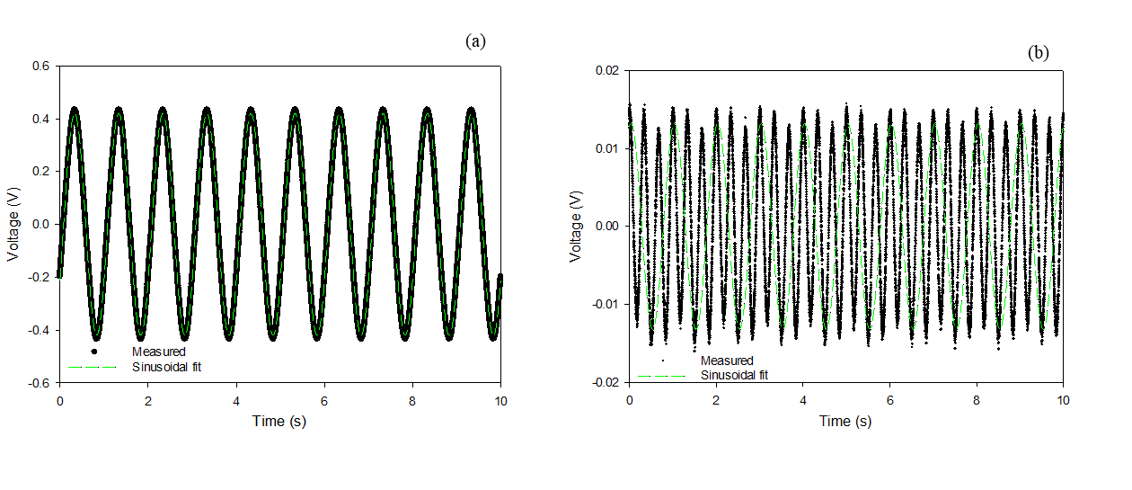
Figure S6: Measured voltage through platinum wire on membrane in air with 75 mA current at 1 Hz AC frequency along with sinusoidal fit (a) and residual between fit and measured voltage, again with a sinusoidal fit to the residual with an oscillation of 3 Hz and amplitude of U_{3ω} (b).

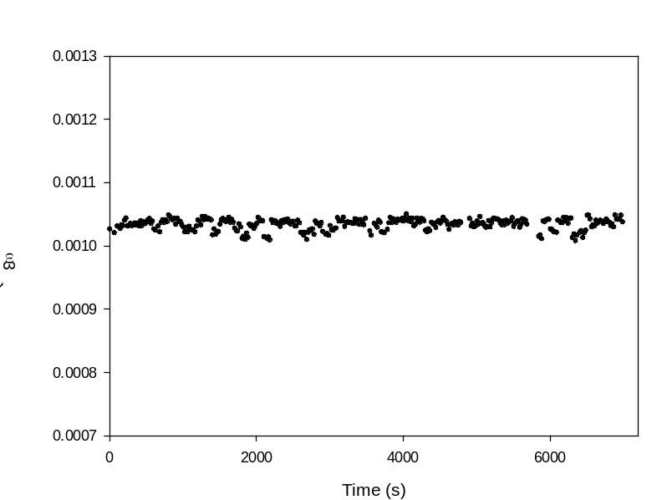
Figure S7: Ù_{3ω} collected at 75 mA AC current with a frequency of 1 Hz in water at room temperature as a reference for continuous filtration experiments.

