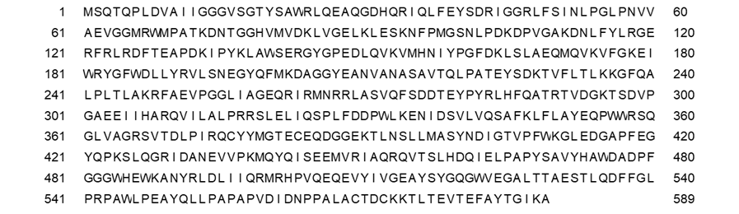
Fig. S1 Amino acid sequence of arginine oxidase from Pseudomonas sp. TPU 7192

Fig. S2 SDS-PAGE of crude purified enzyme from ArgOX and ArgOX mutants; proteins were separated on 10-20% SDS-PAGE gels. Lane M, protein markers of the sizes shown on the left; lane WT, E486R/H/N/Q, and pET22b in 15 μL of crude purified enzyme solution

