Supplementary Information

SI A: Discovering High-Dimensional Distance-Based Structures

Two examples provided below show that with the correct preprocessing approach and an appropriate choice of the distance measure, one can find a metric space where the relative relationship between high-dimensional data points becomes of interest to the domain expert. Then, the intra-cluster distances between high-dimensional points should have rather small values and a smaller variance and inter-cluster distances with larger values and a smaller variance (e.g., SI A, Supplementary Figs. 2 and 4) than those of the full distance distributions¹.

In the first example, the leukaemia dataset consists of 12,692 gene expression measurements from 554 subjects, as reported previously². Each gene expression is a logarithmic luminance intensity (presence call), which was measured in primary bone marrow samples of 455 leukaemia patients and 105 healthy donor samples using Affymetrix technology as described in². Fifteen patients were diagnosed with acute promyelocytic leukaemia (APL), 266 had chronic lymphocytic leukaemia (CLL), and 164 had acute myeloid leukaemia (AML). From a diagnostic point of view, AML and CLL are distinct disease entities, and APL is a subgroup of AML. Regarding therapy, all four groups received different treatments. The AML patients received combined cytarabine in a combined chemotherapy regimen, the CLL patients were treated with specific targeted therapies such as tyrosine kinase inhibitors (TKIs) or immune chemotherapy, the APL patients had an excellent prognosis with retinoic acid and arsenic trioxide treatment³, and the healthy individuals did not require treatment. The dataset was preprocessed. The distinctions are clearly visible in the small class-wise intra-cluster distances (Supplementary Fig. 3, left) and large class-wise intra-cluster distances (Supplementary Fig. 3, right) and the multimodal distance distribution of the whole dataset. The topographic map of the NeRV projection⁴ shows high-dimensional structures with four distinct valleys, one per class (Supplementary Fig. 4), reproducing the results computed by the ESOM projection⁵ and DBS projection⁶.
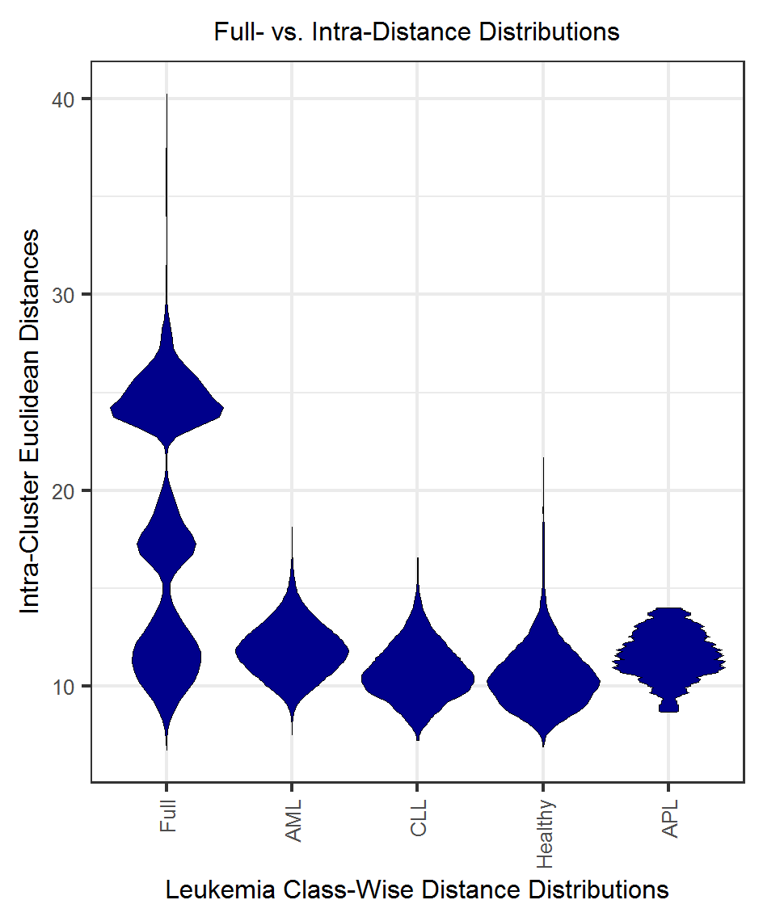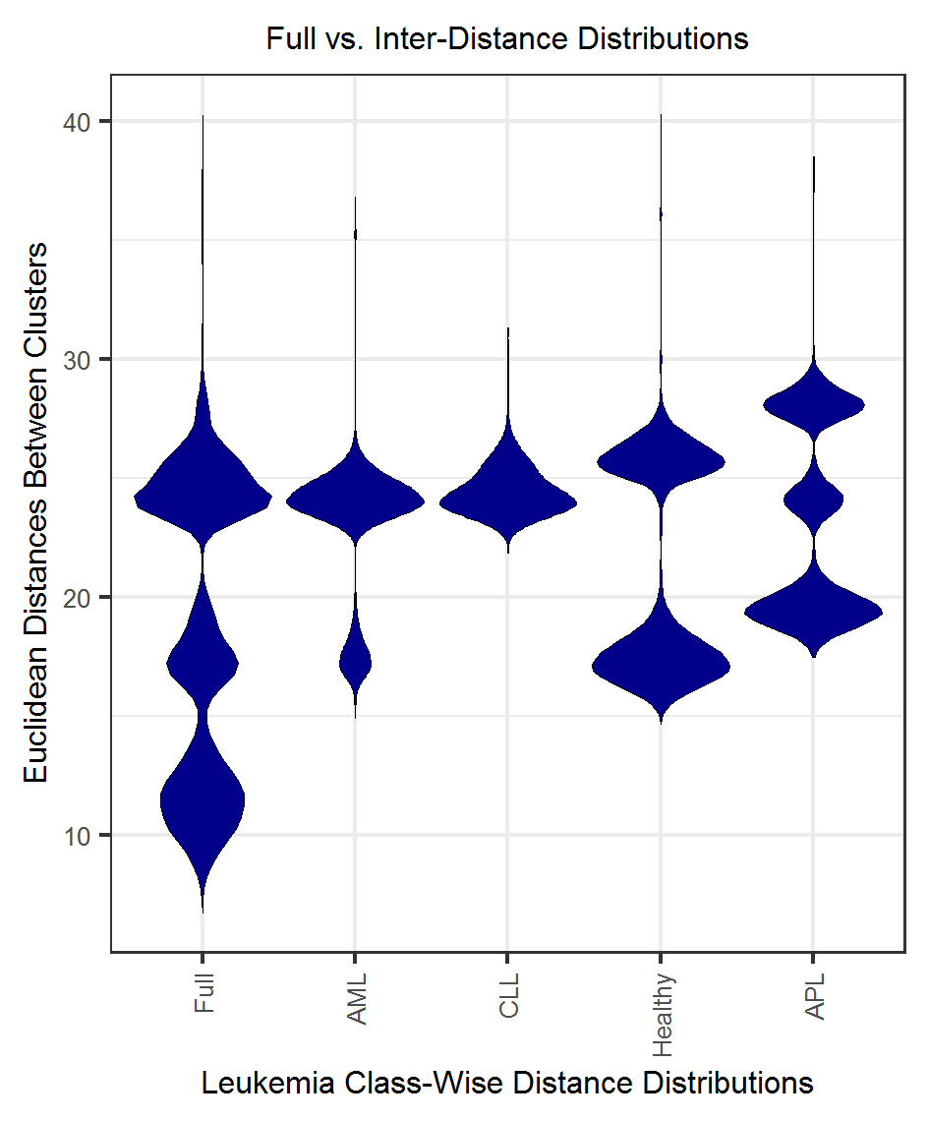
Supplementary Fig. 1. Inter- and intra-distance distributions from the leukaemia dataset reveal a clear distance-based structure because the distances in the clusters (right) are in the first mode of small distances of the full distance distribution and the distances between the clusters (left) are in the second and third modes of the full distance distribution (vast distances).

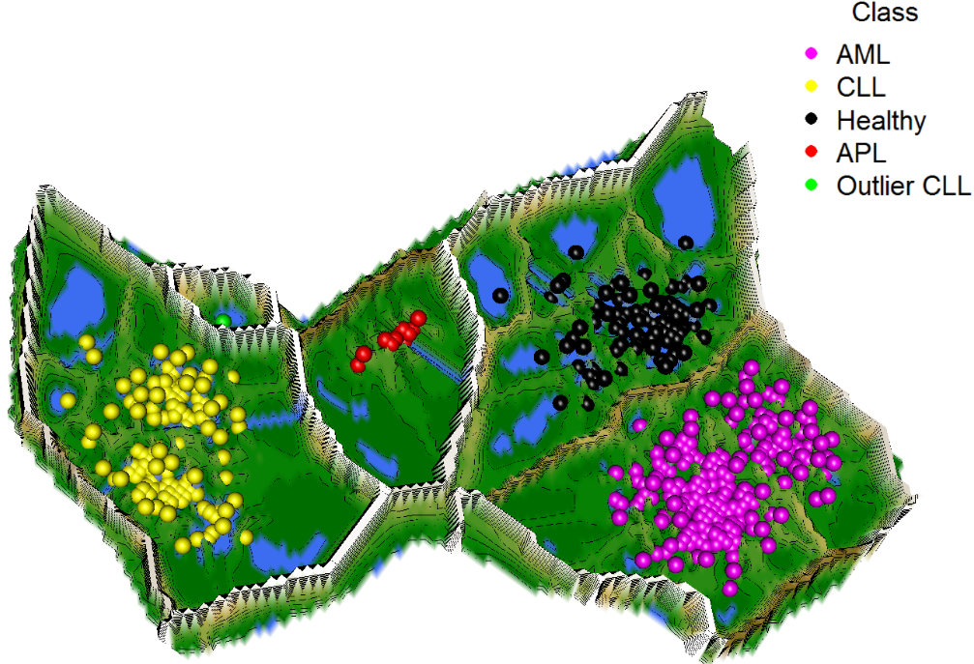
Supplementary Fig. 2. Topographic map of the high-dimensional structures of the leukaemia dataset using the NeRV projection⁴ and the generalized U-matrix⁵ reveals four valleys and one outlier in a volcano. Each subject is symbolized by one point. The projected points are coloured by the class labels defining the various illnesses as well as the healthy subjects. As valleys and classifications overlap, the topographic map indicates a clear cluster structure. Topographic maps also have the potential to reveal when a dataset does not possess any cluster structure at all^{6,7}.
In the second example, the cancer dataset consists of 801 samples with 18,617 features, with each feature being the RNA-Seq gene expression level measured by the Illumina HiSeq platform. It consists of a sample of the data published in⁸ as a part of the Cancer Genome Project (c.f. https://www.sanger.ac.uk/science/groups/cancer-genome-project). The data are available from the UCI ML repository⁹ in which five types of diagnoses are given: lung adenocarcinoma (LUAD), breast carcinoma (BRCA), kidney renal clear-cell carcinoma (KIRC), colon adenocarcinoma (COAD), and prostate adenocarcinoma (PRAD).
Recent research indicates that the organ of origin is less relevant than the type of mutation, which could be the reason that the distance-based cluster structures are less distinct in Supplementary Figs. 5 and 6. Supplementary Fig. 5 indicates that, except for KIRC and LUAD, the class-wise distributions of intra-cluster distances are rather large compared to those of the full distance distribution. The inter-cluster distances in Supplementary Fig. 5 (right) are rather small compared to those of the full distance distribution. In the topographic map in Supplementary Fig. 6, five valleys are still visible, but many outliers and some misclassified points can be identified. Of note, the proximity of the two slightly overlapping valleys for PRAD and BRCA may indicate that the topographic map of the generalized U-matrix may be particularly useful for the definition of therapeutic subgroups because anti-hormonal treatment is the predominant treatment modality for these two cancers. In contrast, LUAD, KIRC, and COAD are treated with different chemotherapy regimens. In sum, the cancer dataset is noisier than the leukaemia dataset, and it can be expected that the given classification is an unstable solution w.r.t. the clustering of distance-based structures.
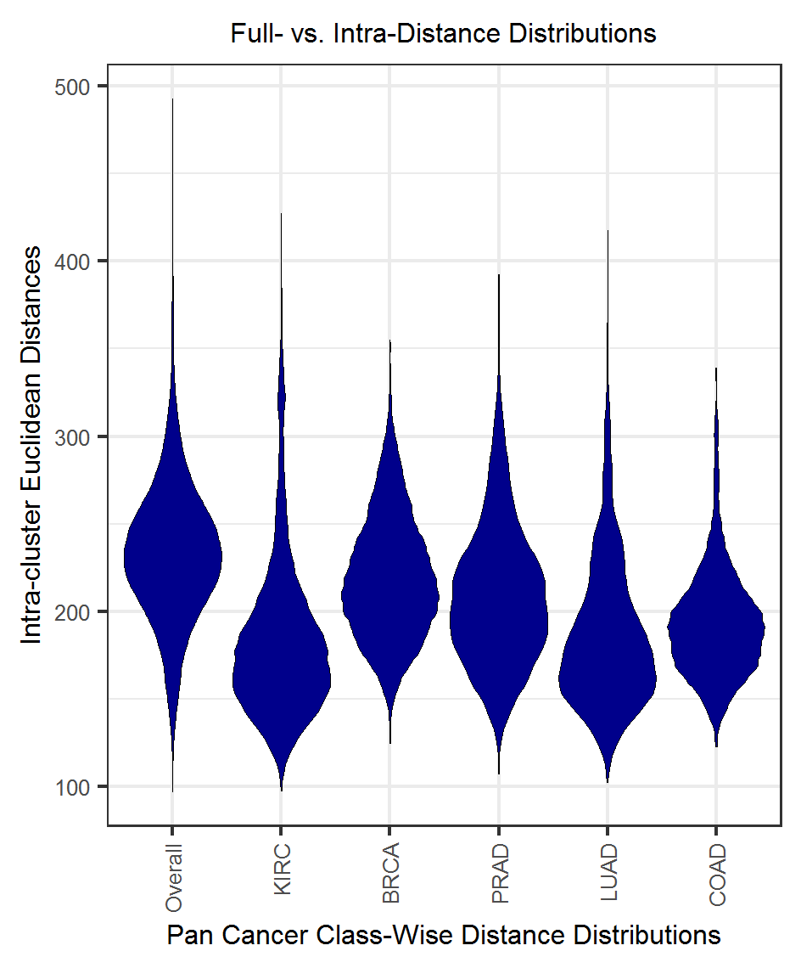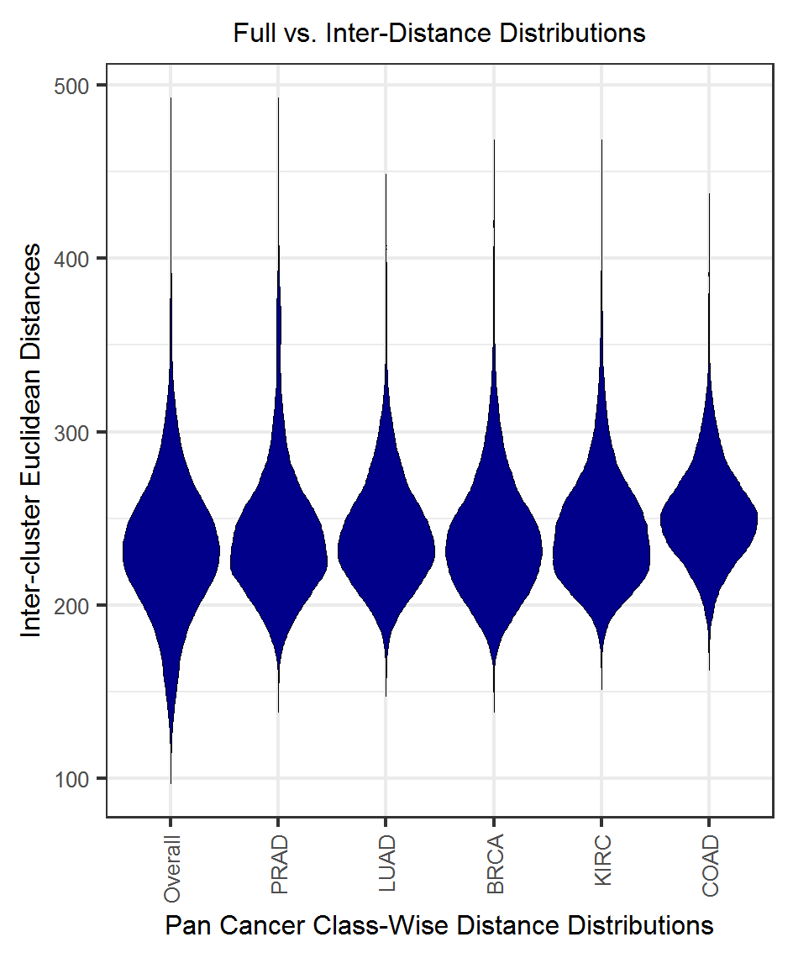
Supplementary Fig. 3. The inter- and intra-distance distributions reveal a clear distance-based structure because the distances in the clusters (right) are in the first mode of small distances of the full distance distribution and the distances between the clusters (left) are in the second and third modes of the full distance distribution (large distances).

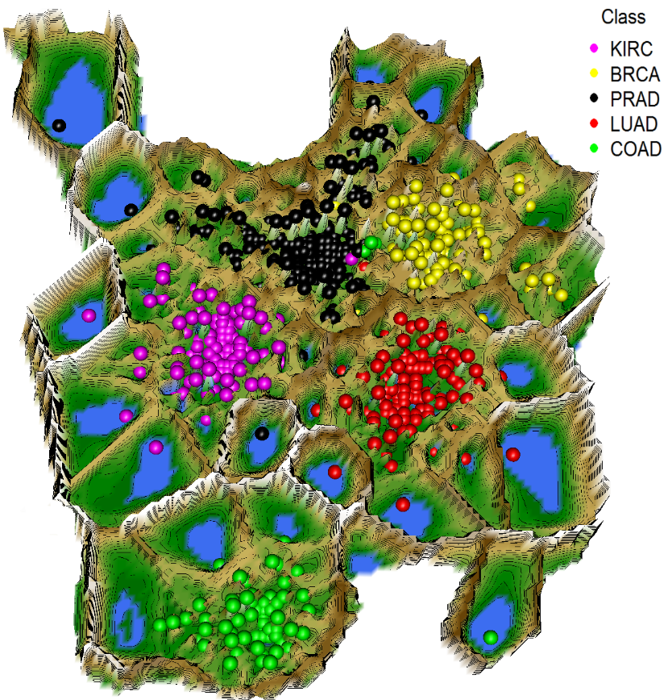
Supplementary Fig. 4. Topographic map of high-dimensional structures using the NeRV projection⁴ and the generalized U-matrix⁵ reveals five valleys and several outliers in volcanoes. Each subject is symbolized by one point with the diagnosis defined in the legend. The colours of the projected points indicate the class labels of the diagnosis. The topographic map indicates a cluster structure because the valleys and classification overlap. However, it seems that, especially between PRAD and BRCA, there are some misclassified points,

SI B: Distance Distributions of Artificially Generated Data Structures
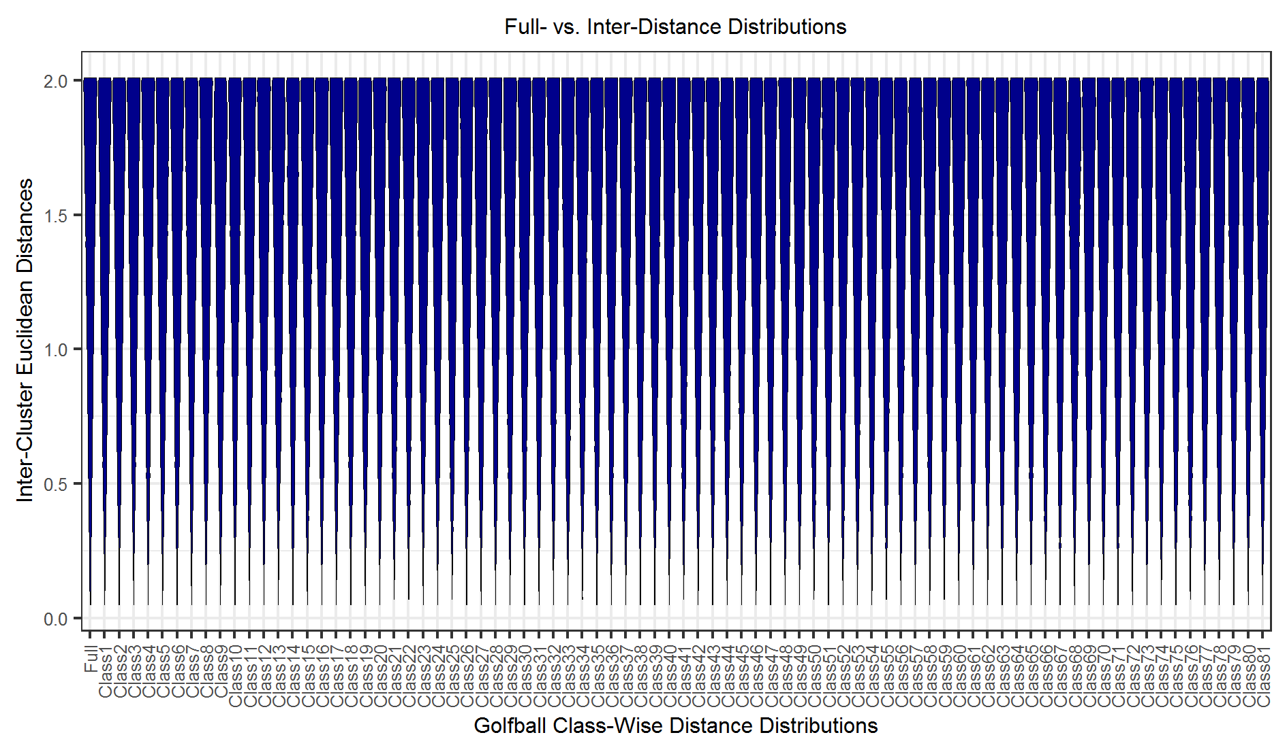
Supplementary Fig. 5. MD-plot of GolfBalls' Euclidean distance distribution and inter-cluster distances defined by SOM clustering for a Davies–Bouldin index¹⁰ of 0.83. No cluster structure is given; the inter-cluster distance distributions (right) have a large variance similar to that of the full distance distribution (first MD-plot on the left).

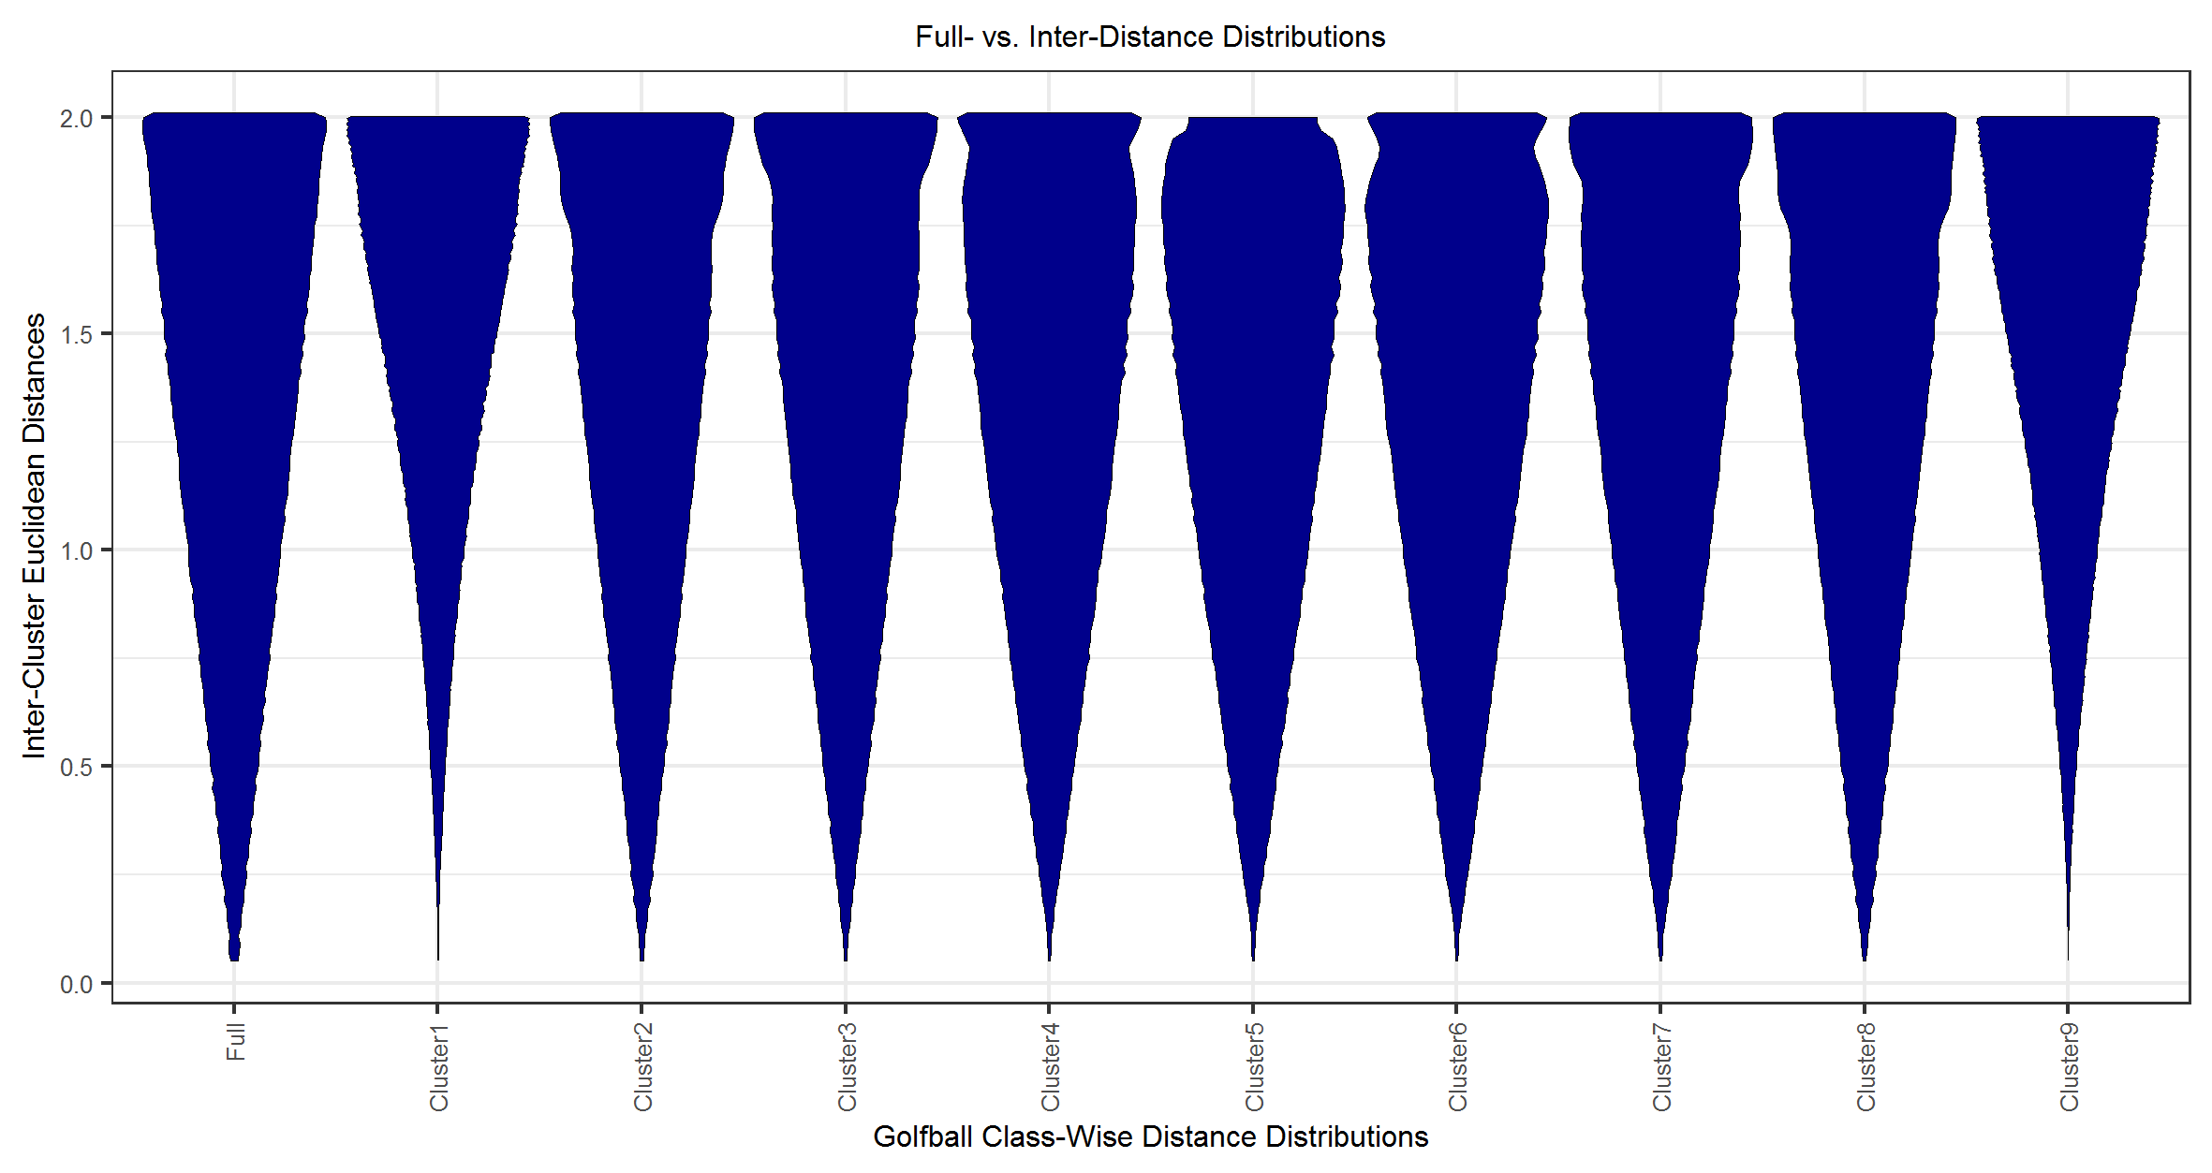
Supplementary Fig. 6. MD-plot of GolfBalls' Euclidean distance distribution and inter-cluster distances defined by SOM clustering for a Davies–Bouldin index¹⁰ of 11.8. No cluster structure is given; the inter-cluster distance distributions (right plot) have a large variance similar to the full distance distribution (first MD-plot on the left).

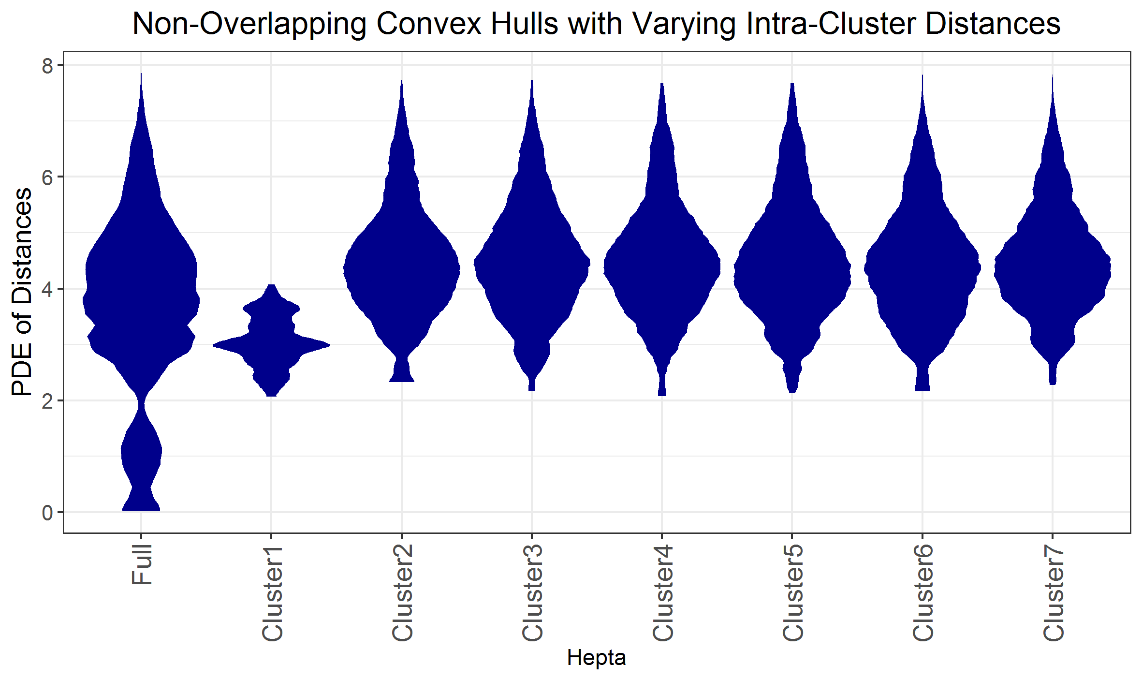
Supplementary Fig. 7. MD-plot of the data structures with non-overlapping convex hulls with varying intra-cluster distances. Full: distribution of the full distance matrix.

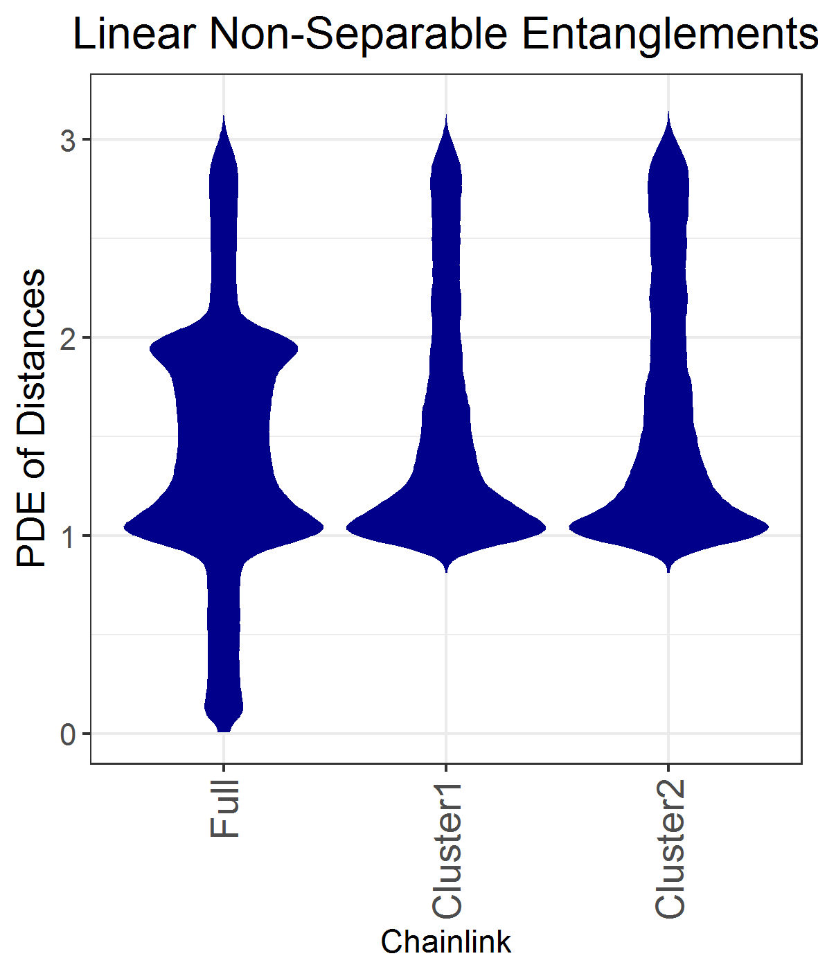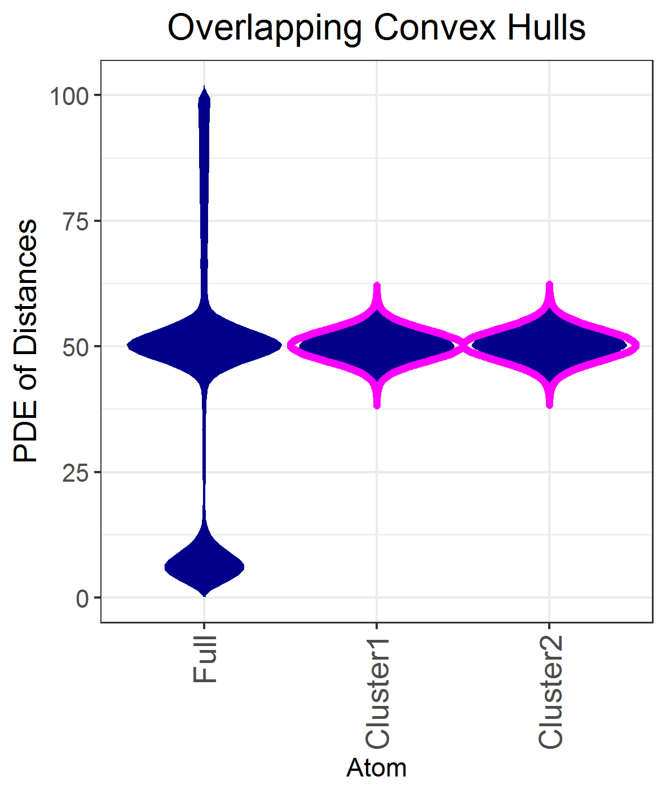
Supplementary Fig. 8. MD-plot of the data structures with linearly non-separable entanglements (left) and overlapping convex hulls (right). Full: distribution of the full distance matrix.

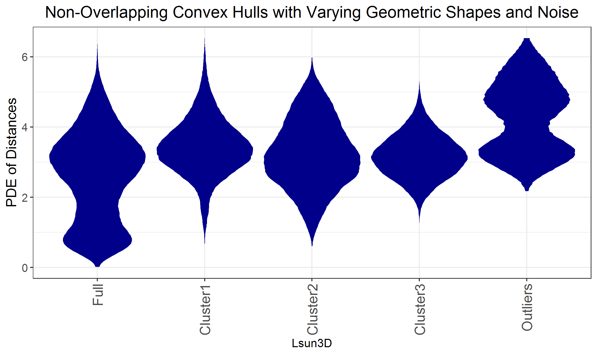
Supplementary Fig. 9. MD-plot of the data structures with non-overlapping convex hulls with varying geometric shapes and noise. Full: distribution of full distance matrix.

SI C: Unstable Clustering Solution of the Cancer Dataset
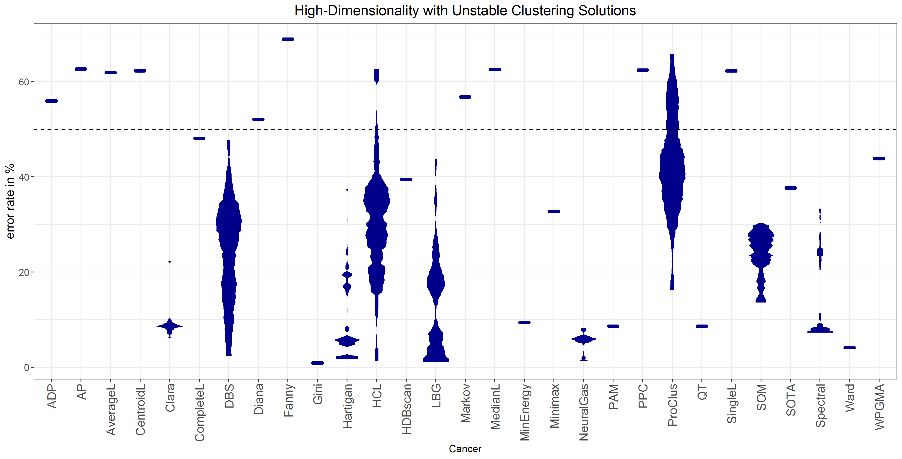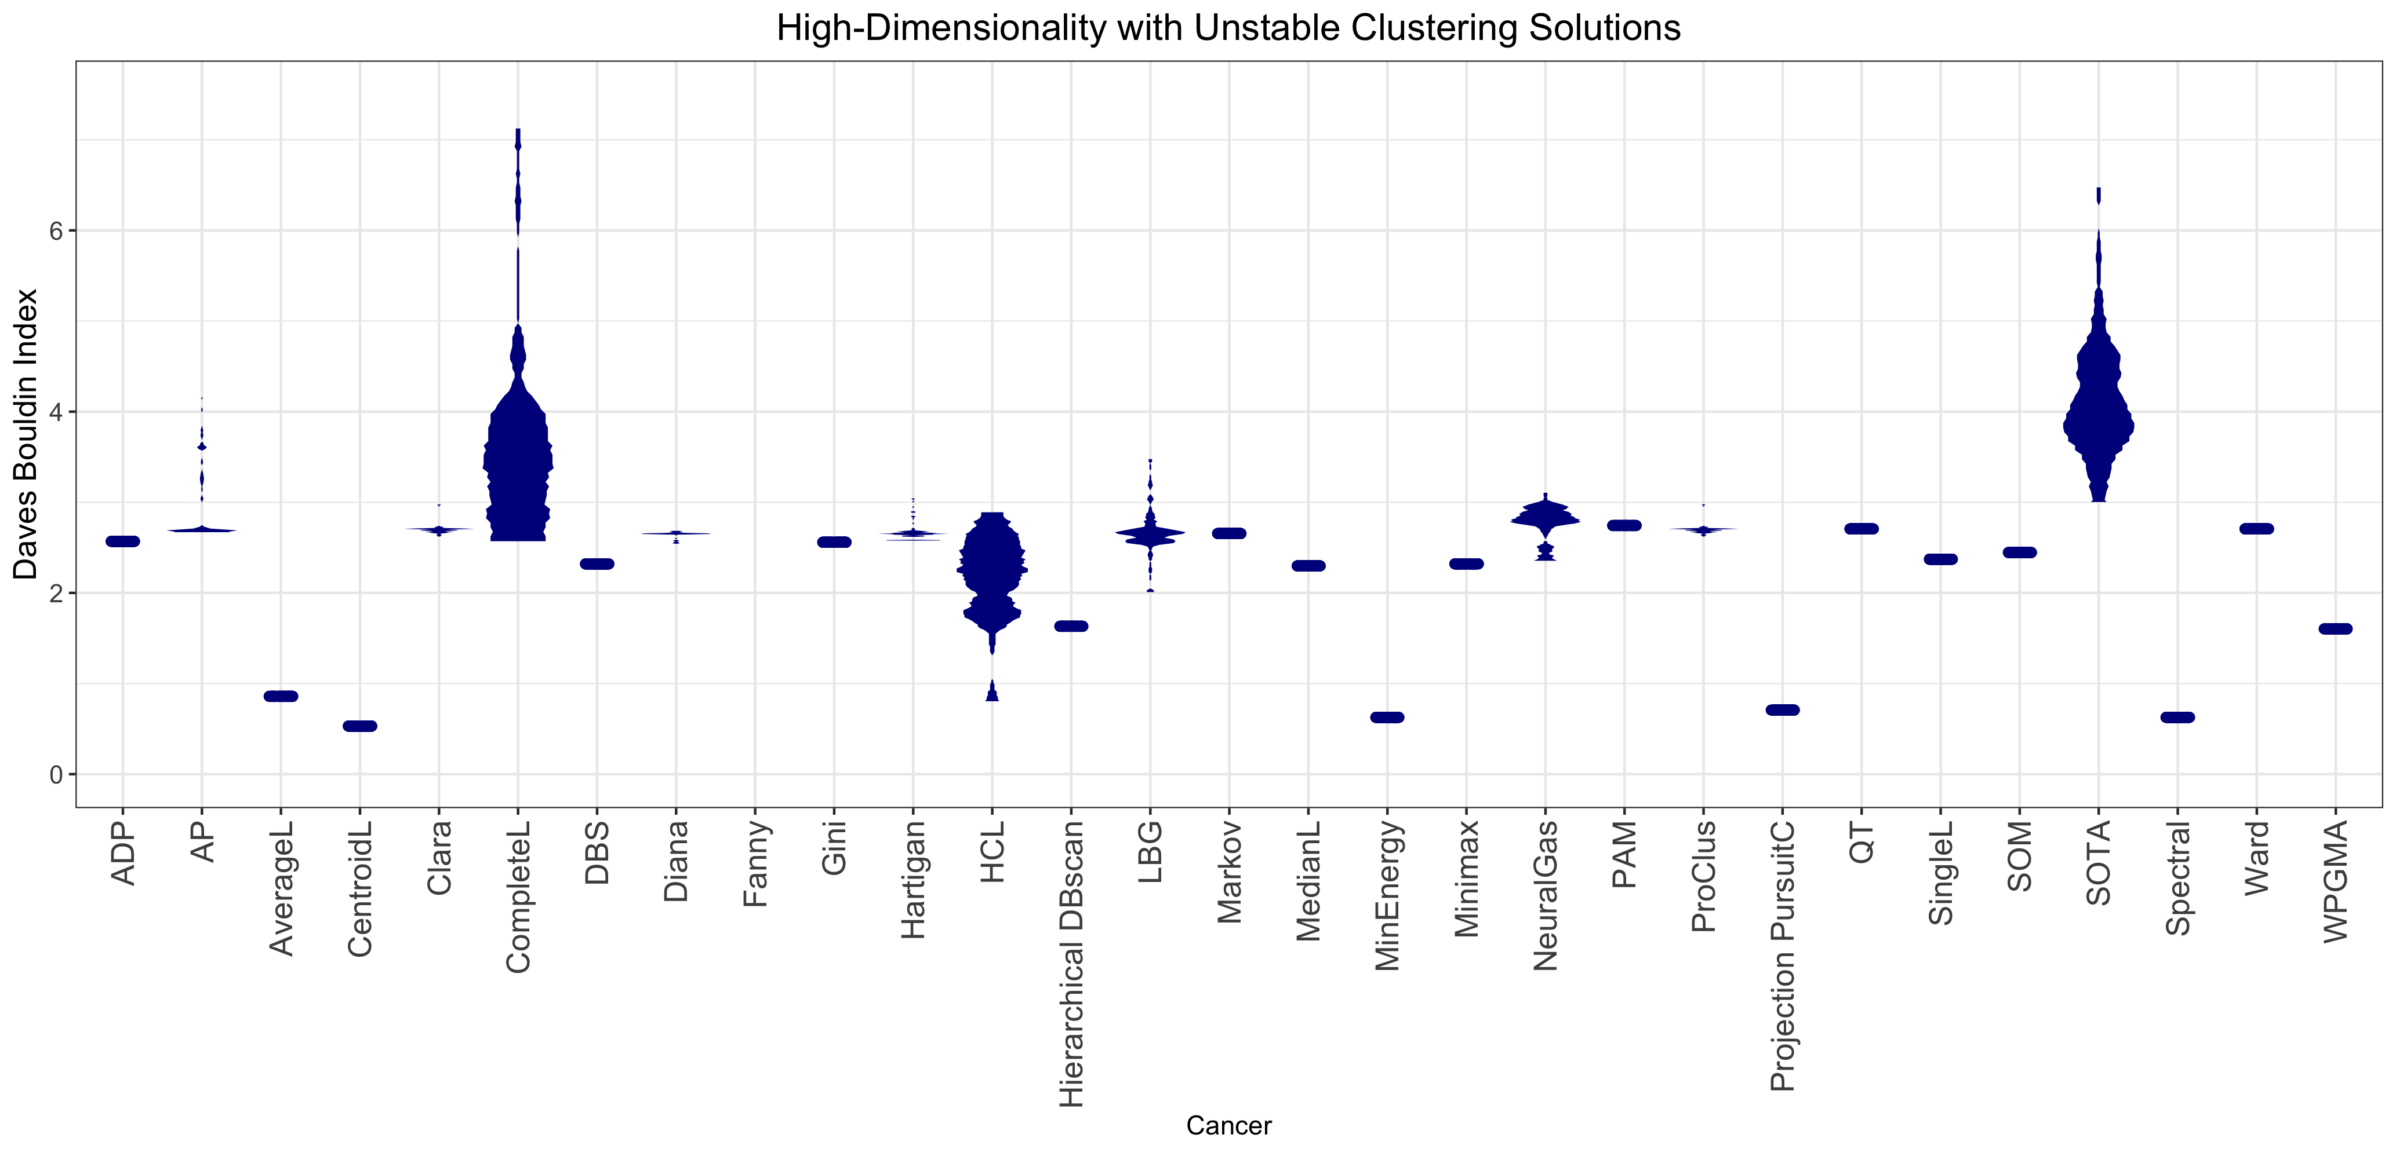
Supplementary Fig. 10. MD-plot of error rate (left) and Davies–Bouldin index (right) for 120 trials per algorithm for 24 clustering algorithms calculated for the cancer dataset. Distance-based structures based on this ground truth cannot be reproduced with high stability. The chance level is shown by the dotted line at 50%. The choice of an algorithm by the Davies–Bouldin index would lead to the selection of CentroidL, Spectral, MinEnergy, or PPC, whereas using the ground truth shows that Gini, DBS, LBG, Hartigan, Ward or NeuralGas can sometimes reproduce the structures; Ward and Gini have a small bias. The results for ModelBased, Orclus, RobustTrimmedC, CrossEntropyC, and Spectrum could not be computed.

SI D: MD plots Reveals Biases and the Various States of Probability
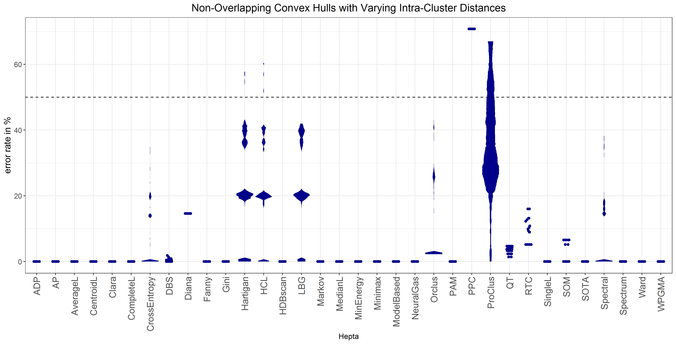
Fig. 11: MD plot of the error rates for 120 trials per algorithm for 34 clustering algorithms is calculated for the Hepta dataset. Non-overlapping convex hulls of spherical shape with varying intra-cluster distances are the best case for high-dimensional data. The chance level is a dotted line at 50%. Different states of probability are visible for CrossEntropy, HCL, LBG and Hartigan, Spectral clustering and ProClus. Contrary to insights from the literature (Duda et al., 2001; Handl et al., 2005; Hennig, 2015; Mirkin, 2005; Theodoridis & Koutroumbas, 2009)¹¹⁻¹⁵, k-means is in this case unable to reproduce a spherical clustering structure in every trial because of the varying intra-cluster distances.

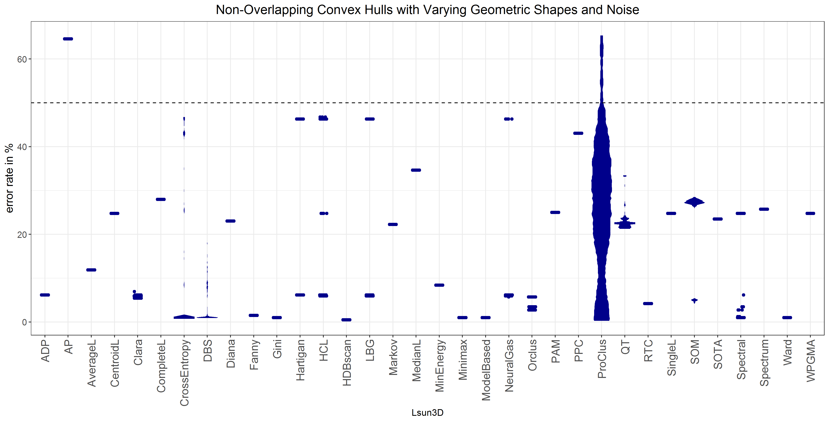
Supplementary Fig. 12. MD-plot of the error rates for 120 trials per algorithm for 34 clustering algorithms calculated for the Lsun3D dataset. Varying geometric shapes and outliers in the structures are not easy for conventional clustering algorithms to tackle. The chance level is shown by the dotted line at 50%. Ward, ModelBased, Minimax, HDBSCAN and Fanny are reasonably robust against outliers. DBS, CrossEntropy and Spectral have some variance. In total, 23 out of the 34 clustering algorithms fail on this task.

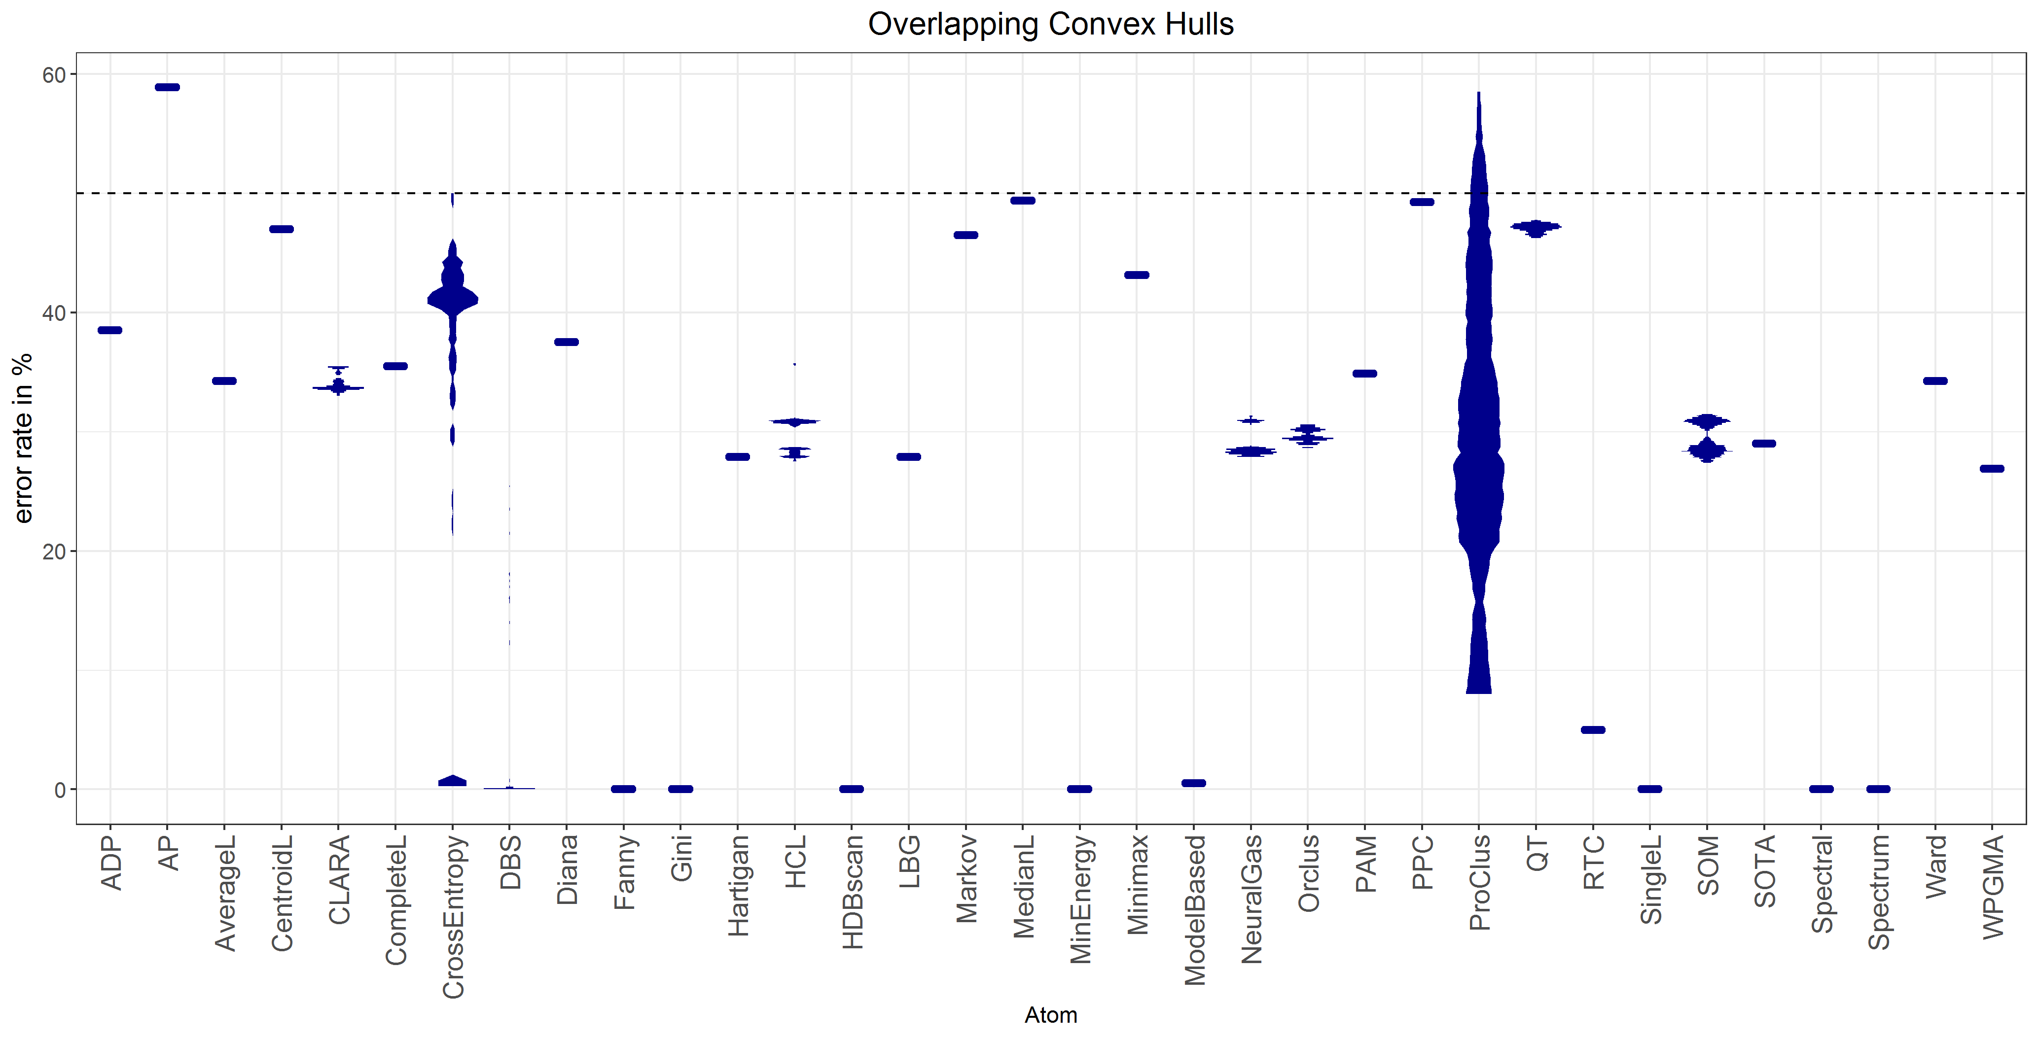
Supplementary Fig. 13. MD-plot of the error rates for 120 trials per algorithm for 34 clustering algorithms calculated for the Atom dataset. Entirely overlapping complex hulls are challenging for typical clustering algorithms. In total, 24 out of the 34 algorithms completely fail at this task. The chance level is shown by the dotted line at 50%.

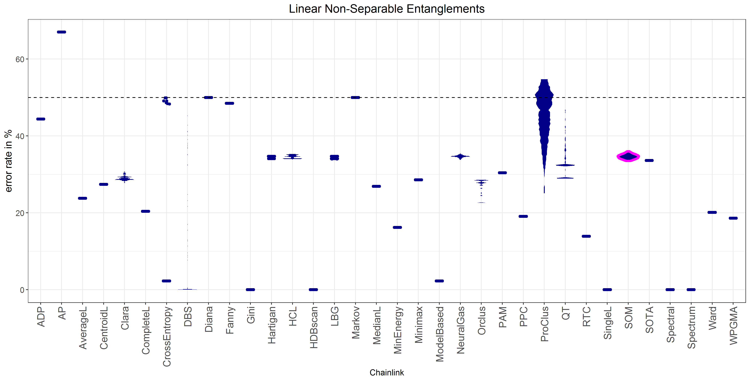
Supplementary Fig. 14. MD-plot of the error rates for 120 trials per algorithm for 34 clustering algorithms calculated for the Chainlink dataset. Finding non-linearly separable entanglements is the most difficult task to tackle in high-dimensional data. The chance level is shown by the dotted line at 50%. Only DBS, Gini, HDBSCAN, Spectral, SingleL, and Spectrum clustering reproduce these structures. ModelBased clustering has a small bias and DBS some variance. In total, 28 out of the 34 clustering algorithms fail in this task.

SI: E Further Leukaemia and Cancer Evaluations
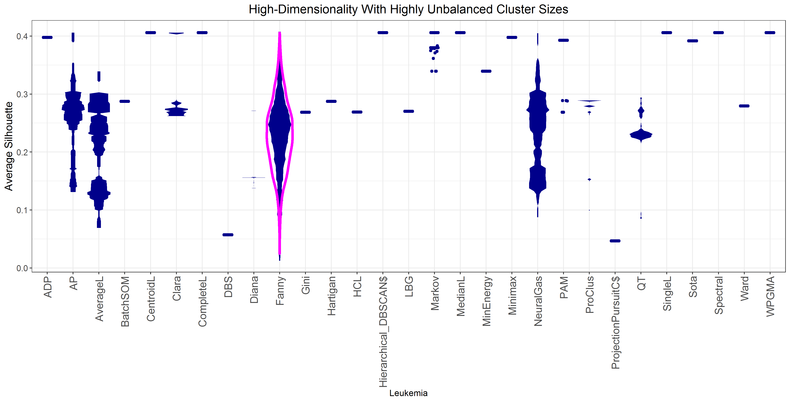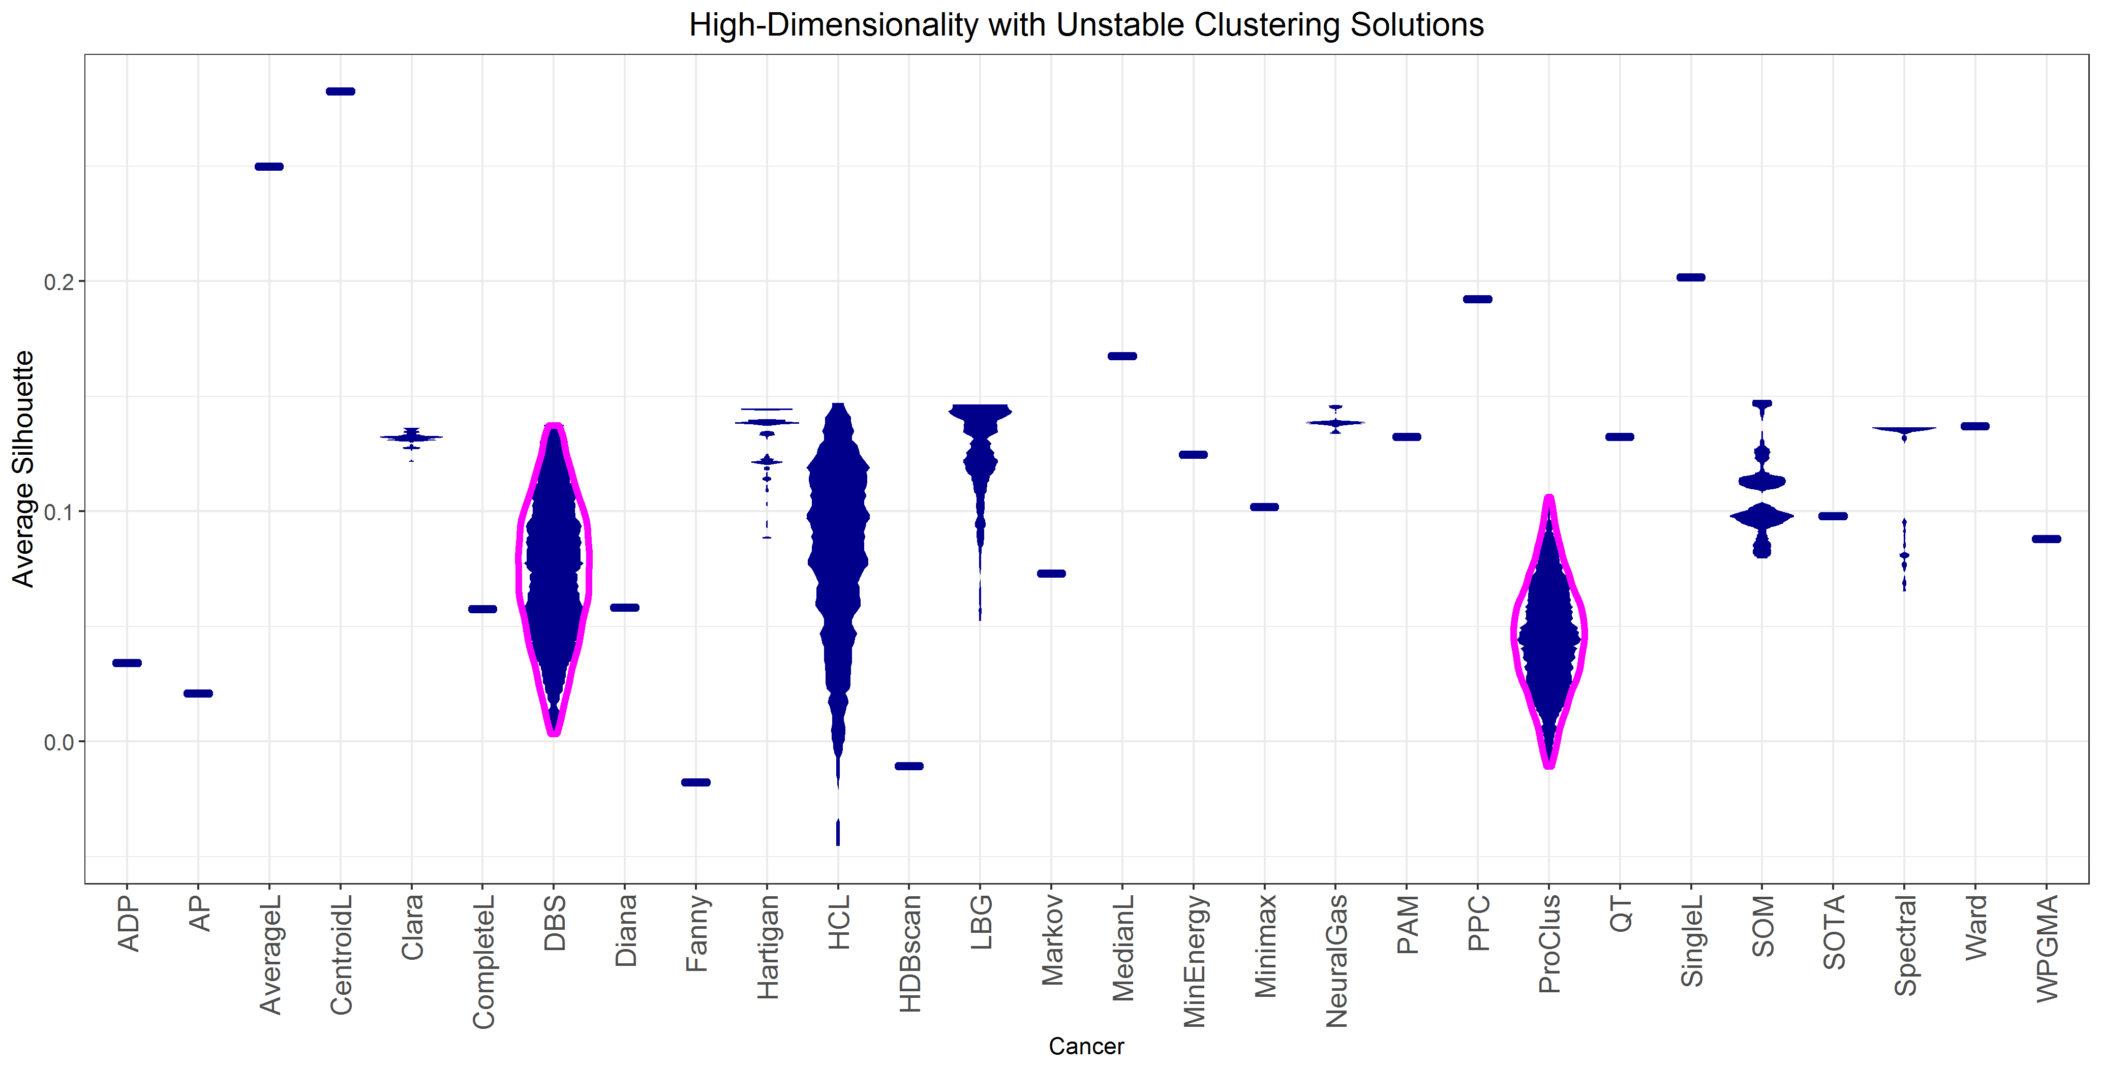
Supplementary Fig. 15. MD-plot of the silhouette index¹⁶ of the leukaemia (top) and cancer (bottom) datasets yields misleading results. Typically, values below 0.25 mean no structures and below 0.5 lead to the assumption that the structure is weak and can be disregarded¹⁶. However, SI A presents a clear distance-based cluster structure. In the case of the leukaemia dataset, HCL clustering would not be selected, and in the case of cancer, the CentroidL algorithm was selected.

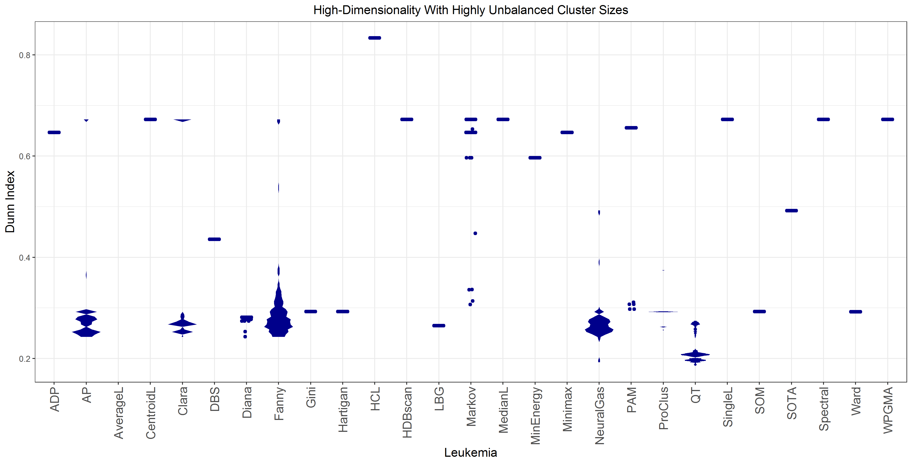
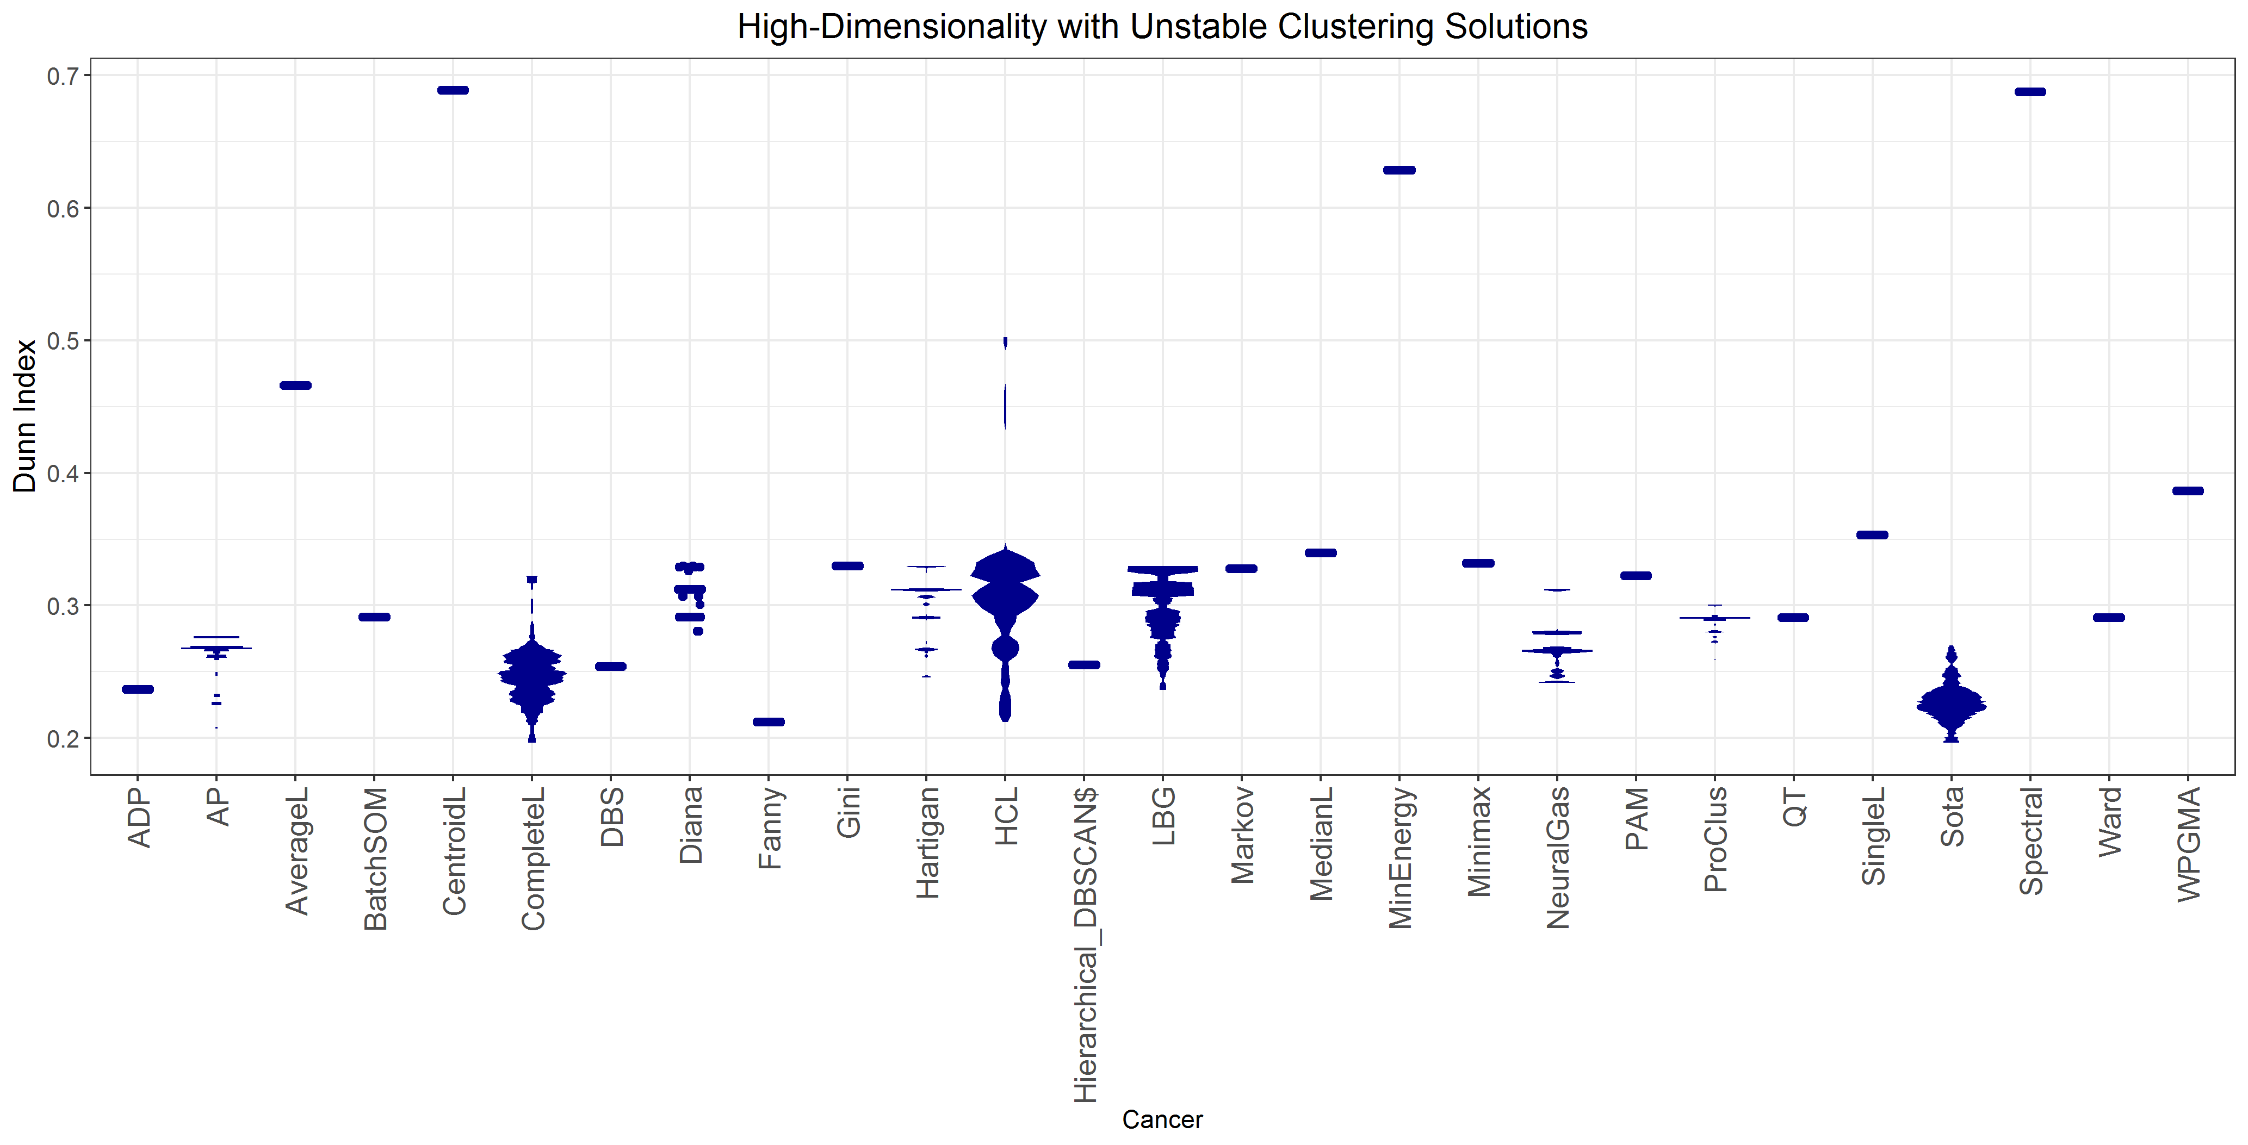
Supplementary Fig. 16. MD-plot of the Dunn index¹⁷ for the leukaemia (top) and cancer (bottom) datasets yields misleading results. In the case of the leukaemia dataset, HCL clustering was selected, and in the case of the cancer dataset, CentroidL or Spectral was selected. It should be noted that Dunn suggests values above 1 as appropriate for clustering¹⁷.

SI F: Clustering Algorithms Used in Benchmarking
Supplementary Table 2 presents the algorithms selected for this work based on¹⁸ and whether the variance of the results can be expected based in the results of this work. It should be noted that the authors were unable to implement transitivity clustering¹⁹.
Supplementary Table 1. Overview of the clustering algorithms used in benchmarking, their abbreviations, whether they require the number of clusters (NOC) to be set, whether they accept data or distances as input, the number of non-default parameters N, whether the variance of the results can be expected, and the authors of the algorithms.
Abbreviations | Algorithm | NOC | DOD | N | Variance | Authors
ADP | Adaptive Density Peak | Yes | Data | 1 | Yes | Rodriguez and Laio²⁰ and Wang and Xu²¹
AP | Affinity Propagation | No | Both | 0 | No | Bodenhofer et al.²² and Frey and Dueck²³
AverageL | Average Linkage | Yes | Both | 1 | No | Sokol and Michener²⁴
CentroidL | Centroid Linkage | Yes | Both | 1 | No | Sokol and Michener²⁴
Clara | Large Application Clustering | Yes | Data | 1 | Yes | Rousseeuw and Kaufman²⁵
CompleteL | Complete Linkage | Yes | Both | 1 | No | Defays²⁶ and Lance and Williams²⁷
CrossEntropy | Cross-Entropy Clustering | Yes | Data | 1 | Yes | Spurek et al.²⁸ and Tabor and Spurek²⁹
DBS | Databionic Swarm | Yes | Both | 1 | Yes | Thrun and Ultsch³⁰
Diana | Divisive Analysis Clustering | Yes | Both | 1 | No | Rousseeuw and Kaufman²⁵
Fanny | Fuzzy Analysis Clustering | Yes | Both | 1 | No | Rousseeuw and Kaufman²⁵
Gini | Genie Clustering by the Gini Index | Yes | Both | 1 | Yes | Gagolewski et al.³¹
Hartigan | Hartigan k-Means | Yes | Data | 1 | Yes | Hartigan and Wong³²
HCL | Hard Competitive Learning (Online Update) | Yes | Data | 1 | Yes | Ripley³³
HDBSCAN | Hierarchical DBSCAN | No² | Both | 0 | No | Campello et al.³⁴ and Hahsler et al.³⁵
LBG | LBG k-means | Yes | Data | 1 | Yes | Linde et al.³⁶
Markov | Markov Clustering | No | Both | 1 | No | Van Dongen³⁷
MedianL | Median Linkage | Yes | Both | 1 | No | Everitt et al.³⁸ and Lance and Williams³⁹
MinEnergy | Minimal Energy | Yes | Both | 1 | No | Szekely and Rizzo⁴⁰
Minimax | Minimax Linkage | Yes | Both | 1 | Yes | Azzalini and Torelli⁴¹
ModelBased | Model-Based Clustering | Yes | Data | 1 | No | Fraley and Raftery⁴²
Neural Gas | Neural Gas | Yes | Data | 1 | Yes | Martinetz et al.⁴³
Orclus | Orclus | Yes | Data | 1 | Yes | Aggarwal and Yu⁴⁴
PAM | Partitioning Around Medoids | Yes | Both | 1 | Yes | Rousseeuw and Kaufman²⁵
ProClus | ProClus | Yes | Data | 1 | Yes | Aggarwal et al.⁴⁵
PPC | Projection Pursuit Clustering | Yes | Data | 1 | No | Hofmeyr and Pavlidis⁴⁶
QT | Stochastic Quality Clustering | No | Data | 1 | Yes | Heyer et al.⁴⁷
RTC | Robust Trimmed Clustering | Yes | Data | 2 | Yes | Fritz et al.⁴⁸ and García-Escudero et al.⁴⁹
SingleL | Single Linkage | Yes | Both | 1 | No | Florek et al.⁵⁰
SOM | Self-Organizing Maps | Yes | Data | 2 | Yes | Wehrens and Buydens⁵¹
Spectral | Spectral clustering | Yes | Data | 1 | Yes | Ng et al.⁵²
Spectrum | Fast Adaptive Spectral Clustering | Yes³ | Data | 0-1 | No | John et al.⁵³
Ward | Ward | Yes | Both | 1 | No | Murtagh and Legendre⁵⁴ and Ward Jr.⁵⁵
WPGMA | McQuitty Clustering | Yes | Both | 1 | No | McQuitty⁵⁶

1. Thrun, M. C. The Exploitation of Distance Distributions for Clustering. International Journal of Computational Intelligence and Applications accepted, (2021).
2. Haferlach, T. et al. Clinical utility of microarray-based gene expression profiling in the diagnosis and subclassification of leukemia: report from the International microarray innovations in leukemia study group. J. Clin. Oncol. 28, 2529-2537 (2010).
3. Lo-Coco, F. et al. Retinoic acid and arsenic trioxide for acute promyelocytic leukemia. N. Engl. J. Med. 369, 111-121 (2013).
4. Venna, J., Peltonen, J., Nybo, K., Aidos, H. & Kaski, S. Information retrieval perspective to nonlinear dimensionality reduction for data visualization. J. Mach. Learn. Res. 11, 451-490 (2010).
5. Ultsch, A. & Thrun, M. C. in 12th International Workshop on Self-Organizing Maps and Learning Vector Quantization, Clustering and Data Visualization (WSOM) (Eds. Cottrell, M.) 1-5 (IEEE, Nany, France, 2017).
6. Thrun, M. C. Projection Based Clustering through Self-Organization and Swarm Intelligence (Springer, Heidelberg, 2018).
7. Ultsch, A. & Lötsch, J. Machine-learned cluster identification in high-dimensional data. J. Biomed. Inform. 66, 95-104 (2017).
8. Weinstein, J. N. et al. The cancer genome atlas pan-cancer analysis project. Nat. Genet. 45, 1113-1120 (2013).
9. Lichman, M. UCI Machine Learning Repository (University of California, School of Information and Computer Science, Irvine, CA, 2013).
10. Davies, D. L. & Bouldin, D. W. A cluster separation measure. IEEE Trans. Pattern Anal. Mach. Intell. 1, 224-227 (1979).
11. Duda, R. O., Hart, P. E. & Stork, D. G. Pattern Classification (John Wiley & Sons, Ney York, NY, 2001).
12. Handl, J., Knowles, J. & Kell, D. B. Computational cluster validation in post-genomic data analysis. Bioinformatics 21, 3201-3212 (2005).
13. Hennig, C., Meila, M., Murtagh, F. & Rocci, R. Handbook of cluster analysis (Chapman & Hall/CRC Press, New York, NY, 2015).
14. Mirkin, B. G. Clustering: A Data Recovery Approach (Chapnman & Hall/CRC, Boca Raton, FL, 2005).
15. Theodoridis, S. & Koutroumbas, K. Pattern Recognition (Elsevier, Canada, 2009).
16. Rousseeuw, P. J. Silhouettes: a graphical aid to the interpretation and validation of cluster analysis. J. Comput. Appl. Math. 20, 53-65 (1987).
17. Dunn, J. C. Well-separated clusters and optimal fuzzy partitions. J. Cybern. 4, 95-104 (1974).
18. Thrun, M. C. & Stier, Q. Fundamental Clustering Algorithms Suite SoftwareX 13, 100642 (2021).
19. Wittkop, T. et al. Partitioning biological data with transitivity clustering. Nat. Methods 7, 419 (2010).
20. Rodriguez, A. & Laio, A. Clustering by fast search and find of density peaks. Science 344, 1492-1496 (2014).
21. Wang, X.-F. & Xu, Y. Fast clustering using adaptive density peak detection. Stat. Methods Med. Res. 26, 2800-2811 (2017).
22. Bodenhofer, U., Kothmeier, A. & Hochreiter, S. APCluster: an R package for affinity propagation clustering. Bioinformatics 27, 2463-2464 (2011).
23. Frey, B. J. & Dueck, D. Clustering by passing messages between data points. science 315, 972-976 (2007).
24. Sokol, R. & Michener, C. A statistical method for evaluating systematic relationships. Kans. Sci. Bull. 28, 1409-1438 (1958).
25. Rousseeuw, P. J. & Kaufman, L. Finding Groups in Data (John Wiley & Sons Inc, Belgium, 1990).
26. Defays, D. An efficient algorithm for a complete link method. Comput. J. 20, 364-366 (1977).
27. Lance, G. N. & Williams, W. T. A general theory of classificatory sorting strategies: 1. Hierarchical systems. Comput. J. 9, 373-380 (1967).
28. Spurek, P., Kamieniecki, K., Tabor, J., Misztal, K. & Śmieja, M. R package cec. Neurocomputing 237, 410-413 (2017).
29. Tabor, J. & Spurek, P. Cross-entropy clustering. Pattern Recognit. 47, 3046-3059 (2014).
30. Thrun, M. C. & Ultsch, A. Swarm intelligence for self-organized clustering. Artif. Intell. 290, 103237 (2020).
31. Gagolewski, M., Bartoszuk, M. & Cena, A. Genie: a new, fast, and outlier-resistant hierarchical clustering algorithm. Inf. Sci. 363, 8-23 (2016).
32. Hartigan, J. A. & Wong, M. A. Algorithm AS 136: a k-means clustering algorithm. J. R. Stat. Soc. C (Appl. Stat.) 28, 100-108 (1979).
33. Ripley, B. D. Pattern recognition and neural networks (Cambridge university press, 2007).
34. Campello, R. J., Moulavi, D., Zimek, A. & Sander, J. Hierarchical density estimates for data clustering, visualization, and outlier detection. ACM Trans. Knowl. Discov. Data (TKDD) 10, 1-51 (2015).
35. Hahsler, M., Piekenbrock, M. & Doran, D. dbscan: fast density-based clustering with r. J. Stat. Softw. 25, 409-416 (2019).
36. Linde, Y., Buzo, A. & Gray, R. An algorithm for vector quantizer design. IEEE Trans. Commun. 28, 84-95 (1980).
37. Van Dongen, S. M. Graph Clustering by Flow Simulation (Universiteit Utrecht, Utrecht, Netherlands, 2000).
38. Everitt, B. S., Landau, S., Leese, M. & Stahl, D. in Cluster Analysis (Eds. Everitt, B. S., Landau, S., Leese, M. & Stahl, D.) 71-110 (John Wiley & Sons, Hoboken, NJ, 2011).
39. Lance, G. N. & Williams, W. T. Computer programs for hierarchical polythetic classification (“similarity analyses”). Comput. J. 9, 60-64 (1966).
40. Szekely, G. J. & Rizzo, M. L. Hierarchical clustering via joint between-within distances: extending ward's minimum variance method. J. Classif. 22, 151-183 (2005).
41. Azzalini, A. & Torelli, N. Clustering via nonparametric density estimation. Stat. Comput. 17, 71-80 (2007).
42. Fraley, C. & Raftery, A. E. MCLUST Version 3: An R Package for Normal Mixture Modeling and Model-Based Clustering. Technical Report No. 504 (Department of Statistics, University of Washington, Seattle, US, 2006).
43. Martinetz, T. M., Berkovich, S. G. & Schulten, K. J. 'Neural-gas' network for vector quantization and its application to time-series prediction. IEEE Trans. Neural Netw. 4, 558-569 (1993).
44. Aggarwal, C. C. & Yu, P. S. in Proceedings of the 2000 ACM SIGMOD international conference on Management of data 70-81 2000).
45. Aggarwal, C. C., Wolf, J. L., Yu, P. S., Procopiuc, C. & Park, J. S. in ACM SIGMOD International Conference on Management of Data 61-72 (Association for Computing Machinery, Philadelphia, Pennsylvania, USA, 1999).
46. Hofmeyr, D. & Pavlidis, N. PPCI: an R package for cluster identification using projection pursuit. R J. 11, 152-170 (2019).
47. Heyer, L. J., Kruglyak, S. & Yooseph, S. Exploring expression data: identification and analysis of coexpressed genes. Genome Res. 9, 1106-1115 (1999).
48. Fritz, H., Garcıa-Escudero, L. A. & Mayo-Iscar, A. tclust: an R package for a trimming approach to cluster analysis. J. Stat. Softw. 47, 1-26 (2012).
49. García-Escudero, L. A., Gordaliza, A., Matrán, C. & Mayo-Iscar, A. A general trimming approach to robust cluster analysis. Ann. Stat. 36, 1324-1345 (2008).
50. Florek, K., Łukaszewicz, J., Perkal, J., Steinhaus, H. & Zubrzycki, S. in Colloquium Mathematicae 282-285 (Institute of Mathematics Polish Academy of Sciences, Poland, 1951).
51. Wehrens, R. & Buydens, L. M. Self-and super-organizing maps in R: the Kohonen package. J. Stat. Softw. 21, 1-19 (2007).
52. Ng, A. Y., Jordan, M. I. & Weiss, Y. On spectral clustering: analysis and an algorithm. Adv. Neural Inf. Process. Syst. 2, 849-856 (2002).
53. John, C. R., Watson, D., Barnes, M. R., Pitzalis, C. & Lewis, M. J. Spectrum: Fast density-aware spectral clustering for single and multi-omic data. Bioinformatics 36, 1159-1166 (2020).
54. Murtagh, F. & Legendre, P. Ward’s hierarchical agglomerative clustering method: which algorithms implement Ward’s criterion? J. Classif. 31, 274-295 (2014).
55. Ward Jr, J. H. Hierarchical grouping to optimize an objective function. J. Am. Stat. Assoc. 58, 236-244 (1963).
56. McQuitty, L. L. Similarity analysis by reciprocal pairs for discrete and continuous data. Educ. Psychol. Meas. 26, 825-831 (1966).

an R implementation does not exist and the ClustEval link (https://clusteval.sdu.dk/1/programs) is broken

