Supplementary Information
Culture conditions for bacterial inoculants
Bacterial isolates stored within 12.5% glycerol at -80oC were removed from the freezer and thawed on ice. Once thawed, isolate was gently vortexed for 10s, 10ul of the isolate-glycerol solution was pipetted into a sterile marine broth agar plate and raked. Bacterial stock solution was then return to the freezer and the plate was placed into an incubator set to 25oC overnight. The following day, the plates were checked to ensure that only 1 morphological form had grown, an individual colony was picked using a sterile inoculating loop and placed into 25ml of liquid marine broth. The solution was vortexed and then placed on a shaker tray set to 100rpm. The culture was grown until it reached a cell density of 5×10⁸ CFU (i.e., culture was in a stationary phase) which was confirmed using spectroscopy(OD ~ 0.600).

Determination of isolate attachment success and custom primers
Inoculation success was tested for both candidate inoculants (Vibrio genomosp and Vibrio Chagasii). This was done by exposing 60 individuals of Hormosira for each inoculant to cell suspensions (cell density 5×10⁸ CFU) of Vibrio genomosp and Vibrio Chagasii for varying lengths of time (5, 15, 30, 60, 120 and 240 minutes). At each timepoint 10 individuals were rinsed with AFSW and swabbed using protocols described in the methods. DNA was extracted using a powersoil pro kit (Qiagen) and qPCR used to determine the abundance of the isolates attached. Custom primers were used; Vibrio genomosp (F) (5’-TCAGCGCCTTTGCTATCGGA-3’), (R) (5’-TGCGGATGGCAGTGAGACAT-3’) and (PRB) (‘5- /56-FAM/TCAGAAGCC/ZEN/ATAGTCGGGAGTAGCC/3IABkFQ/-3’); and Vibrio chagasii (F) (‘5- TACCGCTGACGAAGTATCGC-3’), (R) (‘5- TTCGCATTCCTCGGGTTTCA-3’) and (PRB) (‘5- /56-FAM/TCATGTCCC/ZEN/AGTGTTGTCGCCAAT/3IABkFQ/-3’). 60 minutes was chosen as the appropriate length of time as within both inoculants there was the greatest attachment at this timepoint.

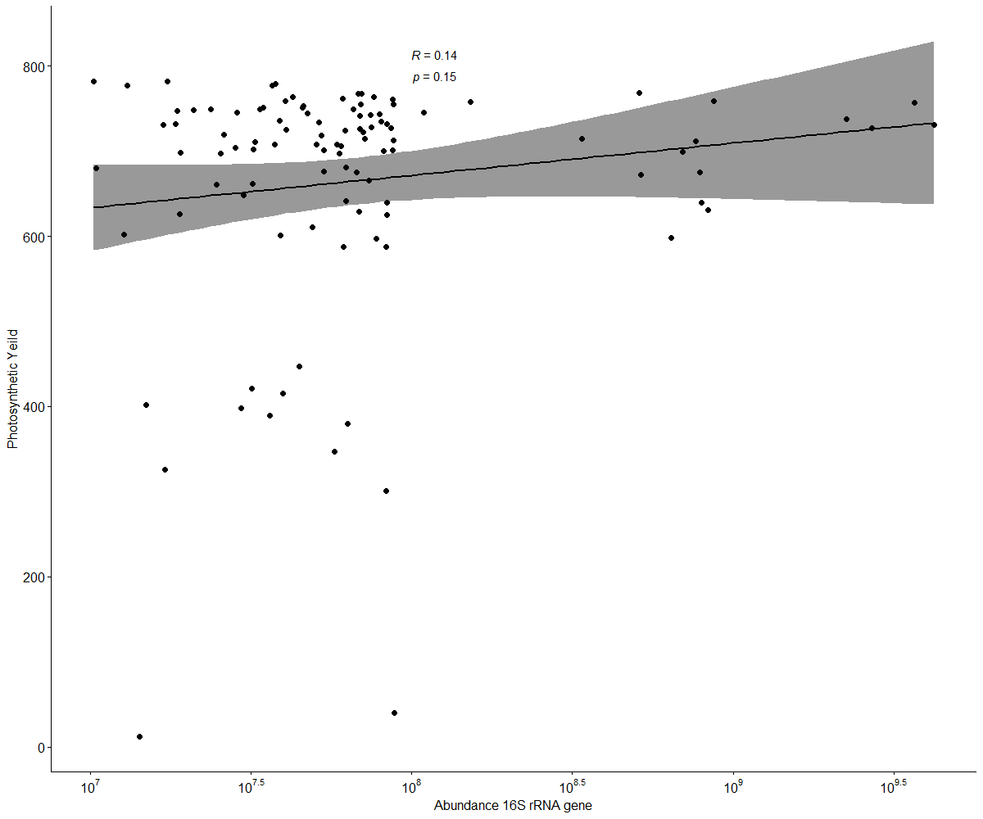
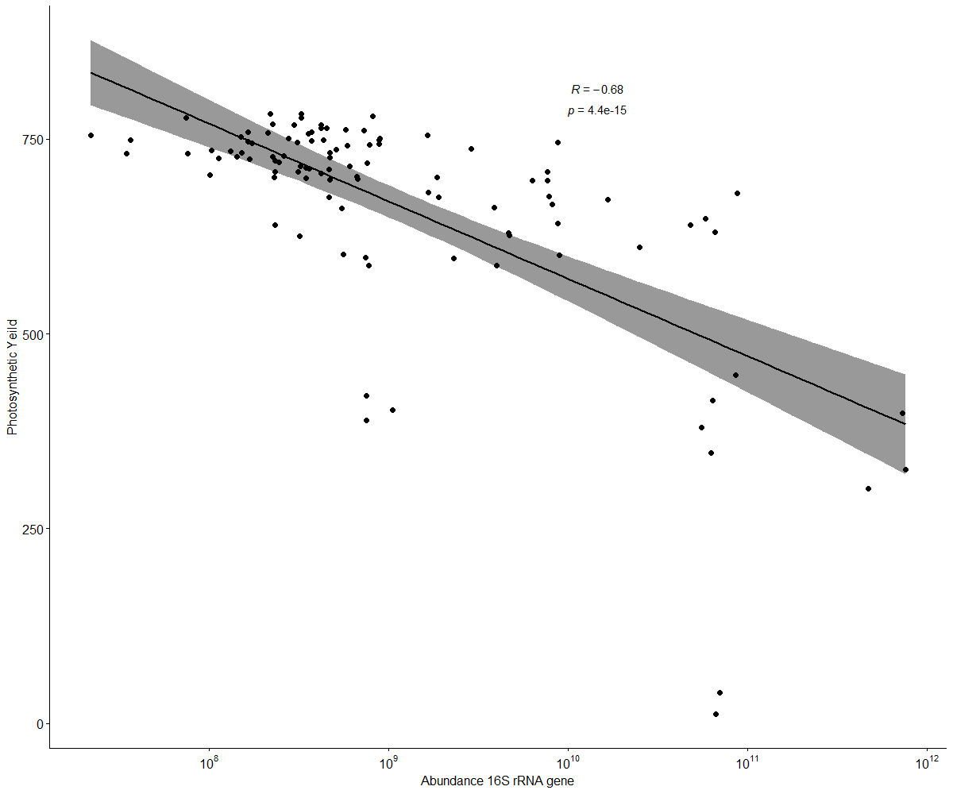
Supplementary figure 1 – Correlation plots between isolates (a) Vibrio genomosp sp and (b) Vibrio chagasii and host function (Photosynthetic yield)
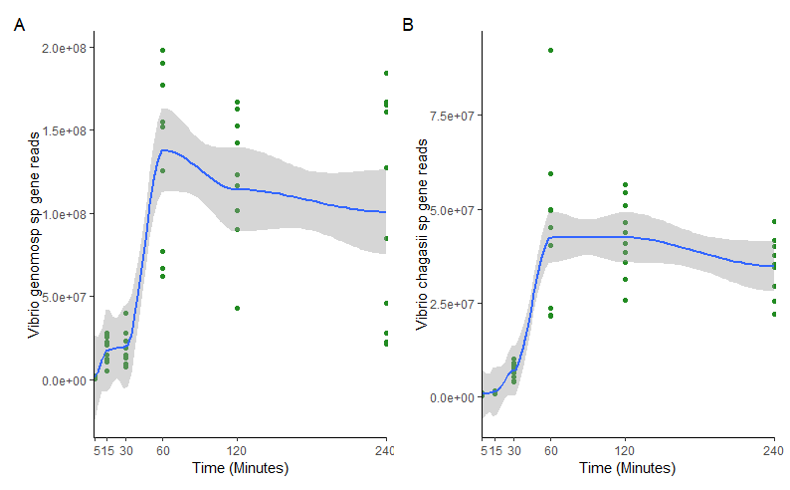

Supplementary figure 2 – Abundances of gene reads extracted from qPCR data using custom primers (A) Vibrio genomosp sp and (B) Vibrio chagasii.

.

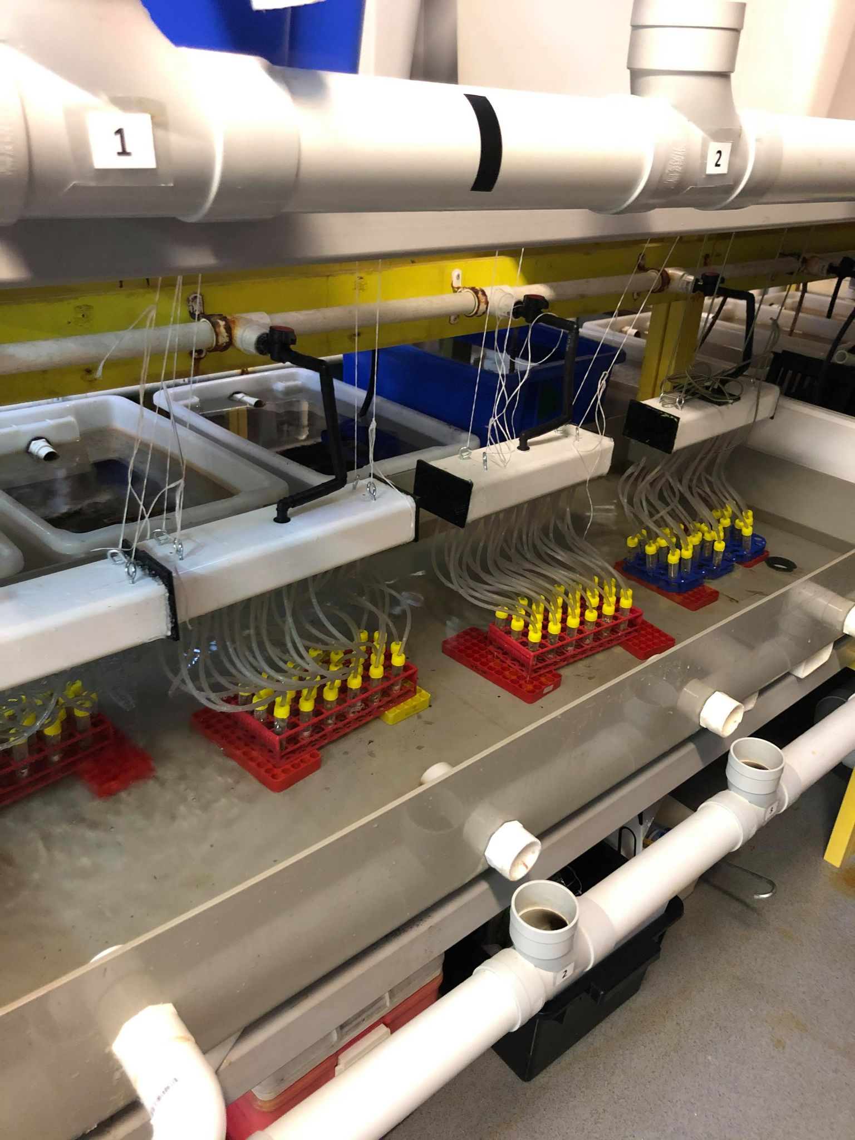
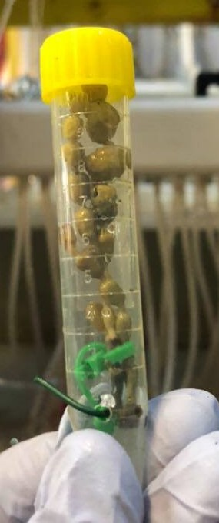
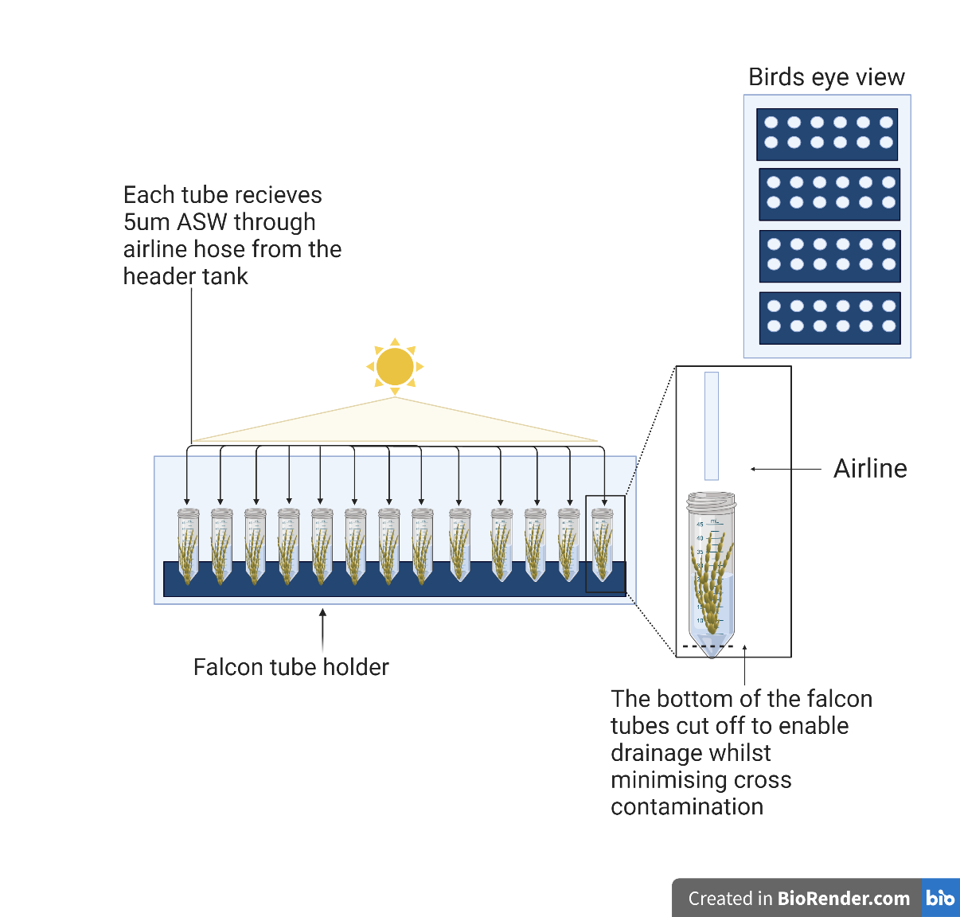
A)
B)

Supplementary figure 3 – Experimental setup showing schematic diagram (A) alongside actual setup (B). Each individual algal was attached by their holdfast to the bottom of a 15ml falcon tube. Each tube is then fed an individual and constant supply of 5um filtered seawater

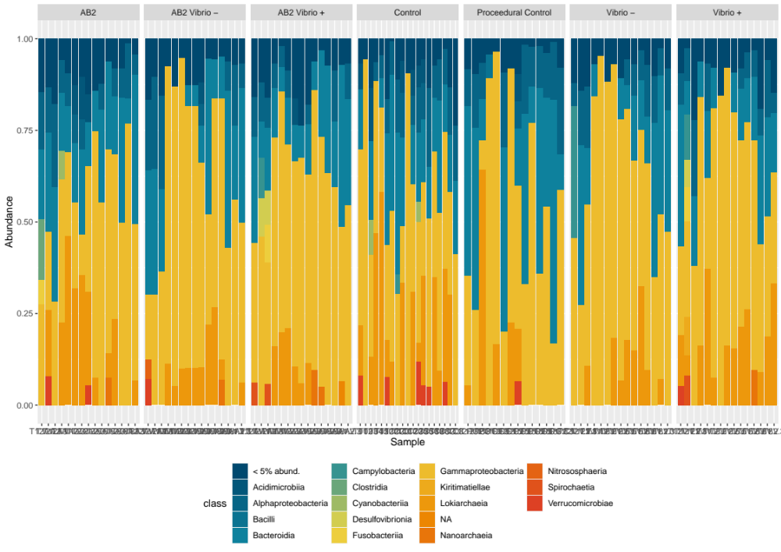
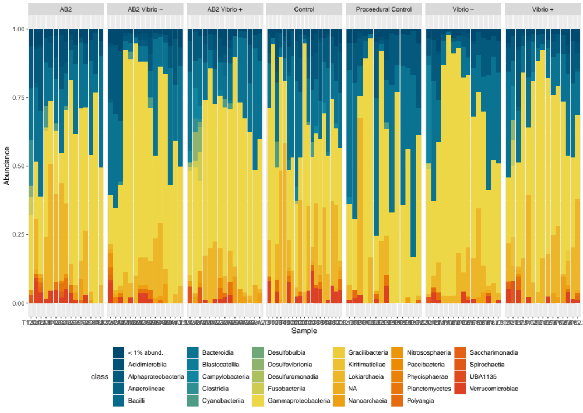

Supplementary figure 3 –Plots showing the abundances of bacterial taxa within each treatment.

Table S1; Description of treatments used within the 3 experiments (Mesocosm, Field and Inoculation)
Experiment | a) Abbreviation | b) Treatment’s specification | c) Treatment application | d) Sampling times for amplicon sequencing | e) Sampling times for Photosynthetic yield
Mesocosm experiment | AB1 | Antiobiotic treatement 1: Penincilin (100mg/L)/Streptomycin(25mg/L)/Norfloxacin (1mg/L)/Kanamycin (25mg/L) | 24 hours in antibiotic solution and rinsed with AFSW | Day 1 (24hours after antibiotic treatement- 06/12/2018); day 2 (7/12/2018); day 5(10/12/2018); day 12 (17/12/2018) | Day 0 (before antibiotic treatment- 05/12/2018); day 1 (24hours after antibiotic treatement- 06/12/2018); day 2 (7/12/2018); day 5 (10/12/2018); day 7 (12/12/2018); day 12 (17/12/2018); day 16(21
Mesocosm experiment | AB2 | Antiobiotic treatement 2: Penincilin (100mg/L)/Neomycin(100mg/L)/Rifampicin(50mg/L) | 24 hours in antibiotic solution and rinsed with AFSW
Mesocosm experiment | AB3 | Antiobiotic treatement 3: Penincilin (100mg/L)/Streptomycin(25mg/L)/Norfloxacin (1mg/L)/Kanamycin (25mg/L)/ Neomycin(100mg/L)/ Chloramphenicol (10mg/L) | 24 hours in antibiotic solution and rinsed with AFSW
Mesocosm experiment | Control | Control (no antibiotics ) | 24 hours in AFSW and rinsed with AFSW at the same time then rinsing of antibiotic treatements
Field experiment | AB2 | Antibiotic treatement 2 (as in laboratory experiment but higher concentrations): Penincilin (900mg/L)/Neomycin(900mg/L)/Rifampicin(600mg/L) | Quick AFSW rinse and application of AB2 for 2 hours and thorough rinse with AFSW | Day 0 (before applying any treatment- 13/05/19); day 2 (2 days after treatment application- 15/05/19); day 9 (22/05/19); day 21 (03/06/19); day 45 (27/06/19) | Day 0 (before applying any treatment- 13/05/19); day 2 (2 days after treatment application- 15/05/19); day 4 (17/05/19); day 7 (20/05/19); day 9 (22/05/19); day 14 (27/05/19); day 16 (29/05/19); day 21 (03/06/19); day 28 (10/06/19); day 36 (18/06/19); day 40 (22/06/19); day 45 (27/06/19)
Field experiment | BetO | Betadine applied once (Povidone iodine solution 10%) | Quick AFSW rinse and application of Betadine for 2 hours and thorough rinse with AFSW
Field experiment | BetM | Betadine applied multiple times (Povidone iodine solution 10%) | Quick AFSW rinse and application of Betadine for 15 minutes and rinsed with AFSW. Same process performed approx. every 2 days (same days then photosynthetic yield sampling see column e)
Field experiment | ProcContO | Procedural control for AB and CBetO | Quick AFSW rinse and application of AFSW for 2 hours and thorough rinse with AFSW
Field experiment | ProcContM | Procedural control for BetM | Quick AFSW rinse and application of AFSW for 15 minutes and rinsed with AFSW. Same process performed approx. every 2 days (same days then BetM and photosynthetic yield sampling see column e)
Field experiment | Control | General control | Quick AFSW rinse
Inoculation experiment | AB2 | Antibiotic treatment 2: Penincilin (100mg/L)/Neomycin(100mg/L)/Rifampicin(50mg/L) | Quick AFSW rinse and application of AB2 for 25 hours and thorough rinse with AFSW | Day 0 (Before treatment), Day 1, Day 2, Day 5, Day 8, Day 12
Inoculation experiment | AB2 V+ | Antibiotic treatment with Active inoculant | microbiome disruption with antibiotic combination (AB2) for 24 hours followed by “active” inoculant (Vibrio genomosp, Cell density 5×10⁸ CFU) for 1 hour,
Inoculation experiment | AB2 V- | Antibiotic treatment with Control inoculant | microbiome disruption with antibiotic combination (AB2) for 24 hours followed by control inoculant (Vibrio chagsii sp. Cell density 5×10⁸ CFU) for 1 hour,
Inoculation experiment | Vibrio + | Active inoculant | microbiome left intact (AFSW) for 24 hours followed by “active” inoculant (Vibrio genomosp,Cell density 5×10⁸ CFU) for 1 hour
Inoculation experiment | Vibrio - | Control Inoculant | microbiome left intact (AFSW) for 24 hours followed by control inoculant (Vibrio chagsii sp. Cell density 5×10⁸ CFU) for 1 hour
Inoculation experiment | PC | Procedural control | Algae left in AFSW for 25Hrs
Inoculation experiment | C | Control | Algae left in aquarium during treatment

Table S2 Method of action and key bacterial targets of antibiotics used
Antibiotic | Method of Action | Bacterial target | Half Life | References | Antibiotic mix
Penincilin | Inhibition of transpeptidase -inhibition of cell wall biosynthesis | Gram-positive bacteria | 0.4-0.9 hrs | Tipper and Trominger, 1965; Waxman et al 1980; Sass, 2023 | 1,2,3
Streptomycin | Interference with ribosomal peptide synthesis | Limited aerobic bacteria due to antibiotic resistance | 2.5hrs | Demirci et al 2013 | 1, 3
Norfloxacin | Inhibits DNA gyrase | Most gram-negative and gram-positive bacteria | 3-4hrs | Goldstein 1987 | 1, 3
Kanamycin | Binding to bacterial 30S and 16S ribosomal subunit – causes misreading of t-RNA | Gram-negative bacteria | 2.5hrs | Brezden et al 2016 | 1, 3
Neomycin | Binding to bacterial 30S ribosomal subunit – inhibits elongation of peptide synthesis | Gram-negative bacteria | N/A | Veirup et al 2022; Patidar et al 2013 | 2
Rifampicin | Inhibits DNA-dependant RNA-polymerase | Gram-positive cocci | 3.5hrs | Campbell et al 2001; McClure et al 1978 | 2
Chloramphenicol | Bacteriostatic inhibitor of protein synthesis – binds to bacterial 50S ribosomal subunit | Gram-positive and gram-negative bacteria | 1.5-3.5hrs | Brook et al 2016; Dinos et al 2016 | 3

Table S3. Statistical results. Analysis of Variance (ANOVA) tests comparing maximum photosynthetic yields of Hormosira banksii across sampling time points and different treatments for the mesocosm experiment
Source | Df | Sum of Sq | Mean Sq | F | P-Value
Treatment | 3 | 0.041843 | 0.0139476 | 20.645 | 5.30E-10
Sampling time | 3 | 0.42831 | 0.0142768 | 21.133 | 3.54E-10
Treatment*Sampling time | 9 | 0.11584 | 0.0128712 | 19.052 | <2.2E-16
Residual | 80 | 0.054047 | 0.0006756

Table S4; Post-hoc analysis comparing maximum photosynthetic yields of Hormosira banksii across sampling time points and different treatments for the mesocosm experiment
Days | Treatment comparison | estimate | SE | df | t.ratio | p.value
0d | No Significant differences
1d
2d
5d | AB2-AB1 | 0.085644 | 0.015 | 80 | 5.707 | <.0001
 | AB3-AB2 | 0.082365 | 0.015 | 80 | 5.489 | <.0001
 | Control-AB2 | 0.088333 | 0.015 | 80 | -5.886 | <.0001
9d
12d | AB2-AB1 | 0.085644 | 0.015 | 80 | 5.707 | <.0001
 | AB3-AB1 | 0.168009 | 0.015 | 80 | 11.196 | <.0001
 | AB3-AB2 | 0.082365 | 0.015 | 80 | 5.489 | <.0001
 | Control-AB2 | -0.088333 | 0.015 | 80 | -5.886 | <.0001
 | Control-AB3 | -0.170698 | 0.015 | 80 | -11.375 | <.0001

Table S5; Statistical results. Analysis of Variance (ANOVA) tests comparing maximum photosynthetic yields of Hormosira banksii across sampling time points and different treatments for the field experiment
Source | Df | Sum of Sq | Mean Sq | F | P-Value
Treatment | 5 | 0.21121 | 0.042241 | 5.6901 | 7.30E-05
Sampling time | 4 | 0.15841 | 0.039604 | 5.3348 | 4.63E-04
Treatment*Sampling time | 20 | 0.65118 | 0.032559 | 4.3859 | 4.29E-08
Residual | 162 | 1.20263 | 0.007424

Table S6; Post-hoc analysis comparing maximum photosynthetic yields of Hormosira banksii across sampling time points and different treatments for the field experiment
Days | Treatment comparison | estimate | SE | df | t.ratio | p.value
0d | No Significant differences
1d
2d
5d
9d | Control-AB | -0.15014 | 0.0461 | 162 | -3.260 | 0.0168
 | ProcContM-BetM | 0.19557 | 0.0461 | 162 | 4.247 | 0.0005
 | ProcContM-BetO | 0.21157 | 0.0461 | 162 | 4.594 | 0.0001
12d
21d | BetM-AB | -0.18786 | 0.0461 | 162 | -4.079 | 0.0010
21d | BetO-AB | -0.26243 | 0.0461 | 162 | -5.698 | <.0001
21d | ProcContM-AB | -0.25743 | 0.0461 | 162 | -5.590 | <.0001
21d | ProcContO-AB | -0.24914 | 0.0461 | 162 | -5.410 | <.0001
21d | Control-AB | -0.28300 | 0.0461 | 162 | -6.145 | <.0001
45d | BetM-AB | 0.19525 | 0.0609 | 162 | 3.205 | 0.0199
 | Control-BetM | -0.186750 | 0.0583 | 378 | -3.201 | 0.0185

Table S7 Statistical results. ANOVA results for analysis of bacterial community alpha diversity measures: number of species and Simpson index in Hormosira banksii individuals within the mesocosm experiment.
Source |  | Df | Sum of Sq | Mean Sq | F | P-value
Treatment |  | 3 | 73457 | 24486 | 6.0464 | 0.00221
Sampling time |  | 6 | 132847 | 44282 | 10.9348 | 4.22e-05
Treatment x Sampling time |  | 9 | 38336 | 4260 | 1.0518 | 0.42293
Residual |  | 32 | 129589 | 4050

Table S8. Statistical results. ANOVA results for analysis of bacterial community alpha diversity measures: number of species and Simpson index in Hormosira banksii subject to different treatments across time in the field). Post-hoc pairwise comparisons are also presented (only showing results of time points and treatments with significant differences).
Source | effect size | Df | Sum of Sq | Mean Sq | F | P-value
Treatment | 0.15 | 5 | 101780 | 20356 | 4.9231 | 0.0004984
Sampling time | 0.21 | 4 | 143095 | 35774 | 8.6519 | 5.911e-06
Treatment x Sampling time |  | 20 | 69236 | 3462 | 0.8372 | 0.6631976
Residual |  | 98 | 372129 | 4135
Pairwise test
Treatment | AB2 - Control | p<0.005**
 | AB2 - CBetM | p<0.5*
 | AB2 -CBetO | p<0.5*
 | BetM - Control | p<0.5*
 | BetM- CBetO | p<0.5*

Table S9; PERMANOVAs based on Bray–Curtis Similarity measure for square root-transformed relative abundance (9999 permutations) of bacterial communities (Zotus) in Hormosira banksii across sampling time points and different treatments the mesocosm experiment. Table S1 has the treatments used. Significant p values(p<0.05) are highlighted in bold and italics.
Source | df | SS | MS | Pseudo-F | P(perm) | perms
Treatment | 3 | 5699.3 | 1899.8 | 2.1882 | 0.0001 | 9798
Sampling time | 3 | 19463 | 6487.7 | 7.4726 | 0.0001 | 9884
Treatment x Sampling time | 9 | 10151 | 1127.9 | 1.2991 | 0.0014 | 9677
Tank | 6 | 1059 | 176.5 | 1.862 | 0.3298 | 9786
Residual | 32 | 27782 | 868.19
Total | 47 | 63095

Table S10; Pairwise contrasts on PERMANOVAs based on Bray–Curtis Similarity measure for square root-transformed relative abundance (9999 permutations) of bacterial communities (Zotus) in Hormosira banksii across sampling time points and different treatments the mesocosm experiment.
Pairwise test | Days | Treatment comparison
Treatment x Sampling time | 12d | AB2 - AB1 | p<0.005**
 | 12d | AB3 - Control | p<0.5*
 | 12d | AB3 - AB1 | p<0.005**
Treatment | AB2 - Control | p<0.005**
 | AB2 - AB1 | p<0.005**
 | AB2 - AB3 | p<0.5*

Table S11. PERMANOVAs based on Bray–Curtis Similarity measure for square root-transformed relative abundance (9999 permutations) of bacterial communities (Zotus) in Hormosira banksii across sampling time points and different treatments the field experiment. Table S1 has the treatments used. Significant p values(p<0.05) are highlighted in bold and italics.
Source | df | SS | MS | Pseudo-F | P(perm) | perms
Treatment | 5 | 22032 | 4406.4 | 7.6284 | 0.0001 | 9811
Sampling time | 4 | 33213 | 8303.2 | 14.374 | 0.0001 | 9846
Treatment x Sampling time | 20 | 26297 | 1314.9 | 2.2763 | 0.0001 | 9591
Residual | 90 | 51987 | 577.64
Total | 119 | 133530

Table S12. PERMANOVAs based on Bray–Curtis Similarity measure for square root-transformed relative abundance (9999 permutations) of bacterial communities (Zotus) in Hormosira banksii across sampling time points and different treatments the field experiment. Table S1 has the treatments used. Significant p values(p<0.05) are highlighted in bold and italics.
Days | Treatement comparison | t |  | P(perm) |  | perms |  | P(MC)
0d | No significant differences
2d | BetO- ProcContO | 2.3292 |  |  | 0.0292 |  | 35 |  | 0.0076
 | BetO- ProcContM | 2.265 |  |  | 0.0292 |  | 35 |  | 0.0091
 | BetO- Control | 2.1701 |  |  | 0.0247 |  | 35 |  | 0.0135
 | ProcContO- BetM | 2.8772 |  |  | 0.0265 |  | 35 |  | 0.0033
 | ProcContO- AB |  | 1.9269 |  | 0.0289 |  | 35 |  | 0.0142
 | BetM- ProcContM | 2.6858 |  |  | 0.0294 |  | 35 |  | 0.0033
 | BetM- Control | 2.446 |  |  | 0.03 |  | 35 |  | 0.0068
 | BetM- AB |  | 1.7065 |  | 0.0279 |  | 35 |  | 0.0543
 | ProcContM- AB | 1.8055 |  |  | 0.0308 |  | 35 |  | 0.0188
 | Control- AB |  | 1.5982 |  | 0.0298 |  | 35 |  | 0.0419
9d | BetO- BetM |  | 2.7522 |  | 0.0319 |  | 35 |  | 0.0026
 | BetO- Control | 1.7677 |  |  | 0.0292 |  | 35 |  | 0.026
 | BetO- AB |  | 1.7588 |  | 0.0296 |  | 35 |  | 0.0366
 | ProcContO- BetM | 3.2668 |  |  | 0.0287 |  | 35 |  | 0.0012
 | ProcContO- AB | 1.8704 |  |  | 0.0303 |  | 35 |  | 0.0195
 | BetM- ProcContM | 3.5876 |  |  | 0.0312 |  | 35 |  | 0.0007
 | BetM- Control | 3.4544 |  |  | 0.0275 |  | 35 |  | 0.0008
 | BetM- AB |  | 2.589 |  | 0.0313 |  | 35 |  | 0.0049
 | ProcContM- AB | 2.013 |  |  | 0.0273 |  | 35 |  | 0.0152
 | Control- AB |  | 1.8592 |  | 0.0256 |  | 35 |  | 0.0198
21d | BetO- BetM |  | 3.0037 |  | 0.0292 |  | 35 |  | 0.0024
 | ProcContO- BetM | 3.5358 |  |  | 0.0313 |  | 35 |  | 0.0009
 | ProcContO- AB | 1.6949 |  |  | 0.0285 |  | 35 |  | 0.0299
 | BetM- ProcContM | 4.3121 |  |  | 0.0281 |  | 35 |  | 0.0008
 | BetM- Control | 3.2017 |  |  | 0.0285 |  | 35 |  | 0.0013
 | BetM- AB |  | 2.7522 |  | 0.03 |  | 35 |  | 0.0019
 | ProcContM- AB | 2.016 |  |  | 0.0287 |  | 35 |  | 0.0104
 | Control- AB |  | 1.5638 |  | 0.0267 |  | 35 |  | 0.0501
45d | BetO- BetM |  | 2.2648 |  | 0.0277 |  | 35 |  | 0.0061
 | ProcContO- BetM | 2.7101 |  |  | 0.0285 |  | 35 |  | 0.0031
 | BetM- ProcContM | 2.4161 |  |  | 0.0261 |  | 35 |  | 0.0037
 | BetM- Control | 2.6674 |  |  | 0.0292 |  | 35 |  | 0.003
 | BetM- AB |  | 2.5228 |  | 0.0286 |  | 35 |  | 0.004

