Table 1. The distribution of images

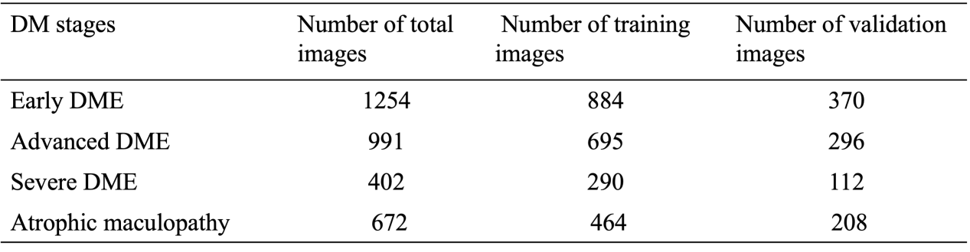

DM: diabetic maculopathy; DME: diabetic macular edema

Table 2. precision、sensitivity and specificity of our model in validation dataset.

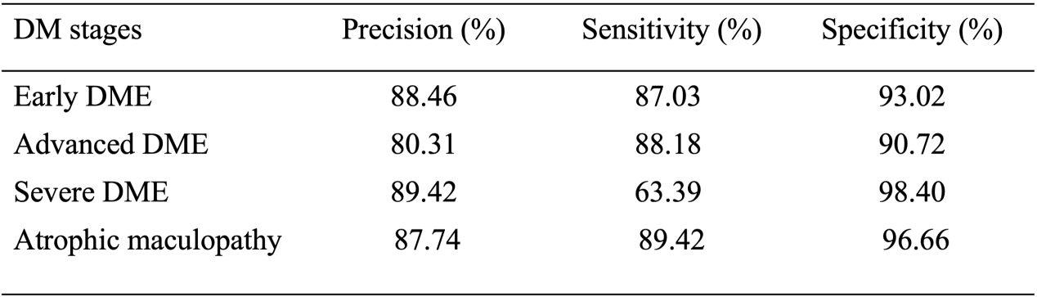

DM: diabetic maculopathy; DME: diabetic macular edema

Table 3. AUC and F1-score of our model in validation dataset.

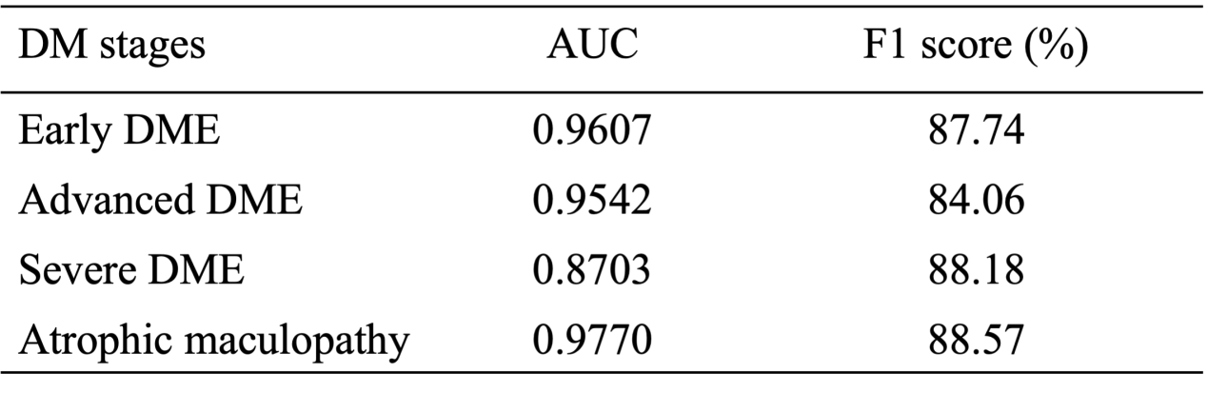

DM: diabetic maculopathy; DME: diabetic macular edema; AUC: area under the receiver operating characteristic curve

