Supplementary Material
The sensitivity test of the inflow turbulence was conducted with the original model of Tanji et al. (2021). They performed a model experiment with the artificial inflow turbulence generated by Okaze and Mochida (2017) and Xie and Castro (2008), but here we replaced it with the laminar inflow as the inflow boundary condition. The fence was non-porous and solid, 0.1 m thick, 1 m high, and 1.5 m long. The integration time was 30 s and we used the wind data after the 10-s spinup time for the snow particle module. The wind profile in the laminar flow experiment and the time-averaged wind profile in the inflow turbulence experiment was 6 m s⁻¹ westerly at 10 m aloft in the log profile [Eq. (1)].
Figure A shows the difference in the snowdrift height between the laminar inflow experiment and the inflow turbulence experiment. In most areas, the absolute value of the difference was under 0.1 m (Fig. Aa). The snowdrift peak height and the peak position with the laminar inflow corresponded to those with the inflow turbulence on the windward side of the fence along $y = 2.5 m$ (Fig. Ab). However, the snowdrift with the laminar flow was uneven and the difference between the two experiments was 0.2 m at most. This difference was probably due to the small sample size for the wind data and would be smaller if we used a larger sample size, as in this paper. Therefore, the laminar flow experiment can produce results for the snowdrift that are similar to those from the inflow turbulence experiment.

References
Okaze T, Mochida A (2017) Cholesky decomposition–based generation of artificial inflow turbulence including scalar fluctuation. Comput. Fluids. 159, 23–32. doi:10.1016/j.compfluid.2017.09.005.
Xie ZT, Castro IP (2008) Efficient generation of inflow conditions for Large Eddy Simulation of street-scale flows. Flow Turbulence Combust. 81, 449–470. doi:10.1007/s10494-008-9151-5.

Figure
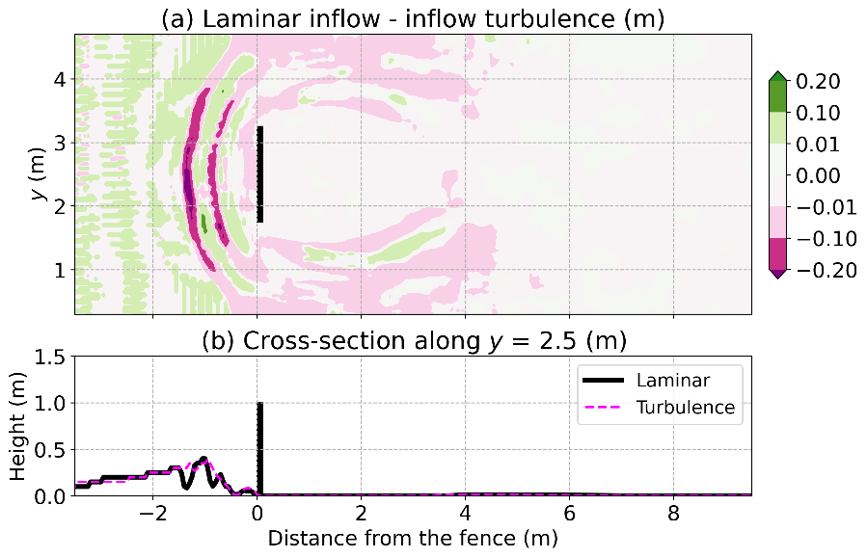
Fig. A (a) Snowdrift height difference between the laminar inflow experiment and the inflow turbulence experiment. Green (pink) areas show the areas where the laminar inflow produced a higher (lower) height. (b) Snowdrift height in the cross section along y = 2.5 m in (solid black line) the laminar inflow and (pink dotted line) the inflow turbulence experiments. Thick black lines in (a) and (b) show the fence.

