Supplementary Material
Supplementary figure 1. Example of gating strategy used (rectangle – A) to sort top ~1% fluorescing cells of P. tricornutum with FACS.
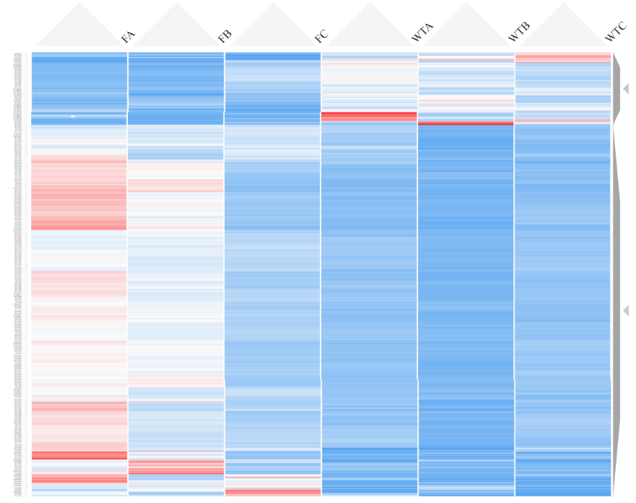
Supplementary figure 2. Heatmap showing relative gene expression between WT and F cultures of P. tricornutum expressed as z-scores. Genes are grouped by GO aspect term with minimum gene pool of 4. Made using Clustergrammer https://maayanlab.cloud/clustergrammer/.

Supplementary figure 3. Cell volume measured using the geometric mean of FSC (Forward Scatter) and SSC (Side Scatter) over the experimental period. Values are FACS replicates divided by WT mean with floating bars from minimum to maximum, n = 5.

Supplementary table 1. Enrichment analysis results depicting fold enrichment and FDR for GO aspect Biological Processes, sorted by fold enrichment.
GO aspect | Pathway | Fold Enrichment | FDR
BP | Protoporphyrinogen IX metabolic process | 19.64 | <0.001
BP | Protoporphyrinogen IX biosynthetic process | 19.64 | <0.001
BP | Porphyrin-containing compound biosynthetic process | 17.28 | <0.001
BP | Porphyrin-containing compound metabolic process | 14.90 | <0.001
BP | Pigment biosynthetic process | 14.73 | <0.001
BP | Tetrapyrrole biosynthetic process | 13.94 | <0.001
BP | Heme biosynthetic process | 13.86 | <0.001
BP | Pigment metabolic process | 13.09 | <0.001
BP | Photosynthesis, light harvesting | 12.16 | <0.001
BP | Tetrapyrrole metabolic process | 12.00 | <0.001
BP | Heme metabolic process | 11.22 | <0.001
BP | Protein-chromophore linkage | 11.10 | <0.001
BP | Photosynthesis, light reaction | 10.78 | <0.001
BP | Photosynthesis | 10.27 | <0.001
BP | Ribosome biogenesis | 6.71 | <0.001
BP | RRNA processing | 5.82 | 0.001
BP | RRNA metabolic process | 5.71 | 0.001
BP | Ribonucleoprotein complex biogenesis | 5.56 | <0.001
BP | Generation of precursor metabolites and energy | 4.04 | <0.001
BP | Cellular component biogenesis | 3.43 | <0.001
BP | NcRNA processing | 3.06 | 0.012
BP | Purine-containing compound metabolic process | 3.02 | 0.048
BP | Cellular component organization or biogenesis | 2.63 | 0.001
BP | NcRNA metabolic process | 2.58 | 0.018
BP | Nucleobase-containing small molecule metabolic process | 2.38 | 0.047
BP | Aromatic compound biosynthetic process | 2.13 | 0.003
BP | Heterocycle biosynthetic process | 2.07 | 0.005
BP | Organic cyclic compound biosynthetic process | 1.99 | 0.008
BP | Organonitrogen compound biosynthetic process | 1.87 | 0.018
BP | Heterocycle metabolic process | 1.82 | <0.001
BP | Cellular aromatic compound metabolic process | 1.80 | <0.001
BP | Organic cyclic compound metabolic process | 1.79 | <0.001
BP | Small molecule metabolic process | 1.79 | 0.032
BP | Organonitrogen compound metabolic process | 1.62 | 0.001
BP | Organic substance biosynthetic process | 1.60 | 0.014
BP | Cellular nitrogen compound metabolic process | 1.55 | 0.007
BP | Biosynthetic process | 1.55 | 0.024
BP | Cellular biosynthetic process | 1.54 | 0.038

Supplementary table 2. Enrichment analysis results depicting fold enrichment and FDR for GO aspect Cellular Component, sorted by fold enrichment.
GO aspect | Pathway | Fold Enrichment | FDR
CC | Light-harvesting complex | 12.46 | <0.001
CC | Photosystem | 10.25 | <0.001
CC | Photosystem II | 10.25 | <0.001
CC | Photosynthetic membrane | 9.43 | <0.001
CC | Thylakoid | 8.73 | <0.001
CC | Nucleolus | 6.67 | <0.001
CC | Plastid | 5.82 | <0.001
CC | Chloroplast | 5.50 | <0.001
CC | Nuclear lumen | 3.80 | 0.003
CC | Membrane protein complex | 3.16 | 0.003
CC | Membrane-enclosed lumen | 3.02 | 0.011
CC | Organelle lumen | 3.02 | 0.011
CC | Intracellular organelle lumen | 3.02 | 0.011
CC | Intracellular membrane-bounded organelle | 1.72 | 0.002
CC | Membrane-bounded organelle | 1.72 | 0.002
CC | Nucleus | 1.62 | 0.044
CC | Intracellular organelle | 1.58 | 0.005
CC | Organelle | 1.57 | 0.005
CC | Intracellular anatomical structure | 1.49 | 0.005

Supplementary table 3. Enrichment analysis results depicting fold enrichment and FDR for GO aspect Molecular Function, sorted by fold enrichment.
GO aspect | Pathway | Fold Enrichment | FDR
MF | Chlorophyll binding | 12.46 | <0.001
MF | Pentosyltransferase activity | 10.91 | 0.001
MF | Tetrapyrrole binding | 5.50 | <0.001
MF | Magnesium ion binding | 4.79 | 0.034
MF | Helicase activity | 4.04 | 0.017
MF | ATP-dependent activity | 2.57 | 0.013
MF | Purine ribonucleoside triphosphate binding | 2.12 | <0.001
MF | Purine ribonucleotide binding | 2.11 | <0.001
MF | Purine nucleotide binding | 2.07 | <0.001
MF | Carbohydrate derivative binding | 2.06 | <0.001
MF | ATP binding | 2.05 | <0.001
MF | Ribonucleotide binding | 2.04 | <0.001
MF | Adenyl ribonucleotide binding | 2.03 | <0.001
MF | Adenyl nucleotide binding | 1.99 | <0.001
MF | Anion binding | 1.92 | <0.001
MF | Nucleotide binding | 1.89 | <0.001
MF | Nucleoside phosphate binding | 1.89 | <0.001
MF | Small molecule binding | 1.81 | <0.001
MF | Hydrolase activity | 1.80 | 0.001
MF | Ion binding | 1.40 | 0.030

