Plate 1: The size and proportion of the interior view Plate 2: The size and proportion of the Interior view of
of the Paediatric Inpatient Ward at UCH the children ward at LUTH
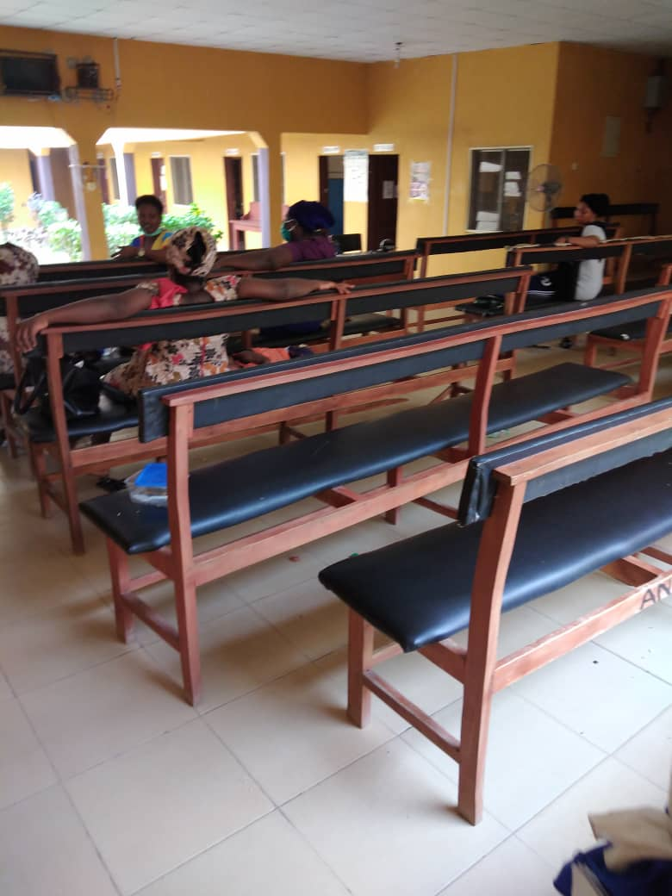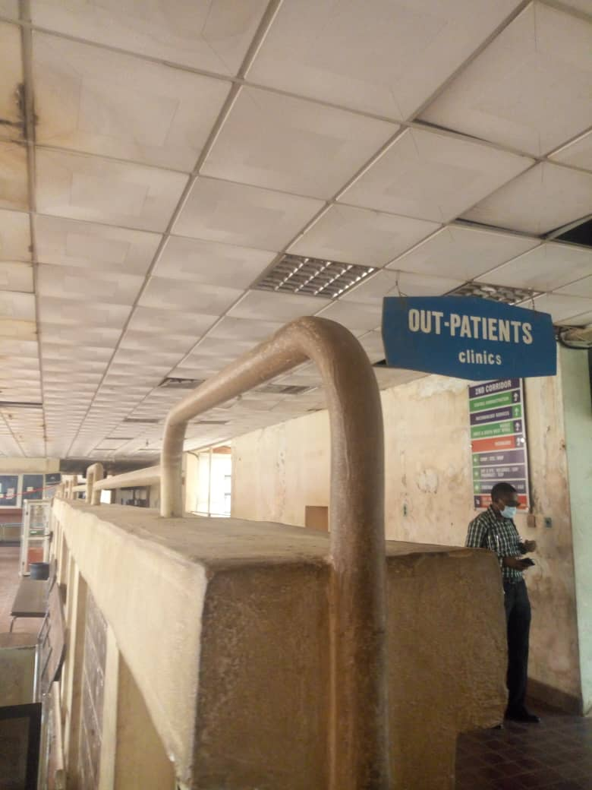
Plate 3: The Waiting Room & Reception of O and G at OAUTH Plate 4: The size and proportion of the record Unit at the
Outpatients Clinic at UCH

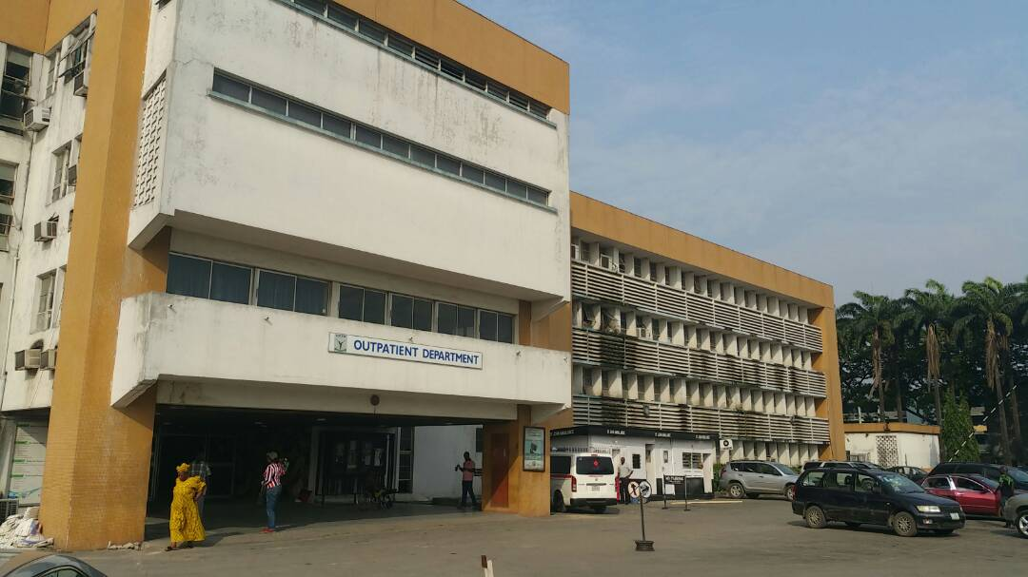
Plate 5: The sizes and number of the windows and doors at UCH, Plate 6: The size and number of Windows at the exterior view of
the out-patients clinic at LUTH
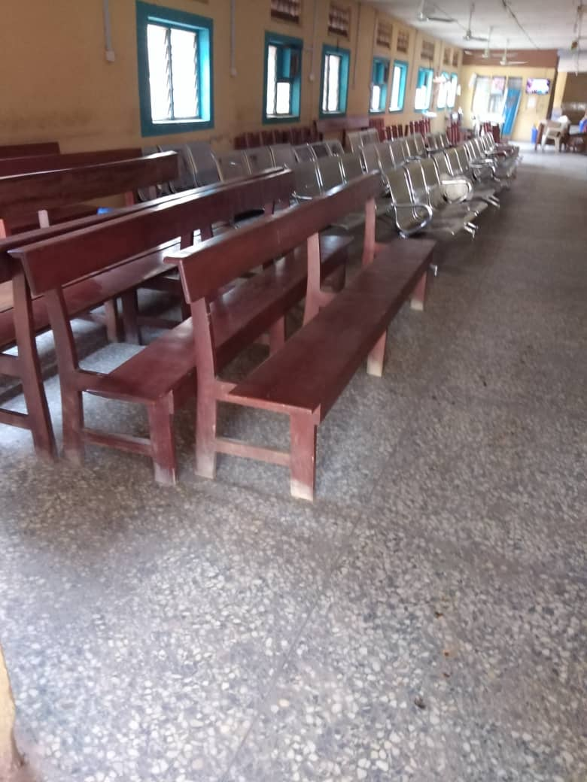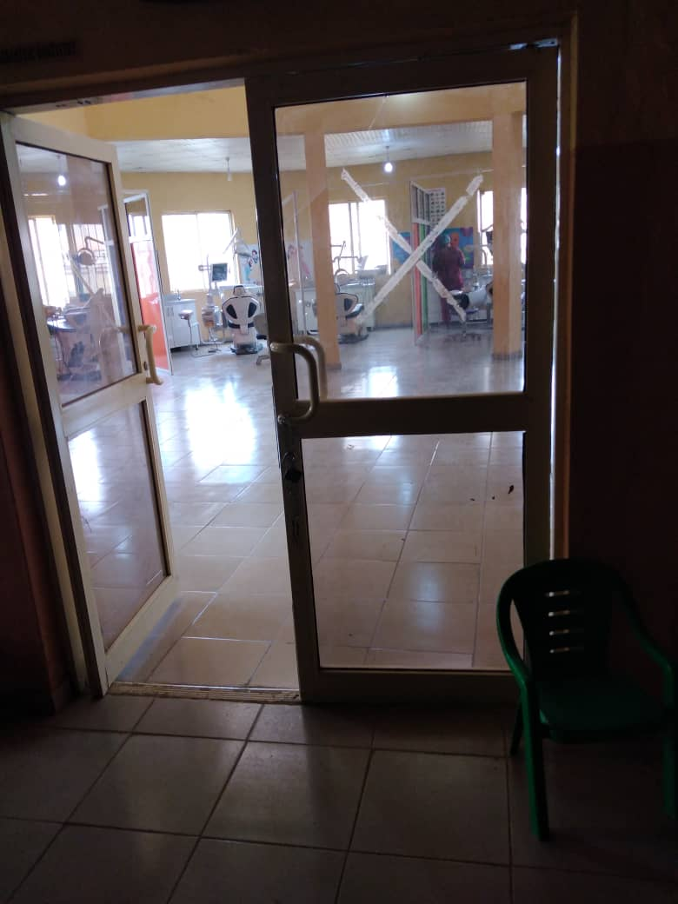
Plate 7: The size and number of the windows within the clinical space at OAUTHC

