Supplementary information
Supplementary results
Root traits in monocultures and mixtures
In glasshouse experiment, the positive biodiversity effect on Piper nigrum (Pn) root traits was reflected in longer total root length in mixtures with neighbors [except P. nigrum mixed with Artocarpus heterophyllus (Pn/Ah)] compared to the monocultures. In the mixture with Areca catechu (Pn/Ac), Pn had the longest total root length (98% longer than in monoculture). By contrast, total root length of five neighbors of Pn in mixtures was significantly lower than in monocultures (Fig. S3a).
The Pn/Ac mixture had the greatest promoting effects on Pn specific root length, which also increased significantly in P. nigrum mixed with Camellia oleifera (Pn/Co) community. However, specific root length of five neighbors of Pn decreased significantly in mixtures compared with monocultures (Fig. S3b). The root tissue density of each plant species increased significantly in the P. nigrum mixed with Coffesa arabica (Pn/Ca) and with Coffea canephora (Pn/Cc) compared with monocultures (Fig. S3c).
The root diameter of Pn and neighbors remained unchanged between mixtures and monocultures (Fig. S4a). The Pn root surface area increased significantly in Pn/Ac and Pn/Co communities compared with Pn monoculture. The root surface area of Ac and Ah was not significantly different between mixtures and monocultures, but root surface area of Ca, Co and Cc decreased in the mixtures with Pn compared with the monocultures (Fig. S4b). There was no significant effect of species mixtures on Pn root volume, but root volume of Ca increased significantly and that of Co decreased significantly in the mixtures compared with the monocultures (Fig. S4c).
The Pn root phosphatase activity was significantly greater in mixtures of Pn/Ca (by 71%) and Pn/Cc (by 30%) than in monoculture. Root phosphatase activity of Pn was not increased by mixing with Ac, Ah and Co. Among the five Pn neighbors, Cc root phosphatase activity in the mixture was 10% higher than in the corresponding monoculture (Fig. S5a). The Pn mycorrhizal colonization in Pn/Ac mixture was 48% greater than in the monoculture. There was no significant difference in mycorrhizal colonization of Pn in other mixtures and that of five neighbors between mixture and monoculture. Among the five communities, Pn/Cc increased Pn root N concentration significantly (by 7%), and Pn/Ah decreased Pn root N concentration significantly (by 14%) (Fig. S5b). There was no significant difference in root N concentration of Pn in other mixtures and in root N concentration of five neighbors between mixture and monoculture (Fig. S5c)
Table S1 Relationship between functional dispersion (FDis) of multi-trait variable and single trait dissimilarity and the complementarity effects (CE) and selection effects (SE) of Pn and neighbors based on the 1st-degree polynomial function.
 | Traits | CE |  | SE
 | Traits | Adjusted R² | P value | Adjusted R² | P value
Multi-traits | All nine root traits | 0.874 | 0.013 | 0.449 | 0.131
Multi-traits | Root morphological traits | 0.699 | 0.049 | 0.43 | 0.139
Single traits | TRL | 0.228 | 0.236 | 0.294 | 0.201
Single traits | RV | 0.510 | 0.108 | 0.248 | 0.225
Single traits | RSA | 0.328 | 0.184 | 0.295 | 0.201
Single traits | RD | 0.649 | 0.063 | 0.456 | 0.128
Single traits | SRL | 0.196 | 0.599 | 0.333 | 0.998
Single traits | RTD | 0.314 | 0.847 | 0.179 | 0.576
Single traits | RPA | 0.911 | 0.007 | 0.747 | 0.037
Single traits | RN | 0.598 | 0.078 | 0.055 | 0.439
Single traits | MC | 0.922 | 0.006 | 0.785 | 0.029
Note: Six root morphological traits: total root length (TRL), root volume (RV), root surface area (RSA), root diameter (RD), specific root length (SRL), and root tissue density (RTD). Root physiological, chemical and mycorrhizal traits: root phosphatase activity (RPA), root nitrogen concentration (RN) and mycorrhizal colonization (MC).

Table S2 Summary of the nine root traits for six independently supported plant species grown in monocultures in pots in glasshouse.
Root trait (abbreviation) | Units | Mean | Median | Min¹ | Max² | CV%³
Total root length (TRL) | m | 14.28 | 15.54 | 5.24Pn† | 21.87Ah | 44.0
Specific root length (SRL) | m/g | 11.61 | 11.44 | 5.54Pn | 17.37Cc | 40.1
Root tissue density (RTD) | g/cm³ | 0.59 | 0.61 | 0.36Ac | 0.78Ah | 27.9
Root diameter (RD) | mm | 1.16 | 0.93 | 0.40Ca | 2.45Ac | 68.2
Root surface area (RSA) | cm² | 21.93 | 200.57 | 92.60Ca | 434.16Ac | 53.2
Root volume (RV) | cm³/plant | 3.06 | 2.08 | 0.91Pn | 7.97Ac | 80.9
Root phosphatase activity (RPA) | μmol/g per h | 5.18 | 5.33 | 2.67Ac | 7.22Cc | 29.3
Mycorrhizal colonization (MC) | % | 32.97 | 30.55 | 21.80Cc | 52.43Ac | 33.5
Root nitrogen concentration (RNC) | mg/g | 13.77 | 12.48 | 7.32Ac | 23.82Pn | 40.7
¹ Min, minimum values of root traits across the six species.
² Max, the maximum value of root traits across the six species.
³ CV%, coefficients of variation.
† For species acronyms see Fig. 1.

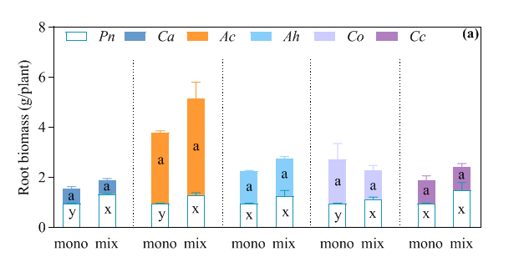
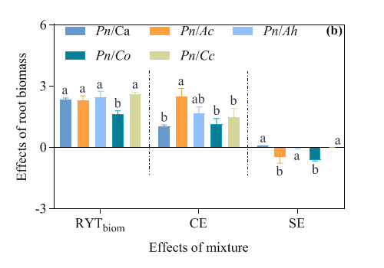
Fig. S1 (a) Root biomass of Pn and five other plant species (see Fig. 1 for species names) in monocultures (mono) and mixtures (mix) (glasshouse exp.). Means + SD. “a and b” or “x and y” denote significant differences (at P <0.05) between monocultures (mono) and mixtures (mix) of each species.
(b) Overyielding effects of Pn and five other plant species (glasshouse exp.). The RYT_{biom} and the complementarity (CE) and selection effects (SE) were calculated from root biomass. Means + SD. For each parameter, values with different letters are significantly different (Tukey’s HSD, P=0.05).
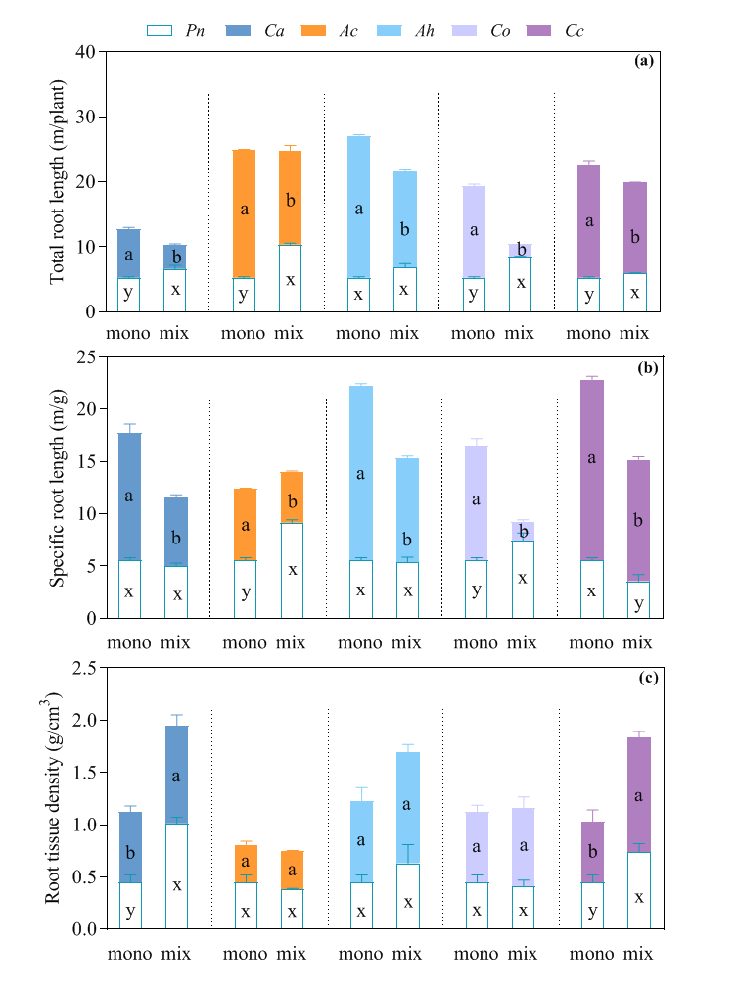
Fig. S2 Root traits of plant species (see Fig. 1 for names) in monoculture and mixture (glasshouse exp.): (a) total root length; (b) specific root length; and (c) root tissue density. Means + SD. “a and b” or “x and y” denote significant differences (at P <0.05) between monoculture (mono) and mixture (mix) of species.
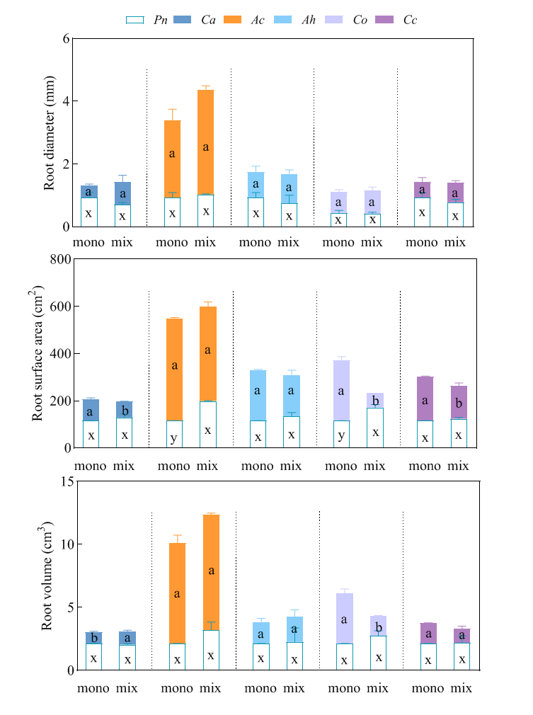
Fig. S3 Root traits of Pn and five other plant species (see Fig. 1 for species names) in monoculture and mixture (glasshouse exp.): (a) root diameter; (b) root surface area; and (c) root volume (glasshouse exp.). Means + SD. “a and b” or “x and y” denote significant differences (at P <0.05) between monoculture (mono) and mixture (mix) of the same species.
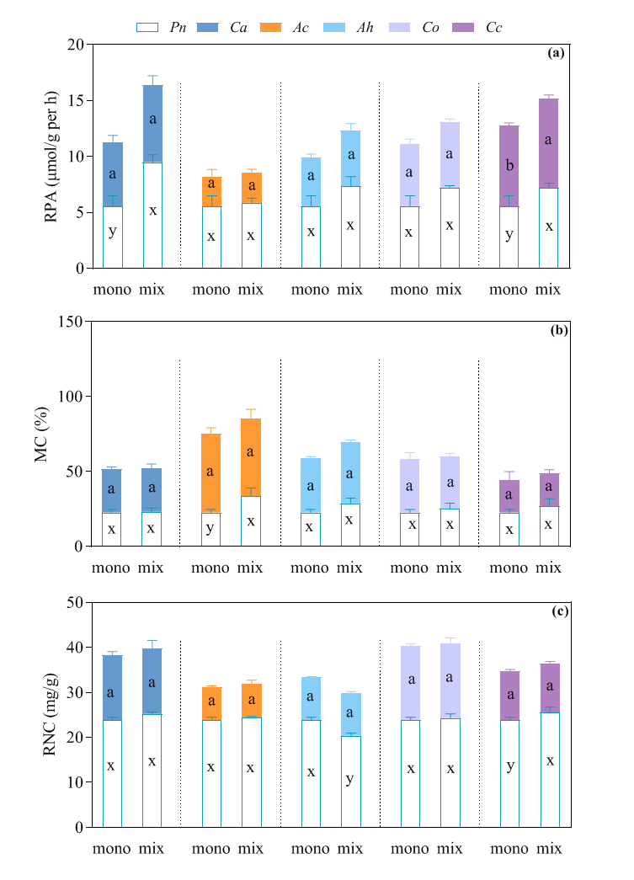
Fig. S4 Root traits of plants (see Fig. 1 for species names) in monoculture and mixture (glasshouse exp.): (a) root phosphatase activity (RPA); (b) mycorrhizal colonization (MC); (c) root nitrogen concentration (RNC). Means + SD. “a and b” or “x and y” denote significant differences (at P <0.05) between monoculture (mono) and mixture (mix) of each species.
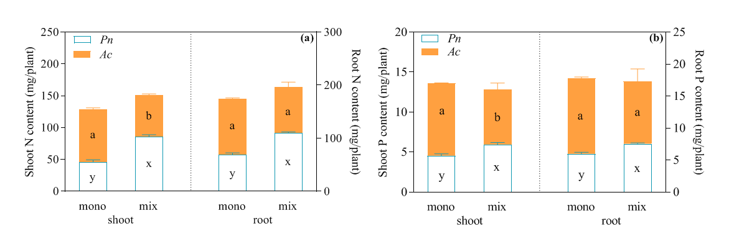
Fig. S5 Shoot and root N (a) and P content (b) of Piper nigrum (Pn) and Areca catechu (Ac) in monoculture and mixture (glasshouse exp.). Means + SD. “a and b” or “x and y” denote significant differences (at P <0.05) between monoculture (mono) and mixture (mix) of each species.

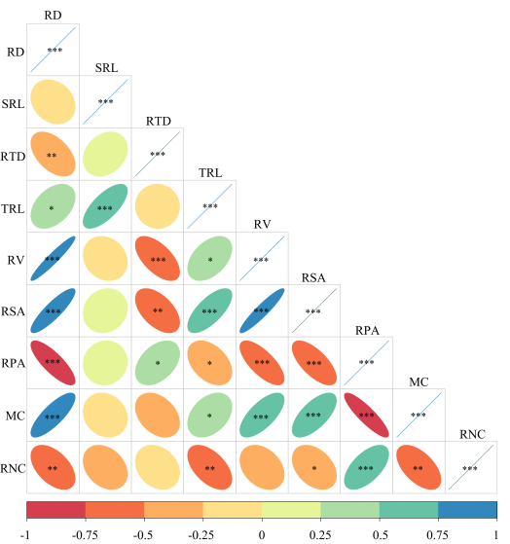
Fig. S6 Pairwise Pearson’s correlations among root traits (RD, SRL, RTD, TRL RV, RSA, RPA, MC, and RNC) in mixtures (glasshouse exp.). The correlation coefficients are proportional to the ellipse sizes, and the asterisks indicate the significance (*, P <0.05; **, P <0.01; ***, P <0.001).

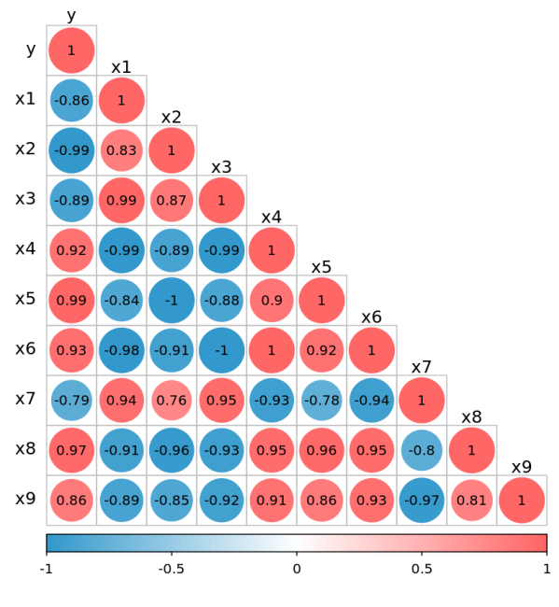
Fig. S7 Pairwise Pearson’s correlations among yield in mixtures and monocultures [y (yield per plant)], root distributions (the horizontal proportions of root length in the shared space in mixtures are denoted x1 for 0-20 cm soil layer, x2 for 20-40 cm, and x3 for 40-60 cm soil layer, whereas the proportions in the individual species space in mixtures are represented by x4 for 0-20 cm soil layer, x5 for 20-40 cm, and x6 for 40-60 cm; the vertical proportion of root length in mixtures are devoted x7 for 0-20 cm soil layer, x8 for 20-40 cm, and x9 for 40-60 cm soil layer) of Piper nigrum (Pn) and Areca catechu (Ac) grown in mixture in the field. The correlation coefficients are in the circle pattern.

