Table 1. Coupling angle on the thigh / shank / foot segment and coordination pattern definition based on the vector coding.
 |  | Pattern | Coupling angle definitions
Sagittal plane | 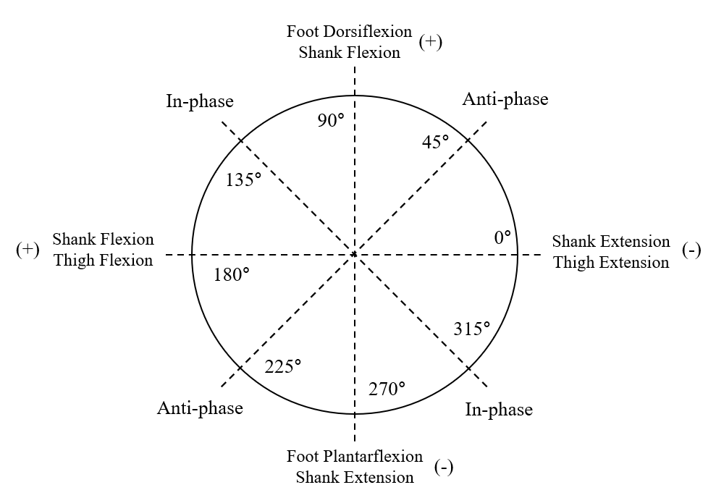 | In-phase | 112.5≤$γ$≤157.5, 292.5≤$γ$≤337.5
Sagittal plane |  | Anti-phase | 22.5≤$γ$≤67.5, 202.5≤$γ$≤247.5
Sagittal plane |  | Proximal phase | 0≤$γ$≤22.5, 157.5≤$γ$≤202.5, 337.5≤$γ$≤360
Sagittal plane |  | Distal phase | 67.5≤$γ$≤112.5, 247.5≤$γ$≤292.5
Frontal plane | 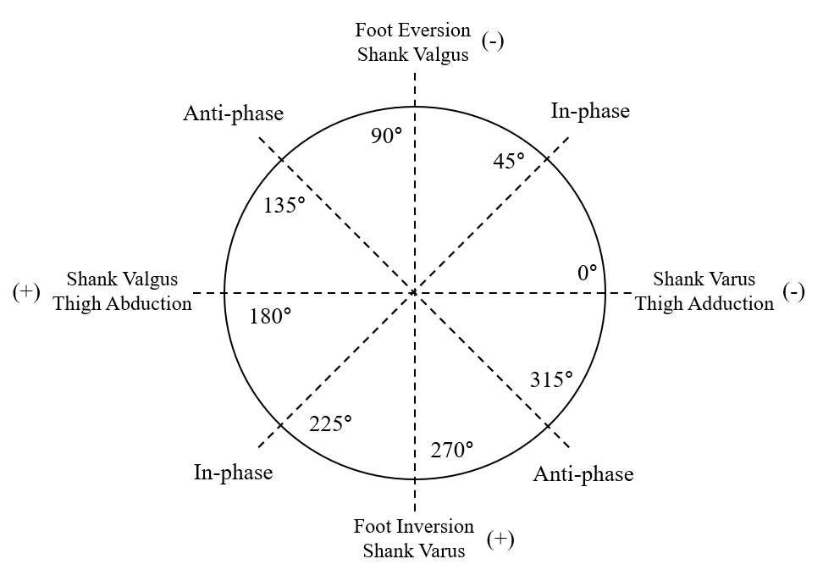 | In-phase | 22.5≤$γ$≤67.5, 202.5≤$γ$≤247.5
Frontal plane |  | Anti-phase | 112.5≤$γ$≤157.5, 292.5≤$γ$≤337.5
Frontal plane |  | Proximal phase | 0≤$γ$≤22.5, 157.5≤$γ$≤202.5, 337.5≤$γ$≤360
Frontal plane |  | Distal phase | 67.5≤$γ$≤112.5, 247.5≤$γ$≤292.5
Horizontal plane | 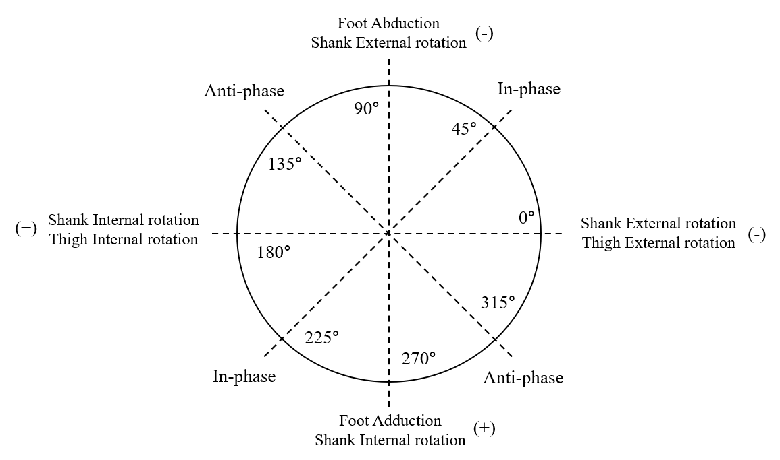 | In-phase | 22.5≤$γ$≤67.5, 202.5≤$γ$≤247.5
Horizontal plane |  | Anti-phase | 112.5≤$γ$≤157.5, 292.5≤$γ$≤337.5
Horizontal plane |  | Proximal phase | 0≤$γ$≤22.5, 157.5≤$γ$≤202.5, 337.5≤$γ$≤360
Horizontal plane |  | Distal phase | 67.5≤$γ$≤112.5, 247.5≤$γ$≤292.5

