EXTENDED DATA

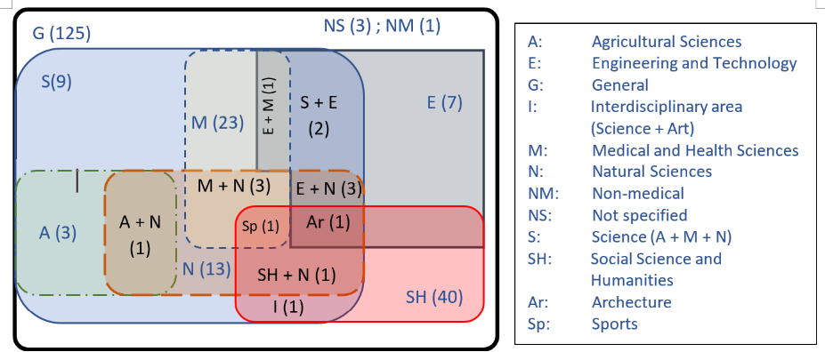
Figure 1. Classification of Disciplines. The number of policy documents listing criteria for the various disciplines encountered are shown in parenthesis next to the abbreviation of the discipline. Disciplines: (A ) Agricultural sciences, (E) Engineering and technology, (G) General, (I )Interdisciplinary Science + Art, (M) Medical and health sciences, (N) Natural sciences, (NM) Non-medical sciences, (NS) Unspecified, (S) Science: Agricultural, Medical and Natural, (SH) Social sciences and humanities, (Ar) Architecture, (Sp) Sport.

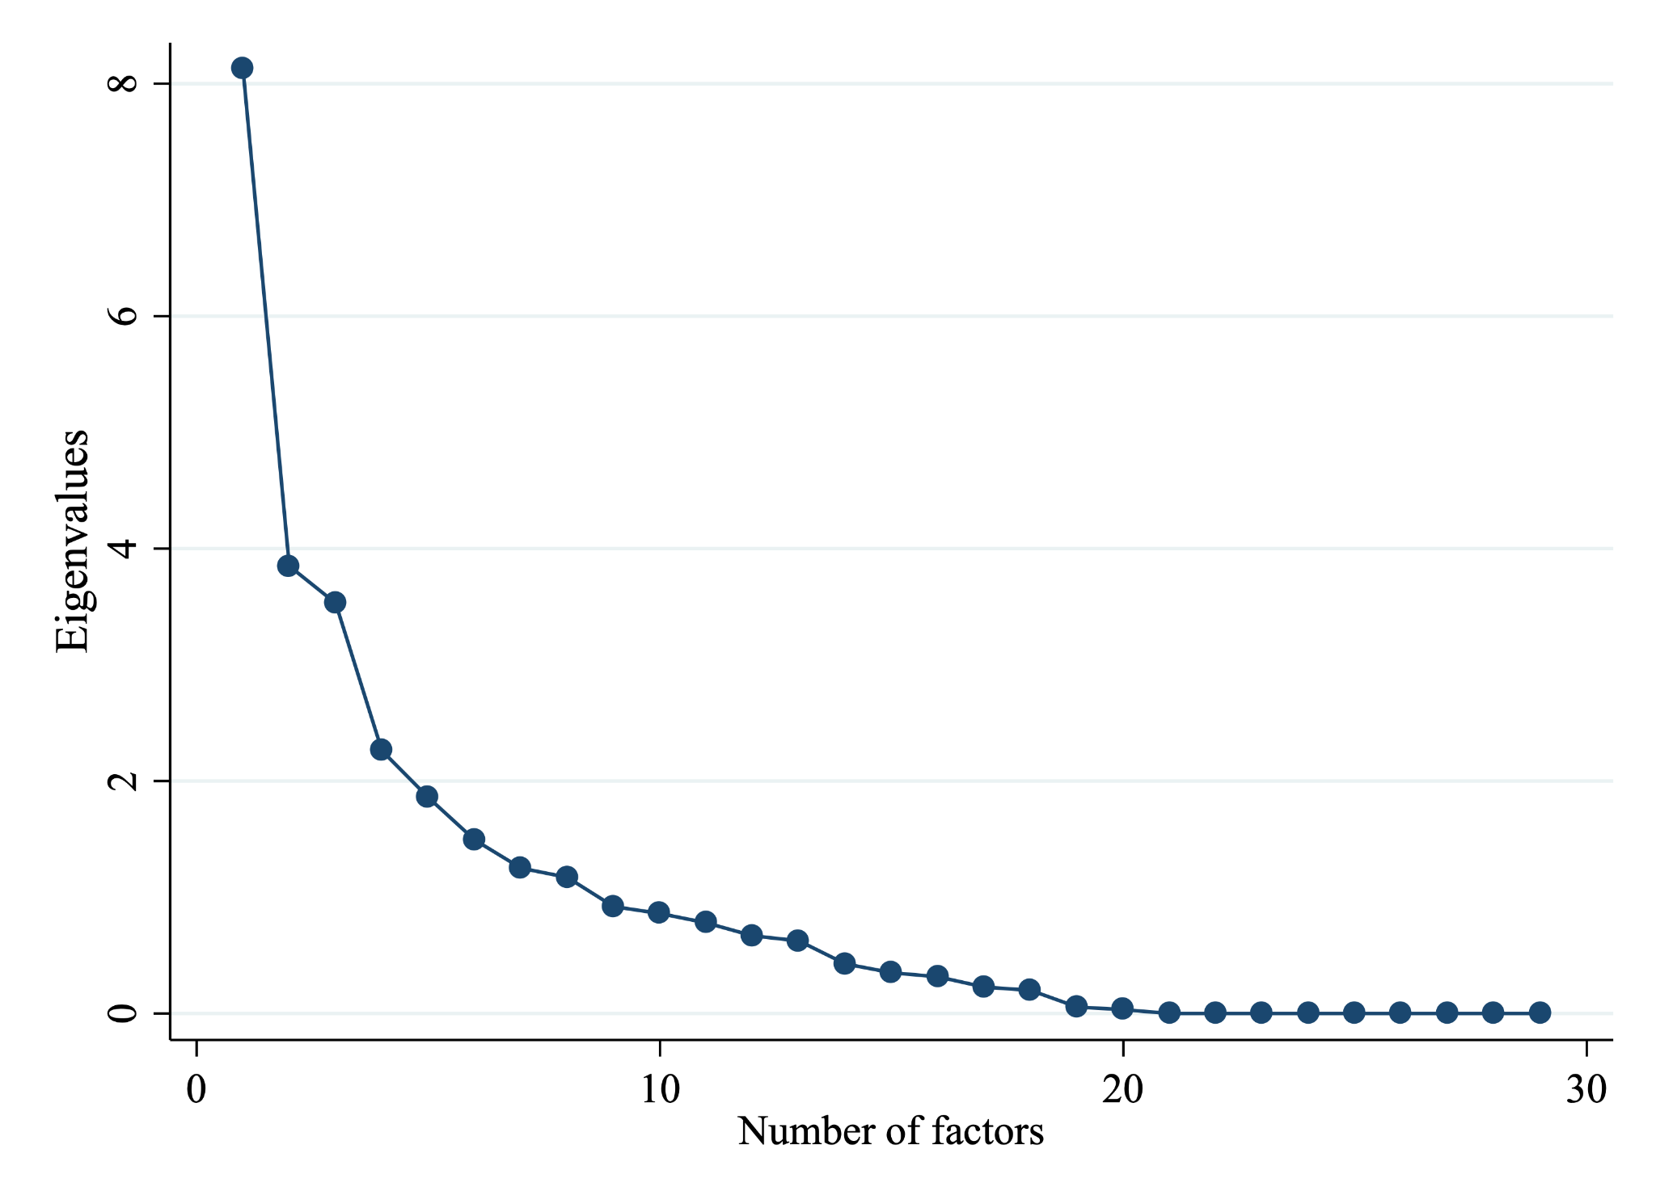
Figure 2. Screeplot for the factor analysis, showing the factors obtained, ordered by eigenvalue.

