Supplementary Information

 | Monkey B |  |  | Monkey T
 | Stim. | Nostim. | p- and z-value | Stim. | Nostim. | p- and z-value
missed resp. | 11.0 % | 6.7 % | 0.0093 / 2.9586 | 6.9 % | 4.3 % | 0.0222 / 2.6778
false alarms | 9.2 % | 7.1 % | 0.1488 / 1.4438 | 9.6 % | 14.3 % | 7.44*10⁻⁵ / 4.2166
eye errors | 10.2 % | 12.0 % | 0.1488 /1.4438 | 15.7 % | 17.2 % | 0.1187 / 2.0581

Supplementary Table 1: Comparison of the frequency of behavioral errors between trials with ICM (Stim.) versus without ICM (Nostim.) and equal visual stimulation. The p- and z-values are the results of Wilcoxon signed-rank tests; p-values < 0.05 were corrected for multi-comparison using Bonferroni correction; monkey B: n = 17; monkey T: n = 37.

Supplementary Note 1: Comparison of V4 LFP-power spectra
To verify the similarity of γ-LFP characteristics during the two task conditions that were part of our analysis, we compared the average power spectra calculated for the MCs 2/3 (Fig. 1C). For the γ-peak frequencies in V4, we observed no significant differences, whether the V2 population receiving ICMs responded to the attended stimulus (target stim., monkey B: µ = 83 Hz ± 4.3 Hz SD; monkey T: µ = 72 Hz ± 8.5 Hz SD) or the non-attended stimulus (distractor stim., monkey B: µ = 81 Hz ± 4.0 Hz SD, p = 0.0802, t = 1.811; monkey T: µ = 77 Hz ± 15.8 Hz SD, p = 0.2458, t = 1.1789; all paired sample t-test). These power spectra (Supplementary Figure 1) represent averages across the power spectra calculated for the V4 sites included in the analysis of RT-modulations (Fig. 2C). The latter were obtained from trials without ICM (Fig. 1C). Details of the spectral decomposition and power calculation are described in Drebitz et al., 2018. The power spectrum of each site was normalized by first subtracting the power spectrum of the baseline period for this site (Fig. 1C) and subsequently dividing by the latter.
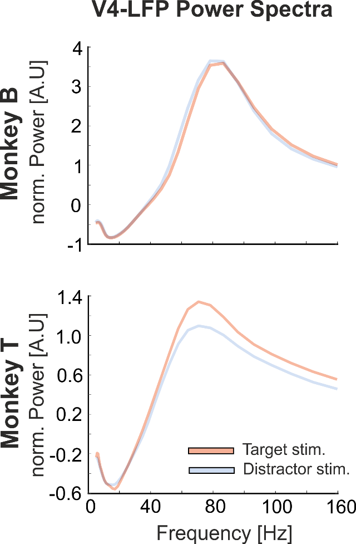
Supplementary Figure 1: Mean power spectra of V4 LFP of monkey B (top, n = 16) and monkey T (bottom, n = 20) during the analyzed conditions: Red graphs represent average power spectra when the ICM-application site in V2 responded to a cued stimulus (Target stim). Blue graphs represent average power spectra when the ICM application site represented an uncued stimulus (Distractor stim.).

Supplementary Note 2: Comparison of RT-modulation between attentional conditions
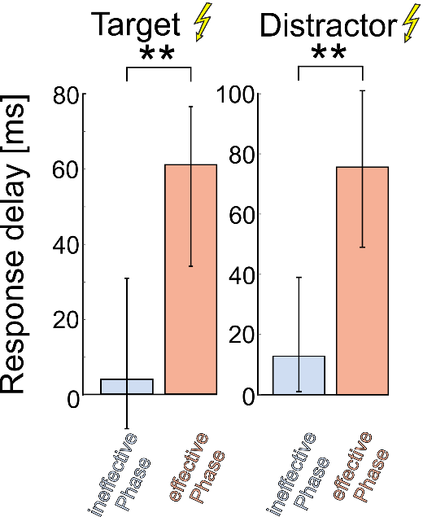
To test whether the pooling of data across attentional conditions is legitimate, we compared the size of the effect caused by ICM on RT between these two conditions (see Fig 1 B/C). V2 neurons receiving ICM either processed the relevant target stimulus or the irrelevant distractor stimulus (while in the V4 RF, there was always one attended stimulus). To compare differences between the impact of ICM-evoked spikes arriving during the effective or the ineffective γ-phase range of the V4-population, both phase ranges were determined separately for each attentional condition of each animal (± 30° around maximum and minimum as in Fig. 2C). This data split made it necessary to pool RTs of both animals for each attentional condition and phase range. We observed that RTs of both attentional conditions falling into the effective phase range were, on average, significantly longer (median target stim: 61 ms, n = 94; median distractor stim: 74 ms n = 75) than during the ineffective phase ranges (median target stim: 4 ms, n = 85, p = 7.6348*10⁻⁴, z = 3.7308; median distractor stim: 11 ms, n = 111, p = 1.4155*10⁻⁵, z = 4.6368, all comparisons Wilcoxon rank-sum tests). These results confirm a similar and phase-dependent effect of ICMs on RTs for both conditions. In addition, there was neither a significant difference between RTs of the effective phase ranges of both conditions (p = 0.1382, z = 1.4826) nor between RTs of the ineffective phase ranges (p = 0.4338, z = 0.7826; all statistical comparisons: Wilcoxon rank-sum tests, Bonferroni-correction was applied for p-values < 0.05).
Supplementary Figure 2: Effect of ICMs on RTs during the effective (red) and ineffective (blue) phase ranges of the V4 γ-cycle. RTs are displayed as difference to the average RT of trials without ICM application. RTs from trials in which the ICM target site processed the relevant stimulus are shown on the left (Target) and trials where the same V2 neurons processed an irrelevant stimulus is shown on the right (Distractor), respectively. The error-bars indicate the 95% confidence interval based onbootstrapped medians. **-indicates high significance at p < 0.01.

Supplementary Note 3: RT modulation in non-ICM trials
To rule out a hypothetical bias in reaction times (RTs) due to the pure timing of visual stimulus progression and ICM (but not the physiological impact of ICM-evoked spikes) and to quantify the level of variability within the data, we assessed the hypothetical dependence of RT delay on the actual ICM application times. We performed a bootstrapping procedure, which randomly paired the actual ICM application times with trials and corresponding RTs without ICM. Then the RT modulation as a function of γ-phases was calculated. This procedure was repeated 5000 times and delivered a distribution of RT-modulations as a function of γ-phases. Contrary to a hypothetical bias, the median RT modulation in trials without ICMs exhibited minimal variation across γ-phases (see Supplementary Fig 3, median displayed in red, 95 % CI highlighted in gray). Additionally, the curve representing trials with ICM application exceeded the 95% confidence interval based on non-ICM trials and corresponding RTs in both animals (Supplementary Fig.3, black curve). These results indicate that the pronounced behavioral effects we observed are indeed attributable to the ICM application rather than the trial time they were applied.
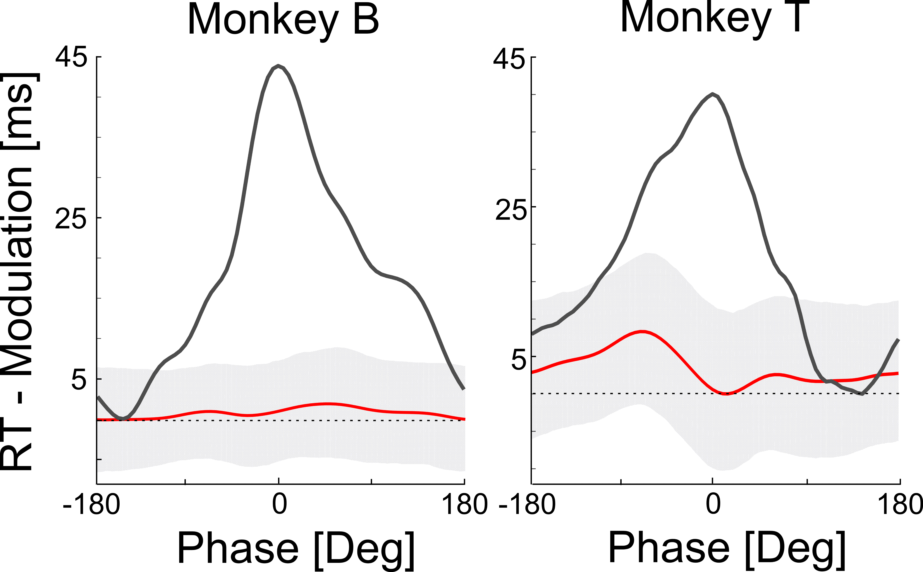
Supplementary Figure 3: γ-phase dependent modulation of RTs from trials with and without ICM application. The red graphs represent the median RT-modulation based on trials without ICM application as a function of the V4 γ-phases. The gray highlighted areas indicate the 95 % confidence interval. The black lines show the RT-modulation of ICM data for comparison.
Supplementary Note 4: Effect of ICMs on γ-oscillation
To assess potential distortions of phase progressions of the ongoing γ-oscillations in V4 caused by ICM-evoked spikes, we analyzed the γ-phase progression in two distinct 15 ms periods. During the first period (5-20 ms after the ICM-pulse, Supplementary Fig. 4A, red bars), ICM-evoked spikes arrived in V4, while the second period (-10-5 ms with respect to the ICM-pulse, Supplementary Fig. 4A, blue bars) served as a reference. Statistical tests indicate no significant differences between the distributions of γ-phase progressions for both 15 ms periods in both animals (monkey B: circular median 5-20 ms: 387°, circular median -10-5 ms: 386°, n = 2311, p = 0.2058, z = 1.2652; monkey T: circular median 5-20 ms: 372°, circular median -10-5 ms: 372°, p = 0.1245, z = 1.536; both Wilcoxon signed-rank tests).
The very similar distributions of phase progressions indicate that the ongoing γ -oscillations in V4 are not consistently affected by ICMs in terms of phase shift or phase reset. However, this does not rule out differential effects of ICMs, depending on the γ-phase at which ICM evoked spikes arrived in V4. To investigate this, we sorted the phase progression values for the 5 - 20 ms period based on the V4 γ-phase 9.2 ms after the ICM-pulse (Supplementary Fig. 4B). We then performed a permutation test to identify significant deviations from the expectation. For this, we randomly paired the γ-phases with phase-progression values (10,000 times) from the period 5 – 20 ms after ICM. We found no consistent effect across animals. For monkey T, neither the minimum nor the maximum showed a significant difference from expectation (both p > 0.05, permutation test). For monkey B, the amplitude of the maximum was not significant after the Bonferroni correction (p = 0.0592, permutation test), while the minimum differed significantly from expectation even after the Bonferroni correction (p = 0.0102, permutation test). However, the effect is small since the minimum (7.5° decrease) corresponds to a decrease in phase progression of only 2 % from the median phase progression in a 15 ms period.

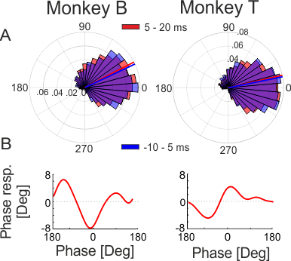
Supplementary Figure 4: Effect of ICM on γ-oscillations. A The histograms depict the distribution of γ-phase progression values within two distinct 15 ms periods of individual data segments for both animals. The bars for the period 5 – 20 ms (with respect to the ICM-pulse) are shown in red. For comparison, the phase progression distribution for the period -10 to 5 ms (shown in blue) are presented, which precede the arrival of ICM-evoked spikes. The red and blue liness depict the median phases for the corresponding distributions. B γ -phase response curve for the period 5 – 20 ms (red in A) plotted as a function of the γ-excitability -phase 9.2 ms after ICM. The values indicate the difference with respect to the median phase progression in the -10 to 5 ms period (blue in A).

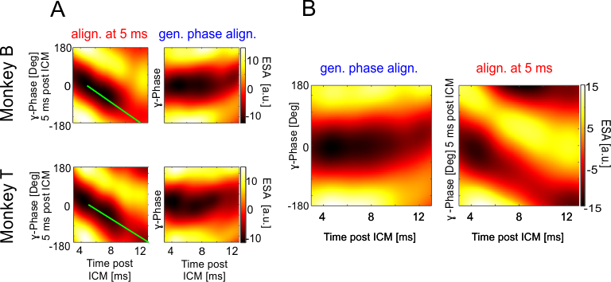
Supplementary Figure 5: Illustration of the harmonization of γ-oscillation-dependent ESA time-course between animals. To pool the ESA across animals with different γ-frequencies, their differences in γ-phase progression had to be removed. A Average ESA-time course following ICM-application depending on γ-phase for monkey B (top left) and monkey T (bottom left). The individual ESA data segments were sorted according to their LFP γ-phase at 5 ms after the ICM-pulse (aligned at 5 ms), and a moving average in the phase dimension was calculated for each time bin using a Gaussian kernel (σ = 30°, window: 180° steps of 5°, see Methods). Note that the LFP γ-oscillations have their trough at 0°, while the antiphasic excitability cycle peaks at 0°. The heat maps illustrate the strong intrinsic LFP γ-phase dependence of spiking activity, showing that the highest activity is concentrated at the trough of the LFP γ-oscillation (at 5 ms). Over time, the peak of spiking activity systematically shifts through the gamma phases, which is illustrated by the green bars. The right panels depict the same data but with a different sorting approach. Here, the ESA values were sorted for each time bin according to the forecasted γ-phases (generally phase aligned). The horizontal alignment of high and low ESA values (stripes) in both animals confirms the accurate prediction of γ-phases following the estimated phase at 5 ms for both animals. B The left panel displays the phase-aligned ESA (each time bin) following ICMs, averaged across both animals. The right panel shows the time course of the average ESA after reconstruction with the average frequency of both animals (see Methods).

