Table 1: Case study used in this Study.
Zaha Hadid | Rem Kolhaass | Peter Eisenman
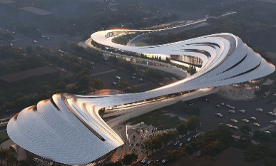 | 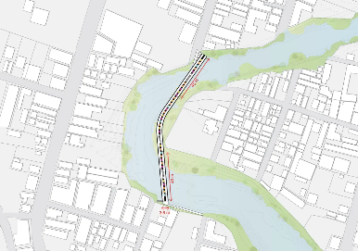 | 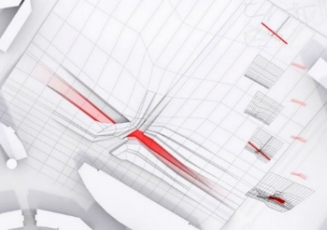
C1: Jinghe New City Culture & Art Centre | B1: Jojutla Bridge | A1: the modern museum and school of fashion
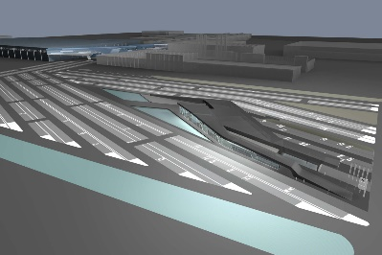 | 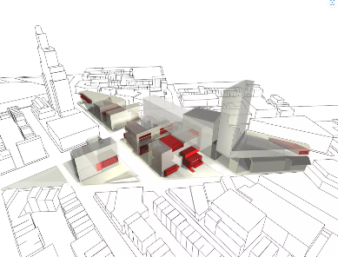 | 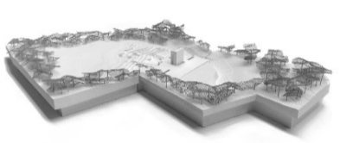
C2: BMW Showroom | B2: Brooklyn Academy of Music | A2: Babynyar Holocaust Memorial Center
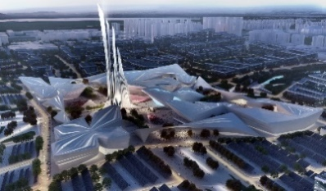 | 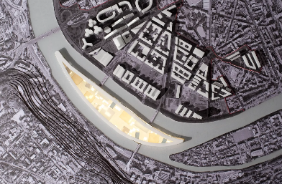 | 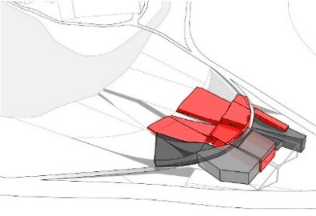
C3: Astana EXPO 2017 FUTURE Energy | B3: Ile Seguin | A3: Liget Budapest House of Music
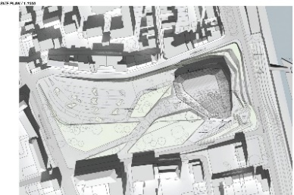 | 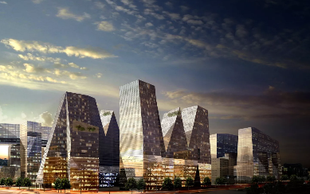 | 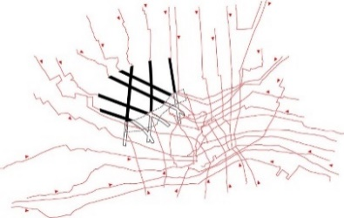
C4: Beethoven Concert Hall | B4: S Project | A4: Yenikapi Archaeological Museum and Archeo-park

Table 2: Sample of Case study analysis used in this Study.
Project Code: | A1 |  |  | 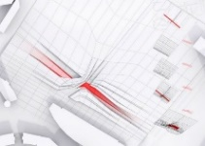
Project Name: | Modern Museum & School of Fashion
Designer: | Peter Eisenman
Location: | Milato, Italy, 2005-2006
Eisenman's proposal attempts to put fashion in the museum back in motion. Therefore, instead of separating the functions of teaching and exhibiting, this project suspends this difference. The idea of fashion in motion can be seen in the building itself. Instead of being seen as an object in the landscape, the building is a fabric itself, a landscape with the folds and pleats of a piece of cloth, torqued against the static forms of the adjacent building complex. As fashion repeatedly breaks from established boundaries, so too does this building break from the boundaries of site and object to become a vortex, only here, instead of spiraling outward, this museum creates a centripetal vortex that pulls its being and program into a centric energy that animates the interior (Eisenman, 2022).
Interactive Strategies of Site Context |  |  |  |  | Graphical Analysis
- Objective Background Context |  |  |  |  | A Surrounding Context
- Totally Ignoring the Site Context |  |  |  |  | 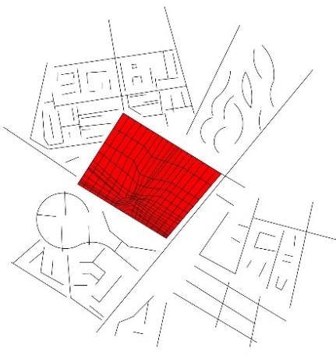
1.2 Partial Integration between Form and Context
  - Contrast Between Form and Background
  - Ignoring Surrounding Pattern
- Artificial Environment
  - Absent of Site Context
  - Form & Context on the Same Level
  - Melting the Form within the Context
2.4 Absent of Form
- Historical Tracing |  |  |  |  | B Site Context with Building
- Pre-existing Element |  |  |  |  | 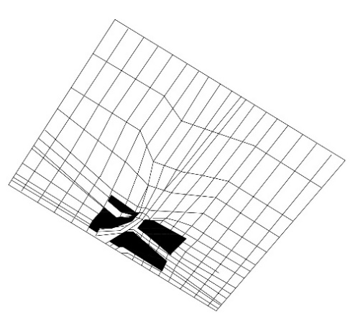
  - Different Maps of the Site
  - Overlaying Different Layers
  - Identical Past and Present Traces
- Topographical-Cultural Geometry
  - Analogue & Textual Reading
  - Abstract Geometry from Culture
  - Archeological Impact of the Site
  - Multi Layers of Ground Condition
- Context Fragmentation |  |  |  |  | C The Building Form
5.1 Mislay Site Identity |  |  |  |  | 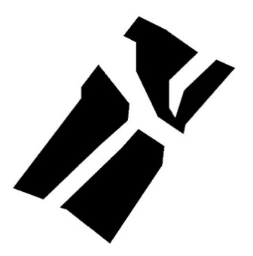
5.2 Created Dominant Context
  - Altering Site Features
  - Scratching Site History
- Natural Context Integration
  - Keeping the Shape of the Site
  - Response the Topography
  - Form follows the Site Condition
  - Harmony between Site & Form

Table3: Graphical Analysis of cases site context with surrounding context.
Zaha Hadid | Rem Kolhaass | Peter Eisenman
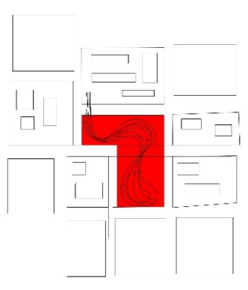 | 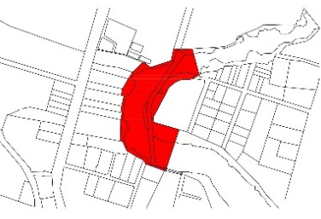 | 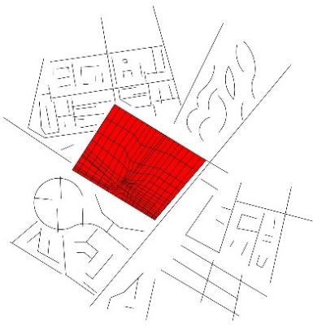
C1: Ignoring the Surrounding Context | B1: Supporting the Surrounding Context | A1: Ignoring the Surrounding Context
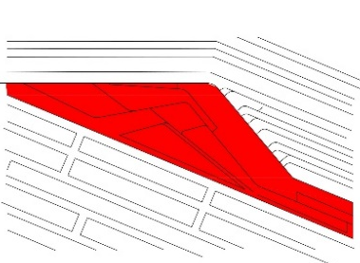 | 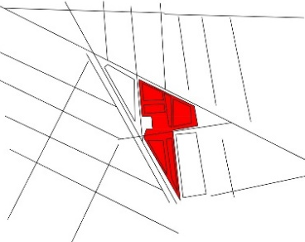 | 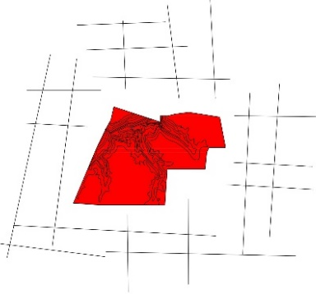
C2: Supporting the Surrounding Context | B2: Supporting the Surrounding Context | A2: Ignoring the Surrounding Context
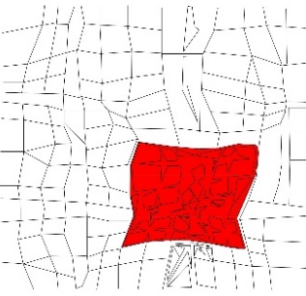 | 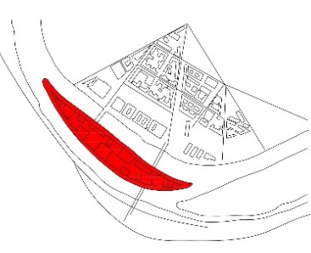 | 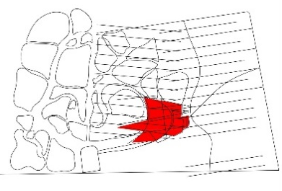
C3: Supporting the Surrounding Context | B3: Supporting the Surrounding Context | A3: Supporting the Surrounding Context
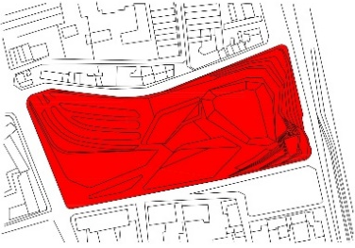 | 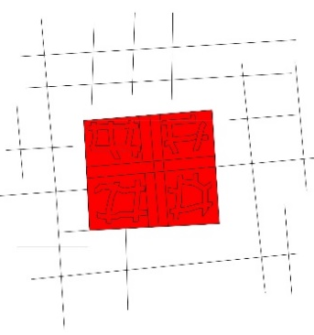 | 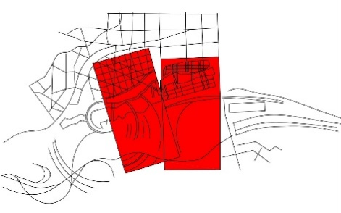
C4: Supporting the Surrounding Context | B4: Supporting the Surrounding Context | A4: Supporting the Surrounding Context

Table4: Graphical Analysis of cases form with site context.
Zaha Hadid | Rem Kolhaass | Peter Eisenman
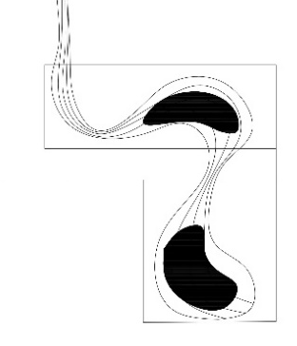 | 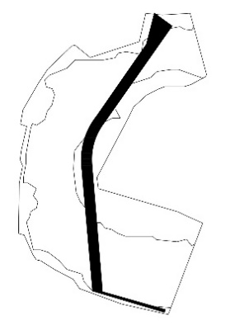 | 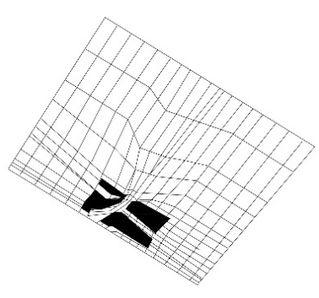
C1: Supporting the Site Context | B1: Ignoring the Site Context | A1: Supporting the Site Context
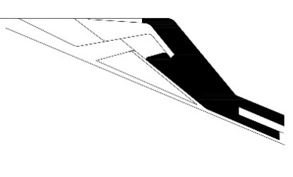 | 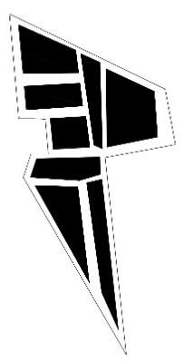 | 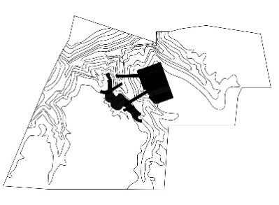
C2: Supporting the Site Context | B2: Ignoring the Site Context | A2: Supporting the Site Context
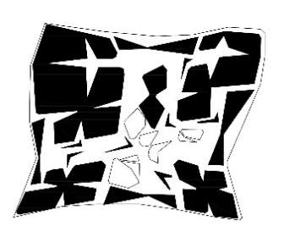 | 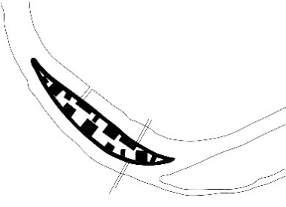 | 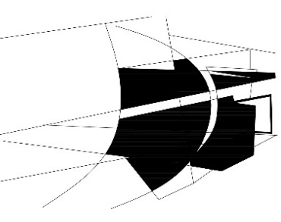
C3: Supporting the Site Context | B3: Ignoring the Site Context | A3: Supporting the Site Context
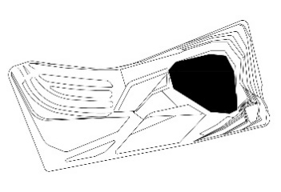 | 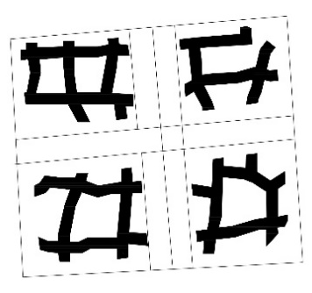 | 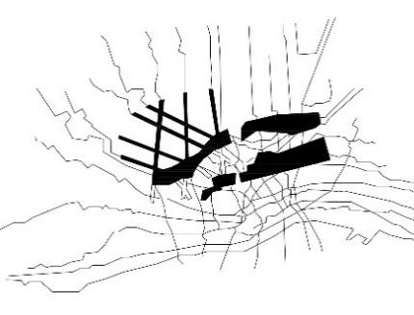
C4: Supporting the Site Context | B4: Ignoring the Site Context | A4: Supporting the Site Context

