Appendix

Project Code: | A2 |  |  | 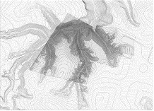
Project Name: | Babynyar Holocaust Memorial Center
Designer: | Peter Eisenman
Location: | Keiv, Ukraine in 2019
Eisenman propose a twofold response: to not produce an object building, and to excavate the site to recall its former contours. Together, the site work and the imprint of a building propose a new icon of remembrance. The project is a plinth, which connects a building volume below grad and a vertical slab wall that contains circulation. The visitor first engages with the landscape. The absence of an object building and the contrast between the toughness of the manmade plinth and the softness of the natural landscapes reinforce the tension of this historical site (Eisenman, 2022).
Interactive Strategies of Site Context |  |  |  |  | Graphical Analysis
1 Objective Background Context |  |  |  |  | A Surrounding Context
- Totally Ignoring the Site Context |  |  |  |  | 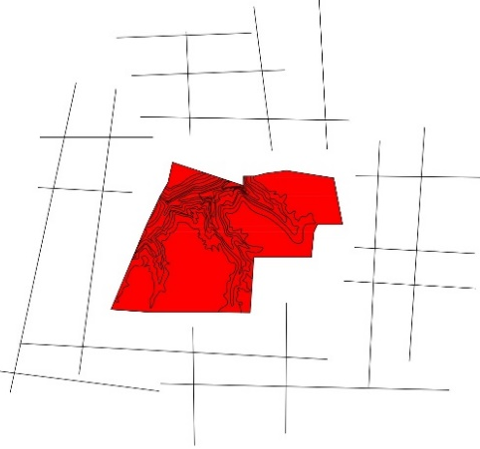
1.2 Partial Integration between Form and Context
  - Contrast Between Form and Background
  - Ignoring Surrounding Pattern
- Artificial Environment
  - Absent of Site Context
  - Form & Context on the Same Level
  - Melting the Form within the Context
2.4 Absent of Form
- Historical Tracing |  |  |  |  | B Site Context with Building
- Pre-existing Element |  |  |  |  | 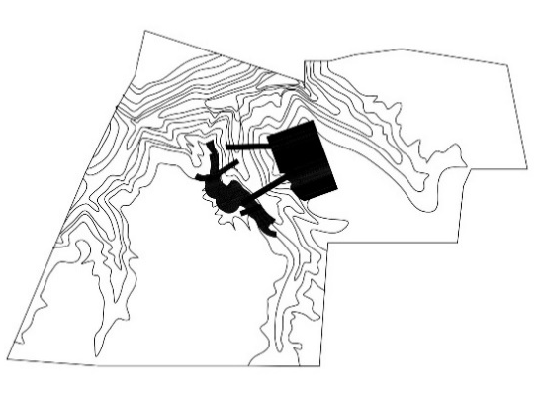
  - Different Maps of the Site
  - Overlaying Different Layers
  - Identical Past and Present Traces
- Topographical-Cultural Geometry
  - Analogue & Textual Reading
  - Abstract Geometry from Culture
  - Archeological Impact of the Site
  - Multi Layers of Ground Condition
- Context Fragmentation |  |  |  |  | C The Building Form
5.1 Mislay Site Identity |  |  |  |  | 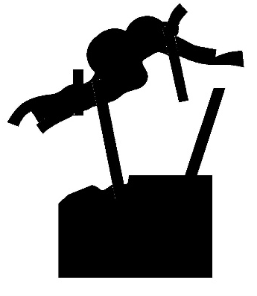
5.2 Created Dominant Context
  - Altering Site Features
  - Scratching Site History
- Natural Context Integration
  - Keeping the Shape of the Site
  - Response the Topography
  - Form follows the Site Condition
  - Harmony between Site & Form

Project Code: | A3 |  |  | 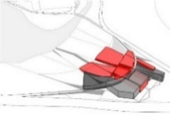
Project Name: | Liget Budapest House of Music
Designer: | Peter Eisenman
Location: | Budapest, Hungary, 2015
The resulting form is the confluence of Liget Park’s histories, which produces both a recognizable civic symbol and a new idea of a cultural icon. As an inter-section of axes and forms rather than a singular, monolithic object, the undulating building aspires to celebrate both the Hungarian Art of Music and Budapest itself, a city itself animated by the act of convergence that occurred with the historical unification of Buda and Pest. Eisenman architectural strategy of differentiated forms reveals the culture of music to park visitors, museum ticket holders, musicians, students, artifact handlers, and museum personnel alike. The traditionally singular nature of a cultural icon – the “one note” – is reconceived as a multivalent collection of building volumes – a play of notes – that acknowledges the park context while simultaneously transforming it (Eisenman, 2022).
Interactive Strategies of Site Context |  |  |  |  | Graphical Analysis
- Objective Background Context |  |  |  |  | A Surrounding Context
- Totally Ignoring the Site Context |  |  |  |  | 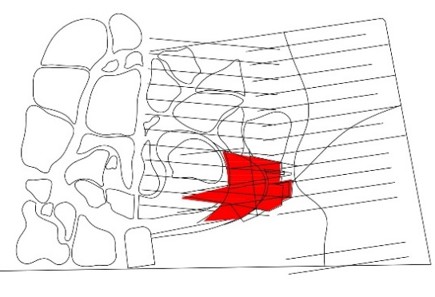
1.2 Partial Integration between Form and Context
  - Contrast Between Form and Background
  - Ignoring Surrounding Pattern
- Artificial Environment
  - Absent of Site Context
2.2 Form & Context on the Same Level
  - Melting the Form within the Context
2.4 Absent of Form
- Historical Tracing |  |  |  |  | B Site Context with Building
- Pre-existing Element |  |  |  |  | 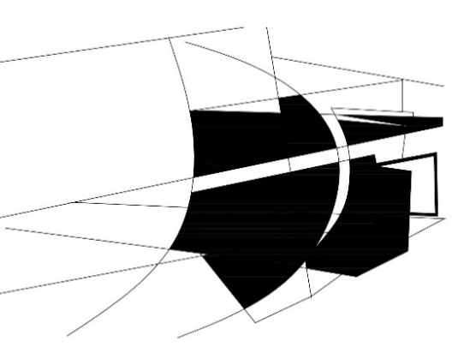
  - Different Maps of the Site
  - Overlaying Different Layers
  - Identical Past and Present Traces
- Topographical-Cultural Geometry
  - Analogue & Textual Reading
  - Abstract Geometry from Culture
  - Archeological Impact of the Site
  - Multi Layers of Ground Condition
- Context Fragmentation |  |  |  |  | C The Building Form
5.1 Mislay Site Identity |  |  |  |  | 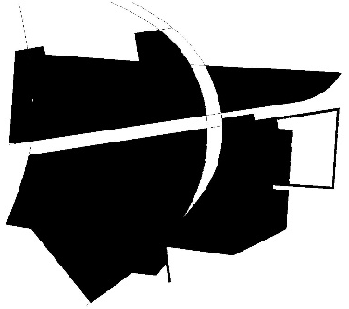
  - Created Dominant Context
5.3 Altering Site Features
5.4 Scratching Site History
- Natural Context Integration
  - Keeping the Shape of the Site
  - Response the Topography
  - Form follows the Site Condition
  - Harmony between Site & Form

Project Code: | A4 |  |  | 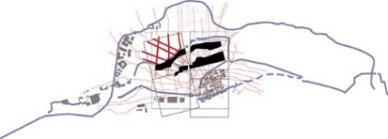
Project Name: | Yenikapi Archaeological Museum & park
Designer: | Peter Eisenman
Location: | Istanbul, Turkey, 2012-2018
The resulting form is the confluence of Liget Park’s histories, which produces both a recognizable civic symbol and a new idea of a cultural icon. As an inter-section of axes and forms rather than a singular, monolithic object, the undulating building aspires to celebrate both the Hungarian Art of Music and Budapest itself, a city itself animated by the act of convergence that occurred with the historical unification of Buda and Pest. Eisenman architectural strategy of differentiated forms reveals the culture of music to park visitors, museum ticket holders, musicians, students, artifact handlers, and museum personnel alike. The traditionally singular nature of a cultural icon – the “one note” – is reconceived as a multivalent collection of building volumes – a play of notes – that acknowledges the park context while simultaneously transforming it (Eisenman, 2022).
Interactive Strategies of Site Context |  |  |  |  | Graphical Analysis
- Objective Background Context |  |  |  |  | A Surrounding Context
- Totally Ignoring the Site Context |  |  |  |  | 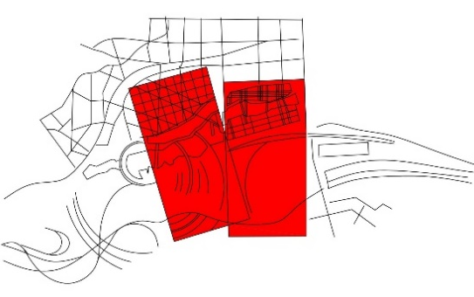
1.2 Partial Integration between Form and Context
1.3Contrast Between Form and Background
1.4Ignoring Surrounding Pattern
- Artificial Environment
2.1 Absent of Site Context
2.2 Form & Context on the Same Level
2.3 Melting the Form within the Context
2.4 Absent of Form
- Historical Tracing |  |  |  |  | B Site Context with Building
- Pre-existing Element |  |  |  |  | 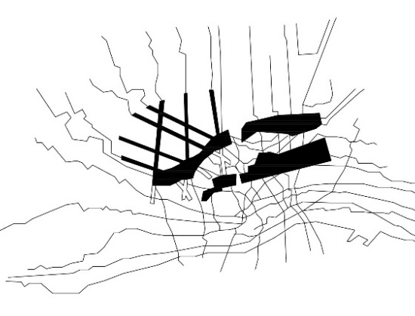
  - Different Maps of the Site
  - Overlaying Different Layers
  - Identical Past and Present Traces
- Topographical-Cultural Geometry
  - Analogue & Textual Reading
  - Abstract Geometry from Culture
  - Archeological Impact of the Site
  - Multi Layers of Ground Condition
- Context Fragmentation |  |  |  |  | C The Building Form
5.1 Mislay Site Identity |  |  |  |  | 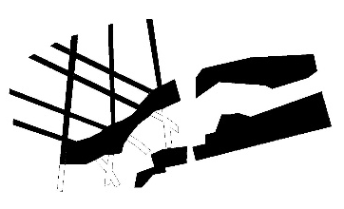
5.2 Created Dominant Context
5.3 Altering Site Features
5.4 Scratching Site History
- Natural Context Integration
6.1 Keeping the Shape of the Site
6.2 Response the Topography
6.3 Form follows the Site Condition
6.4 Harmony between Site & Form

Project Code: | B1 |  |  | 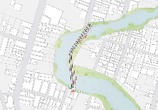
Project Name: | Jojutla Bridge
Designer: | Rem Kolhaass
Location: | Jojutla de Juarez, Mexico, 2018
In Jojutla Bridge OMA, new pedestrian bridge connecting the eastern zone and downtown. Running north-south and dividing Jojutla’s urban center, the Apatlaco River was among the most affected areas. In 2018, OMA New York designed a bridge to facilitate a much-needed link between currently disconnected communities, create a new commercial axis. A linear bridge is bent into a shape dodging private properties, crossing the river twice, and anchoring itself to three distinct points of the city. Its form is akin to a large I-beam, giving way to a double-decker concrete structure. Its upper deck simultaneously provides a higher datum in anticipation of water level rise and shade for the dedicated pedestrian and bicycle paths below (OMA Office, 2022).
Interactive Strategies of Site Context |  |  |  |  | Graphical Analysis
- Objective Background Context |  |  |  |  | A Surrounding Context
1.1Totally Ignoring the Site Context |  |  |  |  | 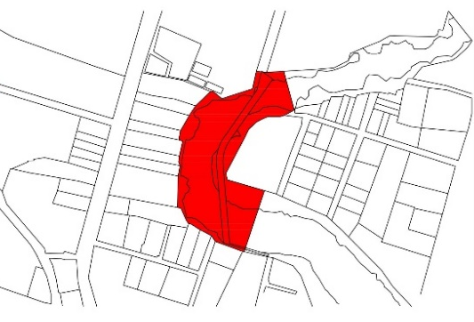
1.2 Partial Integration between Form and Context
1.3 Contrast Between Form and Background
1.4 Ignoring Surrounding Pattern
- Artificial Environment
2.1 Absent of Site Context
2.2 Form & Context on the Same Level
2.3 Melting the Form within the Context
2.4 Absent of Form
- Historical Tracing |  |  |  |  | B Site Context with Building
3.1 Pre-existing Element |  |  |  |  | 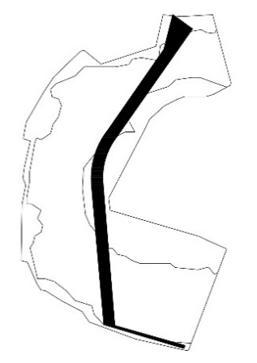
3.2 Different Maps of the Site
3.3 Overlaying Different Layers
3.4 Identical Past and Present Traces
- Topographical-Cultural Geometry
4.1 Analogue & Textual Reading
4.2 Abstract Geometry from Culture
4.3 Archeological Impact of the Site
4.4 Multi Layers of Ground Condition
- Context Fragmentation |  |  |  |  | C The Building Form
5.1 Mislay Site Identity |  |  |  |  | 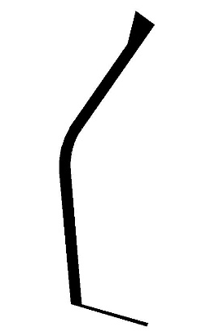
  - Created Dominant Context
5.3 Altering Site Features
5.4 Scratching Site History
- Natural Context Integration
6.1 Keeping the Shape of the Site
6.2 Response the Topography
6.3 Form follows the Site Condition
6.4 Harmony between Site & Form

Project Code: | B2 |  |  | 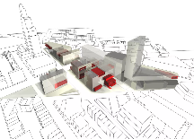
Project Name: | Brooklyn Academy of Music
Designer: | Rem Kolhaass
Location: | Jojutla de Juarez, Mexico, 2018
The project aimed to provide a vibrant new cultural district outside of Manhattan and give a much-needed focus to an important historic Brooklyn neighborhood in the midst of revival. The plan sought to maximize permeability between the new buildings and the surrounding Fort Greene neighborhood. The project seeks to integrate the District's future inhabitants with the cultural life of the site itself (OMA, 2023).
Interactive Strategies of Site Context |  |  |  |  | Graphical Analysis
- Objective Background Context |  |  |  |  | A Surrounding Context
1.1 Totally Ignoring the Site Context |  |  |  |  | 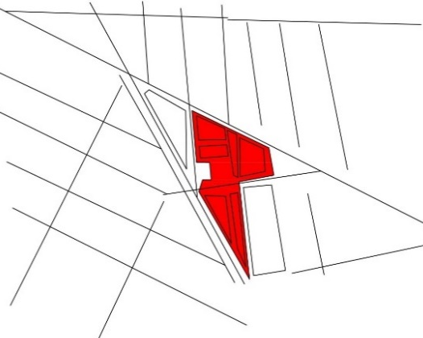
  - Partial Integration between Form and Context
1.3 Contrast Between Form and Background
1.4 Ignoring Surrounding Pattern
- Artificial Environment
  - Absent of Site Context
  - Form & Context on the Same Level
  - Melting the Form within the Context
2.4 Absent of Form
- Historical Tracing |  |  |  |  | B Site Context with Building
- Pre-existing Element |  |  |  |  | 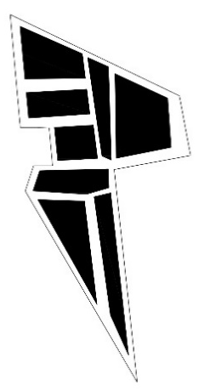
  - Different Maps of the Site
  - Overlaying Different Layers
  - Identical Past and Present Traces
- Topographical-Cultural Geometry
  - Analogue & Textual Reading
  - Abstract Geometry from Culture
  - Archeological Impact of the Site
  - Multi Layers of Ground Condition
- Context Fragmentation |  |  |  |  | C The Building Form
5.1 Mislay Site Identity |  |  |  |  | 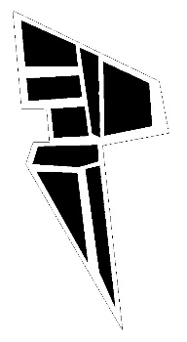
5.2 Created Dominant Context
  - Altering Site Features
  - Scratching Site History
- Natural Context Integration
  - Keeping the Shape of the Site
  - Response the Topography
  - Form follows the Site Condition
  - Harmony between Site & Form

Project Code: | B3 |  |  | 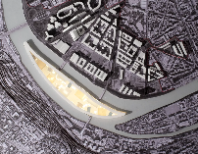
Project Name: | Ile Seguin
Designer: | Rem Kolhaass
Location: | Paris, France, 2009
Ile Seguin returns of the visionary, the social, the large scale – can be planned. The enclosure: both radical and historically correct, it proposes to build the perimeter of the island. It becomes, in its entirety, a building with a huge interior condition that can 'solve' in a flexible way, the relationships between the new and the inheritance of previous commitments. The whole of the island will establish a productive contrast with the ongoing efforts on the Renault site. The linear project: a single piece of architecture can make sense of both the island's past and its future. It acts as a continuous base to the north side, and offers to Sèvres on the south a fixed context where freer and more individual projects can develop (OMA, 2023).
Interactive Strategies of Site Context |  |  |  |  | Graphical Analysis
- Objective Background Context |  |  |  |  | A Surrounding Context
1.1 Totally Ignoring the Site Context |  |  |  |  | 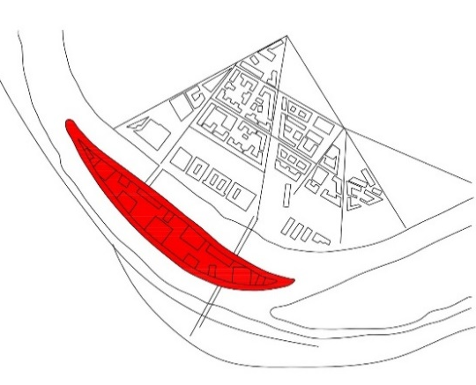
  - Partial Integration between Form and Context
1.3 Contrast Between Form and Background
1.4 Ignoring Surrounding Pattern
- Artificial Environment
2.1 Absent of Site Context
2.2 Form & Context on the Same Level
2.3 Melting the Form within the Context
2.4 Absent of Form
- Historical Tracing |  |  |  |  | B Site Context with Building
3.1 Pre-existing Element |  |  |  |  | 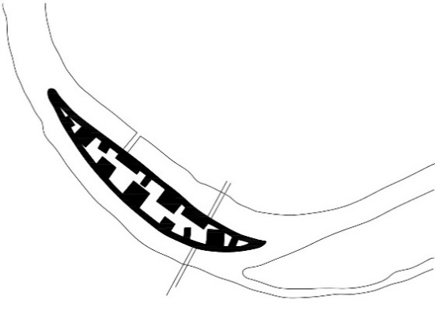
3.2 Different Maps of the Site
3.3 Overlaying Different Layers
3.4 Identical Past and Present Traces
- Topographical-Cultural Geometry
4.1 Analogue & Textual Reading
  - Abstract Geometry from Culture
4.3 Archeological Impact of the Site
4.4 Multi Layers of Ground Condition
- Context Fragmentation |  |  |  |  | C The Building Form
5.1 Mislay Site Identity |  |  |  |  | 
5.2 Created Dominant Context
5.3 Altering Site Features
5.4 Scratching Site History
- Natural Context Integration
6.1 Keeping the Shape of the Site
6.2 Response the Topography
6.3 Form follows the Site Condition
6.4 Harmony between Site & Form

Project Code: | B4 |  |  | 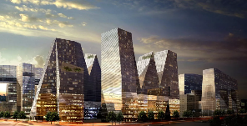
Project Name: | S Project
Designer: | Rem Kolhaass
Location: | Seoul, Korea, 2004
Ile Seguin returns of the visionary, the social, the large scale – can be planned. The enclosure: both radical and historically correct, it proposes to build the perimeter of the island. It becomes, in its entirety, a building with a huge interior condition that can 'solve' in a flexible way, the relationships between the new and the inheritance of previous commitments. The whole of the island will establish a productive contrast with the ongoing efforts on the Renault site. The linear project: a single piece of architecture can make sense of both the island's past and its future. It acts as a continuous base to the north side, and offers to Sèvres on the south a fixed context where freer and more individual projects can develop (OMA, 2023).
Interactive Strategies of Site Context |  |  |  |  | Graphical Analysis
- Objective Background Context |  |  |  |  | A Surrounding Context
1.1 Totally Ignoring the Site Context |  |  |  |  | 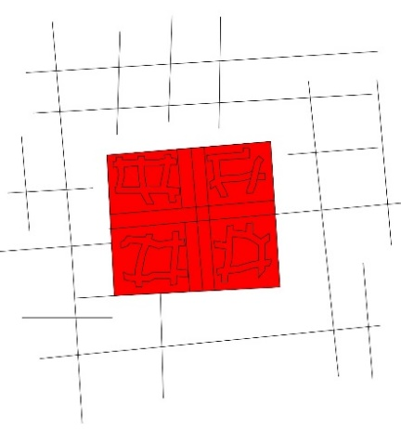
  - Partial Integration between Form and Context
1.3 Contrast Between Form and Background
1.4 Ignoring Surrounding Pattern
- Artificial Environment
2.1 Absent of Site Context
  - Form & Context on the Same Level
2.3 Melting the Form within the Context
2.4 Absent of Form
- Historical Tracing |  |  |  |  | B Site Context with Building
- Pre-existing Element |  |  |  |  | 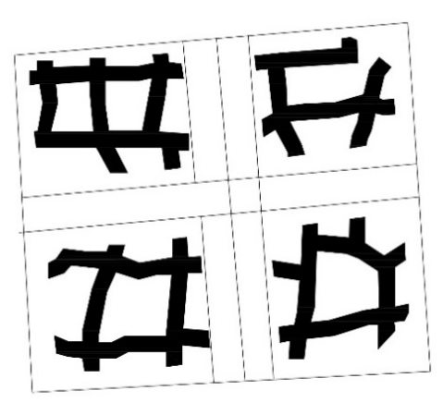
  - Different Maps of the Site
  - Overlaying Different Layers
  - Identical Past and Present Traces
- Topographical-Cultural Geometry
  - Analogue & Textual Reading
  - Abstract Geometry from Culture
  - Archeological Impact of the Site
  - Multi Layers of Ground Condition
- Context Fragmentation |  |  |  |  | C The Building Form
5.1 Mislay Site Identity |  |  |  |  | 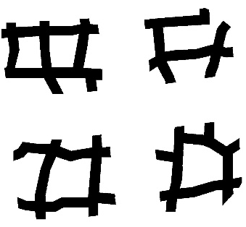
5.2 Created Dominant Context
  - Altering Site Features
  - Scratching Site History
- Natural Context Integration
  - Keeping the Shape of the Site
  - Response the Topography
  - Form follows the Site Condition
  - Harmony between Site & Form

Project Code: | C1 |  |  | 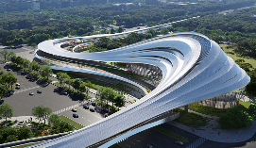
Project Name: | Jinghe City Culture & Art Centre
Designer: | Zaha Hadid
Location: | Shaanxi, China, 2022
The architecture blends with the surrounding landscape, echoing the valleys carved by the Jinghe River through the mountains and landscapes of Shaanxi province. The architecture is organized as a series of flowing volumes, layers, and surfaces, interconnecting with courtyards and landscapes that define a sequence of interior and exterior spaces for its community. The center’s design merges with the city’s existing urban. The curved forms reference the Jinghe River and the mountain valleys it has carved out in the area (Stouhi, 2023).
Interactive Strategies of Site Context |  |  |  |  | Graphical Analysis
- Objective Background Context |  |  |  |  | A Surrounding Context
1.1 Totally Ignoring the Site Context |  |  |  |  | 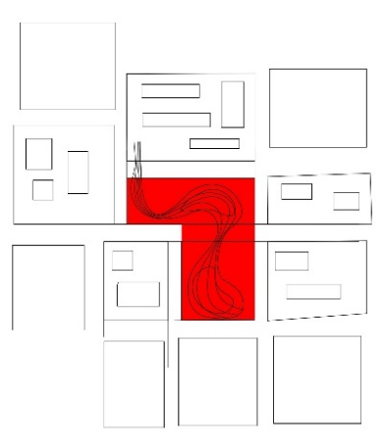
  - Partial Integration between Form and Context
1.3 Contrast Between Form and Background
1.4 Ignoring Surrounding Pattern
- Artificial Environment
2.1 Absent of Site Context
2.2 Form & Context on the Same Level
2.3 Melting the Form within the Context
2.4 Absent of Form
- Historical Tracing |  |  |  |  | B Site Context with Building
3.1 Pre-existing Element |  |  |  |  | 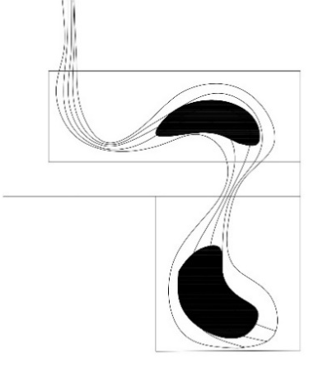
3.2 Different Maps of the Site
3.3 Overlaying Different Layers
3.4 Identical Past and Present Traces
- Topographical-Cultural Geometry
4.1 Analogue & Textual Reading
4.2 Abstract Geometry from Culture
4.3 Archeological Impact of the Site
4.4 Multi Layers of Ground Condition
- Context Fragmentation |  |  |  |  | C The Building Form
5.1 Mislay Site Identity |  |  |  |  | 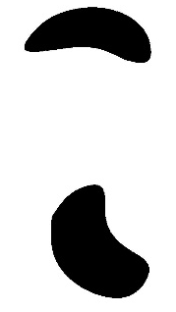
  - Created Dominant Context
  - Altering Site Features
5.4 Scratching Site History
- Natural Context Integration
  - Keeping the Shape of the Site
  - Response the Topography
  - Form follows the Site Condition
  - Harmony between Site & Form

Project Code: | C2 |  |  | 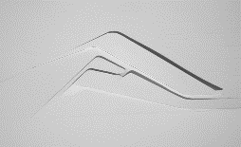
Project Name: | BMW Showroom
Designer: | Zaha Hadid
Location: | Leipzig, Germany, 2006
The showroom references adjacent structures, onsite processes, and the BMW car through its dynamic shape - forming naturally from the surface of the car park, extending its surfaces through two building parts which 'rotate' one around the other to contain showroom and other functions (Hadid, 2023). Hadid's design took this idea of connectivity and used it to inform every aspect of the new building. It serves as a connection between the assembly process steps and the employees. Designed as a series of overlapping and interconnecting levels and spaces, it blurs the separation between parts of the complex and creates a level ground for both blue and white-collar employees, visitors, and cars (Leipzig, 2009).
Interactive Strategies of Site Context |  |  |  |  | Graphical Analysis
- Objective Background Context |  |  |  |  | A Surrounding Context
1.1 Totally Ignoring the Site Context |  |  |  |  | 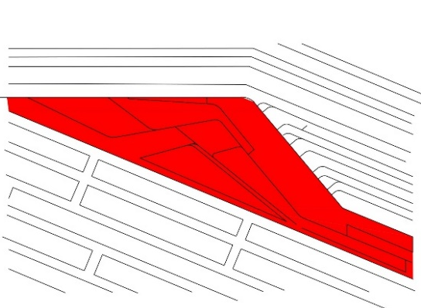
1.2 Partial Integration between Form and Context
1.3 Contrast Between Form and Background
1.4 Ignoring Surrounding Pattern
- Artificial Environment
2.1 Absent of Site Context
2.2 Form & Context on the Same Level
2.3 Melting the Form within the Context
2.4 Absent of Form
- Historical Tracing |  |  |  |  | B Site Context with Building
3.1 Pre-existing Element |  |  |  |  | 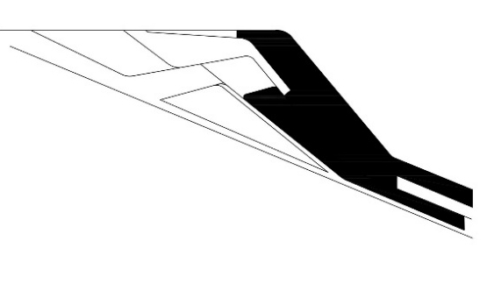
3.2 Different Maps of the Site
3.3 Overlaying Different Layers
3.4 Identical Past and Present Traces
- Topographical-Cultural Geometry
  - Analogue & Textual Reading
  - Abstract Geometry from Culture
4.3 Archeological Impact of the Site
  - Multi Layers of Ground Condition
- Context Fragmentation |  |  |  |  | C The Building Form
5.1 Mislay Site Identity |  |  |  |  | 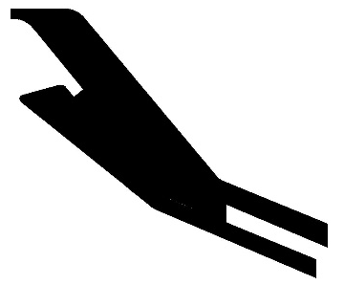
5.2 Created Dominant Context
  - Altering Site Features
  - Scratching Site History
- Natural Context Integration
  - Keeping the Shape of the Site
  - Response the Topography
  - Form follows the Site Condition
  - Harmony between Site & Form

Project Code: | C3 |  |  | 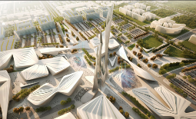
Project Name: | Astana EXPO Future Energy
Designer: | Zaha Hadid
Location: | Astana, Kazakhstan, 2017
The result of the process, which consisted of a thoughtful analysis of the cultural and physical landscape of Kazakhstan, traditional patterns, and ornaments, is the informal fluid interface of urban patterns, landforms and architecture inspired by a combination of local culture and renewable technologies. The proposed urban grid came logically and the urban morphology evolved forming a multiplicity of geometries and orientations that connect to adjacent areas. Building mass is fluid and the contour addresses the neighboring urban conditions, height regulations, and the importance of adjoining streets (Bojovic, 2013).
Interactive Strategies of Site Context |  |  |  |  | Graphical Analysis
- Objective Background Context |  |  |  |  | A Surrounding Context
1.1 Totally Ignoring the Site Context |  |  |  |  | 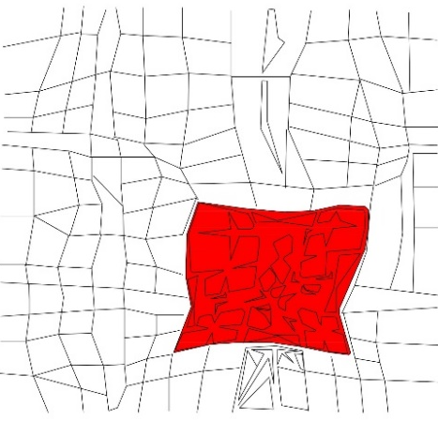
1.2 Partial Integration between Form and Context
1.3 Contrast Between Form and Background
1.4 Ignoring Surrounding Pattern
- Artificial Environment
2.1 Absent of Site Context
2.2 Form & Context on the Same Level
2.3 Melting the Form within the Context
2.4 Absent of Form
- Historical Tracing |  |  |  |  | B Site Context with Building
3.1 Pre-existing Element |  |  |  |  | 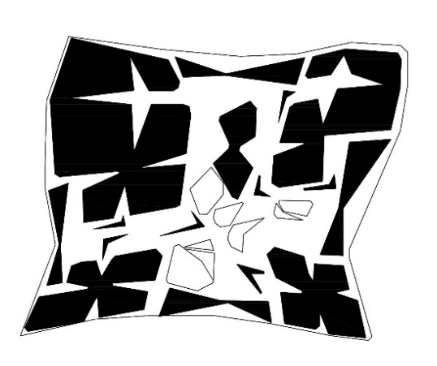
3.2 Different Maps of the Site
3.3 Overlaying Different Layers
3.4 Identical Past and Present Traces
- Topographical-Cultural Geometry
4.1 Analogue & Textual Reading
4.2 Abstract Geometry from Culture
4.3 Archeological Impact of the Site
4.4 Multi Layers of Ground Condition
- Context Fragmentation |  |  |  |  | C The Building Form
5.1 Mislay Site Identity |  |  |  |  | 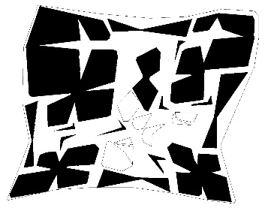
5.2 Created Dominant Context
5.3 Altering Site Features
5.4 Scratching Site History
- Natural Context Integration
6.1 Keeping the Shape of the Site
6.2 Response the Topography
6.3 Form follows the Site Condition
6.4 Harmony between Site & Form

Project Code: | C4 |  |  | 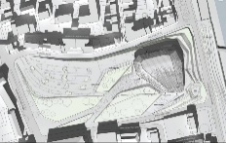
Project Name: | Beethoven Concert Hall
Designer: | Zaha Hadid
Location: | Bon, Germany, 2009
A porous multi-faceted crystalline mass growing out of earth floating out of earth The curvilinear shell opens and closes, creating an ongoing dialogue between interior and exterior. The volume’s form accentuates the continuity between the river and the city with folds and creases underlining the rise from the riverfront to the urban level. The result is a sense of flow, continuity, lightness, and movement’. Zaha Hadid designed the concert hall to create an inspirational venue meeting the orchestra’s growing program, and creating a new public plaza for all citizens (Hadid, 2023).
Interactive Strategies of Site Context |  |  |  |  | Graphical Analysis
- Objective Background Context |  |  |  |  | A Surrounding Context
1.1 Totally Ignoring the Site Context |  |  |  |  | 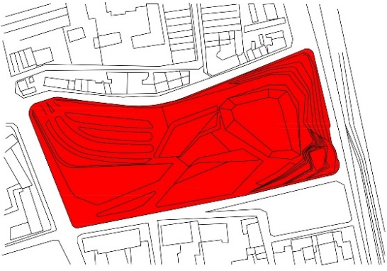
  - Partial Integration between Form and Context
1.3 Contrast Between Form and Background
1.4 Ignoring Surrounding Pattern
- Artificial Environment
2.1 Absent of Site Context
2.2 Form & Context on the Same Level
2.3 Melting the Form within the Context
2.4 Absent of Form
- Historical Tracing |  |  |  |  | B Site Context with Building
3.1 Pre-existing Element |  |  |  |  | 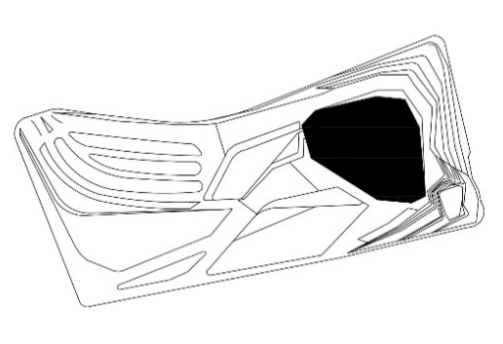
3.2 Different Maps of the Site
3.3 Overlaying Different Layers
3.4 Identical Past and Present Traces
- Topographical-Cultural Geometry
4.1 Analogue & Textual Reading
4.2 Abstract Geometry from Culture
4.3 Archeological Impact of the Site
4.4 Multi Layers of Ground Condition
- Context Fragmentation |  |  |  |  | C The Building Form
5.1 Mislay Site Identity |  |  |  |  | 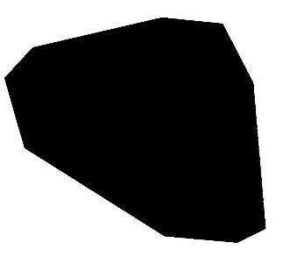
5.2 Created Dominant Context
5.3 Altering Site Features
5.4 Scratching Site History
- Natural Context Integration
6.1 Keeping the Shape of the Site
6.2 Response the Topography
6.3 Form follows the Site Condition
6.4 Harmony between Site & Form

