Demixing fluorescence time traces transmitted by multimode fibers
Caio Vaz Rimoli^{1,2*}, Claudio Moretti¹, Fernando Soldevila¹, Enora Brémont²,
Cathie Ventalon^{2*}, Sylvain Gigan^{1*}
¹ Laboratoire Kastler Brossel, ENS-Universite PSL, CNRS, Sorbonne Universite, College de France, 24 Rue Lhomond, Paris, F-75005, France.
² IBENS, Departement de Biologie, Ecole Normale Superieure, CNRS, Inserm, PSL Research University, 46 Rue d’Ulm, Paris, F-75005, France.
SUPPLEMENTARY INFORMATION
- Supplementary materials - list of contents:
- Supplementary Information 01 – The proof of principle setup
- Supplementary Information 02 – Estimating the number of fluorescence sources with NMF: the NMF rank study
- Supplementary Information 03 – The miniscope detection sensitivity to a single source
- Supplementary Information 04 – Pattern shape dependence on symmetrically positioned beads (with miniscope)
- Supplementary Information 05 – NMF analysis test when binning the image
- Supplementary Information 06 – Comparing GT-NMF and GT-GT correlation coefficients

Supp info 01: the proof of principle optical setup
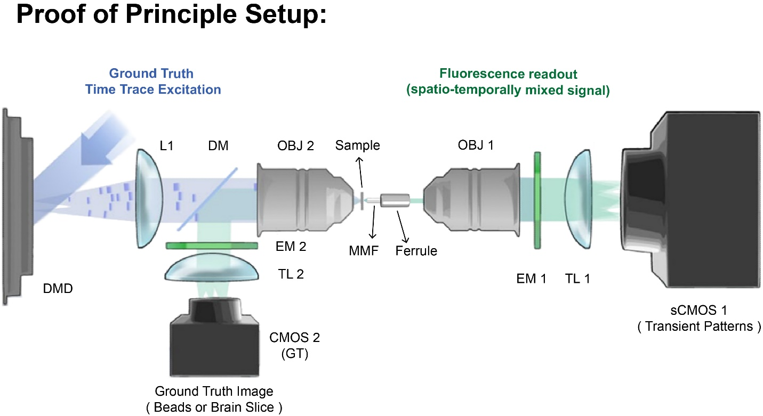
Figure S01 - The proof of principle optical setup. A 473 nm blue laser (LSR-0473-PFM-00100-01, Laserglow Technologies) illuminates a digital micromirror device surface (DMD from Texas Instruments: DLP LightCrafter 6500, same as ⁴³), that was used to create the ground truth (GT) excitation of each fluorescence source present in the sample plane (see sample details in the methods). A tube lens (L1, LA1708-A, Thorlabs) and the lower objective OBJ 2 (Plan-NEOFLUAR × 20 0.5 NA, Zeiss) were used in the excitation path. For the ground truth excitation, genetically encoded calcium indicator (GECI) traces were obtained from neuronal recordings available in the literature, as we did before in previous experiments ^{43,57}. After excitation, the florescent signal propagated through the short multimode fiber (see fiber-ferrule preparation details in the methods) and the fluctuating fluorescent scattering fingerprints on the tip of the fiber were imaged onto a scientific complementary metal-oxide-semiconductor (sCMOS) camera (Iris 15 sCMOS, Teledyne Photometrics) by a microscope objective (OBJ 1, RMS10X PLAN ACHROMAT 0.25NA, Olympus) and a tube lens (TL 1). An emission bandpass filter (MF530-43, Thorlabs) was used in the detection path to block the blue excitation light. In addition, the system has a control path to image the fluorescence sample directly, so that it would be possible to obtain the ground truth image of the sample without passing through the fiber. This is done by imaging the backpropagating fluorescent light from the sample in reflection mode. For this path, a dichroic beam splitter (DM, FF496-SDi01, Semrock) was used to collect the fluorescent signal in reflection and the sample plane was imaged onto a CMOS camera (ACE2014-55um, Basler) after another tube lens (TL 2).

Supp info 02: estimating the number of fluorescence sources with NMF: the NMF rank study
The rank of NMF sets the number of components the NMF will demix from the video data (number of fingerprints and their corresponding time traces) ^{42-44,48}. In the experiment of Figure 02, we probed 6 beads in the FoV. In such case, because we know the number of sources, an expected good rank number (R_{expected}) as an input in NMF would be: R_{expected} = 7, because there were 6 beads + 1 background signal (R_{expected} = N_{beads} + 1_{bgd}). In a neuroscience experiment, one might not know a priori the number of the sources (neurons) one is probing, hence the input rank value on the NMF algorithm is not evident. However, one could still evaluate how well NMF performs to minimize the difference between the product of the two factorized spatial (W) and temporal (H) matrices and the original video matrix (X) with different rank values. The fidelity plot is shown in Figure S02-i. There, the residual error gradually decreases until reaching stabilized values, similar to a plateau (e.g., for rank values higher than 9). The curve profile changes more drastically its curvature around rank 4 and starts to stabilize around the expected rank R_{expected} = 7. Therefore, one could immediately make a rough estimation of the number of sources by just calculating the fidelity of NMF.

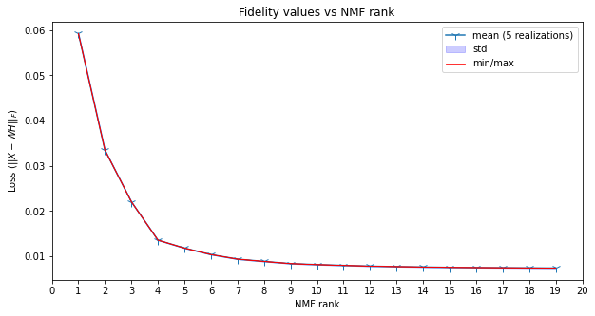
Figure S02-i – Residual error estimation (fidelity plot) for NMF with different factorization ranks. The sample used here is the same as in Figure 02 and contains 6 beads. One might see that the fidelity curve changes its curvature when the tested rank values gets closer to the GT expected rank (6 beads + 1 background). After that, the NMF performance slowly reaches a plateau. For large NMF rank values, the extra fingerprints and time traces obtained are replicas of the GT signal. NMF model parameters were the same as methods, only changing the rank value. Mean value and standard deviations (std) over 5 realizations with 3000 interactions.

However, by investigating more closely these NMF results for ranks between 4 and 10, one might be able to count the number of individual sources with more precision. This is because the extra components are due to NMF forcing to split a single signal (fingerprint and time trace) into two or more positive signals. As a consequence, we expect to obtain fingerprint replicas of the bead patterns and background. For lower ranks, signal from individual sources can be superimposed with data from other sources or with the background. For example, in when we chose rank R =4, the background signal is still mixed with some of the fluorescent bead signal (see Figure S02-ii). In such case, we retrieved relatively well the signal of 3 sources (there is some cross talk between bead 3 and the bead 4), but we lost the remaining ones.

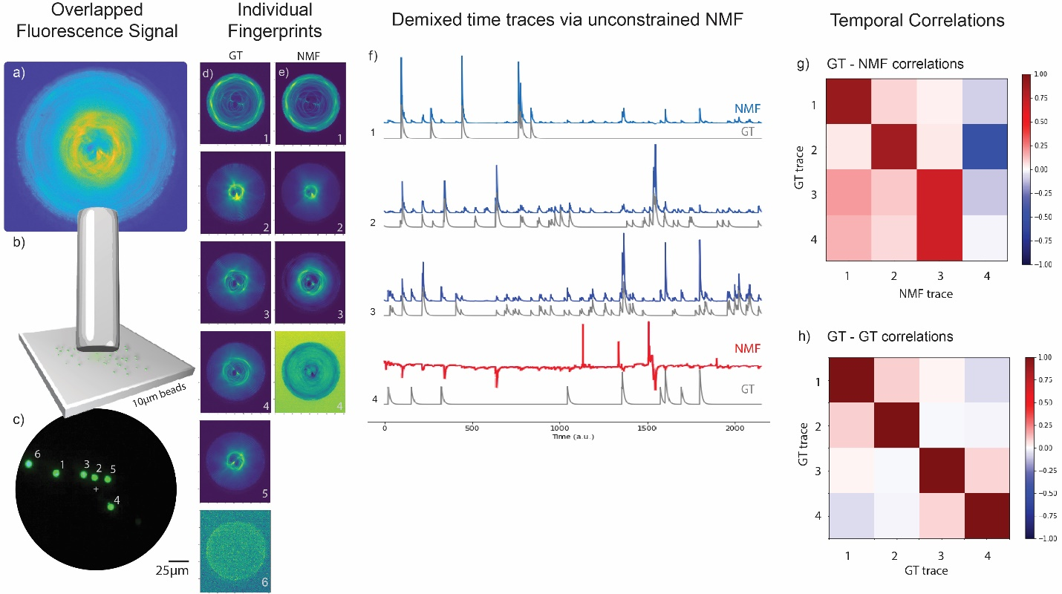
Figure S02-ii – Results of the proof of principle experiment, analyzed when we the input rank of NMF is R = 4. From (a) to (c) we have: (a) the fiber proximal end image of 6 fluorescent bead fingerprint patterns overlapped on the sCMOS camera chip; (b) the short MMF located at a distance of 60 ± 10 µm from the fluorescent beads; (c) a CMOS Basler camera with the ground truth image of the sample. (d) The ground truth (GT) fingerprint patterns. (e) The fingerprint patterns obtained via NMF with rank 4. (f) The individual temporal activity traces of the sources obtained with NMF (blue) and their corresponding GT traces (gray). The red NMF trace (#4) is mainly background superimposed with the time trace activity of the other sources. (g) The Ground truth (GT) – NMF time trace correlations. The average diagonal value of the first 3 beads was < δ_{g,n} > = δ_{avg} = 81.3% with standard deviation of $σ_{δ}$ = 8.9%. (h) The GT-GT temporal trace correlations coefficients.

For rank R = 7, we did retrieve well 5 unique fingerprints and their corresponding time traces, but we did not retrieve well the signal from bead #6 mostly due low SNR ratio. When using a higher rank and sorting the most correlated NMF time traces to the GTs, the background temporal correlations were higher than the time trace signal of the bead itself (see red time trace NMF curve in Figure S02-iii). This result suggests that bead #6 was still embedded in the background for rank R=7.
For higher ranks than the expected one (R > 7), we start to split the signal of the source time traces, but also from the background (see replicas in Figure S02-iv). For NMF rank #9 (see Figure 02) and beyond, NMF always managed to find the hidden signal of bead #6 in the background component, which was correlating more with the GT of bead #6 than the background itself.

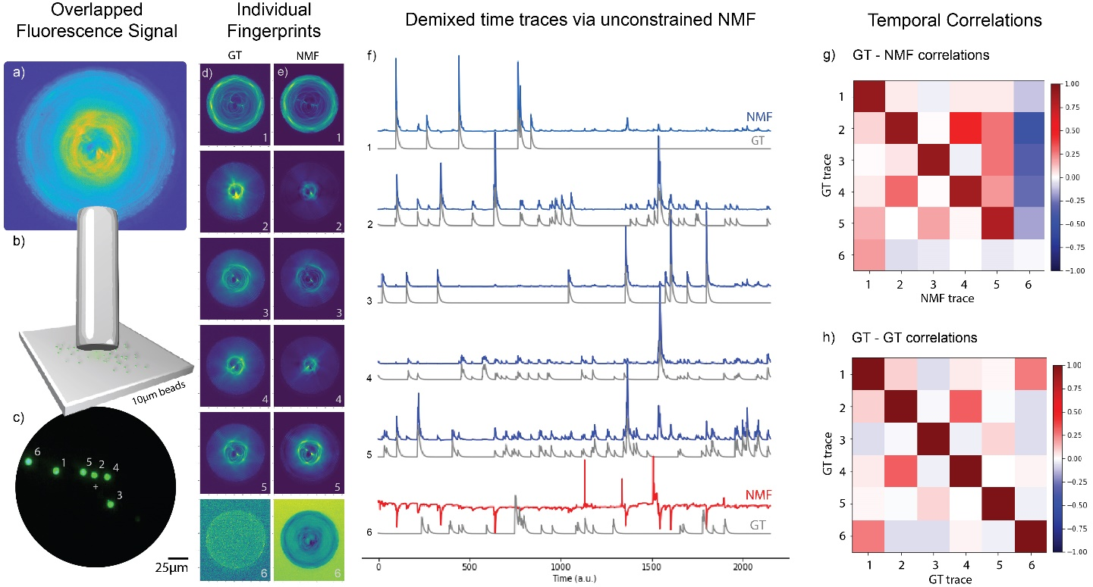
Figure S02-iii – Results of the proof of principle experiment, when NMF rank R = 7. From (a) to (c) we have: (a) the fiber proximal end image of 6 fluorescent bead fingerprint patterns overlapped on the sCMOS camera chip; (b) the short MMF located at a distance of 60 ± 10 µm from the fluorescent beads; (c) a CMOS Basler camera with the ground truth image of the sample. (d) The ground truth (GT) fingerprint patterns. (e) The fingerprint patterns obtained with the NMF. (f) The individual temporal activity traces of the sources obtained with NMF (blue) and their corresponding GT traces (gray). The red NMF trace (#6) was not recovered well by NMF since bead #6 was localized very close to the fiber core edge, therefore yielding low signal/contrast of its pattern (see GT scattering fingerprint of bead #6 in d). (g) The Ground truth (GT) – NMF time trace correlations. The average diagonal value of the first 5 beads was < δ_{g,n} > = δ_{avg} = 88% with standard deviation of $σ_{δ}$= 4%. (h) The GT-GT temporal trace correlation coefficients. The GT-GT correlation coefficients show that GTs from different sources were not fully uncorrelated, although each GT trace was unique in time (singular). For example, GT traces of beads #2 and #4 were fairly temporally correlated (γ_{2,4} = γ_{4,2} = 31.2%, in (h)) and had a very clear spatial overlap (see GT and NMF scattering fingerprints #2 and #4 in (d) and (e)).

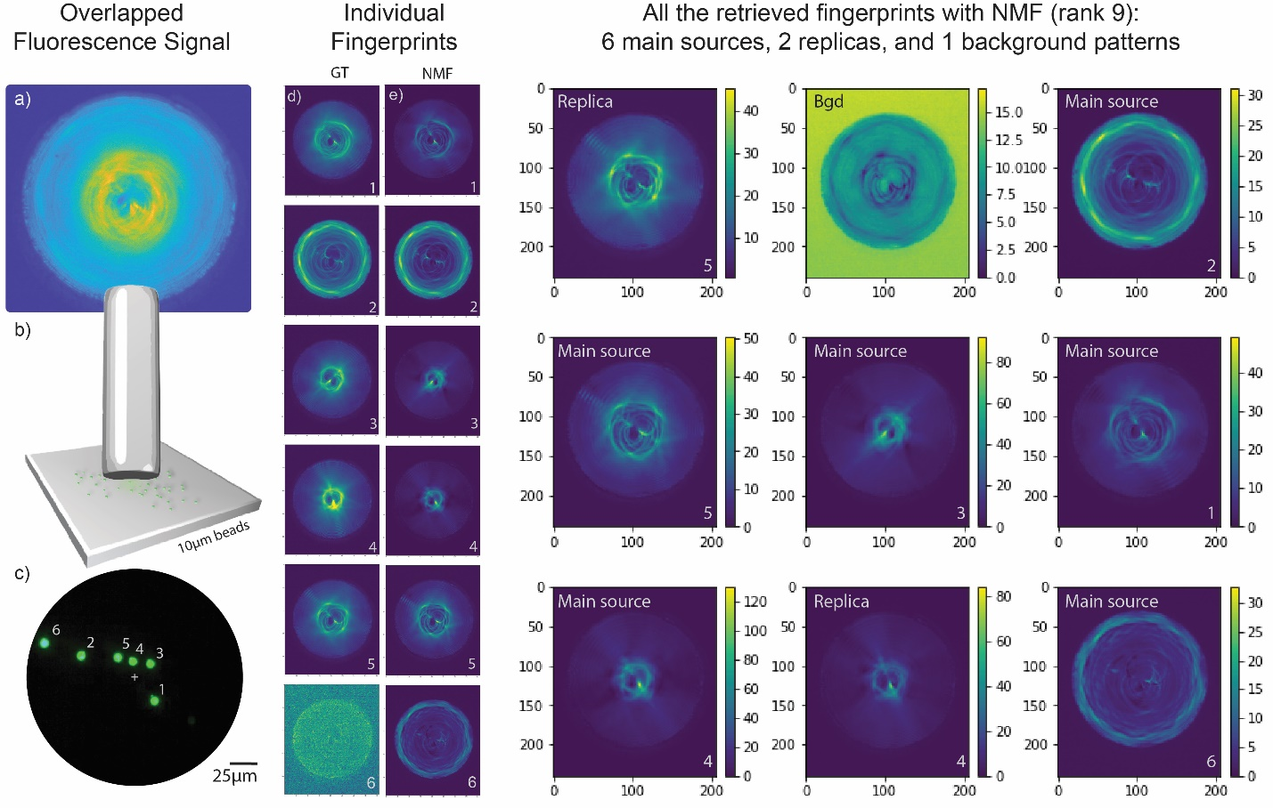
Figure S02-iv – All the fingerprint results of the proof of principle experiment, when NMF rank R = 9 (same as Figure 02). When rank is R = 9, the NMF demixes the data video in 6 main sources, 2 replicas, and 1 background (bgd).

Supp info 03: the miniscope detection sensitivity to a single source
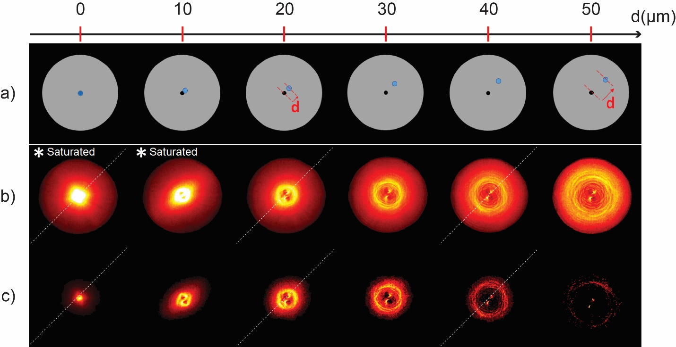
Figure S03 – Miniscope sensitivity to single-bead source upon different DAQ software setting conditions. (a) Illustration of the 10µm fluorescent bead displacement at the distal end of the fiber. The single-bead (blue dot) is displaced in a radial manner of a distance d (red vector) from the center of the fiber (black dot) generating different scattering fingerprints in (b) and (c). (b) Proximal end images of the fluorescence fingerprint patterns when the miniscope settings were for relatively low power and the slowest frame rate: LED power = 20%, corresponding to a transmitted power by the fiber of P_{MMF} = 9.49 ± 0.08 µW, and detection parameters of FPS = 10 Hz, Gain = 1.0. Under this condition, the detected patterns had saturated pixels (check the white pixels in the hot colormap) when the probed bead was closer to the axial center (d < 20µm). (c) Proximal end image of the detected fingerprint patterns when the miniscope settings were for very low power and the fastest frame rate: LED power = 10%, corresponding to a transmitted power by the fiber of P_{MMF} = 6.2 ± 1.2 µW, and detection parameters of FPS = 30 Hz, Gain = 1.0. The diagonal dashed line indicates the orientation of the single source displacement (at the fiber distal end) which coincides with the 2 bright spots orientation (see Supp info 04 for more details).

Supp info 04: pattern shape dependence on symmetrically positioned beads (with miniscope)
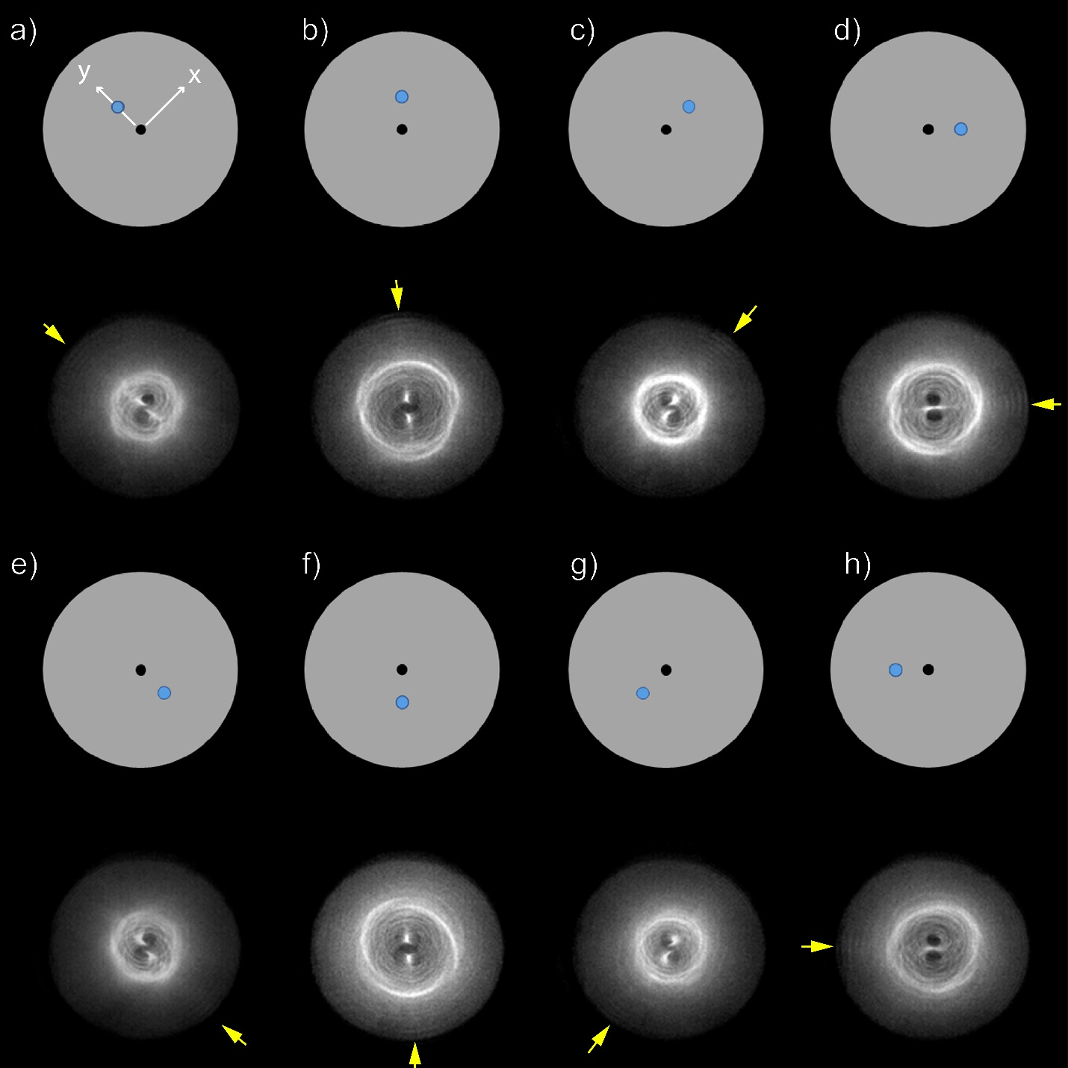
Figure S04 – Beads at different azimuthal orientational positions display rotated patterns in relation to each other. In (a) the white x and y arrows are the main axis of the miniscope optics. The flat gray circles on the top of the patterns illustrate the corresponding distal end of the fiber, where the blue dot represents the 10µm fluorescent bead, and the black dot represents the center of the fiber core. Below each distal end cartoon, there are the corresponding proximal end data images (fluorescence patterns) obtained with the miniscope. Note that, the central structure of the fingerprint patterns (the core area within the bright ring with ramifications) contains bright and dark spots which rotate accordingly to the azimuthal orientation of the single source (blue dot) at the distal end. Yellow arrows point to some subtle bright features (ripples) at the patterns (d) and (h) that can possibly distinguish fingerprints generated from symmetrically positioned beads along one given direction if SNR is good enough. The very subtle shape differences between such two similar patterns from symmetric beads along one direction needs further investigation to confirm that they are really different, which is far from the scope of this work. In most cases, fingerprint pattern shapes seem to be different (not ambiguous) from beads localized at different orientations. Miniscope settings for these measurements were: LED = 30%, transmitted power was P_{MMF} = 13.1 ± 0.8 µW, and detection parameters of FPS = 20 Hz, Gain = 1.

Supp info 05: the binning test
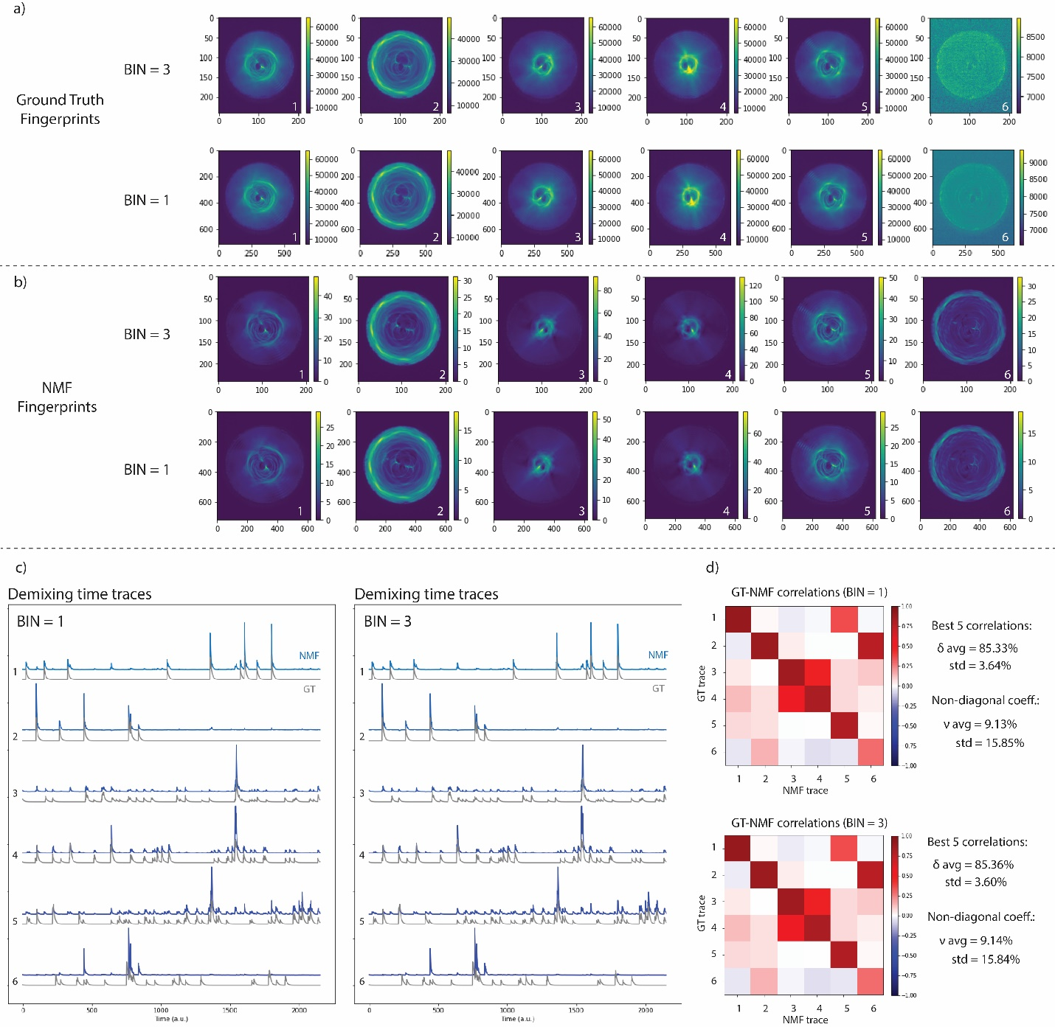
Figure S05 – Testing the results for NMF when spatially binning the recorded video. The tested binning value was bin = 3. Comparison of the results when BIN =1 and BIN=3 for ground truth fingerprints (a), NMF retrieved fingerprints (b), obtained time traces with NMF (c), and GT-NMF time trace correlations. NMF rank = 9, displaying the selected 6 best time traces. Analogous results were also obtained for different rank values. Overall results BIN = 3 are virtually identical to BIN = 1.

Supp info 06: comparing GT-NMF and GT-GT time trace correlation coefficients
The reason why we performed element-wise subtraction between GT-NMF and GT-GT correlation coefficients to evaluate the off-diagonal components is because the GT-GT time traces have some similarity among themselves, i.e., the non-diagonal GT-GT coefficients are not zero ($ν_{i,j}^{GT-GT}≠0$). Consequently, it is expected that the non-diagonal elements of GT-NMF do not reach zero, but values close to the GT-GT coefficients. Let’s consider the following notation for the time traces correlation coefficients:
- GT-NMF time trace correlation coefficients:
GT-NMF diagonal coefficients = $δ_{i,i}$
GT-NMF non-diagonal coefficients = $ν_{i,j}$
For example, when the total number of sources N_{s}= 6:
$$R_{GT-NMF}= \left(\begin{matrix}δ_{1,1} & ν_{1,2} & ν_{1,3} & ν_{1,4} & ν_{1,5} & ν_{1,6} \\ ν_{2,1} & δ_{2,2} & ν_{2,3} & ν_{2,4} & ν_{2,5} & ν_{2,6} \\ ν_{3,1} & ν_{3,2} & δ_{3,3} & ν_{3,4} & ν_{3,5} & ν_{3,6} \\ ν_{4,1} & ν_{4,2} & ν_{4,3} & δ_{4,4} & ν_{4,5} & ν_{4,6} \\ ν_{5,1} & ν_{5,2} & ν_{5,3} & ν_{5,4} & δ_{5,5} & ν_{5,6} \\ ν_{6,1} & ν_{6,2} & ν_{6,3} & ν_{6,4} & ν_{6,5} & δ_{6,6}\end{matrix}\right)$$
- GT-GT time trace correlation coefficients:
GT-GT non-diagonal coefficients = $γ_{i,j}$
For example, when the total number of sources N_{s}= 6:
$$R_{GT-GT}= {\left(\begin{matrix}1 & γ_{1,2} & γ_{1,3} & γ_{1,4} & γ_{1,5} & γ_{1,6} \\ γ_{2,1} & 1 & γ_{2,3} & γ_{2,4} & γ_{2,5} & γ_{2,6} \\ γ_{3,1} & γ_{3,2} & 1 & γ_{3,4} & γ_{3,5} & γ_{3,6} \\ γ_{4,1} & γ_{4,2} & γ_{4,3} & 1 & γ_{4,5} & γ_{4,6} \\ γ_{5,1} & γ_{5,2} & γ_{5,3} & γ_{5,4} & 1 & γ_{5,6} \\ γ_{6,1} & γ_{6,2} & γ_{6,3} & γ_{6,4} & γ_{6,5} & 1\end{matrix}\right)}_{symmetric}$$
To better evaluate how well were the obtained time traces by the NMF, one should compute the absolute mean error between the non-diagonal elements of the GT-NMF and GT-GT values:
$${ζ=ζ}_{i ≠j}= \left(\begin{matrix}s_{1} & \left|ν_{1,2}-γ_{1,2}\right| & \left|ν_{1,3}-γ_{1,3}\right| & \left|ν_{1,4}-γ_{1,4}\right| & \left|ν_{1,5}-γ_{1,5}\right| & \left|ν_{1,6}-γ_{1,6}\right| \\ \left|ν_{2,1}-γ_{2,1}\right| & s_{2} & \left|ν_{2,3}-γ_{2,3}\right| & \left|ν_{2,4}-γ_{2,4}\right| & \left|ν_{2,5}-γ_{2,5}\right| & \left|ν_{2,6}-γ_{2,6}\right| \\ \left|ν_{3,1}-γ_{3,1}\right| & \left|ν_{3,2}-γ_{3,2}\right| & s_{3} & \left|ν_{3,4}-γ_{3,4}\right| & \left|ν_{3,5}-γ_{3,5}\right| & \left|ν_{3,6}-γ_{3,6}\right| \\ \left|ν_{4,1}-γ_{4,1}\right| & \left|ν_{4,2}-γ_{4,2}\right| & \left|ν_{4,3}-γ_{4,3}\right| & s_{4} & \left|ν_{4,5}-γ_{4,5}\right| & \left|ν_{4,6}-γ_{4,6}\right| \\ \left|ν_{5,1}-γ_{5,1}\right| & \left|ν_{5,2}-γ_{5,2}\right| & \left|ν_{5,3}-γ_{5,3}\right| & \left|ν_{5,4}-γ_{5,4}\right| & s_{5} & \left|ν_{5,6}-γ_{5,6}\right| \\ \left|ν_{6,1}-γ_{6,1}\right| & \left|ν_{6,2}-γ_{6,2}\right| & \left|ν_{6,3}-γ_{6,3}\right| & \left|ν_{6,4}-γ_{6,4}\right| & \left|ν_{6,5}-γ_{6,5}\right| & s_{6}\end{matrix}\right)$$
So, the mean of all the non-diagonal values would be:
$$ζ_{avg}=mean\left(ζ_{i ≠j}\right)=\frac{1}{{2 (N}_{s}-1)}\left(\sum_{i≠j}^{N_{s}-1}{\left|ν_{i,j}-γ_{i,j}\right|}\right)$$
And the standard deviation (std) of all non-diagonal elements would be:
$$σ_{ζ}=std(ζ_{i ≠j})$$
Where N_{s} is the total number of sources. These two values ($ζ_{avg} ± σ$) give us an estimation of the whole experiment quality since they should approach to zero.

