Appendixes
Appendix 1. Total number of infections and number of new infections from 01/01/2020 to 01/01/2022
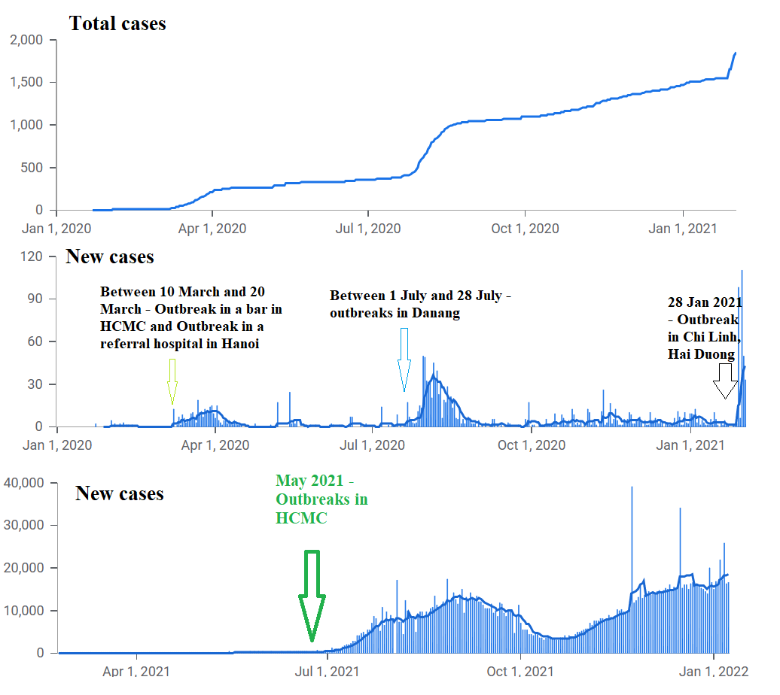
Source: Author’s own synthesis from Johns Hopkins University (2023)
Appendix 2. Eigenvalue and propotion of variances
Component | Eigenvalue | Proportion of variances | Cumulative
Comp1 | 2.4984 | 0.4164 | 0.4164
Comp2 | 0.8214 | 0.1369 | 0.5533
Comp3 | 0.7610 | 0.1268 | 0.6801
Comp4 | 0.7059 | 0.1176 | 0.7978
Comp5 | 0.6610 | 0.1102 | 0.9080
Comp6 | 0.5522 | 0.0920 | 1.0000

Appendix 3. The trends of dependent and independent variables
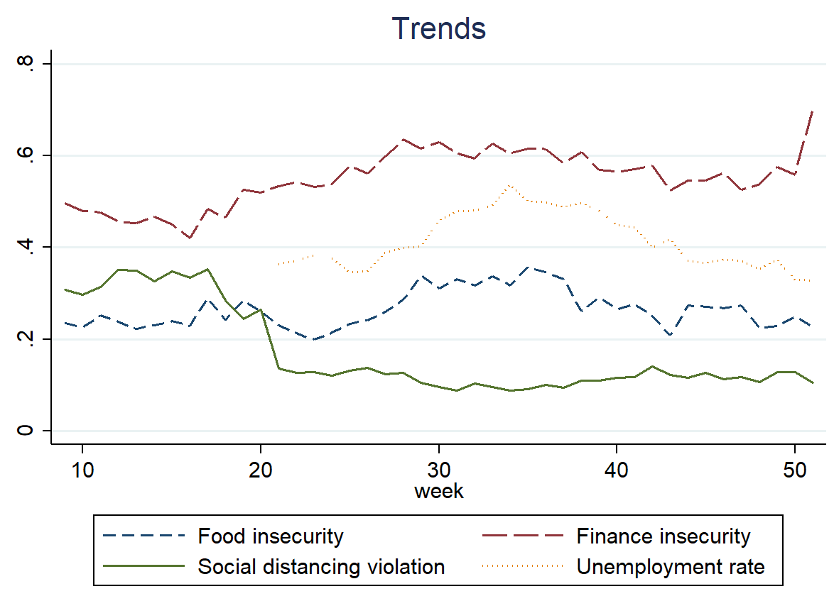

Appendix 4. Financial and food insecurity in Vietnam, from the first quarter to the fourth in 2021
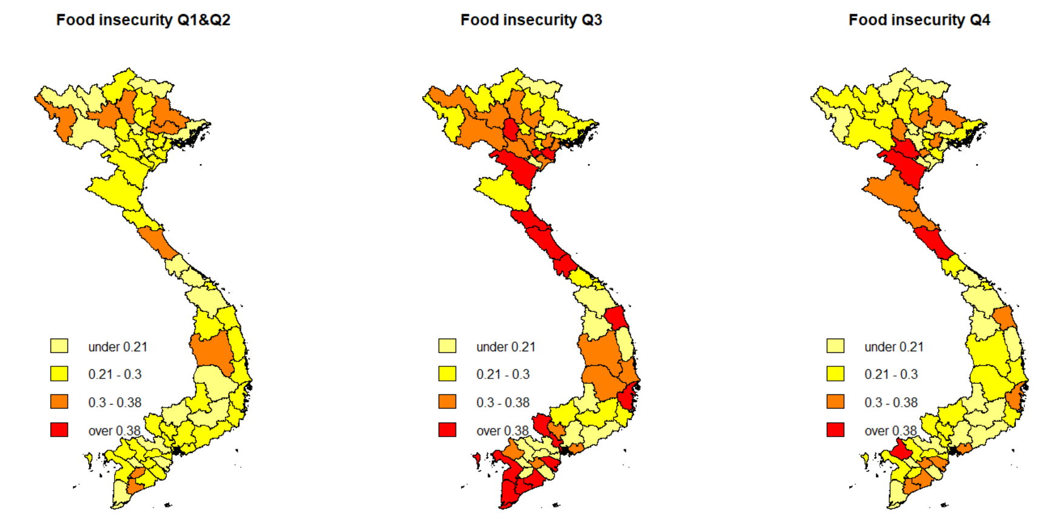
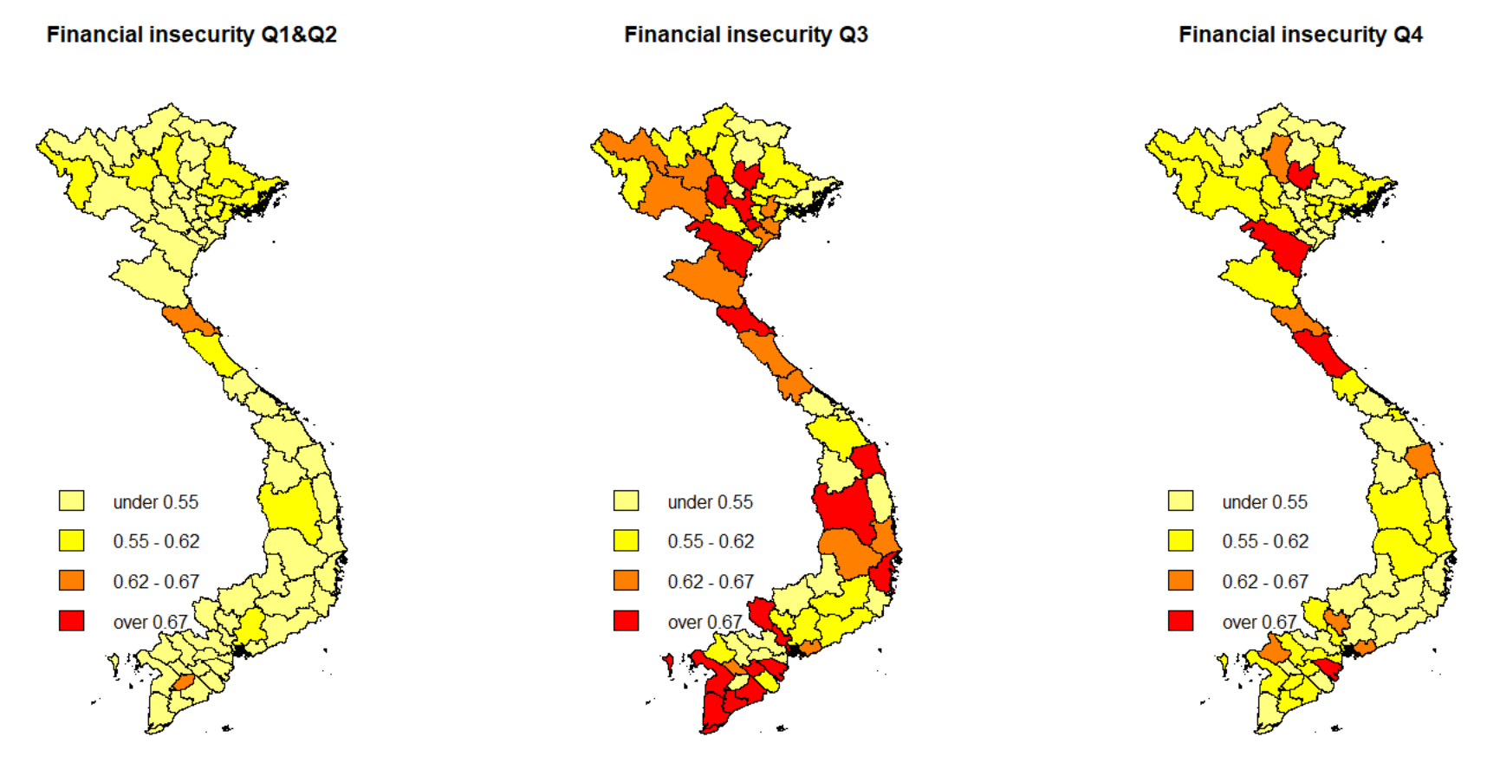

Appendix 5. Differences among demographic groups in terms of social distancing and economic status
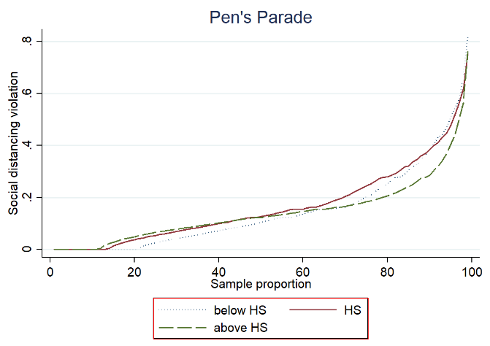 | 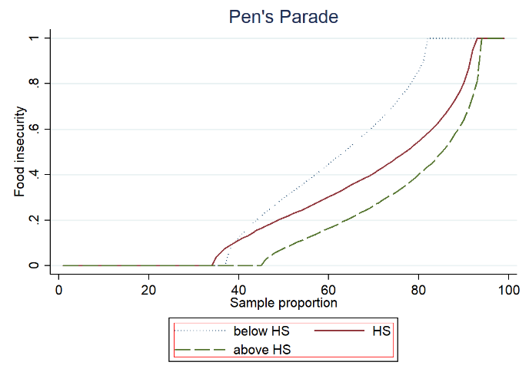
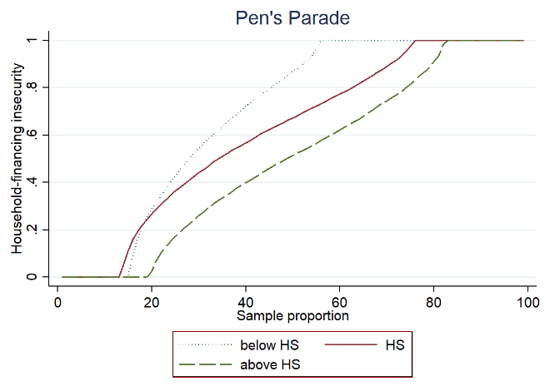 | 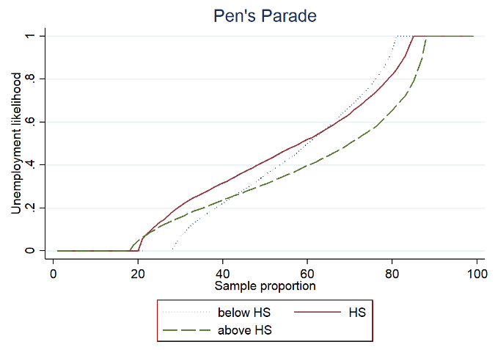
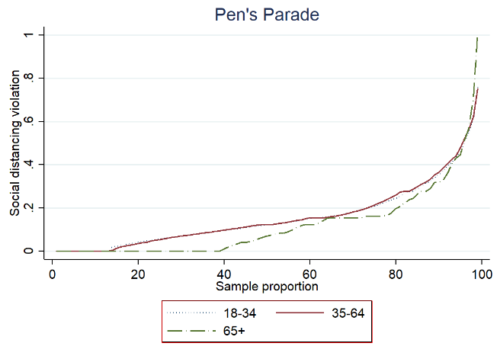 | 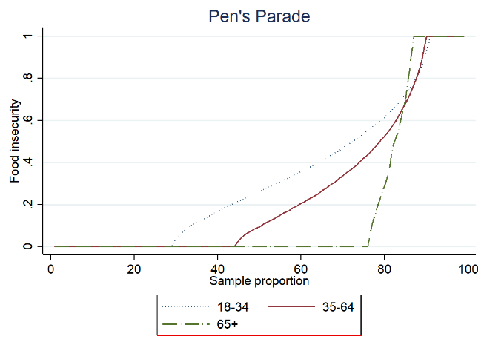
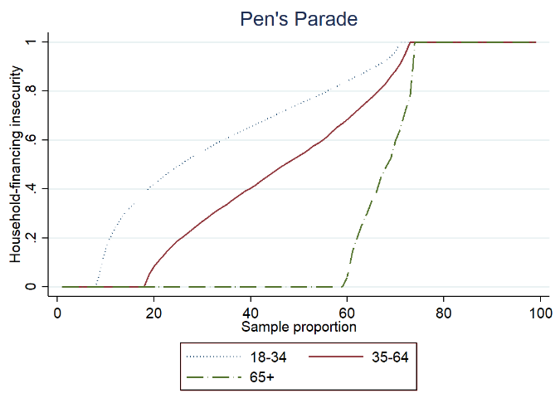 | 