Supplementary Information A – Additional information on Stage 3 CDI input index production
NDVI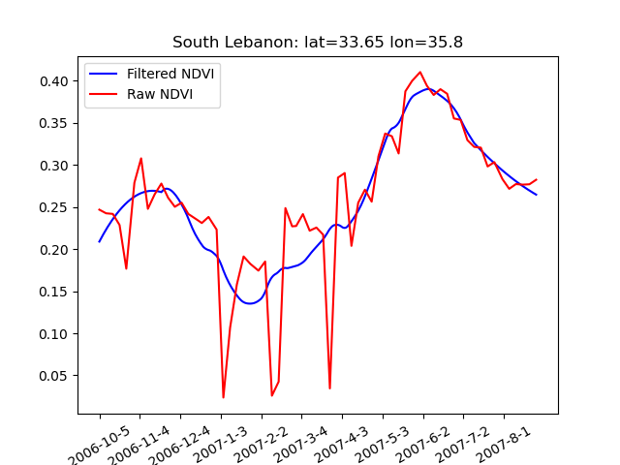
Figure A1 – Example NDVI time-series for a pixel in Lebanon over the hydrological year of 2006-2007. The red line is eMODIS data and the blue line is the filtered time-series.

Diurnal LST
Note this content repeats some material from Section 6, but it provides more fulsome detail and explanation as well as an algorithm for the process.
In relation to identifying cloud presence, we calculate values for the HANTS-derived time series (T_{s}^{hants}) as follows in Equation A1. A temporal sequence of N observations y_{i}, i= 1 to N can be described by a Fourier series as:
Equation A1: $y_{i}=a_{0}+\sum_{j=1}^{M}{\left(a_{j}cos⁡\left(w_{j}t_{i}-Фi\right)\right)}$
Where t_{i} is the time at which the i^{th} sample was taken, M is the number of frequencies of the Fourier series (M <= N), ${a_{j},w}_{j}$ and $Фi$ are respectively the amplitude, the frequency and the phase of the j^{th} harmonic term in the Fourier series.
As an example, for Figure A2 below, HANTS was applied on 1-year daily MOD11A1 data from 2015. It has a frequency M=1 and a number of observations N=365. T_{s} values that deviated more than 4°C from the T_{s}^{hants} were flagged as cloud affected (T_{s} – T_{s}^{hants} < -4°C) and subsequently removed from the clean data set. These pixels were later replaced by updated estimates of T_{s} as described in Section 6 and the algorithm below.
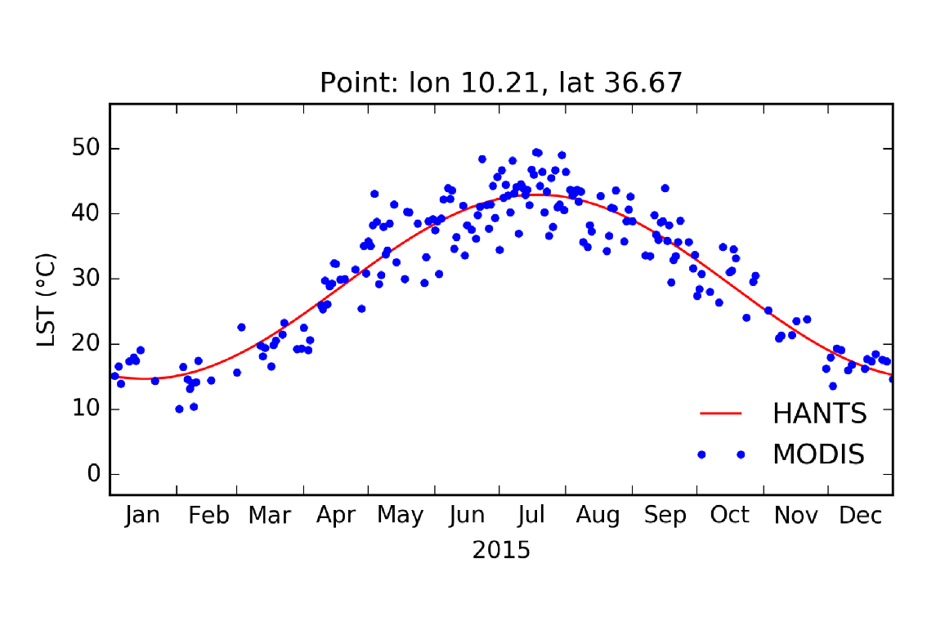
Figure A2: Comparison of daily LST from MODIS (blue dots) under clear sky conditions. The smoothed T_{s} time series using HANTS (red line) (T_{s}^{_hants}) with a frequency equal to 1. One pixel in Lebanon taken for the sake of demonstration.

Algorithm A1 Cloud gap-filling
1: for each month do
3: Produce smoothed time series (T_{s}^{hants}) from MODIS land surface temperature (Ts)
4: if T_{s} - T_{s}^{hants} > 4°C then
5: Flag as cloud affected
6: end if
2: for each time step do
7: Generate “daily perturbation” model (dTobs) for MODIS observed Ts and smoothed Tshants
8: dT_{obs} = T_{s} – T_{s}^{hants}
9: Simulate LST values (T_{s}^{model}) using Noah-MP and produce a smoothed time series (T_{s}^{hants_model})
10: Generate “daily perturbation” model (dT_{model}) of the simulated values
11: dT_{model} = T_{s} – T_{s}^{hants_model}
12: Estimate dT_{obs} for clear and cloudy using a simple linear regression model.
13: dT_{obs} = a * dT_{model} + b
14: if flagged as cloud-affected then
15: Correct the smoothed T_{s}^{hants} and reconstruct temperature data (T_{s}^{reconst}) for cloudy days
16: T_{s}^{reconst} = T_{s}^{hants} + a * dT_{obs} + b
17: end if
18: end do
19: end cloud gap-filling

In the presence of clouds, a non-realistically large difference between the T_{s} value and its smoothed time-series of T_{s}^{hants} arises. The new cloud mask based on the threshold of -4°C performed well (Figure 2) and detected cloudy pixels at the edges of the clouded region that were missed by the original MODIS cloud mask. The gap-filling method was applied after producing the cloud mask.
To evaluate the approach, we assessed the diurnal LST anomaly in Lebanon resulting from the raw and reconstructed (using the gap-filling method) data of the same day. Lebanon is a good example because it has frequent, widespread winter cloud-cover and highly variable topography. Figure A3 shows the difference between the reconstructed and raw MODIS LST data for both day and night.
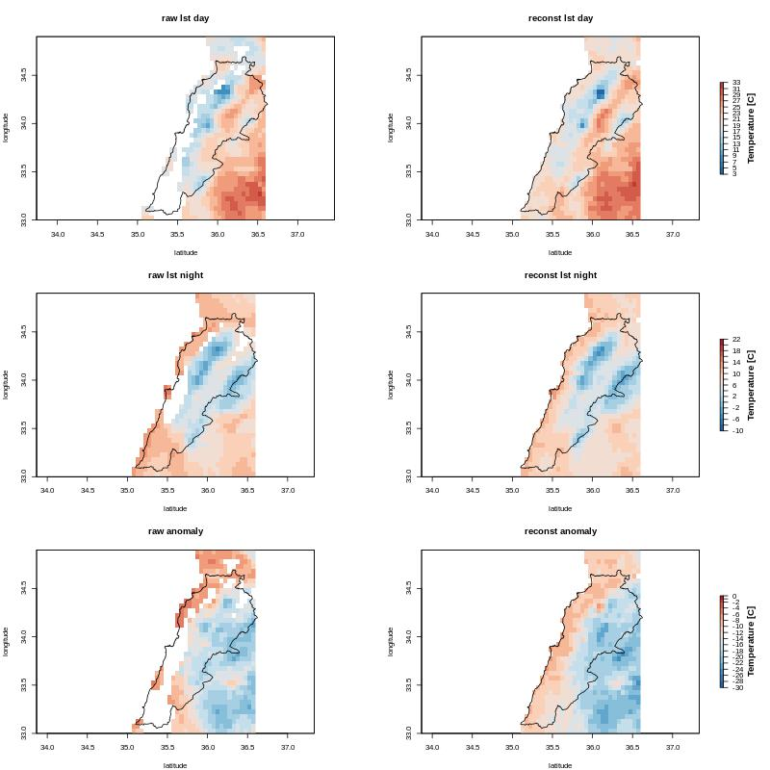
Figure A3 – Comparison of raw MODIS to reconstructed diurnal LST (5km x 5 km). Raw MODIS day (top-left), night (middle-left), and diurnal amplitude of LST (bottom-left); reconstructed day (top-right), night (middle-right), and diurnal amplitude of LST (bottom-right). Note the large areas of south-western and western Lebanon with no values in the bottom left.
Further, we calculated the RMSE of the observed and reconstructed diurnal LST over clear-sky pixels for all of 2018. We obtained an RMSE value of 0.4°C for the whole domain (42 x 40 pixels), which indicates a very accurate simulation of the day-night LST amplitude. Figure A4 below shows the geographical distribution of average and absolute error over the whole domain for all clear-sky pixels in 2018.
The error tends to be slightly higher in mountainous areas and slightly lower in the plains. It generally does not exceed 0.5°C, and we consider an error of 0.5°C to be acceptable (remains credible) for operational use within the drought monitoring system.
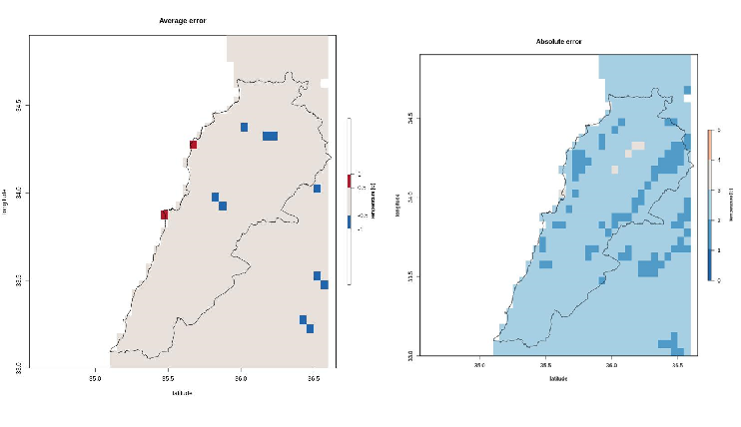
Figure A4– Average (left) and absolute (right) error of raw MODIS compared to reconstructed diurnal LST for clear-sky pixels (5km x 5 km) using all data from clear-sky pixels in 2018.
Overall, the reconstructed diurnal LST follows observed diurnal LST spatial patterns and magnitude very closely. The results provide reassurance that the model reconstruction for gap-filling matches the observed (remotely sensed) data input to the CDI. Additionally, it significantly expands the number of pixels for which the daily values (and therefore the whole index each month) are calculated, which expands the product’s salience.

Supplementary Information B – Additional validation results
Stage 1 precipitation analysis
Note that this analysis was undertaken in Stage 1 and preceded the analysis shown in Table 3 and Supplementary Information C, which was undertaken in Stage 2.
In Jordan and Morocco, CHIRPS precipitation data compared favorably to station data, particularly in the rainy season, which coincides with the agricultural year.
Table B1 below shows the coefficient of determination between the annual and rainy season CHIRPS-derived and station SPI values in Jordan. Overall, better performance was achieved during the rainy season, and more particularly in highlands areas that have higher annual precipitation and are the centre of rainfed agricultural production.
Table B1 - Correlation between CHIRPS-derived SPI and Jordanian observation station SPI values
Station | Annual rainfall (mm) | R² for all year SPI | R² for Rainy season
Irbid | 460 | 0.50 | 0.68
ErRabeh | 337 | 0.28 | 0.52
Amman Airport | 254 | 0.34 | 0.59
Tafileh | 204 | 0.29 | 0.43
Queen AIA | 156 | 0.29 | 0.46
Zarqa | 129 | 0.28 | 0.46
Ruwayshid -H4 | 81 | 0.52 | 0.57
Safawi-H5 | 70 | 0.27 | 0.39
Azraq | 54 | 0.13 | 0.21
Al Jafer | 31 | 0.21 | 0.29

In Morocco, Maroc Meteo and the International Center for Biosaline Agriculture (2019) evaluated 1981-2017 precipitation data from 30 ground stations in relation to CHIRPS and found a high correlation during the agricultural year at almost all stations, as shown in Table B2 below.
Table B2 – Mean Error (ME), Root Mean Square Error (RMSE) and correlation coefficient (r) between observed precipitation at noted rain stations and CHRIPS data for the months of October-November, December-January, and February March covering the period from 1981 to 2017
Stage 2 validation analyses in Lebanon
In Lebanon, NDVI signal was good in areas with agriculture, pasture, and forest land covers. However, above mid-elevation mountain regions, the response was problematic over the winter season – particularly between January and March – due to cloud and snow cover (see Figure A3). This issue – also common to mountainous areas of Morocco and Jordan – suggested the need for cloud gap filling of the NDVI and diurnal LST data.
CDI validation
In Lebanon, we were only able to evaluate the CDI nationally in relation to precipitation observations from a very small number of meteorological stations and the FAO’s Global Information and Early Warning System (GIEWS) data: http://www.fao.org/giews/earthobservation/country/index.jsp?lang=en&code=LBN#. It performed favorably and only had significant disagreement in two years of the period, 2000 and 2001. In those years, the CDI showed higher drought stress than the observed precipitation ranking and the FAO product.
In relation to precipitation, such difference can be attributed to the scarcity of the national Lebanese meteorological observatory and the limited numbers of available stations. The FAO Agricultural Stress Index (ASI; Van Hoolst et al. 2016) is based solely on NDVI data, which may explain some differences with the CDI.
Stage 2 CDI validation in Jordan
In Jordan and Morocco, independent model inputs and the CDI were evaluated against rainfed agricultural data (e.g. cereals production and yield)). The comparison showed that the CDI had better performance than any single input index. However, the relationship is complex due to the timing of drought stress and the specific agricultural effect.
Results of this analysis for several key regions in Jordan are shown in Table B3, which also evaluates the effect of a longer SPI period (6 months). It shows the significant relationship in most instances and the generally better relationship between CDI and cereal yields than production.
Table B3: Correlation between rainfed crop production and yield with CDI and SPI for the period 1994-2016 (Al-Bakri et al. 2019).
Relationship* | Irbid | Ajloun | Jarash | Madaba | Karak
Production and yield vs CDI₆
TP vs. CDI₆ | ns** | ns | 0.48 | 0.21 | 0.54
WP vs. CDI₆ | 0.34 | ns | 0.40 | Ns | 0.50
WY vs. CDI₆ | 0.47 | 0.34 | 0.46 | Ns | 0.45
BP vs. CDI₆ | Ns | ns | 0.47 | 0.42 | 0.43
BY vs. CDI₆ | 0.26 | 0.26 | 0.30 | 0.18 | 0.65
Production and yield vs SPI₆
TP vs. SPI₆ | Ns | ns | 0.38 | 0.30 | 0.52
WP vs. SPI₆ | 0.31 | ns | 0.30 | 0.21 | 0.47
WY vs. SPI₆ | 0.34 | 0.34 | 0.32 | Ns | 0.41
BP vs. SPI₆ | Ns | ns | 0.38 | 0.38 | 0.44
BY vs. SPI₆ | 0.25 | 0.22 | 0.30 | 0.22 | 0.57
Production and yield vs CDI₃
TP vs. CDI₃*** | Ns | ns | 0.36 NJ | 0.22NJ*** | 0.47 DF
WP vs. CDI₃ | 0.30 NJ | ns | 0.38 DF | Ns | 0.42 DF
WY vs. CDI₃ | 0.47 NJ | 0.30 DF | 0.36 NJ | Ns | 0.38 JM
BP vs. CDI₃ | Ns | ns | 0.24 NJ | 0.47NJ | 0.40 DF
BY vs. CDI₃ | Ns | 0.23 DF | 0.23 NJ | 0.24NJ | 0.59 DF
Production and yield vs SPI₃
TP vs. SPI₃*** | Ns | ns | 0.25 NJ | 0.27 NJ | 0.43 DF
WP vs. SPI₃ | 0.26 DF | 0.19 JM | 0.33 NJ | Ns | 0.40 NJ
WY vs. SPI₃ | 0.35 NJ | 0.25 JM | 0.20 NJ | Ns | 0.32 JM
BP vs. SPI₃ | Ns | ns | Ns | 0.42 NJ | 0.40 DF
BY vs. SPI₃ | Ns | ns | Ns | 0.23 NJ | 0.54 NJ
* TP – total production; WP – wheat production; WY – wheat yield; BP – barley production; BY – barley yield
** ns – not significant at P < 0.05
*** Maximum significant seasonal correlation shown with the abbreviations NJ – Nov-Jan; DF – Dec-Feb; JM – Jan-Mar.

Stage 2 CDI validation in Morocco
Table B4 shows the numerical percentage of Moroccan provinces for which the given month’s CDI class is the same as that of the annual wheat production anomaly. The production anomaly is calculated using the same percentile thresholds as the CDI per Section 2.4. The three years represent different types of drought years.
Table B4 - Match between CDI and wheat production anomaly for Moroccan provinces
Month | 2000-2001 (middle of a multi-year drought) | 2004-2005 (single drought year) | 2006-2007 (first year of a two-year drought)
Oct | 17.9% | 53.0% | 33.1%
Nov | 15.4% | 49.8% | 25.2%
Dec | 28.2% | 41.9% | 13.4%
Jan | 35.9% | 29.2% | 7.6%
Feb | 17.9% | 24.4% | 31.3%
Mar | 7.6% | 51.3% | 26.4%
Apr | 7.6% | 40.3% | 42.6%
May | 2.5% | 34.0% | 23.1%

Subsequent analysis in Morocco not reported in this paper highlighted that different agro-ecological zones tended to have different periods of alignment between the CDI and production anomalies, and Bijaber et al. (2018) evaluated the Stage 0 CDI in relation to cereal yields in Morocco including detailed case studies of two regions.
Stage 2 CDI validation in Tunisia
Early Stage 2 CDI validation in Tunisia (December 2017 to April 2018) included surveying a local agriculture official in each governorate about their perceptions of the accuracy of the monthly CDI maps in relation to geographic area and drought intensity. Response rates and locations varied significantly from month to month, so the data couldn’t be examined in a structured fashion. However, there was consistent feedback about the CDI “noise” as described in Section 3.4 that resulted in stakeholders’ decreased perceptions of CDI accuracy. Also, numerous comments about the intra-governorate distribution of drought impacts, both geographically and by sector, were useful for considering future improvements to the CDI and its interpretation by policy decision-makers.

Supplementary Information C – Comparison of CHIRPS and IMERG to observation station data in Jordan, Lebanon, and Tunisia
Lebanon
Comments on data quality:
The available data from Lebanese stations has a limited period, ranging from 7 to 16 years, with many gaps for most stations. The quality of the data is medium to poor, with the exception of Beirut airport, which has minimal gaps and good continuity.
Table C1 – Assessment of CHIRPS and IMERG precipitation data in relation to select Lebanese observation stations.
Station | Period | Correlation (R) |  | RMSE
 |  | CHIRPS | IMERG | CHIRPS | IMERG
Abdeh | 2001-2015 | 0.91 | 0.80 | 100.63 | 104.68
Beirut airport | 2001-2018 | 0.94 | 0.75 | 26.90 | 65.02
Daher elbaider | 2004-2014 | 0.64 | 0.61 | 68.08 | 64.97
Deir Al Ahmar | 2001-2014 | 0.87 | 0.46 | 34.25 | 164.02
Deir El kamar | 2005-2016 | 0.92 | 0.68 | 44.44 | 82.32
Faqra | 2006-2015 | 0.27 | 0.21 | 109.12 | 128.64
Hermel | 2005-2016 | 0.72 | 0.53 | 55.85 | 114.07
Jezzine | 2006-2015 | 0.88 | 0.64 | 64.98 | 104.59
Kfarchakhna | 2001-2014 | 0.87 | 0.69 | 41.90 | 68.26
Kfardounine | 2009-2016 | 0.83 | 0.74 | 52.53 | 66.09
Kfarqouq | 2006-2014 | 0.84 | 0.73 | 43.05 | 60.57
Lebaa | 2005-2014 | 0.81 | 0.65 | 56.92 | 75.49
Marjayoun | 2010-2016 | 0.81 | 0.69 | 57.37 | 75.03
Qartba | 2001-2015 | 0.74 | 0.66 | 75.87 | 90.74
Qousaiyba | 2005-2012 | 0.84 | 0.67 | 51.11 | 75.75
Qoubayat | 2001-2016 | 0.85 | 0.62 | 55.95 | 78.28
Quaoroun | 2003-2015 | 0.78 | 0.65 | 60.96 | 74.56
Riak | 2001-2016 | 0.60 | 0.27 | 64.42 | 69.79
Saida | 2001-2013 | 0.85 | 0.78 | 50.58 | 49.06
Seir eldenneiah | 2009-2014 | 0.84 | 0.62 | 52.75 | 104.28
Sour | 2007-2018 | 0.83 | 0.78 | 51.46 | 52.24
Tripoli | 2001-2018 | 0.93 | 0.76 | 31.90 | 64.18
Zahleh | 2001-2015 | 0.96 | 0.72 | 23.16 | 74.43

CHIRPS data has a better correlation to observed in situ rainfall data compared to IMERG. CHIRPS R scores show a strong correlation in most stations, reaching over 90% for some, such as Beirut airport, Deir Alkamar and Zahleh. Additionally, the CHIRPS data has smaller root mean square errors, which further reinforces the level of confidence in its accuracy for Lebanon.
Jordan
Comments on data quality:
The Jordanian dataset spans 21 years, with the exception of one station that started operation in 2005. The data generally has good continuity, with some gaps and missing data for certain stations. The stations have excellent representativity for the entire territory and cover all of the country's diverse climate zones.

Table C2 – Assessment of CHIRPS and IMERG precipitation data in relation to select Jordanian observation stations.
Stations | Period | Correlation |  | RMSE
 |  | CHIRPS | IMERG | CHIRPS | IMERG
Baqura | Jan 2001 – Apr 2021 | 0.90 | 0.79 | 26.80 | 32.39
Deir Alla | Jan 2001 – Apr 2021 | 0.90 | 0.74 | 20.21 | 23.37
Ghor Safi | Jan 2001 – Dec 2018 | 0.59 | 0.60 | 8.49 | 18.32
Irbed | Jan 2001 – Apr 2021 | 0.90 | 0.67 | 26.49 | 43.61
Er Rabbah | Jan 2001 – Apr 2021 | 0.82 | 0.48 | 24.86 | 38.78
Shoubak | Jan 2001 – Apr 2021 | 0.71 | 0.42 | 20.09 | 27.32
Wadi Dhulall | Jan 2001 – Apr 2021 | 0.86 | 0.56 | 8.94 | 14.24
Samma | Jan 2005 – Apr 2021 | 0.91 | 0.74 | 29.51 | 42.20
Wadi El-rayyan | Jan 2001 – Apr 2021 | 0.89 | 0.72 | 19.81 | 37.65
Swaileh | Jan 2001 – Apr 2021 | 0.90 | 0.60 | 42.07 | 52.08
Qatraneh | Jan 2001 – Apr 2021 | 0.74 | 0.48 | 11.96 | 21.73
Tafileh | Jan 2001 – Apr 2021 | 0.51 | 0.18 | 23.72 | 30.83
Zarqa | Jan 2001 – Apr 2021 | 0.90 | 0.65 | 7.73 | 19.83
Salt | Jan 2001 – Apr 2021 | 0.90 | 0.65 | 42.91 | 58.24
KH Airport | Jan 2001 – Apr 2021 | 0.52 | 0.39 | 4.41 | 16.43
Ras Muneef | Jan 2001 – Apr 2021 | 0.93 | 0.68 | 36.46 | 56.94
Amman Airport | Jan 2001 – Apr 2021 | 0.92 | 0.66 | 15.43 | 24.58
Rwaished (H4) | Jan 2001 – Apr 2021 | 0.79 | 0.70 | 6.98 | 16.83
Mafraq | Jan 2001 – Apr 2021 | 0.88 | 0.65 | 8.38 | 13.64
Safawi (H5) | Jan 2001 – Apr 2021 | 0.71 | 0.68 | 6.40 | 11.73
Azraq South | Jan 2001 – Apr 2021 | 0.62 | 0.54 | 7.15 | 11.88
Q.A.I.Airport | Jan 2001 – Apr 2021 | 0.87 | 0.57 | 11.86 | 19.22
Ma'an | Jan 2001 – Apr 2021 | 0.64 | 0.51 | 4.55 | 12.25
Al Jafer | Jan 2001 – Apr 2021 | 0.40 | 0.53 | 6.34 | 11.06
Ghabawi | Jan 2005 - Apr 2021 | 0.82 | 0.59 | 8.66 | 12.83

The CHIRPS data has better performance and correlation with observation data in Jordan compared to IMERG. CHIRPS correlation reaches up to 90% for some stations. IMERG's correlation is still acceptable but lower, mainly ranging from 50-80%. Additionally, the root mean square error values for CHIRPS are smaller than those for IMERG. Together, the higher correlation values and smaller error values confirm that CHIRPS data is a more reliable representation of rainfall in Jordan compared to IMERG's data estimation.

Tunisia
Comments on data quality:
The Tunisian dataset has the highest quality of the three countries. Many stations have no missing data at all, with excellent continuity, and many have only a small number of missing values or gaps. Although there are fewer stations used in comparison to Jordan and Lebanon, they still represent all the climate zones of the country, from the desert in the south to the humid and subhumid regions in the northwest.
Table C3 – Assessment of CHIRPS and IMERG precipitation data in relation to select Tunisian observation stations.
Stations | Period | Correlation |  | RMSE
 |  | CHIRPS | IMERG | CHIRPS | IMERG
Tabarka | Jun 2000 – Dec 2020 | 0.91 | 0.54 | 36.14 | 99.79
Bizerte | Jun 2000 – Dec 2020 | 0.89 | 0.51 | 25.89 | 113.26
Tunis | Jun 2000 – Dec 2020 | 0.87 | 0.65 | 23.87 | 114.69
Zaghouan | Jun 2000 – Dec 2020 | 0.80 | 0.41 | 26.15 | 98.27
Kelibia | Jun 2000 – Dec 2020 | 0.87 | 0.60 | 22.76 | 122.79
Jendouba | Jun 2000 – Dec 2020 | 0.89 | 0.42 | 18.52 | 66.10
Beja | Jun 2000 – Dec 2020 | 0.89 | 0.49 | 22.31 | 72.51
Kasserine | Jun 2000 – Dec 2020 | 0.76 | 0.48 | 12.93 | 55.71
Kairouan | Jun 2000 – Dec 2020 | 0.83 | 0.57 | 15.58 | 67.79
Sidi-bouzid | Jun 2000 – Dec 2020 | 0.79 | 0.57 | 13.85 | 46.51
Monastir | Jun 2000 – Dec 2020 | 0.86 | 0.66 | 19.06 | 94.65
Sfax | Jun 2000 – Dec 2020 | 0.80 | 0.66 | 14.22 | 51.35
Gabes | Jun 2000 – Dec 2020 | 0.73 | 0.36 | 16.61 | 64.83
Gafsa | Jun 2000 – Dec 2020 | 0.79 | 0.55 | 10.43 | 26.88
Medenine | Jun 2000 – Dec 2020 | 0.72 | 0.62 | 17.50 | 33.32

The results for Tunisia are similar to those for Jordan and Lebanon. CHIRPS data shows clearly better performance in estimating monthly rainfall across all Tunisian stations, despite the wide range of climate characteristics. CHIRPS correlation values are high for all stations, reaching 90% for some stations in the north. None of the values are below 70. On the other hand, IMERG data has poor performance and low correlation values for most stations, with correlations below 50% for many stations. Additionally, comparing the root mean square error values for both satellite sources, CHIRPS has better performance, with small error values compared to IMERG.

