Supplementary Information

2D Quasi-Layered Material with Domino Structure

Haihui Lan^{1,3,5}, Luyang Wang^{2,5}, Runze He^{1,5}, Shuyi Huang², Jinqiu Yu², Jingrui Luo², Yiling Li², Jiaxin Lin³, Shunping Zhang³, Mengqi Zeng^{2*}, and Lei Fu^{1,2*}
¹ The Institute for Advanced Studies, Wuhan University, Wuhan 430072, China
² College of Chemistry and Molecular Sciences, Wuhan University, Wuhan 430072, China
³ Department of Chemistry, Massachusetts Institute of Technology, Cambridge, Massachusetts 02139, United States
⁴ School of Physics and Technology, Wuhan University, Wuhan 430072, China
⁵ These authors contributed equally to this work.

* Corresponding author: zengmq_lan@whu.edu.cn; leifu@whu.edu.cn

Contents
1. OM images of layered GaTe samples grown on vdW substrate 4
2. Temperature-dependent XRD diagrams of Ga 5
3. Calculation of interface interaction between Ga/2D QLDS-GaTe and Ga/layered GaTe 6
4. TOF-SIMS analysis of Te distribution under varied thickness 7
5. Computed formation energies of different GaTe configurations using vdW growth strategy and ISMG strategy 8
6. Synthesis and growth regulation method for 2D QLDS-GaTe 9
7. OM images of 2D QLDS-GaTe synthesized via ISMG strategy 10
8. OM images of orientated growth 2D QLDS-GaTe crystals 11
9. End-point snapshot from AIMD 12
10. AFM image of 2D QLDS-GaTe crystal 13
11. Simulated FFT results of 2D QLDS-GaTe structure with different thicknesses. 14
12. Band structure of 2D QLDS-GaTe structure 15
13. Depiction of bonding lengths in 2D QLDS-GaTe in comparison to the bulk structure 16
14. NBO analysis of the inner bonds of the 2D QLDS-GaTe structure 17
15. COHP analysis of bonding states in 2D QLDS-GaTe structure 18
16. NBO Analysis of Bulk GaTe Structure Bonds 19
17. COHP analysis of bonding states in bulk GaTe structure 20
18. COHP analysis of surface bonding states in 2D QLDS-GaTe structure 21
19. COHP analysis of other surface bonding states in 2D QLDS-GaTe surface 22
20. HER Performance of 2D MoS₂ 23
21. Illustration of region fold theory and ELF in 2D QLDS-GaTe structure 24
22. Bader charge distribution maps of layered GaTe and 2D QLDS-GaTe 26
23. Partial charge density plots across varying energy ranges 27
24. Calculated Gibbs free energy profiles of 2D QLDS-GaTe surface 28
25. Structures of potential HER activation sites on 2D QLDS-GaTe surface 29
26. Calculated Gibbs free energy profiles of another 2D QLDS-GaTe surface 30
27. Structures of potential HER activation sites on another 2D QLDS-GaTe surface 31
28. Calculated Gibbs free energy profiles of layered GaTe 32
29. Structures of potential HER activation sites on layered GaTe surface 33
30. I_{ds}–V_{ds} characteristic curves with different gate voltages 34
31. Analysis of the HER performance of polycrystalline GaTe, layered GaTe, and 2D QLDS-GaTe 35
32. Charge density difference maps with H* adsorption 36
33. Analysis of Ga–Te bonding strength in pristine 2D QLDS-GaTe and 2D QLDS-GaTe with H* adsorption 37
Table S1. Calculated bonding state of the 2D QLDS-GaTe structure corresponding to Supplementary Figure 14. 38
Table S2. Calculated bonding state of the bulk structure corresponding to Supplementary Figure 16. 39
Table S3. Calculated bonding state of 2D QLDS-GaTe structure corresponding to Supplementary Figure 18. 40
Table S4. Calculated bonding state of 2D QLDS-GaTe structure corresponding to Supplementary Figure 19. 41
Table S5. Calculated bonding state of the H adsorption on QL structure corresponding to Fig. 4g 42
Table S6. Calculated bonding state of the H adsorption on QL structure corresponding to Fig. 4h 43

1. OM images of layered GaTe samples grown on vdW substrate
Previous investigations have demonstrated that van der Waals (vdW) substrates can efficiently assist the growth of layered gallium telluride (GaTe) single crystals¹. In this growth paradigm, the substrate and material exhibit no mutual interaction. Upon random nucleation of GaTe crystals, their growth proceeds in arbitrary directions, resulting in no structured arrangement. This method, while facilitating growth, fails to deliver large-area GaTe single crystals and proves ineffectual in manipulating the crystal growth orientation.
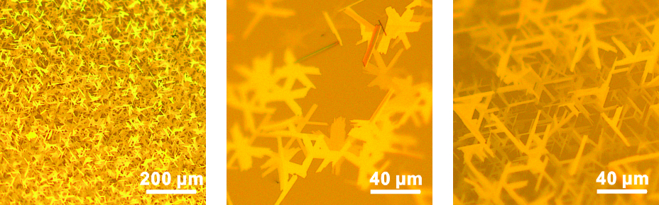
Supplementary Figure 1 | OM images of layered GaTe samples grown on vdW substrate.

2. Temperature-dependent XRD diagrams of Ga
We conducted X-ray diffraction (XRD) analyses on liquid metal at a range of temperatures. Intriguingly, gallium (Ga), despite its transition to the liquid state, preserves an appreciable degree of ordered structure, predominantly along the (211) plane (ICDD PDF No. 00-031-053). This residual order qualifies the liquid metal as an interactive substrate, capable of directing the growth of GaTe single crystals along predetermined orientations. This finding challenges the established symmetry of forces typically observed in traditional van der Waals growth regimes.
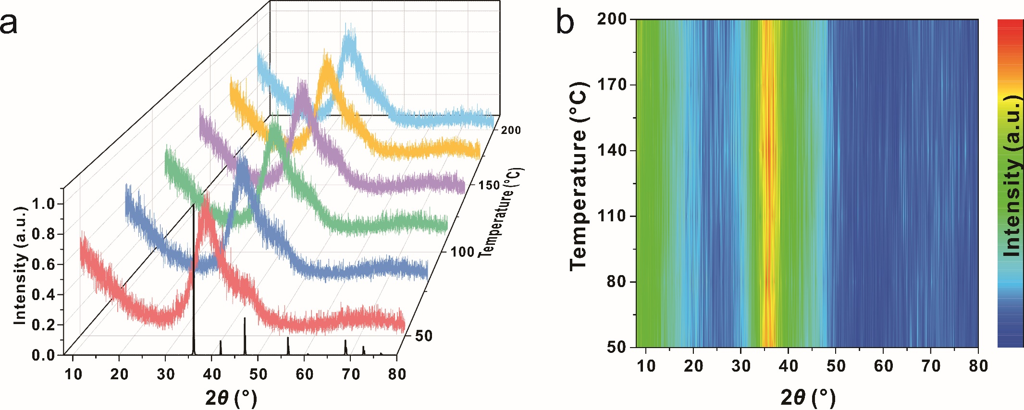
Supplementary Figure 2 | Temperature-dependent XRD diagrams of Ga. a, The XRD diagrams of liquid metal under different temperature. b, Projected XRD results extracted from Supplementary Figure 2a.

3. Calculation of interface interaction between Ga/2D QLDS-GaTe and Ga/layered GaTe
We established models representing the interaction between liquid metal and 2D quasi-layered domino-structured (QLDS) GaTe, and between liquid metal and layered GaTe. Subsequent density functional theory (DFT) calculations on the strength of these interactions revealed a significantly stronger charge interaction between Ga and 2D QLDS-GaTe (0.0032 e Å⁻³), in stark contrast to that observed with layered GaTe (0.0012 e Å⁻³). This underscores the role of liquid metal Ga in amplifying the longitudinal binding forces with the material, thereby disrupting the material's inherent lateral homogeneity. As a result, the synthesis of 2D QLDS-GaTe becomes a viable possibility.
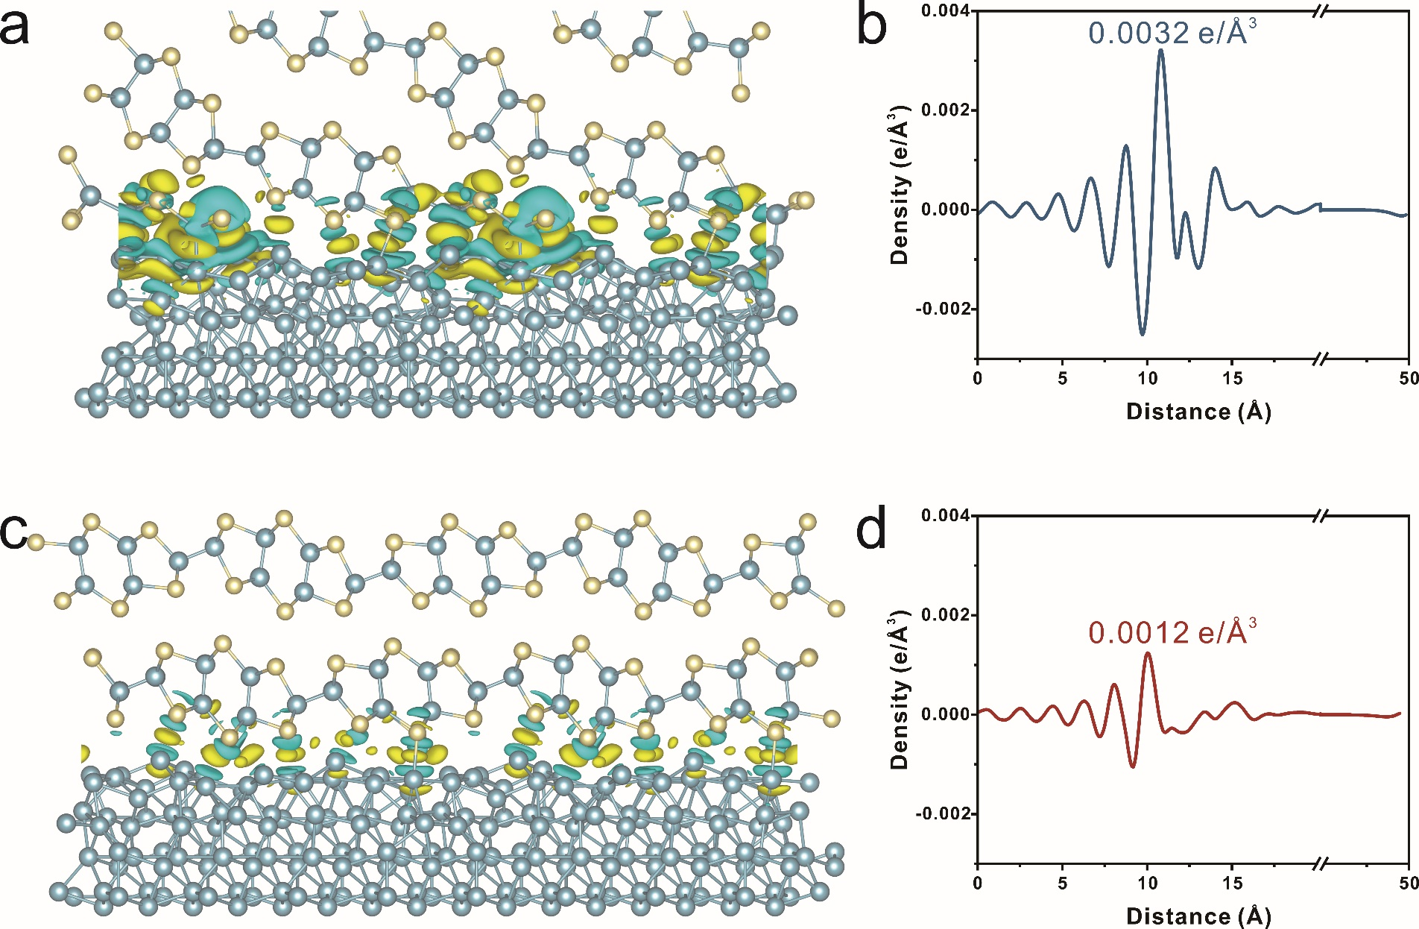
Supplementary Figure 3 | Interface interaction between Ga/2D QLDS-GaTe and Ga/layered GaTe. a, c, Differential charge density of 2D QLDS-GaTe and layered GaTe on Ga substrate, as calculated via DFT. Areas of electron accumulation and depletion are represented in yellow and cyan, respectively. b, d, Planar-averaged electron density difference plots corresponding to panels a and c.

4. TOF-SIMS analysis of Te distribution under varied thickness
Time-of-Flight Secondary Ion Mass Spectrometry (TOF-SIMS) was employed to probe the spatial distribution of the precursor element Te within liquid Ga, as illustrated in Fig. S4a. Upon precipitation of the 2D QLDS-GaTe at the liquid metal interface, an elevated concentration of Te is observed at the surface, declining towards the bulk phase distal from the interface. An interface double layer-like region is formed, where Te concentration gradually decreases at the junction between the material and the liquid metal. This unique characteristic promotes the crystal growth and facilitates the 2D extension of QLDS-GaTe. Additionally, planar projection results, as shown in Figure S4b, reveal that the synthesized material floats on the liquid metal surface, maintaining a smooth interface which endows the material with excellent mobility on the liquid metal, favoring the growth and assembly into a larger single-crystalline material.
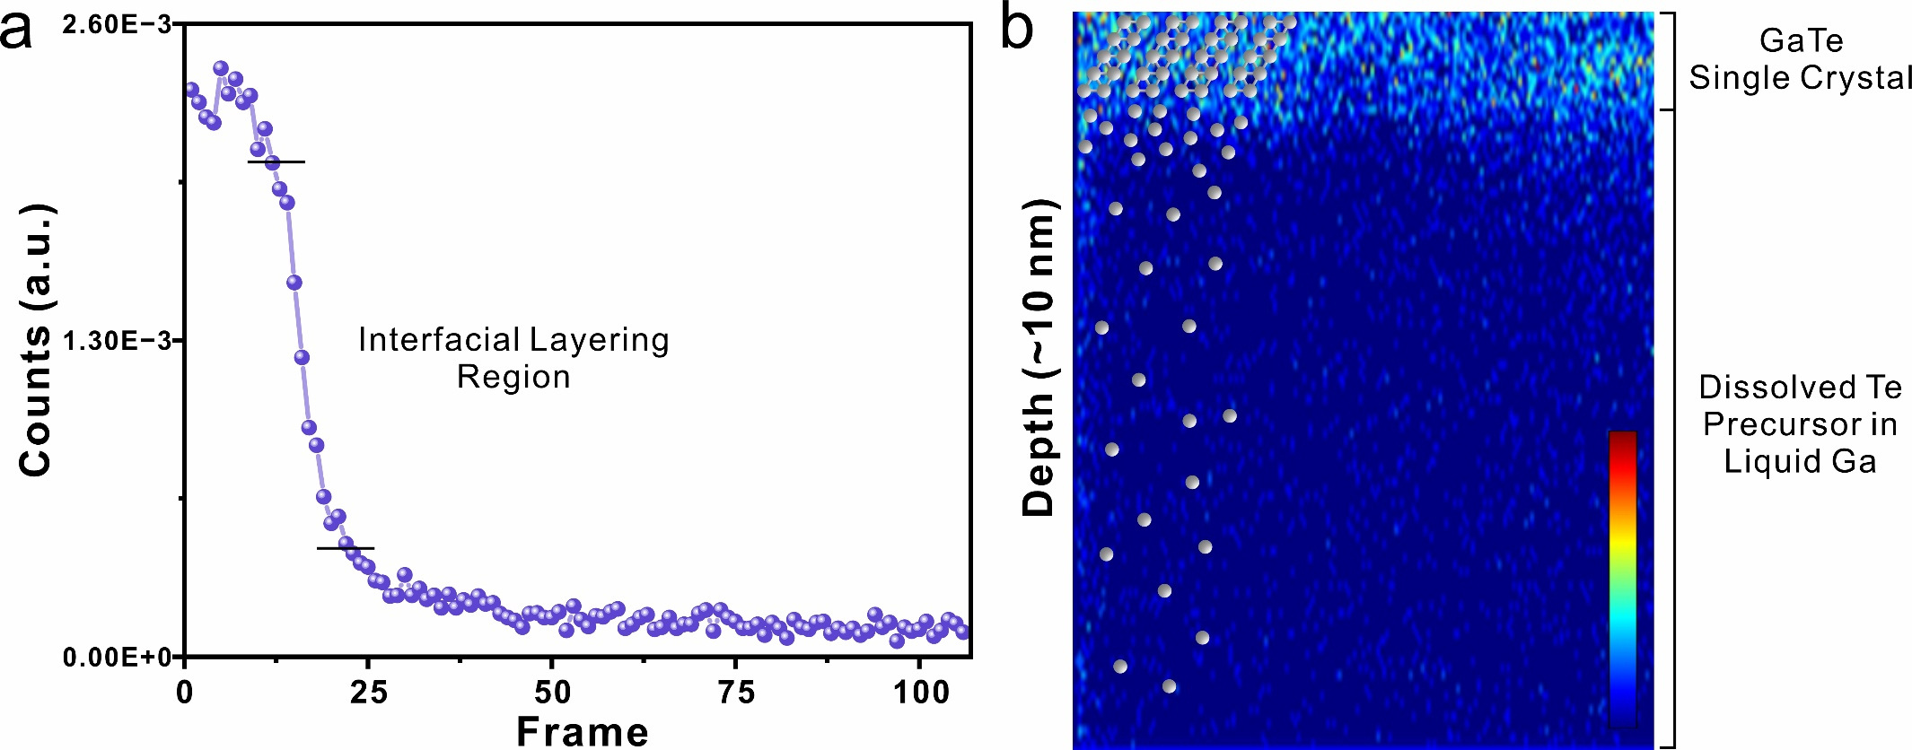
Supplementary Figure 4 | TOF-SIMS analysis of Te distribution under varied thickness. a, Graph depicting the concentration distribution of Te as a function of thickness. b, Schematic representation of the 2D planar projection of Te element distribution.

5. Computed formation energies of different GaTe configurations using vdW growth strategy and ISMG strategy
The computational findings suggest that for the growth of GaTe, the m-phase and h-phase exhibit similar formation energies. Concurrently, the formation energy along the non-planar orientation closely mirrors that of the layered growth mode. This implies that under the vdW growth paradigm, the resulting GaTe may comprise a mixture of phases and polycrystalline material. In contrast, our employed ISMG strategy for GaTe growth can yield 2D QLDS-GaTe across a wide chemical potential window, simultaneously accomplishing phase structure differentiation and orientation segregation. This further validates the viability of the synthesis approach.
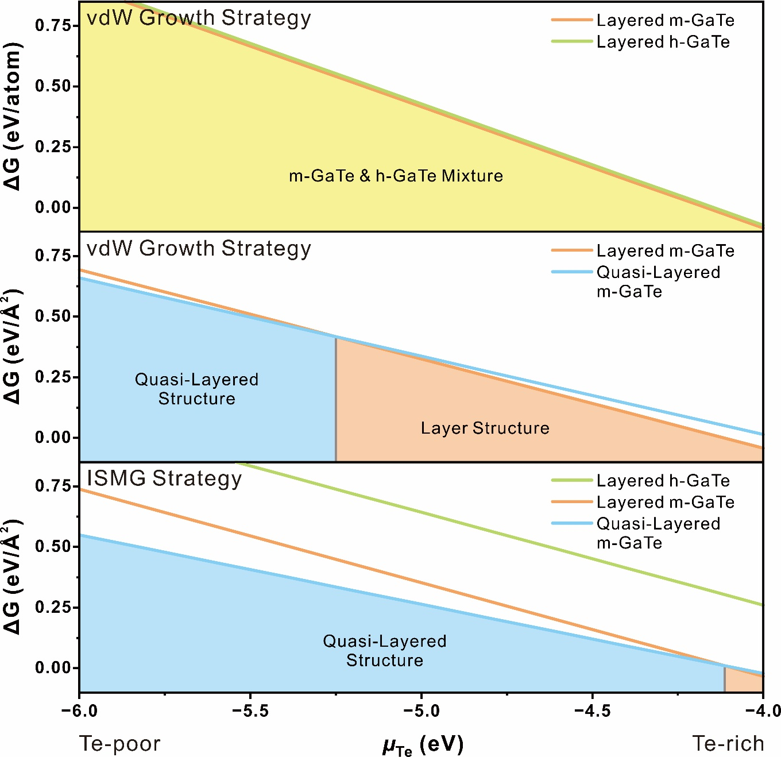
Supplementary Figure 5 | Computed formation energies of different GaTe configurations using vdW growth strategy and ISMG strategy.

6. Synthesis and growth regulation method for 2D QLDS-GaTe
In the CVD synthesis process of 2D QLDS-GaTe, the liquid metal captures gaseous Te precursors and stores them within its structure. As the cooling process ensues, 2D QLDS-GaTe precipitates on the surface of the liquid metal (Supplementary Fig. 6a, 6b). Consequently, under the same annealing time and varying reaction temperatures, the evaporation rate of the precursor decreases with temperature, leading to a corresponding decline in the amount of Te precursors captured by the liquid metal. Therefore, by modulating the reaction temperature, we can adjust the chemical potential of Te, thereby enabling the synthesis of 2D QLDS-GaTe with different thicknesses.
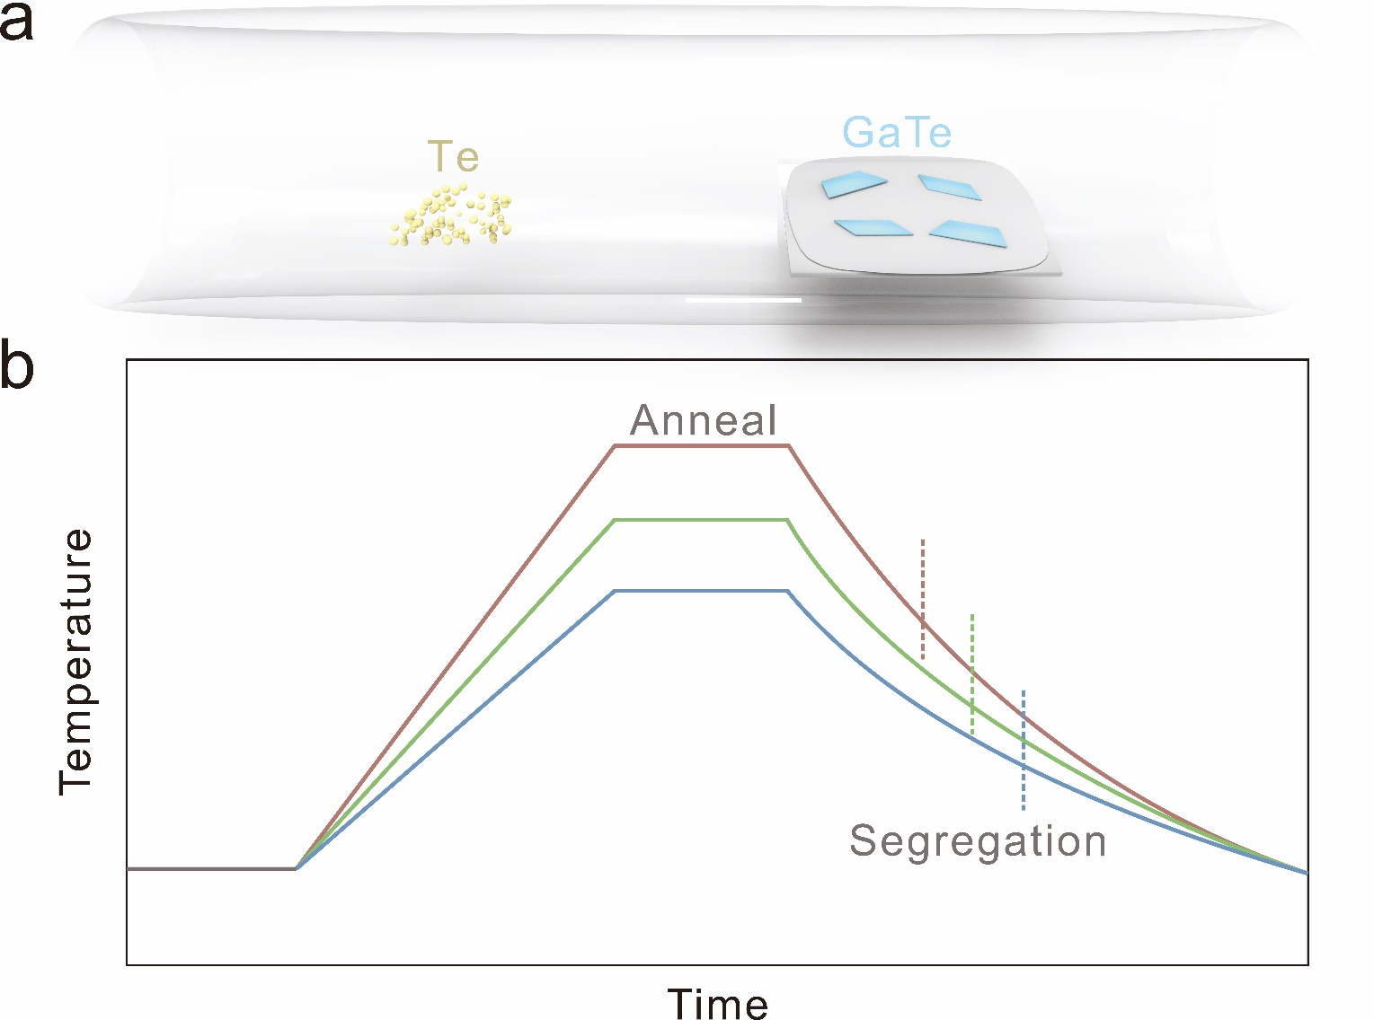
Supplementary Figure 6 | Synthesis and growth regulation method for 2D QLDS-GaTe. a, Schematic diagram of 2D QLDS-GaTe synthesis. b, Illustrative diagram of annealing processes at different temperatures.

7. OM images of 2D QLDS-GaTe synthesized via ISMG strategy
Adopting the ISMG strategy, 2D QLDS-GaTe can be synthesized across a wide chemical potential window. As the chemical potential escalates, the resultant material size also incrementally expands. Given the smooth interface between the liquid metal and 2D QLDS-GaTe, the material can move and coalesce on the surface of the liquid metal, thereby forming a larger scale. As can be observed from the OM images, the 2D QLDS-GaTe exhibits an orderly arrangement. With the ascension of the chemical potential, the grown material can also reach the scale of several hundred micrometers, which is highly conducive to device fabrication. Evidently, the ISMG strategy acts as a vigilant guard, enabling the synthesis of 2D QLDS-GaTe materials of varied sizes and thicknesses at the brink of toppling over.
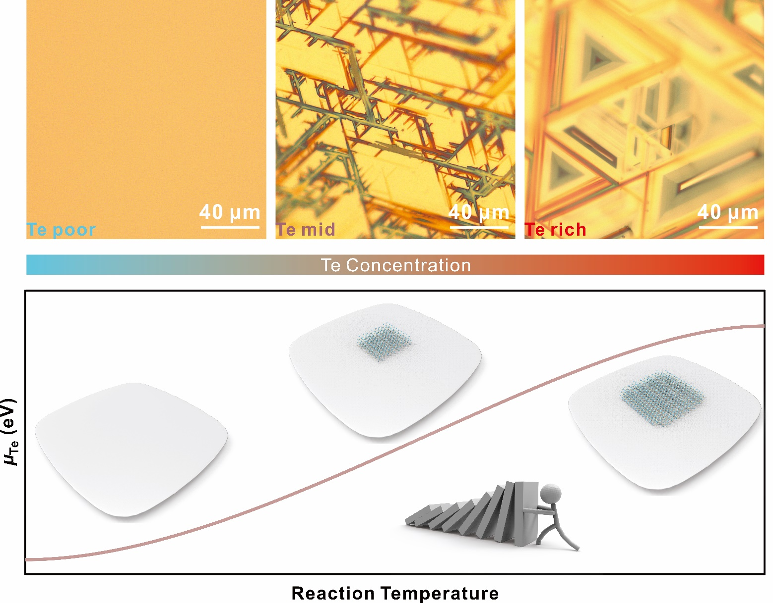
Supplementary Figure 7 | OM images of 2D QLDS-GaTe synthesized under different chemical potentials guided by ISMG strategy.

8. OM images of orientated growth 2D QLDS-GaTe crystals
Within the framework of the ISMG strategy, liquid metal acts as a template, disrupting inherent forces within the material, and consequently inducing its growth. This directional inducement also prompts a relatively ordered arrangement of the material upon the liquid metal surface. The discovery of this phenomenon has laid a solid foundation for the large-scale synthesis of 2D QLDS-GaTe, offering a promising new avenue for the advancement of 2D material growth strategies.
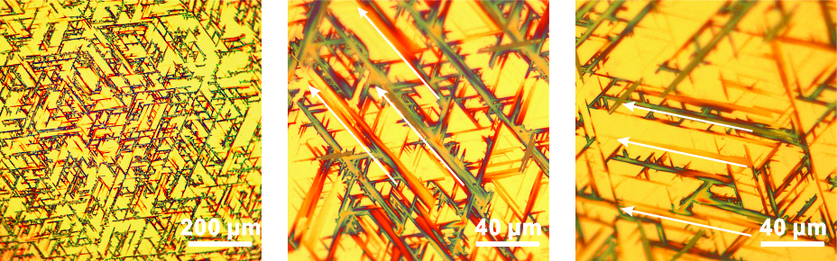
Supplementary Figure 8 | OM images of orientated growth 2D QLDS-GaTe crystals.

9. End-point snapshot from AIMD
To investigate the stability of 2D QLDS-GaTe, Ab Initio Molecular Dynamics (AIMD) methods were employed. The system was gradually heated from 100K to 300K over a span of 2 ps, followed by a pre-equilibration period of 10 ps. The results from the subsequent 25 ps were taken as the AIMD simulation outcomes. As evidenced, the material maintains a stable crystal structure, thereby verifying its stability at room temperature.
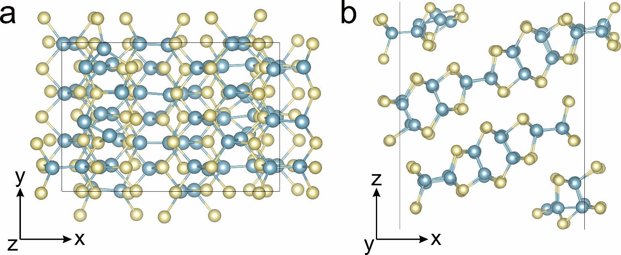
Supplementary Figure 9 | End-point snapshot from AIMD. a, b, Top and side views of the 2D QLDS-GaTe structure corresponding to Fig. 1f, respectively.

10. AFM image of 2D QLDS-GaTe crystal
Atomic Force Microscopy (AFM) results reveal that the synthesized material exhibits a thickness of 1.2 nm, which closely approaches the theoretical limit of the thickness (Fig. 2b). This finding not only validates the feasibility of the ISMG strategy but also paves the way for the manipulation of interlayer interactions in the material. Due to its unique structure, 2D QLDS-GaTe serves as a convenient platform for examining interlayer coupling effects. The experimentally observed contraction of 7.7% is remarkably close to the theoretical limit of 10.8%. This physical phenomenon lays a foundation for acoustic studies under different interlayer coupling conditions, such as thermal conductivity and thermoelectric performance.
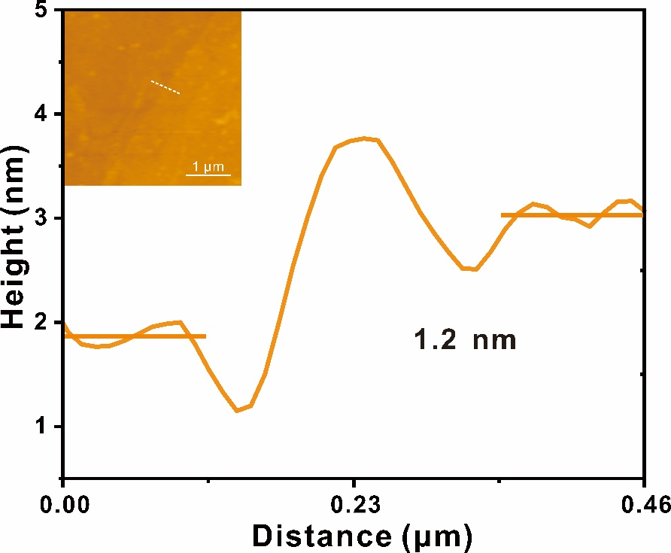
Supplementary Figure 10 | AFM image of 2D QLDS-GaTe crystal.

11. Simulated FFT results of 2D QLDS-GaTe structure with different thicknesses.
As the material thickness diminishes and interlayer coupling effects intensify, the diffraction patterns of 2D QLDS-GaTe correspondingly transform. We simulated the FFT patterns for structures approximately 1 nm and 10 nm thick, derived from our calculations, as shown in the figure below. As the interlayer coupling effect intensifies, a significant contraction in the interplanar spacing of the (101) crystal plane becomes apparent, indicating the enhancement of interlayer coupling effects.
Supplementary Figure 11 | Simulated FFT results of 2D QLDS-GaTe structure with different thicknesses.

12. Band structure of 2D QLDS-GaTe structure
Distinct from bulk materials, the band structure of 2D QLDS-GaTe exhibits two notable characteristics: 1. A novel charge state emerges at the Fermi energy level, which is provided by surface atoms; 2. Due to quantum confinement effects, the intrinsic bandgap of the material is expanded. These two discoveries suggest promising application prospects for this material in the fields of optoelectronics and catalysis.
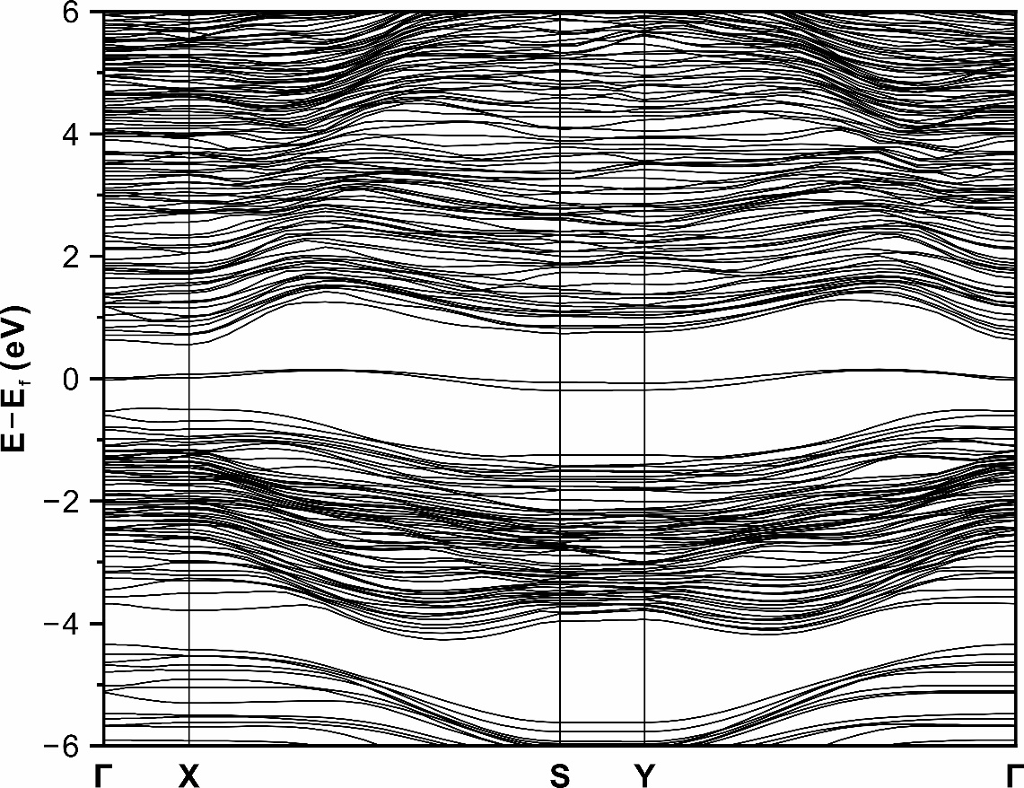
Supplementary Figure 12 | Band structure of 2D QLDS-GaTe structure.

13. Depiction of bonding lengths in 2D QLDS-GaTe in comparison to the bulk structure
The unsaturated surfaces of 2D QLDS-GaTe prompt surface reconstructions, thereby generating unique bonding states that are distinct from those in bulk materials. For instance, bonds with lengths of ~2.57 Å and ~2.8 Å significantly differ from those in bulk materials. These specialized bonding states endow the material with characteristics that are distinct from layered materials, leading to a further weakening of its symmetry. This is considered one of the reasons for the enhancement of the second harmonic signal.
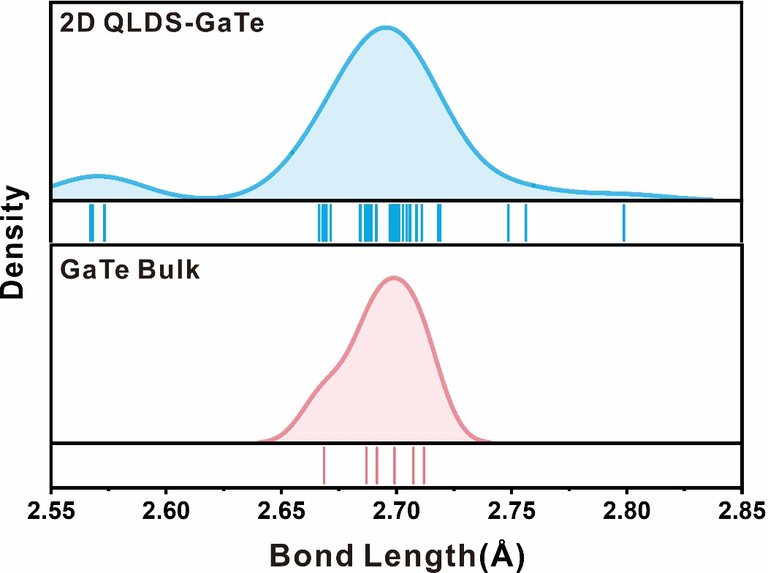
Supplementary Figure 13 | Depiction of bonding lengths in 2D QLDS-GaTe in comparison to the bulk structure.

14. NBO analysis of the inner bonds of the 2D QLDS-GaTe structure
The Natural Bond Orbital (NBO) results underscore the predominant σ bonding effect between Ga and Te. The bonding orbital is primarily contributed by Te, while the antibonding orbital is attributed to Ga (Table S1). The hybridization of Ga is almost entirely sp³, with the contribution of the d orbital being almost negligible. The hybridizations of Te atoms are s^{12.10}p^{87.82}d^{0.08} and s^{12.87}p^{87.07}d^{0.06}, with p orbitals making the primary contribution.
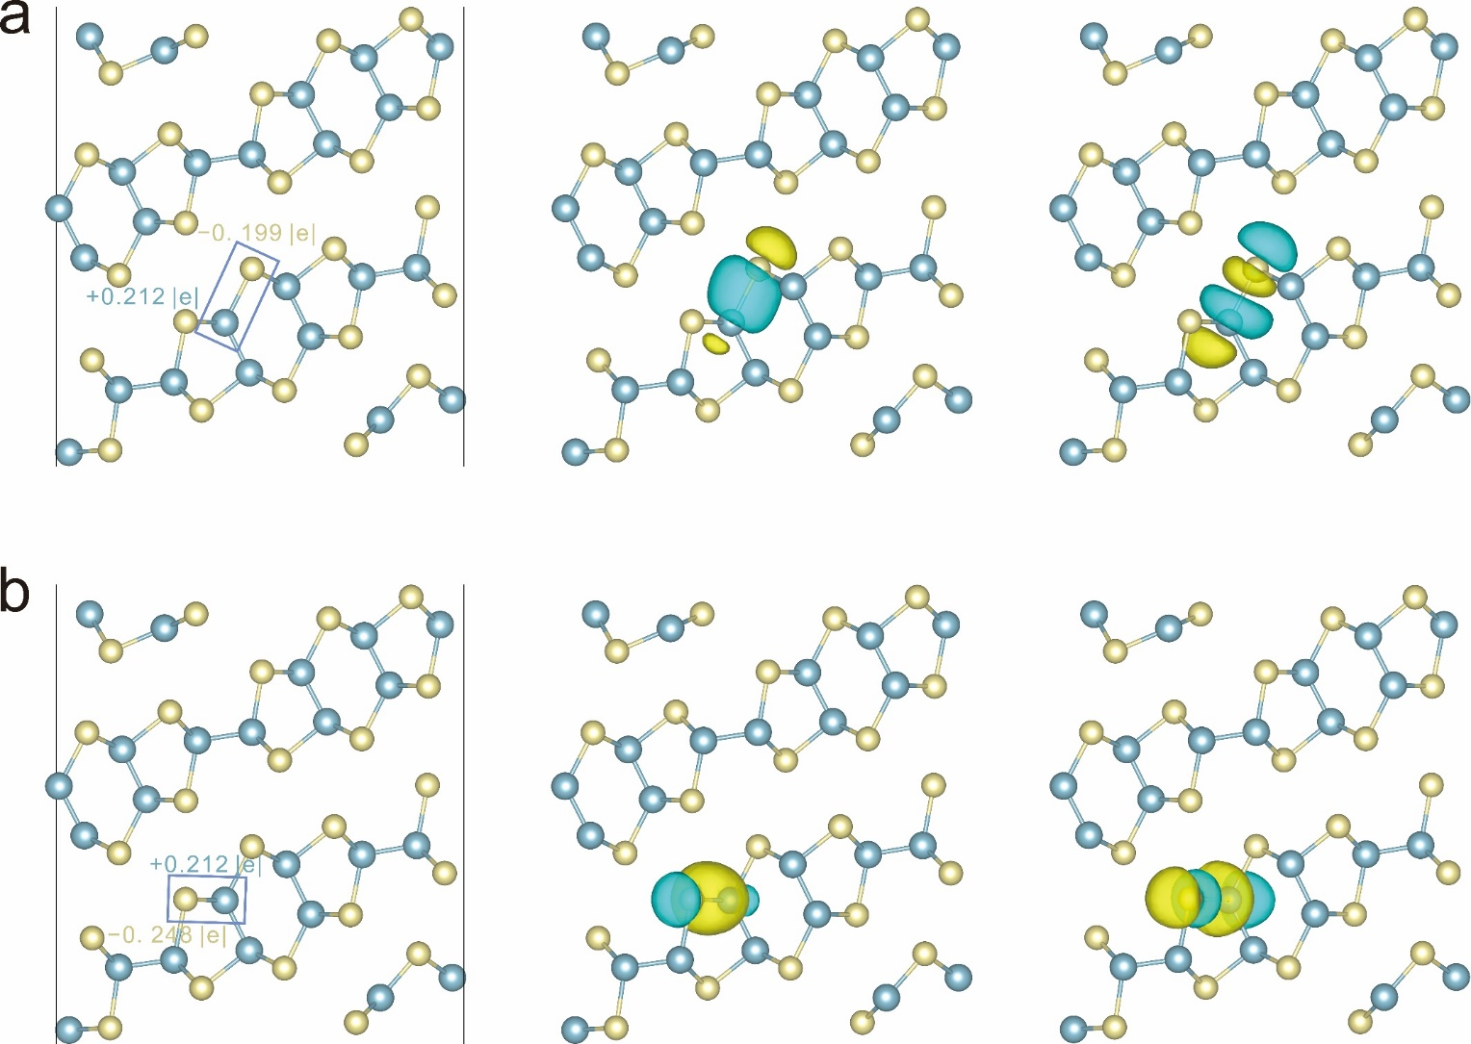
Supplementary Figure 14 | NBO analysis of the inner bonds of the 2D QLDS-GaTe structure. a, b, Structure and the associated bonding and antibonding orbitals within different chemical environments.

15. COHP analysis of bonding states in 2D QLDS-GaTe structure
The Crystal Orbital Hamilton Population (COHP) calculations reveal that the predominant contribution to Ga–Te bonding comes from Ga (4p) and Te (5p) orbitals, followed by substantial contributions from the interactions between Ga(4s) and Te(5p) as well as Ga(4p) and Te(5s). In the subsequent analysis, we will employ these numerical values as benchmarks to determine whether the bonding interactions in the material are consistent.
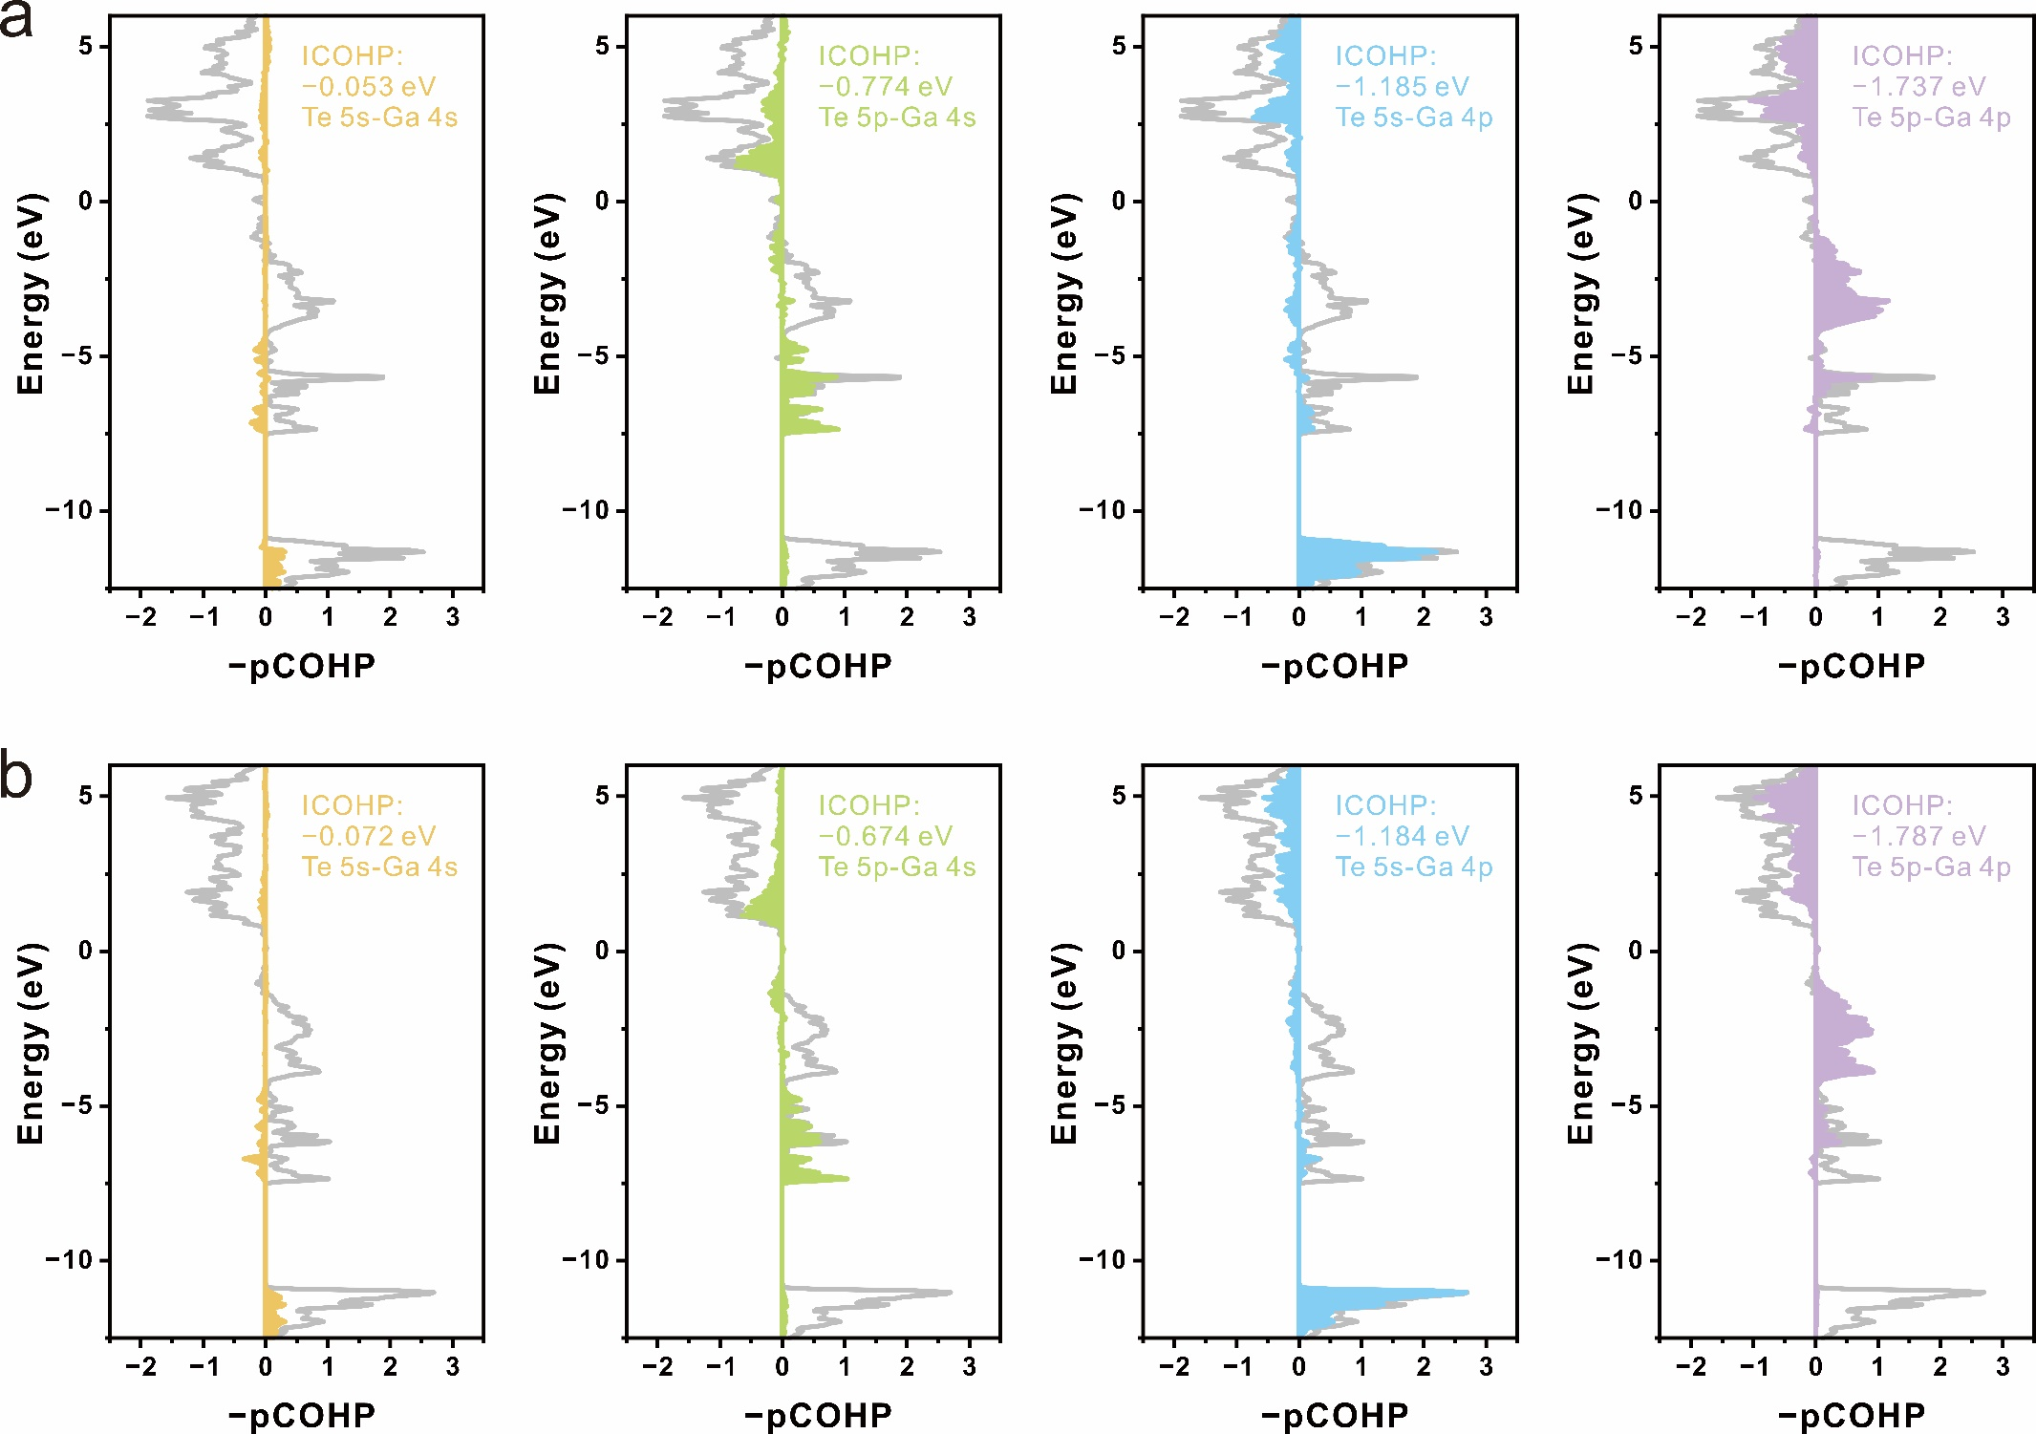
Supplementary Figure 15| COHP analysis of bonding states in 2D QLDS-GaTe structure. a, b, COHP diagram for bonds marked in Supplementary Figure 14.

16. NBO Analysis of Bulk GaTe Structure Bonds
The NBO analysis demonstrates a striking resemblance in the orbital shapes of the inner bonds and bulk structure of 2D QLDS-GaTe. Furthermore, their orbital hybridization, contribution, and electron occupancy exhibit remarkable similarities (Table S2). These findings indicate that the inner atoms in 2D QLDS-GaTe preserve a bonding structure akin to that of the bulk material. These findings indicate that the inner atoms of 2D QLDS-GaTe retain a bonding structure similar to that of the bulk structure.
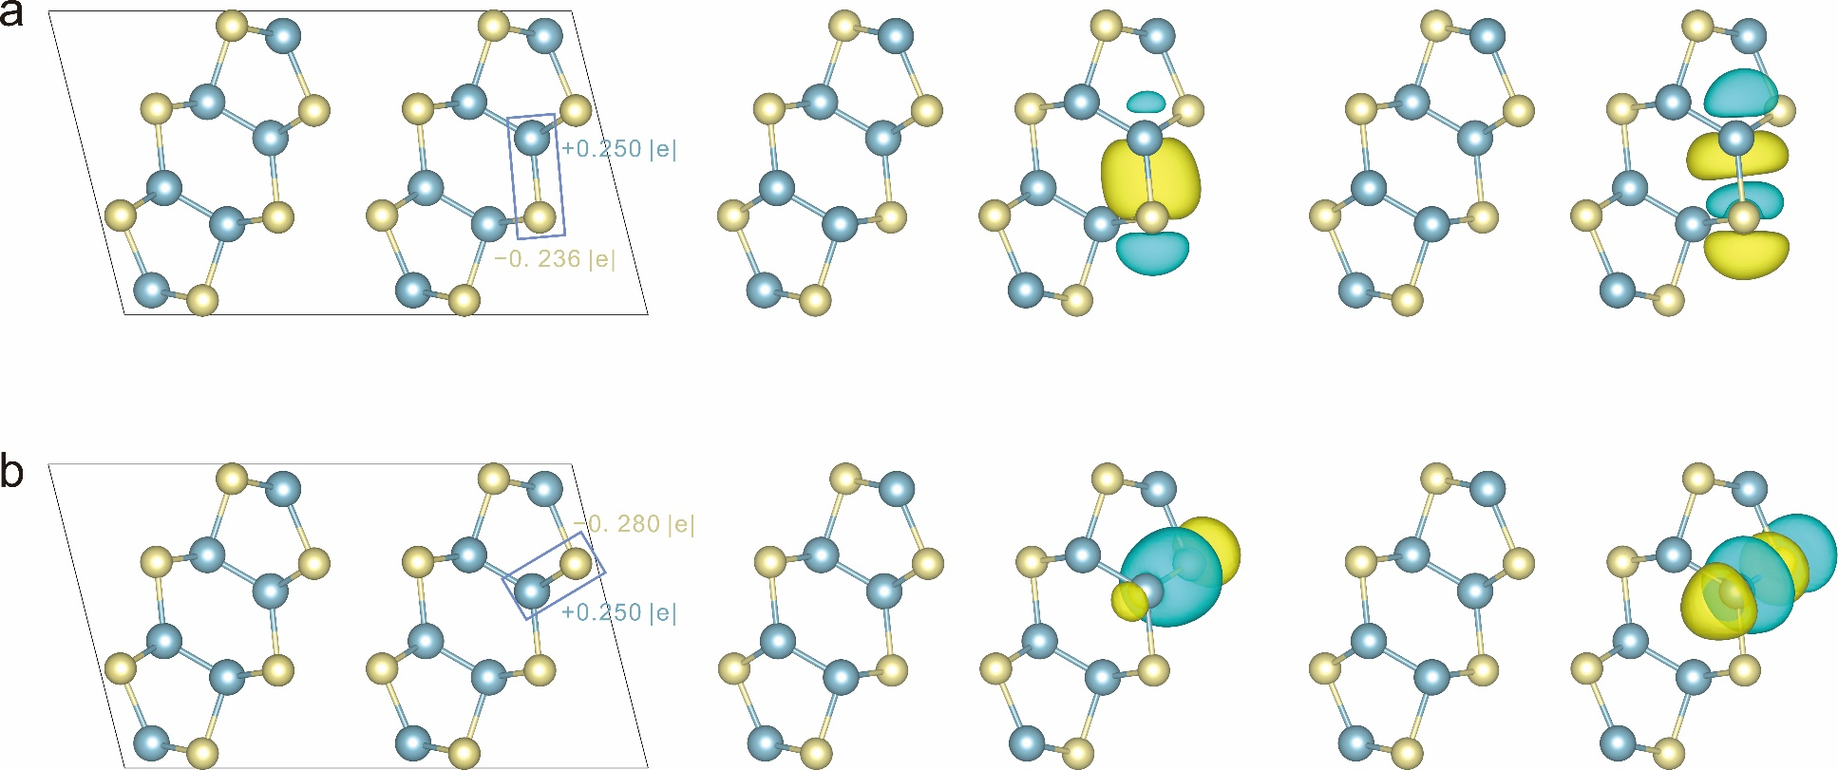
Supplementary Figure 16 | NBO Analysis of Bulk GaTe Structure Bonds. a, b, Representations of the structure and the corresponding bonding and antibonding orbitals within the same bonding environments as depicted in Supplementary Figure 14.

17. COHP analysis of bonding states in bulk GaTe structure
From the ICOHP values, it is evident that the corresponding bonding strengths of bulk structure align closely with the inner bonding state of 2D QLDS-GaTe. The COHP plots also exhibit remarkable similarities, further corroborating the resemblance between the two. These observations provide additional evidence for the similarity between the bonding characteristics of the inner bonds and the overall structure of 2D QLDS-GaTe.
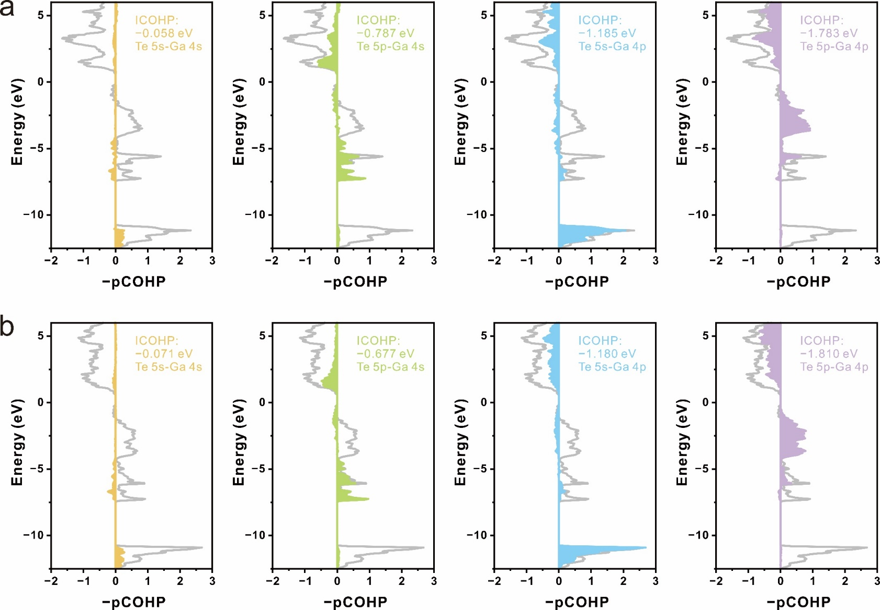
Supplementary Figure 17 | COHP analysis of bonding states in bulk GaTe structure. a, b, COHP diagram for bonds marked in Supplementary Figure 16.

18. COHP analysis of surface bonding states in 2D QLDS-GaTe structure
Based on the values of ICOHP, COHP orbital diagrams, contributions from orbital interactions, and the occupation numbers of orbitals (Supplementary Fig. 18, 19, Table S3, S4), it is evident that the surface bonding states exhibit distinct interactions compared to the inner bonding states. This observation provides insight into the formation of specific bands in the band structure of 2D QLDS-GaTe.
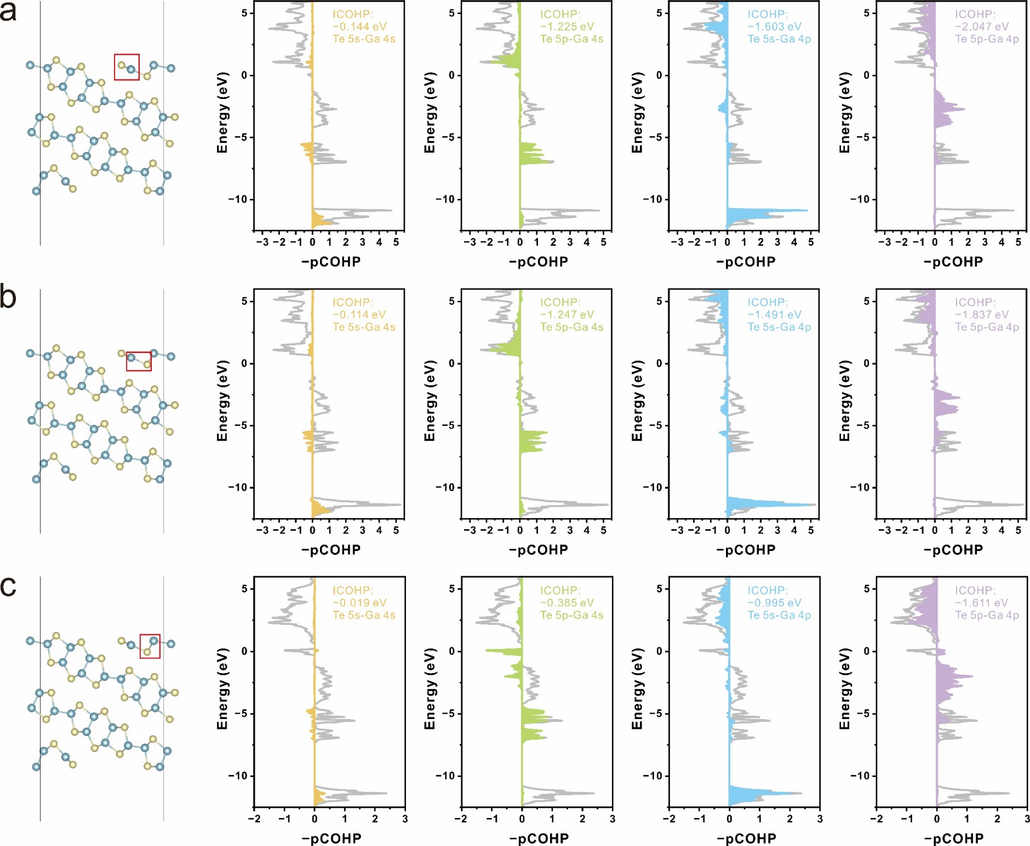
Supplementary Figure 18 | COHP analysis of surface bonding states in 2D QLDS-GaTe surface. Panels (a), (b), and (c) illustrate three representative bonding states formed through surface reconstruction.

19. COHP analysis of other surface bonding states in 2D QLDS-GaTe surface
We also consider another possible surface. It exhibits the relatively same result mentioned in Supplementary Figure 18. Therefore, the proportions of surface charge states within the system play a crucial role in determining the band structure, thus further influencing the electronic properties. As the thickness of the material decreases, significant changes occur in the band structure of 2D QLDS-GaTe. This alteration in the band structure accounts for the enhanced intensity of second harmonic generation (SHG). Additionally, these findings shed light on its potential applications in nonlinear optics.
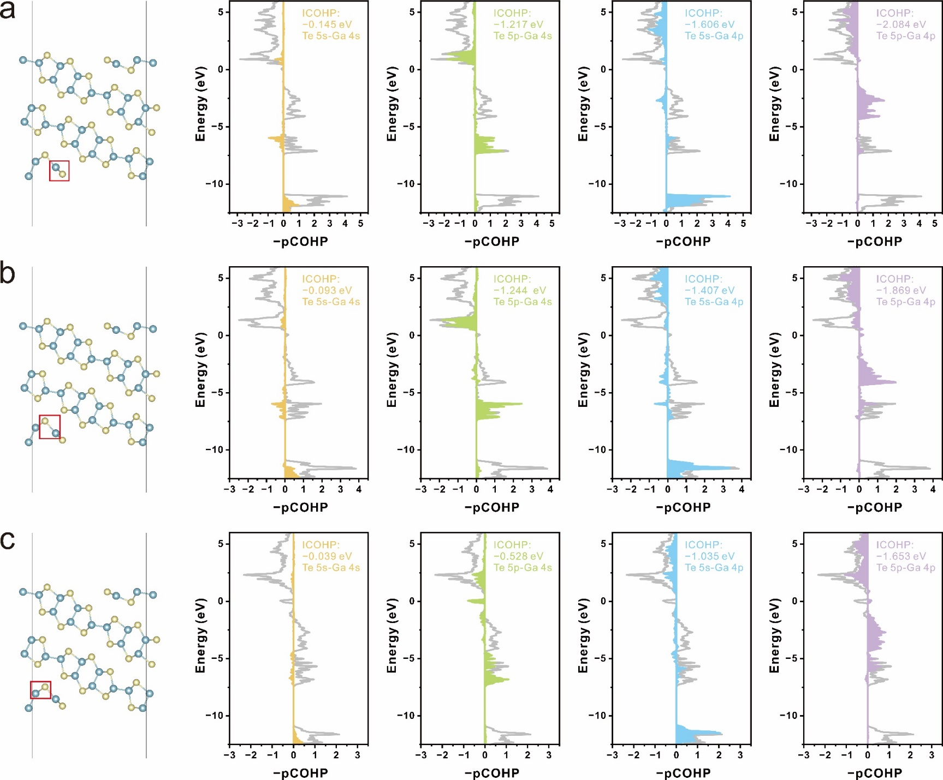
Supplementary Figure 19 | COHP analysis of other surface bonding states in 2D QLDS-GaTe surface. a, b, c, Representative bonding states on another surface.

20. HER Performance of 2D MoS₂
Previous investigations have demonstrated that the edges of MoS₂ exhibit superior catalytic activity^{2–4} as compared to the bulk, as shown in Supplementary Figure 20. The unsaturated edges of MoS₂ are particularly conducive to facilitating the hydrogen evolution reaction (HER), characterized by a lower Gibbs free energy, as well as diminished overpotential and Tafel slope. This exceptional catalytic performance originates from the unique electronic structure inherent to the edges. The 2D QLDS-GaTe, due to its structural peculiarity, essentially projects the unsaturated edges of the layered material onto the growth plane. Therefore, 2D QLDS-GaTe structure may exhibit enhanced catalytic performance.
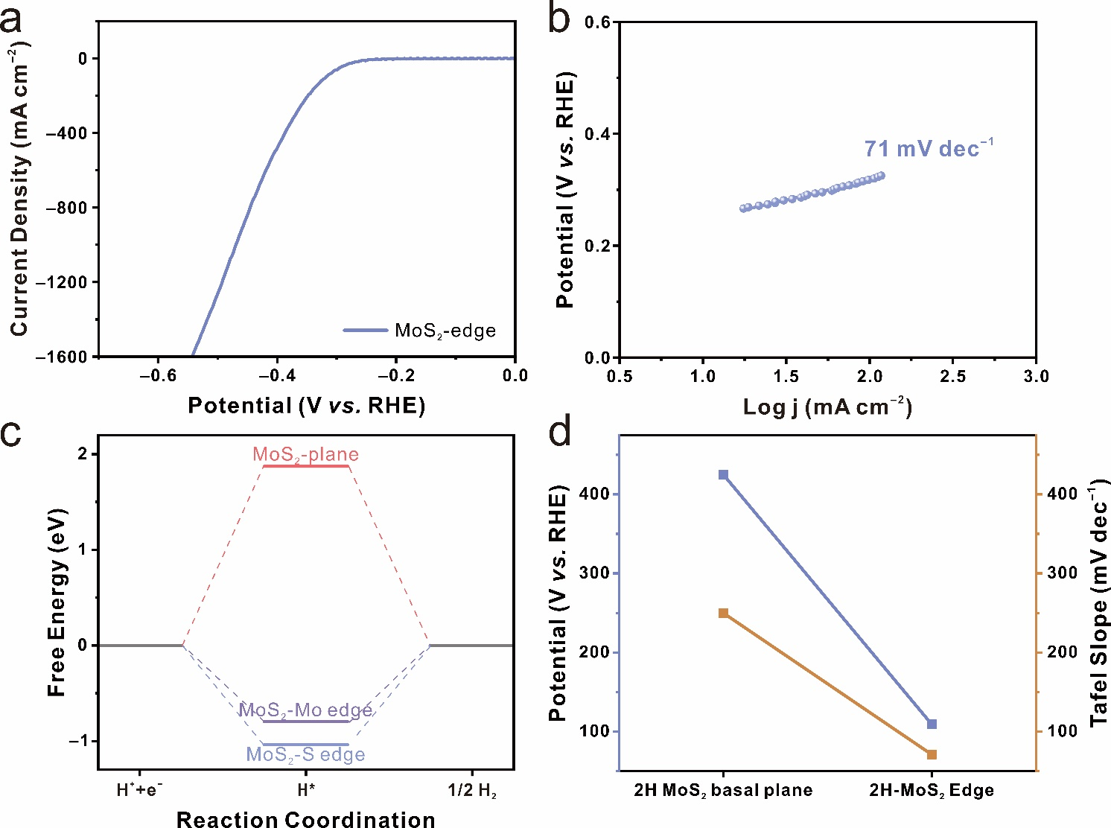
Supplementary Figure 20 | HER Performance of 2D MoS₂. a, b, LSV curves and corresponding Tafel slopes for the MoS₂ edge, respectively. c, Calculated Gibbs free energy profiles of MoS₂ across diverse regions. d, Catalytic activity of the different regions on the MoS₂.

21. Illustration of region fold theory and ELF in 2D QLDS-GaTe structure
Considering that layered materials exhibit diverse catalytic activities in different regions, with the basal plane significantly underperforming compared to the edge region, we drew an insightful inference. If the reactive edge region is projected onto a surface with a larger reactive area, and the catalytically inert basal plane is folded into a region not involved in the reaction, then the catalytic activity of the material would substantially improve. This concept we define as "region fold theory". In this way, we analyzed the 2D QLDS-GaTe structure, which effectively exposes the unsaturated edge region of the layered GaTe on the surface, while folding the catalytically inert saturated surface into the bulk. As a result, the 2D QLDS-GaTe structure demonstrates a pronounced surface charge polarization, which is one of the reasons for its elevated catalytic activity.
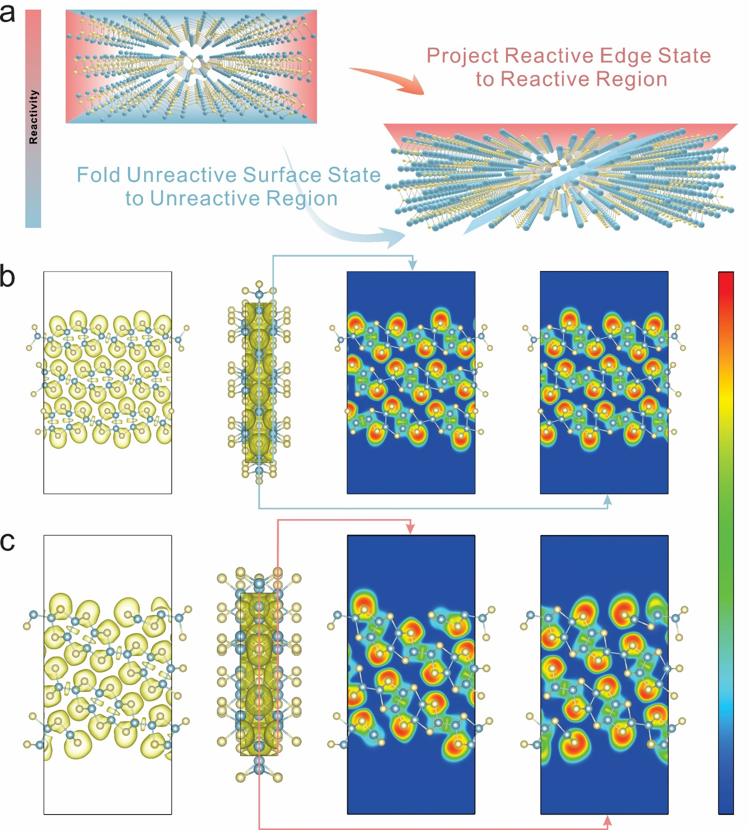
Supplementary Figure 21 | Illustration of region fold theory and ELF in 2D QLDS-GaTe structure. a, Conceptual diagram representing the region fold theory. b, c, ELF diagrams of the layered GaTe and 2D QLDS-GaTe, respectively, featuring two sectional views.

22. Bader charge distribution maps of layered GaTe and 2D QLDS-GaTe
Bader charge color maps further illustrate that the 2D QLDS-GaTe surface atoms exhibit a more pronounced heterogeneity in charge distribution compared to layered materials. In correlation with the previously discussed ELF results, this provides additional validation for the existence of surface charge polarization.
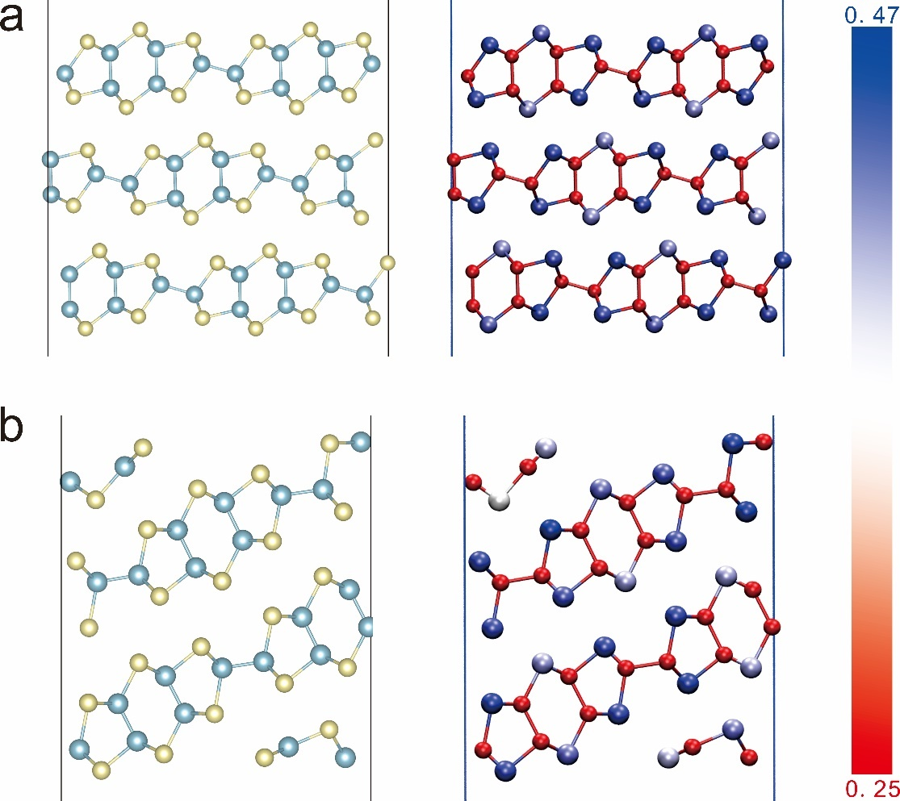
Supplementary Figure 22 | Bader charge distribution maps of layered GaTe and 2D QLDS-GaTe. a, b, Structural representations of layered GaTe and 2D QLDS-GaTe, respectively, color-coded by Bader charge distribution.

23. Partial charge density plots across varying energy ranges
The partial charge density plot results suggest that Te atoms on the surface of 2D QLDS-GaTe can function as atomic donors, facilitating the progression of the catalytic reaction. Surface Ga atoms can serve as both atomic donors and acceptors, thus stabilizing the adsorbed H*. The synergistic effect of these two types of atoms is fundamental to the ultra-low overpotential observed in 2D QLDS-GaTe.
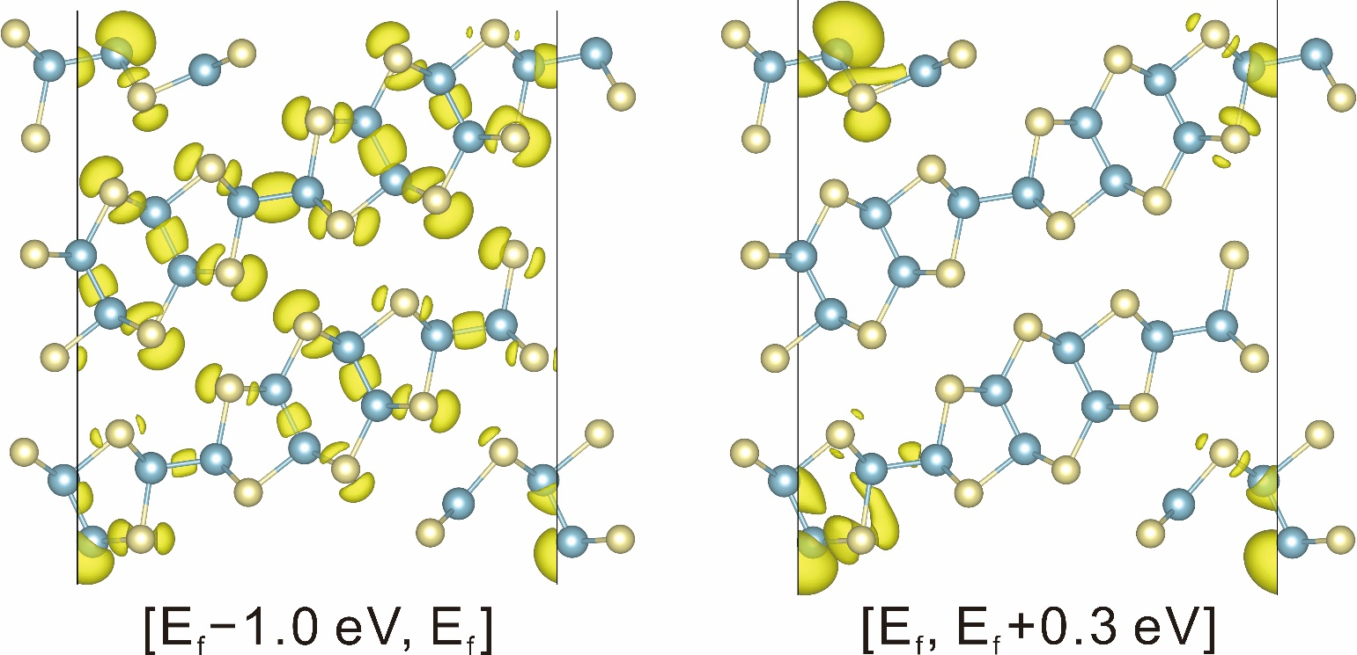
Supplementary Figure 23 | Partial charge density plots across varying energy ranges.

24. Calculated Gibbs free energy profiles of 2D QLDS-GaTe surface
The results indicate that the Te atoms on the surface of 2D QLDS-GaTe all exhibit excellent catalytic activity for the HER. Additionally, Ga atoms can capture adsorbed H*, aiding in the facilitation of the HER process.
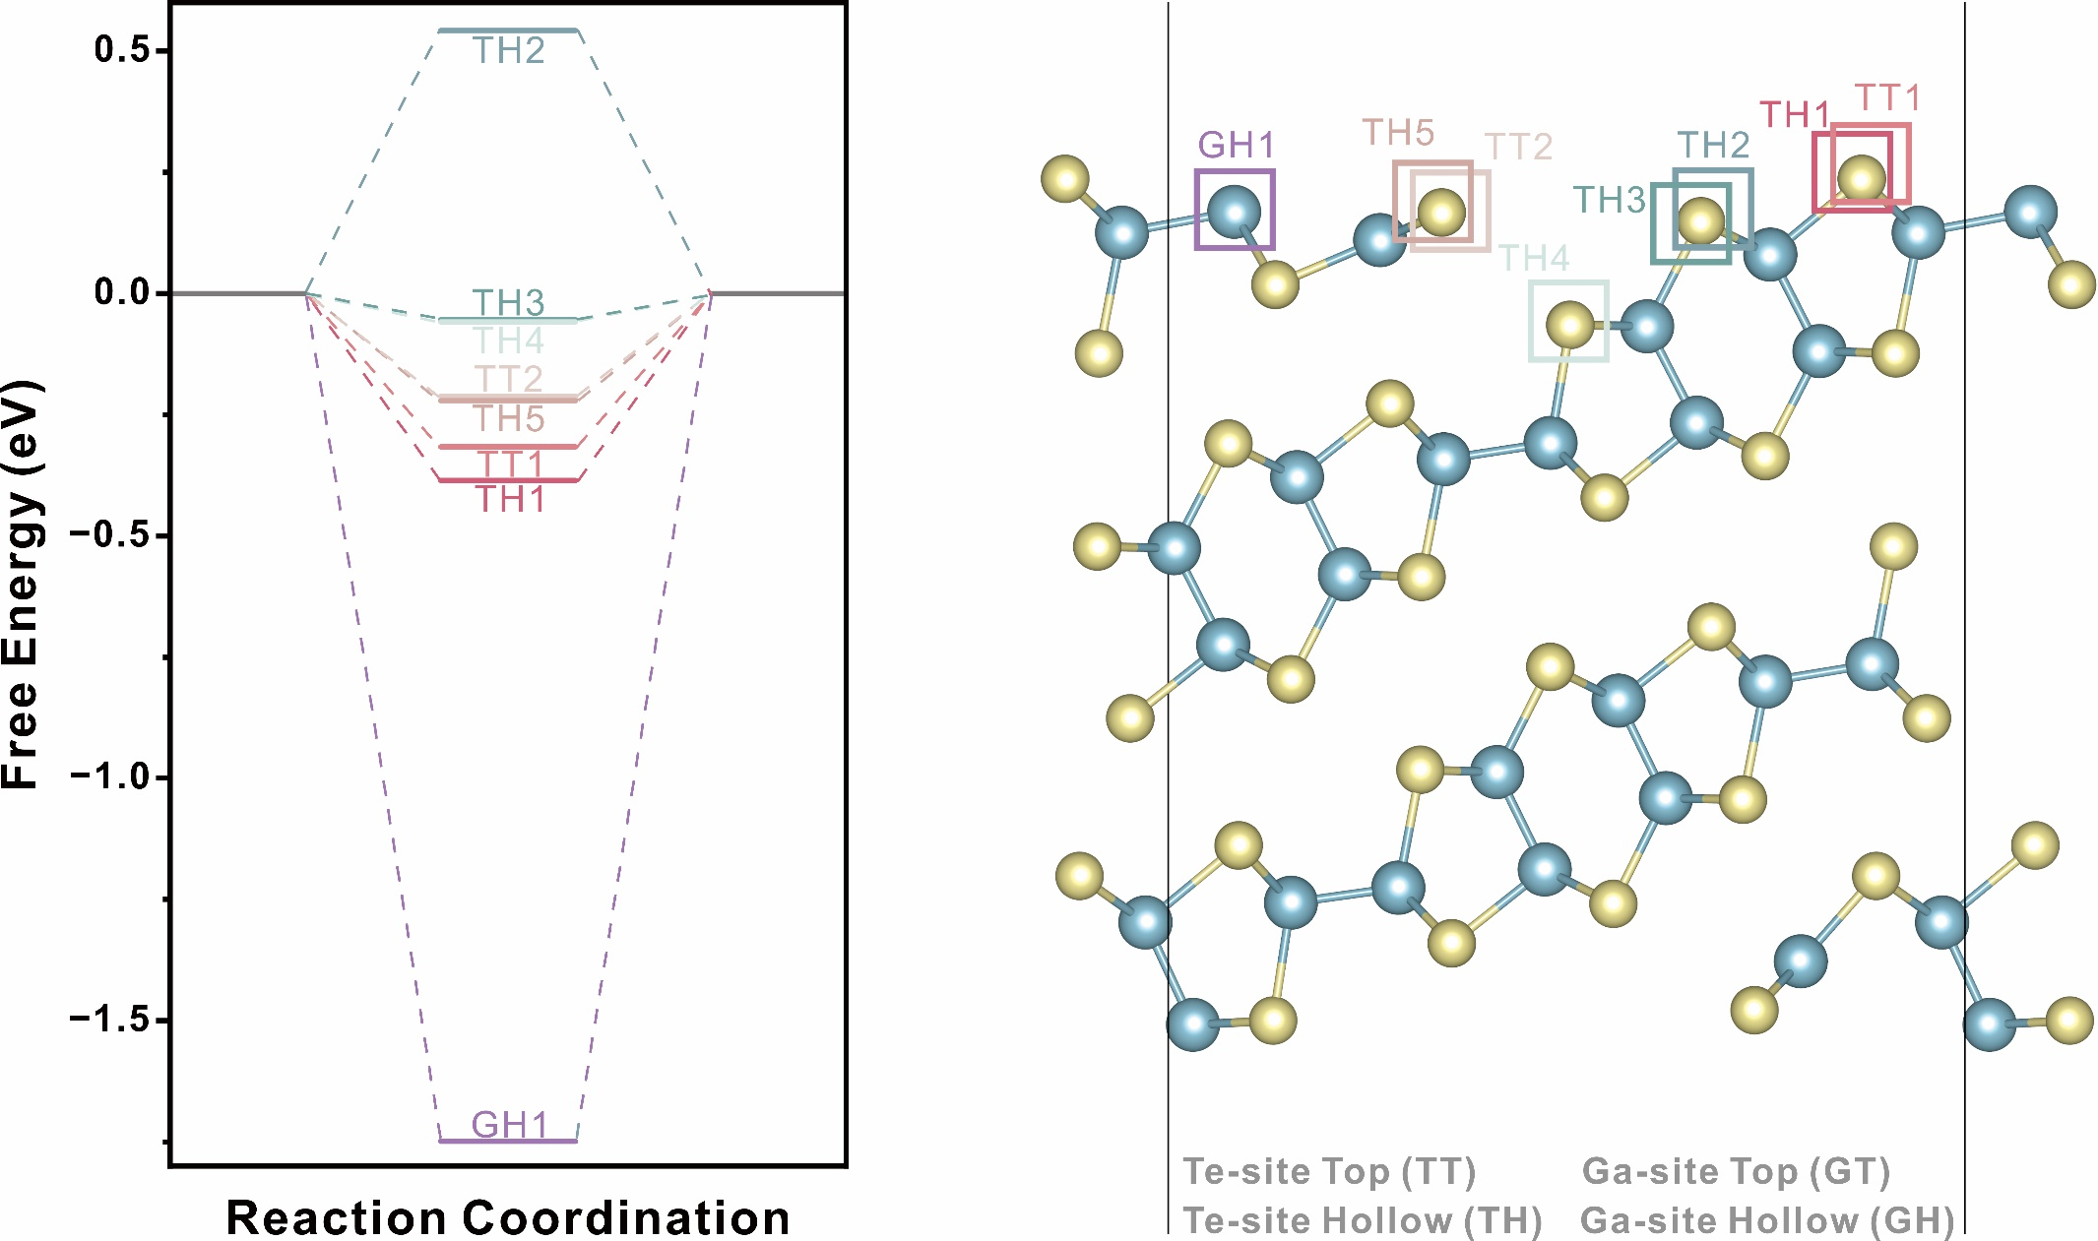
Supplementary Figure 24 | Calculated Gibbs free energy profiles of 2D QLDS-GaTe surface.

25. Structures of potential HER activation sites on 2D QLDS-GaTe surface
The structures below correspond to the active sites involved in the reaction, as shown in Supplementary Figure 24, further substantiating the aforementioned conclusions.
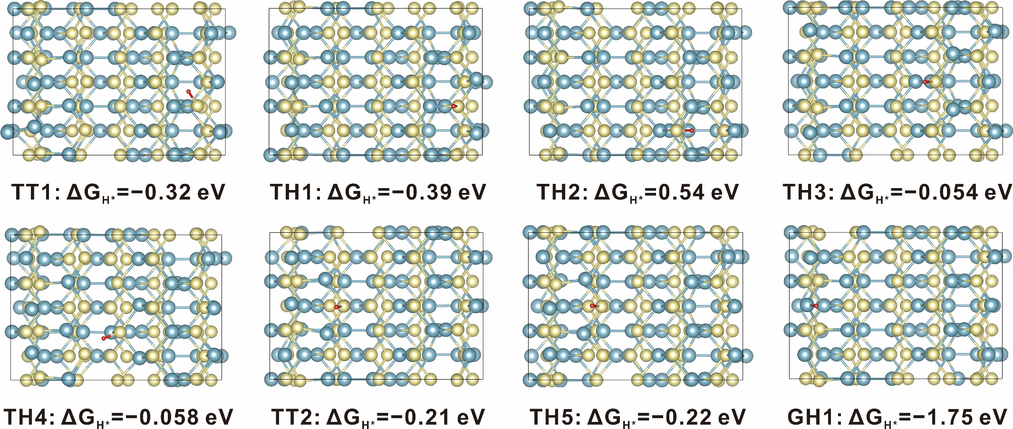
Supplementary Figure 25 | Structures of potential HER activation sites on 2D QLDS-GaTe surface.

26. Calculated Gibbs free energy profiles of another 2D QLDS-GaTe surface
To enhance the precision of our findings, an alternative potential surface structure was considered, and its HER activity was computed. The results indicate that the surface Te atoms retain a high level of HER activity, and the unsaturated Ga atoms can still capture H*, facilitating the reaction pathway. By studying different active sites and configurations, our results become more robust, further highlighting the reactivity of 2D QLDS-GaTe.
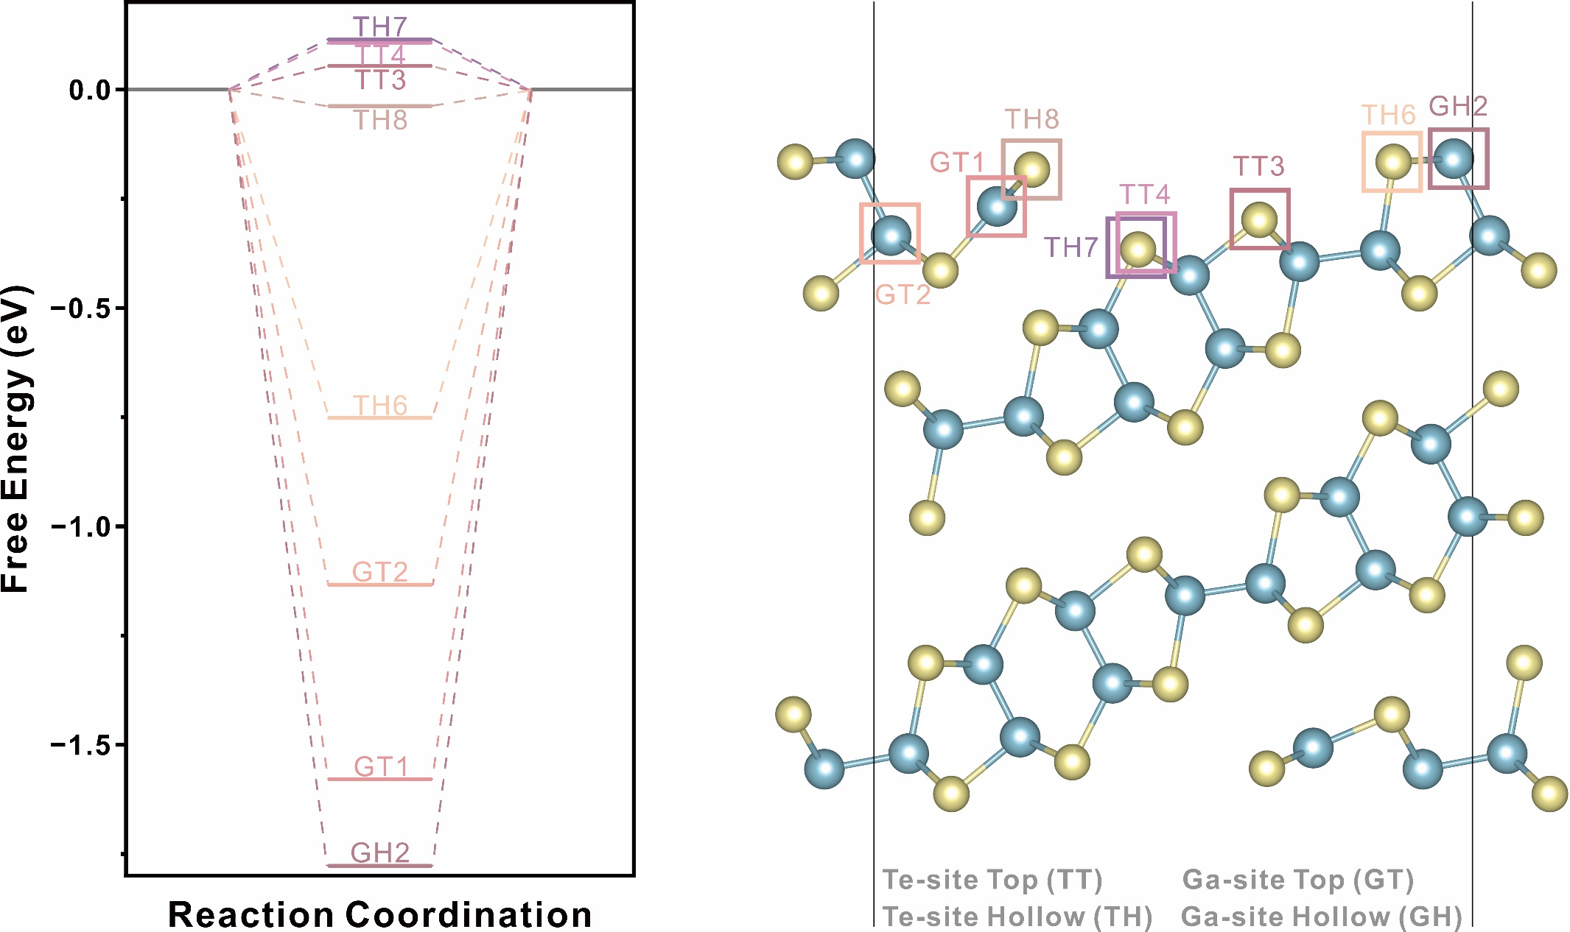
Supplementary Figure 26 | Calculated Gibbs free energy profiles of another 2D QLDS-GaTe surface.

27. Structures of potential HER activation sites on another 2D QLDS-GaTe surface
The structures below correspond to the active sites involved in the reaction, as shown in Supplementary Figure 26, further substantiating the aforementioned conclusions.
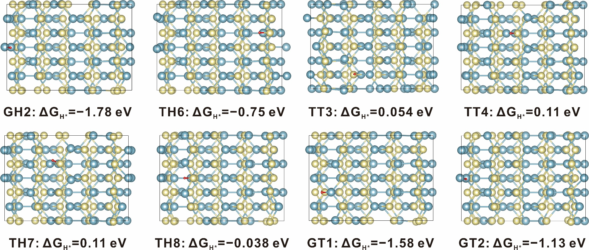
Supplementary Figure 27 | Structures of potential HER activation sites on another 2D QLDS-GaTe surface.

28. Calculated Gibbs free energy profiles of layered GaTe
Calculated ΔG* consistently surpasses 1.7 eV, signifying the inert nature of surface reactions on layered GaTe. This is also responsible for the elevated overpotential and Tafel slope observed in layered GaTe. These findings indirectly corroborate the feasibility of the Region Fold Theory, underlining the importance of structural modification in fabricating 2D QLDS-GaTe. As such, 2D QLDS-GaTe offers a significant platform for exploring edge states in materials.
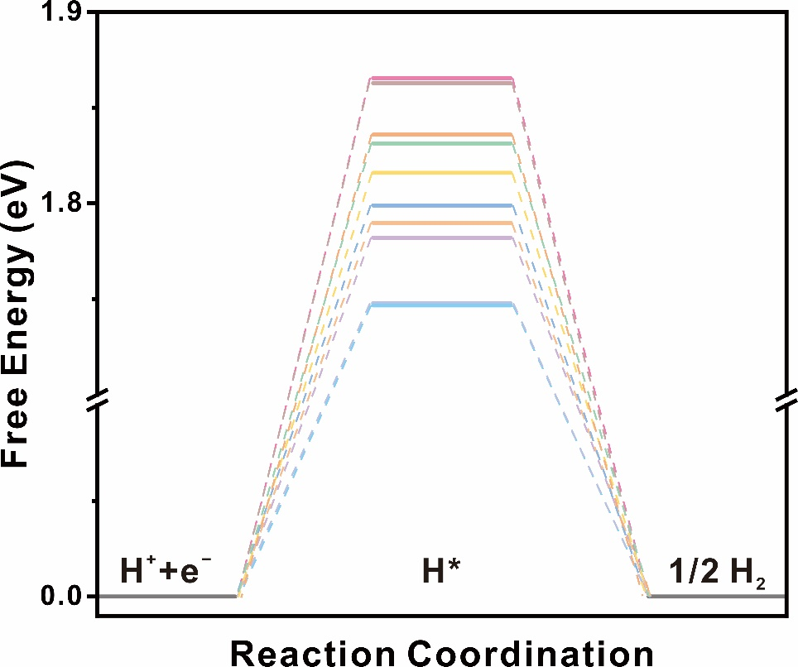
Supplementary Figure 28 | Calculated Gibbs free energy profiles of layered GaTe.

29. Structures of potential HER activation sites on layered GaTe surface
The structures below correspond to the active sites involved in the reaction, as shown in Supplementary Figure 28.
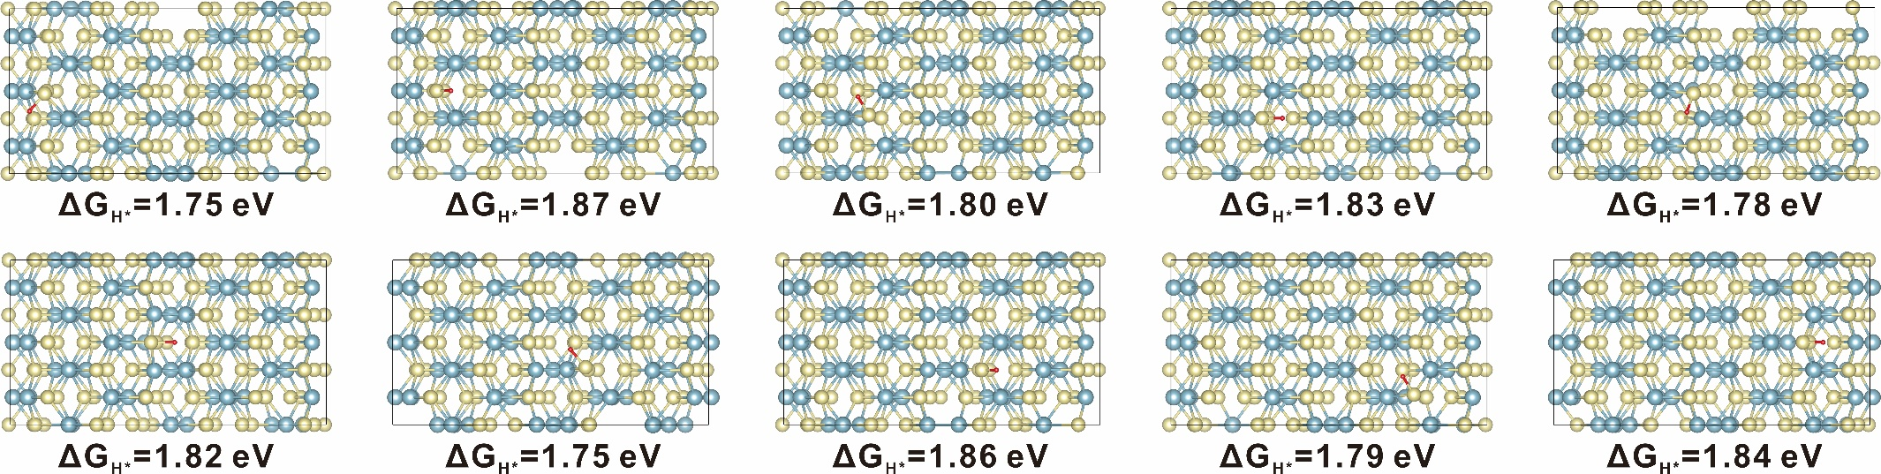
Supplementary Figure 29 | Structures of potential HER activation sites on layered GaTe surface.

30. I_{ds}–V_{ds} characteristic curves with different gate voltages
The I_{ds}–V_{ds} characteristic curves confirm the formation of good ohmic contact between the material and the electrodes. Concurrently, as the gate voltage varies, a significant change in the conductivity is observed, indicating that 2D QLDS-GaTe retains its intrinsic semiconducting properties. These characteristics render the material suitable for applications in field-effect transistors and photodetectors. Moreover, catalytic processes regulated by gate voltage may also be further explored.
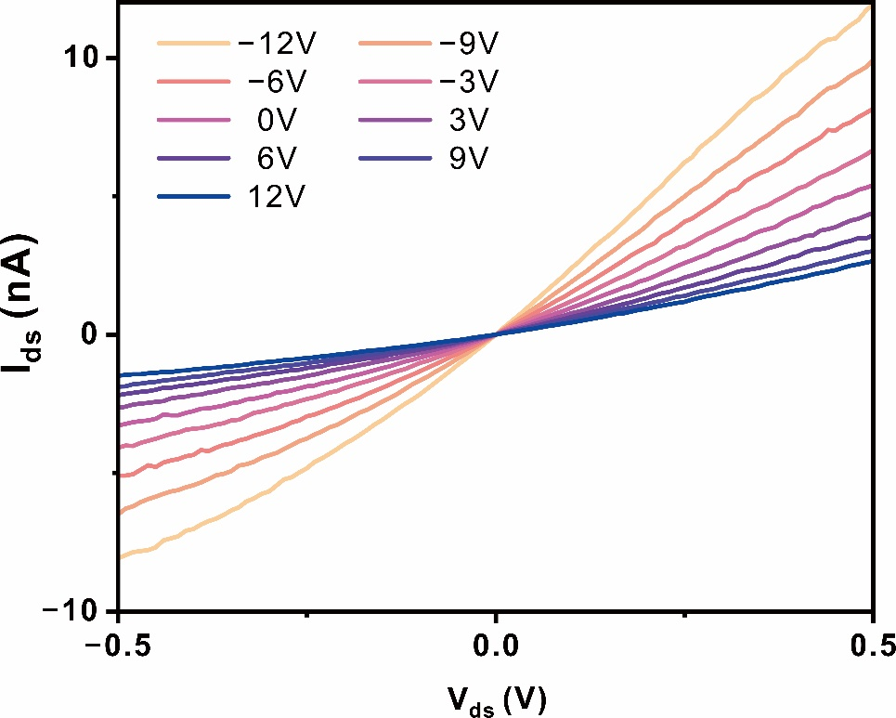
Supplementary Figure 30 | I_{ds}–V_{ds} characteristic curves with different gate voltages.

31. Analysis of the HER performance of polycrystalline GaTe, layered GaTe, and 2D QLDS-GaTe
2D QLDS-GaTe exhibits superior catalytic performance, characterized by a lower overpotential at 10 mA cm⁻² and a higher current density at the same overpotential.
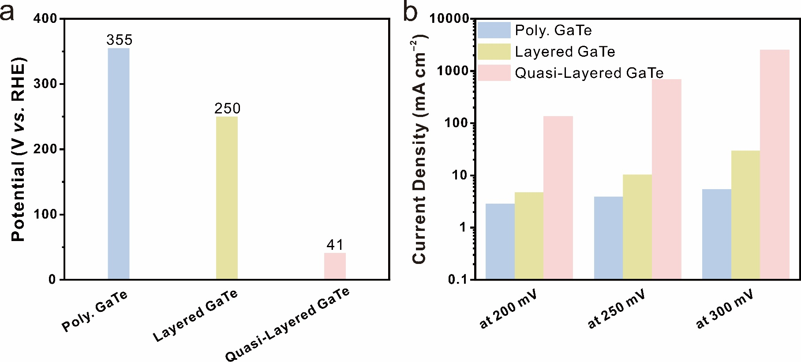
Supplementary Figure 31 | Analysis of the HER performance of 2D QLDS-GaTe. a, Overpotential of polycrystalline GaTe, layered GaTe, and 2D QLDS-GaTe at 10 mA cm⁻². b, Current density of polycrystalline GaTe, layered GaTe, and 2D QLDS-GaTe at various overpotentials.

32. Charge density difference maps with H* adsorption
The structures correspond to insets in Fig. 4g and 4h, demonstrating that 2D QLDS-GaTe exhibits favorable binding with adsorbed H*, whereas layered GaTe shows non-adsorption towards H*.
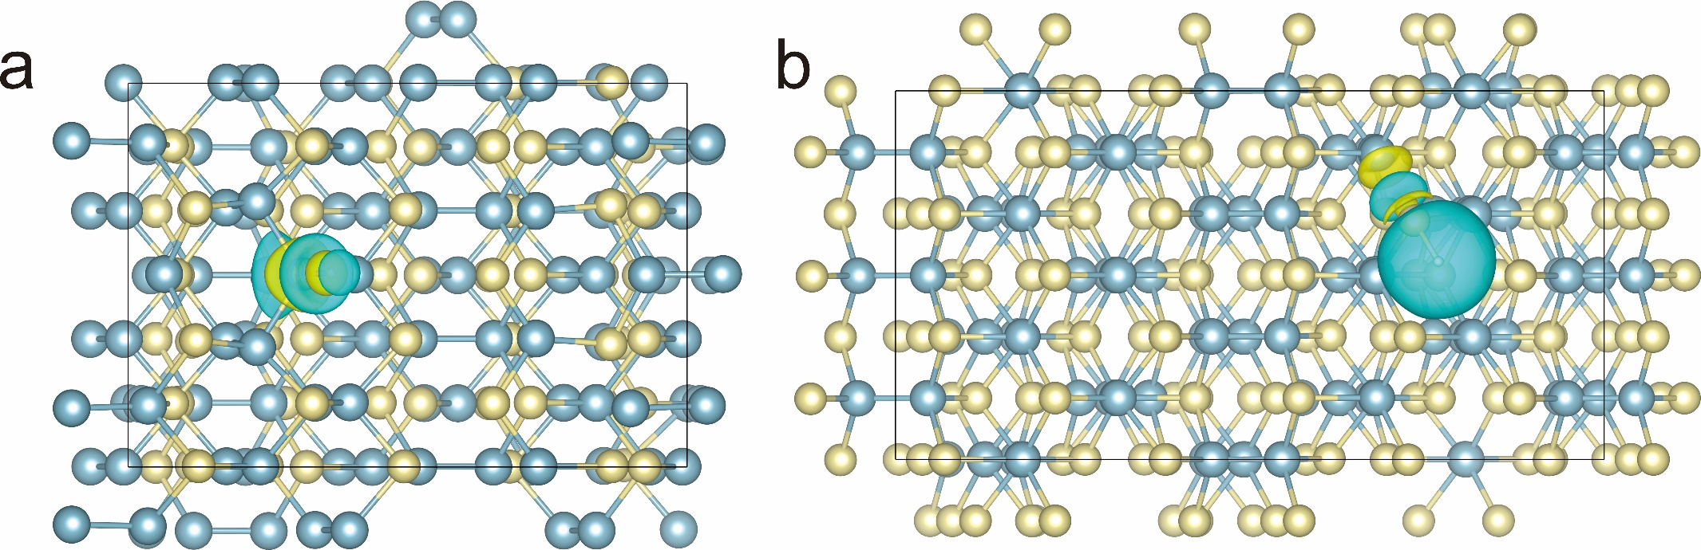
Supplementary Figure 32 | Charge density difference maps with H* adsorption. a, b, Top view of charge density difference plots of 2D QLDS-GaTe and layered GaTe with H* adsorption corresponding to Fig. 4g, 4h.

33. Analysis of Ga–Te bonding strength in pristine 2D QLDS-GaTe and 2D QLDS-GaTe with H* adsorption
Upon H* adsorption, the ICOHP value of the Ga–Te bond in 2D QLDS-GaTe shifts from −3.77 to −3.13, indicating that the original Ga–Te bond is weakened by H* adsorption. This characteristic is also reflected by the significant increase in the Ga–Te bond length with H* adsorption, further validating the reduction in bonding strength. Therefore, in the HER process, 2D QLDS-GaTe effectively captures H*. Meanwhile, to restore its original stable structure, the system promotes the conversion of H* to H₂.
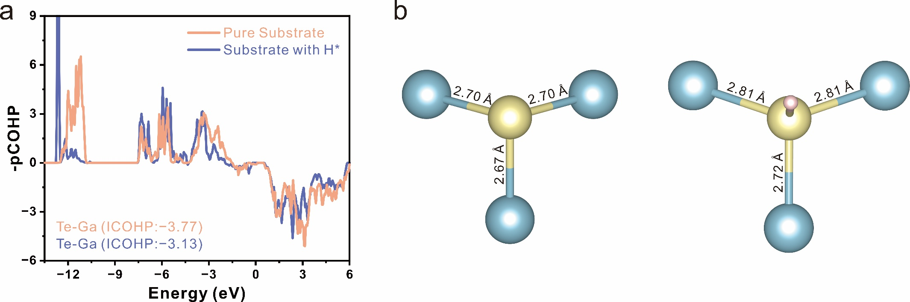
Supplementary Figure 33| Analysis of Ga–Te bonding strength in pristine 2D QLDS-GaTe and 2D QLDS-GaTe with H* adsorption. a, COHP diagram depicting Ga–Te bonding in both pristine 2D QLDS-GaTe and 2D QLDS-GaTe with H* adsorption. b, Depiction of the Ga–Te bonding environment in pristine 2D QLDS-GaTe and 2D QLDS-GaTe with H* adsorption.

Table S1. Calculated bonding state of the 2D QLDS-GaTe structure corresponding to Supplementary Figure 14.
NBO | Occupancy | Center  (bond contribution, %) |  | Hybridization  (Function, %)
Bond1 (σ) | 1.902 | Ga (27.89) | Te (72.11) |  | Ga (s^{25.10}p^{74.90}) | Te (s^{12.03}p^{87.97})
Bond1 (σ*) | 0.143 | Ga (72.11) | Te (27.89) |  | Ga (s^{25.10}p^{74.90}) | Te (s^{12.03}p^{87.97})
Bond2 (σ) | 1.910 | Ga (25.98) | Te (74.02) |  | Ga (s^{19.92}p^{80.08}) | Te (s^{12.94}p^{87.06})
Bond2 (σ*) | 0.116 | Ga (74.02) | Te (25.98) |  | Ga (s^{19.92}p^{80.08}) | Te (s^{12.94}p^{87.06})

Table S2. Calculated bonding state of the bulk structure corresponding to Supplementary Figure 16.
NBO | Occupancy | Center  (bond contribution, %) |  | Hybridization  (Function, %)
Bond1 (σ) | 1.904 | Ga (27.78) | Te (72.22) | Ga (s^{25.11}p^{74.72}d^{0.17}) | Te (s^{12.10}p^{87.82}d^{0.08})
Bond1 (σ*) | 0.144 | Ga (72.22) | Te (27.78) | Ga (s^{25.11}p^{74.72}d^{0.17}) | Te (s^{12.10}p^{87.82}d^{0.08})
Bond2 (σ) | 1.910 | Ga (25.68) | Te (74.32) | Ga (s^{20.02}p^{79.86}d^{0.12}) | Te (s^{12.87}p^{87.07}d^{0.06})
Bond2 (σ*) | 0.120 | Ga (74.32) | Te (25.68) | Ga (s^{20.02}p^{79.86}d^{0.12}) | Te (s^{12.87}p^{87.07}d^{0.06})

Table S3. Calculated bonding state of 2D QLDS-GaTe structure corresponding to Supplementary Figure 18.
NBO | Occupancy | Center (bond contribution, %) |  | Hybridization  (Function, %)
Bond1 (σ) | 1.907 | Ga (31.83) | Te (68.17) | Ga (s^{32.78}p^{67.22}) | Te (s^{12.07}p^{87.93})
Bond1 (σ*) | 0.129 | Ga (68.17) | Te (31.83) | Ga (s^{32.78}p^{67.22}) | Te (s^{12.07}p^{87.93})
Bond2 (σ) | 1.910 | Ga (31.43) | Te (68.57) | Ga (s^{34.55}p^{65.45}) | Te (s^{10.78}p^{89.22})
Bond2 (σ*) | 0.116 | Ga (68.57) | Te (31.43) | Ga (s^{34.55}p^{65.45}) | Te (s^{10.78}p^{89.22})
Bond3 (σ) | 1.731 | Ga (17.38) | Te (82.62) | Ga (s^{33.21}p^{66.79}) | Te (s^{14.00}p^{86.00})
Bond3 (σ*) | 0.549 | Ga (82.62) | Te (17.38) | Ga (s^{33.21}p^{66.79}) | Te (s^{14.00}p^{86.00})

Table S4. Calculated bonding state of 2D QLDS-GaTe structure corresponding to Supplementary Figure 19.
NBO | Occupancy | Center  (bond contribution, %) |  | Hybridization  (Function, %)
Bond1 (σ) | 1.907 | Ga (31.67) | Te (68.33) | Ga (s^{32.42}p^{67.58}) | Te (s^{12.40}p^{87.60})
Bond1 (σ*) | 0.123 | Ga (68.33) | Te (31.67) | Ga (s^{32.42}p^{67.58}) | Te (s^{12.40}p^{87.60})
Bond2 (σ) | 1.885 | Ga (31.34) | Te (68.66) | Ga (s^{35.30}p^{64.70}) | Te (s^{6.75}p^{93.25})
Bond2 (σ*) | 0.180 | Ga (68.66) | Te (31.34) | Ga (s^{35.30}p^{64.70}) | Te (s^{6.75}p^{93.25})
Bond3 (σ) | 1.900 | Ga (23.66) | Te (76.34) | Ga (s^{22.94}p^{77.06}) | Te (s^{11.06}p^{88.94})
Bond3 (σ*) | 0.199 | Ga (76.34) | Te (23.66) | Ga (s^{22.94}p^{77.06}) | Te (s^{11.06}p^{88.94})

Table S5. Calculated bonding state of the H adsorption on QL structure corresponding to Fig. 4g.
NBO | Occupancy | Center (bond contribution, %) |  |  | Hybridization  (Function, %)
Te–H (σ) | 1.979 | Te (55.43) | H (44.57) | Te (s^{4.07}p^{95.58}d^{0.35}) |  | H (s¹⁰⁰)
Te–H (σ*) | 0.061 | Te (44.57) | H (55.43) | Te (s^{4.07}p^{95.58}d^{0.35}) |  | H (s¹⁰⁰)

Table S6. Calculated bonding state of the H adsorption on QL structure corresponding to Fig. 4h.
NBO | Occupancy | Center  (bond contribution, %) |  | Hybridization  (Function, %)
Te–H (σ) | 1.937 | Te  (54.47) | H  (45.53) | Te (s^{1.77}p^{97.96}d^{0.27}) | H (s¹⁰⁰)
Te–H (σ*) | 0.275 | Te  (45.53) | H  (54.47) | Te (s^{1.77}p^{97.96}d^{0.27}) | H (s¹⁰⁰)

Reference
1 Zallo, E. et al. Two-dimensional single crystal monoclinic gallium telluride on silicon substrate via transformation of epitaxial hexagonal phase. npj 2D Mater. Appl. 7, 19 (2023).
2 Zhang, J. et al. Unveiling active sites for the hydrogen evolution reaction on monolayer MoS₂. Adv. Mater. 29, 1701955 (2017).
3 Voiry, D. et al. The role of electronic coupling between substrate and 2D MoS₂ nanosheets in electrocatalytic production of hydrogen. Nat. Mater. 15, 1003–1009 (2016).
4 Wang, Z. et al. Controllable etching of MoS₂ basal planes for enhanced hydrogen evolution through the formation of active edge sites. Nano Energy 49, 634–643 (2018).

