Supplementary Information for

An abrupt shift in gross primary productivity over
Eastern China-Mongolia

Dan-bi Lee¹, Jin-Soo Kim², So-Won Park*¹, and Jong-Seong Kug*¹

¹Division of Environmental Science and Engineering,
Pohang University of Science and Technology (POSTECH), Pohang, South Korea.
²Low-Carbon and Climate Impact Research Centre, School of Energy and Environment, City University of Hong Kong, Tat Chee Avenue, Kowloon, Hong Kong, China.
*Corresponding author. Email: jskug@postech.ac.kr

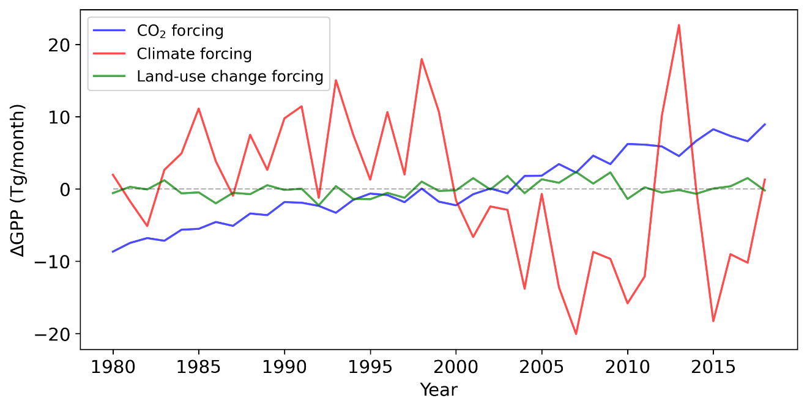
Supplementary Fig. 1 Time series of JJA MME mean of GPP_{TRNDY} anomaly (1980-2018). CO₂, climate, and land use change-driven GPP are calculated through the differences between S1 and S0, S2 and S1, S3 and S2, respectively. All values are averaged over the Eastern China-Mongolia region (40°–52°N and 110°–124°E). (The “S3” simulation is forced by time varying atmospheric CO₂ concentrations, climate, and land use change.)

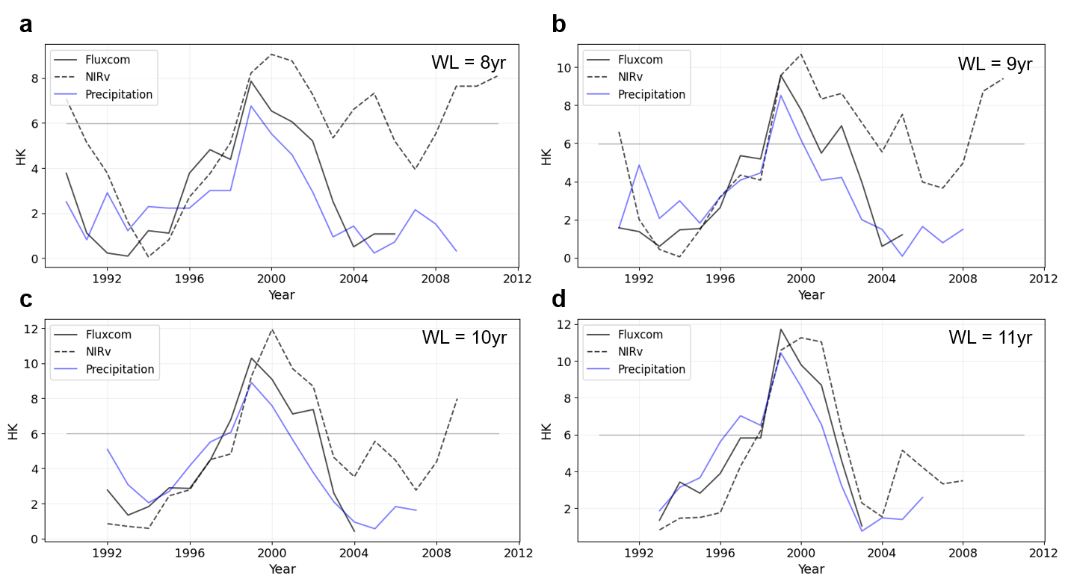
Supplementary Fig. 2 Time series of Lepage statistic (HK) values of JJA mean GPP_{FLUXCOM} (black solid line), GPP_{NIRv} (black dashed line), and precipitation (blue solid line). Same as in Fig. 3, but for different window lengths.
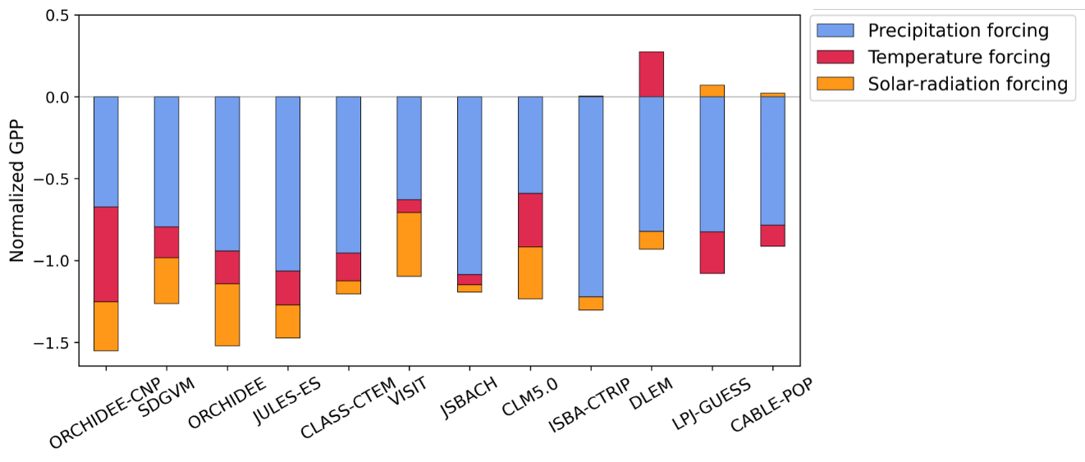
Supplementary Fig. 3 Differences in mean value of normalized GPP_{climate-forcing} between P1' and P2' for the individual TRENDY models, reconstructed from multiple linear regression based on normalized climate factors (precipitation, temperature, and solar radiation). Each bar is the quantitative contribution of precipitation (blue), temperature (red) and solar radiation (orange) to the total difference in GPP_{climate-forcing}. A negative (positive) value indicates a lower (higher) mean state of GPP during P2' compared to P1'.

