Additional files
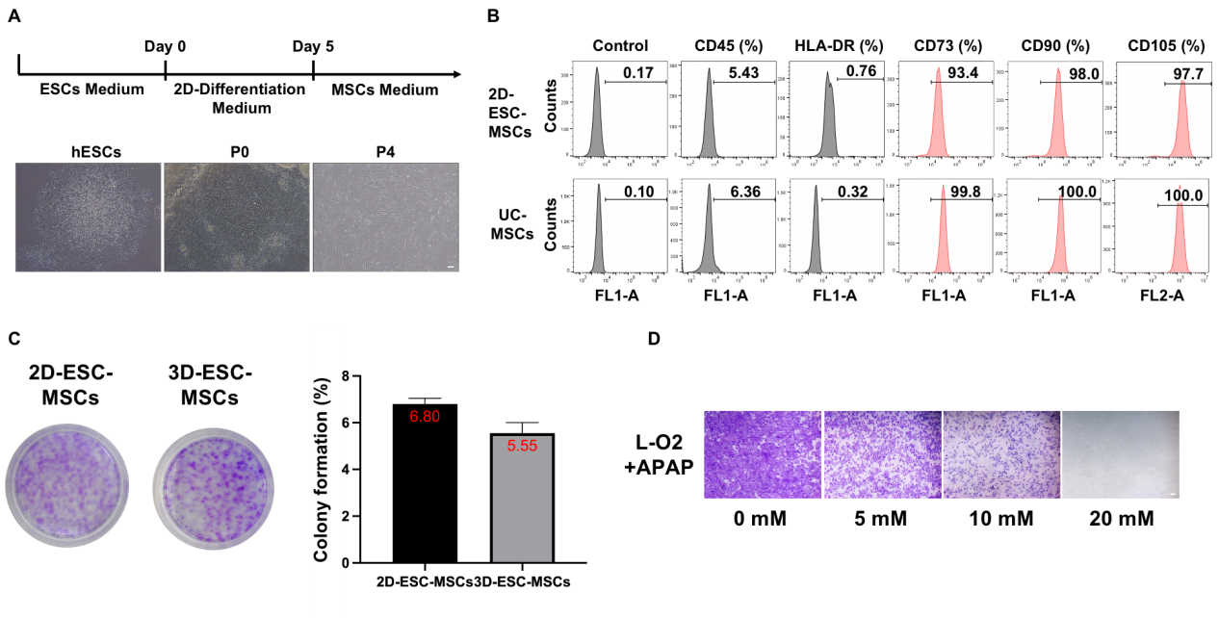
Additional file 1: Figure S1.
A. Induction of hESCs into 2D-ESC-MSCs, and representative morphology of cells at different stages observed under the microscope. (Scale: 200 μm)
B. Flow cytometry was used to detect the expression of MSCS specific surface markers in 2D-ESC-MSCs and UCMSCs.
C. Colony formation of 2D- and 3D-ESC-MSCs.
D. Crystal violet staining of surviving L-02 cells treated with different concentrations of APAP for 24 h. (Scale: 200 μm)

