SUPPLEMENTARY INFORMATION

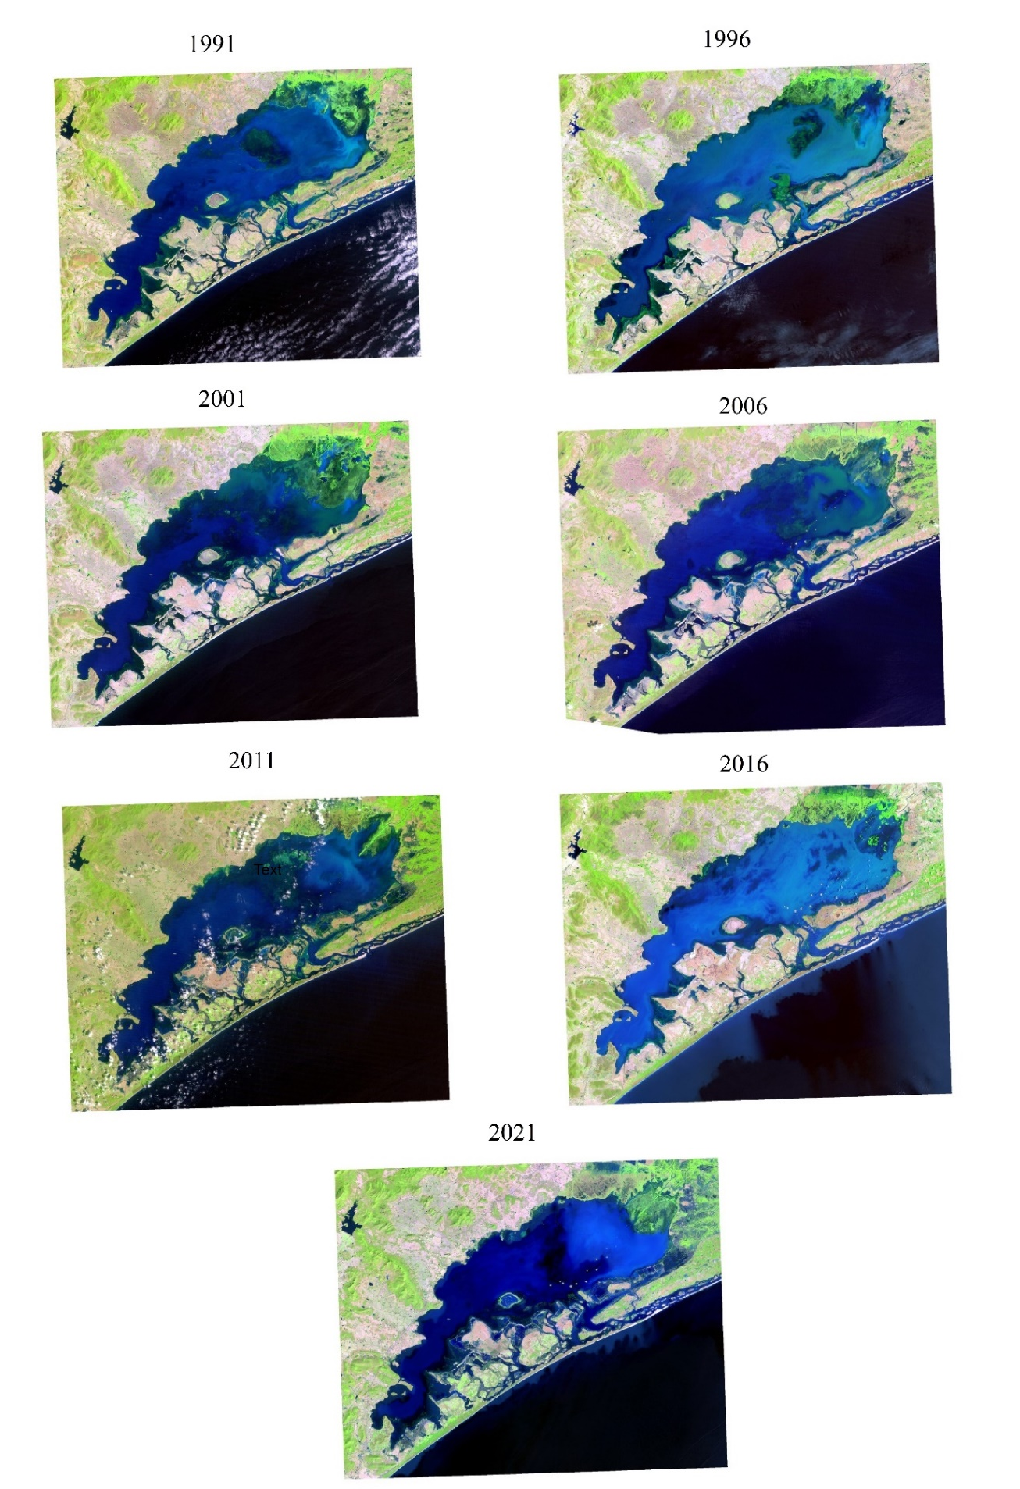

Figure S1: Satellite maps of Chilika Lake
Table S1: Data collected and its specifications
Satellite | Sensor | Acquisition Date | Band Combination | Path / Row | Resolution (m)
Landsat 5 | TM | 20/03/1991 | 1,2,3,4,5,7 | 140/46 | 30 x 30
Landsat 5 | TM | 18/04/1996 | 1,2,3,4,5,7 | 140/46 | 30 x 30
Landsat 5 | TM | 15/03/2001 | 1,2,3,4,5,7 | 140/46 | 30 x 30
Landsat 5 | TM | 13/05/2006 | 1,2,3,4,5,7 | 140/46 | 30 x 30
Landsat 5 | TM | 11/03/2011 | 1,2,3,4,5,7 | 140/46 | 30 x 30
Landsat 8 | OLI | 25/04/2016 | 1,2,3,4,5,6,7 | 140/46 | 30 x 30
Landsat 8 | OLI | 02/03/2021 | 1,2,3,4,5,6,7 | 140/46 | 30 x 30

