Supplemental figure 4.

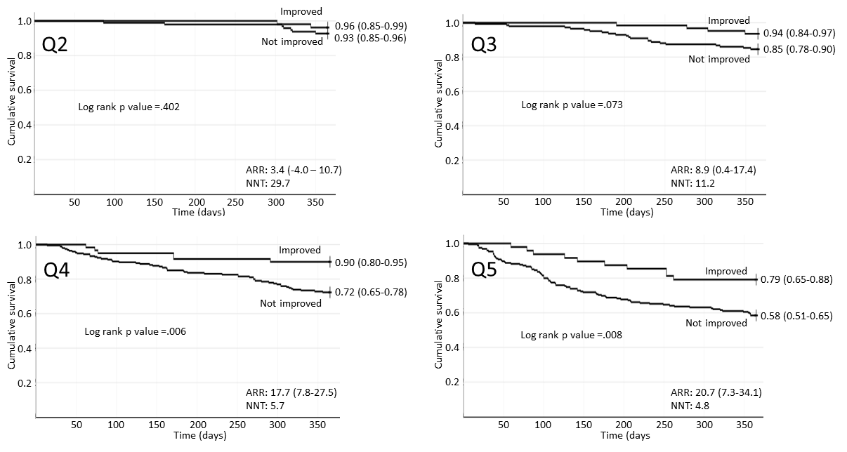

Supplemental figure 4. Cumulative 1-year survival of patients with SFI stratified by improvement in six-minute walking distance to 300 m or more at discharge, across quintiles of the SFI/NT-proBNP risk score. Q denotes quintile, ARR absolute risk reduction, NNT number needed to treat. Number in parentheses are 95% confidence intervals. Because of the low number of patients (N. 33), data for quintile 1 were not reported.

