Supplemental figure 3.

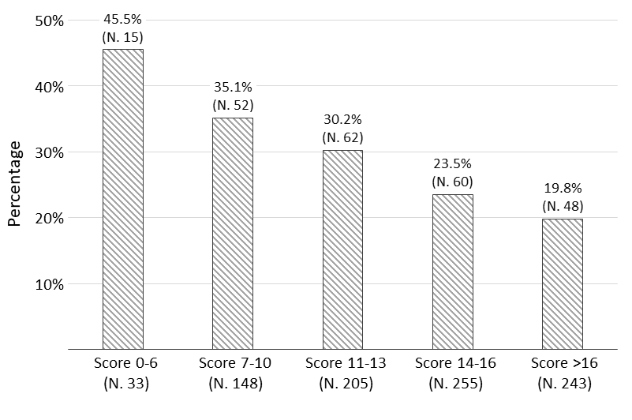
Supplemental figure 3. Proportion of patients who achieved an improvement in 6MWD ≥300 m among those with SFI at admission across quintiles of the SFI/NT-proBNP risk score. N, number of patients.

