Supplemental figure 2.

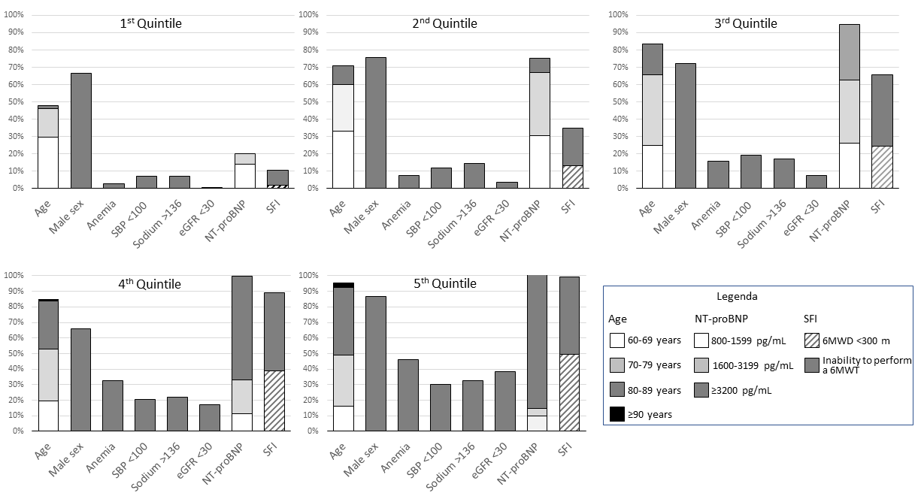
Supplemental figure 2. Prevalence of individual predictors across quintiles of the risk score. SBP, systolic blood pressure; eGFR, estimated glomerular filtration rate; SFI, severe functional impairment; 6MWD, six-minute walking test; 6MWT, six-minute walking distance.

