Supplemental figure 1.

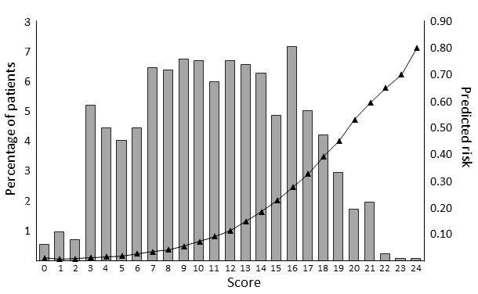

Supplemental figure 1. Distribution of the patients across the risk scores (left axix) and predicted probability of 1-year mortality for each score (right axis).

