Supporting information

A chalcone-based fluorescence probe for H₂S detecting utilizing ESIPT coupled ICT mechanism
Xiaochun Zhang, Xingshang Weng, Zongmei Yang, Peng Zhao, Weijian Chen, Zhengxu Wu, Xuewen Zhuang*
Institute of Chemical Engineering, Guangdong Academy of Sciences, Guangzhou, Guangdong 510665, PR China. E-mail: zhuangxw1991@gmail.com

*Corresponding author

1. The synthesis of 4-azido benzaldehyde
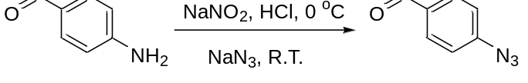
Simple steps synthesized the synthesis of 4-azidobenzaldehyde according to the reported literature [1]. A 4-aminobenzaldehyde (2.0 g, 0.016 mol ) and diluted HCl (150 mL, 4 mol/L) were added to a 500 mL flask, then 20 mL NaNO₂ aqueous solution (2.28g, 0.033mol) was added dropwise under 0 ℃ for 1.5 h. after that, 20 mL NaN₃ aqueous solution (2.15g, 0.033 mol ) was added slowly at 0 ℃, keep the reaction at room temperature for 5 h. After the reaction, the product was extracted with ethyl acetate, and the organic phase was dried with Na₂SO₄. Then ethyl acetate was removed by rotary evaporation to obtain the crude product. The crude product was purified by column chromatography (eluent: EA/PE = 1/5, v/v) to give a brown liquid 4-azidobenzaldehyde (1.65 g, 70%). IR (KBr, cm⁻¹) 3464.83, 3364.60, 3231.08, 2115.98, 1618.53, 1549.20, 1514.37, 1280.62, 1159.54, 825.56.
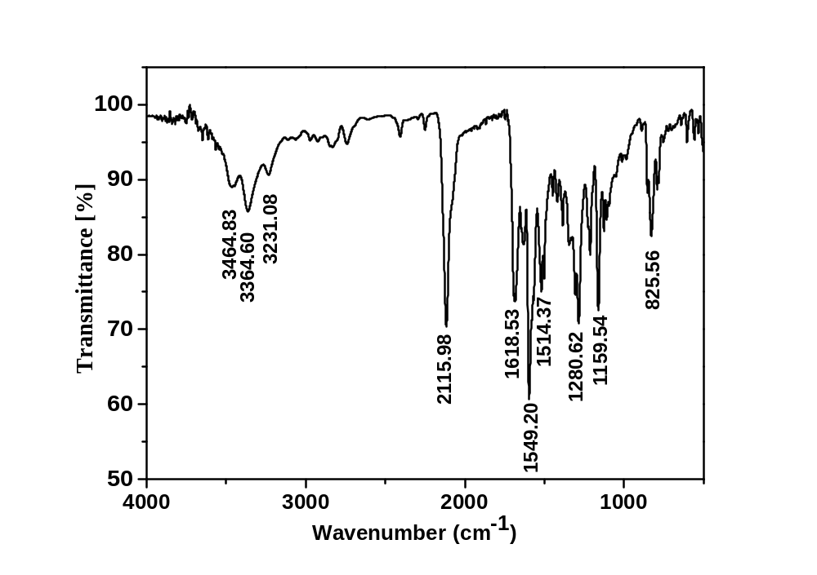
Fig. S1. IR spectrum of probe 4-azidobenzaldehyde.
2. The spectra of Cha-N₃.

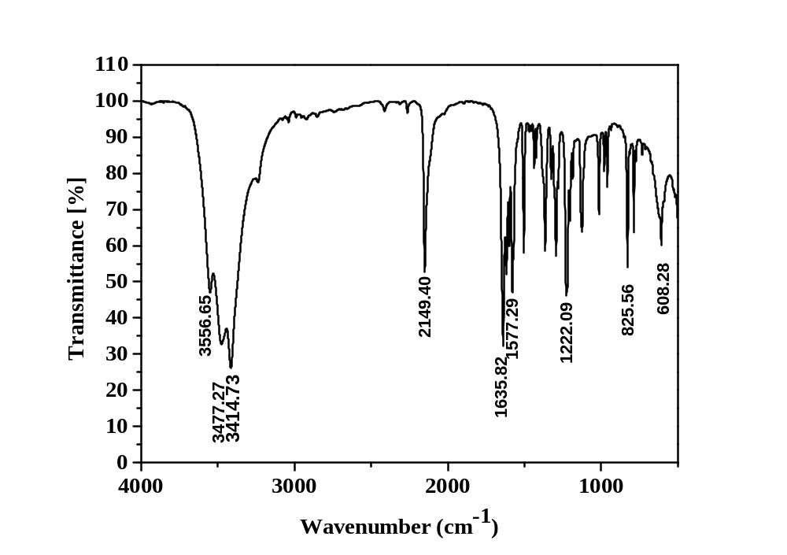
Fig. S2. IR spectrum of probe Cha-N₃.
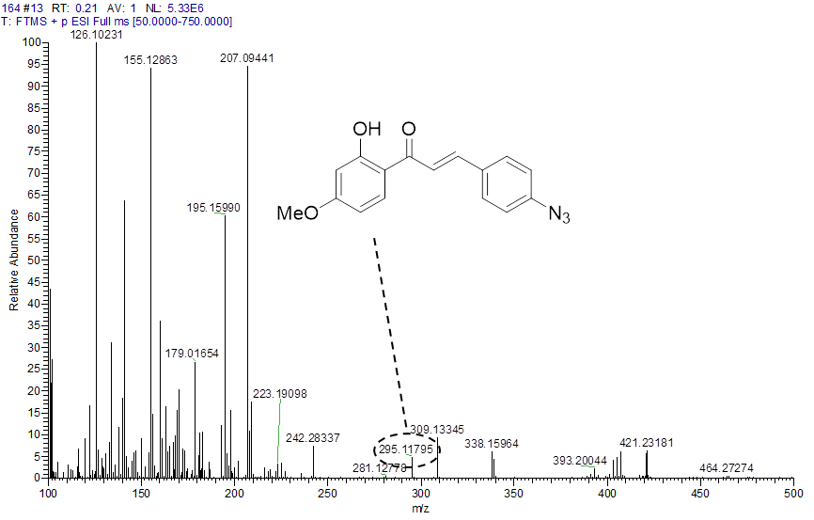
Fig. S3. HRMS spectrum of probe Cha-N₃.
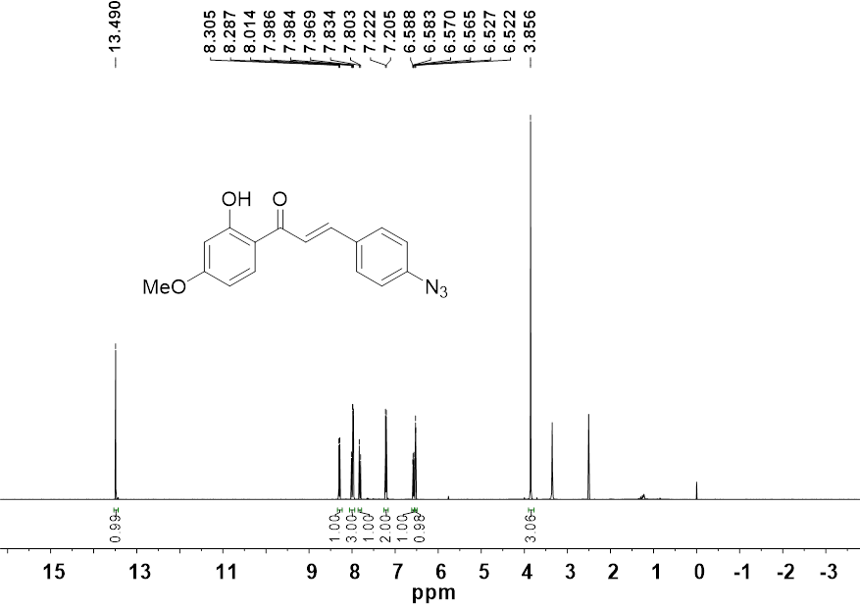
Fig. S4. ¹H NMR spectrum of probe Cha-N₃ in DMSO-d₆.
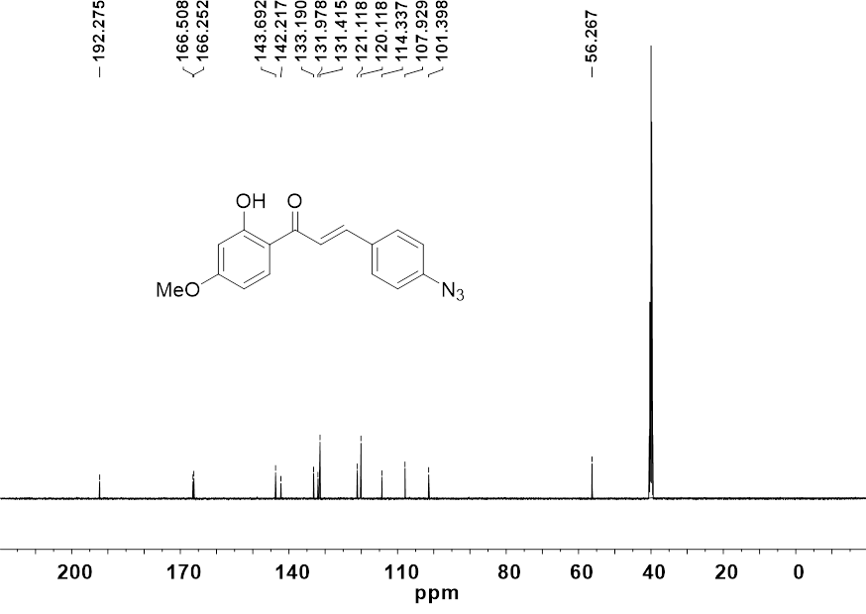
Fig. S5. ¹³C NMR spectrum of probe Cha-N₃ in DMSO-d₆.
3. X-ray crystal structure determinations of Cha-N₃
Crystals of Cha-N₃ was obtained by recrystallization from freezing dichloromethane to give dark orange crystals at 0 °C. Single crystals were coated with inert oil, placed under streaming nitrogen in a Bruker Apex II CCD diffractometer (Mo Kα radiation, λ = 0.71073 Å) for Cha-N₃. The structure was solved using the charge-flipping algorithm, as implemented in the program SUPERFLI[3] and refined by full-matrix least-squares techniques against F_{o}[2] using the SHELXL program[4] through the OLEX2 interface.[5] Hydrogen atoms bonded to carbon were placed at calculated positions and refined isotropically by using a riding model. Both structures were examined using the Addsym subroutine of PLATON[6] to ensure that no additional symmetry could be applied to the models.Crystallographic and experimental details of the structure determination are summarized in Table S1. CCDC 2250386 contain the supplementary crystallographic data for Cha-N₃. These data are provided free of charge by The Cambridge Crystallographic Data Center.
Table S1 Crystal data and structure refinement of compound Cha-N₃.
 | Cha-N₃
Empirical formula | C₁₆H₁₃N₃O₃
Formula weight | 295.29
Temperature/K | 193
Crystal system | monoclinic
Space group | C2/c
a/Å | 11.6033(10)
b/Å | 7.7747(5)
c/Å | 30.858(2)
α/° | 90
β/° | 98.064(3)
γ/° | 90
Volume/Å³ | 2756.2(3)
Z | 8
ρ_{calc}g/cm³ | 1.423
μ/mm⁻¹ | 0.101
F(000) | 1232.0
Radiation | MoKα (λ = 0.71073)
2Θ range for data collection/° | 5.334 to 55.042
Index ranges | -15 ≤ h ≤ 11, -9 ≤ k ≤ 10, -39 ≤ l ≤ 40
Reflections collected | 12430
Independent reflections | 3134 [R_{int}= 0.0467, R_{sigma}= 0.0425]
Data/restraints/parameters | 3152/0/201
Goodness-of-fit on F² | 1.035
Final R indexes [I>=2σ (I)] | R₁= 0.0460, wR₂= 0.1056
Final R indexes [all data] | R₁= 0.0664, wR₂= 0.1172
Largest diff. peak/hole / e Å⁻³ | 0.21/-0.17

4. The absorption and fluorescence spectra of Cha-N₃ with H₂S.
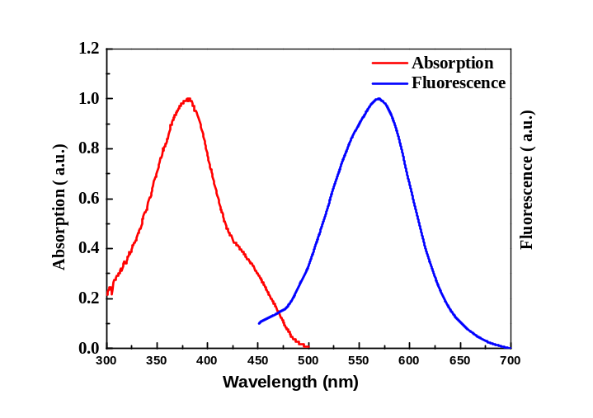
Fig. S6 The absorption and fluorescence spectra of 5 μM probe Cha-N₃ with 5 μM H₂S in DMSO-PBS buffer (4:1,v/v, pH 7.4).

5. The reaction of Cha-N₃ with H₂S.
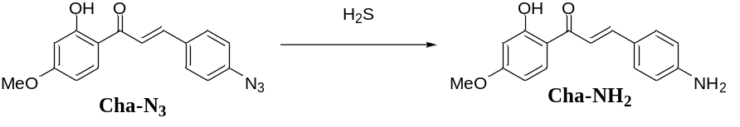
The solution of probe Cha-N₃ (5um, 25 uL of 1 mM stock solution) was added in the DMSO-PBS buffer (4:1,v/v, pH 7.4), then the H₂S solution (5 um, 25 uL of 1 mM stock solution ) was added in the buffer, the color turned to light orange. The reaction was kept at room temperature for 30 min. The mixture was examined with HRMS, a peak found at m/z 270.1121 (Fig. S6) was consistent with the calculated 270.1079, corresponding to Cha-NH₂.
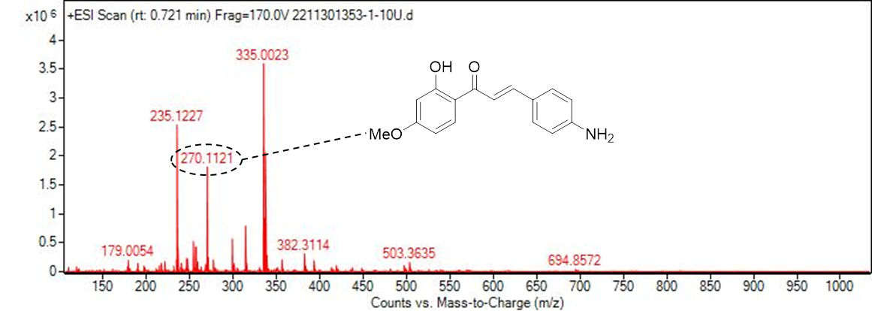
Fig. S7 HRMS spectrum of 5 μM probe Cha-N₃ with 10μM H₂S in DMSO-PBS buffer (4:1,v/v, pH 7.4)

6. The fluorescent probes for H₂S.
Table S2 Comparison of fluorescent probes for H₂S.

Probe structure |  | λ_{ex}/λ_{em}  (nm) | Solvent system | Stokes  shift  (nm) |  | Linear range  (μM) | Detection limit  (nM) | Fluorescence enhancement  (folds) | Ref.
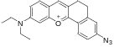 |  | 580/635 | DMSO:PBS  (1:39, v/v, pH 7.4) | 55 |  | 0-6 | 470 | 7 | 1
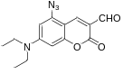 |  | 360/422 | MeCN:water  (3:7, v/v,  pH 7.0) | 62 |  | 0-150 | 3.5 | 217 | 2
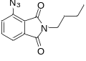 |  | 380/492 | PBS (1.0 mM CTAB, pH=7.4) | 112 |  | 0-40 | 13.6 | 196. | 3
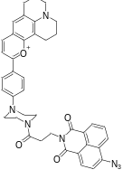 |  | 445/535 | DMF:PBS  (2.5:7.5, v/v  pH 7.4) | 85 |  | 5-100 | 201 | 7.3 | 4
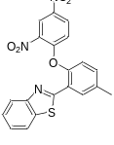 |  | 440/545 | MeCN：PBS (2.5:7.5, v/v, pH 7.4) | 105 |  | 0-12 | 48 | 120 | 5
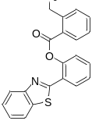 |  | 410/462 | DMSO:PBS  (3:7, v/v, pH 7.4) | 51 |  | 0-60 | 2210 | 400 | 6
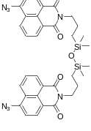 |  | 405/550 | EtOH：PBS  (1:9, v/v, pH 7.4) | 145 |  | 0-10 | 570 | / | 7
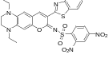 |  | 512/652 | DMF:HEPES (5:5, v/v,  pH 7.4). | 140 |  | 0-30 | 10 | 35 | 8
 |  | 485/610 | HEPES (1.0 mM CTAB, pH=7.4) | 125 |  | 0-20 | 5.7 | 10 | 9
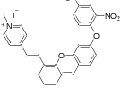 |  | 530/663 | DMSO:PBS  (1:9, v/v,  pH 7.4) | 133 |  | 0-11 | 19 | 27 | 10
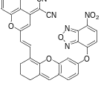 |  | 633/744 | THF:Tris,  (2:8, v/v  pH 7.4). | 111 |  | 0-25 | 26 | 40 | 11
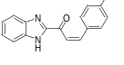 |  | 320/461 | PBS (pH 7.4) | 141 |  | 0-450 | / | / | 12
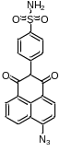 |  | 440/550 | PBS (pH 7.4) | 110 |  | 0-30 | 100 | / | 13
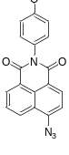 |  | 450/557 | PBS (pH 7.4) | 107 |  | 0-100 | 17.4 | / | 14
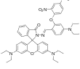 | 350/496 |  | DMSO:HEPES  (1:19, v/v  pH 7.2) |  | 146 | 0-1.25 | 8 | 11 | 15

References
1. C. Su, X. Liu, Synthesis of novel 4 (3H)-quinazolinones with 1, 2, 3-triazoles moiety conjugated by Schiff Base, Asian J. Chem, 2(2014) 5301-5304.
2. Espinal-Viguri, M.; Woof, C. R.; Webster, R. L. Chem. Eur. J. 22(2016) 11605-11608.
3. Palatinus, L.; Chapuis, G. J. Appl. Cryst. 40(2007) 786-790.
4. Sheldrick, G. M. Acta Cryst. (71)2015 3-8.
5. Dolomanov, O. V.; Bourhis, L. J.; Gildea, R. J.; Howard, J. A. K.; Puschmann, H. J. J. Appl. Cryst. (42)2009 339-341.
6. Spek, A. L. Acta Cryst. (65)2009 148-155.
7. K. Liu, C. Liu, H. Shang, M. Ren, W. Lin, A novel red light emissive two-photon fluorescent probe for hydrogen sulfide (H₂S) in nucleolus region and its application for H₂S detection in zebrafish and live mice, Sens. Actuators B-Chem. 256(2018) 342-350.
8. Q. Fang, H. Xiong, L. Yang, B. Wang, X. Song, An instantaneous fluorescent probe for detecting hydrogen sulfide in biological systems, New J. Chem. 43(2019) 13594-13599.
9. L. Yang, X. Liu, L. Gao, F. Qi, H. Tian, X. Song, A selective and sensitive phthalimide-based fluorescent probe for hydrogen sulfide with a large Stokes shift, RSC Adv. 5(2015) 98154-98159.
10. Y. Yang, L. He, K. Xu, W. Lin, A ratiometric fluorescent chemosensor for the convenient monitoring of hydrogen sulfide concentration by the dual fluorescence fluctuation mode of two distinct emission bands in living cells and zebrafish, New J. Chem. 43(2019) 10926-10931.
11. Z. Huang, S. Ding, D. Yu, F. Huang, G. Feng, Aldehyde group assisted thiolysis of dinitrophenyl ether: a new promising approach for efficient hydrogen sulfide probes, Chem. Comm. 50(2014) 9185-9187.
12. B. Deng, M. Ren, X. Kong, K. Zhou, W. Lin, An ESIPT based fluorescent probe for imaging hydrogen sulfide with a large turn-on fluorescence signal, RSC Adv. 6(2016) 62406-62410.
13. X. Wang, Y. Zuo, Y. Zhang, T. Yang, W. Lin, An ICT-based fluorescent probe with bridging Si-O-Si bonds for visualizing hydrogen sulfide in lipid droplets and its application, Anal. Methods-UK 12(2020) 1064-1069.
14. S. Feng, Q. Xia, G. Feng, Iminocoumarin-based red to near-infrared fluorescent turn-on probe with a large Stokes shift for imaging H₂S in living cells and animals, Dyes Pigm. 163(2019) 447-453.
15. L. Yang, Y. Su, Z. Sha, Y. Geng, F. Qi, X. Song, A red-emitting fluorescent probe for hydrogen sulfide in living cells with a large Stokes shift, Org. Biomol. Chem. 16(2018) 1150-1156.
16. S. Gong, Z. Zheng, X. Guan, S. Feng, G. Feng, Near-Infrared Mitochondria-Targetable Fluorescent Probe for High-Contrast Bioimaging of H(2)S, Anal. Chem. 93(2021) 5700-5708.
17. S. Gong, E. Zhou, J. Hong, G. Feng, Nitrobenzoxadiazole Ether-Based Near-Infrared Fluorescent Probe with Unexpected High Selectivity for H(2)S Imaging in Living Cells and Mice, Anal. Chem. 91(2019) 13136-13142.
18. J. Ding, Y. Ge, B. Zhu, A Highly Selective Fluorescent Probe for Quantitative Detection of Hydrogen Sulfide, Anal. Sci. 29(2013) 1171-1175.
19. H. Zhu, C. Liu, C. Liang, B. Tian, H. Zhang, X. Zhang, W. Sheng, Y. Yu, S. Huang, B. Zhu, A new phenylsulfonamide-based Golgi-targeting fluorescent probe for H₂S and its bioimaging applications in living cells and zebrafish, Chem. Comm. 56(2020 4086-4089.
20. Y. Zhang, L. Zhang, A novel “turn-on” fluorescent probe based on naphthalimide for monitoring H₂S levels in living cells and red wine, Microchem. J. 159(2020) 105394.
21. S. Muthusamy, K. Rajalakshmi, D. Zhu, L. Zhao, S. Wang, W. Zhu, A novel lysosome targeted fluorophore for H₂S sensing: Enhancing the quantitative detection with successive reaction sites, Sens. Actuators B-Chem. 320(2020) 128433.

