Table S1. Social-distancing levels by period (2020–2021).
Period | Week | Social distancing intensity* | Social distancing level
2020.01.20. | W4 | Weak | First imported COVID-19 case confirmed in South Korea  Alert level raised to yellow
2020.02.23. | W9 | Weak | Alert level raised to red
2020.02.29.~03.21 | W9~W12 | Weak | Social distancing¹⁾
2020.03.11. | W11 | Weak | WHO declared COVID-19 a pandemic
2020.03.22.~04.19 | W13~W16 | Moderate | Enhanced social distancing¹⁾
2020.04.20.~05.05 | W17~W18 | Weak | Relaxed social distancing¹⁾
2020.05.06.~08.18. | W19~W33 | Weak | Distancing in daily life¹⁾ and Level 1 social distancing²⁾
2020.08.19.~8.29. | W34~W35 | Moderate | Level 2 social distancing²⁾³⁾
2020.08.30.~9.13. | W36~W37 | Moderate | Level 2.5 social distancing
2020.09.14.~10.11. | W38~W41 | Moderate | Level 2 social distancing  * 9.28.~10.10.: Holiday special quarantine:
2020.10.12.~11.6. | W42~W45 | Weak | Level 1 social distancing
2020.11.07.~11.18. | W46~W47 | Weak | Level 1 social distancing⁴⁾
2020.11.19.~11.23. | W47~W48 | Strong | Level 1.5 social distancing (special quarantine for the national university entrance exam)
2020.11.24.~11.30. | W48~W49 | Very Strong | Level 2 social distancing
2020.12.01.~12.07. | W49 | Very strong | Level 2+a social distancing
2020.12.08.~21.02.14. | W50~W6 | Very strong | Level 2.5 social distancing  *Private gathering restricted
2021.02.15.~07.11 | W7~W27 | Strong | Level 2 social distancing
2021.07.12.~10.31. | W28~W43 | Very strong | Level 4 social distancing⁵⁾  *9.13.~9.26.: Holiday special quarantine
2021.11.01.~11.28. | W44~W47 | Weak | Step-by step daily recovery
2021.11.29.~12.31. | W48~W52 | Very strong | Special quarantine measure
¹⁾ Social distancing policy divided into three levels
²⁾ 2020.06.28: Social distancing policy reformed to three levels (Level 1, 2, and 3)
³⁾ Only metropolitan areas
⁴⁾ 2020.11.07: Social distancing altered to five levels (Levels 1, 1.5, 2, 2.5, and 3)
⁵⁾ 2021.07.12.: Social distancing altered to four levels (Levels 1, 2, 3, and 4)
* The social distancing intensity was classified into four levels by the researchers based on social distancing level

Table S2. Analysis of influenza epidemics based on clinical surveillance data.
Season | ILI baseline | Flu advisory  issued date (ILI) | Flu advisory  lifted date (ILI) | Duration of epidemic | Peak point (ILI)
 |  |  |  |  | 1st peak | 2nd peak
2013–2014 | 12.1 | 14.1.2. (15.3) | 14.5.1. (6.4) | 15 weeks | 64.3 (W7) | -
2014–2015 | 12.2 | 15.1.22. (14.0) | 15.5.21. (6.2) | 17 weeks | 45.5 (W8) | 35.6 (W12)
2015–2016 | 11.3 | 16.1.14. (12.3) | 16.5.27. (6.0) | 17 weeks | 53.8 (W7) | 32 (W14)
2016–2017 | 8.9 | 16.12.8. (13.5) | 17.6.2. (6.7) | 26 weeks | 86.2 (W52) | 16.7 (W14)
2017–2018 | 6.6 | 17.12.1. (7.7) | 18.5.25. (6.0) | 25 weeks | 72.1 (W1) | -
2018–2019 | 6.3 | 18.11.16. (7.8) | 19.6.21. (4.7) | 32 weeks | 73.3 (W52) | 44.2 (W16)
2019–2020 | 5.9 | 19.11.15. (7.0) | 20.3.27. (3.2) | 20 weeks | 49.8 (W52) | -
2020–2021 | 5.8 | not issued | - | - | - | -
2021–2022 | 5.8 | not issued | - | - | - | -
ILI, influenza-like illness

Table S3. Selected SARIMA models.
Variable | Selected model | AICc | MASE
ILI cases/1000 outpatient | ARIMA(2,0,2)(1,1,0)[52] | 1838.535 | 0.302
Influenza (all) positivity rate | ARIMA(2,0,3)(0,1,1)[52] | 1859.892 | 0.308
Influenza A positivity rate | ARIMA(2,0,1)(1,1,0)[52] | 1738.978 | 0.390
AICc, corrected Akaike’s Information Criterion; ILI, influenza-like illness

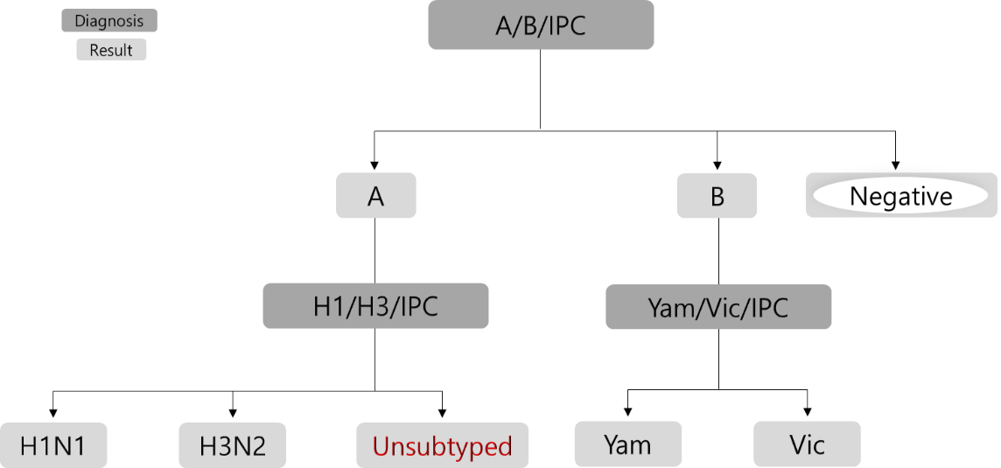

Figure S1. Genetic analysis of influenza viruses in the Korea Influenza and Respiratory Viruses Surveillance System.

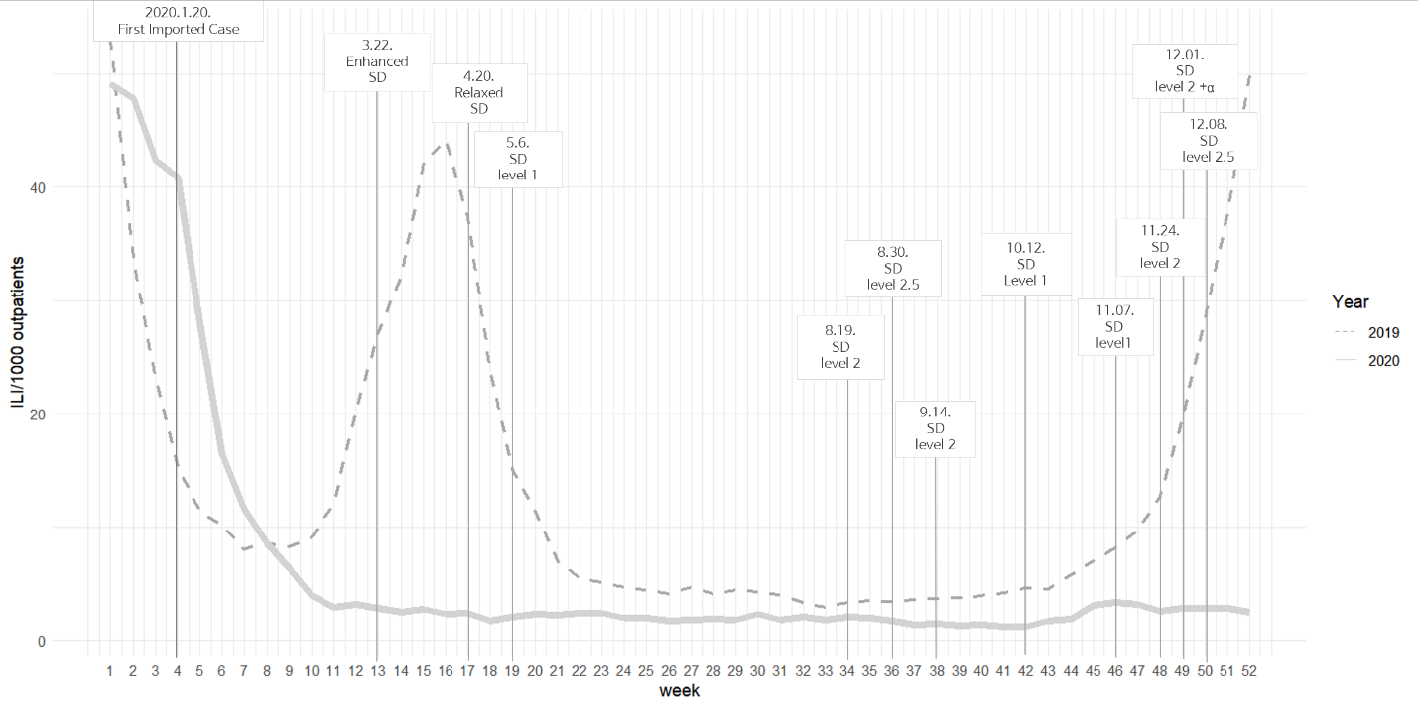
Figure S2. Influenza-like illness (ILI) rate and social-distancing (SD) level in South Korea.

a) | 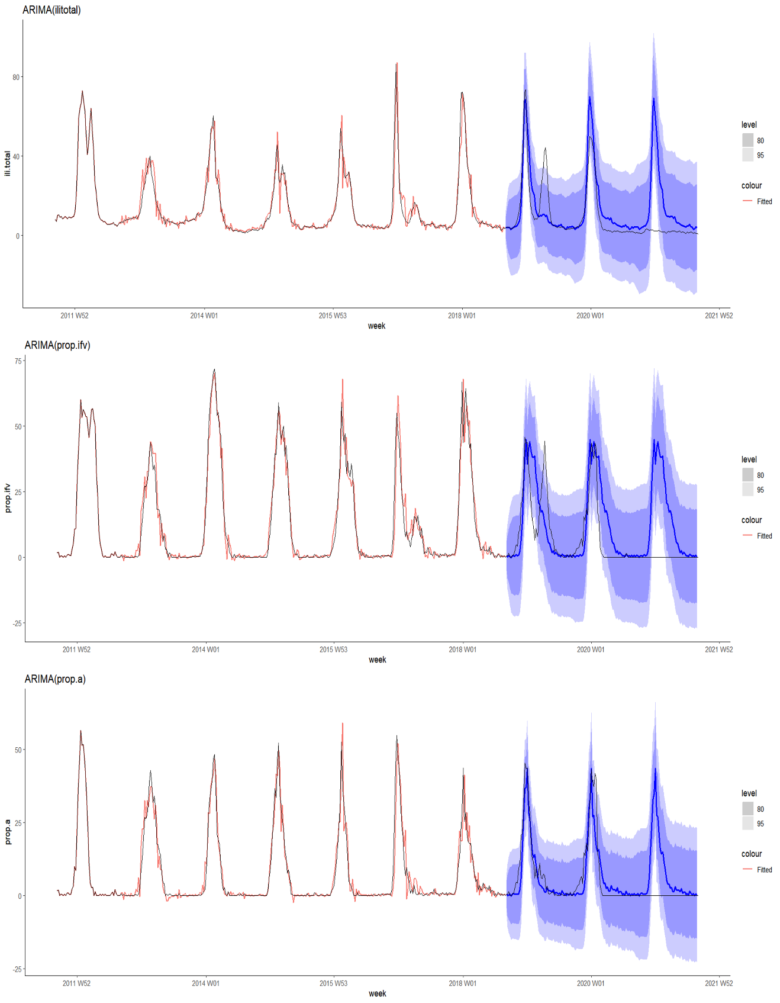
b)
c)
Figure S3. Fitting result of selected SARIMA model.
*Red line indicates fitted value, blue line indicates predicted and black line is observed
a)Forecast of ILI/1000 outpatients
b) Forecast of IFV positive rate
c) Forecast of IFV A positive rate

