One Produces Multi: A Drug-free Cardiovascular Stent Functionalized with Tailored Collagen Supports in-situ Healing of Vascular Tissues

Haoshuang Wu ^{a, #}, Li Yang ^{a, #}, Rifang Luo ª, Kaiyang Huang ª, Yumei Qin ª, Xia Yang ^{b}, Yunbing Wang*^{, a}, Xingdong Zhang ª

ª National Engineering Research Center for Biomaterials, Sichuan University, Chengdu 610065, China
^{b} Shanxi Key Laboratory of Functional Proteins, Shanxi Jinbo Bio-Pharmaceutical Co., Ltd., Taiyuan 030032, Shanxi, China
#: These authors contributed equally
*: Corresponding author
E-mail address: yunbing.wang@scu.edu.cn (Y. Wang).

Contents:
S1. Supporting Methods
Method S1. QCM-D test.
Method S2. Stability test.
Method S3. Ex vivo blood circulation thrombogenicity test.
Method S4. RNA extraction and high throughput RNA sequencing of ECs
Method S5. Differential expression analysis of circRNAs and mRNAs
Method S6. In vivo assessment of subcutaneous implantation.
Method S7. In vivo stent implantation.
S2. Supporting Figures
Figure S1. SEM of (rhCol III /PDA-PEI)_{n} coatings.
Figure S2. Fluorescent staining of the ECs and SMCs on uncoated- and (rhCol III /PDA-PEI)_{n} coated-PLA after incubation for 1 day and 3 days at 37 ℃.
Figure S3. (A) Fluorescent staining of the RAW 264.7 mouse macrophages on uncoated- and (rhCol III/PDA-PEI)_{n} coated-PLA after 1 day and 3 days incubation at 37 ℃. (B) Cell viability, and (C) Rate of increase of RAW 264.7 on the surface of different samples after 3 days of incubation.
Figure S4. (A) Cell viability of the ECs and (B) SMCs after co-incubation with 1640 media containing different concentrations of rhCol III (10, 50, 100, 500 μg/mL) for 1 and 3 days, respectively.
Figure S5. Cell number of the abdominal aorta implanted with control, RAPA, and (rhCol III /PDA-PEI)₂, respectively.

Method S1. QCM-D test
The PDA-PEI coating was deposited on gold-coated quartz crystals (AT-cut/5 MHz) as mentioned earlier, and then UP water was injected into the channel at the same speed of 50 μL/min to rinse the physically absorbed molecular on PDA-PEI coating until reaching the stabilization of the baseline. Then the MES buffer (as described above, containing rhCol III (0.5, 1, 2, and 4 mg/mL, respectively), EDC (0.05 M), and NHS (0.05 M)) was injected at the same speed for about 1 h. After that, the pH of the above-mentioned solution was adjusted from 5.4 to 7.4 and the reaction was continued for several hours. The adsorption and desorption of mass on the material/liquid interface leads to changes in the frequency (Δf). The Frequency-Time curve was recorded to monitor the growing behaviors of the (hCOLIII/PDA-PEI)_{n} coatings.
Method S2. Stability test
Briefly, the (rhCol III /PDA-PEI)₂-coated PLA stent was placed in the commercially bare tube (Ф5.3 mm × 130 mm) and was assembled into an elastic hose of the peristaltic pump for completing the circuit. The device provided a stable flow of blood serum about 20 mL/min and the blood serum changed every day. After 1 week and 2 weeks, the sample was taken out.
Method S3. Ex vivo blood circulation thrombogenicity test
Three adults New Zealand white rabbits (2.5–3 kg) were used in this experiment. The rabbits were under general anesthesia (25 mg/mL, 0.7 Ml per kg, AMRESCO) by injecting pentobarbital sodium through the ear vein. Then the right carotid artery and left external jugular vein of the rabbits were carefully separated and connected with the uncoated, PDA-PEI and (rhCol III /PDA-PEI)_{n}-coated PVC tubes to form a closed-loop circuit. After 2 hours of blood circulation, the samples were quickly taken out and washed carefully with PBS. The thrombus bound to the sample surfaces were collected, weighed, and photographed. The cross-section of the harvested tubes was photographed for analysis of the occlusion rates of the samples. As for the SEM analysis, the samples were fixed with 2.5% glutaraldehyde overnight. Then, the morphology of platelet on the surfaces of uncoated, PDA-PEI and (rhCol III /PDA-PEI)_{n} -coated PVC tubes were observed by SEM.
Method S4. RNA extraction and high throughput RNA sequencing of Ecs
The RNA sequencing was conducted in Illumina Hiseq 4000 by using the TruSeq SR Cluster Kit v3-cBot-HS (Illumina, Inc., USA). The whole process of RNA sequencing was carried out by Aksomics Biotech Co. Ltd (Shanghai, China). Solexa pipeline version 1.8 (off-line base caller software, version 1.8) was adopted to do image processing and base recognition; Ballgown analysis of R software was used to calculate expression difference between groups based on FPKM from genetic and transcriptional levels. CircRNA was mapped to the genome through STAR software. CIRCexplore2 was used to determine back splice junction reads and do read count statistics.
Method S5. Differential expression analysis of circRNAs and mRNAs
Differentially expressed circRNAs (DEcircRNAs) and mRNAs (DEmRNAs) were determined by the Ballgown package under the conditions of foldchange ≥2.0 and p value ≤0.05. Volcano maps were generated using the ggplot2 R package. Hierarchical bidirectional clustering analysis was performed to compare expression patterns of different genes and different samples by using the heatmap R package.
Method S6. In vivo assessment of subcutaneous implantation
Male Sprague Dawley rats (SD rats) weighing about 300 g were used for the assessment of subcutaneous implantation, and each group included 6 parallel samples at each time point. Briefly, SD rats were anesthetized by intraperitoneal injection with 10% chloral hydrate (0.003 ml/g), and then the skin of the SD rats was carefully separated from the tissue. After that, the samples were carefully placed in the subcutaneous. After 15 days and 30 days of implantation, the neointimal wrapped with the sample was harvested and fixed with 4% paraformaldehyde for 2 days. Parts of the neointimal tissue surrounding the samples were stained with hematoxylin and eosin (HE) for histological examination, and the remaining neointimal tissue was used for immunofluorescence staining of CD68 to analyze inflammatory response in vivo.
Method S7. In vivo stent implantation
Before the experiment, un-coated and (rhCol III /PDA-PEI)_{n}-coated PLA stents were sterilized with ethylene oxide at 37 °C for 12 h. Briefly, the rabbits were under general anesthesia (25 mg/mL, 0.7 mL per kg, AMRESCO) by injecting pentobarbital sodium through the ear vein. Then, the abdominal aortic vessels of the rabbits were isolated to give enough length for stent deployment (3 cm) to ensure the stents were delivered to the appropriate position by utilizing the guidewire. Subsequently, the balloon was inserted through the small wound and inflated to secure the stent into the aortic segment.
After 1 and 3 months of implantation, the stents encased in the neointimal tissue were harvested and fixed with 4% paraformaldehyde for 2 days. Parts of the neointimal tissue surrounding the stents were performed by hematoxylin and eosin (HE) staining and immunofluorescence staining of CD68, CD31, eNOS, and α-SMA. The remaining neointimal tissue was observed with SEM after dehydration, dealcoholized, and critical point dried. The intimal hyperplasia area and occlusion rate of the vascular lumen were determined with Image-J software. The expression levels of CD31, CD68, and α-SMA were calculated by Imagepro-plus software. The inflammation score of tissue around stents was measured by CD68 staining according to a previous study. The expression level of various proteins was measured in six locations. The endothelialization ratio and neointimal stenosis ratio were calculated according to the previously described. The detailed process of immunohistochemistry analysis has been reported elsewhere.

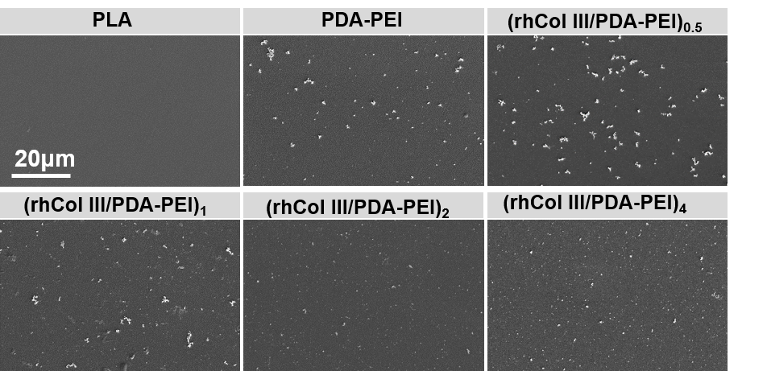
Figure S1. SEM of (rhCol III /PDA-PEI)_{n} coatings.
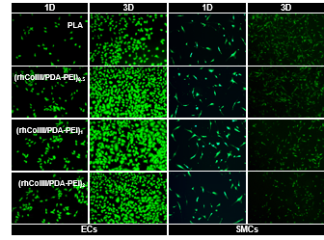
Figure S2. Fluorescent staining of the ECs and SMCs on uncoated- and (rhCol III /PDA-PEI)_{n} coated-PLA after incubation for 1 day and 3 days at 37 ℃.
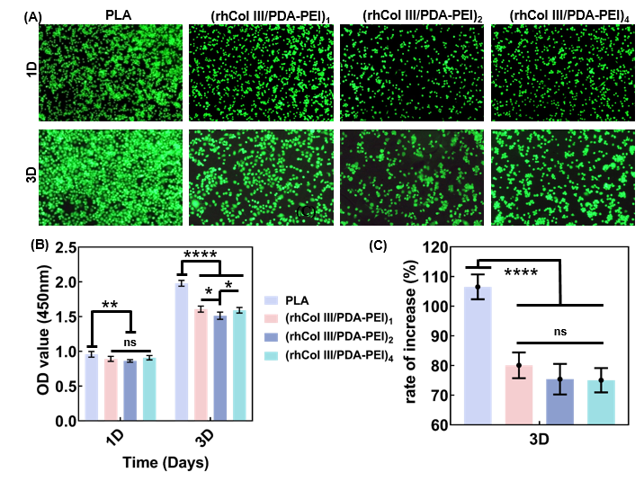
Figure S3. (A) Fluorescent staining of the RAW 264.7 mouse macrophages on uncoated- and (rhCol III/PDA-PEI)_{n} coated-PLA after 1 day and 3 days incubation at 37 ℃. (B) Cell viability, and (C) Rate of increase of RAW 264.7 on the surface of different samples after 3 days of incubation.
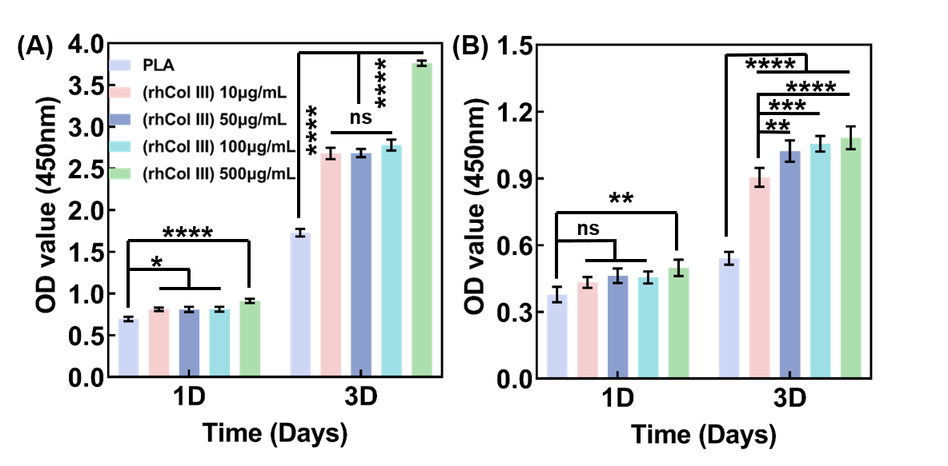
Figure S4. (A) Cell viability of the ECs and (B) SMCs after co-incubation with 1640 media containing different concentrations of rhCol III (10, 50, 100, 500 μg/mL) for 1 and 3 days, respectively.
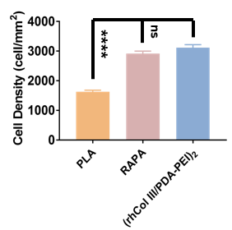
Figure S5. Cell number of the abdominal aorta implanted with control, RAPA, and (rhCol III /PDA-PEI)₂, respectively.

