Additional file 1

Figure S1. Example of generalization hierarchy of dataset 2
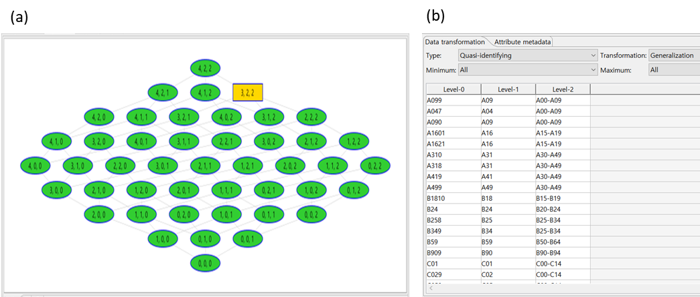

Figure S2. The ORs of the predictors from all 19 de-identified datasets
