Supplementary material

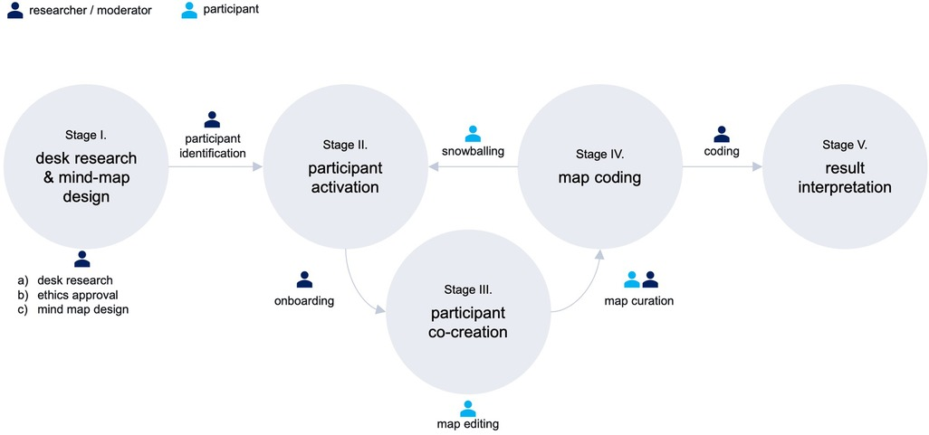
Supplementary figure 1: Final mind-map – Anonymized and color-coded by moderator. Originally published in (Landers et al. 2023b) under CC BY license.

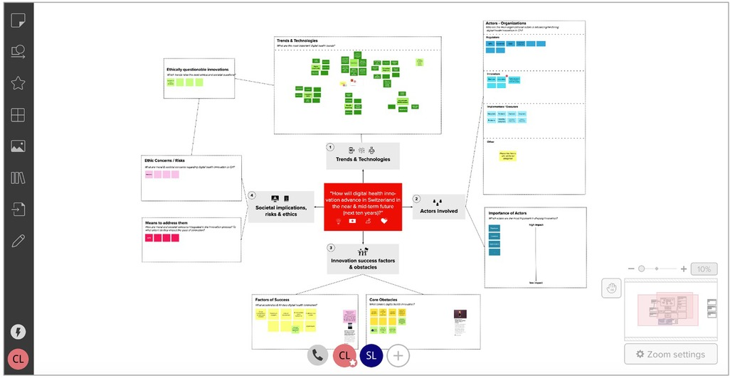
Supplementary figure 2: Final mind-map – Anonymized and color-coded by moderator. Originally published in (Landers et al. 2023b) under CC BY license.

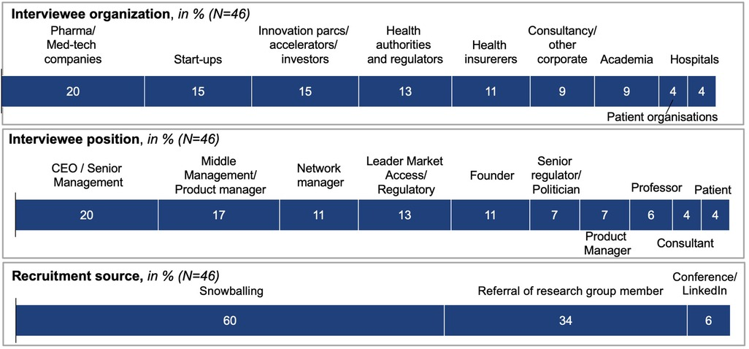
Supplementary figure 3: Final mind-map – Anonymized and color-coded by moderator. Originally published in (Landers et al. 2023b) under CC BY license.
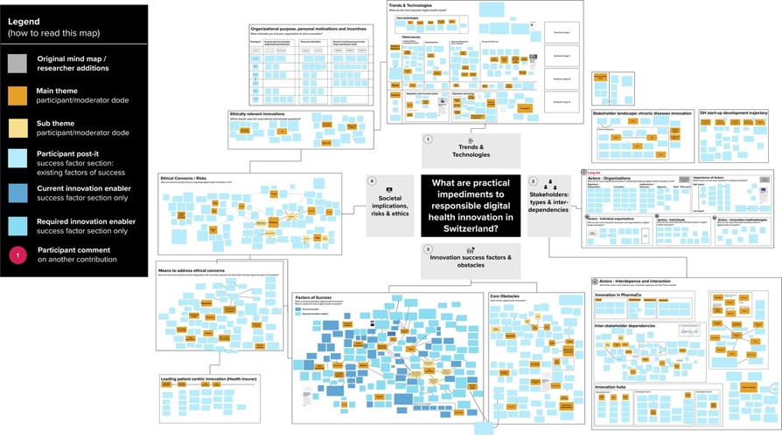
Supplementary figure 4: Final mind-map – Anonymized and color-coded by moderator. Originally published in (Landers et al. 2023b) under CC BY license.

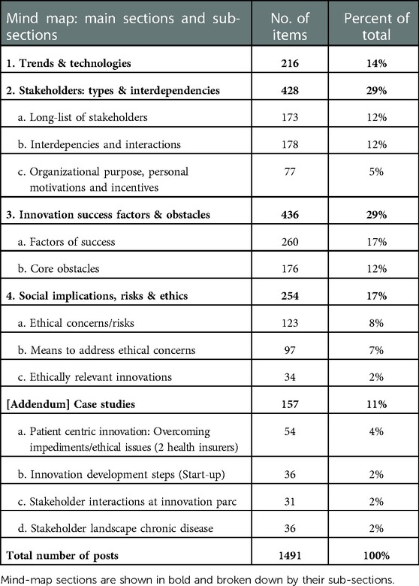
Supplementary table 1: Final mind-map – Anonymized and color-coded by moderator. Originally published in (Landers et al. 2023b) under CC BY license.
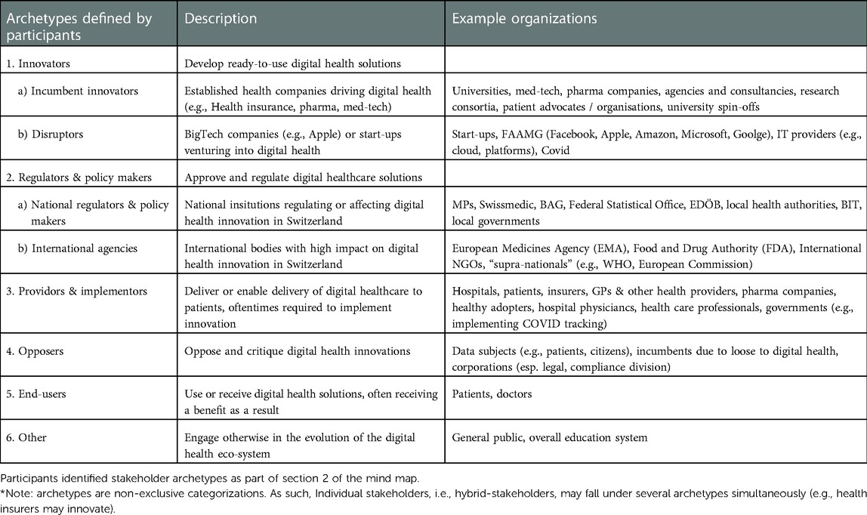

Supplementary table 2: Final mind-map – Anonymized and color-coded by moderator. Originally published in (Landers et al. 2023b) under CC BY license.

