CMIP6 Precipitation and temperature projections for Chile
Alvaro Salazar^{1,2}, Marcus Thatcher³, Katerina Goubanova⁴, Patricio Bernal⁵, Julio Gutiérrez^{1,2}, Francisco Squeo^{1,2}
¹Institute of Ecology and Biodiversity (IEB), Victoria 631, Barrio Universitario, Concepción, Chile
²Departamento de Biología, Facultad de Ciencias, Universidad de La Serena, Casilla 554, La Serena, Chile
³ CSIRO Oceans and Atmosphere, Aspendale, VIC 3195, Australia
⁴Centro de Estudios Avanzados en Zonas Áridas (CEAZA), La Serena, Chile
⁵CSIRO Chile Research Foundation, Santiago, Chile
Appendix
Table S1. Subregional summary of metrics used to validate CMIP6 models against the annual cycle of observations for the period 1986-2014. Precipitation (Pr) in MBE is in mm/day, while temperature (Tas) is in °C. For R and NRMSE values are dimensionless.
Model | Northern Chile |  |  |  |  |  | Central Chile |  |  |  |  |  | Northern Patagonia |  |  |  |  |  | Southern Patagonia
Model | Pr |  |  | Tas |  |  | Pr |  |  | Tas |  |  | Pr |  |  | Tas |  |  | Pr |  |  | Tas
Model | R | MBE | NRMSE | R | MBE | NRMSE | R | MBE | NRMSE | R | MBE | NRMSE | R | MBE | NRMSE | R | MBE | NRMSE | R | MBE | NRMSE | R | MBE | NRMSE
ACCESS-CM2 | 0.96 | 0.31 | 1.03 | 0.99 | 4.62 | 0.36 | 0.96 | 0.44 | 0.50 | 0.99 | 2.93 | 0.25 | 0.97 | 1.94 | 0.68 | 0.97 | 0.88 | 0.14 | 0.66 | 2.18 | 0.85 | 0.95 | 0.46 | 0.18
ACCESS-ESM1-5 | 0.99 | 0.89 | 2.98 | 0.99 | 4.39 | 0.35 | 0.93 | 0.78 | 0.64 | 0.98 | 3.30 | 0.29 | 0.92 | 2.09 | 0.75 | 0.95 | 2.50 | 0.30 | 0.54 | 2.27 | 0.89 | 0.94 | 1.95 | 0.34
AWI-CM-1-1-MR | 0.99 | 0.34 | 1.15 | 0.99 | 1.08 | 0.09 | 0.95 | 0.03 | 0.17 | 0.99 | 0.74 | 0.09 | 0.93 | 1.10 | 0.40 | 0.98 | -0.49 | 0.10 | 0.66 | 1.79 | 0.70 | 0.98 | -0.94 | 0.22
BCC-CSM2-MR | 0.96 | 1.27 | 4.27 | 0.98 | 3.31 | 0.26 | 0.91 | -0.24 | 0.30 | 0.99 | 3.00 | 0.26 | 0.91 | 0.39 | 0.19 | 0.96 | 1.43 | 0.21 | 0.06 | 1.15 | 0.47 | 0.93 | 0.95 | 0.30
CAMS-CSM1-0 | 0.98 | 0.88 | 3.05 | 0.96 | 2.26 | 0.19 | 0.96 | 0.07 | 0.17 | 0.99 | 1.37 | 0.12 | 0.82 | 0.57 | 0.33 | 0.97 | 0.66 | 0.12 | -0.14 | 1.29 | 0.53 | 0.95 | 0.79 | 0.20
CAS-ESM2-0 | 0.92 | 0.64 | 1.79 | 0.97 | 3.07 | 0.24 | 0.95 | 1.06 | 0.88 | 0.94 | 1.05 | 0.14 | 0.83 | 1.22 | 0.44 | 0.92 | 0.64 | 0.16 | 0.83 | 1.27 | 0.50 | 0.88 | 0.87 | 0.25
CESM2-WACCM | 0.99 | 0.51 | 2.00 | 0.99 | 2.22 | 0.18 | 0.91 | -0.15 | 0.27 | 0.99 | 1.84 | 0.17 | 0.96 | 0.74 | 0.33 | 0.98 | 0.40 | 0.13 | 0.23 | 2.11 | 0.84 | 0.98 | -0.12 | 0.16
CIESM | 0.98 | 0.54 | 1.91 | 0.98 | 3.71 | 0.30 | 0.96 | 0.39 | 0.49 | 0.98 | 3.05 | 0.27 | 0.97 | 1.06 | 0.46 | 0.97 | 1.49 | 0.19 | 0.48 | 1.40 | 0.56 | 0.96 | 0.93 | 0.21
CMCC-CM2-SR5 | 0.96 | 1.07 | 4.16 | 0.98 | 2.57 | 0.20 | 0.70 | 0.29 | 0.42 | 0.99 | 2.09 | 0.19 | 0.95 | 0.40 | 0.22 | 0.99 | 0.83 | 0.12 | 0.34 | 1.24 | 0.49 | 0.97 | 0.50 | 0.18
CMCC-ESM2 | 0.97 | 1.02 | 3.93 | 0.98 | 2.66 | 0.21 | 0.81 | 0.39 | 0.42 | 0.99 | 2.06 | 0.19 | 0.95 | 0.52 | 0.25 | 0.99 | 0.70 | 0.13 | 0.27 | 1.21 | 0.48 | 0.98 | 0.36 | 0.19
CanESM5 | 0.98 | 1.02 | 3.66 | 0.99 | 4.77 | 0.38 | 0.97 | -0.13 | 0.15 | 0.99 | 2.25 | 0.20 | 0.91 | 0.25 | 0.15 | 0.98 | -0.04 | 0.11 | 0.64 | 0.68 | 0.27 | 0.96 | 0.04 | 0.19
E3SM-1-1 | 0.96 | 0.70 | 2.76 | 0.95 | 2.57 | 0.21 | 0.97 | 0.23 | 0.22 | 0.97 | 2.54 | 0.23 | 0.92 | 1.31 | 0.45 | 0.95 | 1.36 | 0.20 | 0.52 | 1.75 | 0.69 | 0.94 | 1.34 | 0.28
EC-Earth3-AerChem | 0.97 | 0.45 | 1.65 | 0.97 | 1.84 | 0.15 | 0.92 | 0.60 | 0.50 | 0.96 | 1.92 | 0.18 | 0.95 | 1.36 | 0.48 | 0.97 | 1.94 | 0.23 | 0.60 | 1.83 | 0.72 | 0.96 | 1.93 | 0.32
EC-Earth3-CC | 0.98 | 0.51 | 1.87 | 0.96 | 2.65 | 0.21 | 0.93 | 0.66 | 0.54 | 0.96 | 2.56 | 0.23 | 0.97 | 1.27 | 0.44 | 0.97 | 2.54 | 0.29 | 0.54 | 1.71 | 0.68 | 0.96 | 2.48 | 0.40
EC-Earth3-Veg-LR | 0.97 | 0.50 | 1.84 | 0.95 | 2.28 | 0.19 | 0.94 | 0.76 | 0.63 | 0.94 | 2.38 | 0.22 | 0.95 | 1.48 | 0.53 | 0.95 | 2.22 | 0.27 | 0.41 | 1.70 | 0.68 | 0.96 | 2.13 | 0.35
EC-Earth3-Veg | 0.97 | 0.51 | 1.84 | 0.97 | 2.25 | 0.18 | 0.93 | 0.61 | 0.51 | 0.96 | 2.20 | 0.20 | 0.97 | 1.29 | 0.46 | 0.97 | 2.18 | 0.26 | 0.57 | 1.70 | 0.68 | 0.96 | 2.05 | 0.34
EC-Earth3 | 0.98 | 0.50 | 1.81 | 0.97 | 2.35 | 0.19 | 0.92 | 0.59 | 0.50 | 0.96 | 2.31 | 0.21 | 0.96 | 1.32 | 0.46 | 0.97 | 2.23 | 0.26 | 0.46 | 1.84 | 0.73 | 0.96 | 2.08 | 0.34
FGOALS-f3-L | 0.98 | 0.40 | 1.15 | 0.97 | 1.21 | 0.11 | 0.98 | 0.79 | 0.72 | 0.96 | 1.22 | 0.13 | 0.94 | 1.39 | 0.47 | 0.96 | 0.49 | 0.12 | 0.89 | 1.35 | 0.53 | 0.94 | 0.41 | 0.17
FGOALS-g3 | 0.95 | 1.33 | 4.36 | 0.99 | 1.32 | 0.12 | 0.97 | 1.03 | 0.79 | 0.97 | 0.98 | 0.12 | 0.98 | 0.76 | 0.26 | 0.96 | 0.62 | 0.14 | 0.71 | 0.85 | 0.34 | 0.95 | 0.14 | 0.16
FIO-ESM-2-0 | 0.97 | 0.99 | 3.69 | 0.99 | 2.96 | 0.24 | 0.93 | 0.70 | 0.60 | 0.99 | 2.44 | 0.22 | 0.96 | 0.79 | 0.35 | 0.98 | 1.32 | 0.18 | 0.64 | 1.41 | 0.55 | 0.97 | 0.65 | 0.18
GFDL-CM4 | 0.98 | 0.54 | 2.09 | 0.98 | 0.77 | 0.07 | 0.97 | 0.51 | 0.41 | 0.98 | 0.47 | 0.08 | 0.97 | 1.49 | 0.50 | 0.99 | -0.39 | 0.11 | 0.59 | 1.33 | 0.52 | 0.98 | -0.68 | 0.18
GFDL-ESM4 | 0.98 | 0.59 | 2.25 | 0.97 | 1.66 | 0.14 | 0.97 | 0.51 | 0.45 | 0.97 | 1.35 | 0.14 | 0.95 | 1.51 | 0.52 | 0.97 | 0.39 | 0.11 | 0.60 | 1.58 | 0.62 | 0.97 | -0.09 | 0.14
IITM-ESM | 0.95 | 0.69 | 2.29 | 0.94 | 3.06 | 0.25 | 0.97 | 0.80 | 0.78 | 0.95 | 3.60 | 0.32 | 0.99 | 2.15 | 0.72 | 0.94 | 2.51 | 0.30 | 0.54 | 2.27 | 0.89 | 0.91 | 2.18 | 0.38
INM-CM4-8 | 0.96 | 0.70 | 2.52 | 0.98 | 2.82 | 0.22 | 0.99 | 0.21 | 0.19 | 0.98 | 1.86 | 0.16 | 0.95 | 0.69 | 0.37 | 0.99 | 1.31 | 0.16 | 0.27 | 0.99 | 0.42 | 0.98 | 1.37 | 0.24
INM-CM5-0 | 0.98 | 0.92 | 3.32 | 0.99 | 2.84 | 0.22 | 0.97 | 0.43 | 0.42 | 0.99 | 2.03 | 0.18 | 0.97 | 1.03 | 0.42 | 0.99 | 1.35 | 0.18 | 0.15 | 1.31 | 0.53 | 0.99 | 1.86 | 0.31
IPSL-CM5A2-INCA | 0.96 | 0.43 | 1.44 | 0.96 | 1.78 | 0.15 | 0.97 | 0.36 | 0.29 | 0.94 | 0.85 | 0.12 | 0.94 | 1.40 | 0.47 | 0.96 | -0.54 | 0.13 | 0.75 | 1.38 | 0.55 | 0.97 | -1.25 | 0.24
IPSL-CM6A-LR | 0.99 | 0.48 | 1.74 | 0.95 | 0.11 | 0.06 | 0.96 | 1.29 | 1.04 | 0.96 | 0.16 | 0.09 | 0.97 | 2.05 | 0.69 | 0.97 | -0.44 | 0.10 | 0.65 | 1.99 | 0.79 | 0.96 | -0.54 | 0.16
KACE-1-0-G | 0.91 | 0.33 | 1.07 | 0.98 | 5.09 | 0.40 | 0.98 | 0.26 | 0.36 | 0.99 | 3.03 | 0.26 | 0.97 | 1.84 | 0.63 | 0.98 | 1.38 | 0.18 | 0.40 | 2.21 | 0.86 | 0.96 | 0.82 | 0.20
MIROC6 | 0.98 | 0.78 | 2.88 | 1.00 | 5.06 | 0.40 | 0.98 | 0.84 | 0.80 | 1.00 | 4.68 | 0.39 | 0.95 | 2.05 | 0.75 | 0.99 | 2.53 | 0.29 | 0.82 | 1.97 | 0.77 | 1.00 | 2.62 | 0.41
MPI-ESM1-2-HR | 0.99 | 0.33 | 1.04 | 0.97 | 2.07 | 0.17 | 0.99 | 0.37 | 0.31 | 0.98 | 1.19 | 0.12 | 0.94 | 1.55 | 0.54 | 0.98 | -0.32 | 0.11 | 0.60 | 1.71 | 0.67 | 0.98 | -0.75 | 0.17
MPI-ESM1-2-LR | 0.98 | 0.53 | 1.94 | 0.99 | 1.57 | 0.14 | 0.95 | 0.12 | 0.24 | 0.98 | 1.55 | 0.15 | 0.87 | 1.73 | 0.60 | 0.96 | -0.36 | 0.14 | 0.59 | 1.93 | 0.75 | 0.98 | -0.51 | 0.17
MRI-ESM2-0 | 0.98 | 1.02 | 3.26 | 0.96 | 2.50 | 0.20 | 0.97 | 1.36 | 1.11 | 0.97 | 1.38 | 0.15 | 0.95 | 2.31 | 0.76 | 0.97 | 0.24 | 0.16 | 0.52 | 1.85 | 0.73 | 0.98 | -0.07 | 0.17
NESM3 | 0.95 | 0.81 | 3.09 | 0.93 | 2.58 | 0.21 | 0.92 | 0.08 | 0.25 | 0.96 | 2.10 | 0.20 | 0.82 | 1.24 | 0.55 | 0.92 | 0.17 | 0.15 | -0.43 | 1.65 | 0.68 | 0.94 | -0.13 | 0.18
NorESM2-LM | 0.95 | 0.77 | 2.61 | 0.98 | 6.00 | 0.47 | 0.98 | 0.24 | 0.31 | 0.97 | 4.88 | 0.42 | 0.95 | 0.74 | 0.30 | 0.98 | 2.00 | 0.24 | 0.71 | 1.47 | 0.57 | 0.99 | 1.23 | 0.23
NorESM2-MM | 0.97 | 0.51 | 1.93 | 0.98 | 2.57 | 0.21 | 0.96 | 0.07 | 0.16 | 0.98 | 2.52 | 0.22 | 0.95 | 0.67 | 0.28 | 0.99 | 0.80 | 0.14 | 0.51 | 1.67 | 0.65 | 1.00 | 0.28 | 0.15
TaiESM1 | 0.96 | 0.95 | 3.52 | 0.98 | 2.26 | 0.18 | 0.90 | 0.66 | 0.59 | 0.98 | 2.10 | 0.19 | 0.98 | 1.07 | 0.42 | 0.96 | 0.99 | 0.16 | 0.49 | 1.51 | 0.59 | 0.97 | 0.54 | 0.17

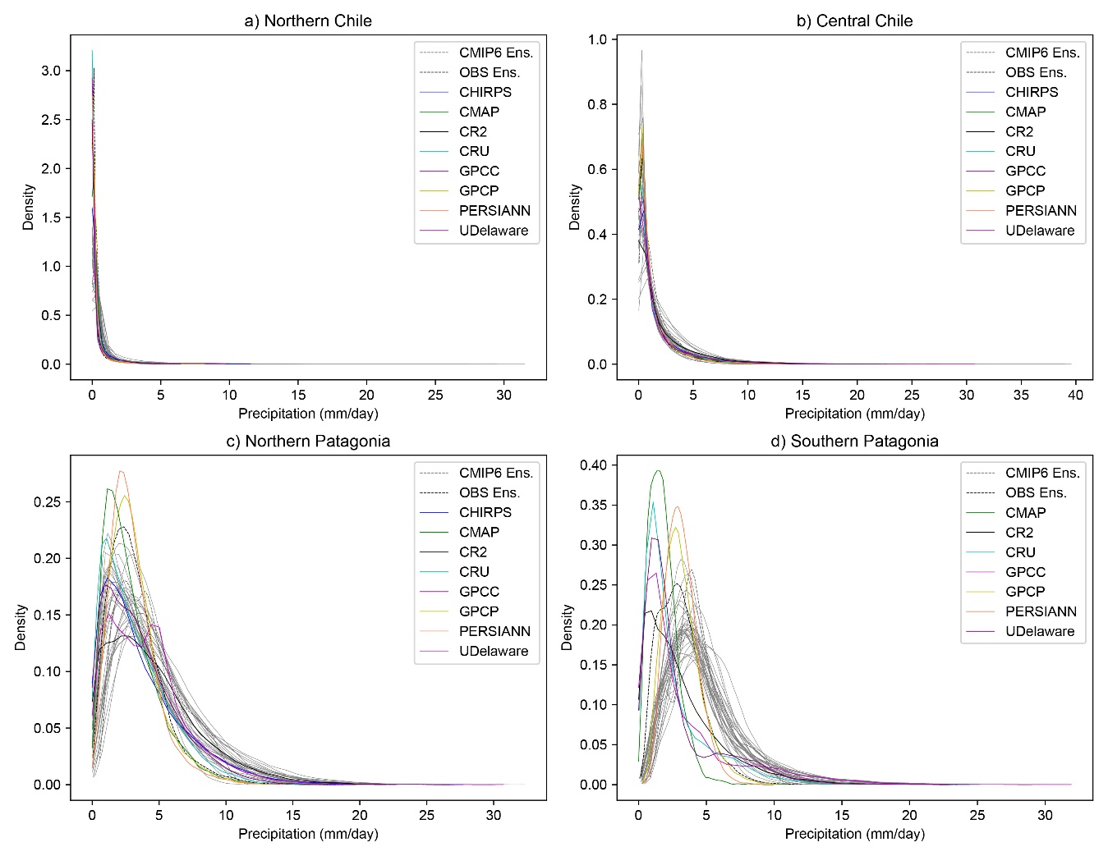
Figure A1. Probability density functions (PDFs) of monthly precipitation for specific intensity ranges over a set of subregions of Chile. To construct the PDFs in each subregion, we separated all monthly precipitation over each latitude and longitude grid cell using 50 bins. GCMs are plotted in grey lines.
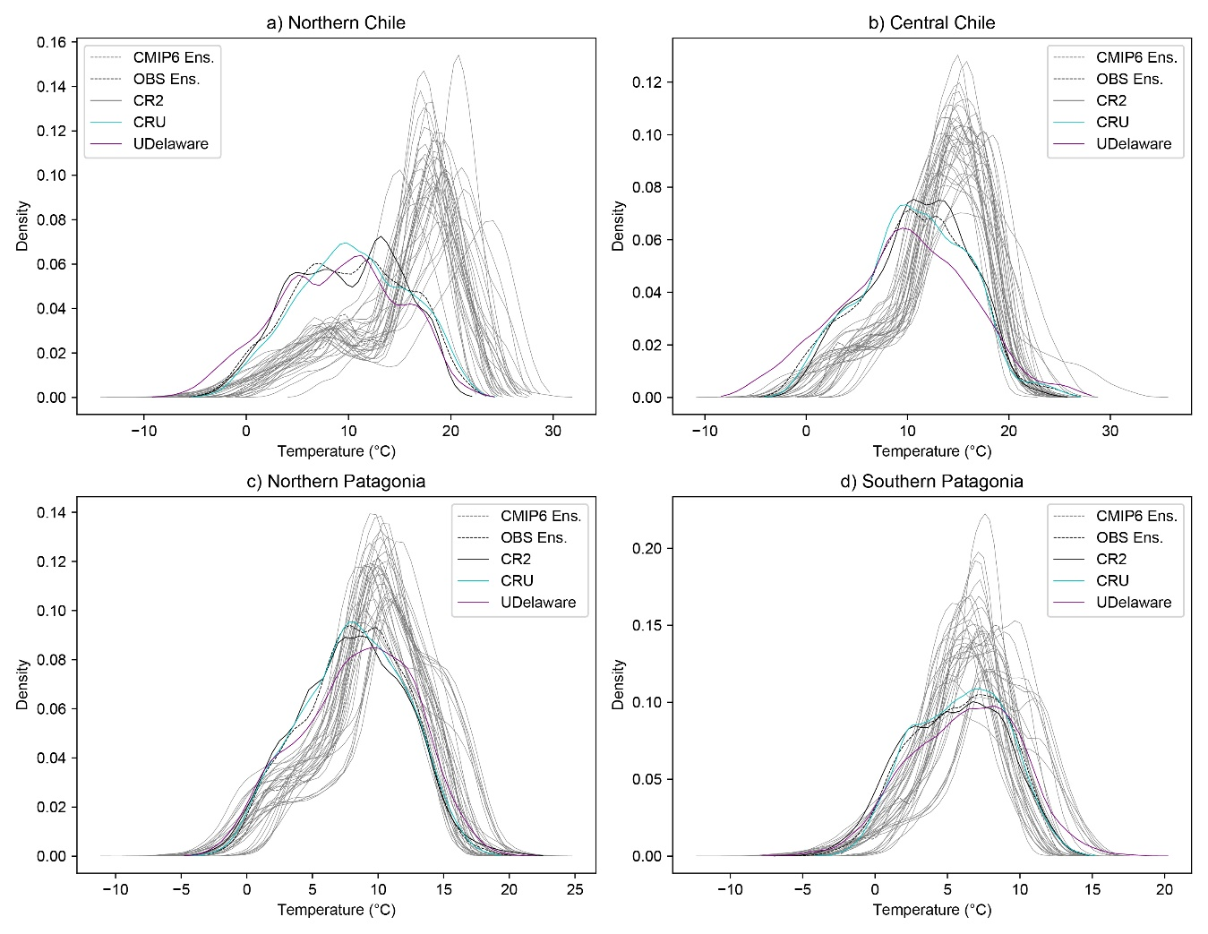
Figure A2. Probability density functions (PDFs) of monthly temperature for specific ranges over a set of subregions of Chile. To construct the PDFs in each subregion, we separated all monthly precipitation over each latitude and longitude grid cell using 50 bins. GCMs are plotted in grey lines.

