Supplemental Figures
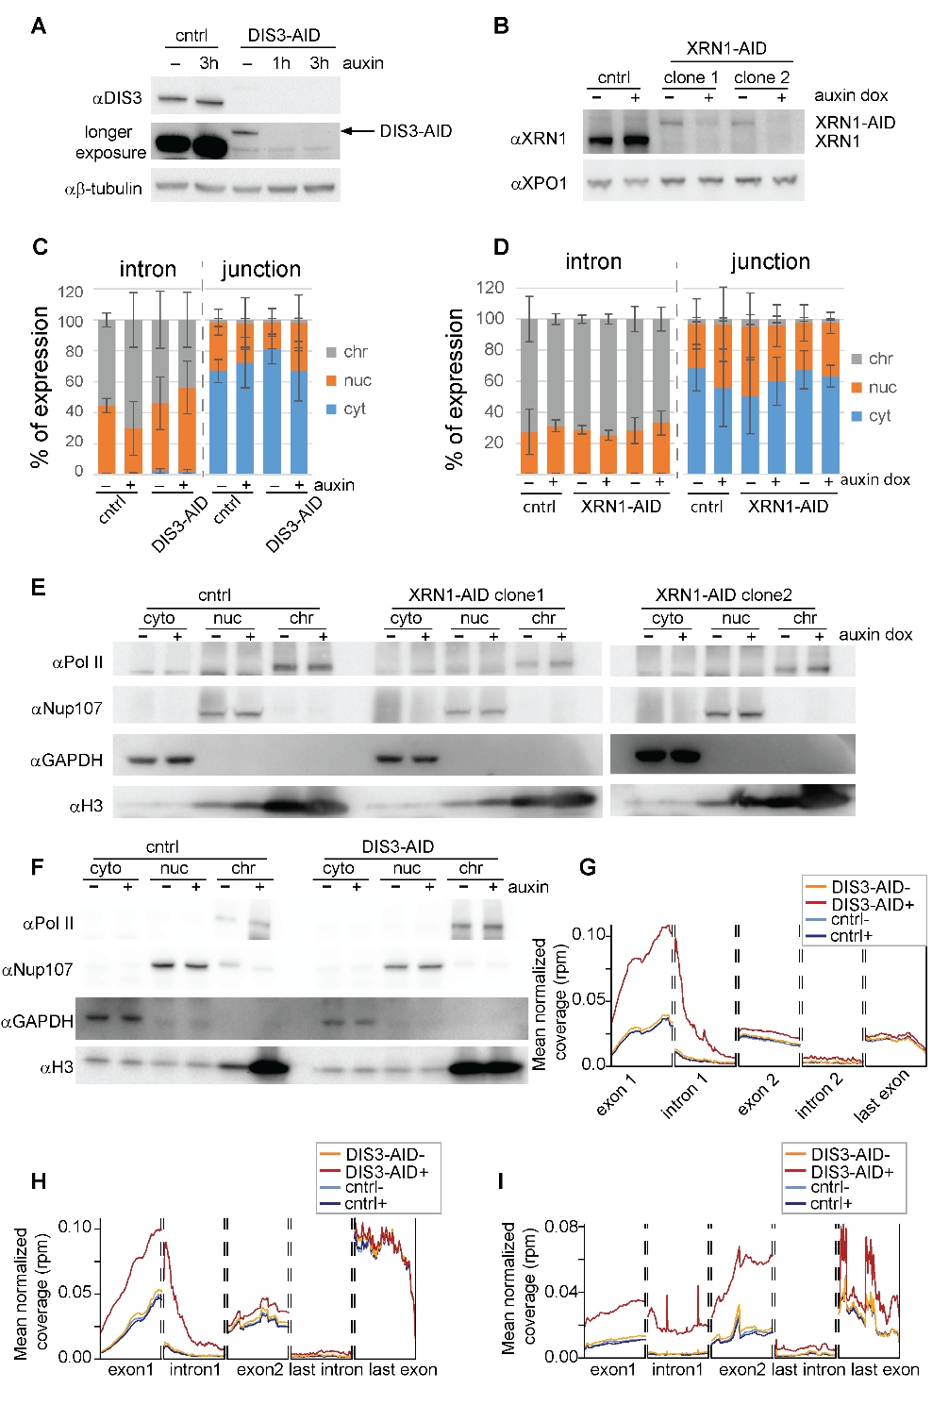
Figure S1. Quality control and data analyses workflow for CYTO-seq. A) Western blot of DIS3 in total protein extracts of DIS3-AID cells treated (+) or not (-) with auxin, β-tubulin is used as a loading control. B) Western blot of XRN1 in total protein extracts of XRN1-AID cells treated (+) or not (-) with auxin and doxycycline for 24h, XPO1 is used as a loading control. C) and D) qPCR quantification of the GAPDH intron and exon-exon junction distribution in % between cellular fractions. Mean and standard deviation correspond to technical triplicates of the experiment. For DIS3-AID and XRN1-AID respectively. E) and F) Western blot of Pol II histone H3, Nup107 and GAPDH in cytoplasm (cyto), nucleoplasm (nuc) and chromatin (chr) fractions of a control (cntrl) and XRN1-AID cells treated (+) or not (-) with auxin and doxycylin and DIS3-AID cells treated (+) or not (-) with auxin. G) and H) Metagene profiling of the genes that were classified as premature transcripts based on upregulation of the first intron and exon in DIS3-AID cells after auxin treatment for lncRNA (n=380) (D) and PCG (n=240) (E). I) Metagene profiling of 200 PCGs containing at least 2 introns.
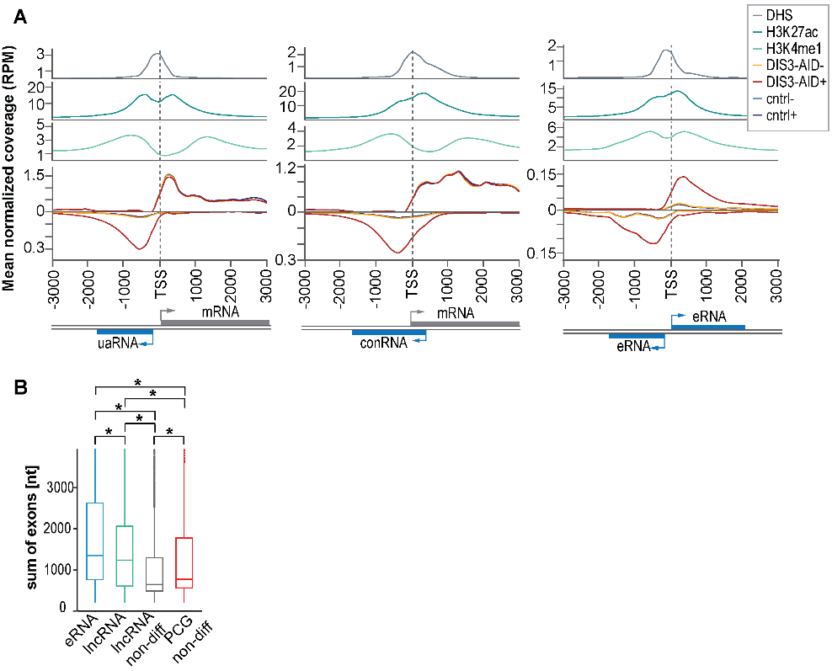
Figure S2. Cytoplasmic and nuclear DISTs share multiple features. A) Metagene profiling of RNA-seq reads for bidirectional cytoplasmic DISTs transcripts: upstream antisense (ua) RNAs (n=667), convergent (con) RNAs (n=497) and bidirectional enhancer (e) RNAs (n=517), together with ChIP-seq of histone marks H3K27ac and H3K4me1 and DNase I hypersensitive site (DHS) characteristic of open chromatin regions. B) Box plot of the processed transcripts length of upregulated DISTs: eRNAs (n= 3025), lncRNAs (n=2137) and non-differentially expressed (non-diff) lncRNAs (n=7748) and PCGs (n=2850). *P-value p<0.001 (two tailed t-test).
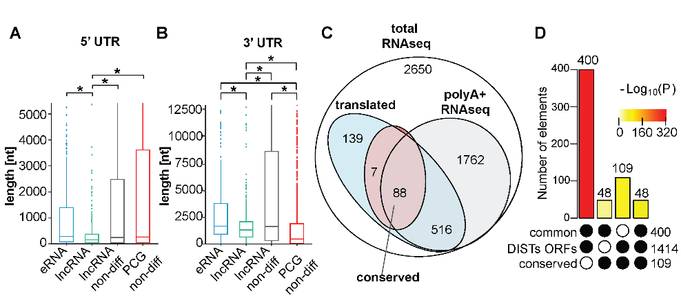
Figure S3. UTRs lengths do not distinguish DISTs from other translated lncRNAs and the polyadenylation is not prerequisite of DISTs translation. A) and B) Box plots of the 5’UTR and 3’UTR length of DIST-ORFs detected by Ribo-seq as actively translated including eRNA (n=381) and lncRNAs (n=369) and non-differential lncRNA (n=982) and PCGs (n=1599) that were also detected to be bound to ribosomes. *P-value < 0.001 (two-tailed t-test). C) Venn diagram of the overlap for 5162 upregulated DISTs detected by total and polyA⁺ RNA-seq (at least 20 counts), potentially translated and conserved. D) Results of super exact test for overlap between DISTs-ORFs, the conserved DISTs-ORFs (conserved) and ORFs detected as translated in at least one other condition in which DIS3 is present in the cell (common).
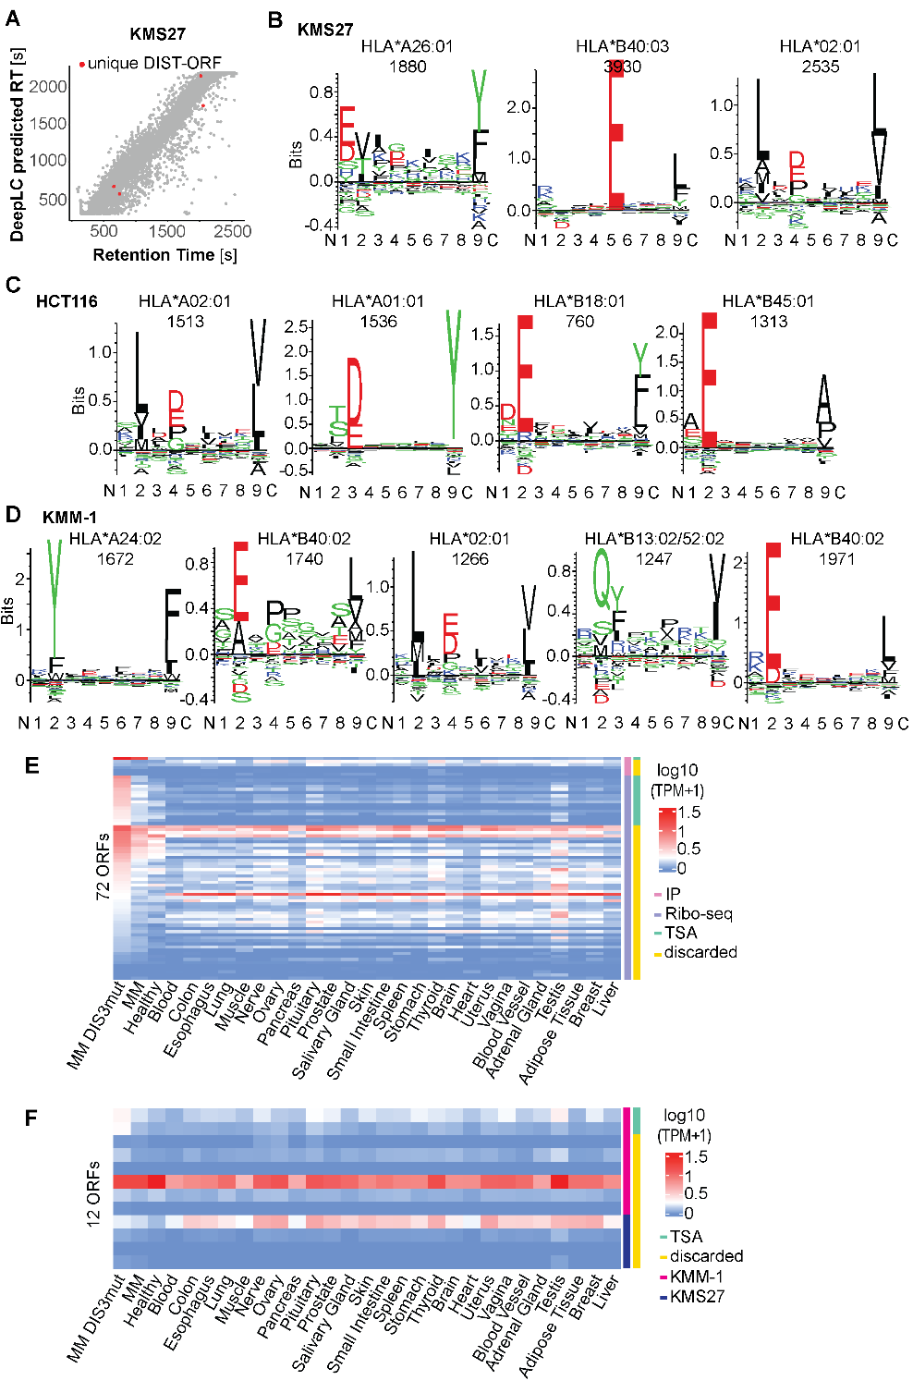
Figure S4. Peptides from HLA immunopeptidomic identify high confident DIST-ORFs peptide that some are classified as potential TSAs. A) Dot plot correlation between retention times (RT) predicted by DeelLC⁷⁶ (y-axis) and observed RT by MS (x-axis), canonical ORFs (grey), unique (red) and multiple (black) for KMS27 cell line. B), C) and D) Results from Gibbs Clustering ⁷⁹ showing the number of clusters with a highest score and amino acid binding motifs for KMS27, DIS3-AID and KMM-1 respectively. The most relevant HLA allele is indicated above each motif with the number of assigned peptides for each cluster. E) and F) Heatmaps of expression in log10 (TPM+1) of ORFs candidates between the GTEx dataset and the MM cohort. E) Pink and violet colours indicate ORFs sub selected based on the immunopeptidomics and Ribo-seq experiments, respectively. F) Dark pink and dark blue indicate ORF for which a peptide was detected in immunopeptidomic of KMM-1 and KMS27 respectively. E) and F) ORFs whose expression is specific to MM-TSAs with TPM<1 in all other tissues, are marked in green.
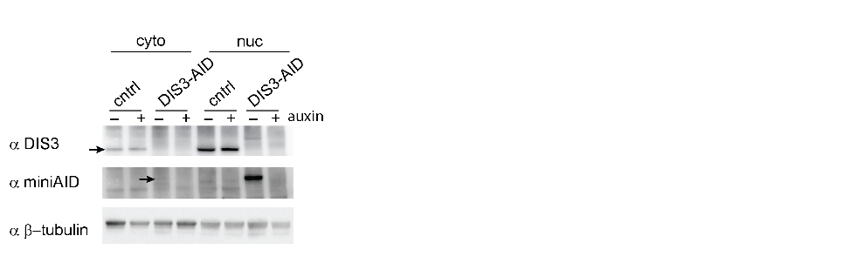
Figure S5. DIS3 is present in the cytoplasm. Western blot showing the presence of some DIS3-AID protein in the cytoplasmic fraction.
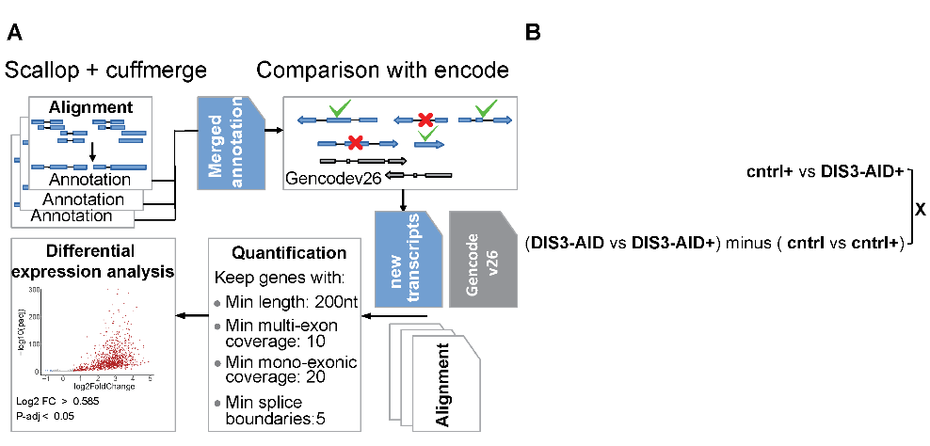
Figure S6. Schemes for bioinformatic analysis. A) Workflow for Scallop analysis of unreferenced transcripts. B) A scheme presenting an example of recursive intersection where only common differentially expressed genes between the DIS3-AID after and before treatment and in comparison, to control, that are not differential in the comparison of control against control after treatment are taken for final analysis. “+” represents conditions with addition of auxin.

Supplementary tables:
Table S4 . Structure impact prediction for DIS3 mutations in MM
PDB CODE | PDB CHAIN | AA CHANGE | Amino acid (AA) position on Q9Y2L1 | DOMAIN | Structural damage detected (Missense 3D)
6d6q | K | E/K | 22 | N-terminal region | YES
6d6q | K | P/L | 63 | Close to PIN | YES
6d6q | K | N/T | 71 | PIN domain | NO
6d6q | K | V/L | 88 | PIN domain | YES
6d6q | K | M/NX, | 163 | PIN domain | truncated protein
6d6q | K | E/K | 196 | Close to PIN domain | NO
6d6q | K | A/D | 293 | Rrp44 domain | YES
6d6q | K | P/L | 375 | Dis3 domain | NO
6d6q | K | A/V | 401 | Dis3 domain | NO
6d6q | K | P/L | 412 | Dis3 domain | YES
6d6q | K | D/G | 479 | RNB domain | YES
6d6q | K | D/H | 479 | RNB domain | YES
6d6q | K | D/E | 479 | RNB domain | NO
6d6q | K | D/A | 479 | RNB domain | YES
6d6q | K | C/W | 483 | RNB domain | YES
6d6q | K | D/N | 488 | RNB domain | NO
6d6q | K | R/T | 526 | RNB domain | YES
6d6q | K | K/E | 579 | RNB domain | NO
6d6q | K | L/Q | 632 | RNB domain | NO
6d6q | K | E/K | 665 | RNB domain | YES
5jea | J | F/L | 775 | RNB domain | NO
5jea | J | R/T | 780 | RNB domain | YES
5jea | J | R/K | 780 | RNB domain | YES
5jea | J | D/E | 784 | RNB domain | YES
5jea | J | R/W | 789 | RNB domain | YES
2vnu | D | L/R | 817 | Close to RNB domain | YES
2vnu | D | H/P | 821 | Close to RNB domain | YES
6d6q | K | F/L | 840 | Close to S1 domain | NO
6d6q | G | G/E | 871 | Rrp44 S1 from Pfam | NA

Table S5 Unique read counts for each sample for RNA-seq and Ribo-seq experiments
 | sample | unique mapped reads number
Cyto-seq DIS3 total | cyt_ctrl_1 | 112,986,522.00
Cyto-seq DIS3 total | cyt_ctrl_2 | 95,068,056.00
Cyto-seq DIS3 total | cyt_ctrl_3 | 76,906,910.00
Cyto-seq DIS3 total | cyt_ctrl_A_1 | 106,745,736.00
Cyto-seq DIS3 total | cyt_ctrl_A_2 | 86,177,470.00
Cyto-seq DIS3 total | cyt_ctrl_A_3 | 75,127,245.00
Cyto-seq DIS3 total | cyt_Dis3_1 | 81,556,973.00
Cyto-seq DIS3 total | cyt_Dis3_2 | 77,609,375.00
Cyto-seq DIS3 total | cyt_Dis3_3 | 69,826,347.00
Cyto-seq DIS3 total | cyt_Dis3_A_1 | 90,698,927.00
Cyto-seq DIS3 total | cyt_Dis3_A_2 | 55,660,686.00
Cyto-seq DIS3 total | cyt_Dis3_A_3 | 71,233,202.00
Cyto-seq XRN1 total | cyt_wt_1 | 60,120,354
Cyto-seq XRN1 total | cyt_wt_2 | 68,952,246
Cyto-seq XRN1 total | cyt_wt_3 | 64,983,411
Cyto-seq XRN1 total | cyt_clone1_1 | 74,706,808
Cyto-seq XRN1 total | cyt_clone1_2 | 85,259,603
Cyto-seq XRN1 total | cyt_clone1_3 | 70,253,596
Cyto-seq XRN1 total | cyt_clone2_1 | 78,469,330
Cyto-seq XRN1 total | cyt_clone2_2 | 82,955,303
Cyto-seq XRN1 total | cyt_clone2_3 | 56,966,776
Cyto-seq XRN1 total | cyt_wt_ad_1 | 54,105,974
Cyto-seq XRN1 total | cyt_wt_ad_2 | 56,383,684
Cyto-seq XRN1 total | cyt_wt_ad_3 | 56,358,076
Cyto-seq XRN1 total | cyt_clone1_ad_1 | 76,132,633
Cyto-seq XRN1 total | cyt_clone1_ad_2 | 65,434,415
Cyto-seq XRN1 total | cyt_clone1_ad_3 | 79,398,389
Cyto-seq XRN1 total | cyt_clone2_ad_1 | 65,032,352
Cyto-seq XRN1 total | cyt_clone2_ad_2 | 83,296,664
Cyto-seq XRN1 total | cyt_clone2_ad_3 | 83,373,978
Cyto-seq DIS3 Poly A eriched | cyt_ctrl_1 | 101,801,004
Cyto-seq DIS3 Poly A eriched | cyt_ctrl_2 | 94,143,625
Cyto-seq DIS3 Poly A eriched | cyt_ctrl_3 | 106,566,403
Cyto-seq DIS3 Poly A eriched | cyt_ctrl_A_1 | 99,887,294
Cyto-seq DIS3 Poly A eriched | cyt_ctrl_A_2 | 92,902,592
Cyto-seq DIS3 Poly A eriched | cyt_ctrl_A_3 | 86,260,852
Cyto-seq DIS3 Poly A eriched | cyt_Dis3_1 | 92,623,648
Cyto-seq DIS3 Poly A eriched | cyt_Dis3_2 | 97,957,853
Cyto-seq DIS3 Poly A eriched | cyt_Dis3_3 | 88,656,151
Cyto-seq DIS3 Poly A eriched | cyt_Dis3_A_1 | 91,124,652
Cyto-seq DIS3 Poly A eriched | cyt_Dis3_A_2 | 87,220,018
Cyto-seq DIS3 Poly A eriched | cyt_Dis3_A_3 | 87,270,510

Table S5 continuation Unique read counts for each sample for RNA-seq and Ribo-seq experiments
sample | unique mapped reads number
ctrl_1 | 79,596,574
ctrl_2 | 3,478,897
ctrl_A_1 | 63,183,200
ctrl_A_2 | 44,187,217
Dis3_1 | 38,103,433
Dis3_2 | 47,757,156
Dis3_A_1 | 64,288,919
Dis3_A_2 | 20,740,534

Table S6 Oligonucleotides used in the study
Name | SEQUENCE | Purpose
Xrn1 fw | AGCACACCTTGGAACTTAAA | Testing XRN1 clones
Xrn1 rev | ATCCTTTCACAGCAGGTCTA | testing XRN1 clones
Neo rev | CCGTCCAGTCTGGGTAGAAA | testing XRN1 clones
miniAID fw | CAGTTAGGAGCTATCGGAAA | testing XRN1 clones
rev gRNA cloning II | AAAACTCTGAGTAAATTTGGCTCTTCGGTGTTTCGTCCTTTCCACAA | gRNA cloning PCRI
Fw gRNA cloning II | TTACGGTTCCTGGCCTTTTG | gRNA cloning PCRI
Fw gRNA cloning II | ACACCGAAGAGCCAAATTTACTCAGAGTTTTAGAGCTAGAAATAGCAAGTTAAAAT | gRNA cloning PCRII
rev gRNA cloning II | GGGCCATTTACCGTAAGTTATGT | gRNA cloning PCRII
insert Fw | GGTGTTTCTAAACCTTCTGAGGGGGGTGGCAGCGGCGACTACAAAGATC | Homology repair cloning
insert Rev | CTTAATTCTAAGAGCCAAATTAAGATACATTGATGAGTTTGGACAAACCACAACTAGAATGCAG | Homology repair cloning
vector FW | CAAACTCATCAATGTATCTTAATTTGGCTCTTAGAATTAAGTTAATTTC | Homology repair cloning
vector Rev | GTCGCCGCTGCCACCCCCCTCAGAAGGTTTAGAAACACC | Homology repair cloning
GAPDH intron FW | GCTGCATTCGCCCTCTTAATG | qPCR
GAPDH intron Rev | GACAAGAGGCAAGAAGGCATGA | qPCR
GAPDH junction FW | AAAGCCTGCCGGTGACTAAC | qPCR
GAPDH junction Rev | ATGAAGGGGTCATTGATGGCA | qPCR
CTD_1 | TTC TGG TCT GCA GAA CGC ACT CCG GTT ACA CTC GGA CCT CGT CGA CAT GCA TT | smFISH
CTD_2 | CTT CGA CTT CCC TCC CAG CAG GCT GTT ACA CTC GGA CCT CGT CGA CAT GCA TT | smFISH
CTD_3 | AGG TCA GGT CTC TCT TTC TGT CCT ATT TCT TAC ACT CGG ACC TCG TCG ACA TGC ATT | smFISH
CTD_4 | CCC GGC ATA CAG CAG CTC TCG GGA ATT ACA CTC GGA CCT CGT CGA CAT GCA TT | smFISH
CTD_5 | ACC GCA TGG CGA TGC CCG GGA GAC TTT ACA CTC GGA CCT CGT CGA CAT GCA TT | smFISH
CTD_6 | CAG CAG GAG AGG AAG GCT CAC CCT CTT ACA CTC GGA CCT CGT CGA CAT GCA TT | smFISH
CTD_7 | GGT GTC TCC CCG AGG AAT CCA AGA CCT TAC ACT CGG ACC TCG TCG ACA TGC ATT | smFISH
CTD_8 | AAA TCC AAA TTA CGT GAA ACC ACA AAG CAT CAT TAC ACT CGG ACC TCG TCG ACA TGC ATT | smFISH
CTD_9 | GCG ACA ACC ATT TCT GAC GCC TTC AAC TTA CAC TCG GAC CTC GTC GAC ATG CAT T | smFISH
CTD_10 | CTG AAT GCT TCT CCC ACC CTT TTG ACT TTA CAC TCG GAC CTC GTC GAC ATG CAT T | smFISH
CTD_11 | TTG TAT CCA TTC TTA GTA ACT TTA GGG AAC CAT TAC ACT CGG ACC TCG TCG ACA TGC ATT | smFISH
CTD_12 | CAA GAA GCA TTA ACC GCA ACG GCC ACA ACT TAC ACT CGG ACC TCG TCG ACA TGC ATT | smFISH
CTD_13 | TCC AAA GGT TTA GAA AGG GCT GGG TTA AGA GCT TAC ACT CGG ACC TCG TCG ACA TGC ATT | smFISH
CTD_14 | TTT GTA CTG AGT ACC TTC GGA ACT GAC TAG TAT TAC ACT CGG ACC TCG TCG ACA TGC ATT | smFISH
CTD_15 | TTA GTC GGC CTG GTG CGC CAA CGC ATT ACA CTC GGA CCT CGT CGA CAT GCA TT | smFISH
CTD_16 | AAG AAA TTT TGA GTC TAA TAC ACC CAC CTC ATT TAC ACT CGG ACC TCG TCG ACA TGC ATT | smFISH
CTD_17 | AGC TCA ATT CTA CCC CCT GGC CGA CTT ACA CTC GGA CCT CGT CGA CAT GCA TT | smFISH
CTD_18 | TGT TAC AAC AGG GTA GTC TCT CAT TCT CTT GTT ACA CTC GGA CCT CGT CGA CAT GCA TT | smFISH
CTD_19 | TCT CCC TGT TTT TCT AAG CGC GAT CCA AAT TAC ACT CGG ACC TCG TCG ACA TGC ATT | smFISH
CTD_20 | AAT GCA AGA CAT TAA GTT GAA CAT CAT CCA GCT TAC ACT CGG ACC TCG TCG ACA TGC ATT | smFISH
CTD_21 | TCT GTA ACA TCG TTT TTA TTT ATC CCC GTC CAT TAC ACT CGG ACC TCG TCG ACA TGC ATT | smFISH
CTD_22 | TCC GTT GGT TAG GGC CTG CAC CTC ATT ACA CTC GGA CCT CGT CGA CAT GCA TT | smFISH
CTD_23 | TGG CGT CTA GGC CCC TAT TAC TCA ACT TAC ACT CGG ACC TCG TCG ACA TGC ATT | smFISH
CTD_24 | TCA AAC AAA GCT TAA AGT CCC ATT TTC TTT CCT TAC ACT CGG ACC TCG TCG ACA TGC ATT | smFISH
*CTD_ abbreviation is used in the table for CTD-2371O3_3 gene
Table S7 Antibodies used in the study
Antibody | SOURCE | IDENTIFIER
Rabbit polyclonal anti- DIS3 | Bethyl | A303-765A-M
Mouse monoclonal anti-b-tubulin | Abcam | ab15568
Rabbit polyclonal anti-Pol II (N-20) | Santa Cruz | sc-899
Rabbit polyclonal anti-Nup107 | Bethyl | A301-787A
Rabbit polyclonal anti-GAPDH | Abcam | ab9385
Rabbit polyclonal anti-H3 | Abcam | ab1791
Mouse monoclonal anti-mini-AID-tag | MBL | M214-3

