Supplemental Figures
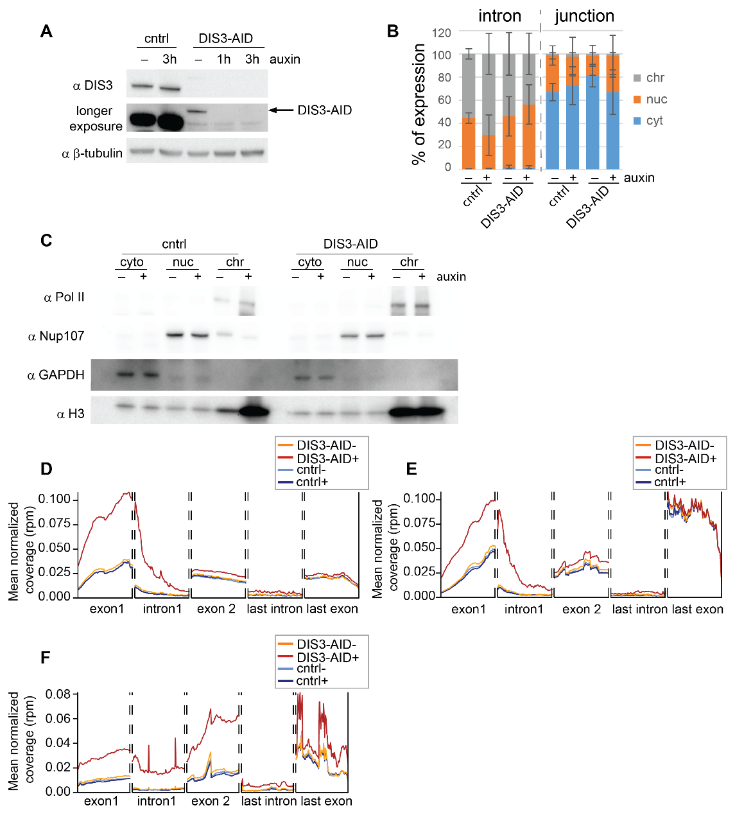
Figure S1. Quality control and data analyses workflow for CYTO-seq. A) Western blot of DIS3 in total protein extracts of DIS3-AID cells treated (+) or not (-) with auxin, b-tubulin is used as a loading control. B) qPCR quantification of the GAPDH intron and exon-exon junction distribution in % between cellular fractions. Mean and standard deviation correspond to technical triplicates of the experiment. C) Western blot of Pol II histone H3, Nup107 and GAPDH in cytoplasm (cyto), nucleoplasm (nuc) and chromatin (chr) fractions of a control (cntrl) and DIS3-AID cells treated (+) or not (-) with auxin. D) and E) Metagene profiling of the genes that were classified as premature transcripts based on upregulation of the first intron and exon in DIS3-AID cells after auxin treatment for lncRNA (n=380) (D) and PCG (n=240) (E). F) Metagene profiling of 200 PCGs containing at least 2 introns.
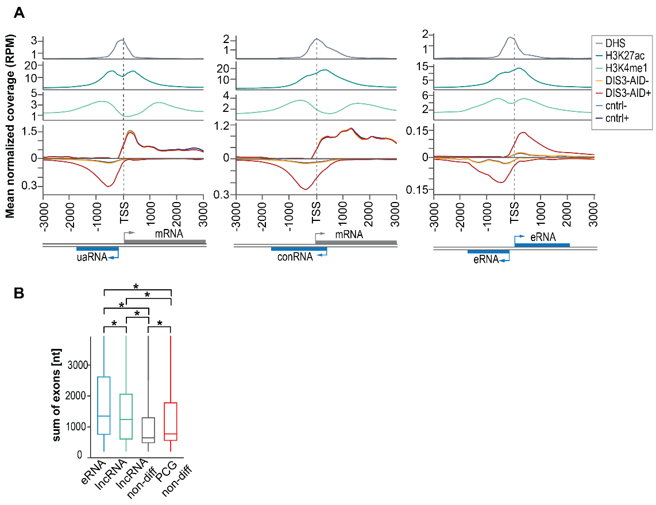
Figure S2. Cytoplasmic and nuclear DISTs share multiple features. A) Metagene profiling of RNA-seq reads for bidirectional cytoplasmic DISTs transcripts: upstream antisense (ua) RNAs (n=667), convergent (con) RNAs (n=497) and bidirectional enhancer (e) RNAs (n=517), together with ChIP-seq of histone marks H3K27ac and H3K4me1 and DNase I hypersensitive site (DHS) characteristic of open chromatin regions. B) Box plot of the processed transcripts length of upregulated DISTs: eRNAs (n= 3025), lncRNAs (n=2137) and non-differentially expressed (non-diff) lncRNAs (n=7748) and PCGs (n=2850). *P-value p<0.001 (two tailed t-test).

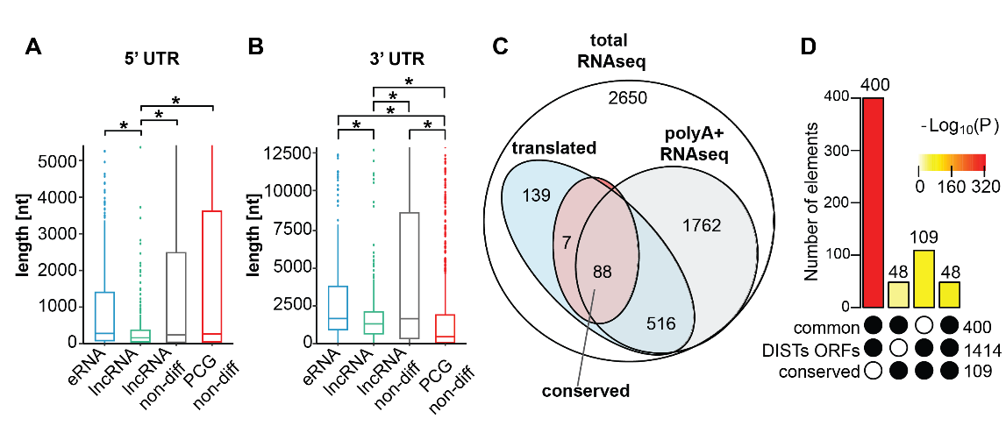
Figure S3. UTRs lengths do not distinguish DISTs from other translated lncRNAs and the polyadenylation is not prerequisite of DISTs translation. A) and B) Box plots of the 5’UTR and 3’UTR length of DIST-ORFs detected by Ribo-seq as actively translated including eRNA (n=381) and lncRNAs (n=369) and non-differential lncRNA (n=982) and PCGs (n=1599) that were also detected to be bound to ribosomes. *P-value < 0.001 (two-tailed t-test). C) Venn diagram of the overlap for 5162 upregulated DISTs detected by total and polyA⁺ RNA-seq (at least 20 counts), potentially translated and conserved. D) Results of super exact test for overlap between DISTs-ORFs, the conserved DISTs-ORFs (conserved) and ORFs detected as translated in at least one other condition in which DIS3 is present in the cell (common).

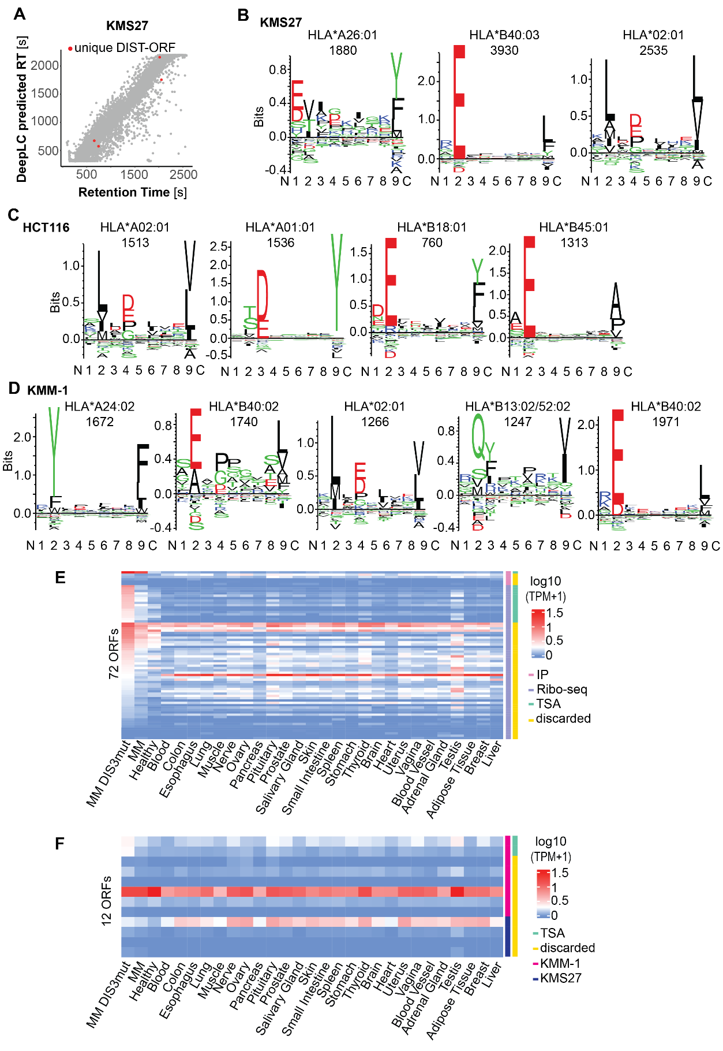
Figure S4. Peptides from HLA immunopeptidomic identify high confident DIST-ORFs peptide that some are classified as potential TSAs. A) Dot plot correlation between retention times (RT) predicted by DeelLC⁵² (y-axis) and observed RT by MS (x-axis), canonical ORFs (grey), unique (red) and multiple (black) for KMS27 cell line. B), C) and D) Results from Gibbs Clustering ⁵⁵ showing the number of clusters with a highest score and amino acid binding motifs for KMS27, DIS3-AID and KMM-1 respectively. The most relevant HLA allele is indicated above each motif with the number of assigned peptides for each cluster. E) and F) Heatmaps of expression in log10 (TPM+1) of ORFs candidates between the GTEx dataset and the MM cohort. E) Pink and violet colours indicate ORFs sub selected based on the immunopeptidomics and Ribo-seq experiments, respectively. F) Dark pink and dark blue indicate ORF for which a peptide was detected in immunopeptidomic of KMM-1 and KMS27 respectively. E) and F) ORFs whose expression is specific to MM-TSAs with TPM<1 in all other tissues are marked in green.
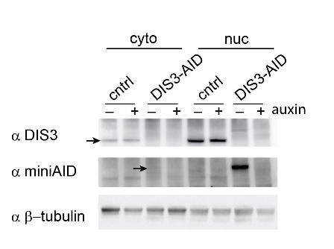
Figure S5. DIS3 is present in the cytoplasm. Western blot showing the presence of some DIS3-AID protein in the cytoplasmic fraction.
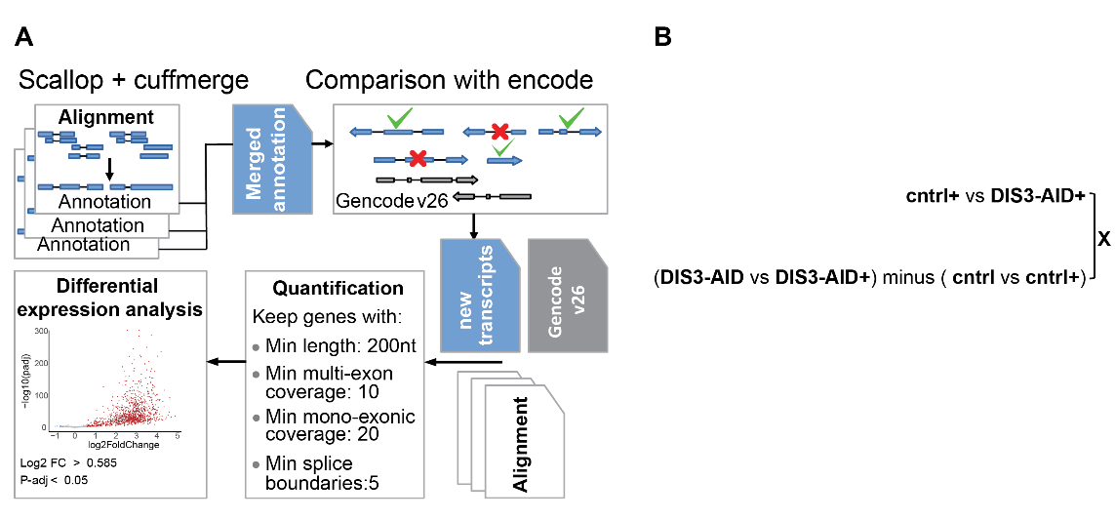
Figure S6. Schemes for bioinformatic analysis. A) Workflow for Scallop analysis of unreferenced transcripts. B) A scheme presenting an example of recursive intersection where only common differentially expressed genes between the DIS3-AID after and before treatment and in comparison, to control, that are not differential in the comparison of control against control after treatment are taken for final analysis. “+” represents conditions with addition of auxin.

