Carbon emissions from rivers may be underestimated: evidence from European drying networks

Supplementary Materials

1 | General characteristics and maps of the 6 studied drying river networks, and sampling dates of each campaign
2 | CO₂ and CH₄ fluxes measured in-situ on each of the habitats in PRs and NPRs.
3 | Detailed methods for the upscaling of CO₂ emissions to the whole 6 DRNs during 2021, with contribution of flowing water and dry riverbed. a. Prediction of CO₂ flux rates; b. Estimation of daily dry and flowing surface; c. Net C-CO₂ emissions in the 6 DRNs along 2021; d. References
4 | Variables used as explanatory variables in Random Forest models ranked based on the compartment of the conceptual model they are relevant for (Fig. 1c).

Supplementary Material 1 |General characteristics and maps of the 6 studied drying river networks, and sampling dates of each campaign
Table 1: General characteristics of the 6 studied drying river networks (DRNs) and sampling dates of each campaign.
DRN (country) | Climate | Ecoregion | Drainage area (km²) | Previous drying knowledge | Sampling dates
Albarine (France) | Temperate | Alpine | 354 | c.a. 25 % of the non-perennial stream network | March 2021  September 2021  Nov-Dec 2021
Bükkösdi-víz (Hungary) | Continental | Pannonian | 185 | c.a. 40-50 % of non-perennial stream network | April 2021  July 2021  November 2021
Butižnica (Croatia) | Mediterranean | Balkanic | 225 | Most rivers dry seasonally | April 2021  July 2021  November 2021
Genal (Spain) | Mediterranean | Mediterranean | 343 | Dry region heavily impacted by climate change | March 2021  July 2021  Jan-Feb 2022
Lepsämänjoki (Finland) | Boreal | Boreal | 208 | Records of drying area not yet available | June 2021  August 2021  November 2021
Velička (Czech Republic) | Continental | Continental | 172 | Region heavily impacted by climate change | April 2021  August 2021  November 2021
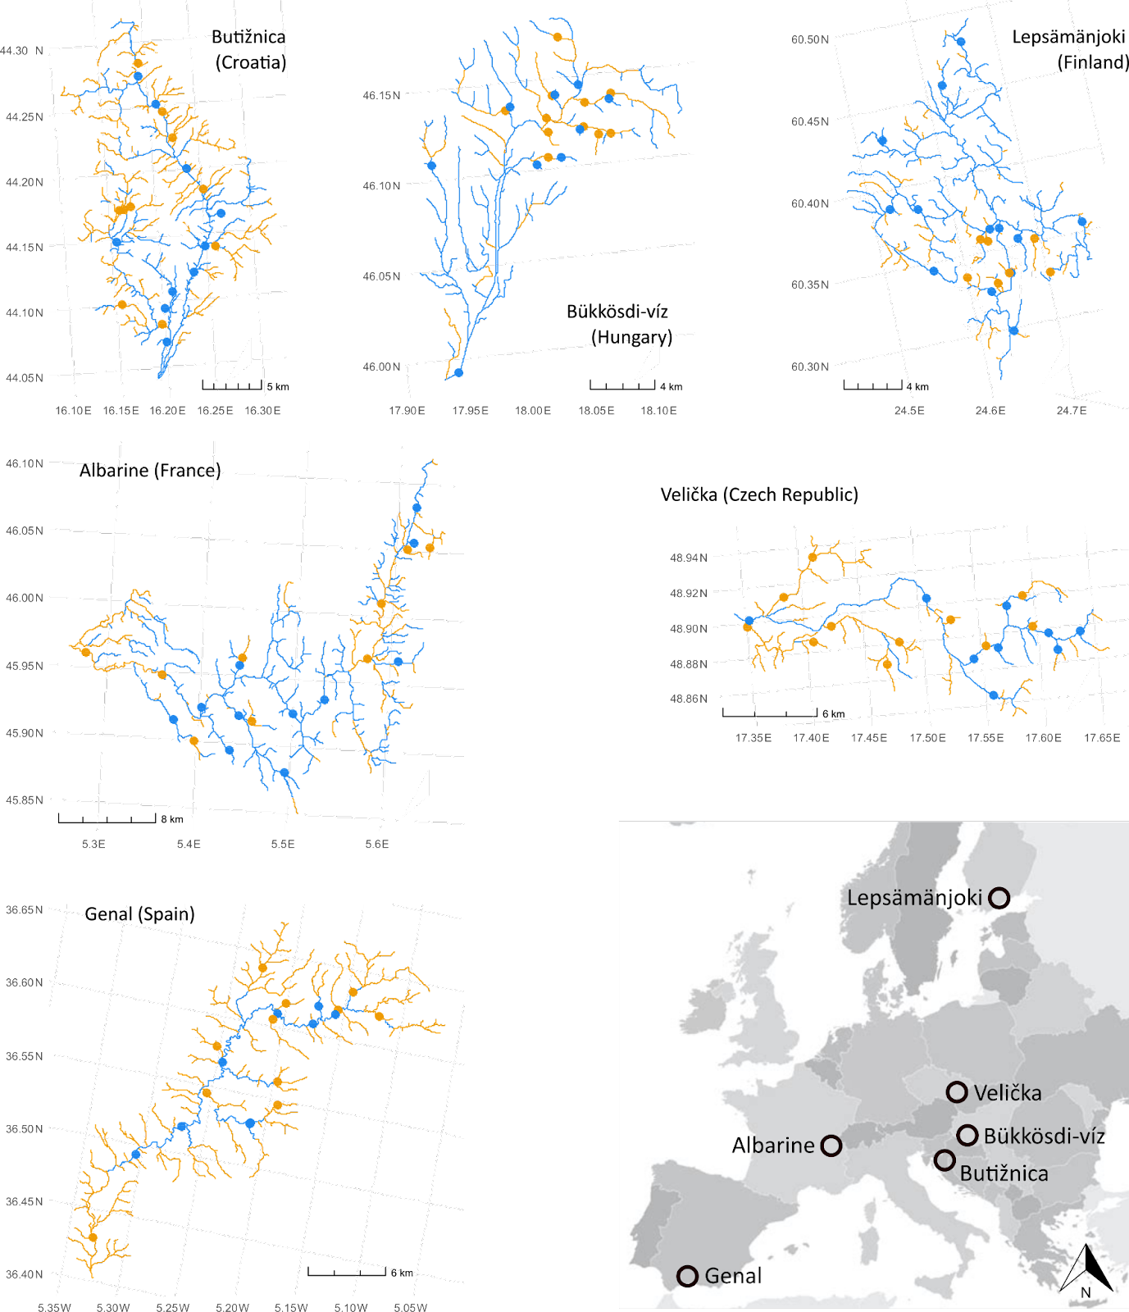
Figure 1: Maps of each DRN indicating the location of the sampling points (dots) and the distribution of perennial and non-perennial reaches (blue and orange represent PRs and NPRs respectively). All maps are oriented north, with an arrow in the European map.

Supplementary Material 2 | CO₂ and CH₄ fluxes measured in-situ on each of the habitats in PRs and NPRs
Table 1: Minimum, 1st quartile, median, mean, 3^{rdt} quartile, maximum value of CO₂ (mg C-CO₂ m⁻²h⁻¹) and CH₄ (µg C-CH₄ m⁻²h⁻¹) fluxes measured on each of the habitats (flowing water, dry riverbed, isolated pools) in perennial (PRs) and non-perennial reaches (NPRs) taking in account all sampling reaches and campaigns; n= total number of measures. Different letters denote significant differences (p < 0.05) between PRs and NPRs (results of models in Table 2)
Variable |  |  | Min. | 1st Qu. | Median | Mean | 3rd Qu. | Max. | n
CO₂ flowing water
 | PRsª |  | 3.39 | 32.47 | 71.81 | 141.93 | 167.79 | 812.25 | 142
 | NPRs^{b} |  | 5.65 | 22.83 | 55.47 | 75.23 | 82.39 | 441.45 | 79
CH₄ flowing waters
 |  | PRsª |  | 10.38 | 113.32 | 510.02 | 690.69 | 2707.07 | 97
 |  | NPRs^{b} |  | 3.59 | 46.98 | 113.03 | 134.52 | 803.32 | 57
CO₂ dry riverbed
 | PRsª |  | 0.25 | 18.50 | 44.496 | 70.677 | 89.581 | 373.85 | 59
 | NPRsª |  | -3.99 | 18.94 | 40.46 | 81.15 | 102.36 | 475.31 | 105
CH₄ dry riverbed
 | PRsª |  | -28.49 | -8.29 | 1.44 | 87.24 | 34.39 | 597.52 | 12
 | NPRsª |  | -54.96 | -13.22 | -2.90 | 51.28 | 3.96 | 1655.05 | 53
CO₂ isolated pools |  |  | 2.69 | 20.97 | 52.88 | 49.15 | 70.61 | 123.05 | 11
CH₄ isolated pools |  |  | 0.97 | 4.54 | 19.09 | 140.05 | 198.99 | 553.22 | 7

Table 2: Results of linear mixed-effects models testing for differences between flow regimes (PR and NPR) for each gas (CO₂ and CH₄) and habitat (flowing water and dry riverbed). numDF: numerator degrees of freedom; denDF: denominator degrees of freedom.
Model |  |  | numDF | denDF | F-value | p-value
CO₂ flowing water
 | (Intercept) |  | 1 | 203 | 995.15 | <0.0001
 | Flow regime |  | 1 | 203 | 9.98 | 0.0018
CH₄ flowing waters
 |  | (Intercept) | 1 | 141 | 719.91 | <0.0001
 |  | Flow regime | 1 | 141 | 29.16 | <0.0001
CO₂ dry riverbed
 | (Intercept) |  | 1 | 148 | 176.27 | <0.0001
 | Flow regime |  | 1 | 148 | 0.78 | 0.3801
CH₄ dry riverbed
 | (Intercept) |  | 1 | 55 | 1447.62 | <0.0001
 | Flow regime |  | 1 | 55 | 2.97 | 0.0905

Supplementary Material 3 | Detailed methods for the upscaling of CO₂ emissions to the whole 6 DRNs during 2021, with contribution of flowing water and dry riverbed.
a. Prediction of CO₂ flux rates
A second set of RF models (including 4 modes: flowing water and dry riverbed, PRs and NPRs) was run for CO₂ emissions, including only those predictor variables available for every river reach of the 6 DRNs (the variables are detailed in Supplementary Material 4 and included: river discharge from hydrological models, climatic and land use variables, and drying metrics for NPRs). The lower number of CH₄ flux measures, together with the importance of local environmental drivers, did not allow the upscaling of methane emissions. As for the first set of RF models (described in Methods), starting from models including all potential predictor variables, we ran a series of models, removing on each step the least explanatory variable, until reaching the model with the highest performance (lowest root mean squared error, RMSE).

When relying on RF’s out-of-bag predictions to assess model performance, the same data used to rank predictor variables according to their importance measures, is also used to estimate the accuracies of the models. As this second set of models was used to predict the daily CO₂ fluxes for every river reach of the sampled DRNs, during 2021 (sampling year), we used a second validation step to better assess the model performance. When, as in our case, models are intended to predict within the same spatial and temporal ranges by which they were trained, random cross-validation (CV) yields fair error estimates because the model's conditionals do not change¹. So, to perform this cross-validation, we calibrated each of the 4 models following the k-fold (5 fold, repeated 3 times) CV method (method = rf, trControl = repeat_cv, metric = RMSE, ‘train’ function, caret R package²). This CV method divides the data set into subsets as k number. Therefore, it repeats the holdout method k number of times, using alternatively each of the k parts of the dataset to make predictions, while the other k-1 parts are used for the training, so finally all the is used both in training and prediction steps. CV provides an assessment of how the model would perform on new data that were not used in its training, and therefore avoids overoptimistic estimates of the model’s predictive ability.

The results of final models are detailed in Table 1 and the results of the model training are detailed in Table 2. The final models were then used to predict the daily CO₂ flux rates (gC-CO₂ m⁻² d⁻¹) from flowing water and dry riverbed for every single reach (including PRs and NPRs) along 2021 (‘predict’ function, randomForest R package³);

Table 1. Results of the second set of RF models for CO₂ emissions from flowing water and dry riverbed for PRs and NPRs. Inc. MSE corresponds to the increase in the mean squared error of the predictions after permutation. Inc. node purity is the average decrease in node impurity measured as the residual sum of squares. Both are used to assess the importance of predictors in RF models. For both measures, the higher the value, the more important the variable.
Response variable |  | Variance explained (%) | Predictor variables | Inc. MSE (%) | Inc. node purity (%)
Flowing water
 | PRs | 51 | Annual precipitation  Reach slope  Discharge  Distance to source  Monthly evapotranspiration  Broadleaf forest  Agriculture  Elevation  Coniferous forest  Monthly mean temperature  Upstream river length  Grassland  Monthly precipitation | 42.17  37.86  34.73  33.99  33.22  34.06  33.38  32.07  33.56  31.56  31.10  26.83  20.91 | 2.05  2.68  2.90  2.04  2.47  1.50  1.86  2.42  1.29  2.21  2.10  1.14  1.73
 | NPRs | 32 | Drying severity  Grassland  Mean annual precipitation  Discharge  Distance to source | 33.99  34.09  30.65  30.17  26.45 | 1.85  1.33  1.52  1.77  1.37
Dry riverbed
 | PRs | 56 | Monthly evapotranspiration  Monthly precipitation  Monthly mean temperature  Distance to source  Upstream river length  Discharge  Coniferous forest  Agriculture | 44.65  44.66  37.13  19.37  18.41  17.98  15.23  14.47 | 1.47  1.32  1.22  0.49  0.52  0.51  0.45  0.67
 | NPRs | 70 | Monthly evapotranspiration  Monthly mean temperature  Monthly precipitation  Mean annual precipitation  Agriculture  Coniferous forest  Broadleaf forest | 62.07  51.74  48.99  40.81  33.93  32.46  25.69 | 4.32  3.88  3.47  1.68  1.77  2.02  1.02

Table 2. Resampling results across tuning parameters. Resampling: Cross-Validated (5 fold, repeated 3 times). mtry: number of predictors sampled from the full set of predictors and used for splitting each tree node; RMSE: root mean squared error; MAE: Mean Absolute Error.

RF model |  | mtry | RMSE | Rsquared | MAE
Flowing water
 | PRs | 2 | 0.31766 | 0.51474 | 0.24797
 |  | 7 | 0.31945 | 0.49788 | 0.24844
 |  | 13 | 0.32247 | 0.48810 | 0.24950
 | NPRs | 2 | 0.29646 | 0.27837 | 0.24098
 |  | 3 | 0.29652 | 0.28754 | 0.24130
 |  | 5 | 0.30132 | 0.27480 | 0.24457
Dry riverbed
 | PRs | 2 | 0.23344 | 0.56715 | 0.18410
 |  | 5 | 0.23107 | 0.56148 | 0.18265
 |  | 8 | 0.23398 | 0.55424 | 0.18546
 | NPRs | 2 | 0.27530 | 0.61874 | 0.20710
 |  | 4 | 0.28142 | 0.59927 | 0.20963
 |  | 7 | 0.28530 | 0.58773 | 0.21248

b. Estimation of daily flow and dry surface

The daily CO₂ emissions at each river reach of each DRN was calculated as the habitat-specific fluxes (flowing water and/or dry riverbed; CO₂ flux rates from RF results) weighted by the surface area they represented. This required to know the daily wetted width (WW) to estimate the flowing area (WW * length) and the dry area [(bankfull width – WW) * length].

We used classical hydraulic geometry relationships (width-discharge relationships⁴) to estimate WW. They proposed two types of hydraulic geometry relationships for width. The first (“downstream”) represents spatial variations in width. Applied to an average annual discharge (QM), the average wetted width (WWM) should vary as

$WWM=ad*QM{}^{bd}$ (eq. 1)

The second (“at-a-station”) represents temporal variations in wetted width (WW) with discharge (Q)

$WW = a * Q{}^{b}$ (eq. 2)

Combining eq. 1 and eq. 2 (as proposed by Damiani et al.⁵ and Lamouroux and Souchon⁶), provides a 3-parameters formulation of spatio-temporal variations in width:

$WW = [ad * QM {}^{bd}] * [\frac{Q}{QM}]{}^{b}$ (eq. 3)

Eq. 3 identifies spatial variations in width (represented by the exponent bd) and temporal variations (exponent b), which is interesting when extrapolating width in space and time, because these two exponents generally differ⁴.

Because discharge and width are approximately log-normally distributed, we fitted a log-transformed, linear version of eq. 3 (eq. 4) to all our observed data in all DRNs. However, we excluded measurements with very low flows (Q < 0.01 m³s⁻¹), for which hydraulic geometry may deviate from the power form of eq. 3.

$ln(WW) = ln(ad) + bd * ln (QM) + b * ln [\frac{Q}{QM}]$ (eq. 4)

Fitting eq. 4 to our field data, using the average discharge QM of year 2021, provided (linear regression, R² = 0.67, p < 10⁻¹⁵): ad = 6.48, bd = 0.35, b = 0.16

Damiani et al.⁵ used the same approach based on the data of Morel et al.⁷, which combines a large part of the hydraulic geometry data available at the scale of stream reaches in flowing waters (1327 reaches of France and New Zealand). These provided results consistent with ours (ad = 7.482, bd = 0.477, b = 0.148).

c. Net CO₂ emissions in the 6 DRNs along 2021

With our estimations of daily WW, we calculated the daily flowing and the dry area for every single reach (a), that, multiplied by the CO₂ emissions rates (b), gave us the daily CO₂ emissions (Tg C-CO₂ y⁻¹) from each of the 6 DRNs, during 2021 (Table 3). Note that when daily WW was estimated larger than bankfull width, we considered that they were equal (fully flowing bed).

Table 3: Estimated CO₂ emissions for each DRN (total of whole river network), during all 2021, split into the emissions from dry riverbed and flowing water.
DRN  (country) | Emissions from dry riverbed  (Tg C-CO₂ y⁻¹) | Emissions from  flowing water  (Tg C-CO₂ y⁻¹) | Total  emissions  (Tg C-CO₂ y⁻¹) | Contribution of dry riverbed (proportion)
Albarine (France) | 196.46 | 706.33 | 902.79 | 0.22
Bükkösdi-víz (Hungary) | 352.56 | 105.82 | 458.38 | 0.77
Butižnica (Croatia) | 337.06 | 960.44 | 1297.50 | 0.26
Genal (Spain) | 402.17 | 257.96 | 660.13 | 0.61
Lepsämänjoki (Finland) | 141.71 | 842.18 | 938.89 | 0.14
Velička (Czech Republic) | 273.71 | 160.39 | 434.10 | 0.63

d. References

1. Roberts, D. R. et al. Cross-validation strategies for data with temporal, spatial, hierarchical, or phylogenetic structure. Ecography 40, 913–929 (2017).
2. Kuhn, M. The caret package. R Found. Stat. Comput. Vienna Austria URL Httpscran R-Proj. Orgpackage Caret (2012).
3. RColorBrewer, S. & Liaw, M. A. Package ‘randomforest’. Univ. Calif. Berkeley Berkeley CA USA (2018).
4. Leopold, L. B. & Maddock, T. The hydraulic geometry of stream channels and some physiographic implications. vol. 252 (US Government Printing Office, 1953).
5. Damiani, M. et al. A high-resolution life cycle impact assessment model for continental freshwater habitat change due to water consumption. Sci. Total Environ. 782, 146664 (2021).
6. Lamouroux, N. & Souchon, Y. Simple predictions of instream habitat model outputs for fish habitat guilds in large streams. Freshw. Biol. 47, 1531–1542 (2002).
7. Morel, M., Booker, D. J., Gob, F. & Lamouroux, N. Intercontinental predictions of river hydraulic geometry from catchment physical characteristics. J. Hydrol. 582, 124292 (2020).

Supplementary Material 4 | Variables used as predictors in Random Forest models, ranked based on the compartment of the conceptual model they are relevant for (Figure 1c).
Table 1: Variables included as predictors in the RF models. In-stream variables were only applicable in models of flowing water; sediment temperature was only applicable in models of dry riverbed; variables in the category Drying metrics were only applicable in models for NPRs. Asterisks (*) denote the variables available for every single river reach, and thus, included in the second set of models used for the network upscaling. Prop: proportion; %: percentage
Variable |  | Unit | Min | 1st Qu. | Median | Mean | 3rd Qu. | Max
In-stream variables
 | Temperature | °C | 0.10 | 6.90 | 10.30 | 11.19 | 15.00 | 23.20
 | Discharge* | L s⁻¹ | 0.08 | 2.19 | 14.22 | 234.00 | 115.33 | 6200.00
 | Wetted width | m | 0.25 | 1.39 | 2.30 | 3.51 | 4.18 | 23.00
 | Depth | cm | 2.20 | 7.56 | 12.78 | 15.96 | 20.92 | 59.51
 | pH | - | 5.03 | 7.42 | 8.01 | 7.75 | 8.32 | 8.90
 | Conductivity | µS cm⁻² | 5.82 | 228.50 | 441.50 | 472.68 | 684.75 | 1780.00
 | Dissolved oxygen | mg L⁻¹ | 0.00 | 8.29 | 9.85 | 9.36 | 10.97 | 15.35
 | Total dissolved nitrogen | µg L⁻¹ | 38.00 | 319.40 | 521.50 | 1079.80 | 891.80 | 20556.00
 | N-Ammonia | µg L⁻¹ | 0.00 | 5.00 | 13.00 | 35.50 | 28.00 | 1415.00
 | Soluble reactive phosphorus | µg L⁻¹ | 0.00 | 2.00 | 7.00 | 37.14 | 26.25 | 809.00
 | Dissolved organic carbon | µg L⁻¹ | 230.00 | 1211.00 | 3064.00 | 5550.00 | 7481.00 | 32375.00
Sediment
 | Temperature | °C | 0.57 | 9.55 | 17.00 | 15.76 | 20.55 | 35.00
 | Moisture | % | 0.49 | 19.00 | 24.80 | 27.70 | 33.21 | 68.61
 | Organic matter | % | 0.47 | 1.49 | 2.52 | 3.98 | 5.73 | 20.40
 | pH | - | 5.35 | 7.49 | 8.11 | 7.92 | 8.52 | 9.96
 | Conductivity | µS cm⁻² | 4.40 | 67.42 | 153.35 | 423.22 | 541.25 | 3740.00
 | CN | - | 0.00 | 16.32 | 29.86 | 73.96 | 89.17 | 4247.58
 | Carbon content | % | 0.00 | 1.53 | 4.25 | 5.18 | 8.31 | 19.63
Land use and geology
 | Coniferous forest* | prop | 0.00 | 0.00 | 0.04 | 0.19 | 0.31 | 1.00
 | Broadleaf forest* | prop | 0.00 | 0.02 | 0.39 | 0.41 | 0.71 | 1.00
 | Grassland* | prop | 0.00 | 0.00 | 0.01 | 0.07 | 0.11 | 0.54
 | Agricultural area* | prop | 0.00 | 0.01 | 0.05 | 0.19 | 0.28 | 0.99
 | Soil clay content | prop | 5.00 | 19.00 | 20.00 | 18.52 | 23.00 | 27.00
 | Karstic area | prop | 0.00 | 0.00 | 69.00 | 49.27 | 100.00 | 100.00
Climate
 | Actual air temperature | °C | -2.80 | 9.50 | 16.00 | 15.84 | 21.50 | 44.36
 | Climatic zone | - | 7 | 7 | 8 | 8.65 | 10 | 12
 | Monthly precipitation* | mm | 0.88 | 38.26 | 60.05 | 59.30 | 80.73 | 143.93
 | Monthly actual evapotranspiration* | mm | -1.24 | 5.10 | 34.21 | 80.62 | 138.50 | 513.26
Spatial structure and fragmentation
 | Distance to source* | m | 55.81 | 1429.69 | 3317.06 | 7455.65 | 7526.95 | 59219.30
 | Total upstream river length* | prop | 2e⁻⁴ | 0.0059 | 0.0165 | 0.1116 | 0.0835 | 0.9647
 | Elevation* | m | 33.64 | 159.94 | 235.56 | 295.35 | 397.34 | 891.79
 | Reach slope* | m/m | 0.00 | 0.01 | 0.03 | 0.04 | 0.05 | 0.20
 | Connected upstream river length | m | 104.80 | 1423.10 | 4197.00 | 25945.50 | 18341.80 | 311748.00
Drying
 | Flow prevalence 2021* | prop | 0.06 | 0.73 | 0.95 | 0.83 | 1.00 | 1.00
 | Drying severity 2021* | days | 0.00 | 0.00 | 5.00 | 17.78 | 23.69 | 155.00
 | Dry days of last 7, 30 and 90 days* | days
 | Drying events of last 7, 30 and 90 days* | -
 | Drying severity of last 7, 30 and 90 days* | days

