Supplemental File

Male histone deacetylase 6 (HDAC6) knockout mice have enhanced ventilatory responses to hypoxic challenge

Paulina M. Getsyª
Gregory A. Coffeeª
Thomas J. Kelley^{a,b}
Stephen J. Lewis^{a,c,d}

ªDepartment of Pediatrics, CWRU, Cleveland, OH 44106, USA
^{b}Department of Genetics and Genome Sciences, Cleveland, OH 44106, USA
^{c}Department of Pharmacology, Cleveland, OH 44106, USA
^{d}Functional Electrical Stimulation Center, Cleveland, OH 44106, USA

*Address correspondence to: Stephen J. Lewis, PhD. Department of Pediatrics, Case Western Reserve University, 10900 Euclid Avenue, Cleveland, OH 44106-4984, USA. Telephone: 843-422-7639. Email: sjl78@case.edu

Supplemental Table 1

Definition of ventilatory parameters described in this study

Parameter | Abbreviation |  | Units |  | Definition
A. Directly recorded parameters
Frequency of breaths |  | Freq |  | breaths/min | Rate of breathing
Inspiratory Time |  | Ti |  | sec | Duration of inspiration
Expiratory Time |  | Te |  | sec | Duration of expiration
End Inspiratory Pause |  | EIP |  | msec | Pause between end of inspiration start of expiration
End Expiratory Pause |  | EEP |  | msec | Pause between end of expiration and start of inspiration
Relaxation time |  | RT |  | sec | Decay of expiration to 36% maximum
Tidal Volume |  | TV |  | ml | Volume of inspired air per breath
Peak Inspiratory Flow |  | PIF |  | ml/sec | Maximum inspiratory flow
Peak Expiratory Flow |  | PEF |  | ml/sec | Maximum expiratory flow
Expiratory flow at 50% |  | EF₅₀ |  | ml/sec | Expiratory flow at 50% expired TV
Non-eupneic breathing index |  | NEBI |  | % | % of non-eupneic breaths per epoch
B. Derived parameters
Minute Ventilation |  | MV = freq x TV |  | ml/min | Total volume of air inspired per min
Ti/Te |  | Ti/Te |  | none | Inspiratory quotient
PEF/PIF |  | PEF/PIF |  | none | Flow balance
Expiratory Delay |  | Te-RT |  | No units | Measure of elongated expiration
Inspiratory Drive |  | TV/Ti |  | ml/sec | Central urge to inhale
Expiratory Drive |  | TV/Te |  | ml/sec | Central drive to exhale
NEBI/Frequency |  | NEBI/Freq |  | %/(b/min) | Balanced rejection index

Supplemental Figure 1

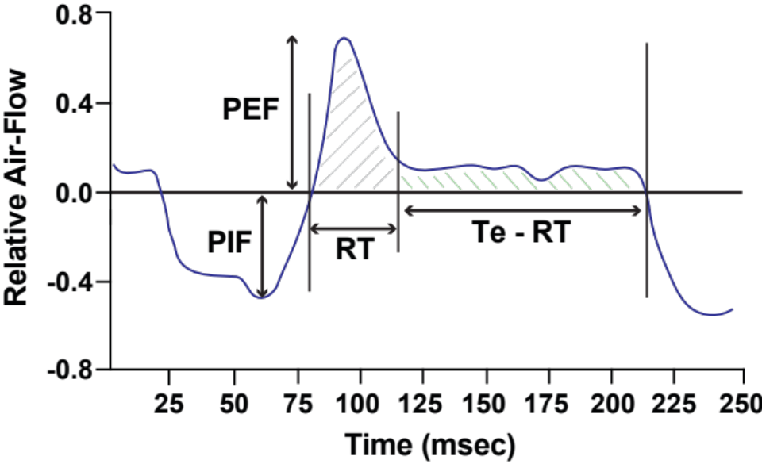

Supplemental Figure 1. Relationships between peak inspiratory flow (PIF), peak expiratory flow (PEF), relaxation time (RT) and expiratory time (Te).

