SUPPORTING INFORMATION

Structural and biological characterization of shortened derivatives of the cathelicidin PMAP-36

Barbara Biondi¹, Luigi De Pascale², Mario Mardirossian², Adriana Di Stasi², Matteo Favaro³, Marco Scocchi^{2*}, and Cristina Peggion^{1,3*}

¹ Institute of Biomolecular Chemistry, Padova Unit, CNR, Padova, Italy
² Department of Life Sciences, University of Trieste, Trieste, Italy
³ Department of Chemical Sciences, University of Padova, Padova, Italy

- NMR data of peptide b
Table S1. ¹H-NMR chemical shifts of peptide b.

- NMR data of peptide g
Table S2. ¹H-NMR chemical shifts of peptide g.
Figure S1. Figure S1. Fingerprint region of the NOESY spectrum (600 MHz) of peptide g in TFE solution (c= 1.2 mM, T=308 K)
Figure S2. Figure S2. Amide NH region of the NOESY spectrum (600 MHz) of peptide g in TFE solution (c= 1.2 mM, T=308 K)

- NMR data of peptide h
Table S3. ¹H-NMR chemical shifts of peptide h.
Figure S3. Amide NH region of the NOESY spectrum (600 MHz) of peptide h in TFE solution (c= 1.2 mM, T=308 K)
Figure S4. Fingerprint region of the NOESY spectrum (600 MHz) of peptide h in TFE solution (c= 1.2 mM, T=308 K). C^{α}H_{i}→NH_{i+2} and C^{α}H_{i}→NH_{i+3} cross-peaks are highlighted in red, and green, respectively.
Figure S5. Region of the NOESY spectrum (600 MHz) of peptide h in TFE solution (c= 1.2 mM, T=308 K). C^{β}H_{i}→NH_{i+2}, C^{β}H_{i}→NH_{i+3} are highlighted in red and green respectively.

- Evaluation of solubility and aggregation
Figure S6. Solubility of PMAP-36 derivatives at different concentrations in PBS after 4h and 24 h incubation
Figure S7. Solubility of PMAP-36 derivatives at different concentrations in completed Mueller-Hinton broth after 4h and 24 h incubation

- NMR data of peptide b

Table S1. ¹H-NMR chemical shifts of peptide b.
Residue | NH | α | β | other
Ac⁰ |  |  |  | 2.14
Lys¹² | 7.66 | 4.15 | 1.95 | γ 1.66; δ 1.86; ε -
Arg¹³ | 8.02 | 4.20 | 2.07, 2.00 | γ 1.88, 1.82; δ 3.29; NHε 7.21
Leu¹⁴ | 7.36 | 4.25 | - | γ -; δ 1.05, 0.97
Lys¹⁵ | 7.72 | 4.20 | 2.02 | γ 1.70, 1.58; δ 1.85; ε 3.08; NHε 7.43
Lys¹⁶ | 8.21 | 3.92 | - | γ -; δ -; ε -
Ile¹⁷ | 8.58 | 3.79 | - | γ -
Gly¹⁸ | 8.11 | 4.03, 3.87
Lys¹⁹ | 7.77 | 4.22 | 2.04 | γ 1.66, 1.56; ε 3.06; NHε 7.39
Val²⁰ | 7.96 | 3.92 | 2.01 | γ 1.05
Leu²¹ | 7.72 | 4.20 | 1.85 | -
Lys²² | - | - | - | ND for overlapping
Trp²³ | 8.07 | 4.57 | 3.67, 3.50 | H1 9.16; H2 7.43; H4 7.7; H5 7.15; H6 7.24; H7 7.48
Ile²⁴ | 8.61 | 3.71 | 2.11 | γ 1.37; γ(CH₃) 1.10; δ 1.02
Ala²⁵ | 8.27 | 4.09 | 1.57
Lys²⁶ | 7.77 | 4.10 | - | -
Ile²⁷ | 8.47 | 4.23 | 1.97 | γ 1.62; γ(CH₃) 1.15; δ 0.97
Val²⁸ | 7.89 | 3.91 | 2.40 | γ 1.16
Gly²⁹ | 8.08 | 3.79
Ser³⁰ | 7.79 | 4.55 | 4.12, 3.99
Ile³¹ | 7.62 | 4.28 | 2.02 | γ 1.64, 1.30; γ(CH₃) 1.03; δ 0.94
-NH₂ |  |  |  | 7.25, 6.14

- NMR data of peptide g

Table S2. ¹H-NMR chemical shifts of peptide g.
Residue | NH | α | β | other
Ac⁰ |  |  |  | 2.15
Lys¹² | 7.98 | 4.08 | 1.88, 1.79 | γ 1.52; δ 1.64; ε 3.05
Arg¹³ | 7.93 | 4.12 | 1.98, 1.93 | γ 1.78; δ 3.26; NHε 7.00
Leu¹⁴ | 7.31 | 4.25 | 1.87, 1.72 | γ 1.67; δ 1.03, 0.95
Lys¹⁵ | 7.78 | 4.18 | 1.99 | γ 1.61, 1.50; δ 1.77; ε 3.05
Lys¹⁶ | 7.62 | 4.16 | 1.93, 1.86 | γ 1.38; δ 1.67; ε 3.05
Ile¹⁷ | 7.92 | 3.93 | - | γ 1.01
Gly¹⁸ | 8.17 | 3.86
Lys¹⁹ | 7.71 | 4.15 | 1.98 | γ 1.52; δ 1.79, 1.67; ε 3.06
Val²⁰ | 7.49 | 4.21 | 1.92 | γ 0.96, 0.91
Leu²¹ | 7.83 | 3.93 | 2.30 | γ 1.52; δ 1.12, 1.06
Lys²² | 8.10 | 4.25 | 1.81 | γ 1.50; δ -; ε 3.06
Trp²³ | 7.78 | 4.73 | 3.14 | H1 9.10; H2 7.21; H4 7.18; H5 7.70; H6 7.24; H7 7.46
Ile²⁴ | 7.49 | 4.20 | 1.93 | γ 1.21
-NH₂ |  |  |  | 6.89

Figure S1. Fingerprint region of the NOESY spectrum (600 MHz) of peptide g in TFE solution (c= 1.2 mM, T=308 K)

Figure S2. Amide NH region of the NOESY spectrum (600 MHz) of peptide g in TFE solution (c= 1.2 mM, T=308 K)
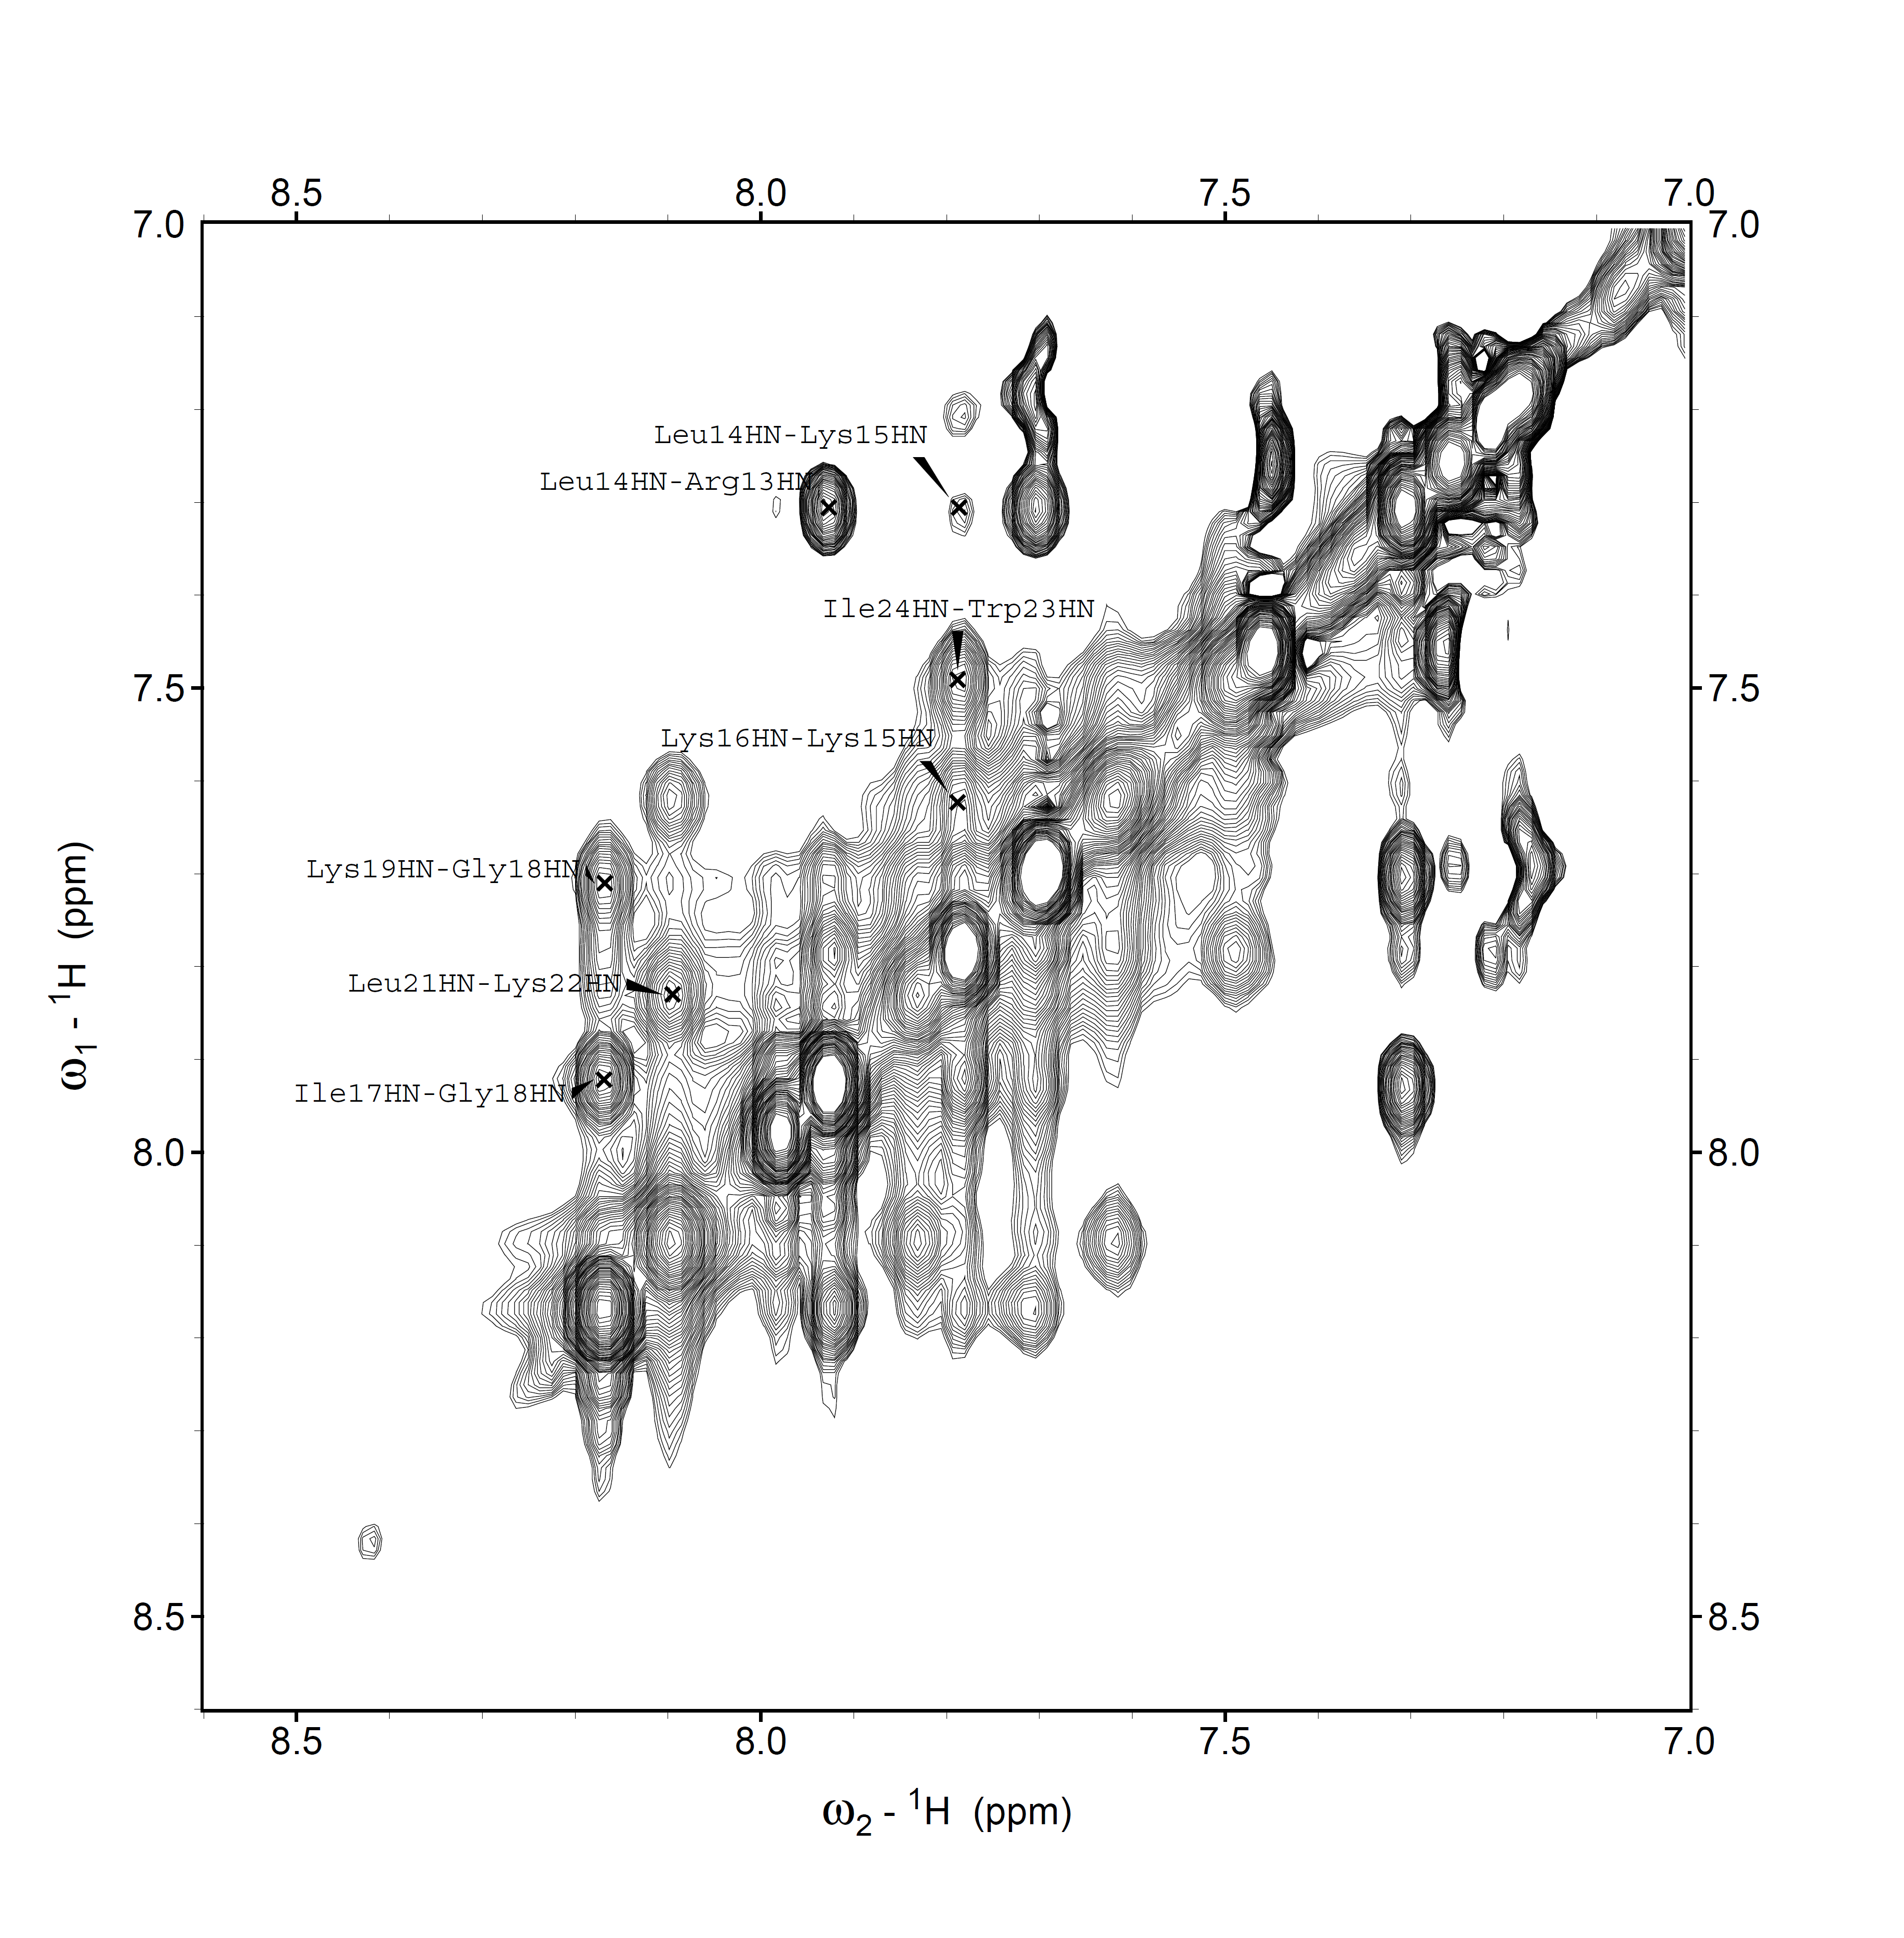

- NMR data of peptide h

Table S3. ¹H-NMR chemical shifts of peptide h.
Residue | NH | α | β | other
Ac⁰ |  |  |  | 2.14
Lys¹² | 8.01 | 4.07 | 1.88 | γ 1.53; δ 1.64; ε 3.05
Arg¹³ | 7.34 | 4.25 | 1.86 | γ 1.69; δ 3.07; NHε 7.31
Leu¹⁴ | 7.95 | 4.12 | 1.94 | γ 1.77; δ -
Lys¹⁵ | 7.65 | 4.28 | 1.98 | γ 1.51; δ 1.67, 1.77; ε 3.05
Lys¹⁶ | 7.76 | 4.19 | 1.98 | γ 1.60, 1.50; δ 1.77; ε 3.04
Ile¹⁷ | 7.85 | 3.97 | 1.98 | γ 1.02
Gly¹⁸ | 8.08 | 3.91
Lys¹⁹ | 7.25 | 4.16 | 1.81 | γ 1.33; δ 1.65; ε 3.38; NHε 7.10
Val²⁰ | 7.68 | 9.91 | 2.25 | γ 1.11, 1.06
Aib²¹ | 8.07 | - | 1.54, 1.48
Lys²² | 7.66 | 4.16 | 1.95 | γ 1.67, 1.51; δ 1.77; ε 3.06; NHε 7.03
Trp²³ | 7.94 | 4.76 | 3.45, 3.38 | H1 9.11; H2 7.25; H4 7.13; H5 7.72; H6 7.25; H7 7.45
Ile²⁴ | 7.51 | 4.25 | 1.97 | γ 1.25; γ(CH₃) 0.97; δ 0.91
-NH₂ |  |  |  | 7.00, 6.00

Figure S3. Amide NH region of the NOESY spectrum (600 MHz) of peptide h in TFE solution (c= 1.2 mM, T=308 K)
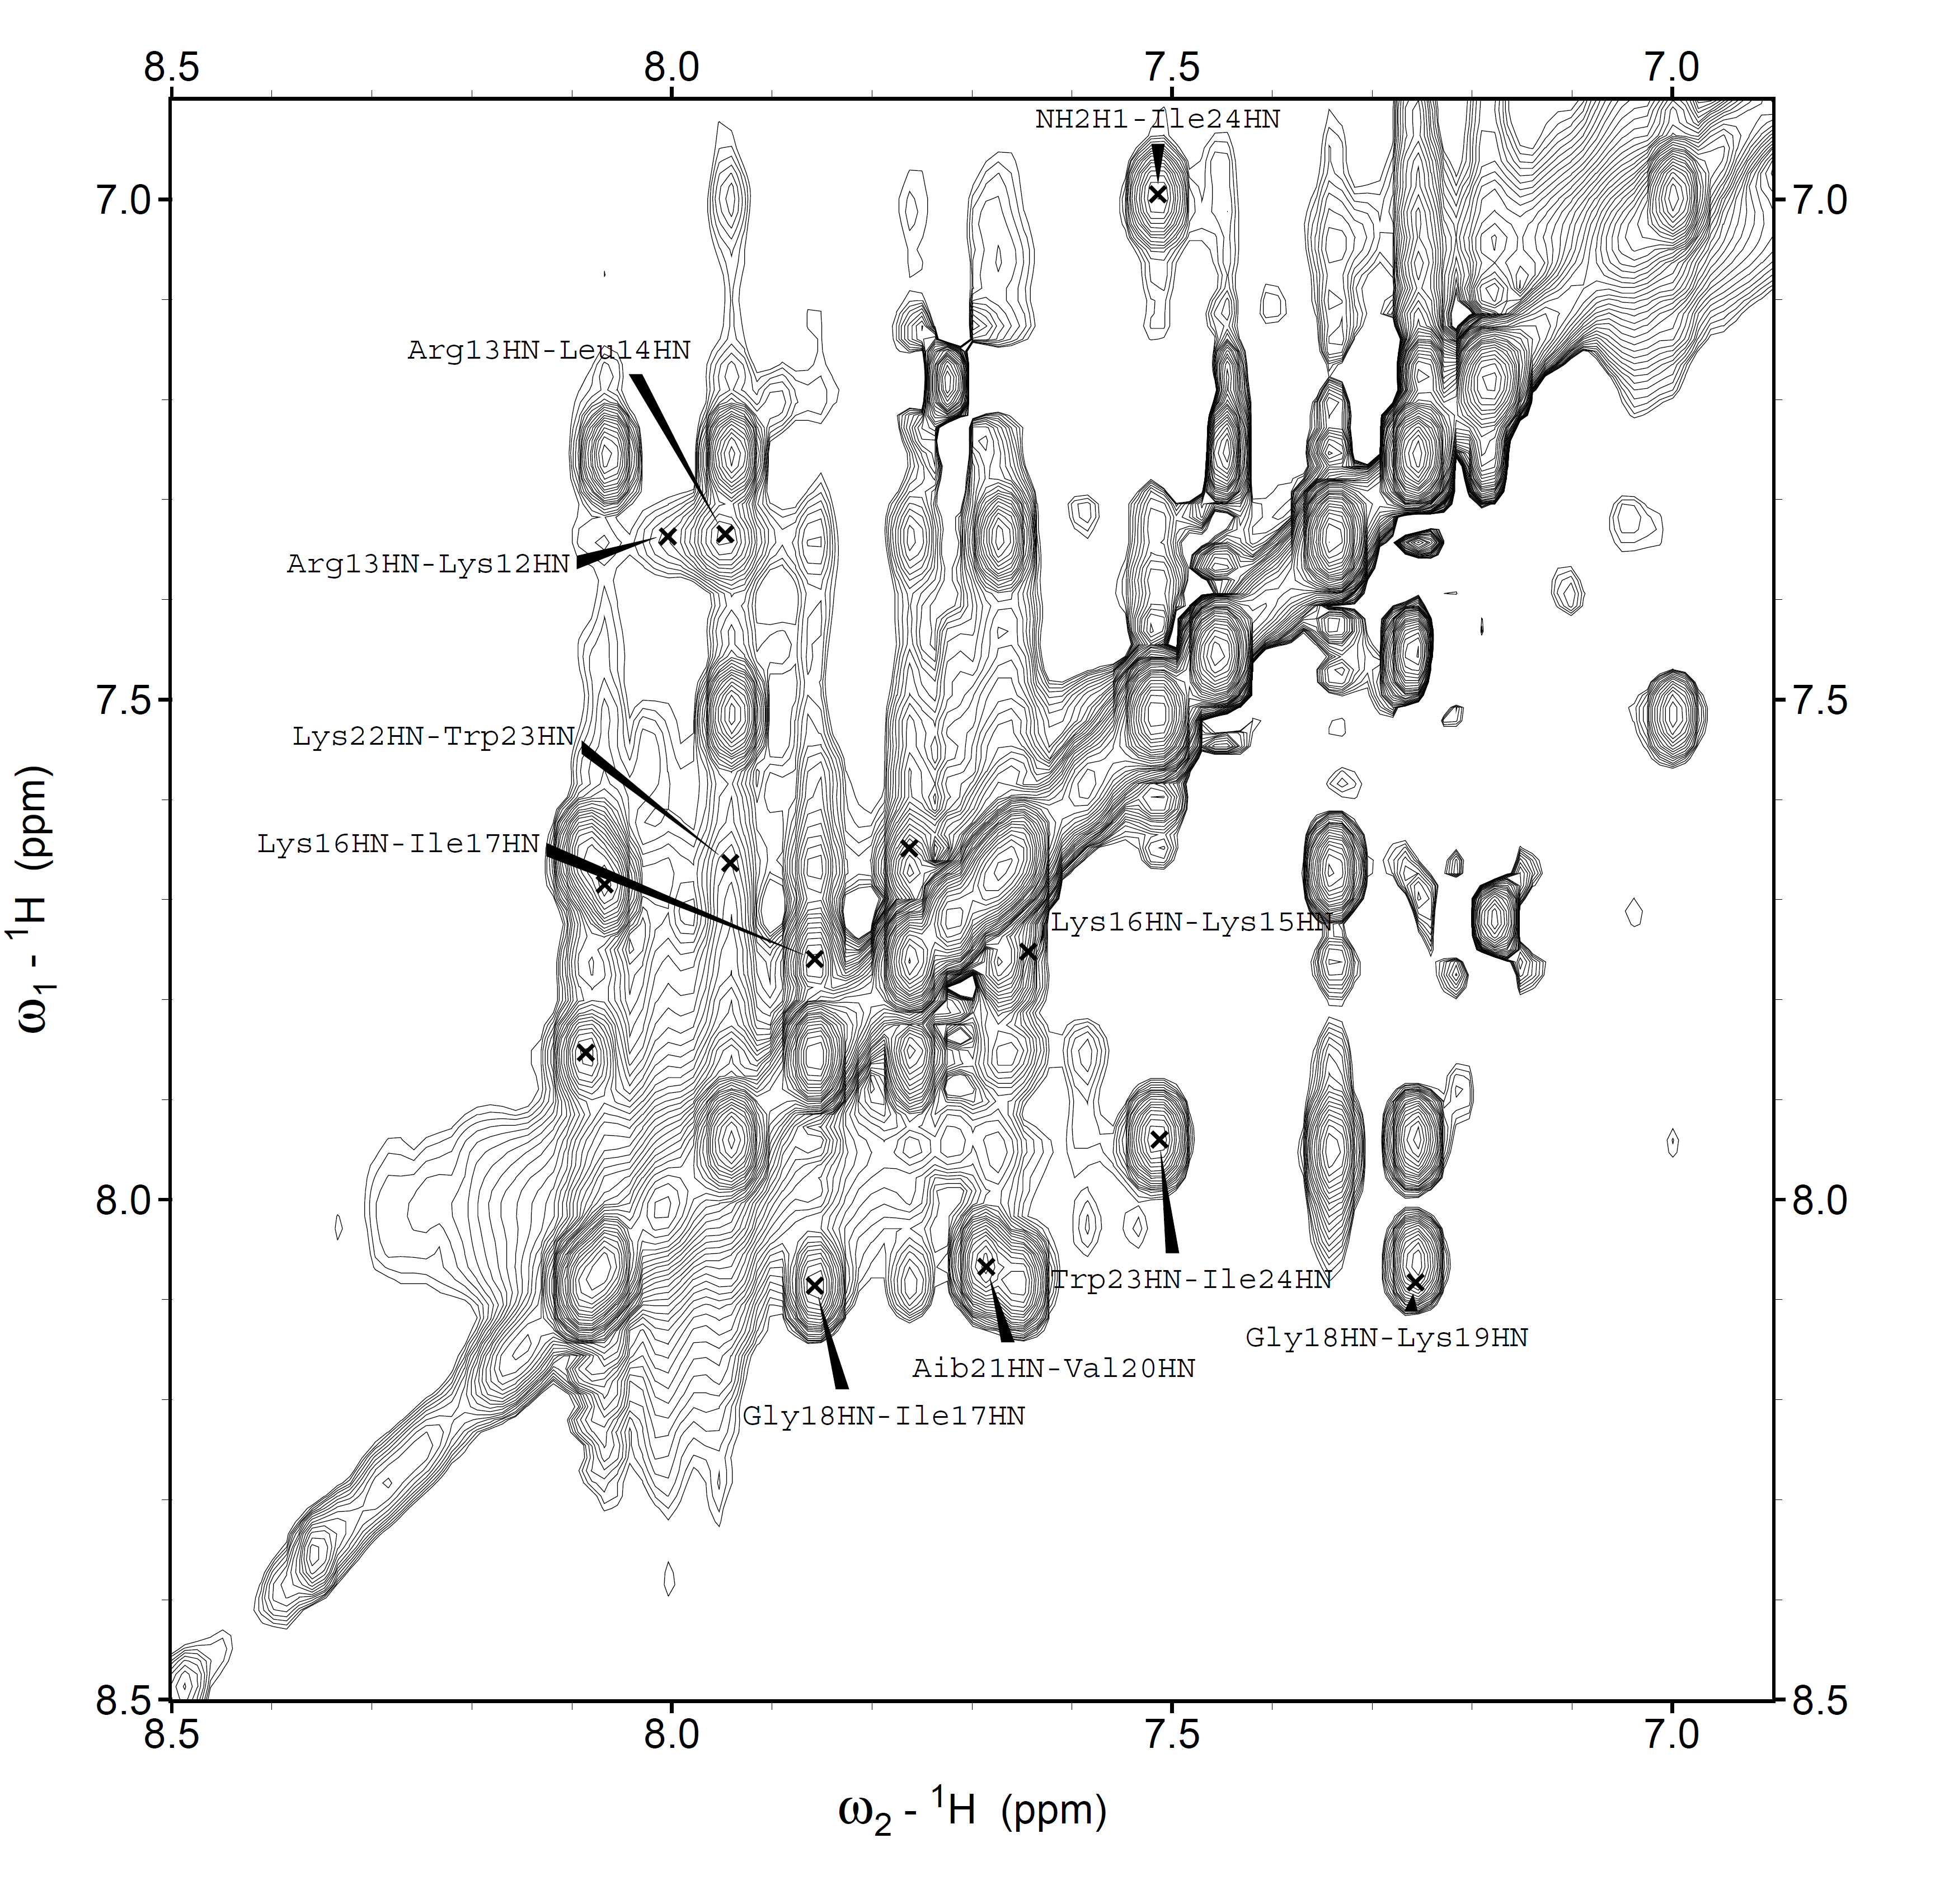

Figure S4. Fingerprint region of the NOESY spectrum (600 MHz) of peptide h in TFE solution (c= 1.2 mM, T=308 K). C^{α}H_{i}→NH_{i+2} and C^{α}H_{i}→NH_{i+3} cross-peaks are highlighted in red, and green, respectively.

Figure S5. Region of the NOESY spectrum (600 MHz) of peptide h in TFE solution (c= 1.2 mM, T=308 K). C^{β}H_{i}→NH_{i+2}, C^{β}H_{i}→NH_{i+3} are highlighted in red and green respectively.

- Evaluation of solubility and aggregation

Figure S6 Solubility of PMAP-36 derivatives at different concentrations in PBS after 4h and 24 h incubation
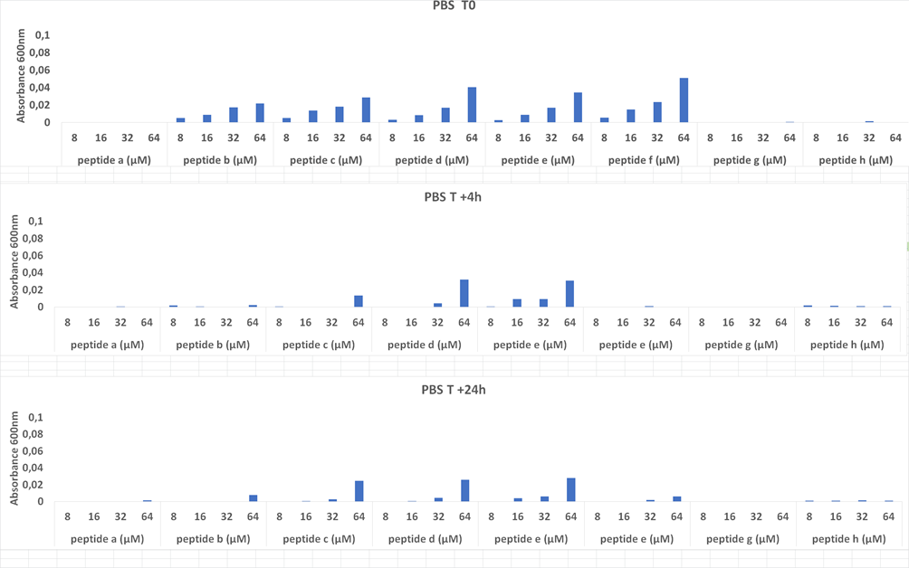

Figure S7 Solubility of PMAP-36 derivatives at different concentrations in completed Mueller-Hinton broth after 4h and 24 h incubation
